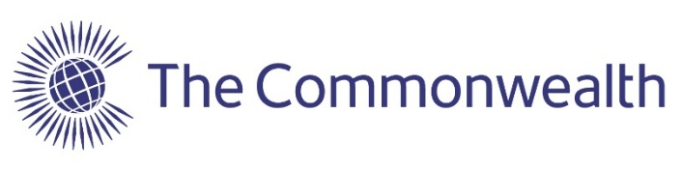
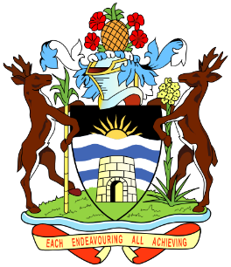
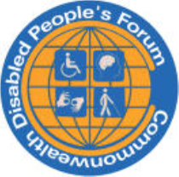

5th November 2026 Antigua Barbuda Symposium:
Implementing Disability Rights Across the Commonwealth
The adoption of the Commonwealth Disability Inclusion Action Plan (DIAP) by the Law Ministers of all 56 member countries and the expected adoption by CHOGM in this 20th Anniversary Year of the Adoption of the United Nations Convention on the Rights of Persons with Disabilities provides a great opportunity across our 56 countries to improve the lives of an estimated 450 million individuals.

The Commonwealth Secretariat , The Government od Antigua Barbuda and the Commonwealth Disabled People’s Forum are organising the Symposium to raise awareness about the Commonwealth Disability Inclusion Action Plan, highlight its importance to the Commonwealth, and advance its implementation. Other objectives include deepening understanding of the relationship between the DIAP and UNCRPD; sharing experiences, expertise and good practices on promoting an protecting disabled people’s rights; enhancing collaboration between governments and disable people’s organisations; and advocating for disabled people’s rights across the Commonwealth.

Following a high-level opening, the Symposium will include three key sessions on legal and policy frameworks; perspectives of the Committee on the Rights of Persons with Disabilities; reasonable accommodation with a focus on education, employment and political processes, climate and sport. The event will close with a plenary considering the way forward for the Commonwealth Disability Inclusion Action Plan. A reception will follow the Symposium. We will have a parallel session in the afternoon for young people with disabilities to develop their views to feed int plenary.

We are aiming to get attendance of a representative from each member country delegation and representatives of organisations of person’s with disabilities, alongside youth representatives and others with an interest.
Dr Richard Rieser OBE, General Secretary CDPF rlrieser@gmail.com
FOR THOSE ATTENDING PLEASE COMPLETE AND RETURN THE APPLICATION OVERLEAF. 1 PER PARTICIUPANT.
Application for 5th November 2026 Antigua Barbuda Symposium:
Implementing Disability Rights Across the Commonwealth

1.Full Name

2.Country of Nationality/representing

3 Gender 4.Age

5.Email Address

6.Telephone with International Dialling Code
If accompanied by Personal Assistant their Name
7. Name of PA
8. Do You consider yourself a Disabled Person Yes NO
9. Other Access Needs-list.

Dietary Needs-list.

Where are you staying in Antigua?

Please Return this form to martha.aldridge@commonwealthdpf.org
Return a.s.a.p. and by 15th October 2026 at the latest.

