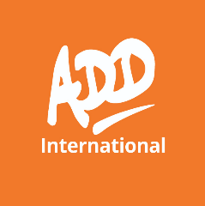
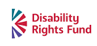
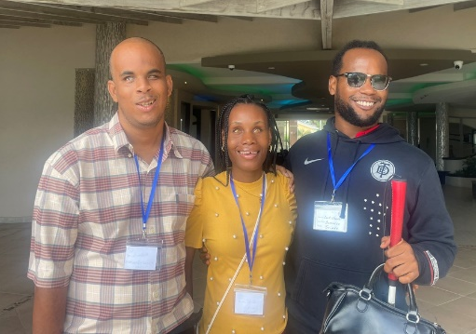
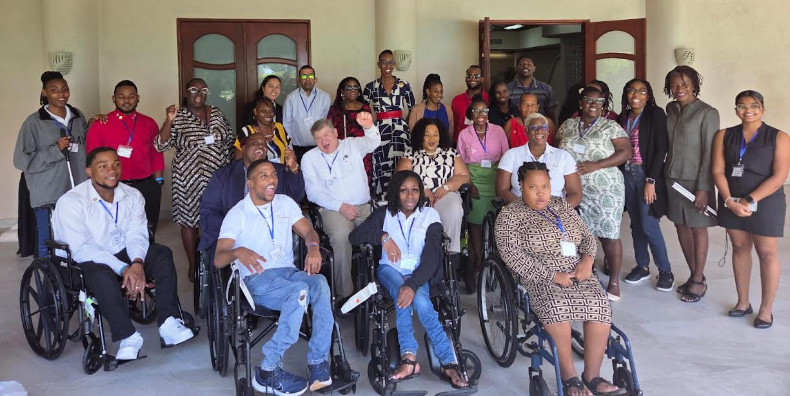
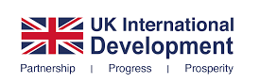
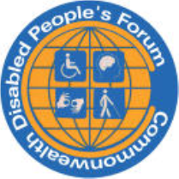
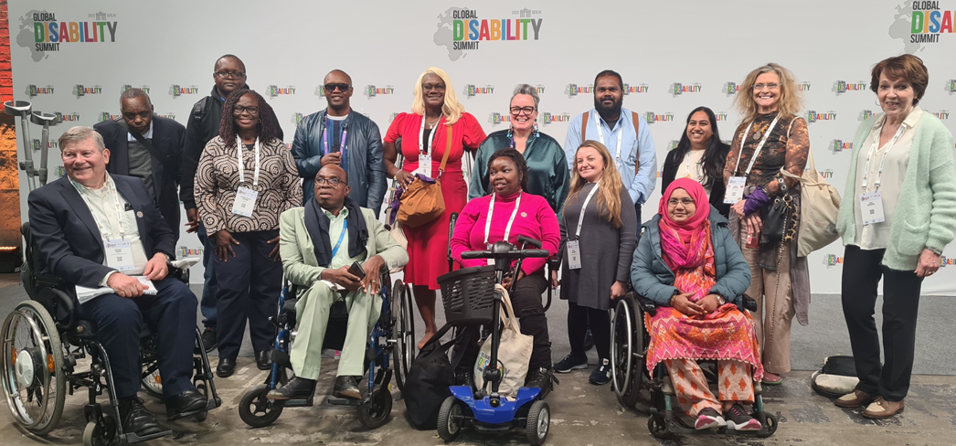
COMMONWEALTH DISABLED PEOPLE’S FORUM

Annual Report 2025
Empowering the voices and rights of disabled people across the Commonwealth

Reporting Period: January – December 2025 Published:
2026 Website: https://commonwealthdpf.org
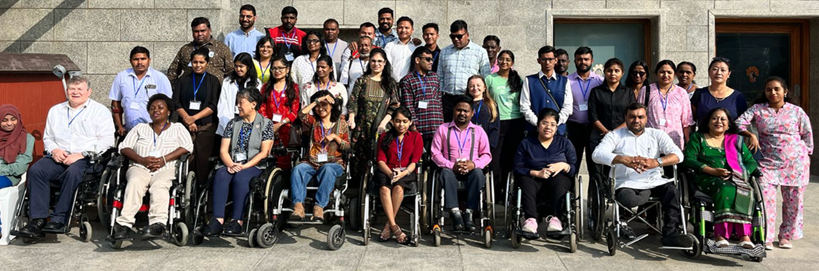

Contents
Executive Summary……………………………………………………………………………………………………… p.3

CDPF Chair’s Report – Sarah Kamau………………………………………………………………………………. p.4

Executive Committee ……………………………………………………………………………………………………p.7

Patrons and Members……………………………………………………………………………………………………p.9

Purpose and Values………………………………………………………………………………………………………p.12

The Commonwealth Disability Inclusion Action Plan………………………………………………………….p.15

Executive Session on LGBT……………………………………………………………………………………………..p.20

INDIA Training Disabled Youth Leadership and Disability Equality………………………………………….p.24

Commonwealth Day………………………………………………………………………………………………………p.29

Global Disability Summit………………………………………………………………………………………………..p.29

Report from COSP 18 AT UN New York………………………………………………………………………………p.37

CHOGM 2024: Reflection on Achievements and Progress……………………………………………………p.43

Barbados Youth Leadership Training…………………………………………………………………………………p.44

Conference of Parties (COP) Report………………………………………………………………………………….p.46

African Disabled Girls Empowerment Project………………………………………….………………………….p.51

Commonwealth Disabled Youth Forum (CDYF) 2025…………………………………………………………….p.54

Inclusive Education, Gender Mainstreaming, Disability Inclusion, Accessibility Rights, SDGs and the Way Forward………………………………………………………………………………………………………………….p.57

Underrepresented Impairment Groups and Neurodiversity Advocacy…………………………………...p61

Indigenous Peoples with Disabilities in the Commonwealth Diethono Nakhro Indigenous Peoples Representative, CDPF…………………………………………………………………………………………………….p.70

CDPF General Assembly 2025 …………………………………………………………………………………………p.73

Women’s Forum Statement to Commission on Status of Women………………………………………… p80

Commonwealth Scholarship……………………………………………………………………………………………p.83

Budget…………………………………………………………………………………………………………………………p.84

Executive Summary
2025 was a year of both growth and consolidation for CDPOF against a background of changing our Governance Structure after a new Constitution was adopted by the AGM. Following a successful AGM in February we elected 2 Assistant Secretaries and set up a Board of mainly Global Officers which meets up to 8 times a year overseeing budget and projects and a larger Executive representing all Regions of the Commonwealth which now meets 4 times a year with members also attending a wider range of working parties to develop policy.

During the year we also instituted senior officers meetings with the CEO/General Secretary, who is now appointed by Board, every fortnight when necessary. The Commonwealth Disabled Youth Forum has continued to thrive and grow running a series of monthly seminars and working on developing on line learning resources. We also for the first time sent a representative to COP in Belem and ran a side meeting on the issue of Climate and disabled people at the UNCOSP. Our face to face training of young disabled in Delhi and Barbados continues to bear fruit with greater involvement and new organistions forming. Ongoing work with JONAPWD Youth Section in Nigeria is leading to a tranche of online learning resources.

Our Executive and Board continues to be a majority of Women and we have successfully steered the Empowering Disabled Girls Project in Africa over two years. A main focus through 2025 was to take forward the commitment achieved from CHOGM 2024 to develop a Disability Inclusion Action Plan with both a DPO Advisory Group and an Expert Working Group of 17 Commonwealth county representatives . On our initiative Professor Anna Lawson of Leeds University was engaged as an independent expert who helped develop 3 useful drafts. We hope this whole process will come to fruition in March and lead to a draft suitable for adoption by the CHOGM in Antigua Barbuda in first week on November 2026.

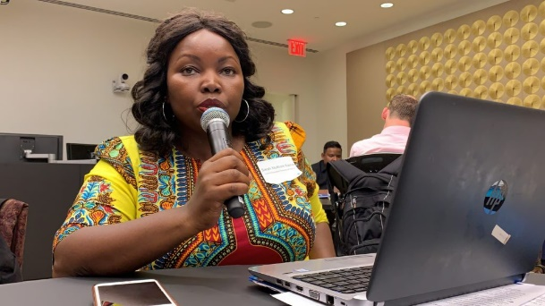
CDPF Chair’s Report – Sarah Kamau
It is my honour as Chair of Commonwealth Disabled Peoples Forum (CDPF), to present
the Annual Report for the year 2025. This report outlines the organization’s key
activities, achievements, challenges, and overall performance during the year under
review.

The year 2025 was marked with growth, transition and by continued commitment to our mission and strategic objectives. The Board worked closely with the Executive
Committee to provide oversight and guidance, with a strong emphasis on long-term
sustainability, financial stewardship, and risk management. The main achievement was the Disability Inclusion Action Plan (DIAP). CDPF formed part of the Advisory Working Group that contributed to the shaping of the final version of the DIAP. DIAP advocates for disability rights in the Commonwealth member states and calls for fast tracking the implementation of the Convention on the Rights of Persons with Disabilities (UNCRPD) which all but one (Tonga) have signed and ratified. This DIAP was formulated to call to action the commonwealth member states and the Commonwealth Secretariat to embed in their structure’s implementation plans and to fast track the realization of the UNCRPD.

The formulation of the Action Plan is now moving forward and should be adopted during the Commonwealth Heads of Government Meeting (CHOGM) 2026.
In response to changing economic conditions, particularly reduced funding from
governments and development partners, CDPF transitioned its registration from a
company to a charity to diversify and engage a broader donor base. Additionally CDPF
planned to convene its General Assembly to be held between February and March
2026.

The year 2025 also marked a change of leadership at the Commonwealth with assumption of Madam Shirley Ayorkor Botchwey, as Commonwealth Secretary-General on 1st April 2025. She succeeded Baroness Patricia Scotland, KC becoming the first African woman and Ghanaian to lead the 56-nation organization. CDPF was privileged to engage with her early enough to introduce ourselves and what we do for the Commonwealth as the only accredited disability organization. During CDPF’s engagement with the Secretary General, the Commonwealth Strategic Plan, which was being developed was discussed and CDPF committed to contribute to its formulation to ensure the disability equality and rights agenda was included.

To ensure persons with disabilities are part of the development discourse, CDPF
conducted disability equality trainings and disabled youth leadership training aimed at empowering persons with disabilities to understand their rights, which are fundamental human rights. In March 2025, a three day regional training was held in India for the Asia region, where 26 participants were trained on the United Nations Convention on the Rights of Persons with Disabilities (UNCRPD) and the Sustainable Development Goals (SDGs), and how they relate to the disability rights.

A similar training conducted in Barbados for the Caribbean region, bringing together
disability advocates, young leaders and policy makers for across the English- speaking
Caribbean. In total, over 50 persons with disabilities were capacity-built in 2025
through these trainings. During the training programs, CDPF executive members
engaged with high-level government officials responsible for disability inclusion. These
engagements enabled CDPF to establish strategic linkages to advance the disability
rights agenda in the host countries and to introduce training content to government
institutions, supporting the integration of disability-inclusive approaches into national
planning and policy processes.

These training workshop form part of CDPF’s ongoing mission to promote full inclusion
of persons with disabilities across all sectors of society, guided by the UN Convention
on the Rights of Persons with Disabilities (UNCRPD) and the Sustainable Development
Goals (SDGs). Due to reduced funding, scheduled training for North and South Africa
and part of the Asian regions had to be cancelled. We are hopeful when funds become
available that they will take place.

CDPF was able to have its presence in international conferences that included, the
Commission on the Status of Women (March 2025) with support from Commonwealth
Gender Section, Global Disability Summit (Berlin), UNCRPD Conference of State Parties (COSP) June 2025, attended the Commonwealth Parliamentarians Association Conference in Barbados and the Caribbean Disability Network Conference on Inclusive Education in Barbados, Conference of Parties (COP30) in Belem, Brazil on Climate Change November 2025.Engagement during conferences are key in amplifying the voice of disability rights and inclusion and making sure “no one is left behind”.

CDPF commemorated the International Day for Persons with Disabilities (IDPWD) on
2nd December 2025 by organizing a round table webinar with all its members. During
the session, participants shared their experiences and lesson learned in disability rights advocacy from their different regions. They also exchanged best practices that can be implemented to advance disability equality and rights in the respective counties. https://commonwealthdpf.org/commonwealth-round-table/

Guided by the principle “Nothing About us Without Us, “now echoed in the call for
“Nothing Without Us”, the need for inclusion across every sphere of life and the
development agenda cannot be overstated. Disability rights are human rights, and
meaningful inclusion is essential to ensuring that no one is left behind. When disability
equality is embedded at all levels of decision-making and development planning,
inclusive and sustainable progress becomes possible for all.

All these achievements would not have been possible without the support of the CDPF
Board of Directors, the Executive Committee and the entire membership organizations. The Membership includes 51 Full Members, 60 Associate Members covering 53 of the 56 Commonwealth countries. Their contribution was invaluable, and it was through their combined efforts that CDPF successfully achieved its goals.

I extend my sincere appreciation to the General Secretary, Richard Rieser, for his leadership, to the Secretariat and to all volunteers for their dedication and hard work. Last but not least, I thank our members, partners, customers, and stakeholders for their ongoing trust and support. I would like to particularly acknowledge Action on Disability and Development International Ltd (ADD) our fiscal partners the Disability Rights Funds (DRF) and the UK Foreign Commonwealth and Development Office our funders, the Commonwealth Secretariat and IFCO who have walked alongside CDPF and financially supported our mission.

As we look ahead to the coming year, the Board is confident that CDPF is well-
positioned to continue delivering on its purpose and creating lasting outcomes for
disability rights and inclusion around the globe provided we now urgently find alternate funders. In conclusion, the year 2025 was a productive and meaningful period for CDPF. With continued support, unity, commitment, and shared vision, I am confident that we will achieve even greater success in the year ahead.

SARAH MUTHONI KAMAU
CHAIRPERSON – CDPF

Executive in 2025
Chair Sarah Muthoni Kamau , United Disabled Persons Kenya sarahmuthoni95@gmail.com Action Committee & Board member
Vice-Chair Dr Sruti Mohapatra, Swabhiman, Odisha, Eastern India sruti_m@hotmail.com Action Committee & Board member
Vice-Chair Kerryann Ifill, Barbados Council of the Disabled kerryann.ifill@gmail.com Action Committee & Board member
Assistant Secretary Abia Akram, Special Talent Exchange Programme, Pakistan abia.akram@gmail.com Board Member
Assistant Secretary Saista Parwin, Swabhiman, Odisha Parwinnluo@gmail.com Board
Treasurer Scader Louis, Federation of Disability Organisations in Malawi (FEDOMA) scaylouis@gmail.com Action Committee & Board member
Communication Officer Prasanna Kuruppu, Disability Organisations Joint Front DOJF, Sri Lanka prasannakuruppu@gmail.com Board member
Representative for Intellectual Disability and under-represented groups Emile Gouws, Autism South Africa gouwse@unisa.ac.za Board member
Women’s Representative Gaudence Mushimiyimana, Rwandan Organisation of Women with Disabilities unaburwanda@yahoo.com Board member
Elected Youth Representative Kihembo Wilbert, Voice of Youth Uganda kihembowilb@gmail.com Board member
Indigenous Peoples Representative Diethoro Nakhro, National Centre for Promotion of Employment for Disabled People, Nagaland, India dnakhro@gmail.com Board Member
Africa Alina Thandiwe Mfulo, Disabled Persons South Africa mfulo.thandiwe@gmail.com
Africa Patience Ogolo-Dickson, Advocacy for Women with Disabilities Initiative (AWWDI) Nigeria patienceodickson@gmail.com and Board member
Africa Eric Ngondi, United Disabled Persons of Kenya – UDPK Engondi1@gmail.com
Africa Rachel Chomba, Zambia Federation of Disability Organizations (ZAFOD) rachealmuuma@yahoo.co.uk
Australia, Britain, Canada, New Zealand and Malta Rebekah Kintzinger, Autism Alliance of Canada rkintzinger@gmail.com
Caribbean Ganesh Singh, Guyana Council of Organisations for Persons with Disabilities ganeshyvg@gmail.com
Pacific Faatino Utumapu, Nuanua O Le Alofa, Samoa tino.mutumapu@gmail.com
Asia Mohua Paul, Access Bangladesh Foundation paulmohua@yahoo.com
Asia Rasanjali Pathirage, Disability Organisations Joint Front DOJF Sri Lanka rasanjali1979@yahoo.com
Asia Yoon Loong Wong, Malaysian Confederation of the Disabled wongyoonlong@gmail.com
Asia Ashnafunnah Nahar Misti, Women with Disabilities Development Foundation (WDDF), Bangladesh wddf.08@gmail.com

Co-options
Australia Clare Gibellini, Australian Federation of Disability Organisations (AFDO)
claregib@hotmail.com Board member
Pacific Region Simon Delaiano, People with Disabilities Solomon Islands PWDSI 4dolaiano@gmail.com
Survivors Mental Health Rose Umutesi, National Organisation of Users and Survivors Psychiatry in Rwanda rosemutesi11@gmail.com
Indian Ocean, Mauritius Dookoo Suvan Sharma, Federation of Disabled People’s Organisations Mauritius (FDPOM) soovan12paix@gmail.com
Maldives Muawiyath Mohamed Didi (Muthu), Maldives Association of Persons with Disabilities, mohamed.muawiyath@gmail.com
Youth Member Namwanje Gorret, Uganda, Commonwealth Disabled Youth Forum namwanjegorret084@gmail.com
Youth Member Sishiro Raulo, India, Commonwealth Disabled Youth Forum sisirraul410@gmail.com
Member of Board only Marsha de Cordova MP, UK

Gender Breakdown 11 Men 19 Women of 30-person Executive
The following have agreed to be CDPF Patrons:
Dame Jane Campbell, UK
Rosemary Kayess, Australia
Floyd Morris, Jamaica
Samuel Kabue, Kenya
Shauib Chalklen, South Africa
Ikponwosa Ero, Ghana

Members
Anguilla Department of Social Development (Observer/ally)
Antigua and Barbuda Antigua and Barbuda Association of Persons with Disabilities (Full)
Australia People with Disabilities Australia (Associate)
Australia First Peoples Disability Network Australia (Associate)
Australia Australian Federation of Disability Organisations (AFDO) (Full)
Bahamas Connects, Disability Advocacy & Inclusion (Associate)
Bangladesh National Grassroots Disability Org (Associate)
Bangladesh Access Bangladesh Foundation (Associate)
Bangladesh Women with Disabilities Development Foundation WDDF (Full)
Bangladesh Disabled Child Foundation (DCF)
Barbados Barbados Council of the Disabled (Full)
Belize Assembly for Persons with Diverse Abilities (Bapda) (Full)
Botswana Federation of the Disabled (Full)
Cameroon Platform Inclusive Society for Persons with Disabilities (Full)
Canada Council of Canadians with Disabilities (CCD) (Full)
Canada Inclusion Canada (Associate) Canada Autism Alliance of Canada (AAC). (Associate)
Canada Environmental Health Association of Quebec. (Associate)
Dominica Dominica Association Persons with Disabilities DAPD (Full)
Fiji Fiji Disabled People’s Federation (Full)
Gabon Fédération Nationale des Associations des et pour Personnes Handicapées du Gabon ( FNAPHG). (Full)
Gambia Gambia Federation of the Disabled (GFD). (Full)
Gambia Gambia Association of Physically Disabled (GAPD). (Associate)
Gambia The Gambia Organisation of the Visually Impaired (GOVI). (Associate)
Ghana Ghana Federation of Disability Organisations GFD (Full)
Grenada Grenada National Council of the Disabled GNCD (Full)
Guyana Guyana Council of Organisations for Persons with Disabilities (Full)
India Humanity Welfare Organisation Helpline (Associate)
India Swabhiman Smile Foundation (Associate)
India National Centre Employment Disabled People (Full)
Jamaica Combined Disabilities Association (Full)
Kenya Ability Africa Media (Associate)
Kenya United Disabled Persons of Kenya UDPOK (Full)
Kenya Disability Development Network Community Board Organisation DDNCBO (Associate)
Kiribati Te Teo Matoa (Full)
Lesotho Lesotho National Federation of Org. of the Disabled LNFOD (Full)
Malawi Disabled Women In Africa DIWA (Associate)
Malawi Federation of Disability Orgs. in Malawi FEDOMA (Full)
Malawi VIHEMA Malawi Visual Hearing Impairment Membership Association (Associate)
Malawi Spinal Injuries Association of Malawi SIAM. (Associate)
Malaysia Damai – Disabled Persons Association (Associate)
Malaysia Harapan OKU. (Associate)
Malaysia Malaysian Confederation of the Disabled. (Full)
Maldives Maldives Association of Persons with Disabilities (Full)
Malta Malta Federation of Organisations of Persons with Disabilities (MFOPD) (Full)
Mauritius Youth with Disabilities Empowerment Platform (Associate)
Mauritius Federation of Disabled People’s Organisations Mauritius (Full)
Montserrat Montserrat Association for Persons with Disabilities (Associate)
Mozambique Mozambiquian Association of Disabled People FAMOD (Full) (Associate)
Mozambique Mozambican Association of Women with Disabilities (Associate)
Mozambique Mozambican Mental Health Users Association AMUSAM (Associate)
Namibia Autism Association of Namibia. (Associate)
Namibia National Federation of People with Disabilities in Namibia (Full)
Nauru Nauru Persons with Disabilities Organisation (Full)
New Zealand Disabled Persons Assembly, Deaf Action (Associate)
New Zealand Disabled People’s Organisations (DPO) Coalition (full)
Nigeria Advocacy for Women with Disabilities Initiative AWWDI (Associate)
Nigeria Association for Comprehensive Empowerment of Nigerians with Disabilities (ASCEND) (Associate)
Nigeria Association of Accessibility Professionals AAP (Associate)
Nigeria Jigawa State Association of the Deaf (Associate)
Nigeria Joint National Association of Persons with Disabilities of Nigeria JONAWPWD (Full)
Nigeria National Association of Women with Disabilities NAWID (Associate)
Nigeria Family Centred Initiative for Challenged Persons FACI (Associate)
Nigeria Spinal Cord Injuries Association of Nigeria. Associate
Pakistan All Sanghar Handicaps’ Association ASHA (Associate)
Pakistan Policy Research and Development (PRAND) Organization. (Associate)
Pakistan Special Talent Exchange Program (Full)
Papua New Guinea Papua New Guinea Assembly of Disabled Persons (Full)
Rwanda Rwandan Union of the Blind RUB (Associate)
Rwanda National Union Disabilities Organizations in Rwanda NOUSPR (Full)
Rwanda Association Generale des Handicapes du Rwanda AGHR (Associate)
Rwanda Rwanda Ex-Combatants and Other People with Disabilities Organisation RECOPDO (Associate)
Rwanda Rwandan Organization Women with Disabilities UNABU (Associate Delegate)
Rwanda National Organisation of Users and Survivors of Psychiatry NOUSPR. (Associate)
St Kitts & Nevis St. Kitts & Nevis Association of Persons with Disabilities (Full)
St Lucia National Council of and for People with Disabilities St Lucia Inc. (Full)
St Vincent and the Grenadines Voice of the Disabled. (Full)
Samoa Nuanua Ol Alofa (Full)
Sierra Leone Sierra Leone Union on Disability Issues SLUDI (Full)
Solomon Islands National Disability Forum Solomon Islands (NDFSI) (Full)
South Africa Disabled Persons South Africa (Full)
South Africa Autism South Africa (Associate)
South Africa South African Disability Alliance SADA. (Associate)
South Africa South African National Council for the Blind SANCB (Associate)
Sri Lanka Disability Organisations Joint Front DOJF (Full)
Sri Lanka Nation Forum of Women with Disabilities, NFWD (Associate)
Sri Lanka Sri Lanka Foundation for Rehabilitation of the Disabled SLFRD (Associate)
Swaziland (Eswatini) Federation of Disabled Persons in Swaziland (FODSWA) (Full)
Tanzania Association of the Deaf (CHAVITA) (Associate)
Tanzania Tanzanian Federation of Disabled Persons Organisations SHIVYAWATA (Full)
Togo Federation Togolaise Des Associations De Personnes Handicapees (Fetaph) (Full)
Tonga Naunau O’E Alamaite Tonga Association (Full)
Trinidad and Tobago Persons with Visual Impairments Associate (Associate)
Trinidad and Tobago Trinidad and Tobago Chapter of Disabled Peoples’ International. (Full)
Tuvalu Fusi Alofa Association (Full)
Uganda Integrated Disabled Women Activities (Associate)
Uganda National Union of Disabled Persons of Uganda-NUDIPU (Full)
Uganda Legal Action for Persons with Disabilities (Associate)
Uganda Youth Physical Disability and Development Forum (Associate)
Uganda The Voice of the Youth with Disabilities. (Associate)
Uganda Triumph Mental Health Support (TRIUMPH) (Associate)
Uganda Uganda Federation of Hard Of Hearing (UFHOH). (Associate)
Uganda Uganda National Association of the Deaf (UNAD). (Associate)
Uganda Shared Sights Foundation (Associate)
UK National Federation of the Blind (Associate)
UK (Wales) Disability in Wales and Africa DWA. (Observer/ally)
UK Reclaiming Our Futures Alliance ROFA (Full)
Vanuatu Vanuatu Disability Promotion & Advocacy Association VDPA (Full)
Zambia Chikankata Ngangula Disabled Farmers Association (Associate)
Zambia Zambia Federation of Disability Organisations ZAFOD. (Full)
Zambia Deafblind Associaton of Zambia (DBAZ). (Associate)
Zambia Deaf Youths Hub (Associate)
Zambia Disability My Image Initiative (Associate)
Zambia Zambia National Federation Organizations of Women and Girls with Disabilities, ZNAFOWD (Associate)

At End 2025 Countries 54, Full Members 51 Associates 60 Observer/Ally 2

Our Purpose and Values
Our Vision
To develop a unified voice for the implementation of disability rights and equality for Disabled People’s Organisations (DPOs) and persons with disabilities across the 56 countries of the Commonwealth.
Our Guiding Principle
Nothing About Us Without Us.
The Commonwealth Disabled People’s Forum (CDPF) serves as a unifying platform for disabled-led organisations and individuals across the Commonwealth. We bring together DPOs and their members irrespective of impairment type, gender, age, race, sexuality, indigenous or geographical background, religion, or political affiliation.
Our work focuses on amplifying collective voices and advocating for the promotion and equalisation of opportunities for all disabled people.
CDPF is committed to engaging with and influencing Commonwealth institutions, governments, and decision-making spaces, including the Commonwealth Heads of Government Meeting (CHOGM). Our advocacy aligns with the principles of inclusion, equality, and empowerment, ensuring that disability rights remain central to the Commonwealth Charter and agenda.
Our foundation is rooted in the adoption of the UN Convention on the Rights of Persons with Disabilities (UNCRPD) in 2006, and its recognition by Commonwealth Heads of Government in the Kampala Statement of 2007. Despite this progress, disabled people continue to face systemic exclusion across the Commonwealth. CDPF exists to challenge these inequalities and ensure that the rights, dignity, and potential of all disabled people are fully realised.

Organisational reach and momentum

CDPF now brings together 52 national umbrella bodies across 52 Commonwealth countries plus 59 associates and is continuing to grow year on year.
Since re-engaging in 2019, CDPF reports steady progress in strengthening its governance, advocacy and programme activity at Commonwealth level.

Strategic policy agenda and advocacy

Disability Inclusion Action Plan: CDPF has driven development of a Commonwealth Disability Inclusion Action Plan, working with 17 member states chaired by Canada and co-chaired by Eswatini, aiming for adoption at the 2026 Commonwealth Heads of
Government Meeting in Antigua

UNCRPD implementation: All Commonwealth countries except Tonga have ratified the UNCRPD, yet implementation, legal reform and reasonable accommodation remain patchy, with over half of countries performing poorly and none doing “as they should.”​
Climate justice: CDPF and members highlighted the near absence of disability in climate negotiations (e.g. lack of sign language, inaccessible venues, exclusion from national climate forums) and called for disability-inclusive climate governance, data, finance and emergency planning.

SDGs and development: Drawing on the UN 2024 Disability and Development Report, speakers stressed that SDGs will not be achieved for disabled people by 2030 without a major course correction in health, education, gender equality, employment, urban design and climate action.

National change and models of good practice
Barbados legislation: Barbados moved from ratification in 2013 to a national policy (2024) and a Rights for Persons with Disabilities Act (January 2025), using an eight-person committee led by people with lived experience, extensive consultations (OPDs, public, ministries, private sector, unions) and a costed 10-point strategy to 2030.​
Constitutional reform: Disability non-discrimination is being embedded in Barbados’ draft constitution, backed by dedicated National Disabilities Advocates placed within government.
Nigeria climate inclusion: A women-led OPD in Nigeria has used research with over 10 ministries, advocacy and training of more than 500 women with disabilities to expose disability gaps in climate and environmental policies and to push for inclusive early-warning systems and gender-responsive climate action.

Youth leadership, neurodiversity and intersectionality
Youth Forum growth: The Commonwealth Disabled Youth Forum now connects more than 166 young disabled people and has launched a capacity-building webinar series with over 150 participants, with plans for a youth-led grant-making programme in the coming year
“Leave No Learner Behind”: In Uganda, a youth-driven model is working with schools to shift attitudes and practices so that learners with disabilities are welcomed and included.

Neurodiversity: CDPF’s under-represented groups representative showcased self-advocates with autism, Down syndrome and learning disabilities, stressing access to communication (AAC), respect and inclusive education/employment as preconditions for participation.

LGBT+ and disability: CDPF underscored the compounded discrimination facing LGBT+ persons with disabilities across the Commonwealth and called for intersectional policies, explicit legal protection, inclusive services and better data.​
Financing, participation and “nothing without us”

Disability in national budgets: CDPF’s treasurer highlighted that disability prevalence (around 10–15% of populations) is not reflected in budgets, which are often small, fragmented, donor-dependent or absent, and that many “inclusive” laws are unfunded.​
Role of DPOs: The forum emphasised that OPDs/DPOs must be supported to analyse budgets, monitor execution and advocate for realistic, sustained and mainstreamed disability funding as a rights-based accountability tool.

Participation in decision-making: Across themes (climate, SDGs, law reform, CHOGM preparations), the consistent message was that disabled people must be in the room – as negotiators, advisors and delegates – not spoken for by others.

Commonwealth Disabled People’s Forum is an accredited Commonwealth Organisation and plays a full part in Commonwealth Secretariat organised events the Independent Forum of Commonwealth Organisations (IFCO).

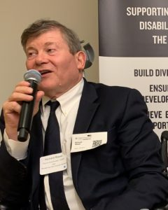
The Commonwealth Disability Inclusion Action Plan.

Dr Richard Rieser OBE General Secretary CDPF
- A major piece of work CDPF carried out in 2024/2025 was trying to progress a Commonwealth Disability Inclusion Action Plan to be adopted by the countries of the Commonwealth and the Commonwealth Secretariat.

- Why a DIAP? Coming from our experience attending as Observers at CHOGM 22 in Kigali where we found no disabled people as speakers, lack of access, sign language, alternative formats and no discussion on disability issues. This being despite exhortations in previous Communique to members to fully implement the United Nations Convention on the Rights of Persons with Disabilities, which all but 1 country (Tonga) of the 56 members had ratified. Beyond this, less than half states had enacted compliant enabling legislation and issues of access, reasonable accommodation and protection from discrimination were very patchy. There was very little collaboration and support between countries to improve the position of person’s with disabilities. We also found this to be more pronounced amongst disabled women and disabled youth with effective access to inclusive quality education massively underfunded. For these reasons in 2023 we launched a Commonwealth Disability Inclusion Protocol. In discussion with Commonwealth Secretariat we agreed to rename this an Action Plan and to utilize the language of the UNCRPD- persons with disabilities, even though we are committed to ‘disabled people’ as we are largely disabled by the barriers beyond us, not our impairments.

- 2024 We circulated our documents and updates to all the London based High Commissioners and had meetings garnering support with a number. Those positive were Nigeria, Gambia, Malta, New Zealand, Canada, Australia, Bahamas, Barbados, Trinidad, Fiji, Samoa, Antigua, Tobago, Belize, South Africa and Namibia. As a result at the Committee of the Whole in March 2023, we managed to get the paragraph below included.

Communique 2024.
“6. Heads reaffirmed their commitment to ensuring, protecting and promoting the full realisation of the human rights and fundamental freedoms of all persons with disabilities, to fully implement the United Nations Convention on the Rights of Persons with Disabilities (CRPD), and to implement the 2030 Agenda for Sustainable Development and the related Sustainable Development Goals (SDGs). Recalling the 2023 Report of the Commonwealth Roundtable on Advancing the Rights of Persons with Disabilities, Heads urged the Commonwealth Secretariat to prioritise and expedite the establishment of a High-Level Advisory Group of Persons with Disabilities together with representatives of Organisations of Persons with Disabilities from across the Commonwealth, to effectively support member states, in advancing the rights of people with disabilities. Heads commended the ongoing work towards the finalisation of a Disability Inclusion Action Plan, and the important role of National Human Rights Organisations in monitoring CRPD implementation”.

4. CHOGM 24 Produced by the Committee of the Whole, but jealously guarded by Com Sec. For example at the Foreign Sec Meeting at Samoa CHOGM 2024, where we had 17 countries led by Fiji who wanted to amend along the lines suggested by CDPF. This was prevented by the assistant Gen Sec Governance. He ruled there could be no amendments, as this would open the door to a whole lot of other amendments, except no one else was seeking an amendment. The amendment refused was to: a) define who the representative group of DPOs
b) agree points A to P of DIAP in our draft as a basis for going forward and
c) to fix a Ministerial Meeting as part of this process.

- Timing. After considerable pressure from CDPF A letter was sent to Law Ministers/Ministries of Justice /Attorney Generals by Com Sec., on 10th February, asking for Government representatives with Expert Knowledge of the UNCRPD to join an Expert Working Group. This mechanism and the structure being used to implement Para 6 were not shared with us. We in fact were told by Justin Pettit, Acting Head of Human Rights, that those we nominated to the High Level Advisory Group of Persons with Disabilities and their representative organisations would be part of the same group along with the nominated experts.

6. Advisory Group CDPF nominated 8 members for the Advisory Group to give a gender split, regional spread and range of impairment experience
Accepted by Com Sec
Richard Rieser, UK, Gen. Sec. CDPF. PD
Sarah Kamau, Kenya, Chair CDPF, PD
Abia Akram, Step Pakistan and CDPF Exec,, PD
Rachael Chomba, Zambia, CDPF Exec, Sign Language user
Setareki Macanawai, Chair Fiji Disabled Peoples Federation, VI.
Floyd Morris, Jamaica, Member UNCRPD Comm and Patron CDPF, VI.
Not accepted by Com Sec
We also nominated Emile Gouws, South Africa, CDPF Exec Neuro-Diverse &
Namwanjee Gorret, Uganda, CDPF Youth Rep Exec, Mental Health. We were told they were rejected as 2 places were being held for the Commonwealth Children and Youth Disability Network CCYDN.In October we were told that the Chair of the EWG from Canada had asked for 2 disabled people from Canada to join the Advisory Group Heather Walkus and Carla Qualthrough. (ex Federal Minister for Disability) to join. We invited them to our pre-meetings and they are now part of the Advisory Group. On 22nd October 4 members of CCYDN joined the joint meeting.

7. The Expert Working Group (EWG) from States met first without Advisory Group Members on 22nd May 25.
Representative were Canada (3) Kerry Anderson (Chair), Remi Calbry-Muzyaka, Tina Lasch (ODI) (Elected Chair), Eswatini(2) Pakama Sjhli, Fikile Shongwe (Vice Chair):Lesotho (1)Relebohile Molapo; Pakistan (1) Muhammad Arshad; Sri Lanka (1) Roshani Hettige, Mauritius (1) Sooraya Gareeboo; Togo (1) Toufaile Tchakou. Later Daryl Lloyd from UK joined plus Jacqueline Tumwine from Cabinet Office (2), Malta (2) Rhoda Garland and Alistair De Gaetano, Bahamas (2) Townsley Roberts and Nalini Bethell, New Zealand (2) Matt Frost and Brian Coffey, Other Countries Trinidad and Tobago, Barbados, South Africa, Kenya adding to 17 in all. From January 2026 Canada stopped being Co-Chair and New Zealand took over with a commitment to getting an agreed draft DIAP for circulation to Justice Ministries throughout the Commonwealth by the en of March 2026.

8. EWG Work. To come up with an agreed formulation. They were presented with the Disability Inclusion Protocol from CDPF of 3rd March 2024 (an old version) and Zero Draft constructed by Com Sec that left out most of the points in our action points and protocol. (We were not consulted on this and sent the Action Points attached which they have refused to put to the EWG. They also told CDPF we had to put in any amendments we had at the first meeting at the Advisory Group AG).
The Com Sec asked them to elect a Chair and Vice Chair. Com Sec said more countries could nominate members. TOR was shared with EWG but not with Advisory Group AG.
Com Sec told them that this is not a treaty making body and the document is not obligatory and no new monitoring mechanism would be developed. There is also no mention of the relationship with the.(Hardly supportive of the process as in Para 6.)

9. An independent consultant has been appointed at CDPFs suggestion, Professor Anna Lawson of Leeds University assisted by Neil Crowther to produce drafts from the outcome of the deliberations of EWG members and take some account of points made by advisory Group. AL started work at end of July and has so far produced 3 drafts. The EWG members are now supporting many of the amendments that AG put forward earlier. So there is much more agreement than we experienced earlier on.

10. Cycles of meetings. The first three in May to which we submitted 27 amendments and June and August the AG met 1 week after the EWG. CDPF argued strongly for joint meetings of EWG and AG and the first occurred on 22nd October for 30 minutes and a second on 9th December for 90 minutes. Our experience of making UNCRPD was that progress only occurred when DPOs and State parties were in the same forum drawing on DPOs lived experience and accumulated wisdom-Nothing About Us Without Us! The Chairs of EWG have now set up a meeting in January 2026 to examine outstanding areas of disagreement.

11. Areas of contention. These have come from Com Sec not EWG. i) Not have a dashboard or separate monitoring mechanism-can use existing global ones; ii) Should not apply to internal mechanisms of Com Sec-access, staffing etc. The EWG have now agreed this and it is in 3rd Draft Dec 20215; iii) No mechanism for representatives of DPOs from across the Commonwealth to form an Advisory Committee -not agreed; iv) that there needs to be a meeting of Commonwealth Ministers with responsibility for disability rights implementation, This could be piggy backed onto COSP or CHOGM-not agreed. Most other areas have been satisfactorily resolved other than issues raised by CCYDN belatedly.

12. The Commonwealth Children and Youth Disability Network CCYDN came late to this process, first to 22nd October meeting and put forward 8 key points for them.
They jointly attended the meeting on 9th December and put forward 64 amendments. CDPF’s view was that many of these were too detailed and if the Purpose had an all encompassing clause of involving young disabled people in consultations and co production, then many of these were not necessary.

13. CCYDN This is what appeared in the 3rd Draft. However, CCYDN on 13th January still put forward many amendments. CDPF only have objections to 2. Firstly , CCYDN argue for a Triple Track approach. We strongly favour a twin track approach. The first general track should include considering the views of young disabled people and a third track is too cumbersome and detailed. Genuine work needs to be carried out to empower young disabled people, help build their organisations and their organisational capacity. This is what CDPF is doing with Commonwealth Disabled Youth Forum, which now numbers more than 250 with its own elected steering group. Secondly, the suggestion which we do not agree with, is that unrepresentative networks like CCYDN, where there is no youth organisation should substitute themselves for the lack of a movement that needs to be built.

14. Prospect for success. The global politics is shifting due to the impact of Trumpism with its attack on Diversity, Equality and Inclusion, the demolition of the Rules Based International Order and growth of influence of powerful autocratic world leaders based on naked power. The Commonwealth is a bulwark against this approach being based on the Democratic principles of the Commonwealth Charter. Now is the time as Mark Carney, Canadian Prime Minister, has argued at Davos to build strong alliances in the Middle Powers many of who are in the Commonwealth i.e. Canada, Australia, New Zealand, UK, India, South Africa, Pakistan and Nigeria, Malaysia. We would argue this has to also apply to regional alliances of smaller island countries such as in the Caribbean and Pacific or across Africa. Economic alliances based on values such as Human Rights. This is not just based on Economic alliances, but also strong alliances based on equality and welfare, especially focussing on gender and disability. The struggle for the agreement at CHOGM 2026 in Antigua is part of this strengthening which should also include commitments to Health, Education and Social Care which needs to become the Fourth Pillar of the Commonwealth Strategy.

The UNCRPD, ratified by 55 out of 56 Commonwealth states, prohibits
discrimination based on disability. It represents a paradigm shift from the
traditional, charity, medical model to a social, human rights model of disability, recognizing people with disabilities as equal rights holders. The time for action is now. We called upon CHOGM leaders in collaboration with the Commonwealth Secretariat to adopt the following measures to ensure meaningful inclusion of Commonwealth citizens with disabilities, starting from the 2024 CHOGM and beyond:

Proposed Action Points for DIAP from CDPF
A. Within two years of this agreement CHOGM agree to hold a meeting of Commonwealth Ministers with responsibility for Disability to consider and share experiences on its implementation with a view to this becoming a regular Commonwealth event;
B. Gather disaggregated statistics in line with the Washington Group questions and protocols in Census, Household Surveys and other statistical activities;
C. Collaborate in setting up a Commonwealth Country Dashboard on progress on the Disability Inclusion Action Plan and implementation of the UNCRPD;
D. The Commonwealth Secretariat will support country members and civil society organizations in the reporting requirements to the UN CRPD Committee in Geneva;
E. For ongoing collaboration in expertise and financial assistance between member countries, especially between those more economically developed and the rest to develop implementation of the UNCRPD and disability equality;
F. Ensure that reasonable accommodations over access to buildings, access to information and accommodation is increasingly built into the planning of Commonwealth events;
G. Over time, develop a pool of Disability Equality Trainers and Access Auditors, within and between Commonwealth countries to facilitate Disability Equality Training and Access Audits of buildings and infra-structure;
H. Develop the capacity in collaboration with Disabled Persons Organisations (DPOs) to run systematic Disability Equality Training for Government Ministers, Members of Parliament, Civil Servants, Advisors and Non-Governmental Organizations;
I. Run all Development Plans through the requirements of the UNCRPD and the need for disability equality;
J. To increase the number and seniority of persons with disabilities employed in the Governments and the Commonwealth Secretariat;
K. Work with the private sector to develop cheap and effective assistive devices and technology and ensure its distribution to those who would benefit most;
L. Develop inter-country training and exchange of technicians who are able to develop the necessary competency to utilize such devices;
M. To implement the UNCRPD; the Commonwealth should give priority to collaborating in developing Inclusive Education, Health Care, Work opportunities for persons with disabilities and supporting measures that will enable persons with disabilities to take part in elections and stand for office.
N. Set up a Commonwealth Disability Advisory Committee with representation from DPOs in the Regions, CDPF, Reps of State Parties, Commonwealth UNCRPD Committee Members and others relevant.
O. Recognising that persons with disabilities are at significantly more risk in climate emergency events and humanitarian situation, agree to prioritise their support and inclusion in climate emergency preparation measures and support in other humanitarian situations.
P. Support the organisation and involvement of Women with disabilities and youth with disabilities and other underrepresented groups of people with disabilities such as indigenous people, neurodiverse individuals, those with mental health conditions and those with cognitive impairments.

Executive Session on LGBT - Jan 2025

1.Training Session LGBT and Disability Issues 12.00-1.00
Clare Gibellini introduced Magherita Coppolino, Co-Chair of ILGA Oceania and a Director of the ILGA Board https://ilga.org is the International Lesbian, Gay, Bisexual, Trans, and Intersex Association.

Magherita from Melbourne Australia excited to be here. LGBT people with disabilities show up UN COSP space 2018. Chaired by Therese previous chair UNCRPD Comm. First Nations, myself Politician and Commissioner all identified LGBT. Half large room filled with people as such a taboo issue. Majority Africa, Middle East South America and Asia had most interests given the politics and the prejudice in their areas. Since 3 side events. 2nd 2022 ILGA World work at UN with an number of regions-Africa, Europe, North America/Caribbean, Latin America, Asia and Oceania 2019 ILGA New Zealand first ever event focus on people with disabilities. 2022 World Conference to use UN Treaties to get issues raised
Gen Comment adopted 2018 .7.Clause 50-53 was first ever inclusion of LGBTI in UNCRPD Document.
“50. As part of the States parties’ general obligations, article 4.3 of the Convention applies to the entire Convention and is of particular importance for implementing other articles. In its concluding observations, the Committee has reminded States parties of their duty to closely and timely consult with and actively involve persons with disabilities, through their DPOs/OPDs, including those representing women and children with disabilities, in the development and implementation of legislation and policies to implement the Convention, and in other decision-making processes concerning issues relating to persons with disabilities.
51. Article 3 of the Convention identifies a set of overarching principles, which guide the interpretation and implementation of the entire Convention. It includes the “full and effective participation and inclusion in society” as one of its general principles, which means that participation of persons with disabilities, through their DPOs/OPDs, cuts across the entire text and applies to the whole Convention.
52. Paragraphs 1, 2, and 5 of article 4, are of the utmost importance in implementing article 4.3, as they include the fundamental obligations of States parties, extending to all parts of federal states without any limitations or exceptions, related to setting the necessary structures and frameworks and taking measures to comply with the Convention.
53. Policies to promote non-discrimination and equality of persons with disabilities stipulated in article 5 should be adopted and monitored in compliance with articles 4.3 and 33.3. The close consultation and active involvement DPOs/OPDs, who represent the vast diversity in society, including but not limited to children, young people, [the LGBTI community], ethnic minorities, and indigenous peoples, rural communities, and stateless, asylum-seeking, refugee persons with disabilities in the adoption and monitoring of specific measures, such as legal frameworks and guidance material to promote de facto equality, including affirmative action measures, is key for their success”. https://www.ohchr.org/sites/default/files/Documents/HRBodies/CRPD/Draft_GC7.docx
When first elected LGBT World Board, raised disability as an intersectionality work with civil society. 2018 IDA developed a statement to include LGBT in their work. Still in discussion with IDA Board. How to work together. ILGA South Africa last year 9 workshops included disabilities.

Women Deliver in Africa last year more comprehensive discussion on intersectionality. LGBT and Disability. April in Geneva this year develop a more comprehensive approach.
CG What are key issues. Australia Trans being denied hormones by care orgs in Australia. Lesbians not access IVF to have children. UNCRPD Committee asked state party to do. Pacific De- criminalisation. Influenced by Missionaries. Beginning to change Queer/Disability panel in the islands and one workshop.
CG Disabled and LGBT get denied support and over representation in prison. Psycho-Social Trans sent to prisons of sex assigned at birth. Denied access to justice. Cases dismissed. Higher rate of violence, access to healthcare.
MC reproductive rights, access to sex education, visibility in pride marches. LGBT community has to learn to include disabled people.
Mountain we have to climb.30 of the 56 Commonwealth member
states criminalise same-sex intimacy.

Situation Across Commonwealth countries
Conversion Therapy to change people’s Sexuality is banned in 9 countries bur not in 47
Same Sex activity
Legal 23 countries. Antigua/Barbuda, Australia, Barbados, Botswana, Canada, Cyprus, Fiji, Gabon, India, Lesotho, Malta, Mauritius ,Mozambique, Namibia, Nauru, New Zealand, Rwanda, St Kitts &Nevis, Seychelles Singapore, South Africa, United Kingdom, Vanuatu
Illegal Men/Legal Female 11 Eswatini, Grenada, Guyana(female uncertain), Jamaica,, Kiribati, Papua New Guinea, Saint Lucia, Samoa, Sierra Leone, Tonga, Tuvalu,
Illegal 19 Bangladesh, Brunei, Cameroon, Dominica, The Gambia, Ghana, Kenya, Malawi, Malaysia, Maldives, Nigeria, Pakistan, Saint Vincent & Grenadines, Solomon Islands, Sri Lanka, Tanzania, Togo, Uganda, Zambia. Of these above.
Death Penalty Brunei, Nigeria, Uganda.
Equal Marriage Legal 7, Foreign Nationals 5, Unrecognised 16, Not Legal 25
Stats from Commonwealth Equality Network 2024 /Kaleidoscope https://commonwealthequality.org/news/. Need to work with them more closely.
There are a large number of Commonwealth Governments. India with the largest population is more liberal on the issue, but Nigeria with largest African population of 220million Africans along with a number of others hostile. We need to make alliances with South Africa who are positive on the issue which we did at CHOGM Samoa. And speaking at an Equalities side meeting in SAMOA.
Need to be putting stronger arguments to Governments. Problem no declarations at UN deal with LGBTI issues because of Geo Politics of this issue, lurch to the right in America. Need to build a wider alliance on Human Rights to the 55 who have ratified. Women’s organisations don’t include disabled people, had back from 3 surveys. How break down the silos. I think we need to produce a basic document disabled people in all areas with a different sexual orientation. International Human Right declaration is often put forward by LGFBT activists, but for 50 years disabled faced this because in the end this was not taken to mean us as disabled people and so we had to fight for our own declaration. LGBT will have to fight for a similar declaration which we will support.
Focus on Governments who say this is a Western Imposition. In fact this came out of colonial laws and so is part of the anti-colonial struggle. However, Neo Conservative churches and missionaries have been busy spreading anti LGBT ideas in Africa. CDPF can play a role with a more reasoned argued document.
MC Next ILGA Conference in Argentina. All Commonwealth countries municipalities. Global City Rainbow Alliance-progress in Mexico City.
CG Partner in ILGA to support this work representation their regions .
RR contact REGARD UK Disabled LGBT group. Sense International NGOs – organisation for have publicised a number of LGBT sensory impaired. More examples how effecting people.
18 people from Executive Mohua Paul Bangladesh already we working on this especially with the Youth. Country in a very difficult position. Have some documents USAID budget 10 organisations collaborating has been stopped for 3 months. 24th January stop immediately.
EG if add Neurodiversity and under-represented groups a lot of emphasis on LGBT. Can be separate. sec RR mentioned Steve South African Deputy Minister met in Samoa, has his own organisation on this. Could work more closely. RR asked EG to send his contact details.
Sarah K Chair from Kenya agreed in principle support disability equality in LGBTQI community. Some countries not accepted this, Many countries , especially in Africa are grappling. When we are addressing this CDPF needs to be very clear about what we are proposing especially now on the safeguarding of LGBT people who are disabled. So it is important that we take this slowly as we address policy makers to make this change especially in places where it is happening, but not widely accepted and is still illegal as such.
Sruti. The community is very strong in India, but the Government is not listening. It has reached the supreme court which is very important because if they rule then the Government has to follow it. But even in the High Court it was struck down. Supreme Court said a decision will not be taken. Since there id freedom of expression you will often find every News channel talking about it. The younger generation are very open and accepting. But as far as legalising same sex marriage it has still not been done. Despite LGBT people being well placed in the society, they are doing well and speaking vocally and the community is very well organised, but for some reason the Government has not been lenient on the issue. I don’t know of any NGO that is working on disability and LGBT?
ILGA world treaties data base for ever country any LGBT mentioned during CRPD scrutiny.
Ganesh Not made any progress in Guyana but even the LGBT community is not as open to persons with disability. If we are invited it is because of requirements by the funders. We sit on a couple of committees on sexual and reproductive health with stakeholders from the LGBT community, however we have not made any strides at our end to better represent disabled people from LGBT a lot of reticence. Our Government has close links with Republicans in US and have heard we were going to have a new secondary curriculum with some parts about LGBT, but it was taken out by Officials at Ministry of Education.
RR Any chance to get disability and LGBT into the curriculum. GS Not in the public realm. May be a chance, but better if just go for disabled people with LGBT.
Soovan Sharma Mauritius. LGBT Conferences in South Africa and Thailand, I have been contributing as how to make disabled people feel more at ease, though I am not part of LGBT community. More afraid and marginalised in coming out and more welcome in Mauritius. Have contacts to foster collaboration in East Africa. Please send contact details.
MC will be at Global Summit in Berlin and put in a paper. Go to ILGA Board in Geneva say a commitment of this network. Become an associate member of ILGA world. Committed to a Disability Plan.
RR will be in Berlin.
CG some great opportunities. Strategically for CDPF very worried about funding and USAID. Thanks MC.
RR Points fit into LGBT /CDPF steering group. SK to convene. Those who want to be on have put their names forward. Please send-in contacts, information and case studies in this topic to go into our strategy document. Working Group to develop policy.

INDIA Training Disabled Youth Leadership and Disability Equality - 9th to 13th March 2025 New Delhi CDPF Training
The Commonwealth Disabled People’s Forum (CDPF) successfully hosted a five-day Training the Trainers & Development Programme in India, bringing together disability rights leaders and advocates from across the region.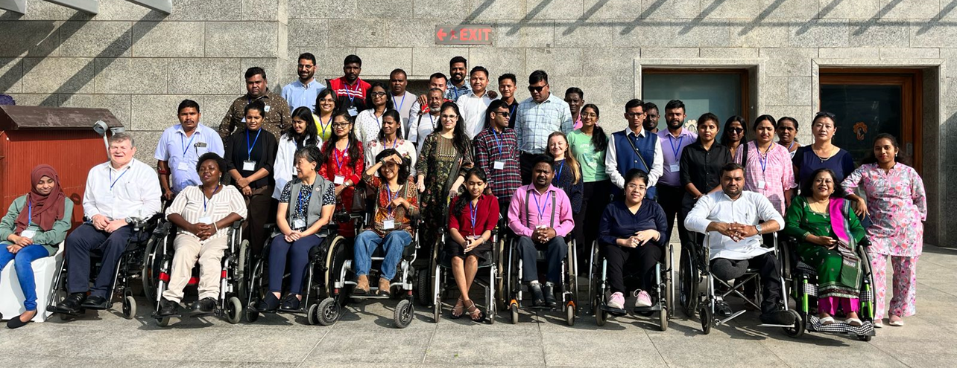

Participation: 5 representatives from Sri Lanka, 2 from the Maldives, 19 participants from across India Unfortunately, due to visa issues, no participants from Pakistan or Bangladesh were able to attend this time.
Demographics:
Gender: Almost equal number. Male - 54% Female - 46%
Trainee Age Groups: 18–25 -12.5%, 26–35- 58.33%, 36–45 - 29.17%
Disability Types Mentioned: Mobility impairment – 9, Speech and Hearing impairment
3, Visual impairment – 8, Thalassemia – 1, Cerebral Palsy – 1, Multiple Sclerosis – 1
Unspecified - 1

Highlights of the Programme
The training focused on strengthening leadership, advocacy, and capacity-building for disability rights, aligned with the UN Convention on the Rights of Persons with Disabilities (UNCRPD).
Key sessions included:
- Paradigm Shift in Disability – history of the disability movement in India and globally, the language we use, and tackling traditional barriers.
- Inclusive Education (Article 24) – designing inclusive schools, addressing segregation vs. inclusion, and role-play advocacy with officials.
- Employment & Livelihood (Articles 27 & 28) – engaging employers, building campaigns with youth, and addressing barriers to equal work opportunities.
- Disability & Health Services (Article 25) – case studies and access to quality health care.
- Guardianship and Supported Decision-Making (Article 12) – implications for mental health and legal systems.
- Media, Representation & Awareness (Article 8) – challenging stereotypes and influencing mainstream narratives.
- Gender Equality in the Disability Movement – empowering women leaders.
- Using the UNCRPD and SDGs for Advocacy – building strategies to influence government policy and public awareness.
The course concluded with participant reflections, evaluation, and certificate presentations.

Trainers The programme was led by a diverse team of international and regional trainers: Richard Rieser, Sarah Kamau , Diethono Nahkro ,Sruti Mohapatra, Arman Ali, Nancy Maguire (NM) Gemma Whit Admin
Programme Education Participants discussed how inaccessible schools, lack of assistive devices, and family attitudes hold disabled children back.
Outcome: Agreement on the urgent need for inclusive schools, trained teachers, and equal access to learning.
Quote: “Families are very influential – they can either open or close the door to education.”
Employment Disabled people continue to face discrimination, unequal pay, and limited workplace adjustments.
Outcome: The group developed ideas to expand opportunities through inclusive hiring, entrepreneurship, and fair workplace policies.
Quote: “Financial independence is harder to achieve because of discrimination, we are denied opportunities, fair pay, and even access to loans to start our own businesses.”
Politics Disabled people are too often excluded from mainstream politics and decision-making.
Outcome: Strong calls were made for voter education, grassroots organising, and greater representation in political parties.
Quote: “We want strong representation so we eventually have someone who will do something for us.”
Women Discussions revealed how disabled women often face stereotypes, lack of privacy, and barriers in healthcare, family life, and relationships.
Outcome: A commitment to challenge these attitudes and ensure disabled women’s rights are fully respected.
Quote: “Doctors sometimes advise sterilisation or abortion without consent — disabled women must have the right to make their own healthcare decisions.”

Brought together 26 participants from across regions gender balanced - India, Sri-Lanka and Maldives
Engaging and active training. Sessions included discussion on CRPD, advocacy, and inclusive employment. Employers from Amazon India and a Indigo Air major airline participated best practice around including disabled people in the workforce. Training enhanced participants' capacity to advocate and champion for disability rights. Participants received certificates upon completion.
Social Media Coverage: Managed by Naddy. Hindi translation-
Access Issues 7 blind people and 2 sign translation, 1 using captions
Additional Highlights: Participants mixed by region and country to promote cross-regional learning. Strong representation from youth voices, including Muso from Maldives. Unfortunately, participants from Bangladesh and Pakistan were unable to attend due to access constraints. Gemma organised a final celebratory meal and Karaoke which was very well received.
Quantitative Ratings
- How do you rate the training?
  - Mostly Excellent, some Good
  - Excellent - 16
  - Good - 7
- Learning and Readiness:
  - Majority of participants (approximately 70%) rated the training as Excellent, indicating high satisfaction with the content, delivery, and relevance.

INDIA TRAINING AND MEETINGS WITH SENIOR GOVERNMENT OFFICIAL MANDATED WITH DISABIITY INCLUSION IMPLEMENTATION
CDPF held a disability Equality Training for the Asian region in New Delhi from 10th to 13th March 2025. The goal of the training was to capacity build disabled people on Disability Equality and Rights and make them champions to advocate for their rights and inclusion in the development agenda. Over 30 disabled youth, women and girls were trained and commissioned to go to their local areas and become advocates for disability rights. After the training the Chair and Vice Chair had opportunity to travel to Odisha to engage with senior government officials on disability rights and inclusion. Since India is quite vast, there was need to reach out more to other local areas with the CDPFs message of Disability Equality and Rights training modules that could be tailored to suit each areas’ need.

VISIT WITH COMMISSIONER NATIONAL COUNCIL FOR PERSONS WITH DISABILITIES - INDIA
The meeting discussed and agreed that the Council will organize a Disability Equality training and Dr. Sruti will do the training together with others in the movement in Odisha. If need be for an online interaction other senior CDPF official that will be organized. The Disability Equality Training Module was shared to sensitize on what was be trained on and also create awareness on disability inclusion matters.
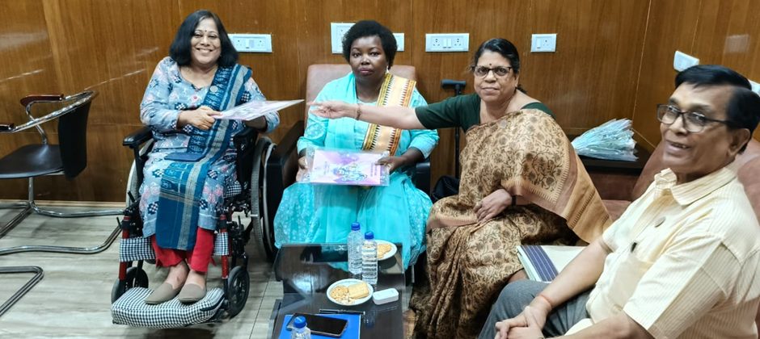
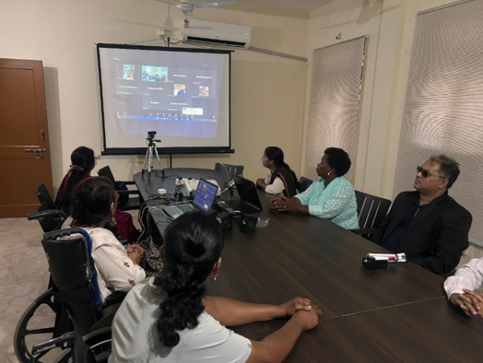
A meeting was held at the Swabhiman office and virtually with diverse groups in Odisha. The CDPF Chair presented on what the goal of CDPF is and took them through the Disability Equality Training topics to appraise them on how they can carry out advocacy at their local areas. The participants also gave their views.

VISIT TO THE UNIVERSITY - 19TH MARCH 2025
The Chair visited the University of Rama Devi Women University. She engaged with the staff and students and finally met with the Vice Chancellor. The students shared their experiences on disability rights studies. The CDPF Chair sensitized the girls on the need to know their human rights and challenge the laws and regulations that deny women and girls their rights in every sphere including reproductive and menstrual rights, gender based violence, access to education on the same level with boys, economic empowerment and independence, being in leadership positions in order to be part of the development at large and influencing retrogressive cultural norms that deny women and girls opportunities in life. Since this a women’s only university, a lot gender inclusion, however more on disability inclusion could be done.
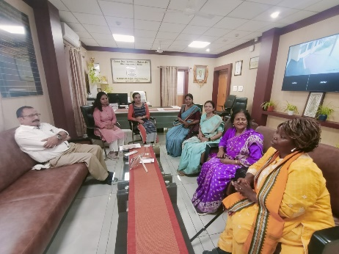
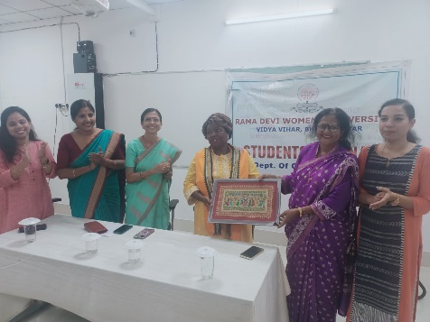

The Vice chancellor (left) of the women university during a courtesy call at his office.

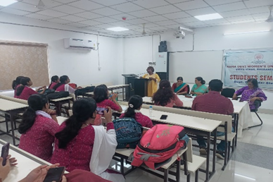

Commonwealth Day - 6th March 2025
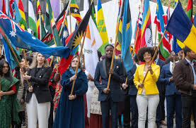
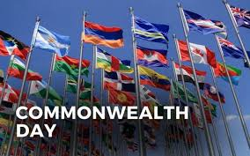
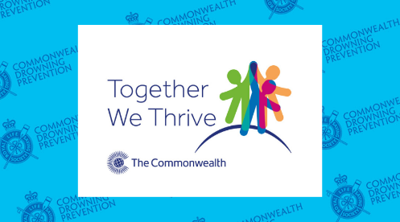

1st to 3rd April 2025 CDPF Global Disability Summit 3 Berlin.
The Summit was sponsored and organised by the German and Jordanian Government, with the International Disability Alliance (IDA).

CDPF Report on Global Disability Summit 3 Berlin 1st to 3rd April 2025.
The Summit was sponsored and organised by the German and Jordanian Government, THE Hashemite Kingdom of Jordan with the International Disability Alliance(IDA)
There was a Civil Society Forum on the 1st of April with more than 500 DPO /NGO representatives attending. There was no discussion or means of altering the statement that had been drawn up by IDA organised Civil Society Reference Group beforehand, but it did reflect the outcomes of the 5 Regional Seminars. The day consisted of four panels with questions sent in by QR code. It was sterile and rather boring with no interactions.
5 Regional Summits had been held to shape the main outcomes and these were influenced significantly by OPDs/DPOs.
Asia 14-15th February, Bangkok
Latin America 9th-11th December, Rio De Janeiro
Arab 13th -14th November, Amman
Africa 5th September, Nairobi
Europe 6th December, Berlin
https://www.globaldisabilitysummit.org/regional-summits/
There was also a pre meeting on Inclusive Education held at Cambridge last September -https://www.inclusive-education-initiative.org/sites/iei/files/2025-02/Jan-2025%20Making%20GDS%202025%20Count%20-%20Pre-GDS%20Workshop%20Recommendations.pdf
https://www.globaldisabilitysummit.org/resource/civil-society-forum-declaration/

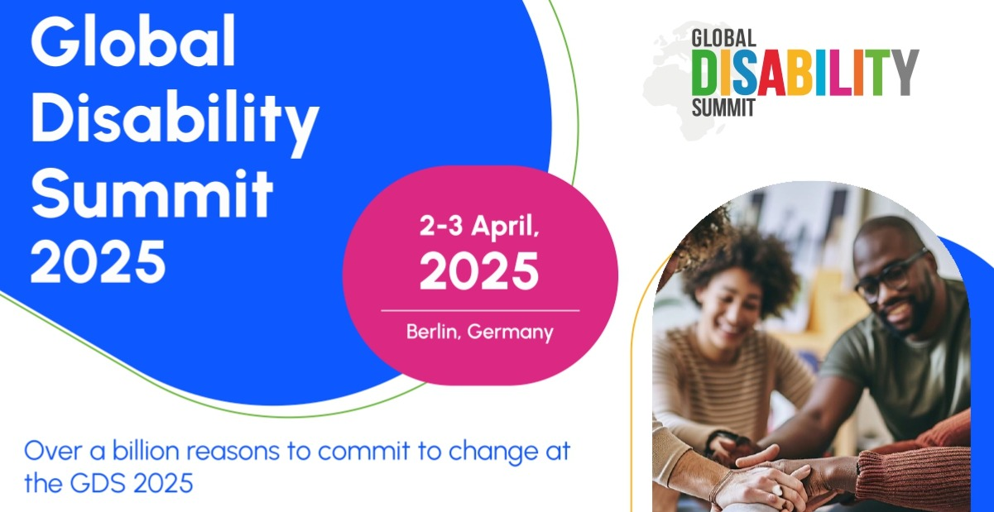

The organisers say 4500 people attended the two-day Global Disability Summit. There were about 20 side events most with no interaction with the audience. More than 200 requests were submitted. Next time more effort needs to be made to accommodate a wider range of views and experiences. More successful were the ‘fireside chats’ which were delivered by silent headphones and text projected on a wall so that the sound did not overwhelm. There could have been more of these slots as the spaces were often not being used. Who got exhibition booths seemed to be allocated by a strange alchemy with the usual suspects of NGOs, not many DPOS having booths. CDPF put in for a side meeting, fireside chat and a booth and got none.
The event led up to the launch of the Amman Berlin Declaration with its slogan 15% of funding for the 15% of disabled people around the world.
The main Amman-Berlin Declaration was supported by around 60 countries and 20 International Organisations
https://www.globaldisabilitysummit.org/wp-content/uploads/2025/03/GDS-Amman-Berlin-Declaration_final-draft.pdf
CDPF offered a leaflet and widely distributed with the following points .
“CDPF widely distributed a leaflet saying :- Support the Amman-Berlin Declaration on Global Disability Inclusion. To make this declaration more than fine words, several things need to occur in the Disability World.

Firstly, recent cutbacks in international aid from USAID following the election of President Trump has led to widespread cutbacks to vital disability programmes in 134 countries. Overseas aid cutbacks are happening in Germany, France, United Kingdom, Netherlands, Belgium and a range of other doner countries. Trump’s approach is based on breaking with more than 70 years of a rules based and equity approach and is inimical to a disability rights approach.
All countries that support the sentiments of the Amman-Berlin Declaration must increasingly pool their efforts and funding to support its achievement.

Secondly, the representative organisations of disabled people (DPOs) or Organisations of Persons with Disabilities (OPDs) need to be empowered by all partners to take the lead in implementing the UNCRPD. Since the UNCRPD was adopted, we have witnessed an increasing amount of influence and funding being given to Non-Governmental Organisations that are neither run and controlled by disabled people, nor do they represent our varied live experiences. They often pay lip service to our involvement, but we would like them to develop these good practices:-

a) Accept the leadership and thinking of Disabled People’s Organisations (DPOs/OPDs) ‘Nothing About Us Without Us’ and not ‘steal our clothes’.
b) Do everything they can to empower and build the capacity of DPOs/OPDs.
c) Reject the charity/ medical model for social/human rights model of disability.
d) Put their organisational, financial and training resources at the disposal of disabled people and DPOs/OPDs.
e) If the organisation provides welfare services and treatment, do they still empower disabled people they work with?

The Commonwealth Disabled People’s Forum (CDPF) is an organisation of over 100 Disabled People’s Organisations (DPOs) from 50 of the 56 Commonwealth countries. The Commonwealth makes up 2/5s of the world’s peoples which means at 16%, 430 million disabled people.

Thirdly, how we organise is important. CDPF use Disabled People and not People with Disabilities, as we are of the view that disability is a cultural and social process that oppresses people with impairments. It is the barriers that need to be removed and it is these attitudinal, organisational and environmental barriers that oppress us. Therefore, we call ourselves disabled people in solidarity with each other, regardless of our wide range of impairments. Impairment is part of the human condition.
However OPDs/DPOs respond to the above in achieving disability equality, we are best served by having cross impairment organisations led and controlled by disabled people. We must be experts on each other’s impairments and access needs. This is not just an argument about language. It is also how we conceive of the task and the actions we need to take to gain full disability equality and implementation of the UNCRPD. The key message disabled people need to internalise in their millions is that the discrimination and prejudice we face is not our fault and use this empowerment to self-organise for our rights.

States and other partners need to promote this view to their wider populations as Article 8 requires. To achieve the above, we need to invest in much more digital, face to face training to build our Movement and we need to include this in school curriculum for all learners.

Fourthly, disabled girls and women face the extra barriers of Sexism and Harassment. Two thirds of CDPF Executive are women and form our Women’s Forum. They have carried out online research, surveys and meetings to put forward strong policy positions at UN Committee on Status of Women and Commonwealth Women Affairs Ministers Meeting. The Women’s Movement in general does not include disabled women. https://commonwealthdpf.org/equality-areas/ and states ignore the additional barriers women and girls face.

Fifthly, Inclusive Education. Despite radical changes in the international Human Rights framework, from exclusion and segregation towards Inclusive Education [UNCRPD Article 24 and SDG 4], most countries have not seriously followed suit. Exclusion (not being in school), segregation (in separate schools and institutions) or poor integration (disabled students attend, but little or no accommodations are made) remain persistently the norm. Everyone agrees that a good education is a firm foundation for a successful life and a strong national economy. So why do we continue to effectively exclude so many disabled young people from accessing equitable quality education and denying our countries their potential? Let us redouble our global efforts on this key issue.

This Global Disability Summit meets at a crucial point in modern history. Will States and Civil Society renege on their commitments and human rights responsibilities or resist in a coordinated and effective way the growing number of international ‘bullies on the block’?”
You can view the main events of the Summit with VIP, Politician and IDA speeches and some entertainment in Hall 7 on recorded video.
Day 1 https://www.youtube.com/watch?v=gmTVC1rqZ74&t=17390s&ab_channel=GlobalDisabilitySummit
Day 2
https://www.youtube.com/watch?v=tvPnSm5BpiI&t=30891s&ab_channel=GlobalDisabilitySummit
Standing out was the end summary by Alexander James Snedden, a young man with learning difficulties. This can be found at 8.35.33 to 8.47.31
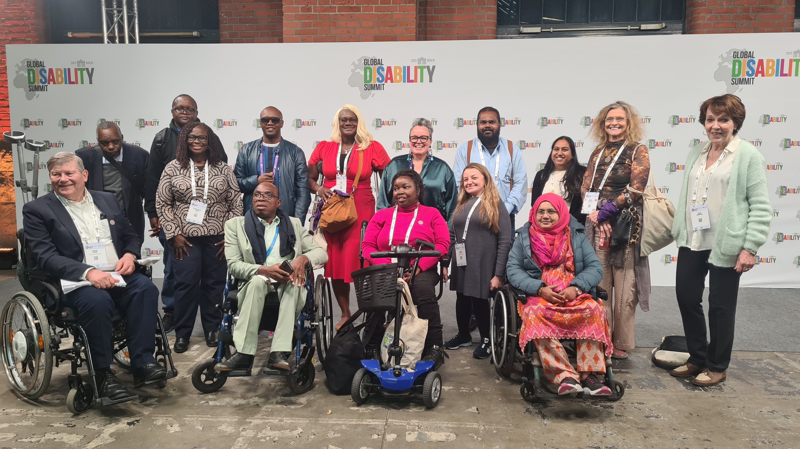

[Official delegates from CDPF were Richard Rieser (UK), our General Secretary; Saraha Kamau (Chair) Kenya; Kerryann Ifill (Vice Chair) Barbados. Others in CDPF membership picture who joined us included Samuel Kabue, Patron and UNCRPD Com Member, Kenya: Eric Ngondi, Chair UDPK Kenya: Erin Brown, Bahamas; Clare Gibellini AFDO Australia, Muviyaha (Muthu) Didi, Maldives and CDPF Exec.; Ashana Misti, WDDF Bangladesh and CDPF Executive and Nancy Maguire (ROFA)UK; Akakpo-Numado Togo (FETAPH) . Other CDPF reps at GDS 3 Abia Akram, CDPF Assistant Secretary, Zara Todd, ROFA,UK; Elizabeth Adams Oyarege &Ibrahim Alhassa Youth Leaders, JONADWP Nigeria; Malonje Phiri, FEDOMA, Malawi; Robinah Alambuya, Triumph, Uganda; Deo Imalingat, Show Abilities, Uganda; Laura Kanushu MP, Uganda and CPA PWD Network.]

As can be seen by the list above, CDPF had quite a lot of delegates at GDS 3, thanks to the 200 free places. These had to be fought for. When the German Government launched the call for participation at COSP 17 in New York last June they were not planning on offering any free places. CDPF argued for them strongly to allow those from lower income countries to be present.

We held two meetings for our delegates who were on a What's App Group.

Two main complaints arose. There was hardly any scope for participating in the events. They were all highly stage managed with no space for contributions from the floor. There were no workshop type rooms, only the fire side chats. CDPF put in for a side event, a booth and a fire side chat but were not allocated any, despite representing more than 100 DPOS from over 52 countries.

Secondly, although access was good in many ways, neurodiverse delegates felt the pace and crush did not accommodate them and the whole event would be better over 3 or 4 days with more participation. It still feels like IDA are the only show in town and not even the whole committee, Jose spoke 7 times. We did like the comrade with learning difficulties summing up and some of the women delegates contributions, but felt a colossal waste of time and resources in not learning from the experience of the majority of 4,500 delegates.
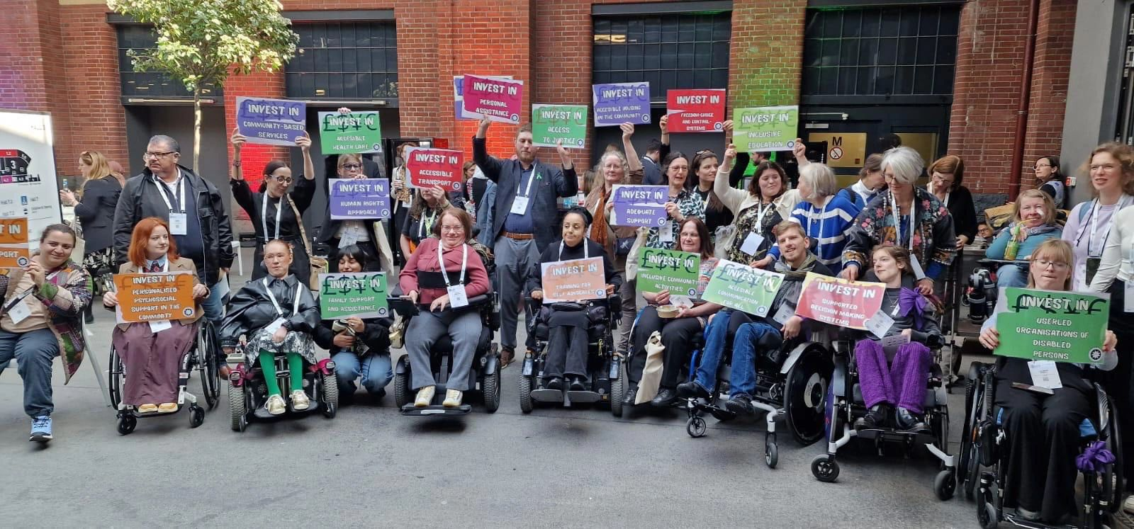
“This triennial event, aimed at mainstreaming and promoting the implementation of disability rights worldwide, faced criticism from disability groups advocating for legal capacity, deinstitutionalization, and independent living—even from disability groups in Germany itself.
IDA and the organizing government were accused of neglecting fundamental issues mentioned above, which are experienced daily by people with disabilities worldwide. The process of determining discussion themes for both main and side events was deemed non-transparent, dismissive of meaningful participation from various disability groups, and undemocratic.
Indonesian Mental Health Association (IMHA), Validity Foundation, Indonesian Syndroma Down Care Foundation (YAPESDI), Women Enable International (WEI) and Transformation Community Inclusion (TCI), issued a joint statement and call for action to protest the absence of discussions on legal capacity and deinstitutionalization. We wore t-shirts with various messages, such as:
"Institutionalize, criminalize, ignored.
GDS stay silent!"
Meanwhile, wheelchair users protested the lack of serious discussions about inclusive living in society (deinstitutionalization), which they also frequently experience. They carried messages such as:
[Protestors: outside Summit raising
"No money for independent
Living]

"No money for institutions!"
"No money for guardianship!"
In many countries, including Indonesia, institutions (care facilities) are still financially supported by the state. The government does not take seriously—or even refuses to imagine—creating an inclusive life without institutions for people with disabilities, as if such a reality were impossible.
The last group, consists of disabled activists from Germany who were not included—or possibly ignored—by this global event. They were unable to enter the venue, heavily guarded by police, and could only voice their protest outside. It is unclear what issues they raised, as their posters and speeches were in Deutsch. Hopefully, these protests made next GDS will more inclusive and democratic.
Disabled People who make up 15% of the global population, or around 1.3 billion people are often excluded from development programs. In response to this gap, and amid shrinking funding for disability inclusion, the summit introduced a new target: ensuring that at least 15% of country-level development projects focus on the inclusion of persons with disabilities.
The summit saw over 800 commitments announced by governments, private sector institutions, and development actors to improve accessibility and enable meaningful participation. The event gathered 4,500 participants from around 100 countries, including disabled people, government officials, and civil society leaders. More than 60 sessions addressed how to better implement the UN Convention on the Rights of Persons with Disabilities and translate commitments into practical action.
In his opening address, His Majesty King Abdullah II called for ongoing efforts to ensure dignity, happiness, and hope for all, emphasizing that inclusion is not only about access but about recognizing human potential and creating environments where everyone can contribute.
German Chancellor Olaf Scholz reaffirmed Germany’s commitment to disability inclusion especially at a time when funding is being cut and endorsed the 15% target. He also announced a joint initiative with Jordan to promote inclusive education.
IDA President, Nawaf Kabbara, stressed that true inclusion cannot happen unless organizations of persons with disabilities are included in funding decisions. "Inclusion must be with organizations of persons with disabilities, not for them," he said.
The Amman-Berlin Declaration calls for at least 15% of development projects to be specifically designed to promote disability inclusion. Currently, only 6% of such projects contribute directly to this goal.
German Development Minister Svenja Schulze noted that development policy can only succeed through cooperation among all stakeholders. She described the declaration as a global commitment not just a pledge by donor countries and emphasized that real inclusion benefits not only the 15% of people with disabilities, but society as a whole.
Several major initiatives were unveiled during the summit. The UK’s Foreign, Commonwealth & Development Office committed to launching an Assistive Technology Investment Mechanism through the AT2030 program, aiming to raise $60 million by 2026. It also pledged to co-chair the Global Action on Disability (GLAD) Network to strengthen global partnerships. UNICEF committed to allocating 10% of its annual budget to children with disabilities by 2030 and expanding data collection, inclusive education, and protection systems across 50 countries.
IDA pledged to strengthen organizations of persons with disabilities in more than 100 countries, launch a leadership program for 80 youth with disabilities, and partner with the UN Global Disability Fund to implement the UN Convention in 50 countries.
In Jordan, 88 national organizations including government entities, civil society groups, academia, media, and private sector institutions submitted 133 commitments to promote disability rights.
During a dedicated session, Minister of Education and Higher Education Azmi Mahafzah announced five strategic, rights-based commitments, including a JD90 million investment from the Association of Banks in Jordan, operating banks, the Ministry of Education, the Ministry of Health, and the Higher Council to support inclusive education, health services, and the adaptation of 250 public schools.
A new partnership between Germany and the African Union was also announced to strengthen organizations of persons with disabilities across Africa, with a focus on youth and women. The multilateral "Education Cannot Wait" initiative will partner with Germany, the UK, IDA, and the Girls’ Education Challenge to improve data collection and accountability in inclusive education in crisis-affected areas by 2028.
According to the HCD, all summit commitments will be published and monitored for transparency via the following link:
[https://gds.idata.tools/home](https://gds.idata.tools/home)
The first summit was held in London in 2017, followed by a virtual edition in 2022 due to the COVID-19 pandemic. The Berlin summit marked the third edition, jointly hosted by three partners with IDA serving as a permanent co-host.

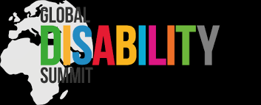
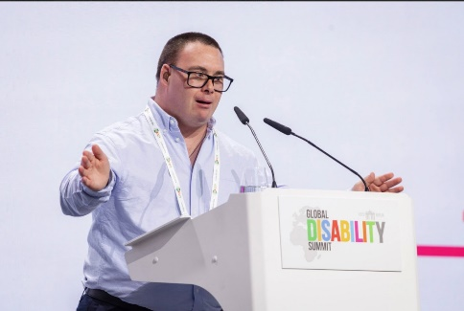
Young Man with Learning Difficulty does a great summary to end the Summit.

CDPF at COSP 18, UN NEW YORK REPORT
CDPF were represented by the Gen Sec Richard Rieser and Chair Sarah Kamau and a number of other member organisations were also represented on other delegations and contributed at our side meetings. We distributed a General Leaflet and spoke to this in the civil Society Forum on Monday 9th June (RR 26.28 to 31.23 on https://webtv.un.org/en/asset/k17/k17w80etpu) CDPF added two amendments to Civil Society Statement which was read out to the opening session on Tuesday 10th June.
These included :-‘We must not forget the denial of human rights that led to the formation of the UNCRPD. False science of Eugenics, forced sterilization, incarceration in long stay institution, segregation in special schools and denial of access to education’.
‘We, the Disability Movement recognise we must continue to defend and implement the UNCRPD against the damaging ideology attacking Diversity, Inclusion and Access’.
A further speech was made to the Second Session Opening by RR General Secretary (https://webtv.un.org/en/asset/k15/k15ng7bofb 1.29.00 to 1.31.43)
Key points made by CDPF were based on the motions passed at the Special General Meeting on 14th February 2025. These included:-

PROTECT AND DEFEND DISABLED PEOPLE RIGHTS
Recent cutbacks in international aid from USAID, following the election of President Trump, led to widespread cutbacks to vital disability programmes in 134 countries. Overseas aid cutbacks are also happening in Germany, France, United Kingdom, Netherlands, Belgium and among other doner countries. Trump’s approach is based on breaking with more than 70 years of a rules based and equity approach and is inimical to a disability rights approach. It is against the spirit and the letter of the United Nations Convention on the Rights of Persons with Disabilities. CDPF calls upon delegates at COSP18 to make clear that they continue to support the UNCRPD and its Implementation.

POOL AND COLLABORATE RESOURCES TO IMPLEMENT THE UNCRPD
The recent financial realignments may have their political backers, but countries that support disabled people’s rights and implementing the Convention need to find ways of pooling aid, assistance and should raise their tax base.

CHALLENGE THE IDEOLOGICAL BASIS OF THE ATTACK ON DIVERSITY, EQUALITY, INCLUSION & ACCESS. REMEMBER THE HISTORY OF OUR OPPRESSION
However, it is the ideological attacks on Equality, Diversity, Inclusion and Access that are the greater danger to disabled people’s rights and must be strongly opposed. Think of the past:
- Where the false science of eugenics in many countries was used to justify forced sterilisation, segregation in special schools and institutions. The mass murder of the ‘useless eaters’ disabled people under the Nazi T4 programme
- Cruel and largely useless medical interventions were used to make disabled people with physical and mental impairments ‘normal’
- Where large numbers of disabled children were labelled as ineducable. Using different approaches we have shown they can make progress
- Widespread bullying and harassment based on untrue disablist stereotypes and stigma that dominated our entertainment and media
- The idea that Equality is based on treating everyone the same and the rejection of ideas and benefits that are designed to make up for the extra costs of disability. Equality is giving everyone what they need to thrive
- Survival of the fittest, competition rather than collaboration
- The myth that we live on a planet of infinite resources. They are limited and need planning, rather than the damage to the majority of people unregulated capitalism can produce
- The Human Rights and Social Model of Disability, where barriers of attitude, organisation and environment are the main factor in disabling people with impairments, are being replaced by a resurgence of medical individual model of disability where Access and inequality are seen as the responsibility of the disabled individual.
The Commonwealth promotes democracy and equality across its member countries with over 2.7 billion citizens. The Commonwealth Charter, in these times of growing autocracy, insecurity and inequality, though far from perfect, provides an alternative way of maintaining parliamentary democracy. independent judiciary and a free media. Over 430 million are persons with disabilities, mainly young people. The self-organisation of Commonwealth Disabled People’s Organisations and their collaboration, capacity building with each other and advocacy play a crucial role in implementing the CRPD and the Sustainable Development Goals. CDPF has more than 100 member DPOs/OPDs across the 56 countries of the Commonwealth including 50 DPO national umbrella organisations. The CDPF has found that although 55 of our member countries have ratified the UNCRPD, implementation of the rights, protections and freedom from discrimination for disabled people is not happening or is very patchy.
DIAP Last year the Commonwealth Disabled People’s Forum (CDPF), put forward a draft Commonwealth Disability Inclusion Action Plan (DIAP). The Heads of Government in Samoa, October 2024, while not adopting it, agreed to set up a High-Level Persons with Disabilities and their representative organisations Advisory Group to an Expert Working Group of representatives of State Parties to achieve an agreed draft. This process is now underway. The agreed draft it is hoped will go to Commonwealth Law Ministers’ Meeting in Fiji, then to the Commonwealth Heads of Government Meeting in Antigua 2026 for agreement. If adopted the DIAP will kick start a wide range of measures and renewed interest in the rights of persons with disabilities, including sharing expertise and experience across countries and implementation of key areas of the UNCRPD. Come to our Side Meeting on this Thursday 12th at 4.45 Room 11. https://commonwealthdpf.org/disability-inclusion-action-plan/
The reversal of the Global consensus on man made climate change and the need to control carbon emissions is being challenged by Trump and other leaders who see accumulation of personal wealth as more important than the millions of people being put at risk of growing heat waves, wild fires, hurricanes, cyclones, floods, mud slides, drought, air pollution and rising sea levels. In these events, Disabled people are up to 10x more at risk. To fulfil Article 11 disability disaster preparation must be practiced to avert preventable casualties. Come to our joint side meeting on building resilience with the Commonwealth Secretariat at 10am in Room 4 Tuesday 10th June.
Disabled girls and women face the extra barriers of Sexism and Harassment. Two thirds of CDPF Executive are women and form our Women’s Forum. They have carried out online research, surveys and meetings to put forward strong policy positions at UN Committee on Status of Women and Commonwealth Women Affairs Ministers’ Meeting. The Women’s Movement in general does not include disabled women. https://commonwealthdpf.org/equality-areas/ and states ignore the additional barriers women and girls face. We need State Parties to provide concrete support to disabled women who are 4x more at risk than non-disabled women from Gender Based Violence.
In the current Geo-Political Situation doing nothing is not enough. Disability Rights only exist because the Disability Movement fought for them. Support Us in Defending our Rights! If you are a DPO/OPD in a Commonwealth country join us https://commonwealthdpf.org/members/join-cdpf
CDPF held a joint side meeting with Commonwealth Secretariat 10am on Tuesday 10th June and although only around 40 attended it was time tabled against the opening ceremony. As it was recorded on UN TV it can be accessed widely.
This was Climate Change, Disability and Resilience. https://webtv.un.org/en/asset/k1n/k1nn9guwmf
Richard Rieser General Secretary CDPF, Closing Words
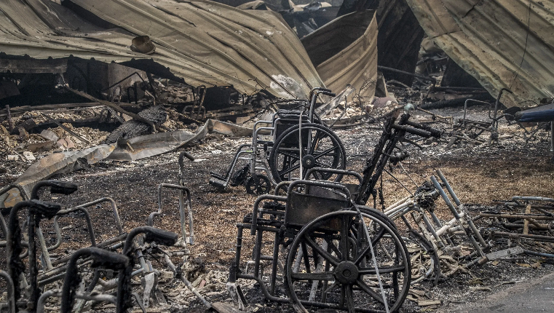
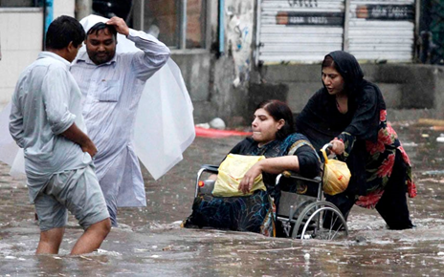

Pakistan Floods left; Many of the 85 who died in Los Angeles Fires were disabled people,
The overarching objective is to raise awareness and share best practices on opportunities and challenges, to strengthen resilience through ensuring the active and informed participation of disabled people in the development of legislation and policy related to emergencies and climate change.
Specific objectives are to:
- Discuss obstacles encountered by persons with disabilities in participating in policy and legislative processes related to emergencies and climate change.
- Share effective means of facilitating inclusive and participatory policy development and implementation of programmes related to emergencies and climate change.
- Exchange experiences, expertise and good practices in strengthening participation of persons with disabilities in the implementation of Article 11 of the CRPD.
- Underscore the importance of intersectional approaches to participation.
- Highlight meaningful engagement and collaboration between disabled people’s organisations and states in implementing Article 11 of the CRPD.
Facilitator Justin Pettit Commonwealth Secretariat, Acting Head Human Rights
Contributions:- Senator Andwele Boyce, Barbados
Sarah Kamau Chair Commonwealth Disabled People’s Forum (CDPF) & UPD Kenya
Extracts from film Rising Tides Rising Voices-impact sea level rise in the Pacific
Faatino Utumapu, Nuanua O Le Alofa, Samoa, CDPF Exec.
Patience Ogolo-Dickson, Advocacy for Women with Disabilities Initiative (AWWDI) Nigeria, CDPF Exec. (filmed contribution)
Clare Gibellini, Australian Federation of Disability Organisations, CDPD Exec.
Abia Akram Special Talent Exchange Programme, Pakistan CDPF Exec. (filmed contribution)
Rasanjali Pathirage, Disability Organisations Joint Front Sri Lanka, CDPF Exec.
Open Discussion
Richard Rieser General Secretary CDPF, Closing Words

The main side meeting of the CDPF was sponsored by Government of Bahamas
Working to develop a unified approach to implementing the UNCRPD across the Commonwealth.
This was in the last slot of the Conference from 4.45 to 6pm on Thursday 12th but still had over 60 attend.
The 56 countries of the Commonwealth comprise 2.7 billion people (including an estimated 430 million disabled people). All but one (Tonga) have ratified, but progress towards implementation of the rights, protections and ending of discrimination contained in the UNCRPD are extremely slow.
Last year the Commonwealth Disabled People's Forum (CDPF), which represent more than 100 OPDs/DPOs, including the Umbrella organisations in 50 countries of the Commonwealth, put forward a draft Commonwealth Disability Inclusion Action Plan (DIAP). The Heads of Government in Samoa, October 2024, while not adopting it, agreed to set up a High-Level Persons with Disabilities and their representative organisations Advisory Group to an Expert Working Group of representatives of the State Parties to achieve an agreed draft. This process is now underway. The agreed draft it is hoped will go to Commonwealth Law Ministers’ Meeting in Fiji for agreement, then to the Commonwealth Heads of Government Meeting in Antigua 2026 for agreement. If adopted the DIAP will kick start a wide range of measures and renewed interest in the rights of persons with disabilities, including sharing of expertise and experience across countries and implementation of key areas of the UNCRPD.
Up to date reports on progress and scope on this project were given.
https://webtv.un.org/en/asset/k1i/k1i4r3rv9o
Facilitator - Sarah Kamau, Chair of CDPF from UPDP Kenya,
Speakers - Nalini Bethel spoke for Hon. Myles Larada Minister Social Services, Inf. & Broadcasting, Bahamas
Rhoda Garland, Commissioner for the Rights of Persons with Disabilities, Malta
Representative of Government of the United Kingdom
Richard Rieser, General Secretary CDPF
Justin Pettit, Commonwealth Secretariat
Arman Ali CEO NCPREDP, India https://commonwealthdpf.org/wp-content/uploads/2025/06/CDPF-Side-Meeting-12th-June-COSP-18.pptx
Rasanjali Pathirage, Disability Organisations Joint Front, Sri Lanka
Senator Andwele Boyce, Barbados
Clare Gibellini, Australian Federation of Disability Organisations
Setareki Macanawai, Chair Federation Disabled People’s Organisations, Fiji
Contributions from the floor.
Chaired by Sarah Kamau from Kenya and CDPF Chair. Nalin Bethel spoke as Chair of National Disability Committee for Hon Myles Larada who had been called away on business. She emphasised the importance of data gathering using the Washington group methods. Other speakers included Rhoda Garland Commissioner for the rights of Persons with Disabilities, Malta, who talked of the importance of collaborating on Access Auditing and Disability Equality Training.
Richard Rieser Gen. Sec. of CDPF gave a history of CDPF and attempts over the last 2 year to establish a Disability Inclusion Action Plan. Justin Pettit from the Commonwealth Secretariat explained that after CHOGM 2024 communique had mandated continued work on developing a Commonwealth Disability Inclusion Action Plan and that it had been decided to set up an Expert Group from State Parties to develop this from the CDPF earlier draft. This had had its first meeting, but they were still recruiting State representatives and at COSP he had talked to South Africa, New Zealand and Barbados about nominating members. [Malta, UK and Bahamas would join Canada (co Chairs), Eswatini (Co Chair), Mauritius, Pakistan, Sri Lanka, Lesotho, Togo]. An Advisory Committee to the Expert Group has been formed of PWD/DPs and rep organisations [with so far 6 reps, gender balanced with different impairments from the different commonwealth regions nominated by CDPF UK, Kenya, Zambia, Pakistan, Fiji and Jamaica]. The aim was to get an agreed draft to take to Commonwealth Law ministers meeting next February in Fiji for agreement and then on to CHOGM in Antigua to be adopted by heads of Government.
Arman Ali CEO from NCPREDP in India then gave a succinct appeal by video to get this done. Rasanjali Pathirage, President of disability organisation Joint Front Sri Lanka gave an interesting glimpse in to their activities and why they would benefit from an agreed Commonwealth DIAP. Senator Andwele Boyce a young disabled Barbadian Parliamentarian gave a lucid and impassioned plea to move forward on implementing the Convention relating what was happening in Barbados. Satareki Macanawai from Fiji Federation of Disability Organisations and a founder member of CDPF, argued strongly that we did not want this process to take long, certainly not the 8 years the recent press and media declaration had taken. He did not even want to come back to COSP 19 without an agreed draft from the Law Ministers meeting next February in his country.
Eswatini and Canada spoke as co chairs of the expert group spoke of wanting a collaborative and inclusive process. Other contribution from DPO reps. from Bangladesh, Nigeria and Australia all briefly supported the process and wanted to contribute. One way would be to get sympathetic representatives from Attorney General or Ministry of Justice to be delegates to the Commonwealth Law Ministers Meeting in Fiji , February 2026″.
More detail on DIAP and reasons for it: Disability Inclusion Action Plan

CHOGM 2024: Reflection on Achievements and Progress
CDPF had a strong presence at CHOGM 2024, using the platform to advance disability-inclusive policies across Commonwealth nations.

Key Highlights
- Preparatory coordination and distribution of 300 awareness leaflets
- Representation secured at the Youth Forum
- High-profile side events on disability and climate change
- Parliamentary engagement promoting a rights-based approach
- Strong alliances formed with policymakers, youth leaders, and advocates
CHOGM 2024 also saw Commonwealth governments commit to establishing a Disability Inclusion Action Plan, reinforcing the relevance of CDPF’s advocacy.

Governance and Organisational Development

Policy and Working Groups
New working groups were established covering:
- Financial controls
- Justice and law
- Climate emergency inclusion
- Under-represented groups
- Parliamentary engagement
- Disability, sexuality, and LGBTQ+ rights

Regional Desks and UNCRPD Monitoring
During the reporting period, six regional desks were established across the Caribbean, Africa, South Asia, and the Pacific. Interns were recruited and trained to support data collection on UNCRPD implementation, with a focus on reasonable accommodation.
Data gathered through questionnaires will be published on the CDPF website, strengthening evidence-based advocacy and peer learning.
- Southern Africa (John Muvla), West Africa (Jerry Okiki) and Caribbean Angaline Sookra well engaged
- Interns: East Africa Abubakar and Pacific Ellen required additional support –
- New intern appointed for Asia Durga provided basic training.

Barbados Youth Leadership Training
Bridgetown, Barbados — The Commonwealth Disabled People’s Forum (CDPF) has launched a major regional workshop in Bridgetown from October 14–16, 2025, bringing together disability advocates, young leaders, and policymakers from across the English-speaking Caribbean. The initiative aims to strengthen inclusive development and accelerate the implementation of the Commonwealth Disability Inclusion Action Plan (DIAP).
The workshop forms part of CDPF’s ongoing mission to promote full inclusion of persons with disabilities across all sectors of society, guided by the UN Convention on the Rights of Persons with Disabilities (UNCRPD) and the Sustainable Development Goals (SDGs).

Aims of the Workshop
The regional meeting will:
- Empower emerging disability leaders to participate meaningfully in national and regional policymaking.
- Promote collaboration among Caribbean governments and civil society to implement inclusive laws and programmes.
- Advance the social and human rights model of disability, reaffirming the principle of “Nothing About Us Without Us.”
- Encourage the inclusion of disability rights in the forthcoming Commonwealth Strategy 2025–2030 and advocate for endorsement of the Disability Inclusion Action Plan at the Commonwealth Heads of Government Meeting (CHOGM) 2026 in Antigua and Barbuda.

Background
The CDPF is an accredited Commonwealth organisation representing umbrella disability bodies in 52 of the 56 Commonwealth countries, speaking for an estimated 430 million persons with disabilities. The Forum continues to press for the full implementation of the UNCRPD and the mainstreaming of disability across all areas of policy and practice.
While the majority of Commonwealth member states have ratified the UNCRPD, progress towards inclusive governance has been uneven. The CDPF urges governments and the Commonwealth Secretariat to renew their commitment to disability inclusion as a central component of social and economic development.

Quotes
“We believe that meaningful inclusion begins when governments work in partnership with persons with disabilities. This workshop is a tangible step toward ensuring that no one is left behind in our Commonwealth,” said Richard Rieser, General Secretary of the Commonwealth Disabled People’s Forum.
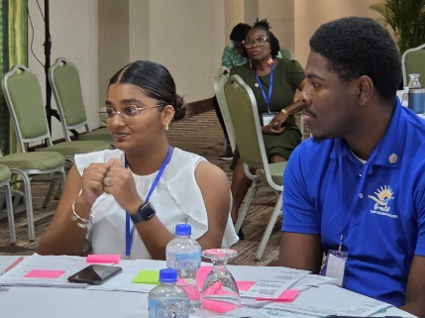
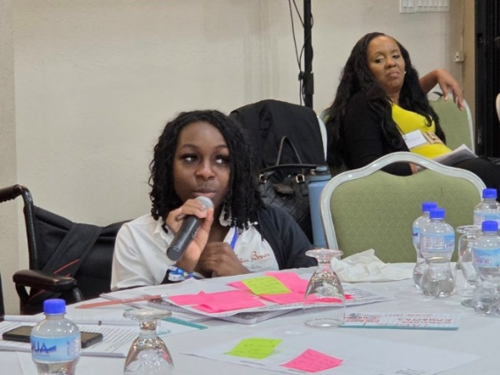
“Barbados offers an excellent example of how engagement with the disability community can lead to progressive laws and policies. We hope to replicate this model across the region,” Rieser added.
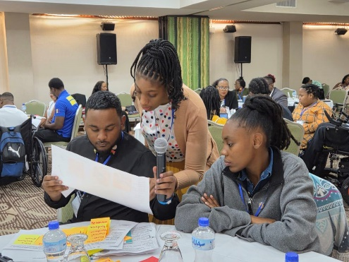
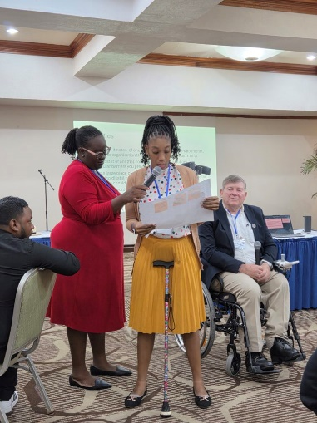
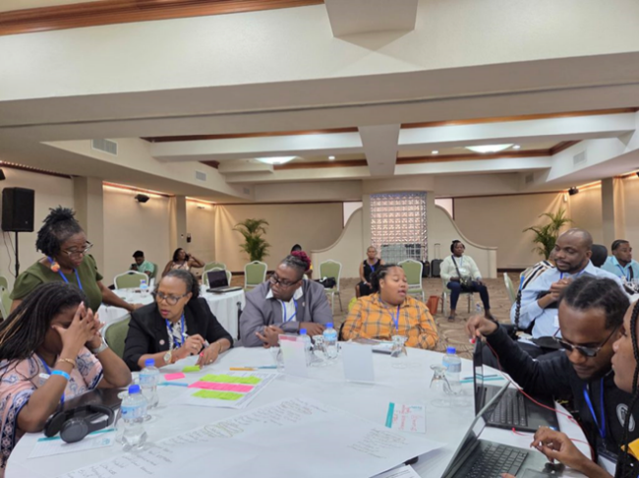

There were 20 participants from 11 Caribbean countries. 5 from Barbados.

Participants scored the training highly

Learning from Training: 4.8/5 average

Organisation of Training: 4.65 /5 average

Building my readiness for the struggle for disability rights: 4.6/5 average.

Focus on Disability in Barbados

Prior to the training The Vice Chair Kerryann Ifill and the Gen Sec were invited to participate in the Commonwealth Parliamentary Association Annual Meeting. Kerryann addressed a successful Town Hall meeting of Disability Activists and Parliamentarians with Disabilities and Richard presented at a workshop on the developing Disability Inclusion Action Plan looking forward to CHOGM 2026 in Antigua Barbuda.

After the Training 5 of the trainees and Richard, Kerryann and Ganesh took part in the Caribbean Disability Network three day conference on developing Inclusive Education in the Region.

[Participants in Barbados Training at Accra Hotel]

CONFERENCE OF PARTIES (COP) Report

30 BELEM BRAZIL 13TH –21ST NOVEMBER 2025 REPORT SRAH KAMAU Chair

The UN Conference of Parties (COP) is an annual event that takes place every year in

a different country. It is the world’s only multilateral decision-making forum on climate

change that bring together almost every country on Earth. During COP, the world

comes together to agree on the actions to address the climate crisis, such as limiting

the global temperature rise to 1.5 degrees Celsius, helping vulnerable communities

adapt to the effects of climate change, and achieving net-zero emissions by 2050.

COP30 brought together world leaders and negotiators from the member states (or

Parties) of the UN Framework Convention on Climate Change (UNFCCC) to further

global progress, with business leaders, young people, climate scientists, Indigenous

Peoples, and civil society sharing insights and best practices to strengthen global,

collective and inclusive climate action.

I attended the COP30 Climate Change Conference held in Belem Brazil from 13th

November to 21st November 2025. Being the first time, this was a learning moment for me on how to engage meaningfully during the negotiations and side events sessions.

I engaged with the Global Disability Climate Caucus members who were attending the

COP30 and advocating for Disability Inclusion and rights. The group is organized by

International Disability Alliance (IDA).

The negotiations are organized in such a way that only accredited constituencies are able directly engage with the United Nation Framework Convention on Climate Change

(UNFCCC) presidency or secretariat. The Disability Climate Caucus has been pushing for Disability to be approved as a constituency in order to directly advocate for Disability Inclusion in the negotiations under UNFCCC Disability Caucus.

The Disability Caucus met with the Special Envoy on Human Rights. During the meeting

the Caucus discussed the disability rights that need to be included in the Climate Action discourse as disability rights are human rights too. Rights on communication, accessibility, transport, women and girls with disabilities. The Special Envoy head agree to submit a letter to UNFCCC on behalf of the Disability Caucus on the Urgent concerns regarding accessibility and inclusion of persons with disabilities at COP30

A meeting with Nigerian High Commission and senior officials to solicit their support during discussion to endorse the UNFCCC Disability Caucus approval was held.

• The Caucus made a powerful speech during the Peoples Plenary on Disability right and Inclusion highlighting their Experience in COP30. Without a Disability Constituency, disability rights and issues ae denied their visibility, and the legitimacy that other groups of rights holders deserve. COP should be a people’s COP, the way is it now it not.

A fire broke out during COP30, and it was a challenge how the information was passed on to participants and the evacuation was conducted. Disabled people were faced with different challenges during evacuation. https://unfccc.int/cop30/auvs. I in particular was left stranded at on of the exit points after a volunteer told me that it was not his work to assist me navigate outside the conference environment. I struggled to get to my hotel because of language barrier and finally got support from the transport team who took me to my hotel. It was a very scary experience for me.

Challenges
- Accessibility into the different venue had significant setbacks: Transport was not accessible to physically disabled participants, no sign language interpretation, no real time live captioning, no accessible format of easy reads, large fronts, braille, inaccessible official website and digital platforms, no adequate rest areas for those who need to take rest due to their psychosocial and mental disabilities, significant military presence, safety preparedness information among others.

Next Steps

1. The Disability Caucus should pursue the agenda of having a disability constituency to enable them speak and become their own advocates. All disabled people and their

organizations should join the Caucus so as to speak in a unified voice on disability

inclusion. The constituency needs to become a negotiator and contributor to the texts

being agreed upon for declaration

2. Engage UNFCCC to get observer status for CDPF

3. Capacity building on disability rights and equality for UNFCC secretariat

Contacts Made

1. Disability Caucus organized by IDA.

2. Jerome CEO World Green Economy Initiative based in Dubai. Contact him to invite

CDPF to speak on Disability Inclusion and Equality during their events.

3. Meet Dr. Nancy Omolo, Commonwealth Climate Finance Gender Adviser. Will follow up to initiate how CDPF can collaborate with that Section.

4. Shawn Hung from China – a young journalist whose organization can offer training on AI for youth. He promised to consider CDPF youth for training.

Disability Inclusion in Climate Policy: Briefing Paper for COP30, Belém

Disability Caucus, November 2025

Background

Persons with disabilities - an estimated 1.3 billion people globally - are among those most impacted by climate change, yet remain systematically excluded from climate policy, planning, and finance. Disability inclusion is not only a human rights obligation under the Convention on the Rights of Persons with Disabilities (CRPD); it is also essential for effective, equitable, and sustainable climate action. At COP30 in Belém, Brazil, Parties must make bold steps to increase disability inclusion across all areas of the UNFCCC process, ensuring no one is left behind 1 in the transition to low-carbon, climate-resilient societies. This brief highlights five priority areas where disability inclusion should be embedded in climate policy negotiations, implementation and monitoring.

1. Just Transition

Current context: COP30 builds on the UAE Just Transition Work Programme, focusing on fair national pathways that combine equity, social protection, and decent work. Key discussions address labour rights, funding, and dialogue mechanisms.

Why It Matters: Persons with disabilities are often excluded from green jobs, workforce planning and skills training due to a lack of accessibility and reasonable accommodation. Inclusive transition planning ensures equal opportunity and strengthens workforce diversity in the green economy.

Recommendations:
- Include disability-related goals and indicators in the Just Transition Work Programme, aligned with ILO guidelines and CRPD Article 27 (right to work). Explicitly ensure that workforce pathways include fairness in career advancement in alignment with all other workers.
- Direct transition finance toward inclusive infrastructure, accessible mass transport, housing and adaptive livelihoods.
- Ensure organizations of persons with disabilities (OPDs) are invited and resourced to participate meaningfully in national planning and dialogue platforms.

2. Global Goal on Adaptation (GGA)

Current context: Parties are finalizing indicators for the GGA, with debates on equity and implementation support.

1 All facing compounded climate risk, including but not limited to persons with disabilities who are from Indigenous Peoples, refugees, women, LGBTQ+ communities, racial minorities, low-income populations, older adults, children, people experiencing homelessness, rural communities, island nations, migrants, and those in conflict zones

Why it matters: If adaptation measures ignore accessibility, they risk excluding persons with disabilities from climate-resilient infrastructure and services and causing harm. Inclusive adaptation recognizes their heightened vulnerability, specific needs, and potential contributions to community resilience.

Recommendations:
- Include disability-disaggregated data and accessibility metrics in GGA indicators.
- Require accessibility audits for climate-resilient key systems - health, transport, education, and shelters.
- Fund local adaptation projects co-designed and implemented with OPDs.

Strengthen technical assistance for Parties to include universal design and accessibility standards into National Adaptation Plans (NAPs).

3. Gender Action Plan (GAP)

Current context: The GAP is being updated to strengthen monitoring and intersectional approaches. Why it matters: Women and girls with disabilities face multiple risks during disasters, including heightened exposure to Gender-Based Violence (GBV), economic exclusion and lack of access to recovery programs. They remain underrepresented in decision-making. Including disability in the GAP ensures that gender-responsive action is also disability-inclusive.

Recommendations:
- Explicitly mention women and girls with disabilities in the new GAP.
- Collect intersectional data on gender, age, and disability across all climate sectors.
- Support women-led OPDs through targeted finance, leadership training and participation in national climate delegations.
- Address GBV risks prevention and accessibility in disaster preparedness and during climate disasters.

4. Nationally Determined Contributions (NDCs 3.0)

Current context: Countries will submit new NDCs for 2035 by late 2025. To date, most drafts still lack measurable inclusion targets or participation mechanisms

Why it matters: Without disability-responsive indicators, NDCs risk perpetuating the exclusion of persons with disabilities from climate action. Embedding inclusion not only strengthens the credibility and effectiveness of NDCs but also ensures alignment with the Sustainable Development Goals (SDGs) and the Convention on the Rights of Persons with Disabilities (CRPD).

Recommendations:
- Require disability indicators, data collection and participation mechanisms in NDC 3.0. submissions.
- Align NDC monitoring to national disability action plans and CRPD reporting frameworks.
- Track progress on accessible climate services and early warning systems.
- Provide technical guidance for Parties on mainstreaming disability in NDC planning and monitoring.

5. Climate Finance

Current context: The New Collective Quantified Goal (NCQG) aims to mobilize $300 billion per year by 2035, with debates on access, transparency and delivery mechanisms.

Why it matters: Climate finance rarely reaches people with disabilities or funds accessibility improvements. Inclusive finance increases equitable and effective resilience.

Recommendations:
- Integrate disability inclusion criteria into all climate funds and NCQG reporting templates.
- Create dedicated funding windows for accessibility and OPD-led projects.
- Make accessibility and participation outcomes mandatory for project approval. Build capacity of OPDs to access, manage and report on climate finance projects.

Call to action

At COP30, Parties and other stakeholders should:
- Ensure disability inclusion in COP30 outcomes through decisions, declarations, and technical mandates across the UNFCCC processes, with OPDs and the disability caucus providing guidance and advocacy support.
- Mandate reporting on disability inclusion in national communications, adaptation communications, and climate finance plans.
- Recognise OPDs as essential partners in climate governance, ensuring accessible participation in all relevant processes.
- Request recognition of the Disability Caucus as a full Constituency.

Conclusion

Inclusion of persons with disabilities is fundamental to achieving fair and effective climate action. At COP30, Parties should embed accessibility, participation, and accountability as standard practice across just transition, adaptation, gender, finance, and NDC frameworks. Doing so will not only fulfil human rights obligations but also strengthen resilience and ensure that the global response to the climate crisis benefits everyone.

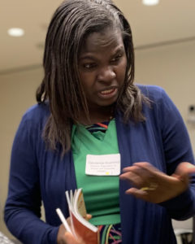
African Disabled Girls Empowerment Project

Gaudence Mushimiyimana Women’s Officer
CDPF African Disabled Girls Empowerment Project
The Disabled Women and Girls Empowerment Project is being implemented under the leadership of the CDPF Women’s Forum and managed by UNABU Rwanda.

Implementation Progress So Far with

The Main Aims: The African Disabled Girls Empowerment Pilot Project 2024-2026. Develop and implement innovative methods to encourage and bring about an increase in the effective inclusive education of disabled girls in primary education; Increase in participation of disabled teenage girls who have completed primary/secondary education in job skills training projects that lead to meaningful self/ employment; Enhance solidarity of disabled girls in effectively challenging gender based violence.
Serves as an opportunity for learning and developing tools for selecting and managing disabled led grass root projects.
The Pilot is coordinated by Rwandan Organization Women with Disabilities (UNABU), MUSHIMIYIMANA Gaudence - Co-founder and Executive Director and CDPF Women’s Officer
Coverage: work with two selected Commonwealth countries DWOs Disabled Women’s Organisations in Africa; Nigeria Advocacy for Women with Disabilities Initiative (AWWDI) and Uganda Mubende Women with Disabilities Association (MUDIWA).

Expected Outcomes
- Established working relationships among disabled girls and women led organizations
- Strengthened capacity of disabled girls and women led organizations
- Improvement in disabled girls ‘school enrolment, access to employment training and livelihoods achieved
- Reductions in gender based violence in community

Key Achievements in Nigeria
- 78 direct beneficiaries have participated,
- over 2,000 indirect beneficiaries have been positively impacted through community awareness and engagement activities.
- project is building a more inclusive environment while empowering girls with disabilities to become confident, self-reliant, and active members of their communities
- 30 girls attending vocational trainings in cosmetology, catering, tailoring, hairdressing, and agro-business. In addition, entrepreneurship and financial literacy modules are enhancing their ability to manage small businesses and make informed economic decisions.

https://www.facebook.com/reel/1232061172061835
You see a tailoring class. We see a brighter future. ​As this student learns to measure, she is actively achieving our project's key goals: She's gaining a skill for economic independence. She's in a safe, supportive learning environment that encourages out-of-school girls to re-enrol.
​She's building the self-reliance needed to be protected from gender-based violence. This is the multi-layered empowerment we are building for girls with disabilities in KUJE, with full support from CDPF.
​ Girls attending vocational skills training in Nigeria Kuje community

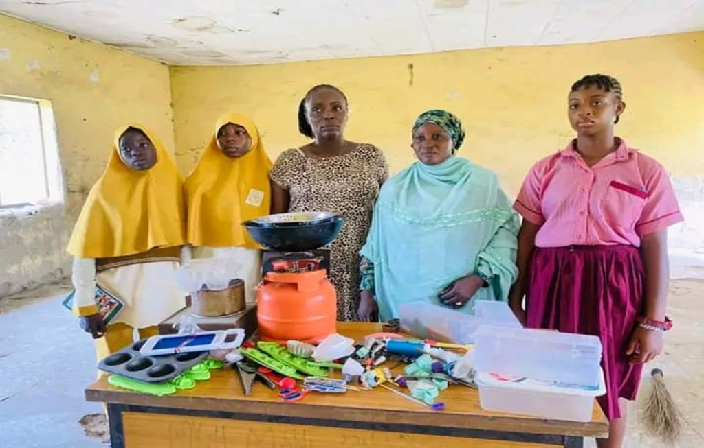

Key Achievements in Uganda
- 50 service providers including , Health, police, social workers, teachers, parents , cultural leaders, religious leaders trained on inclusive GBV response to enhance support system
- 25 were trained in Inclusive Education and Disability Rights and were from the following schools
- identified and enrolled 60 out of school girls with disabilities in inclusive schools and also encouraged parents and guardians to enroll their disabled daughters in school
- 15 GBV survivors linked to legal aid services such Justice Centre and Local Council Three Courts
Project Outcomes
Sarat’s Story Sarat Yusuf, a 17-year-old girl from Kuje who is an amputee without both hands. Despite facing considerable challenges, Sarat has embraced cosmetology training through the project, gaining skills that open doors for her future. She has also demonstrated remarkable resourcefulness by making and selling liquid soap, using the income to cover transport costs for training. Through this journey, Sarat has gained confidence, independence, and a sense of purpose, showing that inclusive vocational opportunities can transform the lives of girls with disabilities and create pathways for economic self-reliance
Some Lesson Learned So Far
- Community sensitization reduces stigma and discrimination in communities and creates supportive system for girls to go back to school.
- The Project doesn’t only empower girls with disabilities but also strengthens the capacity of teachers and caregivers. Practical engagement, mentorship, and tailored approaches enhance confidence, participation, and learning outcomes, demonstrating that investing in people at all levels maximizes the project’s effectiveness and reach.
A teacher in Nigeria who previously struggled to connect with her students with disabilities has transformed her teaching approach, learning to engage all students inclusively, communicate effectively, and adapt lessons to meet diverse needs as result of engaging with the girls with various types of disabilities in vocational trainings

Youth Capacity Building In-Person Training for Young Disabled Leaders Location: Nairobi, Kenya CDPF conducted an in-person training programme for 14 young disabled leaders from across East and Southern Africa. This initiative responded to participant feedback from previous online trainings and focused on building leadership capacity through peer exchange, confidence-building, and interactive sessions. Participating countries included: Kenya, Malawi, Uganda, Tanzania, Rwanda, South Africa, and Zambia. Selection & Accessibility Nomination Process: Participants were nominated by national member organisations, ensuring gender balance. Inclusion: Full accessibility was provided, including personal assistants and simultaneous captioning. Outcomes & Impact 98.7% of participants reported readiness to apply their knowledge 96.2% gave positive feedback on learning outcomes 95% praised the programme’s organisation and methodology Programme Highlights: Each youth participant was paired with a one-on-one mentor from the Executive Committee. While youth sessions were underway, EC members participated in parallel capacity-building activities. Participants commended the inclusive methodology and practical value of the training.

Looking Ahead
CDPF enters 2026 with renewed momentum, strengthened partnerships, and a clear strategic focus. Continued advocacy, capacity building, and leadership by disabled people will remain at the heart of our work.

Together, we strive for a Commonwealth where disabled people are recognised as equal citizens, leaders, and contributors.

Commonwealth Disabled Youth Forum (CDYF) 2025
Kihembo Wilpert Youth Officer

1. Introduction
The Commonwealth Disabled Youth Forum (CDYF) is a youth-led initiative supported by the Commonwealth Disabled People’s Forum (CDPF). CDYF exists to unite, amplify, and empower disabled youth across the Commonwealth through advocacy, leadership development, capacity building, and knowledge sharing. The year 2025 marked a period of consolidation, reflection, and gradual growth for CDYF. Building on foundations laid in 2024, the forum focused on strengthening its identity, improving coordination among members, and maintaining momentum despite operating with limited financial and technical resources.
CDYF continued to prioritize inclusion of disabled youth from diverse backgrounds,
including those from rural communities, conflict-affected areas, and regions with limited digital access. The forum remained committed to creating safe, accessible, and youth-centred spaces where lived experience is recognized as expertise.

Throughout 2025, CDYF functioned primarily through virtual and digital platforms. This
approach enabled cross-border collaboration while also highlighting ongoing inequalities in internet access, assistive technologies, and digital skills among disabled youth.

2. Governance and Structure
CDYF is administered under the guidance and mentorship of the Commonwealth
Disabled People’s Forum (CDPF). The forum is governed by an elected youth leadership team that reflects regional diversity across the Commonwealth.
The leadership structure provides strategic direction, coordination of activities, and
representation of disabled youth interests in relevant spaces. Decision-making within
CDYF emphasizes consultation, transparency, and collective responsibility.
In 2025, CDYF continued to operate through:
- An elected youth leadership team with defined roles and responsibilities
- Informal regional representation to ensure voices from different parts of the
Commonwealth are heard
- Volunteer-driven coordination, reflecting the forum’s grassroots and youth-led
Nature. Despite the absence of a permanent secretariat or full-time staff, the leadership team demonstrated strong commitment and adaptability in sustaining CDYF’s activities.

3. Membership and Engagement
By 2025, CDYF membership grew to over 157 disabled youth from different
Commonwealth countries. Members engaged primarily through: - A WhatsApp
community platform for networking and peer support - Virtual meetings and webinars -
Collaborative discussions on disability inclusion, leadership, and education
The forum remained intentionally inclusive of youth with diverse disabilities, including
those from rural and underrepresented communities.

4. Key Activities in 2025
4.1 Capacity Building Webinar Series
CDYF continued to use virtual learning spaces as a key approach to capacity building in 2025. The Capacity Building Webinar Series was designed to strengthen knowledge, confidence, and leadership skills among disabled youth, while connecting them with
experienced disability rights advocates and practitioners across the Commonwealth.
The webinar series focused on priority themes affecting disabled youth, including inclusion in education systems, leadership development, and rights-based advocacy. Sessions were designed to be interactive, youth-centred, and accessible, with emphasis on lived experience, peer learning, and practical action.

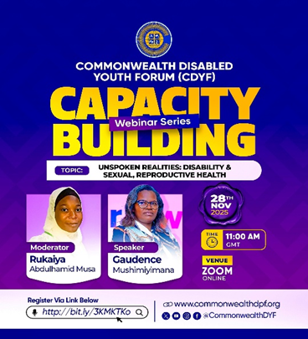
Participation across sessions reflected strong interest from disabled youth across
different regions and time zones, while also highlighting the importance of improved
publicity, accessibility measures, and follow-up engagement.

4.2 Youth Advocacy and Voice
In 2025, CDYF continued to position itself as a collective voice for disabled youth within broader disability and Commonwealth-related discussions. Youth leaders highlighted key advocacy messages, including:
- The persistent underrepresentation of disabled youth in national, regional, and
global decision-making spaces
- The need for meaningful participation rather than tokenistic inclusion
- Barriers faced by youth with high support needs, including communication and
mobility challenges CDYF advocacy emphasized that disabled youth are not only beneficiaries but also contributors to policy, innovation, and community development.

4.3 Digital Community Building
Digital platforms remained central to CDYF’s operations in 2025. The WhatsApp
community group continued to serve as the primary engagement space, enabling
members to: - Share opportunities, resources, and announcements - Discuss lived
experiences and local challenges - Build solidarity across borders and cultures. While digital engagement increased connectivity, it also exposed disparities in access to affordable internet, assistive technologies, and digital literacy, particularly for youth in rural areas.
4.4 Knowledge Sharing and Peer Support
Beyond formal activities, CDYF functioned as a peer support network. Members shared
insights on education, employment, assistive technologies, advocacy strategies, and
self-advocacy. This informal knowledge exchange strengthened trust and fostered a
sense of belonging among members.
4.5 Steering Committee Coordination, Communications, and Planning
In December 2025, the CDYF Steering Committee convened to review progress,
strengthen internal coordination, and improve communication systems across the
forum. The meeting played a key role in aligning leadership, , and technical support
around shared priorities. A strong emphasis was placed on communications and visibility. The Steering Committee reviewed the use of digital platforms including WhatsApp, Facebook, LinkedIn, and Instagram as the most accessible channels for reaching members and wider audiences. Content planning, consistency in posting, and clear calls to action were identified as important areas for strengthening engagement. The committee agreed on practical measures to improve outreach, including the use of coordinated publicity materials, advance reminders for activities, and short accessible content formats such as flyers, captions, and recorded clips. Responsibilities for content design, posting, and moderation were clarified among youth leaders and volunteers.

The CDYF website – www.commonwealthdyf.org was launched and reaffirmed as a
central hub for information, resources, and continuity. Plans were agreed to ensure
recordings, learning materials, and key updates are uploaded and shared for members
who are unable to participate in live sessions.
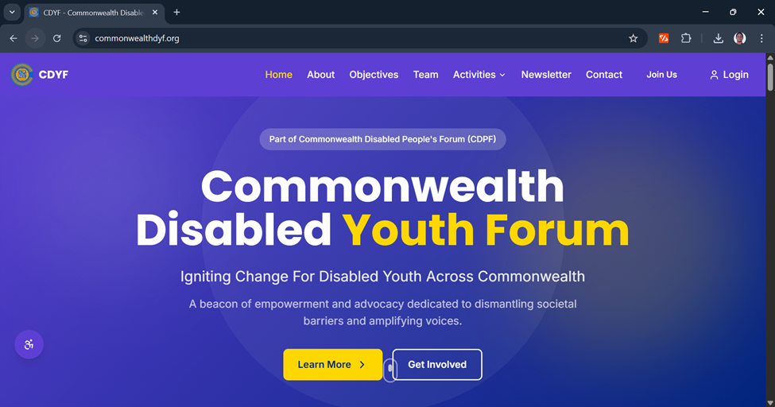

These actions strengthened CDYF’s internal governance, improved communication flow, and reinforced accountability, while ensuring that disabled youth remain informed, connected, and meaningfully engaged across the Commonwealth.

5. Partnerships and Collaboration
In 2025, CDYF, through the Commonwealth Disabled People’s Forum (CDPF),
strengthened strategic partnerships aimed at building long-term capacity for disabled
youth.

A key partnership during the year was with the Joint National Association of Persons
with Disabilities (JONAPWD), particularly its Youth Section, to develop an online youth
training system using the Moodle learning platform (www.cdpfyouthtrain.org ). This
collaboration focused on creating structured, accessible, and rights-based training
materials tailored to disabled youth.
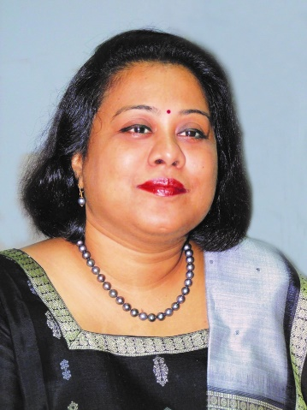

Inclusive Education, Gender Mainstreaming, Disability Inclusion, Accessibility Rights, SDGs and the Way Forward
By Dr. Sruti Mohapatra Vice Chair CDPF, CEO Swabhiman, Odessa, India

When I reflect on my work over the last year, what stands out most powerfully is this:
accessibility is a fundamental right, not a favour. Whether in classrooms, health centres, cities, or decision-making forums, accessibility, when realised, transforms potential into possibility and exclusion into equitable participation. My work, especially in inclusive education and systemic change through disability rights budgeting, has sought to make that right visible, measurable, and sustainable.
1. Inclusive Education - Rights, Systems, and Measurable Impact (SDG 4)
Inclusive education (Addhyayan Program) is more than policy; it is a fundamental right
that ensures every child learns, grows, and thrives without discrimination. According to
CDPF’s doctrine on inclusive education, “inclusive education is a fundamental right, both a means and an end for all children, including the most marginalised.” This approach insists that education systems must transform to accommodate the diverse needs of learners, removing barriers to participation, attendance, and achievement.
At Swabhiman, our approach through multiple programmes has operationalised this
right with impact: Project Saksham, implemented through eight Inclusive Child
Resource Centres (ICRCs) in government schools of Bhubaneswar, supported by Urban Local Bodies and corporate partners, provides holistic education, assistive support, vocational training, and community engagement to children and youth with disabilities. In 2025-26 Phases of Saksham include:
- Teacher training under RTE guidelines, with 700 educators trained, leading to a
reduction in attitudinal barriers for 800+ children with disabilities and more
than 1,000 non-disabled students.
- Holistic year-round support for 300 learners, including tuition, therapeutic
classes, exposure visits, and assistive devices.
- Strengthening school governance through sensitised School Management
Committees and empowered parent groups in 11 schools. Complementing Saksham, Addhyayan expanded inclusive learning through scholarships (37 students), teacher support (1 school), audiobooks in accessible formats (21 students), rural Saksham support (140 students), and youth leadership programmes (45 students), affirming that inclusion must also bridge early education to
higher education pathways. These initiatives align directly with SDG 4 (Quality Education), particularly target 4.5 on eliminating disparities and target 4.a on creating safe, inclusive learning environments, yet they also demonstrate that commitment must be backed by budgets, training, and systemic accountability.

2. Disability Inclusion Beyond Education: SDG 3, SDG 5, SDG 11
Our work recognises that disability inclusion intersects multiple SDGs, and unless
integrated across sectors, progress remains partial.
SDG 3 - Health and Well-Being Health access is a basic right yet remains uneven for persons with disabilities. Through Swabhiman’s engagements, we have linked families to government entitlements like Ayushman Bharat-PMJAY (70+), inclusive screening camps (2), rehabilitation linkages (91), and accessibility audits of public health centres (3). While not standalone statistics, our field data shows that linkages to health schemes reduce catastrophic out-of-pocket expenses and promote school attendance, a clear intersection between education and health outcomes.
SDG 5 - Gender Equality It cannot be realised without the meaningful inclusion and leadership of women with disabilities. Through the Commonwealth Disabled Women’s Forum under the Commonwealth Disabled People’s Forum (CDPF), sustained research, advocacy, and global engagement have made visible the compounded and systemic discrimination faced by disabled women across education, health, employment, political participation, climate action, and protection from violence. Survey evidence (2023) and interventions at global platforms such as CSW68, CHOGM Samoa 2024, the Commonwealth Parliamentarians Association, Women Affairs Ministers’ Meetings, and People’s and Women’s Forums reveal a persistent truth: disabled women remain structurally invisible - excluded from data, leadership spaces, and mainstream women’s movements themselves.

Across these forums, the call has been consistent and urgent: “You cannot empower
what you refuse to count.” The absence of disability- and gender-disaggregated data
undermines accountability across SDG indicators, while inaccessible systems and
discriminatory norms continue to silence disabled women’s voices. CDPF’s Women’s
Forum Declaration calls for inclusive policies, equity-focused budgeting, accessible
services, freedom from gender-based violence, sexual and reproductive rights,
disability-inclusive climate action, and leadership pathways for disabled women.
From health equity to political participation, these engagements underscore that
disabled women are not passive beneficiaries but agents of change. As the 2030 SDG
review approaches, the challenge lies not in frameworks, but in the political will to
implement them inclusively. Disabled women are ready to lead systems must now be
ready to include.

SDG 11 - Sustainable Cities and Accessible Environments Access audits conducted by Swabhiman underscore that accessibility extends beyond school walls. Our accessibility audits of public infrastructure, including schools, marketplaces, and municipal facilities, document physical barriers that prevent participation in public life. Aligning with SDG 11’s targets for inclusive, safe, and sustainable cities, these audits form the evidence base for convincing urban local bodies to invest in ramps, accessible toilets, and navigable pathways.

3. Global Context: Stalled Progress and the UN’s Warning
Despite these initiatives, the United Nations Disability and Development Report 2024
reveals that progress for persons with disabilities across SDG indicators is either
insufficient or regressing. Globally, progress is behind schedule for 30 % of SDG targets, and for 14 % aims, it has stalled or reversed, a stark reminder that inclusion
frameworks must translate into funded plans and measurable outcomes. (UN report)
This global context reinforces why our work, rooted in grassroots realities, rights
norms, and policy frameworks, remains urgent.

4. Training, Exchanges, and Capacity Building (Point IV)
A key contribution this year was the CDPF Training the Trainers Development
Programme in India. This initiative brought together educators, policymakers, and
community leaders to deepen understanding of disability rights, inclusive practice, and
practical tools for accessibility and accountability. As CDPF’s programme articulates,
this training strengthens systems to implement inclusive policies rather than isolated
projects. Participants left the programme with concrete plans to integrate disability inclusion across curricula, infrastructure planning, and monitoring, a crucial step toward sustainable, systemic change.

5. Working with Government: Policy, Schemes, and Accountability
Our engagements with the Government of India span contributions to Accessible India
Campaign Phase II, inclusive education guidelines under Samagra Shiksha Abhiyan, and advocacy on data disaggregation for disability inclusion in national surveys.
These engagements push for institutionalising the principles of accessibility and rights not as add-ons but as core components of national development planning and
budgeting.
6. Media, Narratives, and Public Awareness
Media coverage, from The Hindu to regional outlets like Pragativadi and The New Indian
Express - has increasingly featured stories from Swabhiman’s inclusive education work
and CDPF events. Documenting Anjali International Children &amp; Youth Festivals,
accessible education models, and disabled women’s leadership has helped shift public narratives from benign welfare to rights and justice storytelling. Yet much work remains to make disability inclusion a mainstream development narrative.
7. Challenges and the Path Ahead
Despite progress, persistent barriers remain:
- Attitudinal stigma in classrooms, workplaces, and public spaces impedes full
participation.
- Data gaps hinder evidence-based planning.
- Weak budgetary allocations for disability inclusion across sectors limit sustained
action.
- Intersectional exclusion, especially for women, rural communities and people
with multiple disabilities, remains a pressing issue.
To bridge these gaps, we must ensure disability rights budgeting, strengthen monitoring of SDG implementation with disaggregated data, and amplify disabled leadership.

8.Professional Leadership, Technical Expertise, and Recognition
My work is grounded not only in advocacy but also in technical and institutional
practice. I was selected as one of 15 National Access Auditors by the Government of
India after a rigorous evaluation, recognising expertise in accessibility and universal
design. I have conducted over 1,000 access audits of schools, public buildings, and
institutions, directly influencing the adoption of barrier-free infrastructure standards. I
have also provided technical inputs on inclusive education and accessibility norms to
government departments and institutional stakeholders. I was appointed as a member of the Inclusive Education Focus Group of the Government of India for the development and implementation of the National Education Policy (NEP) 2020, ensuring disability-inclusive perspectives within national education reform. At the community level, I have supported over 300 children with disabilities in school admission, retention, and grade transition through counselling and school-based
advocacy, while engaging more than 50,000 parents and caregivers to reduce stigma
and raise educational aspirations. Parallel efforts to promote the Rights of Persons with Disabilities (RPwD) Act, 2016 have enabled access to disability certificates,
entitlements, and government schemes, while strengthening local governance and
institutional accountability. Swabhiman also established the CDPF Regional Desk in Odisha, strengthening coordination between disability networks, civil society, and government agencies, and enabling sustained changes in attitudes, policies, and practices toward inclusive, rights- based systems.
This work has been recognised through several national and state honours, including
the Femina Achievers Awards 2025 (Odisha Edition), CII National Award for Innovative
Education Model, FICCI Smart Innovation Award in Education of Divyangs, CavinKare
Ability Award, TIMES Power Women Odisha Award, Capital Foundation National
Awards 2025, and the Odisha Accessibility &amp; Equity Leadership Award.
Conclusion: A Rights-Based, Sustainable Road Forward. Inclusion is not a project, it is a sustainable transformation of systems, policies, and mindsets. CDPF’s global platforms, Swabhiman’s grassroots work, and our collective advocacy remind us that realising accessibility as a fundamental right requires courage, evidence, and collaboration. As we look toward 2030, our mandate is clear: embed disability inclusion across all SDGs, backed by budgets, data, and human rights accountability, because sustainable development must work for everyone. (CDPF is supporting the work Sruti is leading on the Sustainable Development Goals funding a researcher).


Commonwealth Disabled Peoples Forum (CDPF) Officer for Underrepresented Impairment Groups and Neurodiversity Advocacy
Dr Emile Gouws

1. Introduction
This report outlines my work and contributions to the Commonwealth Disabled Peoples Forum (CDPF) during 2025. My work focused on amplifying the voices of disabled people across the Commonwealth, with a particular emphasis on autistic people, neurodivergent individuals, and people with learning disabilities from the Global South. My approach throughout 2025 was grounded in lived experience, accessibility, and meaningful participation, ensuring that voices often excluded from policy, advocacy, and international platforms were not only heard but centred.

2. Key Areas of Work and Contribution
  - Representation and Advocacy
- Represented underrepresented disabled communities across 53 Commonwealth countries, particularly from Africa, the Pacific, and other low- and middle-income contexts.

- Brought lived-experience perspectives of autism, non-speaking communication, and neurodivergent individuals into high-level disability, governance, and human rights discussions.
- Advocated for the meaningful inclusion of people with invisible disabilities, learning disabilities, and neurodivergent profiles in policy dialogues, moving beyond tokenistic participation.

2.2 South Africa’s G20 Presidency and the D20 Conference (November 16–17, 2025)
In 2025, South Africa hosted the G20, creating a critical opportunity for underrepresented disabled voices to influence global governance agendas. As the CDPF representative for underrepresented groups, this moment was strategically significant. I was elected to serve on the Steering Committee of the D20 Conference, held in South Africa on 16–17 November 2025. The D20 Conference brought together leaders, activists, researchers, Organisations of Persons with Disabilities (OPDs), government officials, and global partners to shape a unified disability-sector position aligned with South Africa’s G20 Presidency. The conference focused on the theme “Inclusive Governance for Persons with Disabilities” and aimed to ensure that the rights, expertise, and lived experiences of persons with disabilities were embedded across all G20 structures. This was a pivotal moment for the global disability community and an important step towards formalising D20 within global
governance frameworks. The D20 process is led by the National Council of and for Persons with Disabilities (NCPD). It was particularly heartening to witness the active representation and contribution of underrepresented groups, including neurodivergent individuals and people with learning disabilities. These contributions were reflected in the D20 Report submitted to the South African government.

Through participation in the D20 Inclusive Education Working Stream, I made substantive contributions grounded in Article 24 of the UNCRPD, emphasising inclusive education, reasonable accommodation, and the realities faced by neurodivergent learners in the Global South. D20 website: https://disability20.org.za/

3. Media, Public Awareness, and Storytelling
3.1 International Media, Autism, and the Need for a Global Response
Despite increased visibility, I observed with concern that international media coverage of autism during 2025 often reinforced deficit-based and medicalised narratives. Research indicates that, in many Global South and low- and middle-income countries, societal awareness of autism has regressed by approximately 40 years, negatively shaping public perceptions and policy responses.

In response, I initiated a global advocacy campaign titled: Neurodivergence 2030
Neurodivergence 2030 is a visionary global campaign launched from South Africa that
centres the voices of neurodivergent individuals in shaping a more inclusive future.
Why Neurodivergence 2030?
- Because too many people are still being left behind
- Because the Sustainable Development Goals (SDGs) often overlook daily lived
experiences
- Because economic growth is meaningless if human dignity is ignored
- This campaign is a rallying call to policymakers, educators, families, and global leaders to:
- Recognise neurodivergent strengths
- Ensure access to support, education, employment, and healthcare
- Embed neurodivergent inclusion across development and governance plans
Grounded in the UNCRPD, Neurodivergence 2030 aims to encourage and hold
governments accountable so that underrepresented groups are not left behind in the
pursuit of the SDGs.
The movement is structured around the 3A Network:
- Awareness
- Acceptance
- Appreciation
“Nothing about us, without us” is reframed as: “Everything with us, starting now.”
YouTube link of launch: https://youtu.be/xeHq-ev5FpE
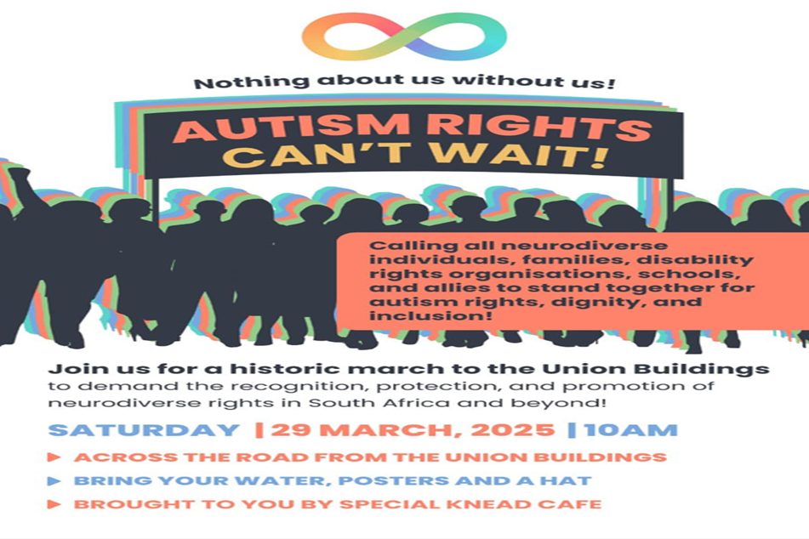
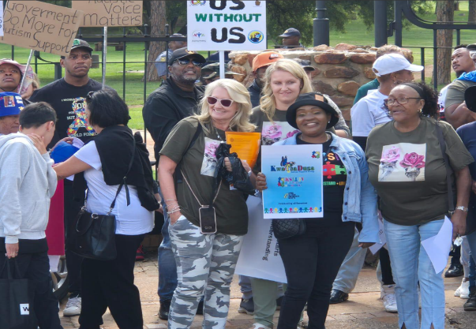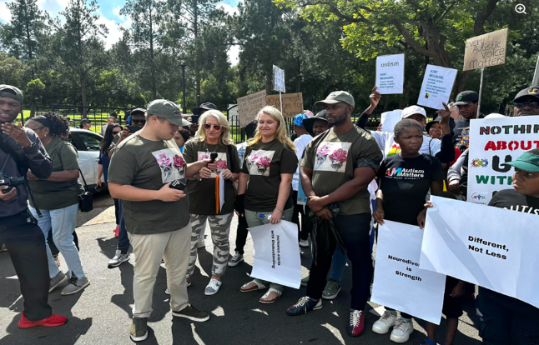

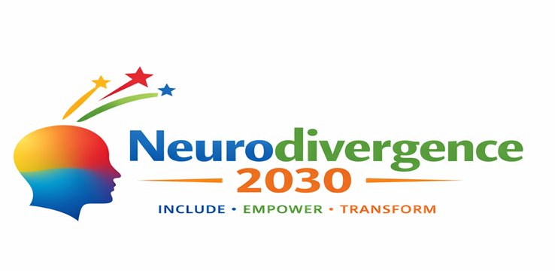
4. Key Campaigns, Actions, and Outcomes in 2025 (3A Network)
4.1 Awareness The George Animation Series
Under the Awareness pillar, I co-created a short animation series titled George, designed to educate society about autism and different forms of neurodivergence through a simple, relatable, and proudly South African lens.

George is not a specialist or an expert; he is a member of society trying to understand his neurodivergent friend better. This approach humanises autism and challenges
misconceptions.
- The series has been widely shared on social media and is scheduled for television broadcast.
- Plans are underway to translate George into 20 African languages to reach diverse communities.
- Funding is being sought to provide captioning and South African Sign Language
interpretation, ensuring accessibility.
Media link: https://www.goodthingsguy.com/lifestyle/sa-animation-autism-awareness/ Youtube link: https://youtu.be/YIMiUKJ0r0A

Autism Rights March – 29 March 2025
On 29 March 2025, with the support of Special Knead Café (our facebook page) and two small NPOs, I organised a historic march to the Union Buildings of South Africa. The march called for reasonable accommodation, inclusive education, and recognition of neurodivergent rights.
The march explicitly centred multiple UNCRPD Articles, including:
- Article 5 – Equality and Non-Discrimination
- Article 9 – Accessibility
- Article 24 – Inclusive Education
- Article 27 – Work and Employment
- Article 29 – Participation in Public and Political Life
Crucially, the march included diverse forms of neurodivergence, with particular attention to the non-speaking community.
A formal memorandum and report were submitted to the Presidency of South Africa, and an official response from the President is pending.
Media links:
https://www.thisability.co.za/2025/02/28/historic-autism-rights-march-to-demand-recognition-and-protection-of-neurodiverse-rights/

https://www.citizen.co.za/rekord/news-headlines/2025/03/30/march-held-at-union-buildings-to-demand-equal-rights-for-people-with-autism/
4.2 Acceptance
Sunflower Lanyard Campaign

A major acceptance-focused advocacy initiative in 2025 was the promotion of the
Sunflower Lanyard campaign. The sunflower lanyard is an internationally recognised
symbol indicating that a person may have a hidden or invisible disability and may require patience, understanding, or additional support.
Through sustained advocacy, I am pleased to report that the Sunflower Lanyard has now been formally accepted across Southern Africa. Previously recognised primarily by major international airlines and airports, the lanyard is now being mainstreamed within regional airlines and public spaces, marking a significant shift towards inclusive public engagement. This campaign contributed to a broader paradigm shift away from medicalised views of disability towards dignity, accommodation, and social understanding.
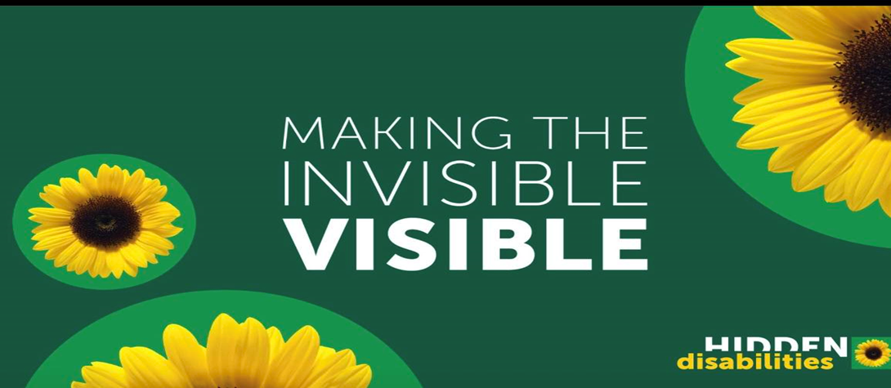
YouTube of our advocacy and interviews to promote the sunflower linear and article: From silent struggles to global autism advocacy and campaign for SA
Podcast interview with Joi Ito: Part 1- https://youtu.be/ZwmPy9msV6g
Part 2: https://youtu.be/Hk_BW9Zpyxs
Part 3: https://youtu.be/6pn9OltVvio

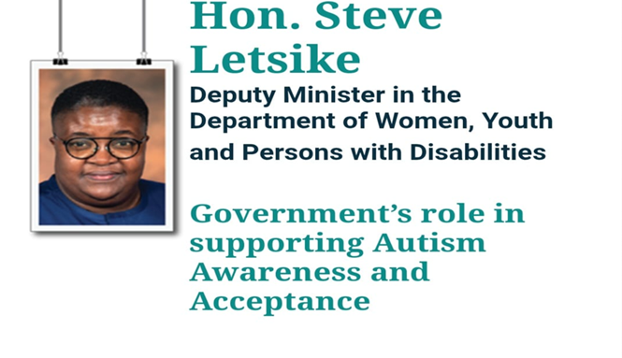
YouTube of the event:DEPT OF INCLUSIVE EDUCATION SEMINAR

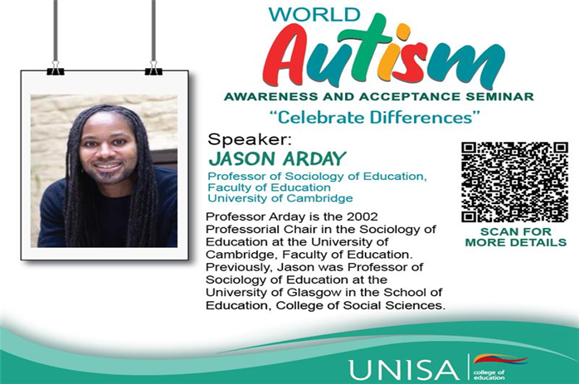

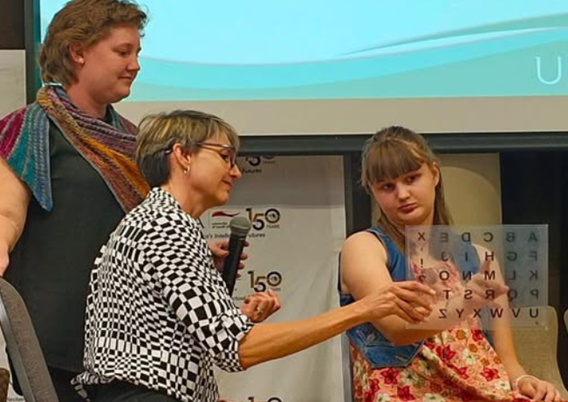

4.4 Communication and Accessibility Barriers
• Inadequate use of AAC, easy-read materials, and plain language.
• Meetings and consultations that are inaccessible to non-speakers or those with processing differences.
• Time pressures that disadvantage neurodivergent communication styles.
• Organising a world AAC conference for non-speakers in Ireland late 2026 Advocacy for a United Nations Special Rapporteur on Autism In 2025, a key international advocacy priority was my call for the establishment of a United Nations Special Rapporteur on Autism. This initiative responds to the continued global marginalisation of autistic people, particularly in the Global South and low- and middle income countries, where access to education, healthcare, employment, protection from discrimination, and reasonable accommodation remains limited and uneven. I formally wrote to the Minister in the Department of Women, Youth and Persons with Disabilities (South Africa) requesting government support for the creation of a dedicated Special Rapporteur mandate. The proposal is grounded in the recognition that autism specific human rights issues are often diluted or overlooked within broader disability frameworks, resulting in weak monitoring and limited accountability.

The initiative has received confirmed support from:
• Five African governments
• The World Bank
• The Autistic Self Advocacy Network (ASAN)
With this support, a formal letter was submitted to the United Nations calling for the establishment of the mandate. To advance the proposal, 35 formal endorsements from governments worldwide are required. Once this threshold is reached, the matter can be formally tabled for discussion at UN level. A follow-up meeting is planned for 2026, where next steps toward the establishment of the Special Rapporteur will be considered.
The proposed mandate aligns directly with the United Nations Convention on the Rights of Persons with Disabilities (UNCRPD), particularly:
• Article 4 (General Obligations)
• Article 5 (Equality and Non-Discrimination)
• Article 24 (Education)
• Article 27 (Work and Employment)
• Article 33 (National Implementation and Monitoring)
Establishing a UN Special Rapporteur on Autism would strengthen global accountability, elevate lived-experience expertise, and ensure sustained international attention to the rights and dignity of autistic and neurodivergent people worldwide.

Conclusion In light of the progress made during 2025 and the critical work that lies ahead in 2026, I respectfully express my commitment and wish to continue serving on the CDPF Board as the representative of underrepresented groups. Continuity in this role is essential to sustain momentum, strengthen Global South leadership, and ensure that the voices of autistic people, neurodivergent individuals, and persons with learning disabilities remain central to international disability governance and accountability processes.

Indigenous Peoples with Disabilities in the Commonwealth Diethoro Nakhro Indigenous Peoples Representative, CDPF
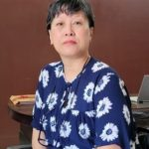
An estimated 54 million Indigenous people live with disabilities globally, with a significant proportion living in Commonwealth nations. Yet Indigenous Peoples with disabilities are among the most marginalised and least represented groups within both disability and Indigenous rights movements. The lasting legacies of colonialism, systemic discrimination, socio-economic exclusion, and geographic isolation continue to intersect with disability, leading to cumulative disadvantage and persistent invisibility.
Key Aspects of the Experience of Indigenous Peoples with Disabilities
High Prevalence and Structural Disadvantage: Indigenous Peoples experience disability at significantly higher rates, often double the national average than non-Indigenous populations. This disparity is not a biological inevitability but a direct consequence of structural inequities, including systemic poverty, inadequate and inaccessible healthcare in remote regions, environmental degradation, and the intergenerational trauma of dispossession.

Intersectional Discrimination: There are layered and intersecting forms of discrimination experienced by Indigenous people living with disabilities based on disability, Indigeneity, and, for women and gender-diverse persons, gender. These intersections heighten vulnerability to violence, social exclusion, and economic marginalisation, and also limits access to justice, education, and livelihoods.

Systemic and Institutional Exclusion: Lack of disaggregated, culturally relevant data on disabled Indigenous people contributes to underdiagnosis, misdiagnosis, and inappropriate or ineffective interventions. Indigenous persons with disabilities are disproportionately represented among populations living in poverty while also being overrepresented in criminal justice systems, child protection systems, and institutional care settings across many Commonwealth countries.

Colonial Legacies and Intergenerational Trauma: Ongoing trauma arising from colonisation, land dispossession, forced assimilation, and the erosion of Indigenous governance systems continues to manifest in higher rates of psychosocial disability. These legacies also limit access to culturally grounded healing practices and community-based support systems, further entrenching exclusion.

Misalignment of Western Disability Models with Indigenous Worldviews: Dominant Western models of disability, rooted in medicalised, deficit-based, and individualised frameworks, tend to be at odds with Indigenous understandings of disability, which are relational, collective, and deeply embedded within community, land, culture, and spirituality. These models frequently pathologise difference, marginalise traditional knowledge systems, and overlook Indigenous concepts of wellbeing and belonging, resulting in policies and services that are culturally unsafe, ineffective, or actively harmful. These challenges are further compounded by climate change, environmental degradation, and displacement, alongside limited access to culturally safe, community-led disability supports in many regions.

While many Commonwealth states have adopted rights-based disability frameworks aligned with the UN Convention on the Rights of Persons with Disabilities (UNCRPD), these frameworks often fail to adequately recognise Indigenous identities, collective rights, cultures, and knowledge systems. Indigenous disabled people remain largely excluded from policy design, leadership roles, and decision-making spaces, and their lived realities, shaped by colonial histories and Indigenous worldviews, are rarely reflected in national disability strategies.

India: Emerging Movement-Building Efforts India is home to one of the largest Indigenous populations globally, constitutionally recognised as Scheduled Tribes and afforded specific protections under the Constitution of India. However, despite this recognition and the presence of progressive disability legislation under the Rights of Persons with Disabilities (RPwD) Act, 2016, Indigenous persons with disabilities remain largely invisible within the disability sector.

At present, India does not have a strong or cohesive Indigenous Peoples’ movement within the disability space. Indigenous disabled people are underrepresented in national disability platforms, policy consultations, and leadership structures, while disability-related concerns remain marginal within broader Indigenous and tribal movements. Structural barriers, including geographic remoteness, linguistic diversity, poverty, limited access to education and healthcare, and weak institutional outreach, continue to constrain participation and inclusion.

Recognising these gaps, efforts are underway to connect with disabled tribal leaders and advocates across various tribal regions of the country, with the aim of strengthening relationships and building a collective Indigenous disability network. In July 2025, a Regional Consultation on Rights of Indigenous Peoples in Northeast India in Imphal in the state of Manipur. North East India is a region with a high concentration of ethnic tribal communities.

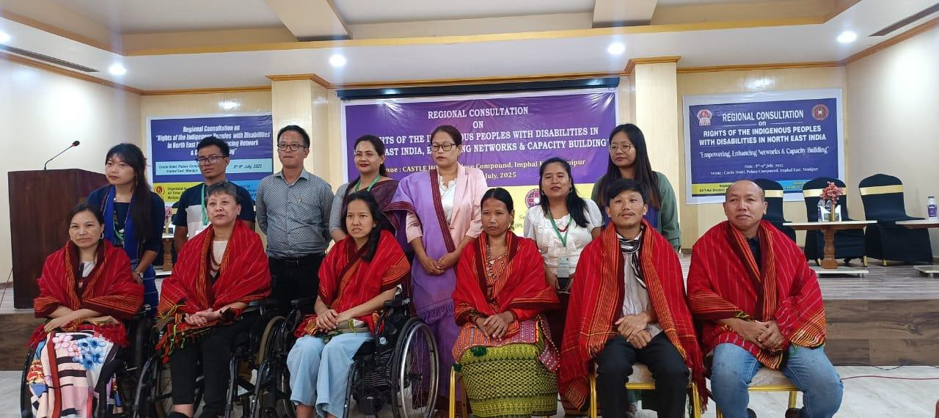
(Regional Consultation on Rights of Indigenous Peoples with disabilities in Northeast India)

The dialogue created a critical space to examine the lived realities of disabled Indigenous people, including access to services, cultural perceptions of disability, intersectional discrimination, and the absence of representation within both Indigenous and disability governance structures.
(Regional Consultation on Rights of Indigenous Peoples with disabilities in Northeast India)

The immediate goal is to strengthen this emerging pan-India network and formalise advocacy efforts, transitioning from isolated voices towards a collective and representative Tribal Disability Forum.

A Call to Action
The path to true inclusion requires a fundamental shift from viewing Indigenous disabled people as passive recipients of aid to recognising them as powerful agents of change. We cannot achieve the goals of the 2030 Agenda for Sustainable Development if we continue to leave behind those at the intersection of indigeneity and disability. To rectify historical exclusions, urgent action is needed in:
- Investing and prioritising funding for autonomous Indigenous disability leadership and the expansion of grassroots networks, such as our growing tribal disability movement in India.
- Developing dedicated Indigenous disability frameworks that harmonise the UN Convention on the Rights of Persons with Disabilities (CRPD) with the UN Declaration on the Rights of Indigenous Peoples (UNDRIP), moving away from Western-centric medical models toward culturally safe, holistic systems of support.
- Guaranteeing that Indigenous disabled people have a "seat at the table" with mandated representation in all local, national, and Commonwealth-level decision-making forums.
- Supporting Indigenous-led research to close the data gap, ensuring that the unique socio-economic realities of tribal communities are accurately reflected in policy. The motto "nothing about us without us" is only possible when our cultural identity and our lived experience of disability are respected as equal parts of our humanity. The time for rhetoric has passed; the time for systemic investment and genuine partnership is now.

CDPF GENERAL ASSEMBLY 2025
To all delegates to the virtual General Assembly of the Commonwealth Disabled Peoples Forum February 2025 The Executive are asking you to vote to adopt the New Constitution of CDPF.
We do not have the capacity or time or space to amend the constitution document. So we are calling on all delegates to vote for the constitution in its entirety.
If you do not vote, abstain or vote against it will count against the two thirds of all member organisations we need to carry this.

The Board and Executive will produce a clearer exposition of rules and procedures in the near future once this constitution is adopted. This constitution is to enable us to become a Charitable Incorporated Organisation in the UK.
Because it has taken longer than anticipated the deadline for return f your ballot paper is midnight GMT on Wednesday 12th February. The result will be announced at the virtual General assembly meeting on Friday 14th February 11 am to 3 pm GMT
Zoom

Commentary on New Constitution
To be adopted our current constitution requires a two-thirds vote of all eligible member organisations to vote for. This means as of January 2025, on current voting 49 Full Associations x 2 votes plus the Commonwealth Disabled Youth Forum =100 votes and 51 Associates
This gives a total of 151 possible votes of which we need 103 votes in favour for the New Constitution to be received and voted by e mail for it to be to be adopted.

The main reasons we are now wanting you to adopt a New Constitution
The Executive in July 2024 decided to become a Charitable Incorporated Organisation (CIO) registered with the English Charity Commission. Working with Third Sector Law, our solicitors, we have checked that our Preamble and objects will be accepted as charitable which they think is the case. [Clause 3,4 and 5). We have added 5i to promote sustainable empowerment programmes for disabled women, youth, LGBTQA+ and disabled indigenous people. The main reasons for becoming a CIO are because we have now decided to become organisationally separate ourselves as an organisation from ADD International Ltd who since 2019 have been our fiduciary partner, providing administration, accounting and managing our income and expenditure. This was because when we re-established CDPF in New York in June 2019 we had no track record of doing these things and so our funder, the Disability Rights Fund required CDPF to do this.

Now CDPF has a track record of innovative, effective work, has grown in influence and organisation and profile and we now have a prospect of direct funding of our core activities and work on an ongoing basis from UK FCDO. Our funder and the Executive want now to be able to establish our own bank account, accounts and audit; to attract more funding for more projects. Our relationship with ADD will change to them being a service provider for CDPF
Registering as a CIO [Charitable Incorporated Organisation] CDPF will gain the following advantages:
- Greater credence with and confidence from potential funders.
ii) Tax relief on donation from the UK
iii) Security in that our governance, accounts and funding and operations will be scrutinised by the Charity Commission.
The Officers group (comprising all elected officers) has been meeting in between our Executive meeting and has proved a more efficient way of governing CDPF operations.
In order to become a registered CIO there are the big changes that will be found in the new draft constitution.
I .CDPF must have Annual General Assembly of members which can be electronic/virtual or face to face.
II. CDPF need a Board of Trustees who are responsible for oversight of the operations of CDPF. (These will be Officers elected by General Assembly, ensure at least 1 rep of each of 5 regions amongst them with up to three disabled people from UK)
III CIOs must have a lot more regulations in their constitutions, than CDPF currently have in the CDPF constitutions developed and adopted in 2008, 2019 and 2022.
[ These are required by Charity Law :
5. Further Powers of CIO;
6. Application of income and property;
7. Benefits and payments to Executive and connected persons i.e Trustees
8.Payment for supply of goods and services;
9.Conflicts of Interests and loyalty;
10. Liability of members (no liability if wound up);
11. Membership of CIO(CDPF) [ This has incorporated Focal points for countries which we to now have not formally operated and then the same categories of membership we have currently with their rights]
12 Admission New Members
13 Admission Procedures
14 Membership Fees [Not coming into force until GA 2026 propose sliding scale. And Associate pay 5 years in one go to save bank charges].
14 Members decisions
15 Decisions taken in a particular way
16 General Assemblies Types [some may be AGM other may be called by Members, Exec or Board]
17 Quorum Gen Assemblies [10% or 25 members]
19 Voting at General Assemblies
20 Defines Board, Executive and Officers
Board will be i/c legally [Max 17 members All Officers and possible ensure at least 1 rep from each region and coopt up to 3 additional members disabled residents UK wilth public profile.]
Executive Committee [ Explains composition This includes 3 new Officer posts and Gen Sec now non-voting]
Officers and Secretariat Lists Officers [Three new Ass Gen Sec positions are new as is the possibility of Job sharing positions subject to agreement of the Board]
Functions and Duties
21 Eligibiility for trustees and Executive
22 Number of Board Members [Max 17 min 3 elected for 5 years and re-election 1year thereafter]
23 First Executive Committee [ applies if starting from scratch. Listed as Appendix 1]
24 Appointment of Officers and Executive [Chair and Vice Chairs 5 year then followed by cycle reelected Exec 2 year followed by another term
25 Elected Executive [ One third retire at each annual Gen Assembly based on how long in office by rotation. Others may stand . If contested then an election]
26 Info for New Board/Executive
27 Retirement and removal from the Board
28 Reappointment of Board
29 Taking decision by the Board
30 Delegation by Board to Executive sub-committees
31 Meetings and proceedings of the Executive [quorum of 10, Chairing, calling meetings, electronic meetings]
32 Execution of documents [signature , 2 Exc members]
33. Use of Electronic communications
34 Keeping Records
35 Minutes
36. Accounting records, accounts, annual report and returns , register maintenance
37 Rules
38 Disputes
39 Amendments of constitution
40 Voluntary winding up
41 Interpretation
Appendix1 use electronic communication
Appendix 2 List of First Trustees.
In the new constitution are a series of changes initiated by the CDPF Executive when they met face to face in Kenya from 8th to 12th July 2024. 19 members were present and unanimously agreed to make these changes and will be open to change and fine tuning once we are a CIO.
1.Voting at General Assemblies. In order to give more equal weight to Full member organisations whether they represent a small or large population, they should have equal weight. So currently each full member organisation being a cross impairment national umbrella group, comprising a majority of disabled people and run and controlled by a majority of disabled people. Has 2 votes. The new constitution increases that to 3 votes/delegates.
DPO Associates that are single impairment national, or of disabled women or youth or cross impairment but less than 50% of their country are DPO Associates and they continue to have 1 vote and delegate to general assemblies.
The Executive in putting this forward hope to get a wider representation amongst Officers elected by the whole general assembly. The representation of areas of more population is contained in the varying numbers of regional representative i.e. South Asia and Malaysia (4), Africa including Nigeria (4), Pacific 1, Caribbean 1 and Australia, Canada Malta, New Zealand and UK (1).
Cooptions The newly elected General Assembly can then coopted up to 7 extra members to cover underrepresented geographic, impairment or social group areas. The Executive can also coopt a further 4 people with expertise to help sub committees knowledge.
The Board will comprise the 14 elected Officers, the General Secretary as non-voting member and up to 3 disabled people resident in the UK. With a public profile. This will be the legally registered board with the Charity Commission and have overall responsibility for CDPD COI. It can delegate most of its work at its discretion to the Executive.
The Annual General Assembly will have to meet each year required by Charity Commission. Rotation of terms of office and eligibility for re-election by General Assembly Formalise that regional members of Executive are chosen at the General Assembly by regional caucuses of all organisation General Assembly delegates in the region. Three new Officers Assistant Sec Membership, Administration and London Liaison. A Job currently filled by Gen Sec. Officer positions can be job shared with consent of the Board,but only have 1 vote.

See New Adopted Constitution 2025 on website. https://commonwealthdpf.org/wp-content/uploads/2026/02/Constitution-of-CDPF-CIO-adopted-14th-February-2025.docx

Ballot for Adoption of New Constitution of CDPF
DECLARATION.
Registered Delegates entitled to vote 133
Voting Yes 119
Voting No 2
Not Voting 12
Majority of delegates Adopting New Constitution 89.4%
Total number of members
Member not registered 3 Full Members 6 votes
9 Associates with 9 votes
Percentage vote of all registered members
Yes 119 / Not registered/Not Voting of No 29
Majority 74.87% in Favour
Martha Aldridge Retuning Officer
Endorsed by General Secretary Richard Rieser 13th February 2025

We are still waiting for approval as a CIO from Charity Commission
CDPF General Assembly 14th February 2025
CDPF held a virtual Special General Assembly during which an e ballot was held adopting a new constitution. [by 74% of delegates of member organisations voting Yes, only 2 votes against and rest non-engaged or voting, counting as abstentions which on a vote of all members count against], This will allow CDPF to become an Incorporated Charity Organisation in the UK. See Results
70 delegates from 33 Commonwealth countries attended on line. We adopted a work plan for 2025/26 which will consolidate the organisation and continue with our representation of the issues prioritised by disabled people/people with disabilities across the Commonwealth. Our main focus will continue to be capacity building, building our disabled women’s forum and Commonwealth Disabled Youth Forum and helping to get Commonwealth member countries to more effectively implement Disability Rights. See Work Plan
Our Annual Report for 2024 was adopted, which you may find of interest as iut maps our many varied activities in the last year. See Windows or PDF version
In addition three motions were passed at the meeting which had 87 delegates from our member organisations across the Commonwealth :-
i) On the Commission on the Status of Women, due in March, which we would like Commonwealth support to get greater involvement of disabled women/women with disabilities and allow amendments from grass-roots organisations of women. Com Sec .has been most supportive in supporting CDPF Women’s Forum and getting delegates to the CSW.
ii) The cut in USAID calling on donor countries-in Commonwealth and beyond to club together to make up the shortfall and work strategically to tackle inequality which policy CDPF would like the Commonwealth to adopt in action in various world fora and across the Commonwealth and members to propose to their Governments
iii) The Path to Disability Inclusion across the Commonwealth in which we praise progress at CHOGM24 and since in setting up the High Level Advice Group and DPO advisors and a Government representatives group. This motion also calls for one of the themes of CHOGM 2026 to Disability Inclusion we hope the Members can support this thinking and approach their Governments.

Outcome of Ballot for 2 Assistant Secretary Posts
Abia Akram | 57 votes x Elected
Saista Parwin | 48 votes x Elected
Setaraki Macanawai | 28 votes
Jonas Lubago | 26 votes
Masauso Ngoma | 26 votes
Total votes cast 185

Resolution on President Trumps Freeze on Public Expenditure including USAID.
“This Special General Meeting of the Commonwealth Disabled People’s Forum calls on the US President to withdraw a highly damaging policy to disabled people in USA and world wide, which is likely to end decades of progress of advancing the rights and inclusion of disabled people [people with disabilities].
Trump when launching the policy of the Federal Office of Management and Budget on 27th January 2025, stated:
“We are rooting out waste. We are blocking woke programmes and exposing activities that run counter to the national interest.”
This led to an immediate freeze on services and payments to over 70 million US citizens with disabilities and a dramatic impact on the Foreign Assistance budget of $60
billion dollars with a 90 day freeze. Only a tiny fraction of this through USAID goes directly to disability projects ($30 million in 2023), a much larger part goes through the State Department to disability friendly projects. All is now stopped with an uncertain future. Laws will in time replace current ones to make it much harder to challenge legally.
The freeze has been several times struck down by federal judges as unlawful.(e.g. 4th February) However, the measures clearly represent a clear and present danger to disabled people across the US and in the 130 countries that receive aid from the State Department (State Department guidance on Inclusion of Disability in Foreign Aid) and USAID Disability Policy is now taken down from website and all projects worldwide ae frozen
Hundreds of Disability Projects have been frozen in Commonwealth countries, for example Inclusion Development Partners which support Inclusive Education in Jamaica, Bangladesh, Lesotho, Malawi, Nigeria, Rwanda, Sierre Leone and Tanzania.
While it is true the USA is one of very few countries not to ratify the UNCRPD, successive Presidents and Governments including Trump (1st term) have supported the principle of equality for persons with disabilities.
As was clearly demonstrated when Trump attacked equal employment policies of hiring disabled air traffic controllers, without any proof as the cause of the Washington DC airport crash killing 67 people Washington Post 2nd February . Trump is quoted as saying previously that he is of the view disabled people should just die.
CDPF therefore calls on all Governments and especially other donor countries to:
a) Put pressure on US Government to permanently withdraw the blanket budget cuts to USAID, especially disability aid projects through all forums including the United Nations
b) In the event of no restoration to pool together their resources to make up the shortfall
c) To make clear supporting disabled people to gain equality and challenge discriminatory practices is not a fashion or ’woke’, but a fundamental human rights issue.
d) Though many doner country projects still give money to intermediaries rather than organisations run and led by disabled people and do not employ sufficient disabled people, this is an argument to reform these aid systems rather than stopping them.

Statement from the Commonwealth Disabled People’s Forum (CDPF) on the Commission on the Status of Women 2025
“On behalf of the Commonwealth Disabled People’s Forum(CDPF) as brought to our attention by our Women’s Forum, we express our deep concern regarding the absence of a specific paragraph addressing women and girls with disabilities in the Zero Draft for the 69th session of the Commission on the Status of Women (CSW69) and the proposed Multi-Year Program of Work for the Commission on the Status of Women.
This omission undermines the Commission's commitment to achieving gender equality, empowering all women and girls, and ensuring no one is left behind, as outlined in key frameworks like the Beijing Platform for Action and the 2030 Agenda for Sustainable Development.
The lack of inclusion of women and girls with disabilities poses significant risks to the overall goals of the Commission on the Status of Women. It fails to address intersectional discrimination, as women and girls with disabilities face compounded discrimination due to their gender and disability status. Ignoring their unique challenges creates a gap in addressing intersectionality, a principle central to achieving meaningful gender equality.
Furthermore, this exclusion undermines inclusive development by limiting their access to education, employment, healthcare, and social protection systems, contradicting commitments to universal access and equitable opportunities. The omission also results in missed opportunities for leadership and political participation. Disabled Women and girls are vital agents of change who can contribute significantly to leadership, innovation, and decision-making processes. Failing to include them in the Commission's agenda diminishes their potential contributions.
Additionally, the draft inadequately responds to structural barriers, highlighting issues such as poverty, violence, attitude and discriminatory practices without acknowledging how these disproportionately affect women and girls with disabilities. Data collection efforts are compromised as the draft calls for disaggregated data collection by various factors but does not emphasize disability as a critical category. This oversight limits the ability to plan for disability inclusion, monitor progress effectively or design evidence-based interventions.
Moreover, the omission weakens global commitments, contradicting frameworks like the Convention on the Rights of Persons with Disabilities (CRPD) and Sustainable Development Goals (SDGs), which emphasize inclusivity and equality.
To address these concerns and uphold its mission, we urge the Commission to take several actions. First, it must include a specific paragraph addressing the rights, needs, and empowerment of women and girls with disabilities in the final draft. Disability should be addressed in all aspects/sectors throughout the document, considering the impact of all proposed actions on this group.
The Multi-Year Program of Work should incorporate disability-specific considerations, ensuring that each priority theme explicitly addresses the situation of women and girls with disabilities.
Furthermore, the Commission should commit to meaningful consultation with organizations of women with disabilities/disabled women and girls in all stages of policy development and implementation.
Data collection efforts should mandate disaggregation by disability status alongside other demographic factors.
Explicit references to women and girls with disabilities should be included in priority themes, review themes, and the multi-year work program.
The CDPF Women’s Forum stands ready to contribute our expertise and lived experiences to strengthen the inclusivity and effectiveness of the Commission's work. We believe that by addressing these concerns, the Commission can truly fulfill its mandate of promoting gender equality and empowerment for all women and girls, leaving no one behind.
Only through these comprehensive measures can the Commission ensure that its goals are met inclusively and that the rights and needs of women and girls with disabilities are fully recognized and addressed in its important work for them to participate on an equal basis with others.
We call upon the CSW Secretariat, UN Women, and member states to:
- Ensure Full Inclusion: Guarantee the active participation of women with disabilities in all discussions, negotiations, and decision-making processes within CSW 2025.
- Reinstate Key Amendments: Address the concerns of grassroots women’s organizations and incorporate necessary amendments that uphold the rights of women and girls with
disabilities.
- Promote Intersectionality: Recognize the unique challenges faced by women with disabilities and ensure disability inclusion in all gender-related policies and frameworks.
- Strengthen Grassroots Involvement: Provide accessible platforms for grassroots organizations, particularly those led by women with disabilities, to contribute to CSW
discussions and outcomes.
- Address Regional Disparities: Implement targeted strategies to support women with disabilities
e.g. in South Asia by improving access to education, economic opportunities, and legal protections against discrimination and violence”.

CDPF Women’s Forum continued to meet through the year at regular intervals .
Statement from the Commonwealth Disabled People’s Forum (CDPF) Women’s
Forum on the Commission on the Status of Women 2025
As women and girls with disabilities continue to face multiple and intersecting forms
of discrimination, their voices must be central in shaping global gender policies and
commitments. On behalf of the Commonwealth Disabled People’s Forum(CDPF) as
brought to our attention by our Women’s Forum, we express our deep concern
regarding the absence of a specific paragraph addressing women and girls with
disabilities in the Zero Draft for the 69th session of the Commission on the Status of
Women (CSW69) and the proposed Multi-Year Program of Work for the Commission
on the Status of Women.

This omission undermines the commitment to achieving gender equality, empowering all women and girls, and ensuring no one is left behind, as outlined in key frameworks like the Beijing Platform for Action and the 2030 Agenda for Sustainable Development.

The lack of inclusion of women and girls with disabilities poses significant risks to the
overall goals of the Commission on the Status of Women. It fails to address
intersectional discrimination, as women and girls with disabilities face compounded
discrimination due to their gender and disability status. Ignoring their unique
challenges creates a gap in addressing intersectionality, a principle central to
achieving meaningful gender equality.

Furthermore, this exclusion undermines inclusive development by limiting their
access to education, employment, healthcare, and social protection systems,
contradicting commitments to universal access and equitable opportunities. The
omission also results in missed opportunities for leadership and political participation. Disabled Women and girls are vital agents of change who can contribute significantly to leadership, innovation, and decision-making processes.Failing to include them in the agenda diminishes their potential contributions.

Additionally, the draft inadequately responds to structural barriers, highlighting issues
such as poverty, violence, attitude and discriminatory practices without
acknowledging how these disproportionately affect women and girls with disabilities.
Data collection efforts are compromised as the draft calls for disaggregated data
collection by various factors but does not emphasize disability as a critical category.
This oversight limits the ability to plan for disability inclusion, monitor progress
effectively or design evidence-based interventions.

Moreover, the omission weakens global commitments, contradicting frameworks like
the Convention on the Rights of Persons with Disabilities (CRPD) and Sustainable
Development Goals (SDGs), which emphasize inclusivity and equality.
To address these concerns and uphold its mission, We call upon the CSW
Secretariat, UN Women, and member states to:

● First, include a specific paragraph addressing the rights, needs, and
empowerment of women and girls with disabilities in the final draft. Disability
should be addressed in all aspects/sectors throughout the document,
considering the impact of all proposed actions on this group
● Ensure the Multi-Year Program of Work should incorporate disability-specific
considerations, ensuring that each priority theme explicitly addresses the
situation of women and girls with disabilities.
● Commit to meaningful consultation with organizations of women with
disabilities/disabled women and girls in all stages of policy development and
implementation.
● Data collection efforts should mandate disaggregation by disability status
alongside other demographic factors.
● Explicit references to women and girls with disabilities should be included in
priority themes, review themes, and the multi-year work program.
● Promote Intersectionality by recognizing the unique challenges faced by
women with disabilities and ensure disability inclusion in all gender-related
policies and frameworks.
● Strengthen Grassroots Involvement by providing accessible platforms for
grassroots organizations, particularly those led by women with disabilities, to
contribute to CSW discussions and outcomes

The CDPF Women’s Forum stands ready to contribute our expertise and lived
experiences to strengthen the inclusivity and effectiveness of the work. We believe that by addressing these concerns, the Commission can truly fulfill its mandate of promoting gender equality and empowerment for all women and girls,
leaving no one behind.

Only through these comprehensive measures can the Commission ensure that its
goals are met inclusively and that the rights and needs of women and girls with
disabilities are fully recognized and addressed in its important work for them to
participate on an equal basis with others. The CDPF Women’s Forum urges all stakeholders to take immediate action to uphold the principles of equality, non-discrimination, and full participation. Without the voices of grassroots women and women with disabilities, gender equality efforts will remain incomplete and ineffective

Commonwealth Disabled People’s Forum (CDPF) Women’s Forum Date: 7th
February 2025

Commonwealth Scholarship
CDPF is a partner with Commonwealth Scholarship Commission in recommending disabled candidates who meet both CSC criteria and CDPF additional criteria to be considered for a scholarship. Each year 5 senior Officers read and score applicants against agreed criteria to get a shortlist of 10 for Masters and 5 for Phd’s.

Criteria Geographic spread, Gender Equality, have an impairment and meeting our Disability Criteria. A) Demonstrate understanding of Reasonable Accommodation B) Involvement in Campaigning for Disability Rights C) Study relevance to Disabled People, D) Impact on Disabled People of what propose to do after return.

Scholarship Selection and Review
- Summary of recent Commonwealth Scholarship selection: large number of applications, most from Nigeria and Pakistan, but little from Caribbean or Pacific.
- Frustration noted that CDPF recommendations are not strongly weighted by the Scholarship Commission, reducing the impact of this time-consuming process.
- Plan to negotiate with the Commission on future process and funding for involvement; possibility of switching to an advisory/consultancy model.
2026 Selected Recommendations for 10 Masters candidates from Long List 62 and 5 PhDs from Long list 26 for 2026.
2025 10 Masters Recommended 3 successful, 1 Reserve and 1 Deferred. 5 PhDs nominated none successful.

Budget
1.Budget 2024/25 and 25/26

 |  |  | notes
Running costs/admin/salaries | 2024/25 | 2025/26
Gen sec + assist + printing and Other etc | 32500 | 45000
Admin Data | 7200 | 9000
Website | 2000 | 3000
ADD Administrator | 15000 | 16000
ADD finance (incl extra) | 15000 | 14000
Lawyers | 0 | 3000
Registation fees | 0 | 2500
Auditing | 0 | 2500
Contingency & Social media |  | 5000
Activities
Regional desks/interns |  | 6120 | (current year topped up from  previous year)
Access for all meetings (and travel to EC) | 86.000 | 30000
Caribbean training |  | 40000
Pacific training |  | 40000
Dev'g women & girls project | 20,000 | 30000 | some left already 2024
Training governments | 15,000 | 6000 | some left already 2024
 | 278300
Forums and subgroups (running costs)
Youth | 0 | 10000
Women | 0 | 10000
Environment etc (4) | 0 | 10000
in person representation and travel
GDS Berlin |  | 5000
UN |  | 10000
COP – Brazil COP |  | 6000
Fiji 2026 CLMM |  | 9000
total
Total | 350000 | 292120
Budget | 350000 | 320000
Difference/contingency |  | 2880
Agreed.

2.USD balances on the old DRF grants
CDPF 3 DRF grant - ended in 2023
 | Grant amount | Expenditure | Balance
Grant Number: 21-155 (GDS18 grant: USD 75,000.00) | $75,000 | $74,861 | $139
Grant Number: 21-156 (OPD Strengthening grant: USD 5,000.00) | $5,000 | $402 | $4,598
Total Grant USD: $80,000 | $80,000 | $75,263 | $4,737
CDPF 4 DRF grant - ended in 2024
Grant Number: 47593834 | Grant amount | Expenditure | Balance
Global Disability Summit (GDS) USD: $90,000 | $90,000 | $93,674 | -$3,674
Core Support USD: $20,000 | $20,000 | $3,686 | $16,314
Total Grant USD: $110,000 | $110,000 | $97,360 | $12,640
CDPF 5 FCDO grant via DRF - ended in 2025
Grant Number: 63775147 | Grant amount | Expenditure | Balance
Total Grant USD (original amount) | $375,255
Extra £50,000 awarded | $64,545
Total Grant USD: USD 439,800 | $439,800 | $400,522 | $39,278
 | TOTAL LEFT |  | $56,655

3. Commonwealth Disabled People's Forum - Grants Financial Report for the Year Ended 31 December 2025
Grant | Donor | Opening Balance at 1 Jan 2025 | Income Received (2025) | Total Expenditure (2025) | Closing Balance at 31 Dec 2025
Conference of State Parties on the UN Convention | Commonwealth Secretariat | 1,960 | - | - | 1,960
CDPF Scholarships | Commonwealth Scholarship Commission | - 440 | 2,800 | 2,360 | -
CDPF 3 - 2022 grant | Disability Rights Fund | 3,969 | - | - | 3,969
CDPF 4 - 2023 grant | Disability Rights Fund | 15,034 | - | 5,140 | 9,894
CDPF 5 - 2024 grant | Disability Rights Fund | 167,221 | - | 136,126 | 31,095
 | Disability Rights Fund Total | 186,224 | - | 141,266 | 44,958
CDPF 6 - 2025 grant | FCDO | - | 146,000 | 137,355 | 8,645
Total |  | 187,744 | 148,800 | 280,981 | 55,563
Budget and Expenditure 2025/26.
The Disability Right Fund administrered the remains of a grant to CDPF until end March 2025. The delay from UKFCDO meant we did not have access to their grant until July 2025. We are very grateful to both organisations to their support and funding to CDPF in 2025.
CDPF were informed on 13th March that our expected grant from UKFCDO may not be forthcoming as UK Government had decided to cut overseas aid by 40% to increase expenditure on armaments. We were also told because we were transferring from a grant from Disability Rights Fund (provided indirectly by UK Government) to a direct grant from UKFCDO this was being treated as a new project. We demonstrated that the funding stream was one we had had since 2019.
A formal letter was sent to UK FCDO requesting release of funds; a positive reply has been received from Daryl Lloyd confirming the £300,000 grant
The revised budget cycle began on 1st July, but:
• Costs can only be incurred from 9th July onwards.
• We got permission from DRF to spend money left over from 24/25 on the period April to July.
• Only invoices and work completed after 9th July will be eligible for reimbursement.
• In October we asked for and got a further £20,000 due to the inflated cost of airfares found in Caribbean and Pacific for 2 trainings running.
Partnership with ADD International
The next tranche of funding from FCDO has been approved. We have drawn up a new agreement with ADD International, affirming the continuation of a successful six-year partnership. The new agreement with ADD needs to be agreed put in place to reflect this ongoing relationship. As part of this process, it has been proposed that Sarah and Kerryann, in their roles as Chair and Vice Chair, will sign the agreement on behalf of CDPF.
In preparation, a number of key policies have been circulated (currently for ADD) will need to be reviewed and formally adopted at the next Executive Committee meeting. These include:
- Counter-terrorism and anti-corruption
- Whistleblowing
- Safeguarding
- Sexual harassment
- Code of conduct
- Conflict of interest all approved full Executive meeting on Thursday 28th August.
Future Funding
We were informed by UKFCDO that the expected continuance of our grant for 2026/27 would now not occur due to policy changes at UKFCDO. We appealed to Baroness Chapman Minister to change policy and restore grant one more year .This was turned down on 5th February 2026. CDPF is now in the position of seeking to get grants from a variety of sources.
We hope that we get Charity Status from UK Charity Commission soon to help with this.
Budget 1(p82) compares last years budget with current year’s budget.
Document 2
This tracks previous three grants from Disability Rights Fund and shows we have $56,665 that we will use as a reserve to bridge to new funding
Document 3 Shows Total Expenditure for £209,981.
In January 2026 the second payment was received from UKFCDO and we will also be able to use remainder of £171,200 once outgoings for 2025/2026 have been paid, also to bridge CDPF to new funding . We estimate this will meet our running costs through to September 2026.
Our accounts are audited as part of ADD ltd as they hold our funds as fiduciary partner.
Scader Louis Treasurer.

