**Commonwealth Secretariat** **and Commonwealth Disabled People’s Forum Joint Meeting**

**Strengthening resilience in emergencies and climate change through enhancing disability inclusion in the Commonwealth**

**Tuesday June 10 2025, 10:00am - 11:15am**

**Room 4 (In Person and Webcast)**

The overarching objective is to raise awareness and share best practices on opportunities and challenges, to strengthen resilience through ensuring the active and informed participation of disabled people in the development of legislation and policy related to emergencies and climate change.

**Specific objectives are to:**

* **Discuss obstacles encountered by persons with disabilities in participating in policy and legislative processes related to emergencies and climate change.**
* **Share effective means of facilitating inclusive and participatory policy development and implementation of programmes related to emergencies and climate change.**
* **Exchange experiences, expertise and good practices in strengthening participation of persons with disabilities in the implementation of Article 11 of the CRPD.**
* **Underscore the importance of intersectional approaches to participation.**
* **Highlight meaningful engagement and collaboration between disabled people’s organisations and states in implementing Article 11 of the CRPD.**

**Facilitator** **Justin Pettit** Commonwealth Secretariat, Acting Head Human Rights

**Contributions:-** **Senator Andwele Boyce,** **Barbados**

**Sarah Kamau** Chair Commonwealth Disabled People’s Forum (CDPF) & UPD **Kenya**

Extracts from film **Rising Tides Rising Voices**-impact sea level rise in the **Pacific**

**Faatino Utumapu,** Nuanua O Le Alofa**, Samoa**, CDPF Exec.

**Patience Ogolo-Dickson**, Advocacy for Women with Disabilities Initiative (AWWDI) **Nigeria**, CDPF Exec. (filmed contribution)

**Clare Gibellini,** **Australian** Federation of Disability Organisations, CDPD Exec.

**Abia Akram** Special Talent Exchange Programme, **Pakistan** CDPF Exec. (filmed contribution)

**Rasanjali Pathirage**, Disability Organisations Joint Front **Sri Lanka**, CDPF Exec.

**Open Discussion**

**Richard Rieser** General Secretary CDPF**, Closing Words**

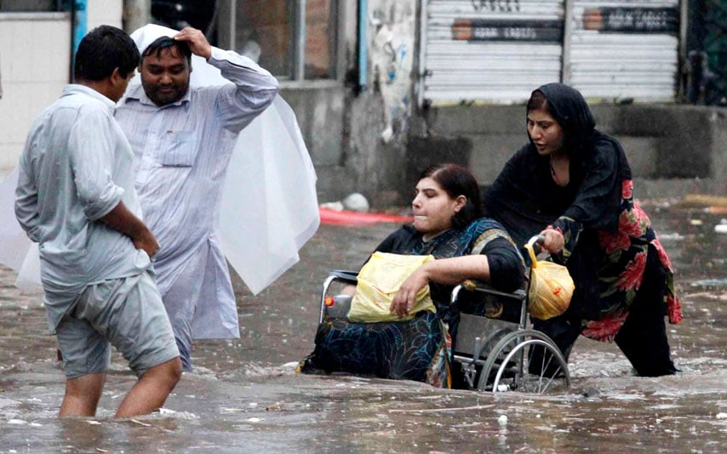

Pakistan Floods left; Many of the 85 who died in Los Angeles Fires were disabled people, right.