****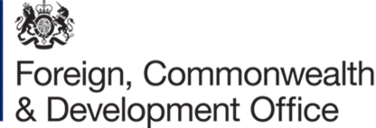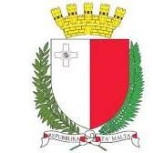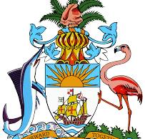

**Working to develop a unified approach to implementing the UNCRPD across the Commonwealth**

**Thursday 12th June 2025 4.45 pm Room 11 (In Person and Webcast)**

**Sponsor: The Permanent Mission of the Bahamas. Co-Sponsors: The United Kingdom Foreign, Commonwealth & Development Office, Malta Commission for the Rights of Persons with Disabilities & CDPF.**

The 56 countries of the Commonwealth comprise 2.7 billion people (including an estimated 430 million disabled people). All but one (Tonga) have ratified, but progress towards implementation of the rights, protections and ending of discrimination contained in the UNCRPD are extremely slow.

Last year the Commonwealth Disabled People's Forum (CDPF), which represent more than 100 OPDs/DPOs, including the Umbrella organisations in 50 countries of the Commonwealth, put forward a draft Commonwealth Disability Inclusion Action Plan (DIAP). The Heads of Government in Samoa, October 2024, while not adopting it, agreed to set up a High-Level Persons with Disabilities and their representative organisations Advisory Group to an Expert Working Group of representatives of the State Parties to achieve an agreed draft. This process is now underway. The agreed draft it is hoped will go to Commonwealth Law Ministers’ Meeting in Fiji for agreement, then to the Commonwealth Heads of Government Meeting in Antigua 2026 for agreement. If adopted the DIAP will kick start a wide range of measures and renewed interest in the rights of persons with disabilities, including sharing of expertise and experience across countries and implementation of key areas of the UNCRPD.

Up to date reports on progress and scope on this project will be given.

**Facilitator** - **Sarah Kamau**, Chair of CDPF from UPDP **Kenya,**

**Speakers -** **Hon. Myles Larada** Minister Social Services, Inf. & Broadcasting, **Bahamas**

**Rhoda Garland**, Commissioner for the Rights of Persons with Disabilities, **Malta**

**Representative** of Government of the **United Kingdom**

**Richard Rieser,** General Secretary CDPF

**Justin Pettit**, Commonwealth Secretariat

**Arman Ali** CEO NCPREDP, **India**

**Rasanjali Pathirage**, Disability Organisations Joint Front, **Sri Lanka**

**Senator** **Andwele Boyce**, **Barbados**

**Clare Gibellini, Australian** Federation of Disability Organisations

**Satareki Macanawai,** Chair Federation Disabled People’s Organisations, **Fiji**

Contributions from the floor.

For more information on DIAP[**https://commonwealthdpf.org/disability-inclusion-action-plan/**](https://commonwealthdpf.org/disability-inclusion-action-plan/)

**Attend If you are a Diplomat, Politician or Disability activist from a Commonwealth country.**

**Contact** [**CDPF-richard.rieser@commonwealthdpf.org**](mailto:CDPF-richard.rieser@commonwealthdpf.org)