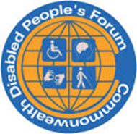
CDPF Special Newsletter
Commonwealth Disabled People’s Forum
Message from Global Disability Summit Berlin

CDPF Report on Global Disability Summit 3 Berlin 1st to 3rd April 2025.
The Summit was sponsored and organised by the German and Jordanian Government, with the International Disability Alliance (IDA).
There was a Civil Society Forum on the 1st of April with more than 500 DPO /NGO representatives attending. There was no discussion or means of altering the statement that had been drawn up by IDA organised Civil Society Reference Group beforehand, but it did reflect the outcomes of the 5 Regional Seminars. The day consisted of four panels with questions sent in by QR code. It was sterile and rather boring with no interactions.
5 Regional Summits had been held to shape the main outcomes and these were influenced significantly by OPDs/DPOs.
Asia 14-15th February, Bangkok
Latin America 9th-11th December, Rio De Janeiro
Arab 13th -14th November, Amman
Africa 5th September, Nairobi
Europe 6th December, Berlin
https://www.globaldisabilitysummit.org/regional-summits/
There was also a pre meeting on Inclusive Education held at Cambridge last September -https://www.inclusive-education-initiative.org/sites/iei/files/2025-02/Jan-2025%20Making%20GDS%202025%20Count%20-%20Pre-GDS%20Workshop%20Recommendations.pdf
https://www.globaldisabilitysummit.org/resource/civil-society-forum-declaration/
The organisers say 4500 people attended the two-day Global Disability Summit. There were about 20 side events most with no interaction with the audience. More than 200 requests were submitted. Next time more effort needs to be made to accommodate a wider range of views and experiences. More successful were the ‘fireside chats’ which were delivered by silent headphones and text projected on a wall so that the sound did not overwhelm. There could have been more of these slots as the spaces were often not being used. Who got exhibition booths seemed to be allocated by a strange alchemy with the usual suspects of NGOs, not many DPOS having booths. CDPF put in for a side meeting, fireside chat and a booth and got none.
The event led up to the launch of the Amman Berlin Declaration with its slogan 15% of funding for the 15% of disabled people around the world.
The main Amman-Berlin Declaration was supported by around 60 countries and 20 International Organisations
https://www.globaldisabilitysummit.org/wp-content/uploads/2025/03/GDS-Amman-Berlin-Declaration_final-draft.pdf
“CDPF widely distributed a leaflet saying :- Support the Amman-Berlin Declaration on Global Disability Inclusion. To make this declaration more than fine words, several things need to occur in the Disability World.

Firstly, recent cutbacks in international aid from USAID following the election of President Trump has led to widespread cutbacks to vital disability programmes in 134 countries. Overseas aid cutbacks are happening in Germany, France, United Kingdom, Netherlands, Belgium and a range of other doner countries. Trump’s approach is based on breaking with more than 70 years of a rules based and equity approach and is inimical to a disability rights approach.
All countries that support the sentiments of the Amman-Berlin Declaration must increasingly pool their efforts and funding to support its achievement.

Secondly, the representative organisations of disabled people (DPOs) or Organisations of Persons with Disabilities (OPDs) need to be empowered by all partners to take the lead in implementing the UNCRPD. Since the UNCRPD was adopted, we have witnessed an increasing amount of influence and funding being given to Non-Governmental Organisations that are neither run and controlled by disabled people, nor do they represent our varied live experiences. They often pay lip service to our involvement, but we would like them to develop these good practices:-

a) Accept the leadership and thinking of Disabled People’s Organisations (DPOs/OPDs) ‘Nothing About Us Without Us’ and not ‘steal our clothes’.
b) Do everything they can to empower and build the capacity of DPOs/OPDs.
c) Reject the charity/ medical model for social/human rights model of disability.
d) Put their organisational, financial and training resources at the disposal of disabled people and DPOs/OPDs.
e) If the organisation provides welfare services and treatment, do they still empower disabled people they work with?

The Commonwealth Disabled People’s Forum (CDPF) is an organisation of over 100 Disabled People’s Organisations (DPOs) from 50 of the 56 Commonwealth countries. The Commonwealth makes up 2/5s of the world’s peoples which means at 16%, 430 million disabled people.

Thirdly, how we organise is important. CDPF use Disabled People and not People with Disabilities, as we are of the view that disability is a cultural and social process that oppresses people with impairments. It is the barriers that need to be removed and it is these attitudinal, organisational and environmental barriers that oppress us. Therefore, we call ourselves disabled people in solidarity with each other, regardless of our wide range of impairments. Impairment is part of the human condition.
However OPDs/DPOs respond to the above in achieving disability equality, we are best served by having cross impairment organisations led and controlled by disabled people. We must be experts on each other’s impairments and access needs. This is not just an argument about language. It is also how we conceive of the task and the actions we need to take to gain full disability equality and implementation of the UNCRPD. The key message disabled people need to internalise in their millions is that the discrimination and prejudice we face is not our fault and use this empowerment to self-organise for our rights.

States and other partners need to promote this view to their wider populations as Article 8 requires. To achieve the above, we need to invest in much more digital, face to face training to build our Movement and we need to include this in school curriculum for all learners.

Fourthly, disabled girls and women face the extra barriers of Sexism and Harassment. Two thirds of CDPF Executive are women and form our Women’s Forum. They have carried out online research, surveys and meetings to put forward strong policy positions at UN Committee on Status of Women and Commonwealth Women Affairs Ministers Meeting. The Women’s Movement in general does not include disabled women. https://commonwealthdpf.org/equality-areas/ and states ignore the additional barriers women and girls face.

Fifthly, Inclusive Education. Despite radical changes in the international Human Rights framework, from exclusion and segregation towards Inclusive Education [UNCRPD Article 24 and SDG 4], most countries have not seriously followed suit. Exclusion (not being in school), segregation (in separate schools and institutions) or poor integration (disabled students attend, but little or no accommodations are made) remain persistently the norm. Everyone agrees that a good education is a firm foundation for a successful life and a strong national economy. So why do we continue to effectively exclude so many disabled young people from accessing equitable quality education and denying our countries their potential? Let us redouble our global efforts on this key issue.

This Global Disability Summit meets at a crucial point in modern history. Will States and Civil Society renege on their commitments and human rights responsibilities or resist in a coordinated and effective way the growing number of international ‘bullies on the block’?”
You can view the main events of the Summit with VIP, Politician and IDA speeches and some entertainment in Hall 7 on recorded video.
Day 1 https://www.youtube.com/watch?v=gmTVC1rqZ74&t=17390s&ab_channel=GlobalDisabilitySummit
Day 2
https://www.youtube.com/watch?v=tvPnSm5BpiI&t=30891s&ab_channel=GlobalDisabilitySummit
Standing out was the end summary by Alexander James Snedden, a young man with learning difficulties. This can be found at 8.35.33 to 8.47.31
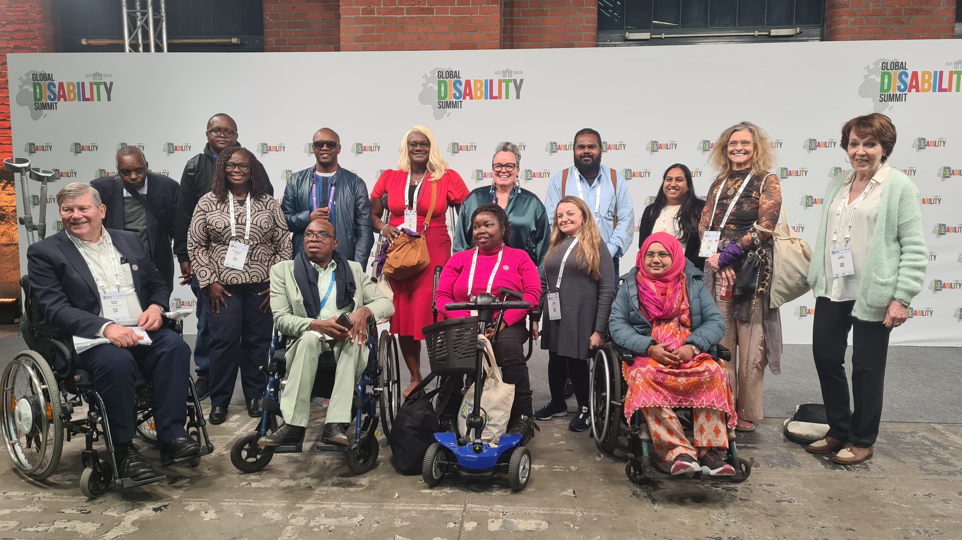

Official delegates from CDPF were Richard Rieser (UK), our General Secretary; Saraha Kamau (Chair) Kenya; Kerryann Ifill (Vice Chair) Barbados. Others in CDPF membership picture who joined us included Samuel Kabue, Patron and UNCRPD Com Member, Kenya: Eric Ngondi, Chair UDPK Kenya: Erin Brown, Bahamas; Clare Gibellini AFDO Australia, Muviyaha (Muthu) Didi, Maldives and CDPF Exec.; Ashana Misti, WDDF Bangladesh and CDPF Executive and Nancy Maguire (ROFA)UK; Akakpo-Numado Togo (FETAPH). Other CDPF reps at GDS 3 Abia Akram, CDPF Assistant Secretary, Zara Todd, ROFA,UK; Elizabeth Adams Oyarege &Ibrahim Alhassa Youth Leaders, JONADWP Nigeria; Malonje Phiri, FEDOMA, Malawi; Robinah Alambuya, Triumph, Uganda; Deo Imalingat, Show Abilities, Uganda; Laura Kanushu MP, Uganda and CPA PWD Network, Faatino Utumapu, Nuanua O Le Alofa, Samoa, Rasanjali Pathirage, Disability Organisations Joint Front DOJF Sri Lanka, Wong Yoon Long Malaysian Confederation of the Disabled.

As can be seen by the list above, CDPF had quite a lot of delegates at GDS 3, thanks to the 200 free places. These had to be fought for. When the German Government launched the call for participation at COSP 17 in New York last June they were not planning on offering any free places. CDPF argued for them strongly to allow those from lower income countries to be present.

We held two meetings for our delegates who were on a What's App Group.

Two main complaints arose. There was hardly any scope for participating in the events. They were all highly stage managed with no space for contributions from the floor. There were no workshop type rooms, only the fire side chats. CDPF put in for a side event, a booth and a fire side chat but were not allocated any, despite representing more than 100 DPOS from over 52 countries.

Secondly, although access was good in many ways, neurodiverse delegates felt the pace and crush did not accommodate them and the whole event would be better over 3 or 4 days with more participation. It still feels like IDA are the only show in town and not even the whole committee, Jose spoke 7 times. We did like the comrade with learning difficulties summing up and some of the women delegates contributions, but felt a colossal waste of time and resources in not learning from the experience of the majority of 4,500 delegates.

Other protests occurred.
“This triennial event, aimed at mainstreaming and promoting the implementation of disability rights worldwide, faced criticism from disability groups advocating for legal capacity, deinstitutionalization, and independent living—even from disability groups in Germany itself.
IDA and the organizing government were accused of neglecting fundamental issues mentioned above, which are experienced daily by people with disabilities worldwide. The process of determining discussion themes for both main and side events was deemed non-transparent, dismissive of meaningful participation from various disability groups, and undemocratic.
Indonesian Mental Health Association (IMHA), Validity Foundation, Indonesian Syndroma Down Care Foundation (YAPESDI), Women Enable International (WEI) and Transformation Community Inclusion (TCI), issued a joint statement and call for action to protest the absence of discussions on legal capacity and deinstitutionalization. We wore t-shirts with various messages, such as:
"Institutionalize, criminalize, ignored.’’
GDS stay silent!"
Meanwhile, wheelchair users protested the lack of serious discussions about inclusive living in society (deinstitutionalization), which they also frequently experience. They carried messages such as:
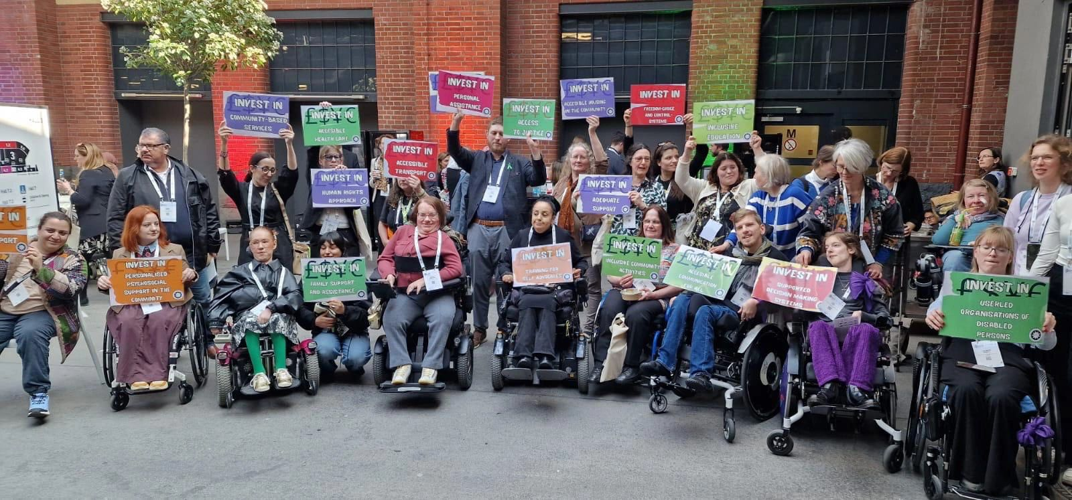
"No money for institutions!"
"No money for guardianship!"
In many countries, including Indonesia, institutions (care facilities) are still financially supported by the state. The government does not take seriously—or even refuses to imagine—creating an inclusive life without institutions for people with disabilities, as if such a reality were impossible.’’
The last group, consists of disabled activists from Germany who were not included—or possibly ignored—by this global event. They were unable to enter the venue, heavily guarded by police, and could only voice their protest outside. It is unclear what issues they raised, as their posters and speeches were in German. Hopefully, these protests will lead to more inclusive and democratic GDS 4.

Steve Allen, Global Transforming Communities for Inclusion (TCI) is an Organisation of persons with psychosocial disabilities [an OPD].

Disabled People who make up 15% of the global population, or around 1.3 billion people are often excluded from development programs. In response to this gap, and amid shrinking funding for disability inclusion, the summit introduced a new target: ensuring that at least 15% of country-level development projects focus on the inclusion of persons with disabilities.
The summit saw over 800 commitments announced by governments, private sector institutions, and development actors to improve accessibility and enable meaningful participation. The event gathered 4,500 participants from around 100 countries, including disabled people, government officials, and civil society leaders. More than 60 sessions addressed how to better implement the UN Convention on the Rights of Persons with Disabilities and translate commitments into practical action.
In his opening address, His Majesty King Abdullah II called for ongoing efforts to ensure dignity, happiness, and hope for all, emphasizing that inclusion is not only about access but about recognizing human potential and creating environments where everyone can contribute.
German Chancellor Olaf Scholz reaffirmed Germany’s commitment to disability inclusion especially at a time when funding is being cut and endorsed the 15% target. He also announced a joint initiative with Jordan to promote inclusive education.
IDA President, Nawaf Kabbara, stressed that true inclusion cannot happen unless organizations of persons with disabilities are included in funding decisions. "Inclusion must be with organizations of persons with disabilities, not for them," he said.
The Amman-Berlin Declaration calls for at least 15% of development projects to be specifically designed to promote disability inclusion. Currently, only 6% of such projects contribute directly to this goal.
German Development Minister Svenja Schulze noted that development policy can only succeed through cooperation among all stakeholders. She described the declaration as a global commitment not just a pledge by donor countries and emphasized that real inclusion benefits not only the 15% of people with disabilities, but society as a whole.
Several major initiatives were unveiled during the summit. The UK’s Foreign, Commonwealth & Development Office committed to launching an Assistive Technology Investment Mechanism through the AT2030 program, aiming to raise $60 million by 2026. It also pledged to co-chair the Global Action on Disability (GLAD) Network to strengthen global partnerships. UNICEF committed to allocating 10% of its annual budget to children with disabilities by 2030 and expanding data collection, inclusive education, and protection systems across 50 countries.
IDA pledged to strengthen organizations of persons with disabilities in more than 100 countries, launch a leadership program for 80 youth with disabilities, and partner with the UN Global Disability Fund to implement the UN Convention in 50 countries.
In Jordan, 88 national organizations including government entities, civil society groups, academia, media, and private sector institutions submitted 133 commitments to promote disability rights.
During a dedicated session, Minister of Education and Higher Education Azmi Mahafzah announced five strategic, rights-based commitments, including a JD90 million investment from the Association of Banks in Jordan, operating banks, the Ministry of Education, the Ministry of Health, and the Higher Council to support inclusive education, health services, and the adaptation of 250 public schools.
A new partnership between Germany and the African Union was also announced to strengthen organizations of persons with disabilities across Africa, with a focus on youth and women. The multilateral "Education Cannot Wait" initiative will partner with Germany, the UK, IDA, and the Girls’ Education Challenge to improve data collection and accountability in inclusive education in crisis-affected areas by 2028.
According to the HCD, all summit commitments will be published and monitored for transparency via the following link:
[https://gds.idata.tools/home](https://gds.idata.tools/home)
The first summit was held in London in 2017, followed by a virtual edition in 2022 due to the COVID-19 pandemic. The Berlin summit marked the third edition, jointly hosted by three partners with IDA serving as a permanent co-host.
The CDPF’s 2nd leaflet and registered commitment was widely given out:
“Commonwealth Disability Inclusion Action Plan - Action Points. This Draft is about to be deliberated up[on by representatives of DPOs/OPDs nominated by CDPF and Government representatives of Commonwealth countries to produce a draft Action Plan top go to the Commonwealth Law Ministers Meeting in Fije in February 2026 for approval and hopefully then onto the Commonwealth Heads of Government Meeting in Antigua in June 2026 for adoption by the 56 leaders of Commonwealth countries.
“We recognise the UNCRPD prohibits discrimination based on disability. It represents a paradigm shift from the traditional, charity, medical model to a social, human rights model of disability, recognizing people with disabilities as equal rights holders. To this end the 56 Commonwealth Governments and the Commonwealth Secretariat will:
A. Within two years of this agreement CHOGM agree to hold a meeting of Commonwealth Ministers with responsibility for Disability to consider and share experiences on its implementation with a view to this becoming a regular Commonwealth event;
B. Gather disaggregated statistics in line with the Washington Group questions and protocols in Census, Household Surveys and other statistical activities;
C. Collaborate in setting up a Commonwealth Country Dashboard on progress on the Disability Inclusion Action Plan and implementation of the UNCRPD;
D. The Commonwealth Secretariat will support country members and civil society organizations in the reporting requirements to the UN CRPD Committee in Geneva;
E. For ongoing collaboration in expertise and financial assistance between member countries, especially between those more economically developed and the rest to develop implementation of the UNCRPD and disability equality;
F. Ensure that reasonable accommodations over access to buildings, access to information and accommodation is increasingly built into the planning of Commonwealth events;
G. Over time, develop a pool of Disability Equality Trainers and Access Auditors, within and between Commonwealth countries to facilitate Disability Equality Training and Access Audits of buildings and infra-structure;
H. Develop the capacity in collaboration with Disabled Persons’ Organisations (DPOs) to run systematic Disability Equality Training for Government Ministers, Members of Parliament, Civil Servants, Advisors and Non-Governmental Organizations;
I. Run all Development Plans through the requirements of the UNCRPD and the need for disability equality;
J. To increase the number and seniority of persons with disabilities employed in the Governments and the Commonwealth Secretariat;
K. Work with the private sector to develop cheap and effective assistive devices and technology and ensure its distribution to those who would benefit most;
L. Develop inter-country training and exchange of technicians who are able to develop the necessary competency to utilize such devices;
M. To implement the UNCRPD; the Commonwealth should give priority to collaborating in developing Inclusive Education, Health Care, Work opportunities for persons with disabilities and supporting measures that will enable persons with disabilities to take part in elections and stand for office;
N. Set up a Commonwealth Disability Advisory Committee with representation from DPOs in the Regions, CDPF, Reps of State Parties, Commonwealth UNCRPD Committee Members and others relevant.
O. Recognising that persons with disabilities are at significantly more risk in climate emergency events and humanitarian situation, agree to prioritise their support and inclusion in climate emergency preparation measures and support in other humanitarian situations.
P. Support the organisation and involvement of Women with disabilities and Youth with disabilities and other underrepresented groups of people with disabilities such as indigenous people, neurodiverse individuals, those with mental health conditions and those with cognitive impairments.
We will campaign to get this Disability Inclusion Action Plan agreed at CHOGM 2026 in June 2026 in Antigua Barbuda by the Commonwealth Heads of Government”
Supported by following National Umbrella OPDs/DPOS
Australia Australian Federation of Disability Organisations, People with Disabilities Australia Bangladesh National Grassroots Disability Org., Women with Disabilities Development Foundation, Barbados Council of the Disabled, Belize Assembly for Persons with Diverse Abilities, Botswana Federation of the Disabled, Cameroon Platform Inclusive Society for Persons with Disabilities, Canada Council of Canadians with Disabilities, Dominica Association Persons with Disabilities, Fiji Disabled People’s Federation , Fédération Nationale des Associations des et pour Personnes Handicapées du Gabon, Gambia Federation of the Disabled, Ghana Federation of Disability Organisations, Guyana Council of Organisations for Persons with Disabilities, India National Centre Employment Disabled People, Jamaica Combined Disabilities Association, United Disabled Persons of Kenya, Kiribati Te Teo Matoa , Lesotho National Federation of Org. of the Disabled, Federation of Disability Orgs. in Malawi, Malaysian Confederation of the Disabled, Maldives Association of Persons with Disabilities, Malta Federation of Organisations of Persons with Disabilities, Federation of Disabled People’s Organisations Mauritius , Mozambiquian Association of Disabled People, National Federation of People with Disabilities in Namibia, Nauru Persons with Disabilities Organisation, New Zealand Disabled People’s Organisations (DPO) Coalition, Joint National Association of Persons with Disabilities of Nigeria, Pakistan Special Talent Exchange Program, Papua New Guinea Assembly of Disabled Persons, National Union Disabilities Organizations in Rwanda, National Council of and for People with Disabilities St Lucia, St Vincent and the Grenadines Voice of the Disabled, Samoa Nuanua Ol Alofa, Sierra Leone Union on Disability Issues, People with Disabilities Solomon Islands, Disabled Persons South Africa, Sri Lanka Disability Organisations Joint Front, Federation of Disabled Persons in Swaziland, Tanzanian Federation of Disabled Persons Organisations SHIVYAWATA, Naunau O’E Alamaite Tonga Association, Trinidad and Tobago Chapter of Disabled Peoples’ International, Tuvalu Fusi Alofa Association, National Union of Disabled Persons of Uganda, UK Reclaiming Our Futures Alliance, Zambia Federation of Disability Organisations. With a further 50 Associates in 49 countries and 2 overseas territories.
General Secretary Richard Rieser +44(0) 7715420727 or + 44(0) 207 359 2855
Company Registration7928235
If you are from a DPO/OPD from within the Commonwealth and are not yet a member of CDPF why not consider joining.
Website https://commonwealthdpf.org
email.richard.rieser@commonwealthdpf.org
Commonwealth Disabled People’s Forum
Message from Global Disability Summit Berlin

