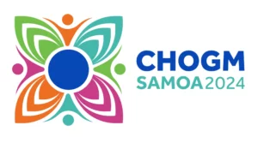
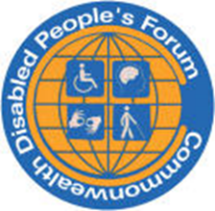
Commonwealth Foundation People’s Forum Delegate Led Session
2.00 to 2.45 Main Hall
Monday 21st October
Double Whammy: Disabled People and the Climate Crisis
Disabled People, Climate Emergencies in the Commonwealth
Sarah Kamau Chair CDPF, Kenya
Dr Richard Rieser OBE, CDPF General Secretary UK
Jodie Santos Disability Justice Project the Film Maker (3 min)
Film ‘Rising Tides Rising Voices’, audio described and captioned (18 mins)
Faatino Utumapu, CDPF Executive, Nuanua O Le Alofa, Samoa
Sovaia Sisi Coalala, Pacific Disability Forum
Around the world, wherever there are climate emergencies, Disabled People are more than doubly impacted, due to the current barriers they face. We are less likely to be formally employed, our livelihoods depend on fishing and farming, which have been significantly affected by climate change. During disasters, the structural barriers that Pacific Islanders with disabilities face every day – like the lack of accessible information and transportation – can become a death sentence. Faced with the urgency of increasing disasters, disabled grassroots activists across the Pacific are championing disability-inclusive climate action. It’s a fight not just against nature, but against a world that often overlooks people with disabilities. https://disabilityjusticeproject.org/
Commonwealth Disabled People’s Forum https://commonwealthdpf.org is campaigning hard for all our countries to implement the rights they have signed up to for disabled people. Not least UNCRPD Article 11
“All necessary measures to ensure the protection and safety of persons with disabilities in situations of risk, including situations of armed conflict”
Let’s Make the Rights Real
Contact: Richard Rieser rlrieser@gmail.com

