Developing Disability Inclusion and Equality across the Commonwealth : Commonwealth Disabled People’s Forum
Wednesday 23 October, 1pm – 2:30pm Law Court TC 1
The meeting will highlight the need for a paradigm shift in implementing the UN Convention on the Rights of Persons with Disabilities across the Commonwealth. It emphasises moving from a medical/charity model to a social, rights-based approach in areas such as education, work, climate, health, law, and political participation. Speakers will discuss how this shift promotes solutions that engage the whole community to ensure no-one is left behind. The meeting will relate to all CHOGM themes, focusing on human rights, climate resilience, economic inclusion, and societal empowerment, urging support for the Disability Inclusion Action Plan as a key transformative tool.
Chair Sarah Kamau Chair CDPF , United Disabled Persons Kenya
Speakers:
Dr. Richard Rieser OBE General Secretary Commonwealth Disabled People’s Forum, UK
Dr Sruti Mohapatra Vice Chair CDPF, CEO Swabhiman, Odisha, India
Hon. Priyanca Radhakrishnan MP Commonwealth Parliamentary Association, Former Minister for Disability Issues in New Zealand and is the current Disability Spokesperson for the New Zealand Labour Party
Rhoda Garland Commissioner Commission for the Rights of Persons with Disabilities, Malta
Kihembo Wilbert, CDPF Youth Representative, Voice of Youth Uganda
Faatino Utumapu, CDPF Executive, Nuanua O Le Alofa, Samoa
Saista Parwin CDPF Executive Disabled Youth, India
Invited Prof Luis Franceschi Com. Sec. Deputy Secretary
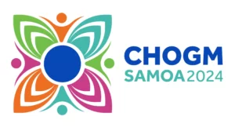
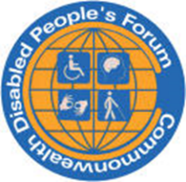
Other Speakers and Discussion on the way forward
Contact person and e-mail: Richard Rieser, General Secretary CDPF Email Address, Website: https://commonweealthdpf.org

