COMMONWEALTH LAW MINISTERS MEETING REPORT
This report provides highlights from Commonwealth Law Ministers Meeting (CLMM) held in Zanzibar from March 4th to 8th, 2024.
WORD OF THANKS
The Chair and I were honored to represent CDPF at this critical meeting. Our participation ensured "nothing about us without us" was heard and provided valuable insights for achieving meaningful disability inclusion. Thank you Richard for trusting us and for breaking a leg to cover costs for the Treasurer’s attendance. Big thanks to Gemma for her tireless efforts in making this possible. She is a STAR!
SIDE EVENT AND MEETINGS
On Monday, 4th March, in collaboration with the Commonwealth Human Rights Unit, we held a successful side event on Practical pathways to strengthening access to justice for disabled people in the Commonwealth. The side event was attended by over 30 Judicial officers, Judges and Attorney Generals from various Commonwealth countries. The session was moderated by Steve Onwuasoanya, Acting Head of the Human Rights Unit and panelists included CDPF Chair, Ms. Sarah Kamau, CDPF Treasurer Ms. Scader Louis, Ms. Angelina Atabong, Sub-Director of International Cooperation, Cameroon Ministry of Justice and Justice Ilvin Mugeta, Judge of the High Court of Tanzania and Vice President of the Commonwealth Magistrates and Judges Association.
After presentations from panelists, feedback received from Namibia, Malawi, Zambia, Seychelles and other countries had the following key takeaways;
- Standardization: There was a consensus on the need to develop standard guidelines for administering justice to disabled people building on what Tanzania is doing. Participants found Tanzania's existing framework particularly useful (copy attached, courtesy of Judge Mugeta)
- Training: Formal training on disability and equality for justice administrators was seen as crucial. Collaboration between the CDPF, Commonwealth Secretariat, and respective countries was suggested.
- Attitudinal Barriers: Judge Mugeta emphasized the significant challenge of negative attitudes towards people with disabilities within the justice system.
- Positive Examples:
  - Tanzania: We learned about their impressive initiative to digitize access to judgments and legal documents through https://tanzlii.org/legislation/
  - Cameroon: Despite ratifying the UNCRPD late (2023), Cameroon is already taking strides towards access to justice for all. These initiatives include installing ramps in new courthouses, training magistrates, and assigning designated officers for disability-related cases.
In our submissions (recordings to be shared) we lobbied for the adoption of the Commonwealth Disability Inclusion Action Plan previously a Protocol
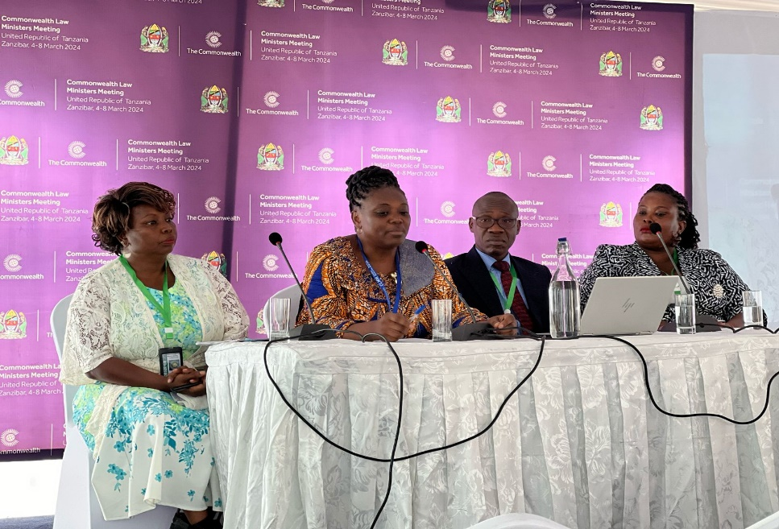
In the picture above – From far left CDPF Chair Sarah Kamau, Ms. Angelina, Judge Mugeta and CDPF Treasurer, Scader Louis during the event
The Commonwealth Human Rights Unit covered the event on Twitter see https://x.com/commonwealthsec/status/1764628293850952064?s=46&t=OfC2NFFOm13fX-WiqJWb7Q
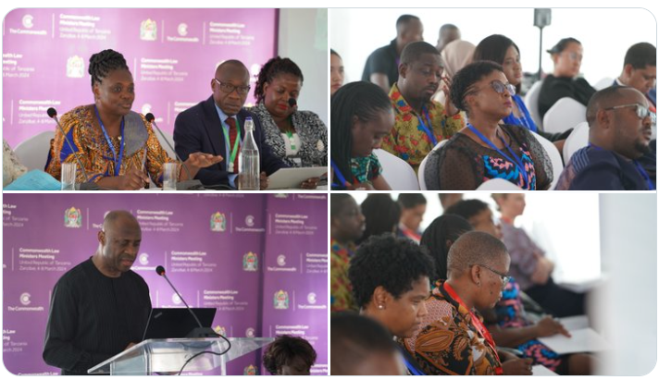

Other engagements/ Meetings
I participated in the Commonwealth Law Ministers Meetings (March 5-7) on strategic legal issues and national progress reports. While the agenda included a discussion paper on disability access to justice, time constraints prevented its review. In parallel, I also attended side events, including "Innovating for Justice," where I made interventions and advocated for improved access to justice for disabled people. Additionally, I met with Attorney Generals and Justice Ministers, including the Commonwealth Secretary-General sensitizing and lobbying for the adoption Commonwealth Disability Inclusion Action Plan (Action Plan) in Samoa.
The Namibian Justice Minister, while supportive of the action plan, expressed concern about the disability movement's effectiveness in Namibia. She cited a misinterpretation of "nothing about us without us," suggesting a lack of recognition for non-disabled advocacy efforts.
Ann from the Commonwealth Foundation supports the Action Plan and indicated that CF is ready to fund CDPF participation and a side event in Samoa. She commended CDPF for the great work it is doing and is happy to have a zoom call to discuss this further.
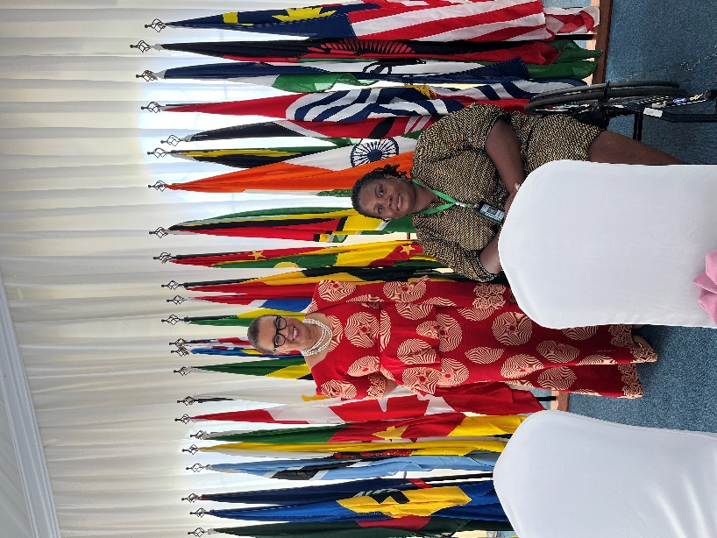
Challenges: (Scader)
Unfortunately, the arrival arrangements in Zanzibar was marred by significant accessibility issues. My wheelchair was misplaced during transit, and transportation arrangements were not adapted for my needs. Additionally, assistance at the Nairobi airport (the passenger assistance unit is not working) as I had to be carried down flight stairs on an aisle wheelchair, quite indignifiying. I hope it will be repaired before our EC meeting in Nairobi in July. Despite clear communication from Gemma regarding my requirements, no plans were put in place to ensure my smooth travel and participation.
The return journey also presented difficulties. As VIPs, check-in was handled by the Zanzibar team, our (myself and my assistant) luggage went missing. I got my bag on Monday this week
Opening Ceremony Absence:
Due to communication lapses regarding transportation arrangements, I was unable to attend the opening ceremony on Monday evening. I received a written apology from Steve (attached) and verbal apologies from the Deputy Secretary-General and Director of Event Planning. Not enough. I did not understand why and how.
Despite the initial difficulties, I was able to participate in other CLMM program activities till Thursday and took time to have fun!
My quote - "Discussions at the Commonwealth Law Ministers Meetings mark a positive step towards equal access to justice. Let's translate these commitments into concrete action for a more inclusive future by adopting and actively support implementation of the Commonwealth Disability Inclusion Action Plan’’.

