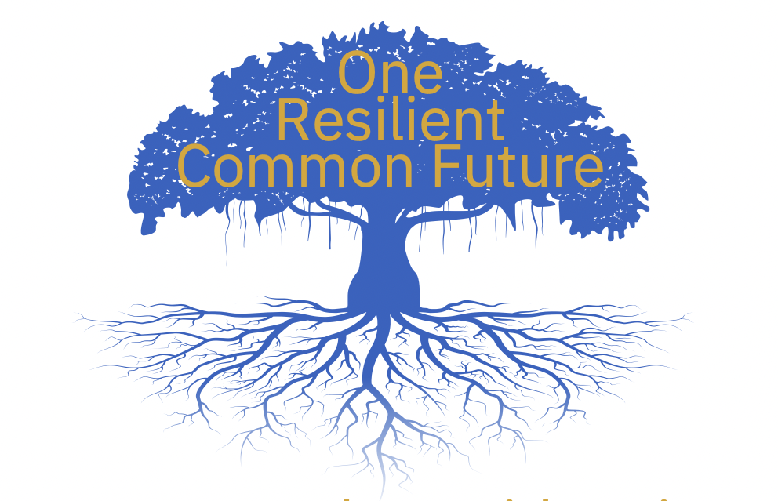
CDPF Message for Commonwealth Day

“We Are Fed up With Being
Marginalised’’
Commonwealth Day is 11 March 2024 #CommonwealthDay
This year, in 2024, The Commonwealth Disabled People’s Forum is working hard to get all Commonwealth Governments to agree on a Disability Inclusion Action Plan at CHOGM in Samoa in October 2024.
More than 400 million disabled people/people with disabilities really need a step change in implementing disability rights as part of the Commonwealth Heads of Government communiques on One Resilient Common Future.

CDPF c/o78 Mildmay Grove South,
London, N1 4PJ
Initial Contact: martha.aldridge@commonwealthdpf.org
General Secretary CDPF Commonwealthdpf.org
rlieser@gmail.com

