Commonwealth Disabled People’s Forum Disabled Youth Leadership Course Module 3: Building DPOs
Plain English version
Please watch the video before reading these notes. Some of these notes are saying what was in the video, but there are many clips of people talking.
Introduction:
Kerryann Ifill, Vice-Chair of the Commonwealth Disabled People’s Forum. “I come from Barbados in Caribbean and am also President of the Barbados Council of the Disabled. We are a group of organisations of different disabled people.
We have found by coming together and listening to each other we have much more chance of helping get the National Government to improve things for disabled people, across Barbados and across the Caribbean Region.
I would like to welcome you to this third module of our online course aimed at developing Disabled Youth Leaders around the Commonwealth.
Our theme today and this Month is:-
Building DPOs - Ensuring Equity, which means fairness and justice, within the Disabled People’s Movement. Thinking about different impairments, Sex, where someone comes from or where they live, or how old they are.
A word on the language we use in the Commonwealth Disabled People’s Forum (CDPF). Disabled people: In the CDPF we call ourselves ‘disabled people’ because society disables us. This means it is the world we live in that stops us from doing what we want or being where we want to be.
So there was a really big change in thinking.
This means moving away from

a) ideas and attitudes where people think impairment is a punishment, or from evil spirits or Gods

b) Charity ideas based on pity (where people feel sorry for us)

c) ‘Medical model’ ideas that just look at our impairment and healing us. The problem is often medical science has no answers and makes us feel different from ‘normal’. Of course we need medical support, but we don’t want to be made to feel different or alone.

Impairment: long term or permanent loss of something in our bodies.

We use the social model of thinking that means it’s the world around us that stops us doing what we want.

We have to do it together-collectively.
We realised that we know what is needed to include us which is why we say: Nothing About Us Without Us.

Based on this understanding, disabled people and our organisations campaigned and won at a global level at the United Nations (UN) the need for Human Rights to be extended to all Disabled People.

This was finally achieved in the United Nations Convention of Persons with Disabilities (UNCRPD) in 2006.

What we are looking at today is what we need to come together with our different impairments and experiences.
Other people have made us feel bad for being different and we need to come together to make ourselves and each other strong.
In Barbados we have lots of organisations and we choose who is in charge of us. We work together to change things. In Barbados, the government got us to give parking tickets to people who parked in disabled spaces!
I am blind and this is what I need. This is called Disability Etiquette (which is good manners)
- Make sure I can read the information. I might need braille, or things in larger print.
- Meet me at the door and make sure I know where to go. Tell me who I am sitting next to so I can feel safe.
- Make sure people helping understand what people need.
- Look at whether the lights are ok and bright enough for people who can’t see very well. Keep bags out of the way.
- Ask me what I need.
- Don’t touch me unless I ask you.
- If I have a dog please don’t touch it.
- If I am with someone helping me, ask me not the helper.
- Make sure you ask me to join in.
That was all from Kerryann in Barbados.
Now Richard says:
When disabled people come together it needs to be a good experience. We need to respect each other.
Sometimes we think that we have to be really strong and not ask for help.
I used to get tired until my partner helped me realise I needed a chair.
It is important to ask for what we need! If you don’t, you can’t help others get what they need.
All our organisations should have these principles (what is good and important) which come from the UNCRPD:
Respect for someone to choose
Don’t treat people differently
Respect difference
Give people the same chances to join in
Equality between men and women

So it is important to have these rules:
One person speaking at a time
Allowing time for people to speak, or communicate
Keeping things confidential (not talking about what people have said afterwards)
Respecting other people’s views and opinions (what they think, even if it’s different to yours)
Barriers (things that make things harder)
We use English in the CDPF but we know that not everyone speaks English.
Sexism – where men and boys think they are better.
Racism – where white people settled in other countries a long time ago, the people that were there first (‘first nation’ people) are still being treated differently.

Other things to think about
Youth- young people are not given the proper space and respect or have their needs met.
Intersectionality – where disabled people might be young, women, gay, or trans. They are in more than one group of people.
Groups to make sure are included in your organisation:
D/deaf people (Deaf with a D is culture, way of life)
Deafblind people
Blind and visually impaired people
Autistic people
People with mental health issues
Disabled people in rural areas
They are often left out of programmes
There are not as many centres, not as much information
transport is not as good or less accessible
less schools, not enough education, or training not planned for those that learn differently
People thinking negatively towards disabled people (thinking they can’t do things)
Disabled People’s Organisations in rural areas need to become confident at looking at these areas.
- Make a small group of people who understand disability rights with the social model
- Learn to meet access and communication needs
- Educate the local community to show what disabled people can do
- Bring in family members and others to support you but disabled people must stay in control
- Campaign to get resources (money and support) into the area for inclusive projects
- Put forward representatives to local decision makers
- Use radio and other media to get your message out.
Many of these come under a process called CBR which stands for Community Based Rehabilitation.
The picture below says, ‘A disabled child growing up has the same needs as other children’ and then has pictures showing play, respect, friendship and love, helping and work, adventure and testing of limits, school and taking part in community activities.

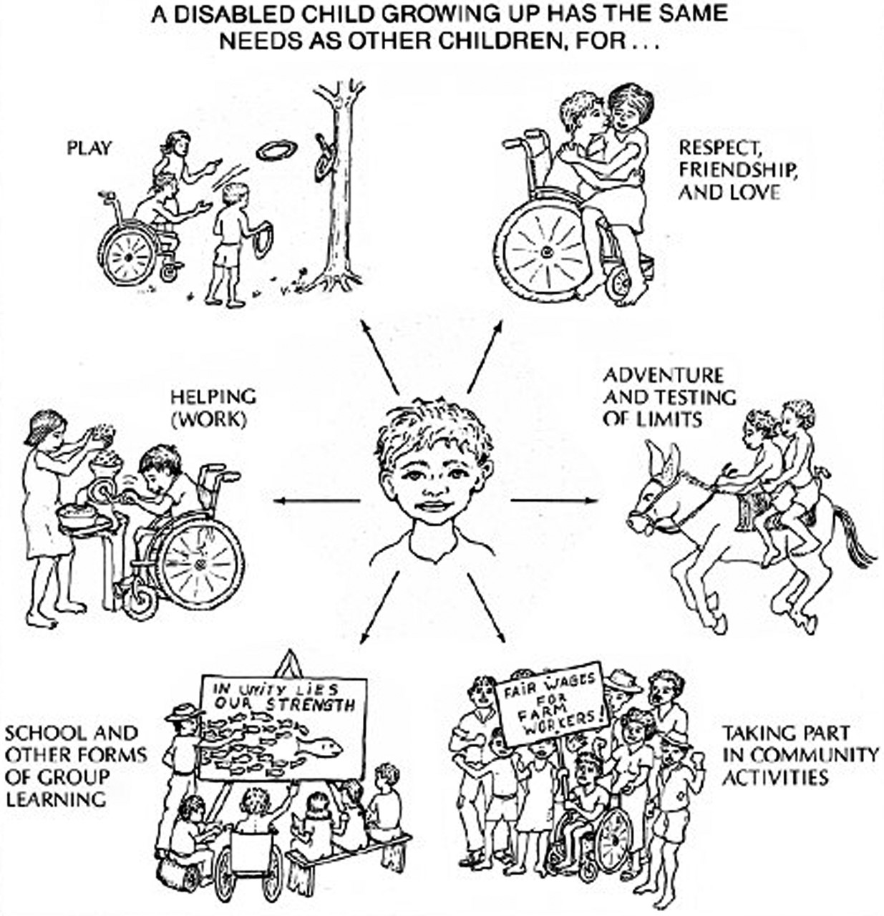
Conclusion
We have to build DPOs with different people with different impairments and be strong together. Our history shows that when we get together we can achieve great things. Richard said he is lucky to have been part of the large group of people that made the UN Convention, but it was only because there were more than 80 different organizations from around the world working together.
We need to function democratically (which means everyone having a vote, a fair chance, a voice). But we need to make sure that we include people’s needs.
We need to challenge prejudice and abusive behaviour among our members. This means that if people are mean or not being kind we have to stop it. We also need to change how the levels society are made, inside our movement.
We should have clear aims.
We need to make sure we include groups that are not yet brought in.
We need to keep separate from government.
This is a good phrase:
“If you always do what you have always done, you will always get what you have always got… Be the change.”

Or as Gandhi said, "Be the Change You Want to See in Society".

Module 3 tasks:
After studying the presentation, this text and the Appendix, try and complete the following tasks:-
- For a DPO you know in your country, find out and write answers:
- How did it start?
- When did it start and who was involved?
- What were the main aims?
- Who does the DPO represent?
- What has it achieved?
- What are some difficulties the DPO has faced?
- What should the DPO do to keep things getting better?
- Put forward a set of 6 rules for DPO meetings. For each ground rule say why you think this is important.
- You arrive in a new part of your country. There are no DPOs to represent disabled people.
- What 3 things would you do to set up a new DPO? why?
- You are organising the first meeting with few resources, other than a free community centre. What would be your main thoughts to set up a good meeting for a cross impairment group? (Cross impairment means lots of different impairments)
- How would you know if the meeting was successful?
- What would be the next things you should do to build a representative DPO? (representative means lots of different people with different impairments and from different places and ages)
Appendix: Good Manners to Disabled People or Disability Etiquette.

Involving people with mobility impairments
- When talking with a wheelchair user, either get a chair and sit down or ask if they prefer you to stand or crouch. If you do stand, make sure they don’t have to look up because they can get in a stiff neck. Stand a little way away so that you can have a conversation eye to eye, on an equal level.
- Before inviting wheelchair users to a building, find out about the access to that building. Provide the wheelchair user with the information, so that they can make a decision about whether or not the building will be accessible to them. If the building is not accessible, you should not use it.
- A wheelchair is part of the “body space‟ of the person using it. Do not lean on it.
- If you wish to speak to the Personal Assistant of the wheelchair user, ask first and make sure that you do not exclude the disabled person from the conversation.
- In public places or offices, ensure that items are not left lying around on the floor. Make sure there is enough space for people to get around and that access is safe for everyone.
Crutch or stick users:
- For some stick or crutch users, stairs may be difficult. Where you have access for wheelchair users, ask if they would find this more helpful.
- People who need sticks or crutches may find it hard to use their hands when standing up, for example, to count money, or to fill in a form.
- At events where people are standing, provide chairs and stools so they can choose to use them if in pain or tired.

Involving people who are D/deaf, deafened and hard of hearing
- D/deaf culture describes the social beliefs, art, literary traditions, history, values, and shared experiences of Deaf people who use a sign language. When used this way, the word ‘deaf’ is referred to as ‘big D Deaf’. Culturally Deaf people tend to/may often view ‘deafness’ as a difference in human experience rather than a disability. Deaf culture therefore does not automatically include all people who are deaf or have a hearing loss. Like most cultures, the exact boundaries of Deaf culture are argued about. For example, where hearing people who have Deaf parents (and sign fluently) fit in.
- Some people with hearing impairments are not Sign Language users. They might use lip reading / lip speakers or might wear hearing aids. It is important to make sure you find out what each person needs.

General Etiquette (good manners) speaking to a Deaf or deaf person
- The usual etiquette for getting someone's attention is to tap them lightly on the arm, between the shoulder and the elbow. Ask the SL interpreter or the Deaf people at the event as to the best way to call people to attention.
- Always speak directly to the person.
- Speak in a natural tone, like you are chatting. You don’t need to speak loudly.
- Be aware with written information; SL has a very different structure from English or the Community Language, and D/deaf people may therefore have limited reading or writing skills in English or the Community Language.
- Make direct eye contact. Natural facial expressions and gestures are important.
- When talking, do not cover your face or your mouth.
- Bright and dark places can be a barrier to clear communication. Good lighting is important, but keep in mind the glare factor and do not stand in front of a bright window.
- Ensure that background noise is kept to a minimum.
- If a person is lip reading, speak clearly and slowly but do not exaggerate your speech. Be aware that lip reading has its limitations, as many words look the same on the lips, and even the best lip reader would only be able to lip read 50-60% of what is being said.
- If a word or phrase is not understood, rephrase it by using different words with the same meaning.
- Changing the topic of conversation suddenly can cause confusion. Use transitional phrases between topics, such as “let’s talk about exams now‟.

Working with Sign Language interpreters and lip speakers
- If a person uses a Sign Language (SL) interpreter, address your comments and questions to the Deaf person, not the interpreter.
- Always speak in a natural, conversational tone. The interpreter will tell you if something needs to be repeated or if you need to slow down.
- Normally, the SL interpreter sits opposite the Deaf person. Depending on the situation, however, the Deaf person will be able to advise on the best arrangement for effective communication.
- Interpreting is physically and mentally demanding so plan for frequent breaks. Generally, a SL interpreter working alone should have 10mins break in every half hour. However, this may vary for individuals and type of event, so do discuss this with the BSL interpreter beforehand.
- It is useful to provide any written material to the interpreter in advance of a meeting so that they can familiarise themselves with details about the meeting.
- Find a suitable place to talk, with good lighting, away from noise and distractions.
- Remember not to turn your face away from a D/deaf person. Always turn to your listener so they can see your face.
- Check that the person you're talking to can follow you. Be patient and take the time to communicate properly.
- Use plain language and don't waffle. Avoid jargon and unfamiliar abbreviations.

Involving people who are visually impaired
- First of all, identify yourself clearly, and then introduce anyone else who is present and where they are placed in the room.
- Ask the person if they require any assistance and, if so, how best this should be provided.
- When offering a handshake, say something to indicate that you wish to shake hands.
- When meeting someone out of their home or in their workplace, ask what central point they are familiar with and arrange to meet them there. Please ensure you arrive at the agreed time and make your presence known when they arrive by introducing yourself.
- When offering a seat, speak to the person through the process (chair on right, left, back of you, etc) and place the person's hand on the back or the arm of the chair, so that they are aware of the position of it.
- At the end of a conversation, do not just leave. Say when you wish to end a conversation, or when you are moving away.
- If you are running a meeting or an activity that visually impaired people will be attending, make sure that materials are prepared in advance in accessible formats so that everyone has the same access to the information available. Ensure that you ask the attendees what format they would like it in, for example, large print, Braille or if it is helpful to have the information emailed to them in advance.
- Always say what you want, as gestures are useless communication tools to most visually impaired people.
- Always talk to the visually impaired person and not to his or her guide or support worker.
- If a visually impaired person attends a meeting or an event without a guide or support worker, then ensure that assistance with refreshments and locating the toilets is offered even if they do have a guide dog/white stick.
- Do not interact with a guide dog without prior agreement of the visually impaired person. These are working dogs and some people prefer that you do not pet them.

Making information accessible to people with visual impairments
Some designs can be unclear, confusing and difficult to read for many people, including people with visual impairments. The Royal National Institute of Blind People (RNIB) has produced ‘Clear Print Guidelines’ to help avoid this. Top tips for achieving Clear Print:
- Document text size should be 12-14 point, preferably 14 pt and capable to expand to 16-20 point.
- The font you choose should be clear, avoiding anything stylised.
- All body text should be left aligned.
- Use bold sparingly, only highlight a few words rather than a paragraph.
- Keep the text layout clear, simple and consistent.
- Don't use blocks of capitalised letters and try not to use any italics or underlining.
- Text shouldn't be on images.
- The coatings should not be glossy or reflective.
- The contrast between the text and background is as high as possible.
- All text should be the same orientation on the page.
- Space between columns of text is large enough to be distinct.
- Any information conveyed in visuals or colour use Alt text or audio description.
- Word processed documents save as a Word Document, not a PDF, so Screen readers can work.

Involving people who have learning difficulties
- Don't make assumptions.
- Position yourself at the same level.
- Position yourself so that the person can see your face.
- Keep your hands away from face.
- Never shout.
- Use simple words and sentences.
- Always check information has been understood.
- Minimise background noise wherever possible.
- Don't use jargon.
- Don't talk too fast.
- Take time to listen and understand.
- Explain things very clearly.
- Speak to the person and not their support worker.
- Don't be afraid to ask people to repeat themselves. Tell them that you did not understand.
- Don't pretend that you have understood what was said when in fact you didn't.
- Don't assume that people will be able to find another point of advice. You might need to give some extra support.
- Go back over the information. Say the main points again.
- Use a variety of information support tools, such as pictures. For example, draw a clock with time when arranging a meeting or talking about a start, open or close time.
- Documents should be Easy Read in plain language with pictograms.

Involving people with speech impairments
- Make eye contact and be especially attentive with a person who has difficulty speaking or who uses a communicator.
- Wait quietly and listen whilst the person talks.
- Resist the temptation to speak for the person, or to finish their sentences.
- Some people may prefer to be asked questions that require either a short answer, or a nod or shake of the head. Offer this option if it is appropriate to the situation or ask if they will write down words or phrases you are having difficulty understanding.
- Be sure you understand fully what the person means before making any assumptions.
- It can be helpful to say what you have understood and ask the person to confirm or clarify.
- If you don't understand what is being said, don't be afraid or embarrassed to ask the person to repeat it, maybe several times.
- Don't make assumptions about the person's hearing or intellect just because he or she has difficulty speaking.
- If the area is noisy, take account of this and, if possible, move to a quieter area.
- Lack of time is often the biggest barrier.

Involving people who have mental health issues:
- Do not make assumptions.
- Ask people what is the best way for them to work with you?
- Do not have events or meetings in the early morning.
- Ask people if they require a reminder about your meeting.

Making information accessible.
All people benefit from information that is in plain English and concise. However, as mentioned above, it should be noted that medication and fatigue (extreme tiredness in the mind and body) issues linked to some long-term health conditions can sometimes limit concentration span, and some people may also feel overwhelmed by an excess of information.
- Send information in advance so that groups can meet to discuss the issues you need help with.
- When planning your activity, think about regular breaks.

Accessibility for autism
When presenting information to autistic people, be mindful that not all autistic people have the same accessibility needs. Some autistic people experience sensory overload more than others and in different ways.
Common causes of sensory overload in autistic people include:
- Too many noises being made at the same time.
- Bright colours or extreme colour clashes e.g. bright yellow on a white background.
- Getting too much information at once.
- Too many things happening in the background.
Many of these apply to websites, printed and digital documents. Some of those examples can also happen in phone calls, video calls and face-to face meetings.

Websites and apps
To make a website or app autistic-friendly, these steps are worth taking:
- If possible, use a pastel background colour for each page of your website or app.
- If you can, install an accessibility plug-in that will let users change font size and background colours. For WordPress.org websites, WP Accessibility is widely-used.
- Have a clear drop-down menu where all the main pages on your website are just one click away.
- Have panels on homepages and landing pages leading to key pages e.g. to any referral form pages you have.
- Use a sans-serif font for your body text. These are easier to read. Century Gothic, Arial, Calibri and Verdana are good examples.

Digital documents – PDFs, Word docs, spreadsheets
For any written documents, PDFs, spreadsheets and slideshows, these steps are worth considering:
- Pastel backgrounds work well.
- Clear, concise language is a must. This is especially true if trying to explain something that is complicated like making a membership form.
- Make your documents easy to navigate. For longer documents, please use page numbers and headings.
- For documents with different sections, set them up so when clicking on a Contents page item, they go to that point of the document.
- Tick/check boxes for forms are useful to save time for the person filling them in.
- Line spacing of at least 1.15, spacing between paragraphs is useful for breaking up text.
- For spreadsheets, have the top row or first column frozen so it appears when scrolling.
- In spreadsheets, it is worth using alternating colours for different columns. This makes it easier to find the stat or number needed.
Print documents – leaflets, posters, flyers
These steps are worth bearing in mind for producing any printed resources:
- Where possible, using pastel-coloured backgrounds can make text more readable. If you can, use these colours for printing out notes, newsletters and so on.
- Increased line spacing of at least 1.15 can make it easier to read text.
- For A4 newsletters, use no more than three columns per sheet.
- For A5 leaflets and flyers, use no more than two columns per sheet. If possible, stick to one column.
- If you are making a folded leaflet, make them bi-fold. Tri-fold leaflets can be confusing for some people to navigate.
Verbal information – phone calls, video calls and face-to-face meetings
When speaking to autistic people in person, on the phone or via video call:
- Be clear and concise. Try not to talk too much.
- Use concrete language – say what you mean e.g. “The COVID vaccine comes in two doses.”
- Do not expect the person to maintain eye contact throughout. For some autistic people, eye contact can be quite painful to make.
- Make sure there is little to no background noise when you are speaking. If there is background noise, it can be hard for them to filter out what you are saying.
- For appointments, please give a specific time for when you will speak. Then, the person you are calling will be less surprised and taken aback when you call.
- Find out what works for the person you are speaking to. Give them a choice – video call, phone call, face-to-face meeting or text chat.
- Try not to come across as patronising or condescending when speaking to an autistic person via video call or on the phone.
- If you are going to be late to a meeting, keep the person informed. This is useful in case they are anxious that you won’t be there.

For further information about Clear Print, see RNIB's See it Right book, contact: accessibleinfo@rnib.org.uk or visit www.rnib.org.uk
Making information accessible for neurodivergent people Leeds Autism AIM part of Advonet https://www.wypartnership.co.uk/application/files/3716/4735/6437/making-information-accessible-for-neurodivergent-people-final-v2-20.04.21.pdf With lots more information and links about access for different forms of neuro diversity.

