Commonwealth Disabled People’s Forum
Disabled Youth Leadership Training
Module 1: ‘Implications of the Paradigm Shift from Individual/Medical to Social/Human Rights Approach of Disability’
This means people have changed the way we should think about disability. The individual or medical model means trying to change the person. The Social model means changing society.
Welcome to the course. There are 150 of you. We know that there are not young people in DPOs but there are lots of young disabled people in the Commonwealth.
Language
Disabled People we say disabled people because society disables us.
The main bit of this part pf the course, or module, is looking at this change we talk about above.
In the individual or medical model way of thinking, disabled people are not valued. But in the social or human rights model, they are valued owners of human rights.
History
An impairment is something a disabled person has that might make life harder for them, like being Deaf or not being able to walk very well. Or finding it harder to understand things.
But in history, people thought that disabled people had done something wrong, or they or their parents had committed a sin. Sometimes babies were left to die. Stories made some people’s impairments sound worse because they thought disability was a bad thing. This is called Traditional Ways of thinking about disability.
Albinism
In 29 countries in Africa, some people have Albinism, which affects their skin and their eyesight. These people used to be bullied and hurt badly and sometimes their lives were in danger. Then in 2022, Kenya managed to stop the bullying and hurting by talking to communities and educating people to change Traditional Thinking.
Activity 1: Traditional ideas in your culture
Think about Traditional Ways of Thinking in the place where you grew up.
Think about why it is wrong and the best ways to talk to people about it.
Charity thinking came from religious thinking, like Christianity (Churches), Judaism (Jewish faith) and Islam (Muslim faith). This means that people should look after people who have less than them. This means that people feel sorry for disabled people. Some charities that say they work for disabled people don’t really help things move forward. We say ‘Nothing about us without us’.
You could test whether a charity is really helpful to disabled people’s organisations and ask:
Do they accept the leadership of DPOs?
Do they help DPOs get stronger?
Do they understand ‘nothing about us without us’?
The Medical Model
As medical science got better they tried to cure disabled people. But not everything can be fixed. And not everyone can afford the equipment which would help them.
Some things are good like curing diseases which lead to impairments.
But thinking from the Medical Model means that people would always think about what disabled people couldn’t do. And then they were separated and kept apart.
The Paradigm shift from the medical to the social model.
Paradigm (sounds like ‘para dime’) means really big. So there was a really big change in thinking.
Medical model thinking holds disabled people back and stopped them from thinking they could change things. The Social Model meant that people thought differently and wanted to change things around them. This includes attitudes of others. (‘Attitude’ is the way people think and act towards someone else).
A union called ‘UPIAS’ said, in 1975:
We know we need medical help sometimes. But we are people not patients. Don’t take decisions behind our backs.
Disabled people and their organisations run by themselves from lots of countries came together in 1981 in Singapore.

A lot of planning had gone into this meeting after they left the Medical Model dominated Rehabilitation International.

Disabled Peoples’ International,( 1981) agreed:-
“Impairment is the loss or limitation of physical, mental or sensory function on a long term or permanent basis.
Disability is the loss or limitation of opportunities to take part in the normal life of the community on an equal level with others due to physical and social barriers.”

This social model approach focused on need to:
• Change people’s thinking about disabled people
• Change the environment to make it accessible
•Change organisations and how they do things
• Urgently support disabled people to claim their rights and feel good about themselves…
A shift in thinking from altering disabled people so that they can fit into a disabling world
To getting rid of barriers, changing society and attitudes.
This change is at the heart of the UN Convention on the Rights of Persons with Disabilities, adopted in 2006.
Recognising that disability is an evolving concept and that disability results from the interaction of persons with impairments and attitudinal and environmental barriers that hinders their full and effective participation in society on an equal basis with others.
Looking back, it is amazing to see how far we have come, in that nearly everybody accepts this change.

Activity 2 View or listen
Here are 2 short films showing the impact of this change of thinking.
A) Comic Relief: Break Down The Wall 1995 http://worldofinclusion.com/res/altogether/atb9.flv
B) NDACA & UK: Disability History Month Social Model of Disability https://youtu.be/24KE__OCKMw

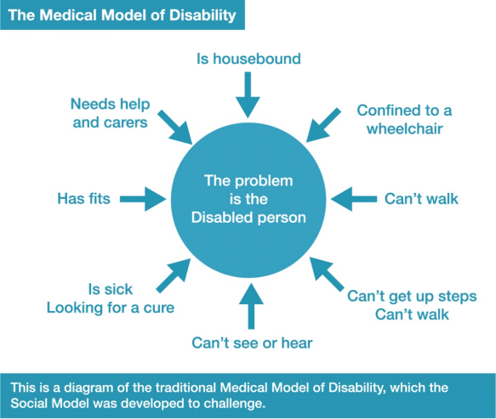
The Diagram describes the Medical Model of Disability and means ‘the problem is the Disabled person’. It has these things pointing towards them: Is housebound (they cannot leave the house), Confined to a wheelchair (they need to use a wheelchair, but ‘confined to a wheelchair’ is the wrong way of saying it), Can’t walk, Can’t get up steps, Can’t see or hear, Is sick/looking for a cure, Has fits, Needs help and carers.
This is the traditional Medical Model of Disability, which the Social Model was developed to challenge.
The diagram below is the social model of disability.
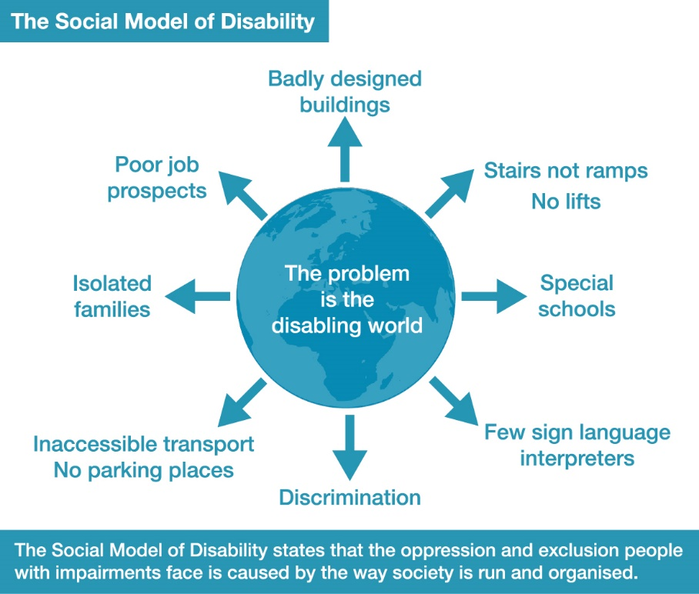
This Diagram describes the Social Model of Disability which says ‘the problem is the disabling world’. This means that it is the world around you that makes you disabled. In the picture these things are pointing away from it: Badly-designed buildings, Stairs not ramps/No lifts, Special schools, Few sign language interpreters, Discrimination, Inaccessible transport/No parking places, Isolated families, Poor job prospects.
The Social Model of Disability states that the oppression and exclusion people with impairments face is caused by the way society is run and organised.
Oppression means being treated in an unfair way by someone who has more power. Exclusion means not being allowed to do something or be part of something.

Activity 3: Follow Up Identifying Barriers
Describing barriers (things that stop you doing something), and suggesting solutions (ways around them) is one of the most powerful things we can do in the Disability Movement to make things better.
Think about barriers in your country for 2 of these groups of people:
- People who need to use a stick or wheelchair
- People with autism
- People with learning difficulty
- People who use mental health services
- Blind or deafblind people
- Deaf or hard of hearing people
- People with long term sickness or condition or who have had cancer
The different ways to think about barriers are Environment (places around you), Attitude (how people act towards you), Culture (what people believe), Organisation (groups of people), Legislation (laws), or other.
Activity 4: See what you have and where the same things come up for different groups. Pick some and talk about how they could be changed or got rid of.
 | Barrier 1 | Barrier 2 | Solutions
A. Barriers of Environment

B. Barriers of Attitude

C. Barriers of Culture

D. Barriers in Organisation

E. Barriers of
Legislation

F. Other barriers

The Human Rights Approach to Disability
In 1948 the United Nations was new. The Second World War was recently over. The UN came together to make the ‘Universal Declaration of Human Rights’. This said that everyone had the same rights, wherever they lived, what colour they were, what religion, and various ‘other’. It didn’t list disabled people but we think we were under the ‘other’.
It says that everyone is born free and equal and has the same rights.
There was more work on rights in 1976 and we have the International Bill of Human Rights.
As they keep talking, they include and name groups for rights. Like disabilities, women, children, migrants, minorities and indigenous peoples. (Indigenous people means people that were in countries before people went there to make colonies).
The United Nations Convention on the Rights of Persons with Disabilities (UNCRPD) was made by disabled people. It took 5 years to make. It talks about disability rights.
Theresia Degener and Gerard Quinn say that the social model was useful to build the Disability Movement, but the UNCRPD is better for human rights. The CDPF agrees, but we need both.
There are 6 points:
- The social model explains disability, but the human rights model includes human dignity of disabled people.
- The social model supports civil rights (the rights of a country’s people) but the human rights model also includes other rights, like economic (money).
- The social model doesn’t talk about disabled people feeling pain or dying early. The human rights model understands this.
- The social model doesn’t talk about ‘identity politics’ like being proud to be gay or black. But the human rights model understands this.
- We also need help with our health and medical issues.
- The human rights model understands the link between poverty (being poor) and disability.
The UNCRPD gives us a very clear ‘road map’ on what needs to be done to develop disabled people’s rights as nearly all countries have now ratified the UNCRPD. This means that nearly all countries have signed the UNCRPD and have agreed to make changes.
See more here:
UNCRPD in Brief https://www.un.org/development/desa/disabilities/convention-on-the-rights-of-persons-with-disabilities/the-convention-in-brief.html
Human Rights Handbook for those with developmental impairments
https://hpod.law.harvard.edu/pdf/we-have-human-rights.pdf

Activity 5:
Try to study the UNCRPD, until you understand the main rights you are getting as a disabled person.
To get everybody these rights is our main purpose and for that we need a strong, disabled people’s movement in each country, region and district. In the next 5 modules we will see how we can do this.

