Contents
Module 1: Implications of the Paradigm Shift from Individual/Medical to Social/ Human Rights Approach of Disability 2
Welcome (by Dr Sruti Mohapatra, Vice Chair CDPF). 2
The Language We Use 2
UN DESA 3
Key Changes in the Paradigm Shift 3
But how did we get to this transformational thinking? 4
Traditional Ways of thinking about disability have dominated human history. 4
Albinism: a case study 5
Educating people, 6
Activity 1 (thinking about traditional ideas in your culture): 6
How to test if a Charity or Non-Governmental Organisation is a good Ally to Disabled People’s Organisations 7
The Medical Model: 7
The Paradigm Shift from the Medical to the Social Model of Disability 8
The social model approach recognises the need to: 10
Activity 2: Online Films that explain the Paradigm Shift 11
Diagrams that explain the medical and social models of disabliity 11
Activity 3: Follow Up Identifying Barriers 12
Activity 4: 13
The Human Rights approach to Disability 15
What is the difference between the social and the human rights model of disability and why is the CRPD a manifestation of the latter? 16
Conclusion 18
Activity 5: 18

Commonwealth Disabled People’s Forum Disabled Youth Leadership Training

Module 1: Implications of the Paradigm Shift from Individual/Medical to Social/ Human Rights Approach of Disability
Welcome (by Dr Sruti Mohapatra, Vice Chair CDPF).
We would like to welcome all of you onto the first Module of the CDPF Disabled Youth Leadership Course. We are running this course from now to the end of March 24 as our contribution to Commonwealth Year of Youth. There are around 150 of you who have been selected because you are interested in becoming leaders of the Disabled People’s Movement. We have developed this course because, as the umbrella organisation representing over 90 DPOs [Disabled People’s Organisations] across 50 Commonwealth countries, we are aware of the age gap between the current leaders and the 60% of the Commonwealth population under 30. We will be holding seminars with those leaders to explore ways of making their DPOs more representative.
CDPF’s mission is to implement the United Nation Convention on the Rights of Persons with Disabilities [UNCRPD] and promote the human rights and equality of the 450 million disabled people across the Commonwealth.

The Language We Use
Disabled people: Why we still choose to call ourselves ‘disabled people’: In the Commonwealth Disabled People’s Forum (CDPF) we call ourselves ‘disabled people’ because of the development of the ‘social model of disability’. In the C19th and C20th, a disabled person’s medical condition was thought to be the root cause of their exclusion from society, an approach now referred to as the ‘medical or individual model’ of disability. We use the ‘social model of disability’, where the barriers of environment, attitude and organisation are what disable people with impairments and lead to prejudice and discrimination. So, to call ourselves ‘persons with disabilities’ is to accept that we are objects and powerless. We also view ourselves as united by a common oppression regardless of which impairment we have, so are proud to identify as ‘disabled people’ rather than ‘people with disabilities’. When we are talking about the UN Convention on the Rights of Persons with Disabilities we will use ‘people or persons with disabilities.
The core to this Module is to understand the fundamental shift in thinking about disabled people that is represented in the transition from the individual/medical model view to the social model/human rights view.
As United Nations Department of Social and Economic Affairs [UNDESA] put it, soon after the Convention was adopted in 2006:
UN DESA
“The Convention follows decades of work by the United Nations to change attitudes and approaches to persons with disabilities. It takes to a new height the movement from viewing persons with disabilities as "objects" of charity, medical treatment and social protection towards viewing persons with disabilities as "subjects" with rights, who are capable of claiming those rights and making decisions for their lives based on their free and informed consent as well as being active members of society.”
(See film)
We hope these presentations and the written notes you will be able to access will generate questions and discussions that can be addressed in your monthly live on-line regional meetings and that you will be able to make a presentation at the end of the course from which we will ascertain that you have put your learning to good use. Most of all CDPF hopes you will join in the struggle for disabled people’s rights and equality and help to make a lasting transformation.
Richard Rieser, General Secretary, CDPF: The fundamental changes of thinking towards disabled people go from a wide variety of traditional views to seeing the problem in the person and seeing them through a medical lens. Based on the efforts of disabled people themselves there was a major transition leading to a social model of disability and human rights approach. We can show this change across these 10 areas.

Key Changes in the Paradigm Shift
Individual/Medical Model | Social/Human Rights Model
Disabled Person as Object | Subject. Empowered, collective strength
Impairment as an Individual’s Issue | Disablement as a Social and Human Rights Issue
Not valued | All disabled people as valued owners of human rights
Impairments Assessed/Labelled | Self-Identification of Barriers and Solutions
Not capable to Contribute | Contribute with Support and Reasonable Accommodations
Segregation | Inclusion
Emotional Needs on hold | Relationships Nurtured
Medical Treatment/deficit thinking | Strengths and needs defined by Self and allies
Individual Action | Collective Action
Victimhood | Challenging Disablement
The world stays the same | The world changes for the better

But how did we get to this transformational thinking?

Traditional Ways of thinking about disability have dominated human history.
Impairment has always been with us. Differences in our genes, results of diseases, environmental catastrophes, wars, accidents and emotional insecurities have led to us having long term impairments that make our bodies or minds different to most people.
The response is usually negative, resulting in stigma, taboos, negative attitudes, and stereotypes that still persist in many cultures.
Examples
People were thought to be disabled because they or their parents had done something wrong and because all-powerful gods, deities or fate had made them disabled (karma or sin).
Disabled people were often subjected to inhuman treatment. Being seen as bringing shame on their families, they were hidden or locked away.
Euthanasia was widely practised on babies born with significant impairments. Such children were often abandoned and if they survived had to rely on begging to survive.
Greek society following teaching of Aristotle and Plato argued for the ‘exposure’ of disabled babies. They were a war-like people who depended on marshal skills. It was thought disabled children would not be capable of doing this.
The Bible contains more than 40 negative references to disabled people as penitent sinners and prohibitions from being priests. Old and New Testament have these negative views. Stopping disabled people from worshipping or being priests or being sinners who, if they repent, may be cured. This assumes disability as a punishment and that God can take it away.
Often viewed as not fully human or possessed by evil spirits Witchcraft Hunts Europe 1480–1680 when up to 8 million women, often disabled were put to death for sorcery, witchcraft and communing with the Devil.
Ridicule court jesters or in ‘freak shows’ Henry VIII in England had jesters with learning difficulty resident at court as the Tudors believed they would always speak the truth and were connected directly to God.
Shakespeare’s play King Richard III was based on Tudor accounts of Richard as a mass murderer, scheming his way to the throne. As the discovery of his body in a Leicestershire car park has shown, as identified by DNA, he did have Scoliosis (“hump back”) though he had strong upper body strength to wield a sword. He did not have a withered arm or “lame leg”, as Shakespeare’s play gave him. The politics of this was because the Tudors had stolen the throne from Richard at the battle of Bosworth Field (1485) and had to make him look bad. So, he was said to be evil and multiply disabled.
The application of the false science of Eugenics to Disabled People in C19th and C20th In UK and USA towards the last part of C19th people began to use Darwin’s theories of natural selection to apply to humans. They identified the mentally deficient, who were also morally weak, unemployed, or having babies out of wedlock, as a group who would weaken the population. This was not true and was based on false science, but many were sterilized in USA or locked away in the UK. Adolf Hitler copied this approach in Germany and went further to the compulsory killing of disabled children and adults (as many as I million in Greater Germany and the Nazi Empire). These people were also the try out for the mass killing of Jews and others later.
The Last ’freak show’ closed in Conley Island, New York in 2001.

Albinism: a case study
Across much of Sub-Saharan Africa people with Albinism are treated as outcasts or second-class citizens.
People who inherit the Albinism gene have low pigment or melamine in their skin and this also impacts on their eyesight.
Folklore and tribal customs reinforced by witch doctors has labelled Albinos as ‘Ghost People’ often believed to be caused by the mother. People with Albinism are ‘regularly singled out and subjected to torture, cruel, inhuman, and degrading treatment or killings because of harmful practices related to accusation of witchcraft and ritual attacks’ (HPAWR).
In 29 countries across Africa, people with Albinism are ritually banished, attacked, and accused of witchcraft. Their graves are also desecrated for the stealing and trafficking of their body parts.
These human rights violations occur due to dehumanizing myths and beliefs that people with Albinism and their body parts can bring good luck, wealth, and medical cures, as well as success in elections.
The African Albinism Network, a DPO, has managed to turn this situation round. The Republic of Kenya has not been spared a share of the hundreds of cases of attacks and other extreme discrimination against people with Albinism in Africa.
Its approach to tackling the issue was swift, strategic and effective. The Kenyan model, as it is now called and affirmed by respondents in a regional survey of Albinism groups conducted in 2022, is being replicated across Africa.

Educating people, involving local community leaders and families of disabled people, empowering disabled people locally in self-advocacy groups have all proved to be effective ways to challenge and change traditional thinking. If these approaches are firmly grounded in a social model human rights approach to disablism they are much more effective. These sentiments are also backed by the Commonwealth Charter to which all Governments are signatories.

Activity 1 (thinking about traditional ideas in your culture):
Think about traditional ideas about disabled people in the culture where you live or where you were brought up. a) Identify the idea; b) Record your arguments about why this thinking is wrong and the best ways to challenge those who think in this way.
Charity thinking emerged from religious thinking. The idea that one should provide support and service to those less fortunate than oneself. Routes of this can be found in Judaism, Christianity, and Islam. The Charity idea used the emotional power of fear, pity and guilt to raise resources for affected persons. Punishment or retribution was one of the strongest and most persistent ideas about disability and closely linked to charity, as it offers an excuse as to why the barriers that disable should not be tackled.

However, when the state did not provide welfare and support charities were in the past seen as progressive. Fundamentally though their thinking was derived from the guilt response of non-disabled people.

In the wake of the forming of the United Nations Convention on the Rights of Persons with Disabilities, many charities and organisations that do things for disabled people have put themselves forward as the agencies to implement the UNCRPD.

They already existed, some for a long period. They had existing structures, accountancy systems and staff, mainly non-disabled and were able to run large programmes funded by Government donors. However, they were and are not run and controlled by disabled people. If they are to be good allies in our struggle for rights then they must comply with the following principles.
A popular slogan of DPOs is ‘Rights Not Charity’.
Disabled people want to be treated as normal citizens with rights. They want to be treated equally and participate as equal citizens in their own communities. To achieve this, political and social action to change society is needed and Governments as State Parties must step up and take charge of implementing the UNCRPD.

How to test if a Charity or Non-Governmental Organisation is a good Ally to Disabled People’s Organisations
a) Do they accept the leadership and thinking of Disabled People’s Organisations (DPOs)?
b) Do they do everything they can to empower and build the capacity of DPOs?
c) Do they reject the charity/medical model in favour of social/human rights model of disability?
d) Do they put their organisational, financial, and training resources at the disposal of disabled people and DPOs?
e) If the charity provides welfare services and treatment, do they still empower disabled people they work with?
f) Do they allow disabled people and their organisations to lead, ‘Nothing About Us Without Us’ and not ‘steal our clothes’?
The Medical Model: As the medical science developed it was applied to disabled people with a view to ‘curing’ us or making us ‘normal’. Under medical model thinking disabled people were in the position they were in because of the impairment they had. If the impairment could be fixed, then the disadvantage would disappear. The trouble was, and often still is, that medical science did not know how to get rid of many types of impairments. People who could be fixed or rehabilitated often could not afford to access the treatment they needed or get access to the assistive technology which would reduce the impact of their impairment.
Medical knowledge has massively increased in the last 170 years. Improvements in medical science, as long as they can be provided in a low-income environment, can reduce certain types of impairment through rehabilitation, or even eradicate them through better living conditions, nutrition, hygiene, reproductive health and vaccination. This is obviously a good thing and should be encouraged.
When we talk of ‘medical model’ thinking, we are referring to the way in which disabled people are seen largely or exclusively through a medical lens. Their impairment is focused on, to the exclusion of their entitlement to live with the same rights as other members of society. The approach focused on the loss of normal function and led to us being viewed as negative or in deficit, needing to be made normal. In the majority of cases this approach did not work. Even where it did work, the disabled person was seen as a collection of symptoms to be treated or subjected to therapy, with their ordinary life put on hold.
What disabled people ‘could not do’ led to their being categorised by type and degree of impairment and as a result labelled, separated and related to differently from non-disabled people. This attitude often reinforced, and was grafted on to, the persistent traditional views outlined above and so became a potent means of oppression.

The Paradigm Shift from the Medical to the Social Model of Disability
The identification, by disabled people, of ‘medical model thinking’ as holding them back from winning their full rights, does not mean that disabled people do not welcome or need interventions from medically trained professionals. Of course they do.
A vital part of disabled people’s lives and rights are access to medically-based interventions to keep them alive, minimise their impairments and provide the best support available. In much of the South, this knowledge and support is not readily available and is strongly linked to the wealth of the country.
With the development of ‘social model thinking’ over the last 55 years, disabled people themselves began to challenge the consequences of medical model thinking on their lives.
The Union of Physically Impaired Against Segregation (UPIAS) 1975, who were the first to articulate that it was the barriers in society that denied our rights, was very clear that segregation must be opposed if disabled people were ever to be fully included in society. The focus has shifted from viewing the problem in the person and their permanent impairment to examining the barriers of attitude, organisation and environment that deny disabled people access to an ordinary life in the culture and society in which they live. This is what has now been identified as a key paradigm shift.
“It is of course a fact that we sometimes require skilled medical help to treat our physical impairments – operations, drugs and nursing care. We may also need therapists to help restore or maintain physical function, and to advise us on aids to independence and mobility. But the imposition of medical authority, and of a medical definition of our problems of living in society, have to be resisted strongly. First and foremost, we are people, not ‘patients’, ‘cases’, ‘spastics’, ‘the deaf’, ‘the blind’, ‘wheelchairs’ or ‘the sick’. Our Union rejects entirely any idea of medical or other experts having the right to tell us how we should live, or withholding information from us, or taking decisions behind our backs.” UPIAS, 1975
This new mood was echoed in thinking developing in among other places Canada, Zimbabwe, India, Japan and Sweden, as delegates from newly formed disabled led organisations clashed with the Medical/Rehabilitation professionals in Winnipeg at the Rehabilitation International Conference in June 1980. An ‘Equality Amendment’ from the disability activists stating that the Board should be 50% disabled people was defeated leading to a walk out by the activist delegates and the eventual formation in Singapore the following year of Disabled People International. A Planning Committee of over 300 delegates agreed unanimously the new coalition should “be based on the philosophy of equal opportunity and full participation of handicapped people (disabled people) in all aspects of society as a matter of justice rather than charity”.

The first DPI World Congress would be held in conjunction with the United Nations in November 1981 in Singapore. DPI was founded as a social movement and represented the social model and a rejection of the medical model of disability. This was an important philosophical principle, which had had prompted the split with Rehabilitation International.
It was argued “rehabilitation tries to change the disabled person to accommodate society. Our organizations accept that many disabilities are permanent and tries to change society so that it accommodates disabled people”.
Following on from UPIAS in 1981, Disabled Peoples’ International at its founding World Summit in Malaysia adopted the following statement:
“Impairment is the loss or limitation of physical, mental or sensory function on a long term or permanent basis.
Disability is the loss or limitation of opportunities to take part in the normal life of the community on an equal level with others due to physical and social barriers.”
Disabled Peoples’ International, 1981
This proved incredibly liberating to many disabled people who had internalised society’s negative attitudes and treatment of them, often leading to very low self-esteem and isolation. If they were not responsible for the barriers, they could join together across different impairment groups and challenge the barriers and change society.

The social model approach recognises the need to:
• Change people’s thinking about disabled people
• Alter the environment to make it accessible
• Transform organisations and their policies, practices and procedures
• Urgently counter low self-esteem and poor self-attitude by empowering disabled people to insist upon their rights.
The focus shifts from altering disabled people so that they can fit into a disabling world to addressing barriers, transforming society and bringing about changing attitudes and removing barriers.
This change in thinking is at the heart of the UN Convention on the Rights of Persons with Disabilities. Its preamble states: Recognising that disability is an evolving concept and that disability results from the interaction of persons with impairments and attitudinal and environmental barriers that hinders their full and effective participation in society on an equal basis with others.
Looking back, it is interesting to see how far we have come, in that nearly everybody, from the World Health Organisation, the World Bank to the UN, now appears to accept this formulation.
However, it is quite another thing to apply this analysis effectively. There are now many examples of disability development inclusion projects going wrong for lack of disabled advocates. Inclusion projects need to be led by politically aware disabled people.

Activity 2: Online Films that explain the Paradigm Shift
View or listen to one or more of these films online and then record what is the core of a social model approach to disability.
Here are 4 short films showing the impact of this change of thinking. A) Comic Relief: Break Down The Wall 1995 http://worldofinclusion.com/res/altogether/atb9.flv B) NDACA & UK: Disability History Month Social Model of Disability https://youtu.be/24KE__OCKMw C) Trainer and Consultant, Mik Scarlett: Social Model https://youtu.be/XGXqXlsxiSA D) Social Model, Scope https://youtu.be/0e24rfTZ2CQ

Diagrams that explain the medical and social models of disabliity
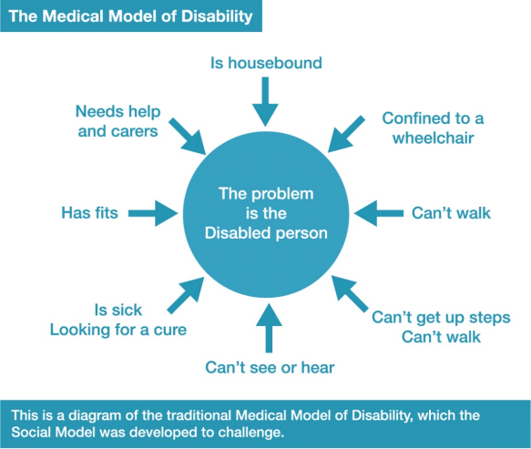
The Diagram describes the Medical Model of Disability with the central idea here that ‘the problem is the Disabled person’ and these factors referring to a person are pointing towards them: Is housebound, Confined to a wheelchair, Can’t walk, Can’t get up steps, Can’t see or hear, Is sick/looking for a cure, Has fits, Needs help and carers. This is a diagram of the traditional Medical Model of Disability, which the Social Model was developed to challenge.

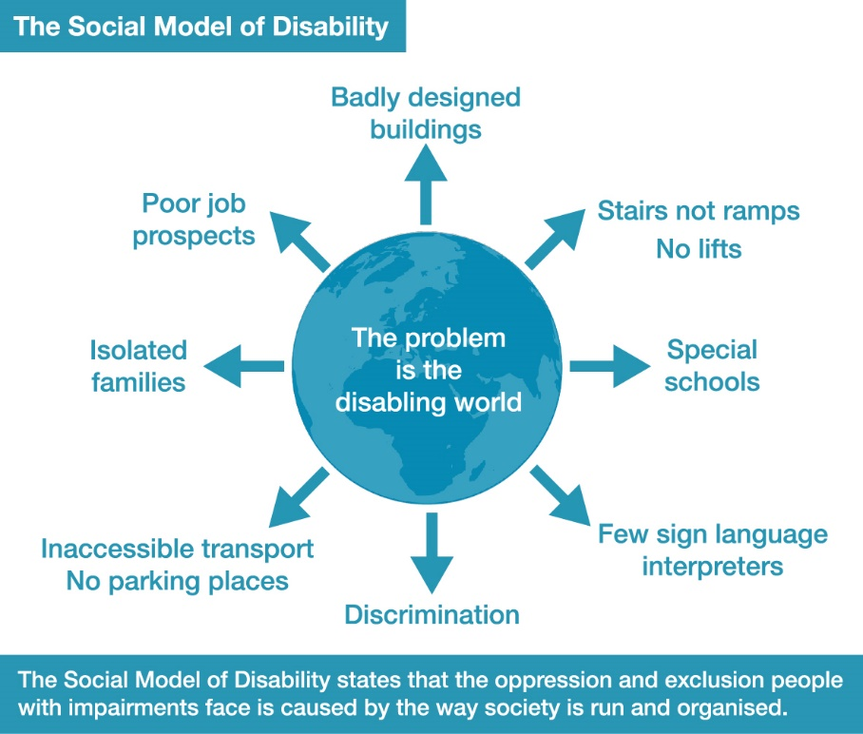
This Diagram describes the Social Model of Disability with the central idea that ‘the problem is the disabling world’ and these factors are pointing away from it: Badly-designed buildings, Stairs not ramps/No lifts, Special schools, Few sign language interpreters, Discrimination, Inaccessible transport/No parking places, Isolated families, Poor job prospects.

Activity 3: Follow Up Identifying Barriers
Analysing Barriers and putting forward solutions is one of the most powerful tools we have in the Disability Movement to bring about both local and structural change.
For your country/local area fill in barrier “bricks” e.g. attitudes, environments and organisation that prevent the following impairment groups from being included in society. Use 1 grid for each of these 7 impairment groups. Pick 2 from a) to g)
a) Ambulant impaired, stick, crutch or wheelchair user
b) Neuro-diverse-Autistic Continuum
c) Learning Disabled/Learning Difficulty
d) Mental Health System User/Survivor
e) Sensory Impaired-Blind People/ DeafBlind People
f) Deaf People/ Hard of Hearing People
g) Long term sick/metabolic condition/cancer survivor
For each of the 2 grids identify barriers on different bricks in the wall for A: Environment, B: Attitude, C: Culture, D: Organisation, E: Legislation, F: Other.
Come up with barriers from beyond the person’s impairment which are preventing them being fully included. (Make 2 copies and complete for 2 impairment groups you know.)
Activity 4: Once completed, examine the barriers and understand how much of an overlap there is. Pick 6 or more different barriers you have identified on your 2 sheets and explain how these barriers could be solved, be minimised or got rid of in your society.
 | Barrier 1 | Barrier 2 | Solutions
A. Barriers of Environment

B. Barriers of Attitude

C. Barriers of Culture

D. Barriers in Organisation

E. Barriers of
Legislation

F. Other barriers

A Useful Tool for creating an understanding of Disability Equality: Ways of undertaking Barrier Activity In the future
Once you have explained the shift from Traditional/Medical thinking and shown one or two films on it, undertake this activity. You can do this in many different ways.
In a large group you can give out brick shaped cards and felt pens or post-it notes and pens to smaller sub-groups or people grouped around tables. Allocate one of the impairment groups to each sub-group. Tell them to come up with barriers from beyond the person’s impairment which are preventing them being fully included. Read them all out once stuck up to form a wall of barriers. Ask are they all different or overlapping for all barriers?
There will be a large amount of overlap, showing the common discrimination and oppression disabled people face.
Mix up the barrier cards or post-its. Give them out to the sub-groups and get them to come up with solutions for a selected number of barriers.
This can be extended when training staff at a school, health centre, municipality or employer.
Ask participants to choose the main disabling barriers and to develop as a plan for what can be done to address the barriers, in the short term-next few months, middle term 6 -18 months and long term 3-5 years. This can then form the basis of a Disability Inclusion Action Plan.

The Human Rights approach to Disability
In 1948 the Newly formed United Nations came together under the influence of Eleanor Roosevelt and in the wake of the horrors of the Second World War adopted the Universal Declaration of Human Rights. This did not mention disabled people just grouped us as part of the ‘other’ category.
It represents the universal recognition that basic rights and fundamental freedoms are inherent to all human beings, inalienable and equally applicable to everyone, and that every one of us is born free and equal in dignity and rights. Whatever our nationality, place of residence, gender, national or ethnic origin, colour, religion, language, or any other status, the international community on December 10 1948 made a commitment to upholding dignity and justice for all of us.
Building on the achievements of the UDHR, the International Covenant on Civil and Political Rights, and the International Covenant on Economic, Social and Cultural Rights entered into force in 1976. The two Covenants have developed most of the rights already enshrined in the UDHR, making them effectively binding on States that have ratified them. They set forth everyday rights such as the right to life, equality before the law, freedom of expression, the rights to work, social security and education. Together with the UDHR, the Covenants comprise the International Bill of Human Rights.
Over time, international human rights treaties have become more focused and specialized regarding both the issue addressed and the social groups identified as requiring protection. The body of international human rights law continues to grow, evolve, and further elaborate the fundamental rights and freedoms contained in the International Bill of Human Rights, addressing concerns such as racial discrimination, torture, enforced disappearances, disabilities, and the rights of women, children, migrants, minorities, and indigenous peoples.
The United Nations Convention on the Rights of Persons with Disabilities (UNCRPD) was adopted in December 2008 by the United Nations following 5 years of discussions at the Ad Hoc Committee that drafted the Convention. As diplomats did not know about these issues Disabled People’s Organisations and Non-Government Organisations (NGOs) had the main input in drafting the Convention making it the first Convention in History to be drafted by those who it was about. The Convention was said to bring no new rights, but it certainly does bring new rights in practice.
The Convention enshrines a number of substantive provisions that bring new challenges to conventional human rights theory and jurisprudence. The most challenging being the right to be recognized as an equal person before the law (article 12) closely followed by the right to independent and community living (article 19). However, states parties obligations relating to accessibility (article 9) and reasonable accommodation (articles 2 and 5) are equally revolutionary, not to speak of the right to inclusive education (article 24). Some of the dialogues with states parties in the course of reviewing their reports showed that there is a deep misunderstanding relating to the scope and content of state obligations under these and other provisions of the CRPD.
It has been argued by Theresia Degener and Gerard Quinn that while the ‘social model’ was very useful in building the Disability Movement and creating a space for the UNCRPD and disabled people to struggle for equal treatment that the UNCRPD, as a human rights document goes farther than the social model.
We in the CDPF agree, although we still think the fundamental change in disabled people’s lives was the shift from a medical model to a social model approach. We agree that human rights go further and that is why we have argued for a social model/human rights approach.

What is the difference between the social and the human rights model of disability and why is the CRPD a manifestation of the latter?
They offer 6 arguments and some of these make a lot of sense. Which is why CDPF combines the social model approach as human rights are inherent, universal, inalienable, indivisible, rather than spending a lot of time on theoretical arguments.
1.“Human dignity is the anchor norm of human rights. Each individual is deemed to be of inestimable value and nobody is insignificant. People are to be valued not just because they are economically or otherwise useful but because of their inherent self-worth. The human rights model focuses on the inherent dignity of the human being and subsequently, but only, if necessary, on the person’s medical characteristics. It places the individual centre stage in all decisions affecting him/her and, most importantly, locates the main ‘problem’ outside the person and in society.”
The social model merely explains disability, the human rights model encompasses the values for disability policy that acknowledges the human dignity of disabled persons. Only the human rights model can explain why human rights do not require absence of impairment. The CRPD reflects this message in its preamble and in the language of its articles. E.g., when the universality of all human rights for all disabled persons is reaffirmed, or when it is recognized that the human rights of all disabled persons, including those with more intensive supports needs, have to be protected. The article on the rights to equal recognition as a person before the law with equal legal capacity is of course another example of this assumption.
2.While the social model supports anti-discrimination policy civil rights reforms, the human rights model of disability is more comprehensive in that it encompasses both sets of human rights, civil and political as well as economic, social, and cultural rights. The social model of disability served as a stepping-stone in struggles for civil rights reform and anti-discrimination laws in many countries. Meanwhile, the social model of disability has become officially recognized by the European Union as the basis for its disability policy.
3.Whereas the social model of disability neglects the fact that disabled persons might have to deal with pain, deterioration of quality of life and early death due to impairment, and dependency, the human rights model of disability acknowledges these life circumstances and demands them to be considered when social justice theories are
developed.
- The social model of disability neglects identity politics as a valuable component of disability policy whereas the human rights model offers room for minority and cultural identification. The social model also has been criticized for neglecting identity politics as a valuable component of emancipation. Identity politics can be defined as politics which values and cares for differences among human beings and allows persons to identify positively with features which are disrespected in society. Gay pride, black pride, feminism, or disability culture are manifestations of these identity politics.
- Viewing disability as a human rights issue is not incompatible with prevention of health conditions as long as prevention respects the rights and dignity of people with disabilities, for example in the use of language and imagery. … Preventing disability should be regarded as a multidimensional strategy that includes prevention of disabling barriers as well as prevention and treatment of underlying health conditions.
- The human rights model offers a roadmap for change. From early on, social model proponents and critics acknowledged the close link between poverty and disability. Indeed, the interrelatedness of poverty and disability was put forward as evidence that not only disability but also impairment is a social construct. There is now abundance of evidence that impairment and poverty are mutually reinforcing. Impairment may increase the risk of poverty and poverty may increase the risk of impairment.

Conclusion
To paraphrase a well-known philosopher- ‘Theorists have argued about the world; our job is to change it’.
The United Nations Convention on the Rights of Persons with Disabilities gives us a very clear road map on what needs to be done to develop disabled people’s rights as nearly all countries have now ratified the UNCRPD.
Go to https://social.desa.un.org/issues/disability 187 countries have ratified the UNCRPD.
Full text of the UNCRPD https://www.un.org/development/desa/disabilities/convention-on-the-rights-of-persons-with-disabilities/convention-on-the-rights-of-persons-with-disabilities-2.html
UNCRPD in Brief https://www.un.org/development/desa/disabilities/convention-on-the-rights-of-persons-with-disabilities/the-convention-in-brief.html
Human Rights Handbook for those with developmental impairments
https://hpod.law.harvard.edu/pdf/we-have-human-rights.pdf

Activity 5:
At whatever level you can, access the above to study the UNCRPD, until you understand the key rights you are getting as a disabled person.
To implement these rights is our key objective and for that we need a strong, effective and involved disabled people’s movement in each country, region and district. In the next 5 modules we will examine ways of achieving this.

https://www.researchgate.net/publication/283713863_A_human_rights_model_of_disability

