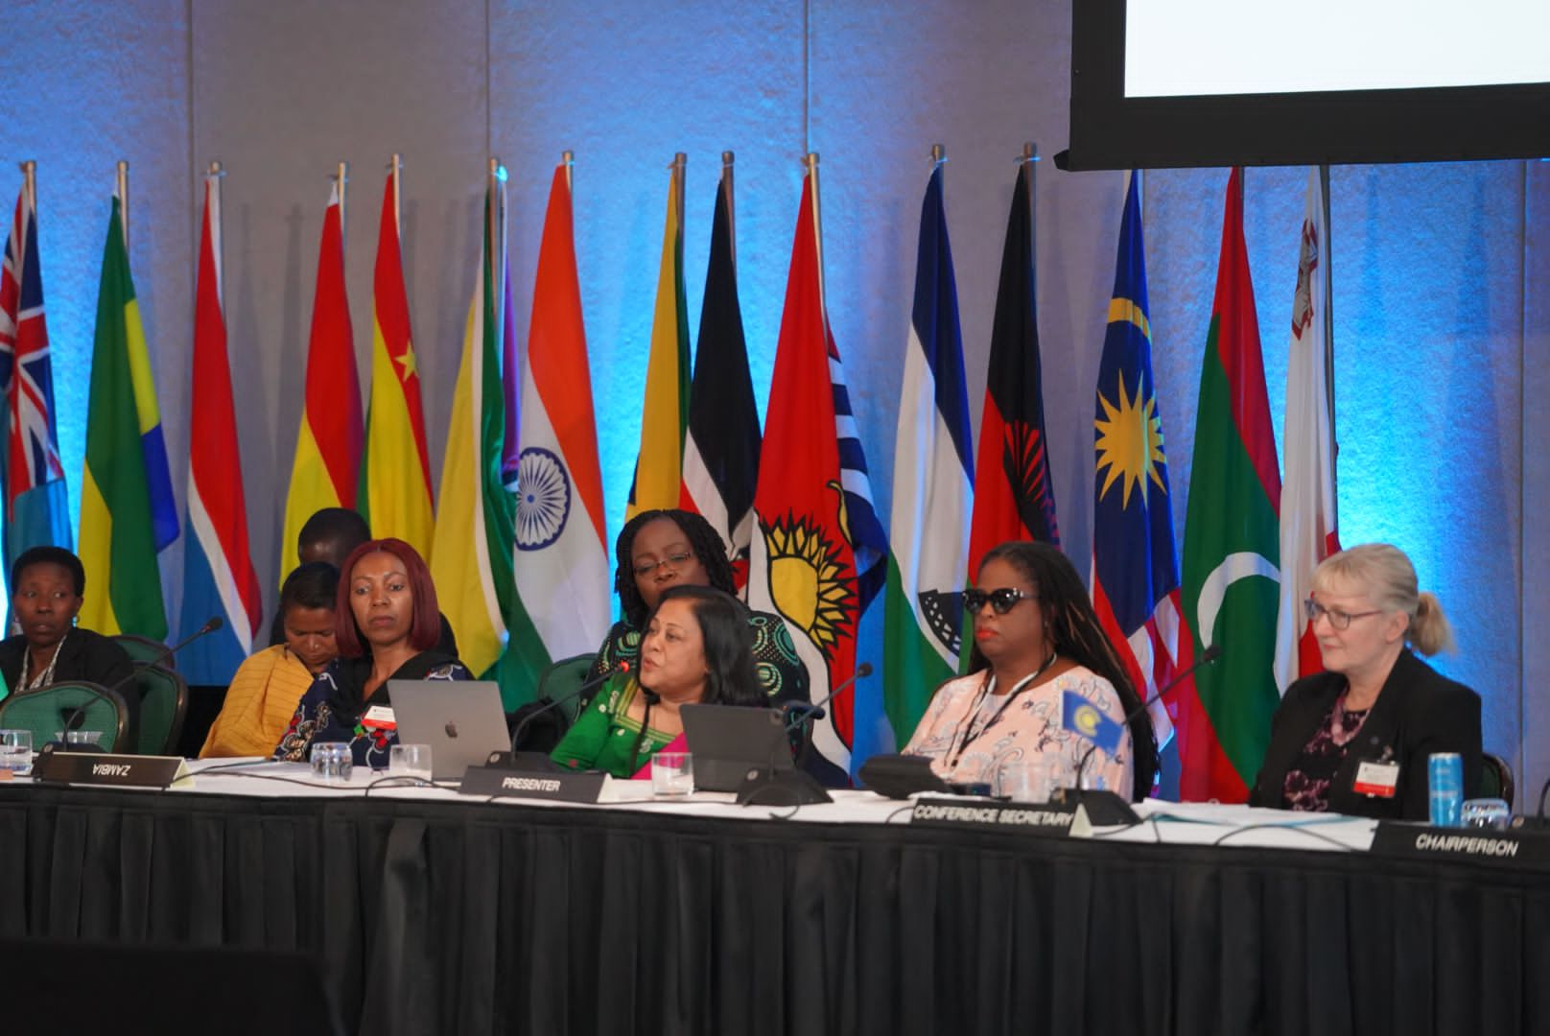

Paper on “Woman & Disability” developed with Human Rights Unit of the Commonwealth Secretariat was delivered by CDPF Vice Chairs Dr. Sruti Mohapatra (4th from left) & Kerryann Ifill (to Sruti’s right) during the session on Gender Equality at the 13 Commonwealth Woman Affairs Ministers Meeting in Nassau, Bahamas on 23 August 2023 (Photo Credit Dr. Sruti Mohapatra).

IN THIS ISSUE:

01. DISABLED PEOPLE / PEOPLE WITH DISABILITIES: WHAT IS IN A NAME?

02. CONFERENCE OF STATES PARTIES TO THE CRPD: UNHQ, NEW YORK: 13 - 15 JUNE 2023

03. COMMONWEALTH WOMEN’S AFFAIRS MINISTERS MEETING: BAHAMAS, AUGUST 2023

04. FEATURE ARTICLES 01: CHASING MY CHILDHOOD DREAM: TRIUMPHING OVER ADVERSITY IN THE UNFAVOURABLE UGANDAN EDUCATION SYSTEM

05. SITUATION RFPORT 01: NATIONAL CURRICULUM FRAMEWORK FOR SCHOOL EDUCATION – INDIA

06. SITUATION REPORT 02: MALAWI INITIAL REPORT REVIEWED BY CRPD COMMITTEE

07. CDPF NOTICES:

(I). COMMONWEALTH SCHOLARSHIPS – 2024

08. UN CHARTER BODY / TREATY BODY REVIEW OF COMMONWEALTH COUNTRIES.

09. RECOGNITIONS/ACKNOWLEDGEMENTS

109. UPCOMING EVENTS…

(I). MEETING OF COMMONWEALTH YOUTH MINISTERS

(II). COP

**DISABLED PEOPLE / PEOPLE WITH DISABILITIES: WHAT IS IN A NAME?**

PAULA TESORIERO is the Chief Executive at WHAIKAHA - The New Zealand Ministry of Disabled People. Paula and is a disabled parent of three children, a former Paralympian Gold Medallist and has held management posts in the private and public sector. Paula informed us at the recent United Nations CoSP14 that the choice of the name ‘**MINISTRY OF DISABLED PEOPLE**’ was not an accident, but a conscious decision based on a social model understanding of disability. This is a welcome and important decision.

We agree the use of the term ‘**DISABLED PEOPLE’** in the Commonwealth Disabled People’s Forum (CDPF) and have twice voted to keep this in our name. ‘**PERSONS WITH DISABILITY**’ is both inaccurate and a misnaming of a ‘**SOCIAL MODEL**’ approach to our human rights as people with long term impairments.

This summer in Korea there is an attempt to re-unify Disabled People International 42 years after its founding conference in Malaysia in 1981. One of the key decisions of that founding conference was to distinguish between impairment and disability.

**“IMPAIRMENT” -** is the functional limit within the individual caused by physical, mental or sensory impairment.

**“DISABILITY” -** is the loss or limitation of opportunities to take part in the normal life of the community on an equal level with others due to physical and social barriers.

To be disabled you must have a long-term impairment, but having such an impairment you are disabled, not by the impairment, but by physical and social barriers that are socially and economically created. This means people with very different impairments can unite and provide solidarity for each other against the discrimination and oppression they experience, as cross impairment organisations. We call ourselves **DISABLED PEOPLE**.

If, on the other hand, you think people with disabilities are ‘**PEOPLE FIRST’** putting the person first, this detracts from our solidarity in challenging the barriers. When people ask what your disability is they usually mean what is your impairment. What we want is for the world to view us as **DISABLED PEOPLE** with a wide variety of impairments who are oppressed by attitudinal, environmental and organisational barriers that have to be addressed by Governments and Society.

By identifying as disabled people in cross-impairment organisations we learn how to meet each other’s needs and can provide solidarity and action to get those needs met. This makes us much stronger as a Movement. Calling ourselves ‘**PEOPLE WITH DISABILITIES**’ puts the locus back on the impairment restricting our opportunities. Just saying that, as persons with disabilities we have human rights, such as under the UNCRPD does not deal with the confusion.

If like CDPF and the Government of New Zealand, we call ourselves ‘DISABLED PEOPLE’, it is clearer we face a common oppression ‘**DISABILISM**’, which is handed out to the wide range of people with impairments through the barriers we face that are socially created like stigma, negative attitudes and practices and gives Disabled People the solidarity and common cause to challenge these. This in no way detracts from our impairment specific needs, particular types of habilitation and rehabilitation, access needs, support and reasonable adjustments which we still need to struggle to achieve.

There is a nod to this ‘**SOCIAL MODEL’** thinking in the preamble and in Article 1 of UNCRPD, but the repeated use of **PEOPLE WITH DISABILITIES** blurs the distinction between impairment and socially created disability.

*Recognizing* that disability is an evolving concept and that **disability results** from the interaction between **persons with impairments** and **attitudinal and environmental barriers that hinders their full and effective participation in society on an equal basis with others.** (UNCRPD Preamble [e])

**Persons with disabilities** include **those who have long-term physical, mental, intellectual or sensory impairments which in interaction with various barriers may hinder their full and effective participation in society on an equal basis with others**. (UNCRPD Article 1)

Despite the clear juxtaposing of disability and impairment laid out in the UNCRPD, most people describe their **impairment as their disability,** rather than the barriers beyond them that lead to their lack of equality as **disabling**.

People First language originated in the USA from a Parents’ Movement that sought to see their disabled children as children first, not viewed primarily as the medicalisation of their children’s impairment which separated them from other children. The problem of this approach was it ignores the social discrimination and weakens the recognition of being equal but different.

However, those who first came up with the ‘**SOCIAL MODEL**’ approach in the 1970s, the Union of Physically Impaired Against Segregation (UPIAS) did not reject our medical needs being met. They instead stated our lives should not be viewed through this lens, but that we should focus on the barriers of discrimination, stigma and denial of opportunities as **DISABLED PEOPLE**. Since the beginning of humanity impairment has always been with us. What has changed the need to recognise and unite around removing disabling barriers in our lives. Not having ‘**DISABLED PEOPLE**’ as a unifying name leaves ‘**PEOPLE WITH DISABILITIES’** open to division and confusion.

Calling ourselves **DISABLED PEOPLE** makes it clear we are part of a common struggle for our Human Rights.

**RICHARD RIESER**, CDPF - General Secretary & CEO - World of Inclusion Ltd, UK

**CONFERENCE OF STATES PARTIES TO THE CRPD, UNHQ - NEW YORK: 13 - 15 JUNE 2023**

NOTE: Photo Credit for this article: Sarah Kamau & Gaudence Mushimyimna

INTRODUCTION

Sixteenth Session of the Conference of State Parties (16COSP) to the United Nations Convention on the Rights of Persons with Disabilities (UNCRPD) was held this year under the OVERARCHING THEME: “*Harmonizing National Policies and Strategies with the CRPD: Achievements and Challenges”.* Sub-Themes were:

(1). Ensuring equal access to and accessibility of sexual and reproductive health services for persons with disabilities,

(2). Digital accessibility for persons with disabilities

(3). Reaching the under-represented groups of persons with disabilities.

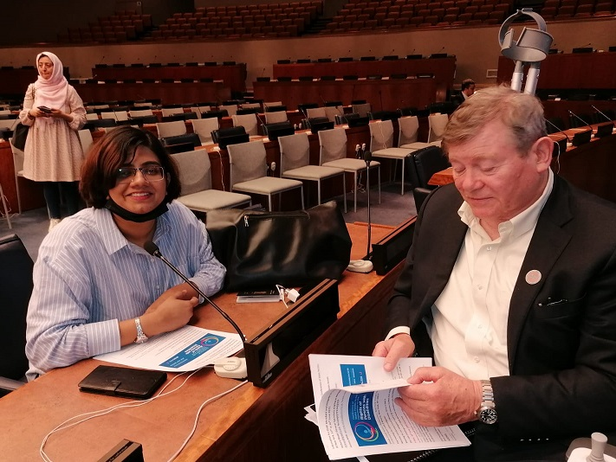

CDPF Exec members Saista Parwin and Richard Rieser

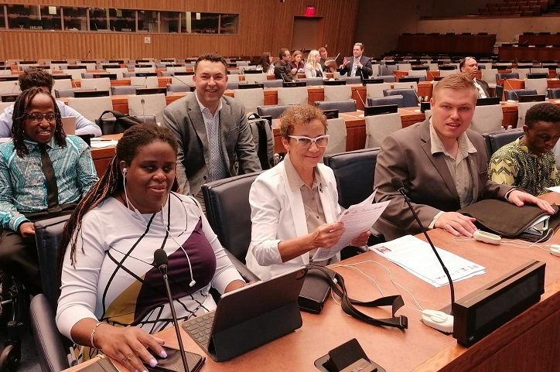

CDPF exec members Kerryann, Emile and Kihembo with

Barbados’ Roseanna (next to Kerryann) and Chris Gilkes behind, with Emile’s PA to his right

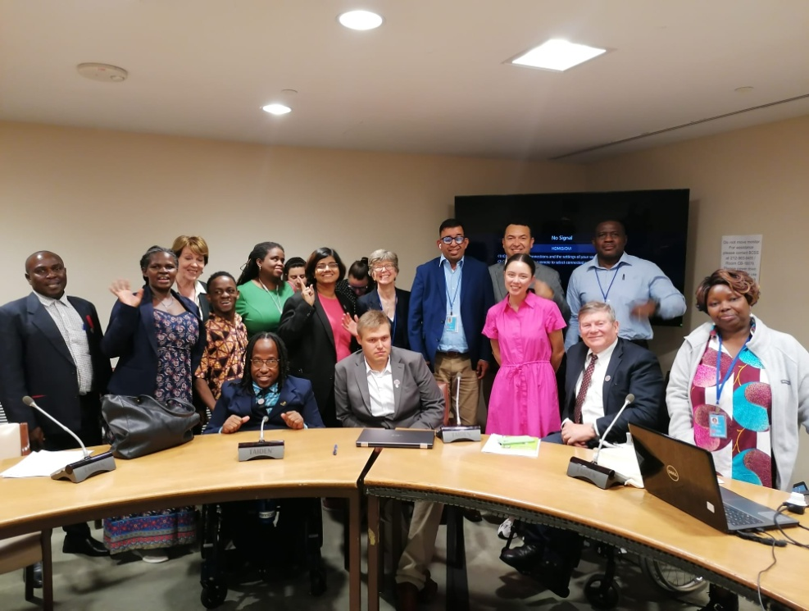

L-r back row Kihembo PA, Gaudence, Richard PA, Kihembo, Kerryann, unknown, Saista, unknown, Penny Innes, Ganesh, Emile PA, unknown

L-r front row Chris Gilkes (Barbados), Emile, Charlotte Young (Australia), Richard, Sarah

CPDF representation at the 16COSP was a success with three side meetings of CDPF with the collaboration of UKFCDO, Commonwealth Secretariat, Government of Barbados, African Albinism Federation and Disability Rights Fund. CDPF delegates have show case its presence throughout the conference and made successful intervention. Detailed side event reports appear below.

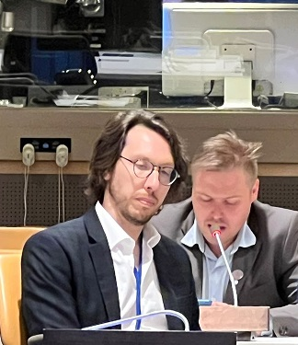

Emile (right)

1. **EVALUATING DPO/OPD COLLABORATION WITH STATE PARTIES ON IMPLEMENTING ELEMENTS OF THE UNCRPD ACROSS THE COMMONWEALTH**

Wednesday, 14 June 2023 from 01.15pm – 02.30pm (EST) - (In Person + Zoom + Recorded)

Sponsors: Governments of Barbados, Government of Kenya, Albinism Africa, Disability Rights Fund & organised by Commonwealth Disabled People's Forum.

Chair: **Richard Rieser -** General Secretary - CDPF.

Speakers: **Hon. Kirk Humphrey -** Minister of People Empowerment and Elder Affairs, Barbados; **Kerryann Ifill** – Vice Chair - CDPF & President, Barbados Council of the Disabled; **Moses Kamau -** Social Protection Department, Ministry of Labour, Kenya; **Sarah Kamau –** Chairperson,CDPF & United Disabled Persons of Kenya; **Ero Ikponwosa -** Executive Director, Albinism Africa (on the Kenyan Model of challenging stigma); **Rasanjali Pathirage -** CDPF Executive (South Asia Regional Rep) & Disability Organisation Joint Front, Sri Lanka.

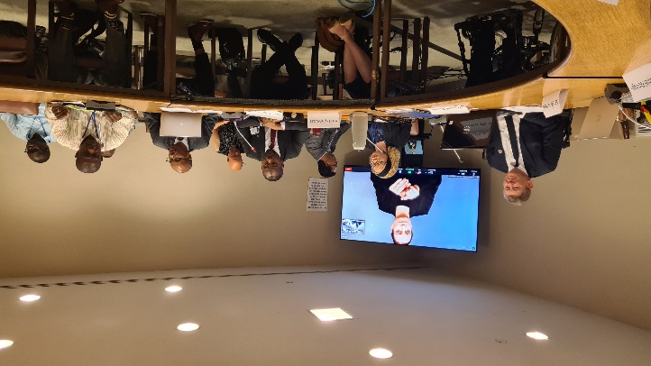

L-r Richard, Ero Ikponwosa, (others tbc)

There was a very nuanced and interesting dialogue with representatives of the Barbadian and Kenyan Governments explaining how working with DPOs had been fundamental in how they were approaching implementation of UNCRPD. This was balanced by DPO reps from these two countries explaining the gains made in terms of being taken seriously as the representative voice of Disabled People. In areas such as registration, moving away from charity and medical model thinking, but both said there was still a long way to go.

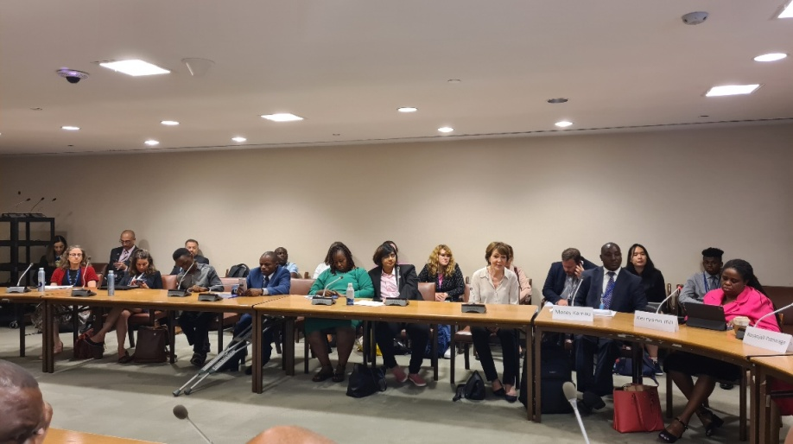

L-R Kihembo (3rd from left), unknown, Rose, Saista, Richard’s PA, Moses Kamau, Kerry Ann

Sri Lanka reported far less collaboration with the Disability Rights Bill stuck in Parliament for many years. Albinism in Africa explained how discrimination had ceased because of a strong Government response in Kenya led by empowered self-advocates. The CDPF raised the results of a member’s survey from last year showing that more that half of their national umbrella DPOs members thought core funding from Government so they could carry out their representative role under 4.3 and 33.3 was essential. Barbados had done this Kenya was still to do it.

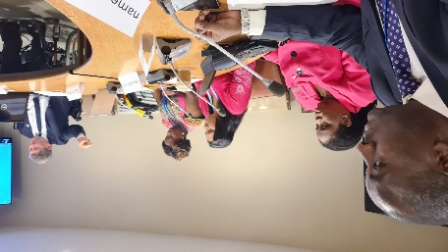

L-R: Moses from the Kenyan government;, Kerryann, Rasanjali, Sarah, Richard

Another theme was the need for Umbrella organisations to be cross impairment and unite around their common oppression regardless of type of impairment. People are disabled by barriers not because of having impairment. This is why we call ourselves COMMONWEALTH DISABLED PEOPLE’S FORUM.

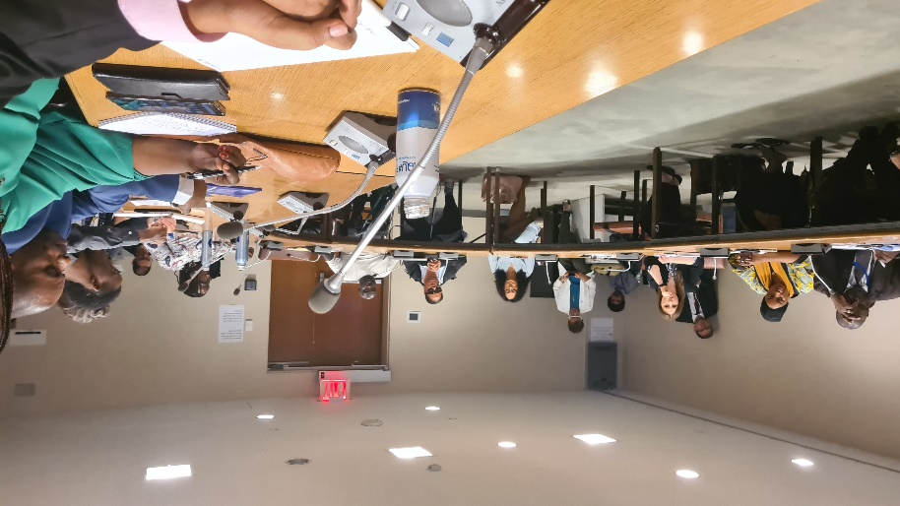

The other end of the room; Tino central, Kihembo 2nd from right

We heard from a floor speaker that this was why New Zealand had adopted the name MINISTRY OF DISABLED PEOPLE. General setting up collaborative structures of DPOs and Government was useful, but when we come up against Government blocking, we still need to use the tools of struggle. Remember Rights are not given but have to be struggled for by those who will benefit.

Partial Signed recording: <https://youtu.be/lFUOmHpi_qU>

Audio Recording: <https://commonwealthdpf.org/wp-content/uploads/2023/06/CDPF_collaboration1.mp3>[Leaflet for Meeting](https://commonwealthdpf.org/wp-content/uploads/2023/06/Flyer-COSP-16-CDPF-Side-Meeting-Collaboration-1-15-to-2.30-14th-June-Revised.docx)

For more information: Contact Gen. Sec CDPF [rlrieser@gmail.com](mailto:rlrieser@gmail.com)

1. **DEVELOPING WAYS OF CREATING EQUAL ACCESS FOR DISABLED GIRLS AND WOMEN TO SEXUAL AND REPRODUCTIVE HEALTH SERVICES AND GREATER EQUALITY.**

Thursday, June 15 2023 from 08.15am -09.30am (EST) (In Person + Zoom + Recorded)

Sponsors:Foreign, Commonwealth & Development Office of United Kingdom, Disability Rights Fund, Commonwealth Secretariat & organised by Commonwealth Disabled People's Forum.

Chair: **Sarah Kamau,** CDPF –Chairperson & United Disabled Persons Kenya.

Speakers: **Gaudence Mushimiyimana,** CDPF Executive (Women's Rep) & Rwandan Organisation of Women with Disabilities; **Diana Dalton,** Head of Gender and Equalities Dept, FCDO, UK; **Dr. Shavana Haythornthwaite,** Adviser and Head, Human Rights Unit, Commonwealth Secretariat; **Saista Parwin,** CDPF Executive (Youth Rep) & Swabhiman Foundation, India; **Dr. Richard Rieser,** CDPF General Secretary on Men’s role as allies.

A very thorough and insightful discussion on sexual and reproductive health rights for disabled women and girls and wider issues of gender equality and the role of men as allies was held. Experiences from a number of Commonwealth countries were recounted by the disabled speakers and the Commonwealth Secretariat pleas for the enforcement of Human Rights for Disabled Women and Girls to have choice and the right to sexual and romantic relationships, to have children or terminations, access to contraception and to force the stopping of sterilization, alongside Availability, Acceptability and Support for Access to Public Health e=Education, Emergency Services.

Nothing would change in reality until non-disabled people across countries such as India changed their attitudes.

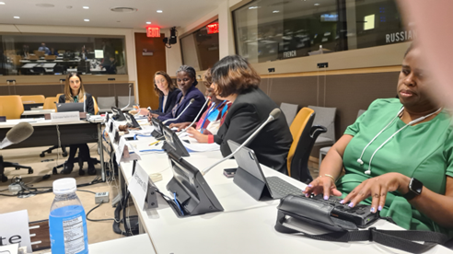

L-R Shavana Haythornethwaite (ComSec), Diana Dalton (FCDO), Gaudence, Sarah, Saista

The UK Foreign Commonwealth Office spoke about their stance on challenging the global roll back on women’s rights and pointed to a number of initiatives they were involved in to empower disabled women and girls and community based initiatives, including for men to change their sexist behaviors.

Male members especially leaders of the Disabled People’s Movement must be held accountable for their sexism and change to allies in the struggle for Disabled Women and Girls Rights. CDPF survey had shown the General Women’s Movement had little connection with Disabled Women’s Issues. This has to change! The chair pointed participants to the CDPF [Commonwealth Women’s Declaration](https://commonwealthdpf.org/wp-content/uploads/2023/03/CDPF-WOMEN-DECLARATION-Version-1-24_03_23-1.docx) and urge all to redouble their efforts to achieve full equality for Disabled Women and Girls

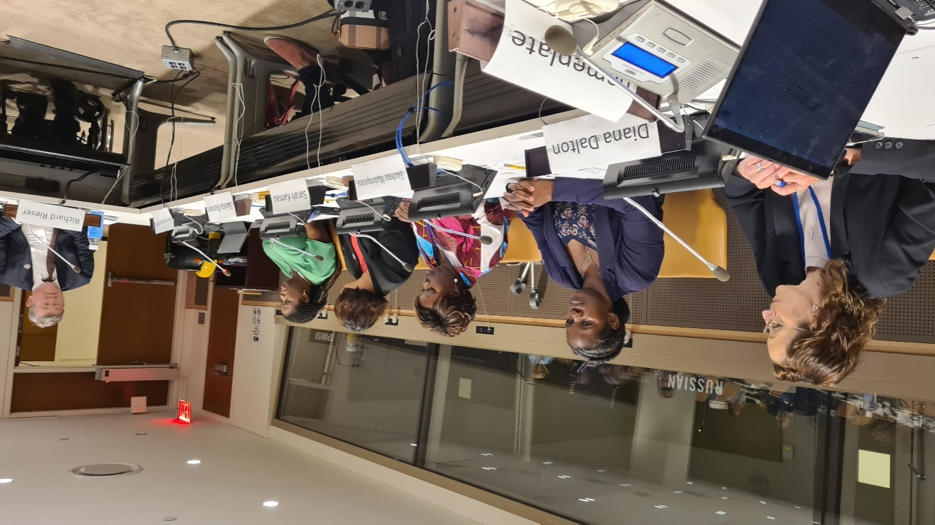

Left to right: Diana Dalton, Gaudence, Sarah, Saista, Richard

You can also find this event on our UN WebTV

[And our UNDESA YouTube Channel:](https://youtu.be/c-foNnLv-tg) https://youtu.be/c-foNnLv-tg

On [www.Commonwealthdpf.org/News](http://www.Commonwealthdpf.org/News)[Flyer for meeting](https://commonwealthdpf.org/wp-content/uploads/2023/06/Flyer-Developing-ways-of-creating-Equal-Access-for-Disabled-Girls-and-Women-to-Sexual-and-Reproductive-Health-Services-and-Greater-Equality-4.docx)

More information from CDPF Gen Sec [rlrieser@gmail.com](mailto:rlrieser@gmail.com)

**03: DISABLED YOUTH INVOLVEMENT, AWARENESS, EMPOWERMENT AND LEADERSHIP IN DPOS / OPDS ACROSS THE COMMONWEALTH**

Wednesday, Jun 15 2023 from 03.00pm - 04.45pm (EST) (In person + Zoom & Recorded)

Sponsors:Government of Barbados, Foreign, Commonwealth & Development Office of United Kingdom & organised by Commonwealth Disabled People's Forum.

Chair: **Saista Parwin** – CDPF Executive (Youth Rep) & Swabhiman Foundation, India.

Speakers: **Penny Innes** - Head of Disability Inclusion team, FCDO UK; **Kihembo Wilbert** – CDPF Executive (Youth Rep) & Voice of Youth, Uganda; **Emile Gouws,** CDPF Executive (Underrepresented Groups Rep) & Autism, South Africa; **Christopher Gilkes -** Public Relations Officer, Council for the Disabled, Barbados; **Charlotte Young -** Council for youth with Disabilities, Australia; **Ganesh Singh -** CDPF Executive & Council of Organisations for Persons with Disabilities, Guyana; **Richard Rieser -** General Secretary, CDPF on Training Disabled Youth for Leadership project.

Ensuring Disabled Youth are aware of their rights, become empowered, engage with DPOs/OPDs and join the struggle to implement their rights is crucial. Number of Disabled Children and Youth with long term impairments in the Commonwealth is growing and their exclusion from education, training, employment, health and wellbeing is increasing, especially in low and middle income countries. The World Health Organisation now identify 16% of the population as disabled people, 1.3billion people. In the Commonwealth where 60% of the population are aged 30 years or under, there are likely to be 230-250 million disabled children and youth in the Commonwealth. 2023 is Commonwealth Year of Youth. The Commonwealth Disabled Peoples Forum (CDPF) which represents Disabled People's Organisations in 50 of the 58 countries in the Commonwealth wants this year to make a difference. Two thirds of the Commonwealth population are under the age of 30.

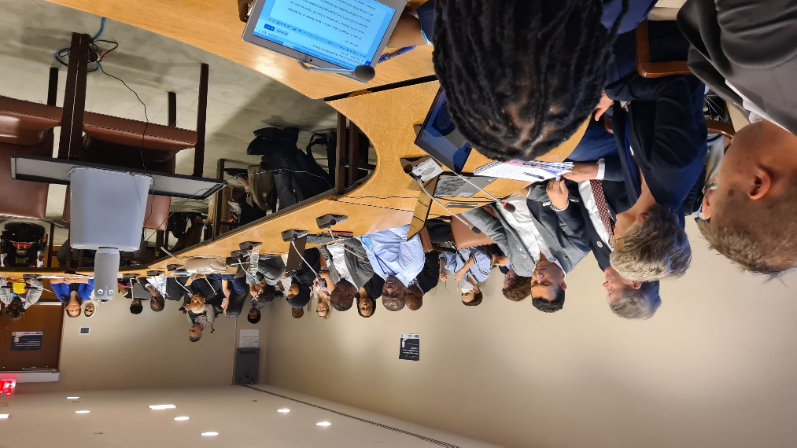The presentations and discussion were vibrant and full of hope. We need to get to the grassroots especially in hard to reach areas and train and recruit disabled youth. Drastic action is needed for a drastic problem especially for neurodiverse and cognitively impaired youth across the Global South.

In the high income countries especially inter-sectionality needs to be a watchword, especially when working with indigenous disabled youth. In large economies such as India we have to get employers and Governments to understand disabled youth can bring profits through their skills. We must use digital media as a tool to reach disabled youth and to empower them as in Uganda. In South Africa real change can only come from the bottom up involving those hitherto excluded. We heard how in Guyana the umbrella DPO had embarked with support from USAID on a several year project to train and empower disabled youth and bring them into DPO leadership. In Barbados, the Disability Council has been engaging for a number of years through youth conferences and training projects on empowerment. The Australian Council for Youth with Disabilities had held regular conferences and has been presenting the views gathered to the Government.

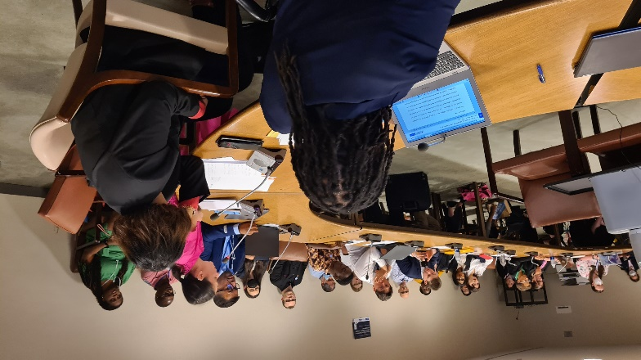

CDPF Youth Leadership Training was explained and publicised. It was emphasised this would be based on a paradigm shift and capacity building.

UKFCO were thanked for their support and complimented for their Disability Strategy which emphasises building and supporting the development of DPO voices which may take longer than quick fixes from NGOs, but because rooted in the community is likely to have far reaching and longer lasting impact especially if encouraging disabled youth involvement.

Video Link <https://www.youtube.com/watch?v=A5zzrdt_bYw>

Kihembo’s Video <https://youtu.be/m39XG1GxBGg>

[Meeting Leaflet](https://commonwealthdpf.org/wp-content/uploads/2023/06/COSP-16-Side-Meetings-run-by-Commonwealth-Disabled-People.docx)

[CDPF Disabled Youth Manifesto](https://commonwealthdpf.org/manifesto-for-commonwealth-year-of-youth/)

More information Contact General Secretary CDPF [rlrieser@gmail.com](mailto:rlrieser@gmail.com)

(blank space – pages continue)

**13TH COMMONWEALTH WOMEN’S AFFAIRS MINISTERS MEETING (13WAMM)**

**NASSAU- BAHAMAS 21-23 AUGUST 2023**

NOTE: Photo courtesy for this article: Dr Sruti Mohapatra, Kerryann Ifill & Commonwealth Secretariat.

**Introduction**

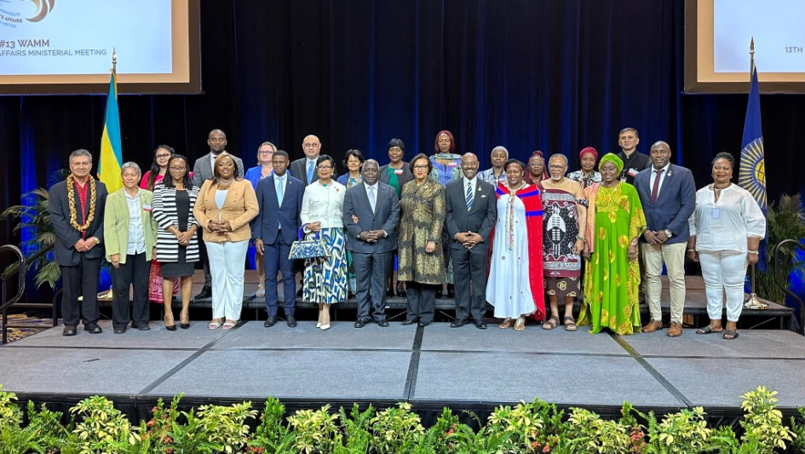The 13th Commonwealth Women’s Affairs Ministers Meeting (13WAMM) was held four years after the 12WAMM in 2019 in Nairobi, Kenya. During this time, the pandemic and climate change both had accelerated economic turmoil and political polarisation in the world. These events in turn adversely had impacted gender equality and the empowerment of women and girls globally. Ministers reflected on these developments and shared progress and initiatives from their countries designed to strengthen gender equality and the empowerment of all women and girls.

13WAMM called for stronger action on gender equality priorities in the face of intensifying global environmental and economic challenges. It was held at the Atlantis Paradise Island Resort in Nassau, the Bahamas, from 21 to 23 August 2023 under the theme ‘**Equality Toward a Common Future’**. 26 member countries participated through ministers, parliamentarians and senior secretaries from ministries. The Prime Minister of The Bahamas, Hon. Philip Davis KC addressed the opening ceremony. Hosted by the Government of the Bahamas, the meeting reviewed progress made towards achieving four Commonwealth priorities for gender equality and women’s empowerment. The four priorities are:

1. Women in leadership;
2. Women’s economic empowerment;
3. Ending violence against women and girls; and
4. Gender and climate.

At this year’s meeting, a special focus was on the inclusion of women and girls with disabilities.

Agenda and Structure of WAMM

The Senior Officials Meeting took place on 21 August 2023 in Nassau and was chaired by the Hon. Obediah Wilchcombe, Minister of Social Services and Urban Development. The High-level Side Event on Transformative Leadership for Gender Equality and Women’s Empowerment was hosted by Mrs. Ann Marie Davis, Spouse of the Prime Minister of the Commonwealth of the Bahamas, as a high-level side event on 21 August 2023. 22 and 23 August 2023 saw intense discussions and interventions on the priority areas.

On 21 August 2023 a side event was hosted by Commonwealth Businesswomen’s Network (CBWN). It is an accredited organisation directly recognised by 56 governments across six continents committed to advancing UN Sustainable Development Goal 5 and the Commonwealth Charter focused on encouraging, enabling and embedding women in leadership and women’s economic empowerment through work in trade, talent and training. Kerryann Ifill, CDPF Vice Chair spoke on the occasion about CDPF, its vision, members and expounded on why CDPF prefers disabled people over persons with disabilities.

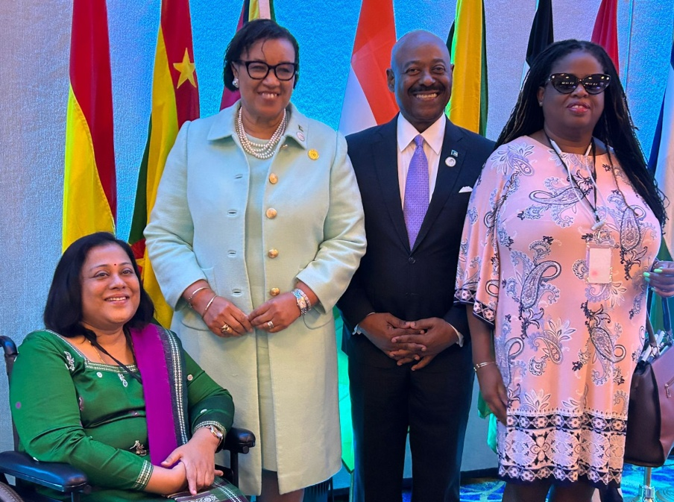

L-R Sruti, Right Hon. Patricia Scotland, (person tbc), Kerryann

On 22 August 2023 the opening plenary chaired by the Hon. Obediah Wilchcombe MP, Minister of Social Services and Urban Development Bahamas. The first session was addressed by the Right Hon. Patricia Scotland, KC, Secretary-General of the Commonwealth and the Hon. Aisha Jumwa, Cabinet Secretary, Ministry of Public Service, Gender and Affirmative Action, Kenya as the outgoing Chair of WAMM. It was followed by the session on Gender Equality in the Commonwealth – progress and ambition to 2030, where all member countries presented their report. The session was so long that the last session on Commonwealth Priorities for Gender Equality and Women’s Empowerment – Women in Leadership was shifted to 22 August 2023. The other session’s were Climate Change and Gender Equality – Commonwealth efforts to strengthen gender responsive climate action and Gender equality & disability inclusion.

On 23 August 2023, the last session of previous day was taken up. It was followed up by session on Empowering Women for a Sustainable Future; Commonwealth Priorities for Gender Equality and Women’s Empowerment – Ending Violence Against Women and Girls. The way forward was a closed session to finalise the outcome document.

**CDPF Participation and Intervention**

Com Sec Human Rights Unit developed a paper on Women and Disability to the 13th WAMM Conference in collaboration with CDPF. Dr. Sruti Mohapatra was selected as the first delegate Kerryann Ifill was the second delegate. The session on Gender Equality and Disability Inclusion commenced with the presentation on the paper on Gender Equality and Disability Inclusion by Dr. Shavana​ Haythornthwaite, Adviser and Head, Human Rights Unit from Governance and Peace Directorate of Commonwealth Secretariat. It was followed by the presentation of Vice Chair Sruti Mohapatra, following an introduction of CDPF by Kerryann Ifill.

Quoting from the inaugural speeches of the Prime Minister and, Social and Urban Development Minister of Bahamas, she expressed happiness over mention of women with disabilities as a group. Quoting from Secretary General’s speeches, from inaugural and in the plenary, she urged upon Commonwealth Ministers to come together to free disabled people from the shackles of poverty, hunger, illiteracy, poor health, isolation, exclusion and discrimination just as they had played a role in freedom of Nelson Mandela. She designated 13WAMM as a historic moment/event in the inclusion of the disabled in Commonwealth and the Commonwealth to lead a way for the world to see and achieve inclusion in Agenda 2030.

She defined the attributes of the population with disability, expounded how global agenda can only be achieved by the inclusion of the disabled, explained the survey results, outlined key priority areas for action, followed by asks to the governments. She advocated for the adoption of a Disability Inclusion Protocol to ensure disability Equality and Access is part of All Commonwealth deliberations, activities and policies and not just an add on; and reservations of a small proportion of national income for funding for DPOs to be representative, to be able to participate and express their voices in all national, regional and international meetings impacting lives of the disabled. She concluded urging Commonwealth country governments to move from equality to equity.

The special newsletter 9 looked beautiful standing on almost all the tables in the meeting during the session on Gender Equality and Disability Inclusion. Many delegates reached out with their appreciation for the facts in the document. Both the Secretary General and the Chair, expressed that CDPF delegates were able to catch the attention of the Commonwealth Ministers and Parliamentarians. The session had the maximum interventions. Both delegates were appalled by the use of the words “specially able” by one of the ministers present.

**Way Forward**

The two delegates, Sruti Mohapatra and Kerryann Ifill, suggest following follow-up actions:

1. Letter of thanks to all ComSec officials involved in the preparation of the paper.
2. Letters to all participants, delegation heads, reminding them of their commitments and the relevant sections of the outcome document.
3. Regular engagement with Bahamas, which holds the chair for next three years.
4. Regular engagements with ComSec on disability inclusion, gender equity and related areas.
5. Engagement with women affair ministers from all 56 countries of Commonwealth.
6. Preparation of a draft Inclusion Protocol for CHOGM 2024 by December 2023.
7. A section in every newsletter on the Way Forward action points undertaken in that time period towards CHOGM 2024 and 14WAMM.

**SRUTI MOHAPATRA -** CDPF Vice Chairperson & Swabhiman, Odisha, India.

**KERRYAN IFILL** -CDPF Treasurer & Barbados Council of the Disabled.

**SITUATION RFEPORT 01: NATIONAL CURRICULUM FRAMEWORK FOR SCHOOL EDUCATION**

The National Curriculum Framework for School Education (NCF) was developed to facilitate the implementation of the National Education Policy (NEP) 2020. It was released in April 2023 by Ministry of Education.

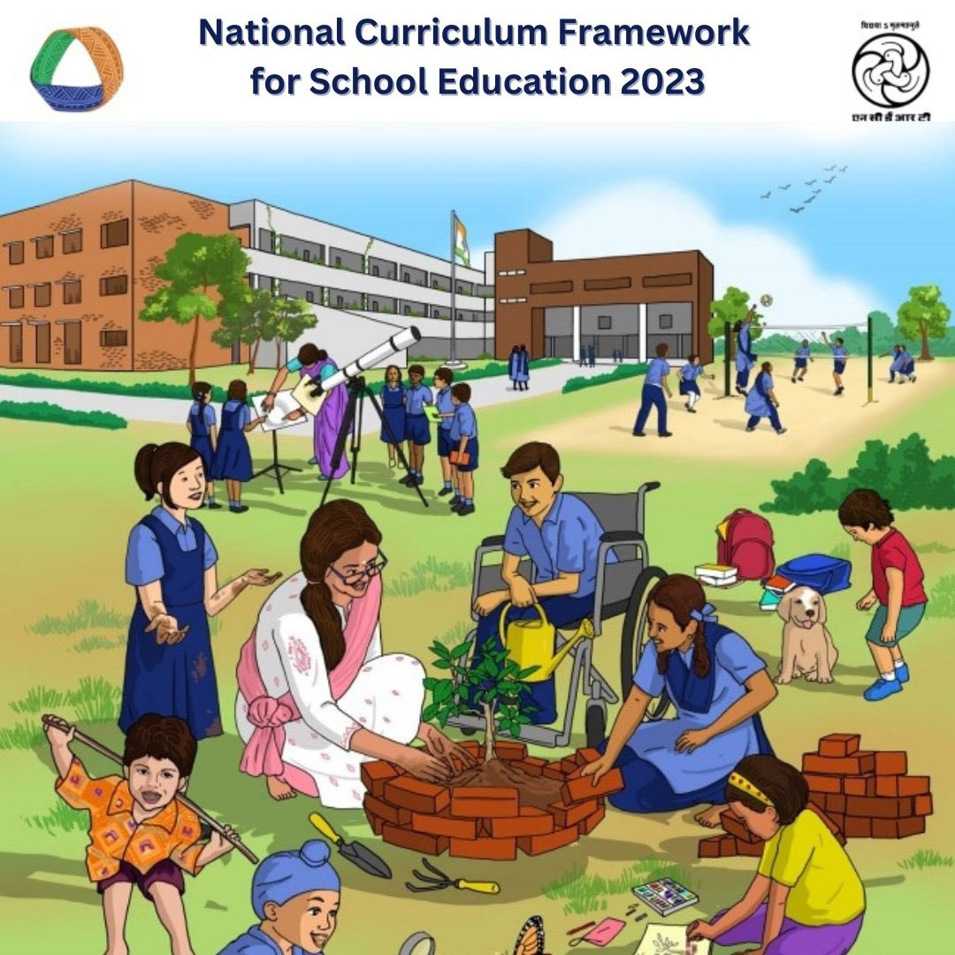

The NEP-2020 which was started by the Union Cabinet of India on 29 July 2020 outlines the vision of new education system of India. The new policy replaces the previous National Policy on Education, 1986 and is a comprehensive framework for elementary education to higher as well as vocational training in both rural and urban India. The policy aims to transform India's education system by 2030 and provide a holistic and flexible learning experience to students by minimizing the school curriculum content and focusing on 21st-century skills such as analytical and critical thinking, experiential learning, and creativity.

With an emphasis on Early Childhood Care and Education, the 10+2 structure of school curricula has been replaced by a 5+3+3+4 curricular structure corresponding to ages 3-8, 8-11, 11-14, and 14-18 years respectively. This has brought the hitherto uncovered age group of 3-6 years under the school curriculum, which has been recognized globally as the crucial stage for the development of the mental faculties of a child. The new system will have 12 years of schooling with three years of Anganwadi/ pre-schooling.

The NEP 2020 aims to increase state expenditure on education from around 3% to 6% of the GDP as soon as possible. Salient features include:

• Implementation of skills, understanding and new learning methods in every child.

• More focus on practical learning rather than theoretical learning.

• Every student can get quality education no matter caste, gender or any disability.

• Different learning techniques and experiments used by the teachers.

• Freedom of choosing any subjects/streams with no boundaries.

• Giving importance to the Indian Languages and Ethics.

• Equality in Caste, Gender and Category.

The first NCF was released in 1986, followed by revisions in 2000, 2005, and 2020. The modifications of the NCF have taken into account the changing educational landscape, such as new developments in academic research and technology, changing social and economic contexts, and the evolving needs of students and society. The NCF 2023 addresses education for children from 3 to 18 years old across all Indian school system.

It applies to all four Stages of the NEP 2020-envisioned 5+3+3+4 Curricular and Pedagogical Restructuring of School Education. This NCF draft focuses on the developmental perspectives, adopting different teaching methods, and curriculum changes at four different learning stages: Foundational, Preparatory, Middle, and Secondary levels.

NATIONAL EDUCATION POLICY 2020 AND NATIONAL CURRICULUM FRAMEWORK

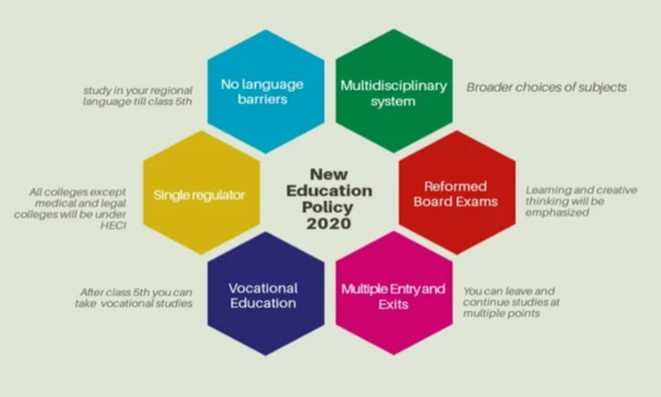The National Education Policy 2020 (NEP 2020) aims to devise four National Curriculum Frameworks (NCFs):

1. National Curriculum Framework for Early Childhood Care and Education (NCFECCE)

2. National Curriculum Framework for School Education (NCFSE)

3. National Curriculum Framework for Teacher Education (NCFTE)

4. National Curriculum Framework for Adult Education (NCFAE)

FUNDAMENTAL PRINCIPLES OF NATIONAL CURRICULUM FRAMEWORK

The fundamental principles of the National Curriculum Framework are:

Holistic Development: The NCF 2023 emphasizes the need for a holistic approach to education that promotes the overall development of students. It could include developing students’ physical, emotional, social, and cognitive skills.

Inclusivity: The NCF 2023 is likely to prioritize the creation of an inclusive education system that caters to the needs of all students, including those from marginalized communities. It may guide the creation of a safe and inclusive school environment free from discrimination and bias.

Interdisciplinary Learning: The NCF 2023 may advocate for multidisciplinary learning that integrates, different subject areas and encourages students to make connections between them. It could help students to develop a broader understanding of the world and prepare them for the complexities of the 21st century.

Competency-Based Education: The NCF 2023 may focus on competency-based education, emphasizing developing skills and competencies rather than mere knowledge acquisition. It could include a focus on critical thinking, creativity, communication, and problem-solving skills.

Use of Technology: The NCF 2023 may emphasize the importance of technology in education and guide how to integrate technology into teaching and learning. It could include using digital resources for teaching and learning and technology for assessments and evaluation.

Listen and communicate: Take the time to listen to your child and have regular conversations with them. Be ready to offer advice and assistance and express interest in their ideas and feelings.

OBJECTIVES OF NATIONAL CURRICULUM FRAMEWORK

Development of curriculum: One of the NCF’s main goals is to offer a framework for curriculum development. The curriculum should be meaningful, relevant, and tailored to the specific requirements of the learners, according to the framework.

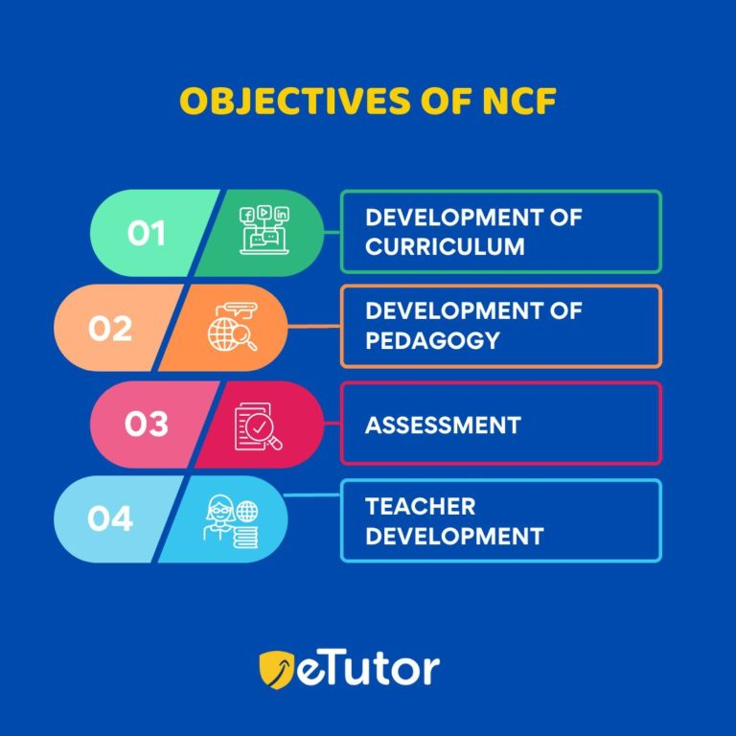Development of pedagogy: The NCF acknowledges the importance of excellent pedagogy in fostering an inclusive and all-encompassing atmosphere for learning. To encourage active learning, student-centered teaching, and interactive instruction, the framework strives to design pedagogical strategies like 5+3+3+4.

Assessment: The NCF tries to provide assessment procedures that are fair, honest, and relevant because it understands how critical assessment is to the learning process. The framework promotes formative assessment, which gives learners input to help their development.

Teacher development: The NCF knows teachers’ crucial contribution to creating a good learning environment. As a result, the framework attempts to create programs for teacher training that give educators the knowledge, abilities, and perspectives they require.

NCF DRAFT PROPOSALS FOR STUDENTS WHO WANT TO ACQUIRE KNOWLEDGE

Up to Grade 02: The NCF suggests a play-based pedagogical approach to teaching for children aged 3-8 enrolled in grades between preschool and class II. Textbooks will have to be used from Grade 1 and most of the content should be concrete materials – toys, puzzles, and manipulative. According to the draft, explicit tests and exams are not suitable for evaluating students in the Foundational stage, which encompasses preschool to class 2. The assessment process should be inclusive of learning styles and methods of expression. Given that children learn and demonstrate their learning differently, teachers should have the flexibility to design various forms of assessment for a single learning outcome and apply each assessment appropriately.

Preparatory Stage (Grade 3-5): It is the Preparatory Stage, and the NCF draft proposes introducing the written tests as part of the knowledge evolution pattern. For the preparatory stage, it proposes students should be introduced to textbooks on languages, and mathematics, while also continuing with an activity and discovery-based approach. Also, conduct summative assessments to know if the child is prepared for the next class.

Middle Stage (Grade 6-8): As per the NCF draft, grade 6-8 is the Middle Stage and critical to prepare students for the following secondary stage. Here the curriculum focuses on conceptual abilities like projects, experiments, databases, role-play, and investigations. In the middle stage, natural as well as social sciences will be introduced. As per the NCF, the textbooks need to play a central role in mediating the content in the Middle Stage. Conduct periodic assessment to synthesize their knowledge at year-end, mid-term, and unit-end.

Secondary Stage (Grade 9-12): In the middle stage, natural as well as social sciences will be introduced. As per the NCF, the textbooks need to play a central role in mediating the content in the Middle Stage. There are 16 essential courses for both grades 9 and 10. Each grade with 8 basic courses. Students need to complete 2 of the essential courses from the 8 essential courses. For grades 9 and 10, semester structured patterns are followed. By the end of grade 10, students must complete apparent grade 8, which shows that they have dutifully completed the 2 essential courses during grades 9 and 10.

Grade 11-12: For grades 11 and 12, 8 choice-based curricular course areas will be shown based on the disciplines. Here the exam pattern is semester-based, and students must complete 16 choice-based courses to complete grade 12 successfully.

WHEN WILL THE CHANGES COME INTO EFFECT?

• According to the government’s announcement, textbooks based on the revised NCF will be introduced in schools from the 2024-25 academic session.

• This indicates that the changes proposed in the NCF will begin to be implemented in classrooms starting from the academic year2024-25.

CONCLUSION:

NCF signifies a substantial movement toward a more adaptable, learner-centered, and inclusive approach to education. It offers a thorough foundation for curriculum design and instructional techniques in Indian education schools all over India. It considers the shifting demands of students and society in the twenty-first century.

Moreover the proposals outlined in the NPE 2020 and the proposed NCF 2023 display a remarkable level of vision and consideration. However, the success of these initiatives ultimately depends on the commitment and actions of the various stakeholders involved. Given that India is home to one of the world’s largest youth populations, it is disheartening to note that our current employability rate stands at a mere 50%. The introduction of these new initiatives holds tremendous potential to bring about the necessary changes in the coming years. However, it will take at least one academic year, when these changes are fully implemented, to accurately assess their true impact.

**DR. SRUTI MOHAPATRA** - Vice-Chair –CDPF & Chief Executive, Swabhiman- Odisha, India**.**

**SITUATION REPORT 02: MALAWI INITIAL REPORT REVIEWED BY CRPD**

The Committee on Rights of Persons with Disabilities (CRPD) has reviewed reports for Malawi during its 29th Session and have shared its final observations on 08th September. The [detailed report](https://www.ungeneva.org/en/news-media/meeting-summary/2023/08/experts-committee-rights-persons-disabilities-acknowledge) can be accessed in the link.

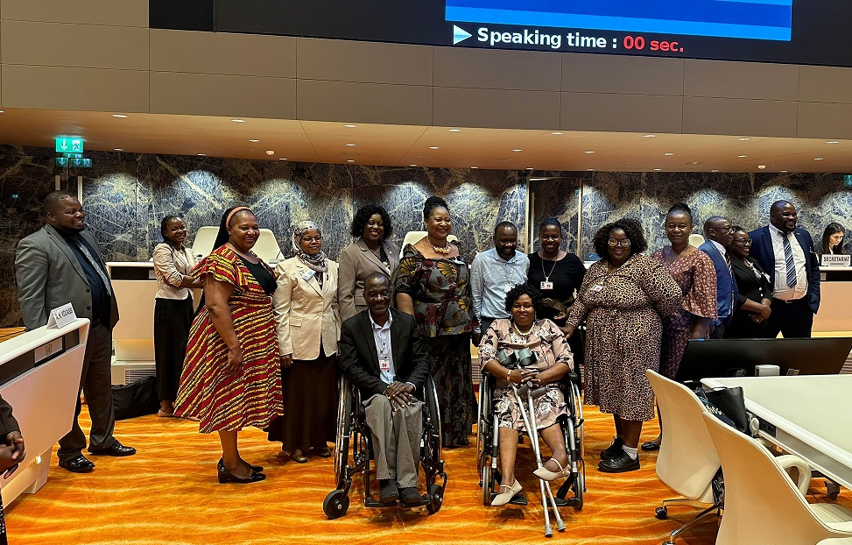

Conference in Malawi. Persons tbc.

This was the first review by the Committee since Malawi ratified the Convention on 27th August 2009. Key observations included;

* delays in enacting the amended Persons with Disabilities Bill which aims at domesticating the UNCRPD
* the fulfilment of rights for women and girls with disabilities, and adoption of laws and policies that are sensitive to both gender and disability
* prevention mechanisms for women and girls with disabilities, and the facilitation of access to health services, including those related to sexual and reproductive health.

The Committee also observed the lack of an independent mechanism for monitoring the implementation of the Convention, the insufficient funding allocated to the Malawi Human Rights Commission, and the resulting impact on its ability to effectively carry out its designated responsibilities. At its twenty-ninth session, the Committee will consider the combined initial and second periodic reports of Malawi.

Malawi delegation included representatives from the Federation of Disability Organisation in Malawi (FEDOMA) which is a member organisation of CDPF and from Disabled Women in Africa (DIWA).

**SCADER LOUIS** - CDPF Treasurer & Federation of Disability Organisations in Malawi.

**FEATURE ARTICLE: CHASING MY CHILDHOOD DREAM**

**TRIUMPHING OVER ADVERSITY IN THE UNFAVOURABLE UGANDAN EDUCATION SYSTEM**

## My journey through education as a person with Cerebral Palsy has been a testament to resilience, determination, and the transformative power of inclusive education. Despite countless obstacles, I have persevered and achieved academic success, fuelled by the support of my parents, the acceptance of my school community, and the incredible impact of technology. Sharing my story is not only an inspiration but also sheds light on the challenges faced by individuals with disabilities within the Ugandan education system.

## From a young age, I harboured a burning desire for knowledge and the dream of earning a PhD. At the tender age of five, I expressed my longing for education, and my parents recognized its profound significance in my life. With unwavering dedication, they enrolled me in a private school where the inclusive environment nurtured my growth and fostered a sense of belonging.

## Throughout my primary education, I confronted numerous obstacles due to my disability. The act of writing with a pen proved to be a significant challenge, often leaving my teachers struggling to decipher my handwriting. However, the course of my educational journey took a remarkable turn when a dear friend from the UK gifted me a laptop. This technological marvel transformed my academic pursuits, enabling me to write legibly and comfortably. Equipped with this invaluable tool, I achieved remarkable success in my final national examinations, attaining a distinction with a first-grade distinction.

## Embarking on my secondary education in 2014, I continued to rely on technology as my steadfast ally. Utilizing a laptop for studying and completing exams not only boosted my academic performance but also empowered me to actively engage in classroom discussions, collaborate with classmates, and explore an extensive array of educational resources online. Technology became the catalyst that allowed me to transcend the limitations imposed by my disability, enabling me to make remarkable strides in my education.

## The pursuit of my childhood dream to obtain a bachelor's degree faced a significant setback when I did not achieve the required grades for direct enrolment. Undeterred, I enrolled in a computer science diploma program at the International University of East Africa. The unforeseen arrival of the COVID-19 pandemic necessitated a shift to online learning, which proved to be a blessing in disguise. Embracing the virtual classroom, I seized the opportunity to acquire knowledge and hone my skills from the comfort of my own home, determined not to let any obstacles hinder my educational journey.

## However, the path to my bachelor's degree encountered further challenges. The university I initially chose discontinued its online system, making on-campus attendance compulsory. This presented insurmountable hurdles related to accessibility, transportation, and financial constraints. Faced with the heart-wrenching decision, I had to discontinue my studies at that institution, putting my childhood dream temporarily on hold.

## Yet, my unyielding determination refused to be defeated. A glimmer of hope emerged in the form of Cavendish University, which offered an online system for pursuing a bachelor's degree in Information Technology. This lifeline allowed me to continue my studies without the limitations of physical attendance. With unwavering commitment, I wholeheartedly embraced online learning, maximizing the available resources, such as YouTube and Udemy, to expand my programming skills and deepen my knowledge.

## While my personal journey showcases triumph over adversity, it is crucial to acknowledge the severe challenges posed by the Ugandan education system for students with disabilities. Limited accessibility, inadequate resources, and a lack of inclusive pedagogy hinder their educational progress, perpetuating exclusion and limiting opportunities.

## The absence of inclusive infrastructure and facilities in many Ugandan schools creates a daunting environment for students with disabilities. Scarce funding and a lack of assistive devices, such as wheelchairs, hearing aids, and Braille materials, further exacerbate the difficulties they face. The educational curriculum often fails to address their unique needs and learning styles, hindering their academic potential and personal growth.

## Moreover, the deeply entrenched stigma and discrimination against individuals with disabilities within the Ugandan society can cause profound emotional pain. Negative attitudes and a lack of understanding from teachers, peers, and society at large can isolate and undermine their self-worth. Insufficient awareness and training among educators in inclusive pedagogy only perpetuate missed opportunities and untapped potential for students with disabilities.

## Despite these challenges, I remain resolute in my pursuit of education and my childhood dream of earning a PhD. My journey is not only a testament to personal triumph but also a call to action for the Ugandan education system. It is essential to invest in inclusive infrastructure, provide specialized resources and support services and prioritize comprehensive teacher training in inclusive pedagogy. By fostering an educational environment that celebrates diversity and accommodates diverse learning needs, we can empower individuals with disabilities and create a more inclusive and compassionate society.

**KIHEMBO WILBERT** - CDPF Executive Officer (Youth Rep) & Voice of Youth - Uganda.

**CPDF NOTICES:**

COMMONWEALTH SCHOLARSHIPS - 2024

Posted on CDPF website on 29th August 2023

The CPDF is a partner of the [Commonwealth Scholarship Commission](https://cscuk.fcdo.gov.uk/about-us/scholarships/) (CSC). Applications for CSC-2024 must be submitted by 17th October 2023. Those who are disabled applying to the CSC for 2024 may also apply to CDPF for selection for a recommendation.

Each year CDPF select and recommends 10 Masters Candidates and 05 for PhD Candidates for the CSC. Requests for [CDPF recommendation](https://commonwealthdpf.org/news/) should be send to CDPF General Secretary by email [rlrieser@gmail.com](mailto:rlrieser@gmail.com) and must be in by 14th November 2023.

CDPF Criteria to recommend for a CSC Scholarship:

* Must be disabled and provide proof of long term impairment;
* Show understanding of concept of Reasonable Accommodation (50 words);
* Must demonstrate experience in aiding the struggle for disability rights and equality (200 words);
* Must demonstrate how their proposed study will improve the position of disabled people in their country (200 words);
* CDPF operates strict gender balance equality criteria;
* [**FOR MASTERS**](https://cscuk.fcdo.gov.uk/ngos-and-charitable-body-nominators/)**:**
* Should have a 2.1 or better degree unless can show a lack of reasonable accommodations prevented them achieving this grade,
* This must be backed up a letter from Tutor, Dean of Studies or Vice Chancellor of University or similar at which they undertook the study;
* [**FOR PHD**](https://cscuk.fcdo.gov.uk/ngos-and-charitable-body-nominators/)**:**
* Including above should have a clear research project benefit disabled people,
* Have been accepted at a UK university to pursue this and have a Tutor and have published in the field.
* All must have 03 Testimonials, have completes CSC on-line registration and submit required document and send copies of these to CDPF with your answers to the above.

**ELIGIBLE COUNTRIES FOR MASTER’S CANDIDATES:** Bangladesh, Belize, Botswana, Cameroon, Dominica, Eswatini, Fiji, Ghana, Grenada, Guyana, India, Jamaica, Kenya, Kiribati, Lesotho, Malawi, Malaysia, Maldives, Mauritius, Montserrat, Mozambique, Namibia, Nauru, Nigeria, Pakistan, Papua New Guinea, Rwanda, Samoa, Sierra Leone, Solomon Islands, South Africa, Sri Lanka, St Helena, St Lucia, St Vincent and the Grenadines, Tanzania, The Gambia, Tonga, Tuvalu, Uganda, Vanuatu, Zambia. (Masters candidates need: 2 references + university transcript showing a 2.1 degree).

**ELIGIBLE COUNTRIES FOR PHD CANDIDATES:** Bangladesh, Cameroon, Kenya, Kiribati, Lesotho, Malawi, Mozambique, Nigeria, Pakistan, Rwanda, Sierra Leone, Solomon Islands, Tanzania, The Gambia, Tuvalu, Uganda, Zambia only.

**UN CHARTER BODY / TREATY BODY REVIEW OF COMMONWEALTH COUNTRIES**

CRPD COMMITTEE STATE PARTY REVIEWS OF COMMONWEALTH COUNTRIES

|  |  |  |  |
| --- | --- | --- | --- |
| **COUNTRY** | **STATE PARTY REPORT DUE/SUBMITTED** | **REVIEW DATE** | **SESSION** |
| Canada | 11-Apr-20 / 07-Nov-20 |  |  |
| India | 1-Nov-25 |  |  |
| Ghana |  | 2024 or later |  |
| Kenya |  | 11 – 15 Sept 2023 | 18 Per Session WG |
| Malawi |  | 14 Aug- 08 Sept 2023 | 29th Session |
| Maldives |  | 2024 or later |  |
| Malta | 10-Oct-26 |  |  |
| Mauritius |  | 2024 or later |  |
| Mozambique |  | 2024 or later |  |
| Namibia |  | 2024 or later |  |
| New Zealand | 24-Aug-22 |  |  |
| Pakistan |  | 2024 or later |  |
| Rwanda | 14-Jan-23 |  |  |
| Siera Leone |  | 2024 or later |  |
| Sri Lanka |  | 2024 or later |  |
| Trinidad and Tobago |  | 2024 or later |  |
| Tuvalu | 23-Nov-26 | 2024 or later |  |
| Uganda | 25-Oct-22 | 2024 or later |  |
| United Kingdom | 8-Jul-23 |  |  |
| Vanuatu | 23-Nov-26 |  |  |
| Zambia |  | 2024 or later |  |

UNIVERSAL PERIODIC REVIEWS OF COMMONWEALTH COUNTRIES

|  |  |  |
| --- | --- | --- |
| **COUNTRY** | **UPR SESSION** | **REVIEW DATE** |
| Australia | 43rd Session | 3-May-23 |
| Bangladesh | 44th Session | 13-Nov-23 |
| Barbados | 43rd Session | 5-May-23 |
| Botswana | 43rd Session | 3-May-23 |
| Cameroon | 44th Session | 14-Nov-23 |
| Canada | 44th Session | 10-Nov-23 |
| Tonga | 43rd Session | 1-May-23 |
| Tuvalu | 44th Session | 8-Nov-23 |

**RECOGNITIONS/ACKNOWLEDGEMENTS**

# **FAREWELL TO STEVE ESTAY – CDPF EXECUTIVE AND A FOUNDER MEMBER**

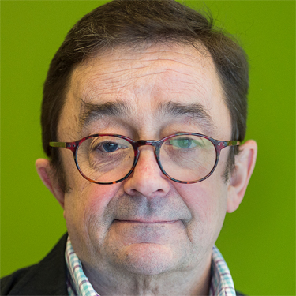

It is with great sadness and a sense of loss to the disability movement that CDPF acknowledges the demise of Steve Estey. He was a founder member of the Commonwealth Disabled People's Forum being on the Executive till his untimely death on Monday 11th September. Steve was a leading advocate in restoring the CDPF. ([Refer link for Photo credit/courtesy](https://kidsbrainhealth.ca/steven-estey/)).

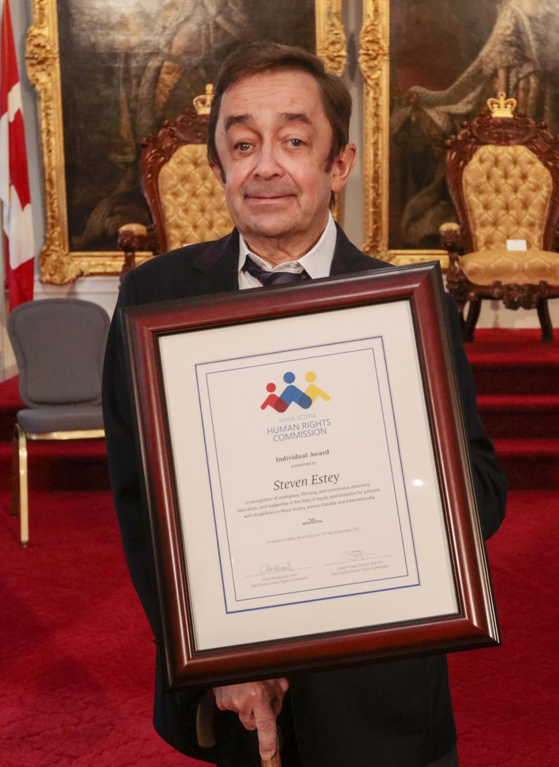

Steve had been a disability activist, humanitarian disarmament campaigner and disability rights consultant for more than 40 years as a profoundly deafened man. He has worked with organizations such as the Council of Canadians with Disabilities, Disabled Persons International, human rights institutions, governments, intergovernmental organizations, and United Nations agencies to advance disability rights. Steven was advisor to the Canadian Government delegation to the United Nations that drafted the Convention on the Rights of People with Disabilities (CRPD). From 2007 until 2010 he led Disabled Persons International’s work to encourage governments around the world to sign and ratify the CRPD. As a consultant, Steven has devoted his life to projects strategically aimed at the effective implementation of the CRPD, the full realization of disability rights and effective implementation of the CRPD around the world. ([Refer link for photo credits/courtesy](https://humanrights.novascotia.ca/2021-nova-scotia-human-rights-award-recipients): )

Steven has a Bachelor’s degree in Philosophy from St. Francis Xavier and a Master’s in International Development Studies from Saint Mary’s; both Universities are in Nova Scotia. In 2021 he was awarded the [2021 Nova Scotia Human Rights Award](https://humanrights.novascotia.ca/2021-nova-scotia-human-rights-award-recipients).

We will miss Steve's wealth of advice shaped by his experience. Her loss will be enormous and felt all over the disability movement in Canada, in the Commonwealth & rest of the World. We send our love and condolences to his family. Please share this sad news with your colleagues and friends. We will honour him by carrying on the struggle for Disability Rights.

LEADING CRUSADOR FOR DISABILITY RIGHTS: DR. SRUTI MOHAPATRA

DISABILITY RIGHTS ACTIVIST, SWABHIMAN- ODISHA, INDIA AND CDPF VICE-CHAIR

The principal of gender equality is enriched in the Indian Constitution in its Preamble, Fundamental Rights, Fundamental Duties and Directive Principles. The constitution not only grants equality to women, but also empowers the State to adapt measures of positive discrimination in favour of women. Within the framework of a democratic polity, laws, development policies, plans and programs have aimed at women’s advancement in different spears.

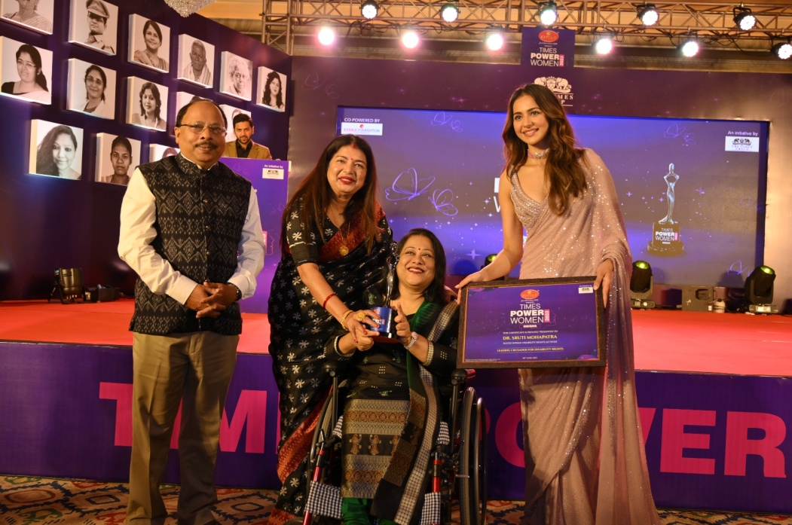

Sruti (3rd from left)

**The Times of India** Group - the most trusted news brand & world’s largest English daily has launched its flagship property –“**TIMES POWER WOMEN ODISHA**”- across around 30 various categories, as an extension of the survey conducted by an independent research agency to highlight the significant contribution from different walks of life and towards the society by women, brimming with talent and potential who have made their mark and turned their dreams into reality.

**DR. SRUTI MOHAPATRA,** founder and the head of[SWABHIMAN](http://www.swabhiman.org), first cross disability organisation in ODISHA, INDIA and CDPF VICE-CHAIR has been recognised by The Times of India as the **LEADING CRUSADOR FOR DISABILITY RIGHTS**. Dr. Sruti has been playing a leading part of the disability rights movement from the passage of the PwD Act, CRPD and India’s ratification, amendment of RTE Act, Census enumeration of disabled, Accessible Elections in India to the recent RPwD Act 2016; with a focus to create a rights-based environment in India for persons with disabilities. She has successfully transitioned from leading a business to heading an NGO in the disability sector, an astute professional with around 25 years of experience in addressing the entire spectrum of disabilities, a dynamic go-getter and effective leader with impressive communication skills; enhanced interpersonal, team management, negotiation, presentation, and networking skills, having the ability to think out of the box, take risks and drive initiatives for achieving operational excellence, have travelled across India, UK, North America & Asia, speak fluently in English, Hindi, Odia and knowledge of Bengali, have a PhD in Developmental Biology and published several papers and authored books and a C7-T1 quadriplegic.

**UPCOMING EVENTS**

MEETING OF COMMONWEALTH YOUTH MINISTERS

The tenth (10) [COMMONWEALTH YOUTH MINISTERS MEETING](https://thecommonwealth.org/news/commonwealth-heads-declare-2023-year-youth#:~:text=Heads%20then%20sealed%20their%20commitment,'Year%20of%20the%20Youth) (CYMM) will be take place in London, United Kingdom from 11th to 15th September 2023. Previously, it was schedules o be take place in Islamabad, Pakistan from 23rd to 26th January 2023 but was postponed. The 09th CYMM was held between 31 July and 04 August 2017 in Kampala, Uganda.

The Commonwealth Secretariat convenes a four-yearly Commonwealth Youth Ministers Meeting (CYMM), including a Youth Leaders Forum and Stakeholders Forum. The meeting enables government ministers and senior officials to share good practices, debate emerging issues, take stock of pioneering initiatives and forge new partnerships for resourcing youth development. The recommendations from each Commonwealth Youth Ministers Meeting are considered by leaders at the biennial Commonwealth Heads of Government Meeting (CHOGM).

Saista Parwin – CDPF Executive (Youth Representative) has been designated as CDPF Delegate to attends for the 10CYMM as an observer. CDPF has been invited to have a stall on Commonwealth Expo on Friday, 15th September to show case what CDPF is doing for Youth. CDPF submission to 10CYMM in September 2023 (word Document) and CDPF Youth Rep & Executive Officer [Kihebmo Wilbert Presentation (Power-point)](https://commonwealthdpf.org/wp-content/uploads/2023/09/Kihembo-wilbert-Presentation1-1.pptx) is available in the [CDPF Website](https://commonwealthdpf.org/year-of-youth/).

2023 CONFERENCE OF THE PARTIES (COP28) OF THE UNFCC

28th session of the 2023 UN CLIMATE CHANGE CONFERENCE (COP28) is schedules to be held from 30 November to 12 December 2023 in United Arab Emirates.

