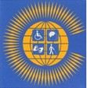
Disabled Young People’s Rights and Participation.

Rationale
The aim of this training session is to ensure that Disabled Youth are aware of their rights, become empowered, engage with DPOs/OPDs and join the struggle to implement their rights is crucial. The number of Disabled Children and Youth with long term impairments in the Commonwealth is growing and their exclusion from education, training, employment, health and well-being is increasing, especially in low and middle income countries. The World Health Organisation now identify 16% of the population as disabled people, 1.3 billion people. In the Commonwealth where 60% of the population are aged 30 years or under, there are likely to be 230-250 million disabled children and youth.
2023 is Commonwealth Year of Youth. The Commonwealth Disabled Peoples Forum (CDPF) which represents Disabled People's Organisations in 50 of the 58 countries in the Commonwealth wants this year to make a difference. Two thirds of the Commonwealth population are under 30.
CDPF calls on Disabled People’s Organisations (DPOs) or Organisations of People with Disabilities (OPDs) to champion the rights of disabled youth, develop, listen to, and prioritise their concerns and support them to become leaders. CDPF calls on the Commonwealth and member Governments to prioritise tackling the barriers disabled youth face to leading equal lives and develop long term strategies to ensure that no on e is left behind.

1: UNCRC and (UNCRPD) upholding the human rights of disabled children and young people (youth)

What are human rights?

The rights of a person are human rights because they are a human being and have basic needs to live, survive, develop, thrive and have the right to be safe and treated with dignity. Human rights are universal and apply to all individuals, including disabled persons. The international Human Rights Framework which includes various conventions and treaties that hold governments accountable for protecting human rights. It highlights the Convention on the Rights of the Child (CRC) and the Convention on the Rights of Persons with Disabilities (CRPD) as significant instruments for safeguarding the rights of disabled young people. Disabled young people experience challenges such as poverty, abuse, limited access to education, and discrimination. It emphasizes the continuous fight for inclusion, accessibility and transformation

The International Human Rights Framework

In 1948 rights for every human being were written in a set of principles in the United Nations Universal Declaration of Human Rights (UDHR). Even though UDHR is not legally binding it is however a statement of intent and has been the strong foundation of which a number of human rights treaties which are also referred to as conventions have been developed, these further interpret the UDHR principles into legally binding duties on the countries that ratify them.

Key Human Rights treaties/conventions

- International Covenant on Civil and Political Rights, 1966 in force from 1976
- International Covenant on Economic, Social and Cultural Rights, 1966 in force from 1976
- International Convention on the Elimination of all Forms of Racial Discrimination, 1966
- Convention on the Elimination of all Forms of Discrimination against Women, 1979
- Convention against Torture and Other Cruel, Inhuman or Degrading Treatment or Punishment, 1984
- Convention on the Rights of the Child, 1989
- Convention on the Rights of Migrant Workers and the Members of their Families, 1990
- Convention on the Protection of All Persons from Enforced or Involuntary Disappearances, 2010
- Convention on the Rights of Persons with Disabilities, 2008

For further information f the treaties visit https://www.ohchr.org/en/professionalinterest/pages/internationallaw.aspx

These treaties are human rights tools to holding governments accountable to their duties to which their respective countries have sanctioned for the protection of the human rights of persons in their country.
‘Young people with disabilities are one of the most marginalized and excluded groups in society. Facing daily discrimination in the form of negative attitudes, lack of adequate policies and legislation, they are effectively barred from realizing their rights to healthcare, education, and even survival.

The most important statistics regarding young people with disabilities
- Up to 200 million children globally have a disability.¹
- Children with disabilities are disproportionately likely to live in poverty.²
- Children with disabilities are disproportionately vulnerable to both physical and sexual abuse.³
- At least 90% of children with disabilities across the developing world have no access to education.⁷
- The violations of their rights are often severe: worldwide, up to 68 per cent of girls and 30 per cent of boys with intellectual or developmental disabilities will be sexually abused before their 18 birthdays^{. 9}
‘Denying children with disabilities their right to education has a lifelong impact on learning, achievement and employment opportunities, hence hindering their potential economic, social and human development’. (UNICEF 2018)
Recognising disabled children and young people as rights holders

With an estimation of between 180 and 220 million youth with disabilities worldwide, and an estimation that there are 93 million children with disabilities, of which nearly 80% live in developing countries already one of the most disadvantaged groups.¹⁵ The Convention on the Rights of the Child is the most widely accepted human rights treaty. Disabled children and young people knowing and understanding these rights is essential step forward to ensuring their inclusion, participation, and role as disability rights actors, changemakers within the disability movement and as rights holders.

UNCRC and UNCRPD

The Convention on the Rights of the Child (UNCRC) was adopted by the United Nations General Assembly in 1989. Its an international law that which is applicable for youth under the age of 18 years. These laws ensure that young children with disabilities are equal and can participate freely in all aspects of society.

UNCRC has four main principles known as general principles:

- Non-Discrimination. All children are equal and have the same rights. (Article 2).
- Best interest of the child. Every child has the right to have their basic needs fulfilled. (Article 3).
- Right to life survival and development. Ensure every child survives and develops to reach their full potential. (Article 6).
- Right to be heard. Every child has the right to express their views, feelings and wishes in all matters affecting them. (Article 12).

The Convention on the Rights of Persons with Disabilities is relevant to all persons including children, young and older people with disabilities and has certain articles with specific provisions which apply to disabled children and young people. The overall aim of the Convention is to “promote, protect and ensure the full and equal enjoyment of all human rights and fundamental freedoms by all persons with disabilities, and to promote respect for their inherent dignity.”

Specific provisions for children with disabilities:
The following articles explains the obligations and rights of youth and children with disabilities.

Article 7 Children with disabilities.

The best interests of Children with disabilities must be of primary consideration.

Preamble
Children with disabilities have the right to express their views on matters affecting them, and they should be provided with disability-appropriate assistance to exercise this right.

Article 3 General principles
There must be respect for the evolving capacities of children with disabilities and their right to preserve their identities.

Article 4 General obligations:

Children with disabilities should be consulted and involved in the development and implementation of legislation and policies that concern them, including through their representative organizations.

Article 13 Access to justice
Age-appropriate measures should be implemented to ensure access to justice for children with disabilities.

Article 16 Freedom from exploitation, violence and abuse:

Measures must be taken to prevent exploitation, violence, and abuse, providing age, gender, and disability-sensitive protection and rehabilitation services. Child-focused legislation should be established to address exploitation, violence, and abuse.

Article 18 Liberty of movement and nationality:

Children with disabilities have the right to liberty of movement, nationality, and family life. Forced sterilization is prohibited, and efforts should be made to provide support to families and prevent abandonment, concealment, and segregation.

Article 24 Right to Education
Inclusive education should be ensured at all levels, providing children with disabilities the same rights to receive a general education as their non-disabled peers. Necessary support, technical aids, and accommodations should be accessible, respecting their linguistic identity and utilizing appropriate educational techniques and materials. No child must be left behind.

Article 30 Participation in cultural life, recreation leisure and sport:
Children with disabilities should have equal access to participate in cultural, recreational, leisure, and sporting activities, including those within schools.

2. The impact of stigma, taboos and discrimination on disabled children and young people’s rights and safety.

Disability stigma and taboos persist, exacerbating the disadvantages and discrimination faced by disabled children and young people. These negative attitudes and beliefs have a detrimental impact on their early years, childhood experiences, and opportunities in life. As a result, their human rights may be violated, preventing them from fully participating in society and realizing their potential. It is crucial to challenge and address disability stigma and taboos to create a more inclusive and equitable society for disabled children and young people, where their rights are respected and upheld.

While there has been some progress in reducing the stigma and taboos surrounding disabilities, the process has been slow. Disability advocacy, the involvement of social actors such as community and faith leaders, families, organizations, and governments play a crucial role in addressing these issues. However, the consequences of stigma and taboos, such as discrimination, fear, isolation, exclusion, violence, abuse, and dehumanization, continue to impact the lives of disabled individuals. More efforts are needed to combat these negative experiences and promote a society that respects and values the rights and dignity of all disabled persons.

Factors which contribute to disability stigma

- Violence against disabled children, including harmful practices based on superstitions or beliefs in witchcraft.
- Infanticide of newborn disabled children due to cultural beliefs or perceptions of shame and burden.
- Children accused of witchcraft, particularly targeting disabled children, leading to discrimination, violence, neglect, and abandonment.
- Children with disabilities living in chains or physical restraints, often in orphanages or institutions, resulting in severe neglect and abuse.
- Lack of access to education due to low expectations and mistaken beliefs about disability, leading to exclusion and limited opportunities.
- Violence, abuse, and neglect faced by disabled girls, who are at higher risk due to assumptions about their communication abilities and vulnerability.
- Abandonment by fathers, leaving mothers as the sole caregivers.
- Discrimination and violence against young women and girls with disabilities, including forced contraception, forced sterilization, and high rates of violence during crises or disasters.

These examples highlight the urgent need to address disability stigma, improve understanding, and protect the rights and well-being of disabled children and young people. Efforts should focus on promoting inclusion, combating discrimination, and providing support and services that enable their full participation in society.

The Sustainable Development Goals 2030 Agenda and Disabled Children and Young People

The Sustainable Development Goals (SDGs) provide a framework for global development and aim to ensure that no one is left behind. However, children with disabilities are often overlooked in the pursuit of these goals. Despite their significant numbers and unique challenges, disabled children and young people face exclusion and barriers in various areas addressed by the SDGs.

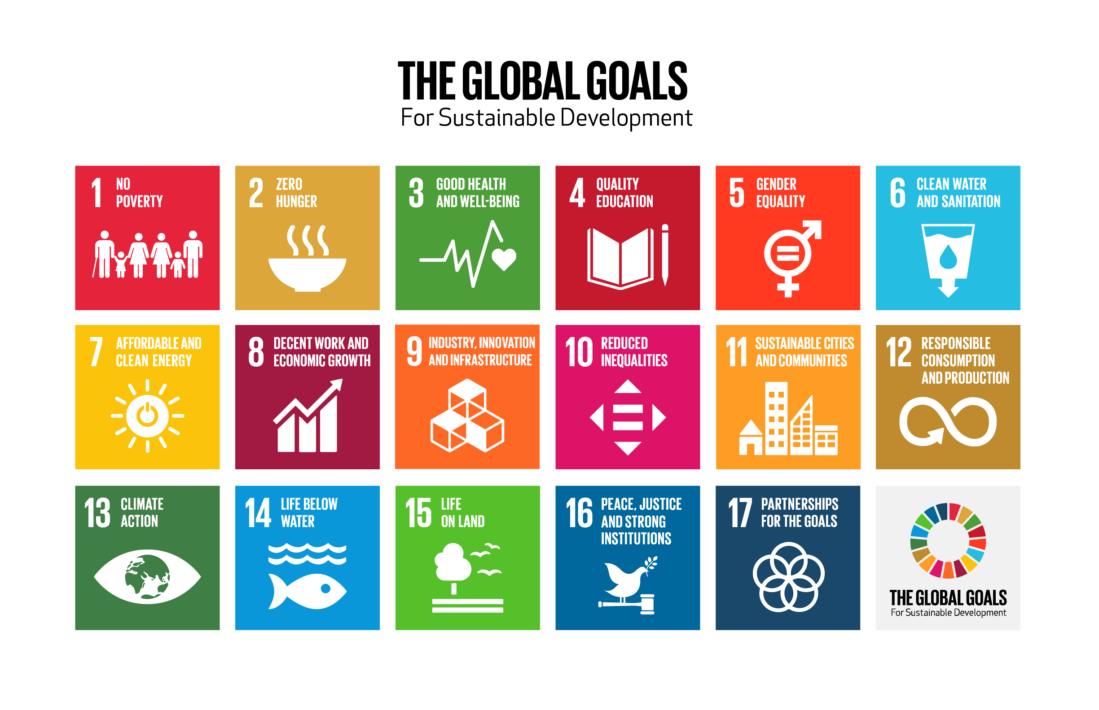
The Sustainable Development Goals (SDGs) are a global call to action to end poverty, protect the planet and ensure that all people enjoy peace and prosperity. The SDGs aim to “Leave no one behind”, and make a commitment to reaching the world’s most marginalised groups. In the first four SDGs, it is evident that disabled children are being left behind:

- SDG 1: No Poverty: Studies have shown a strong link between childhood disability and poverty, indicating that disabled children are more likely to experience poverty.
- SDG 2: Zero Hunger: Children with disabilities are more prone to malnutrition compared to their non-disabled peers.
- SDG 3: Good Health and Well-being: Disabled children are at a higher risk of serious health conditions, both related to their impairment and general illnesses. Their access to healthcare is often limited.
- SDG 4: Quality Education: Disabled children face exclusion from education at a significantly higher rate than non-disabled children. They encounter barriers that prevent them from accessing inclusive and equitable education.

Several SDGs explicitly recognize the need to include persons with disabilities to achieve the goals. SDG 4, for example, emphasizes inclusive and equitable quality education, aiming to eliminate disparities and ensure equal access for vulnerable groups, including persons with disabilities. It also calls for child, disability, and gender-sensitive education facilities.

To achieve the SDGs and leave no one behind, it is crucial to prioritize disabled children and young people. The disability movement and duty bearers, such as states that have signed human rights treaties like the UNCRC and UNCRPD, must ensure the inclusion of disabled children and young people at local and national levels in the implementation of the SDGs.

The implementation of disability-inclusive SDGs should empower disabled children, young people, and their families to fully enjoy their rights as outlined in the UNCRC and UNCRPD. The disability movement plays a critical role in advocating for the rights of disabled children and young people within the SDG implementation. By applying the principles of "Nothing about Us, Without Us" and "Leave No One Behind," the UNCRC, UNCRPD, and SDGs can work together to realize the rights of disabled children and young people.

The active and meaningful participation of disabled children and young people is vital in driving change and achieving the SDGs. Inclusive participation means treating them as equal partners and advocates, ensuring their voices are heard and their perspectives are considered in decision-making processes. Their inclusion is essential for creating the momentum needed to achieve Agenda 2030.

The CDPF’s Youth Manifesto

CDPF calls on Disabled People’s Organisations (DPOs) or Organisations of People with Disabilities (OPDs) to champion the rights of disabled youth, develop, listen to and prioritise their concerns and support them to become leaders.

CDPF calls on the Commonwealth and member Governments to prioritise tackling the barriers disabled youth face to leading equal lives and develop long term strategies in the areas highlighted below.

- Prejudice and discrimination against disabled youth and other marginalized groups is called disabilism, and it is deeply rooted in our cultures. Stereotypes, stigma, and traditional beliefs reinforce this discrimination. Governments should challenge these views among the general population and in schools and colleges, especially media, journalists, and public relations professionals (Article 8 of the UNCRPD).

- There is a need for a Commonwealth Protocol on Disability Access and Inclusion to improve the situation for disabled youth and all disabled people. The protocol should include practical procedures for access, representation at conferences and forums, and involvement of disabled people's organizations in its development (Article 9 of the UNCRPD). This protocol should be jointly produced with representative Disabled People's Organizations.

- Digital inclusion should be prioritized as it benefits disabled people by allowing them to live more independent lives and reduces social isolation. Strategies should be developed to promote digital inclusion, such as making websites and digital services accessible and providing training and assistance in using digital technologies. All digital communications across the Commonwealth and governments should be made accessible during the Year of Youth. More free access points to the internet should also be created.

- Disabled youth involvement and equality should be developed through innovative approaches that ensure their voices are heard and responded to. Mechanisms should be set up to regularly hear the views of disabled youth, including those with communication challenges, mental health issues, learning impairments, and complicated health requirements.

- Sufficient government funding is needed to prioritize disabled youth involvement. Supports and services that are critical to their rights must be safeguarded. Disabled People's Organizations (DPOs) need long-term core funding to represent the diversity of disabled people and work with governments to implement disability rights (Article 4.3 and 33.3 of the Convention).

- Global environmental justice and compensation for the impact of climate change should include the needs of disabled youth and people. They are at a higher risk of negative impacts during climate emergencies and should be included in all emergency responses.

- Education should focus on inclusive systems and address barriers to access, teacher preparation, and suitable curriculum and assessment. Disabled children and youth should be engaged in anti-bullying policies and educated as rights holders. Specific schemes to improve access to schools, colleges, and universities should be developed.

- Disability equality training should be provided to business leaders and public service professionals based on the shift from medical to social human rights thinking on disability. Disabled youth should be trained and empowered to take the lead in this training.

- Efforts should be made to increase employment opportunities and vocational training for disabled youth. Pressure should be put on employers to hire disabled staff, and support should be provided for disabled youth to set up their own enterprises.

- Equality for disabled young women should be promoted through public campaigns, implementation of effective measures against harassment and abuse, and support for their participation in public service jobs.

- Health, including mental health, should focus on early intervention and prevention, emotional well-being, and equal access to child and adolescent mental health care for disabled youth.

- Provision and access to mobility aids, rehabilitation, and assistive technology should be increased for disabled youth. This includes sign language, braille, and alternative forms of communication. Local centers should have the right equipment, support, and professional expertise to help unlock the potential of disabled youth.

- Equality for neurodiverse young people, deafblind youth, and youth with mental health issues should be recognized and prioritized. Funding should support training for teachers, education staff, and employment opportunities for these groups. Legislation should be enacted for self-advocacy and supported decision making.

- Family life and relationships for disabled youth should be supported, and they should have access to comprehensive sex and relationships education. Independent living solutions should be provided to end segregation and promote inclusion.

- Disabled youth should be engaged and involved in the democratic system, and positive action should be taken to support their participation. Measures should be introduced to make it easier for disabled youth to resolve issues in the legal system, including reasonable accommodations and free legal representation.

- Efforts should be made to enhance peace, equality, and sustainable development by mobilizing disabled youth and their families to embed sustainable development programs in the community, businesses, schools, colleges, and media. Local participatory structures should be set up to monitor and implement government commitments to the Sustainable Development Goals (SDGs).

