Developing ways of creating Equal Access for Disabled Girls and Women to Sexual and Reproductive Health Services and Greater Equality
UN COSP 16 Side Meeting Thursday June 15th 2023 - 8:15 - 9:30 am EST. In Person, Online and Recorded.
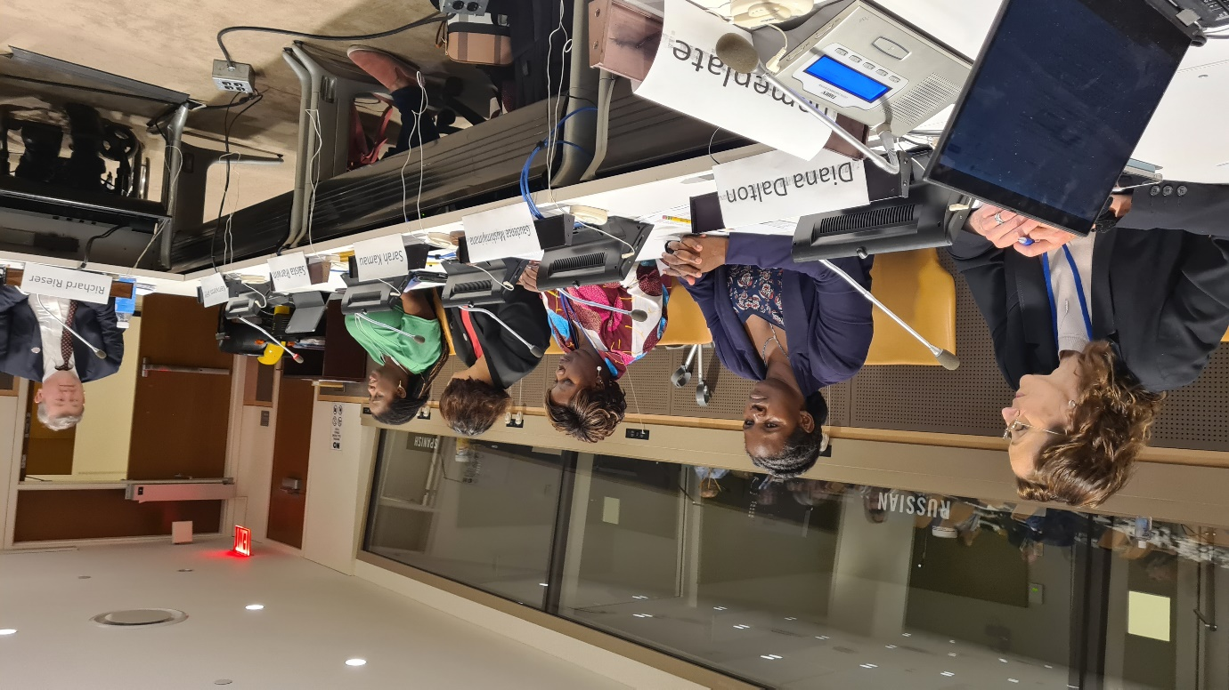

Sponsored by United Kingdom FCDO, Commonwealth Secretariat, Disability Rights Fund. Organised by Commonwealth Disabled People's Forum.
Chair: Sarah Kamau, United Disabled Persons Kenya. Chair CDPF
Gaudence MushimiyimaNa, Rwandan Organisation of Women with Disabilities. CDPF Women's Rep
Diana Dalton, Head of Gender and Equalities Dept, UK FCDO
Dr Shavana Haythornthwaite, Adviser and Head, Human Rights Unit, Commonwealth Secretariat
Saista Parwin, Young Member CDPF Executive, India
Dr.Richard Rieser, General Secretary CDPF on Men’s role as allies.

A very thorough and insightful discussion on sexual and reproductive health rights for disabled women and girls and wider issues of gender equality and the role of men as allies was held. Experiences from a number of Commonwealth countries were recounted by the disabled speakers and the Commonwealth Secretariat Pleas for the enforcement of Human Rights for Disabled Women and Girls to have choice and the right to sexual and romantic relationships, to have children or terminations, access to contraception and to force the stopping of sterilization, alongside Availability, Acceptability and Support for Access to Public Health e=Education, Emergency Services. Nothing would change in rality until non-disabled people across countries such as India changed their attitudes The UK Foreign Commonwealth Office spoke about their stance on challenging the global roll back on women’s rights and pointed to a number of initiatives they were involved in to empower disabled women and girls and community based initiatives, including for men to change their sexist behaviors. Male members especially leaders of the Disabled People’s Movement must be held accountable for their sexism and change to allies in the struggle for Disabled Women and Girls Rights. CDPF survey had shown the General Women’s Movement had little connection with Disabled Women’s Issues. This has to change! The chair pointed participants to the CDPF Commonwealth Women’s Declaration and urge all to redouble their efforts to achieve full equality for Disabled Women and Girls

You can also find this event on our UN WebTV

And our UNDESA YouTube Channel: https://youtu.be/c-foNnLv-tg

On www.Commonwealthdpf.org/News Flyer for meeting
More information from CDPF Gen Sec rlrieser@gmail.com

