Disabled Youth Involvement, Awareness, Empowerment and Leadership in DPOs/OPDs across the Commonwealth
COSP 16 Side Meeting Thursday 15th 20223 3.00 -4.15 pm EST In person, Zoom and recorded
Sponsors Government of Barbados, United Kingdom Foreign Commonwealth Development Office. Organised by Commonwealth Disabled Peoples Forum

Chair: Saista Parwin , India, Youth Member CDPF Executive
Speakers include:
Penny Innes, Head of Disability Inclusion team, FCDO UK
Kihembo Wilbert, Voice of Youth Uganda, CDPF Youth Rep
Emile Gouws, Autism South Africa, CDPF Rep. Underrepresented Groups
Christopher Gilkes, Public Relations Officer of the Barbados Council for the Disabled
Charlotte Young National Youth Council Disabilities Australia
Ganesh Singh Guyana Council of Organisations for Persons with Disabilities CDPF Executive
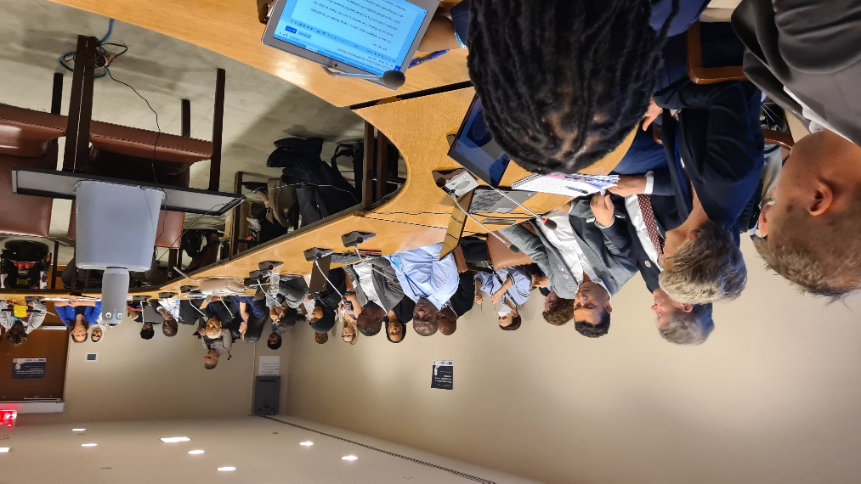
Richard Rieser, General Secretary CDPF on Training Disabled Youth for Leadership project
The presentations and discussion were vibrant and full of hope. We need to get to the grassroots especially in hard to reach areas and train and recruit disabled youth. Drastic action is needed for a drastic problem especially for neurodiverse and cognitively impaored youth across the Global South.In the high income countries especially intersectionslity needs to be a watchword especially when working with indigenous disabled youth. In large economies such as India we have to get employers and Governments to understand disabled youth can bring them profits through their skills. We must use digital media as a tool to reach disabled youth and to empower them as in Uganda, In South Africa real change can only come from the bottom up involving those hitherto excluded.We heard how in Guyana the umbrella DPO had embarked with support from USAID on a several year project to train and empower disabled youth and bring them into DPO leadership. In Barbados the Disability Council has been engaging for a number of years through youth conferences and training projects on empowerment. The Australian Council for Youth with Disabilities had held regular conferences and were presenting the views gathered to Government. CDPF Youth Leadership Training was explained and publicised. It was emphasised this would be based on a paradigm shift and capacity building.
UKFCO were thanked for their support and complimented fo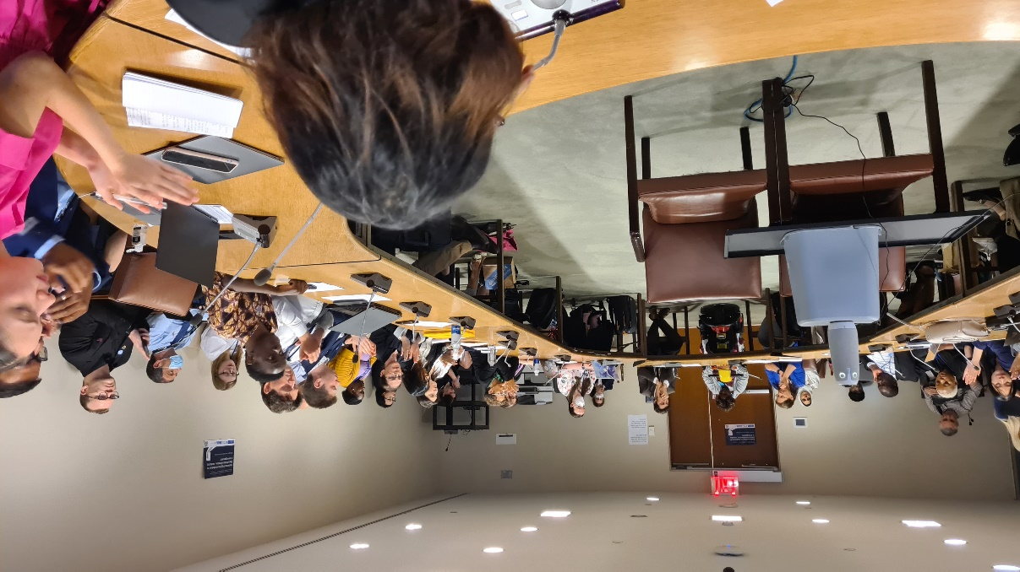r their Disability Strategy which emphasises building and supporting the development of DPO voices which may take longer than quick fixes from NGOs, but because rooted in the community is likely to have far reaching and longer lasting impact especially if encouraging disabled youth involvement. 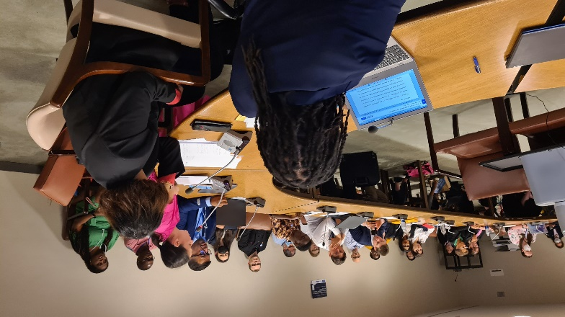
Video Link https://www.youtube.com/watch?v=A5zzrdt_bYw
Kihembo’s Video https://youtu.be/m39XG1GxBGg
Meeting Leaflet
CDPF Disabled Youth Manifesto
More information Contact General Secretary CDPF rlrieser@gmail.com

