Evaluating DPO/OPD Collaboration with State Parties on Implementing Elements of the UNCRPD across the Commonwealth
COSP 16 Side Meeting Wednesday 14th June 2023 1.15 to 2.30 EST
Sponsors Governments of Barbados, Kenya, Albinism Africa, Disability Rights Fund. Organised by Commonwealth Disabled People's Forum In person, Zoom and recorded
Chair Richard Rieser General Secretary CDPF
Hon. Kirk Humphrey Barbados Minister of People Empowerment and Elder Affairs
Kerryann Ifill President Barbados Council of the Disabled, Vice Chair CDPF
Moses Kamau, Social Protection Department, Kenyan Ministry of Labour
Sarah Kamau, United Disabled Persons of Kenya and CDPF Chair
Ero Ikponwosa, Executive Director, Albinism Africa on the Kenyan Model of challenging stigma.
Rosanjali Priyadarshani Disability Organisation Joint Front Sri Lanka, CDPF Exec.

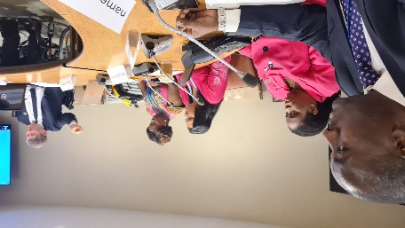
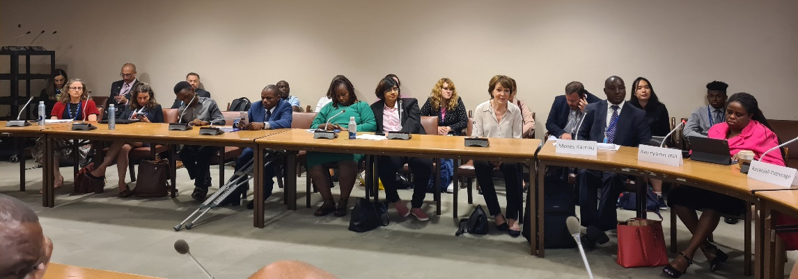
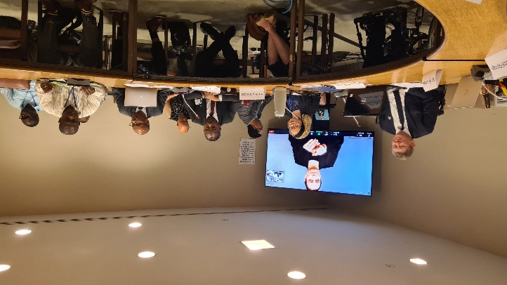
There was a very nuanced and interesting dialogue with representatives of the Barbadian and Kenyan Governments explaining how working with DPOs had been fundamental in how they were approaching implementation of UNCRPD. This was balanced by DPOs reps from these two country’s explaining the gains made in terms of being taken seriously as the representative voice of Disabled People. In areas such as registration, moving away from charity and medical model thinking, but both said there was still a long way to go. Sri Lanka reported far less collaboration with the Disability Rights Bill stuck in Parliament for many years. A lbinism in Africa explained how discrimination had ceased because of a strong Government response in Kenya led by empowered self-advocates. The CDPF raised the results of a member’s survey from last year showing that more that half of their national umbrella DPOs members thought core funding from Government so they could carry out their representative role under 4.3 and 33.3 was essential. Barbados had done this Kenya was still to do it. Another theme was the need for Umbrella organisations to be cross impairment and unite around their common oppression regardless of type of impairment. Disabled by barriers not because you have an impairment. This is why we call ourselves Commonwealth Disabled People’s Forum. We heard from a floor speaker that this was why New Zealand had adopted the name Ministry of disabled people. General setting up collaborative structures of DPOs and Government was useful, but when we come up against Government blocking, we still need to use the tools of struggle. Remember Rights are not given but have to be struggled for by those who will benefit.

Partial Signed recording https://youtu.be/lFUOmHpi_qU Audio Recording https://commonwealthdpf.org/wp-content/uploads/2023/06/CDPF_collaboration1.mp3 Leaflet for Meeting More Information contact Gen. Sec CDPF rlrieser@gmail.com

