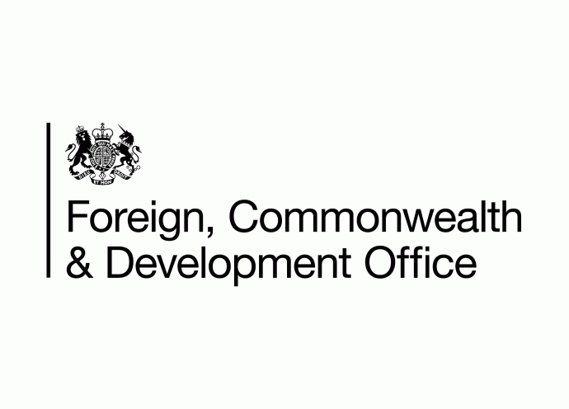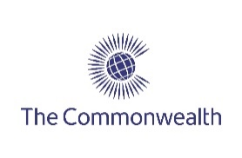**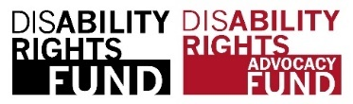A Solid Circle in Blue with words Commonwealth Disabled People's Forum in white around edge. Inside this a Globe outline with lines of latitude and longitude. Superimposed in Middle 4 squares with outline image person in a wheelchair, Hand signs, A brain and a person walking with a cane.**

**COSP 16 Side Meetings run by Commonwealth Disabled People’s Forum**

**Thursday June 15th - 8:15 - 9:30 am**

**Developing ways of creating Equal Access for Disabled Girls and Women to Sexual and Reproductive Health Services and Greater Equality**

Sponsored by United Kingdom FCDO, Commonwealth Secretariat, Disability Rights Fund. Organised by Commonwealth Disabled People's Forum.

In person and zoom Conference Room 11. Zoom <https://us02web.zoom.us/j/89322783228>

Chair: **Sarah Kamau,** United Disabled Persons Kenya. Chair CDPF

**Diana Dalton,** Head of Gender and Equalities Dept, UK FCDO

**Gaudence MushimiyimaNa**, Rwandan Organisation of Women with Disabilities. CDPF Women's Rep.

**Dr Sruti Mohapatra,** CEO Swabhiman, Odisha, India. Vice Chair CDPF

**Dr Shavana Haythornthwaite**, Adviser and Head, Human Rights Unit, Commonwealth Secretariat

**Kerryann Ifill**, President Barbados Council of the Disabled. Vice Chair CDPF

**Saista Parwin,** Young Member CDPF Executive, India

**Richard Rieser**, General Secretary CDPF on Men’s role as allies.

A Statement by UN Women in June [2022](https://www.unwomen.org/en/news-stories/statement/2022/06/statement-reproductive-rights-are-womens-rights-and-human-rights) “Reproductive rights are integral to women’s rights, a fact that is upheld by international agreements and reflected in law in different parts of the world. To be able to exercise their human rights and make essential decisions, women need to be able to decide freely and responsibly on the number and spacing of their children and to have access to information, education, and services.” Because Disabled Girls and Women are othered through outdated cultural stigma and stereotypes, the denial of the right to sexual and reproductive services and education is multiplied[, as is violence against them.](https://worldofinclusion-my.sharepoint.com/personal/richardrieser_worldofinclusion_com/Documents/Desktop/COSP%2016/ssets.publishing.service.gov.uk/media/57a089ade5274a27b20001e9/What_Works_Inception_Report_June_2014_AnnexW_Interventions_for_abuse_against_WWD.pdf) In launching the UK FCDO strategy, it was pointed out by Alicia Herbert ‘There is also increasing momentum behind systematic attempts to roll back on women’s and girls’ rights internationally, nationally and at the community level. This isn’t just about rhetoric, this is about real-life impacts on women’s and girls’ lives – limiting access to sexual and reproductive health and rights, condoning violence against [women and girls](https://blogs.fcdo.gov.uk/fcoeditorial/2023/03/15/rights-freedom-and-potential-our-women-and-girls-strategy/#:~:text=Lead%20by%20example%2C%20putting%20women,DAC)%20markers%2C%20by%202030.).’ In this situation, the rights of Disabled Women and Girls are even more under threat. The perspective of Rights for Disabled Women and Girls is underrepresented,

The meeting will present different aspects of the struggle for sexual and reproductive health and other rights for disabled girls and women. It will be in the context of the wider ongoing need to challenge the twin oppressions they face of disabilism and sexism, in different societies.

The Commonwealth Secretariat will speak about their support for Disabled Women’s Equality.

The UK FCDO will talk about their [International Strategy for Girls and Women 2023 to 2030](https://assets.publishing.service.gov.uk/government/uploads/system/uploads/attachment_data/file/1141525/international-women-and-girls-strategy-2023-2030.pdf), the implications for girls and women with disabilities and relevant work they are funding. Several of the female leaders of the Commonwealth Disabled People's Forum will talk about their ongoing work to empower disabled women and girls through their policy forum. They will give practical examples of the barriers faced and solutions developed and ways to reduce the high levels of violence in different national contexts. CDPF [Commonwealth Women’s Declaration](https://commonwealthdpf.org/wp-content/uploads/2023/03/CDPF-WOMEN-DECLARATION-Version-1-24_03_23-1.docx)

The meeting will also examine how men, particularly disabled men, can be good allies in these struggles. Discussion from participants will seek to share the best approaches.