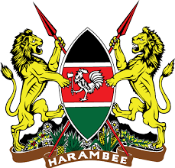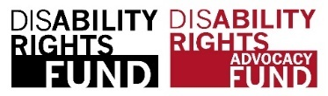 **A Solid Circle in Blue with words Commonwealth Disabled People's Forum in white around edge. Inside this a Globe outline with lines of latitude and longitude. Superimposed in Middle 4 squares with outline image person in a wheelchair, Hand signs, A brain and a person walking with a cane.**

**COSP 16 Side Meetings run by Commonwealth Disabled People’s Forum**

**Wednesday 14th June 1.15 to 2.30**

**Evaluating DPO/OPD Collaboration with State Parties on Implementing Elements of the UNCRPD across the Commonwealth**

**Sponsors Governments of Barbados, Kenya, Albinism Africa, Disability Rights Fund. Organised by Commonwealth Disabled People's Forum**

**In person and zoom Conference Room C - Zoom link** [**https://us02web.zoom.us/j/86590792554**](https://us02web.zoom.us/j/86590792554)

**Sign Language and Live Captioning**

**Speakers**

Chair **Richard Rieser** General Secretary CDPF

**Moses Kamau,** Social Protection Department, Kenyan Ministry of Labour

**Sarah Kamau,** United Disabled Persons of Kenya and CDPF Chair

**Hon. Kirk Humphrey** Barbados Minister of People Empowerment and Elder Affairs

**Kerryann Ifill** President Barbados Council of the Disabled, Vice Chair CDPF

**Rosanjali Priyadarshani** Disability Organisation Joint Front Sri Lanka, CDPF Exec

**Ero Ikponwosa,** Executive Director, Albinism Africa on the Kenyan Model of challenging stigma.

Speaker from Disability Rights Fund

**RATIONAL** 186 countries and 53 of 56 Commonwealth countries have ratified the UNCRPD. We find countries at many different stages of implementing the Convention so as to make real positive changes to the lives of their disabled citizens. Speakers will focus on lessons learned from collaborating as Governments and DPOs and draw out the factors which were important for bringing about positive change. The country report concluding comments of UNCRPD Committee chart some progress, but everywhere has a long way to go. The purpose of the meeting is to demonstrate when DPOs are closely involved in discussions with their State Parties more progress can be made in developing statues, policies and practices, following the fundamental paradigm shift that is necessary from the traditional/medical model to a social model human rights approach.

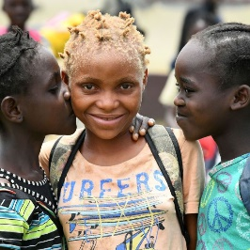Albinism Africa will talk about collaboration with Kenyan Government -The Kenya Model: how the partnership of civil society, government and strategic visionaries put Kenya ahead in Africa’s response to the crisis of extreme violence and discrimination against people with albinism in Africa.

The purpose of the meeting is to encourage closer collaboration and identify barriers that have inhibited such collaboration. Speakers will illustrate this with examples for employment, social protection, health, education, awareness raising and accessibility. Towards the end of the meeting contributors will be asked to identify the key factors that led to successful implementation of elements of the UNCRPD in their countries and regions.

[www.commonwealthdpf.org](http://www.commonwealthdpf.org)