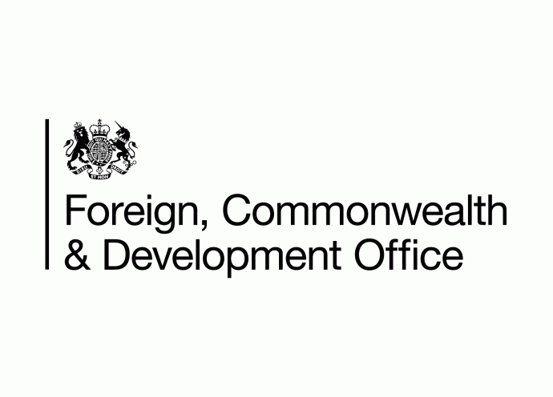**A Solid Circle in Blue with words Commonwealth Disabled People's Forum in white around edge. Inside this a Globe outline with lines of latitude and longitude. Superimposed in Middle 4 squares with outline image person in a wheelchair, Hand signs, A brain and a person walking with a cane.**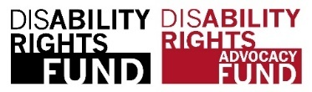

**COSP 16 Side Meetings run by Commonwealth Disabled People’s Forum**

**Thursday 15th 3.00 -4.15 pm**

**Disabled Youth Involvement, Awareness, Empowerment and Leadership in DPOs/OPDs across the Commonwealth**

 Sponsors Government of Barbados, United Kingdom Foreign Commonwealth Development Office. Organised by Commonwealth Disabled Peoples Forum

In person and zoom Conference Room C Zoom Invite Link <https://us02web.zoom.us/j/81278151088>

Chair: **Saista Parwin** **,** India,Youth Member CDPF Executive

Speakers include:

**Penny Innes**, Head of Disability Inclusion team, FCDO UK

**Kihembo Wilbert,** Voice of Youth Uganda, CDPF Youth Rep

**Saista Parwin,** Swabhiman Foundation, India, CDPF Executive

**Emile Gouws,** Autism South Africa, CDPF Rep. Underrepresented Groups

**Christopher Gilkes**, Public Relations Officer of the Barbados Council for the Disabled

**Charlotte Young** Children and Young People with Disabilities Australia

**Ganesh Singh** Guyana Council of Organisations for Persons with Disabilities CDPF Executive

**Richard Rieser,** General Secretary CDPF on Training Disabled Youth for Leadership project

**Rational** Ensuring Disabled Youth are aware of their rights, become empowered, engage with DPOs/OPDs and join the struggle to implement their rights is crucial. The number of Disabled Children and Youth with long term impairments in the Commonwealth is growing and their exclusion from education, training, employment, health and well-being is increasing, especially in low and middle income countries. The World Health Organisation now identify 16% of the population as disabled people, 1.3 billion people. In the Commonwealth where 60% of the population are aged 30 years or under, there are likely to be 230-250 million disabled children and youth.

2023 is Commonwealth Year of Youth. The [Commonwealth Disabled Peoples Forum (CDPF)](https://commonwealthdpf.org/) which represents Disabled People's Organisations in 50 of the 58 countries in the Commonwealth wants this year to make a difference. Two thirds of the Commonwealth population are under 30.

CDPF calls on Disabled People’s Organisations (DPOs) or Organisations of People with Disabilities (OPDs ) to champion the rights of disabled youth, develop, listen to and prioritise their concerns and support them to become leaders. CDPF calls on the Commonwealth and member Governments to prioritise tackling the barriers disabled youth face to leading equal lives and develop long term strategies in the areas highlighted below.

After consulting, CDPF has produced a [Disabled Youth Manifesto](https://commonwealthdpf.org/manifesto-for-commonwealth-year-of-youth/). Two of the key aims are to recruit and develop the capacity of Young Disabled Leaders with a customised Leadership on-line course, building on the [14 unit Disability Equality Course,](https://commonwealthdpf.org/training/) CDPF produced in 2021.

To compliment this initiative, CDPF will hold two regional seminars for the leaders of all our 96 members to develop the best ways of engaging disabled Youth in their organisations and develop guidelines on the best ways to embed a new generation of DPO/OPD leaders. We welcome other people’s perspective on what should be in these guidelines.

PRIORITISE DIGITAL INCLUSION which benefits disabled people by allowing them to live richer, more independent lives. Covid showed the large number of young people excluded digitally. For disabled people digital inclusion aids in the reduction of social isolation and the promotion of social inclusion is particularly important. Develop strategies for promoting digital inclusion for people with impairments i.e. Make their websites and digital services accessible to people with different ways of functioning.