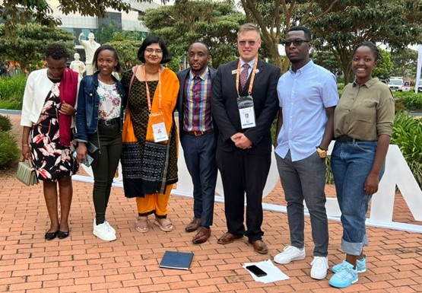I

IN THIS ISSUE:

01. COMMONWEALTH YEAR OF THE YOUTH – 2023.

02. THE COMMONWEALTH AND THE COP27 OF THE UNFCCC, EGYPT- 07 TO 18 NOVEMBER 2022.

03. COMMONWEALTH CONFERENCE OF EDUCATION MINISTERS (21CCEM).

04. BRIEF INFORMATION ON GLOBAL DISABILITY SUMMIT CONSULTATIONS 2020-2021- IDA.

05. CDPF APPROACH: CHILD PROTECTION AND PREVENTION OF SEXUAL EXPLOITATION, ABUSE AND HARASSMENT (PSEAH).

06. SITUATION REPORT 01: ADDRESSING EMERGING HUMAN RIGHTS ISSUES IN MENTAL HEALTH SERVICES DELIVERY IN MALAWI

07. SITUATION REPORT 02: SCHOOL HITS THE AIRWAVES: SIERRA LEONE TURNS TO EDUCATION RADIO AS A RESPONSE TO COVID19

08 SITUATION REPORT 03: PRELIMINARY OBSERVATION OF THE 2021 GENERAL ELECTIONS - ZAMBIA FEDERATION OF DISABILITY ORGANISATIONS

09. SITUATION REPORT 04: OPENING THE DOORS OF PERCEPTION: A YOUNG DEAF WOMAN FINDS HER CALLING THROUGH TECHNOLOGY, COMMUNITY AND EDUCATION.

10. CDPF NOTICES:

(I). CDPF Women’s Committee Convened

(Ii). CDPF DPO Youth Advocates Network

11. UN CHARTER BODY / TREATY BODY REVIEW OF COMMONWEALTH COUNTRIES.

12. UPCOMING EVENTS…

(i). Webinar on Inclusive Quality Police Services for Persons with Disabilities in Africa

(II). Commonwealth Youth Climate Network Launch Competition to Boost Youth-Led Action

(iii). Meeting of Commonwealth Youth Ministers

**COMMONWEALTH YEAR OF THE YOUTH - 2023**

**COMMONWEALTH HEADS DECLARE 2023 THE YEAR OF THE YOUTH**

“The heads of Government declare 2023 as a year dedicated to youth-led activity for sustainable and inclusive development, and call for stakeholders of all levels to renew and strengthen their commitments to youth engagement and empowerment. Heads encourage young people in member countries to work towards a renewed vision of the Commonwealth, founded on the principles and values of the Commonwealth charter, and to work with all partners, stakeholders, to build a fairer, more sustainable and more secure, prosperous future. Heads further welcome the announcement by Pakistan to host the next COMMONWEALTH YOUTH MINISTER MEETING in Islamabad”.

**Leaders of the 54 Commonwealth countries have demonstrated their commitment to tackling the endemic challenges facing children and young people.** Their landmark declaration at the end of the 2-day Commonwealth Heads of Government Meeting (CHOGM) comes on the heels of the devastating global pandemic that released a tsunami of health, education, economic, employment and safe-guarding challenges, and aims to get youth development on track for global-agreed development goals deadlines. Their 22-page [COMMUNIQUE](https://production-new-commonwealth-files.s3.eu-west-2.amazonaws.com/s3fs-public/2022-06/CHOGM%202022%20Communique.pdf?VersionId=sqWEwpE4gyzg8wIdTCoPO0yQgVNZ7Izy), issued after their historic meeting, which was twice delayed by Covid-19, includes commitments which will specifically benefit young people such as the landmark [KIGALI DECLARATION ON CHILD CARE AND PROTECTION REFORM](https://production-new-commonwealth-files.s3.eu-west-2.amazonaws.com/s3fs-public/2022-06/Kigali%20Declaration%20on%20Child%20Care%20and%20Protection%20Reform.pdf?VersionId=6_6fX1KMGJ7hQpxX_Ju45uW5A4wdDUuP).

Heads then sealed their commitment to ensuring the Commonwealth’s attention is firmly fixed on the empowerment of young people, who represent more than 60 percent of the Commonwealth’s 2.6 billion population, with a declaration that 2023 will be the ‘[YEAR OF THE YOUTH](https://thecommonwealth.org/news/commonwealth-heads-declare-2023-year-youth#:~:text=Heads%20then%20sealed%20their%20commitment,'Year%20of%20the%20Youth)’.

**COMMUNIQUE OF THE COMMONWEALTH HEADS OF GOVERNMENT** MEETING “DELIVERING A COMMON FUTURE: CONNECTING, INNOVATING, TRANSFORMING”

**YOUTH -** *Youth Participation*

91. Heads acknowledged the significant contribution made by the Commonwealth Youth Programme (CYP) in promoting youth development and youth work globally. In honouring the commitment made by Heads to establish the CYP in 1973, Heads declared 2023 a year dedicated to youth-led action for sustainable and inclusive development and called on all stakeholders at all levels to renew and strengthen their commitment to youth engagement and empowerment. Heads encouraged young people in member countries to work towards a renewed vision for the Commonwealth, founded on the principles and values of the Commonwealth Charter, and to work with all partners and stakeholders to build a fairer, more sustainable, more secure, and prosperous future. Heads further welcomed the announcement by Pakistan to host the next Commonwealth Youth Ministerial Meeting in Islamabad in January 2023.

**CDPF AT THE COMMONWEALTH YOUTH FORUM DUIRNG CHOGM 2022: 19-21 June 2022**

Photo Credit for Cover Page & this article: Emile Gouws

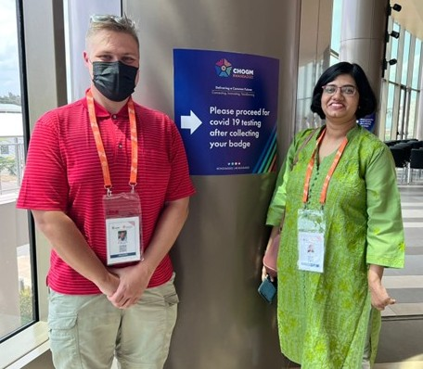

Commonwealth Youth Forum (CYF) brought together young leaders from across the Commonwealth to exchange ideas, build networks, identify and debate development issues, challenges, and opportunities, agree on youth-led initiatives to mitigate challenges facing young people and create opportunities to enhance their lives. Rwanda brought over 300 delegates, including two official youth delegates from each member country, as well as key youth sector stakeholders.

CDPF delegates attended plenary meetings, lab sessions, and made connections with key role players in youth development in their respective countries. During the sessions CDPF delegates actively contributed for the deliberations specifically for the inclusion of disabled youth voices. Recommendations made during the discussions:

• Establish a **FORUM FOR COMMONWEALTH DISABLED PEOPLE**:

Inclusions and reasonable accommodation services for PWD’s seems conveniently neglected at Youth Forum and Peoples Forum and the presence of PWD’s make the CHOGM visible and inclusive.

• Forum to convene **SESSION ON** HYBRID MODE:

Challenges in representation of PWD’s from various continents could be easily mitigated by convening sessions in Hybrid mode, giving equal opportunity for intervention. Recently concluded Commonwealth Ministers of Education Summit in Kenya was a very successfully convened hybrid event, where online participants never felt excluded.

• Emphasis the importance of **CELEBRATE DIVERSITY**:

Uplifting the disabled people by embracing the theme “Celebrate Diversity”, in line with the social model towards disability and could be a major disability advocacy event at the Commonwealth.

• Make Labs / Plenary sessions more **INCLUSIVE AND MEANINGFUL**:

Some thematic discussions lacked meaningful participation, representation and clarity. Solutions for the challenges confronted by disabled people needs the insiders’ perspectives and expertise as the personal experience is highly relevant.

It was a major honour to represent CDPF as disabled youth delegates at the Commonwealth Youth Forum and raise our voices on behalf of all the disabled youth in the Commonwealth.

**SAISTA PARWIN** (Swabhiman Foundation – India) & **EMILE GOUWS** (Autism South Africa)

CDPF Executive Officers

**CPDF POLICY POSITION ON THE DISABLED YOUTH**

The Commonwealth Disabled People’s Forum are of the  view disabled youth have been largely left out, both our delegates to the recent Youth Forum at CHOGM reported feeling marginalized with no disabled platform speakers and little effort made to include them and few reasonable adjustments.

This underlines one of CDPF’s main aims during the year to get the Commonwealth to develop a Disability Inclusion Protocol which does not currently exist, unlike the United Nations that adopted such a protocol in 2014.

If we take the conservative estimate that 10% of children and youth in the Commonwealth are disabled, then there are 156 million disabled children and youth, aged 30 or less. The record is appalling of our 58 Commonwealth countries in addressing the rights of this group and implementing the United Nations Convention on the Rights of Persons with Disabilities, which nearly all Governments have ratified.

Most do not attend school, complete their studies or get access to quality vocational education or higher education or employment. Many are subject to stigma and prejudice on a systematic basis and amount to harassment and abuse. Disabled children and youth in the main, do not have access to quality healthcare, rehabilitation or to the aids and appliances which would empower them. Neither are the vast majority made aware of the liberation paradigm of the UNCRPD or Medical model which would empower them to become part of the solution and not be seen as the ‘problem’.

CRPD is calling on all our member organizations and their members to mass e-bomb the leaders of their respective countries on 02nd December - International Day of Disabled People. Calling on Leaders to meet with National DPOs/OPDs with Youth Representative soon in the New Year to agree a programme of Conferences, events and actions to tackle these inequalities.

We are also calling on all our DPO members to prioritize Disabled Youth Involvement in their DPOs. CDPF will get funding to develop a training course for Disabled Organization Youth Leaders.

CDPF Executives on 24th November 2022

**COMMUNIQUE OF THE COMMONWEALTH HEADS OF GOVERNMENT** MEETING “DELIVERING A COMMON FUTURE: CONNECTING, INNOVATING, TRANSFORMING”

**YOUTH -** *Youth Participation*

89. Heads took note of the fact that young people across the Commonwealth are mobilising to gain a greater voice in all public affairs, to call for systemic change and increased accountability from governments. With three out of every five citizens of the Commonwealth under age 30, young people play a pivotal role in achieving the 2030 Agenda. In this regard, Heads committed to increasing meaningful representation of youth in decision-making processes and mechanisms, including in conflict resolution and peacebuilding.

**VIEWS OF THE CDPF YOUTH ADVOCATES ABOUT COMMONWEALTH YEAR OF THE YOUTH**

*“As a young leader with a disability, I think that there is a vacuum in terms of developing youth capacity to become an empowered generation. I would like to see an increasing number of youth with disabilities enrolling in higher education institutions. Persons with disabilities are the hardest hit and most vulnerable due to the ongoing economic crisis and high cost-of-living where youth with disabilities face trauma as a result of economic, environmental, and discriminatory issues. We need to find possible solutions for these issues in a more proactive and innovative way. Need effective interventions to address the mental health concerns of young men and women. The obligation of the authorities are to have regulations that will integrate youth with disabilities in public planning processes, which should be implemented by community leaders through local and national programming; create more employment opportunities where accessibility and communication needs are addressed through the concept of reasonable accommodation. I also urge the governments to exclude disabled people, their organisations and disability service providers/companies from paying taxes”.*

**KIHEMBO WILBERT** - CDPF Exceptive Officer (Elected Youth Representative)

& Voice of Youth Uganda. Email: [kihembowilb@gmail.com](mailto:kihembowilb@gmail.com)

*“As a representative of underrepresented groups in the Commonwealth Disabled People’s Forum, year of the youth is a fantastic opportunity for young people especially disabled activists to showcase their talents and leadership skills. As the COMMONWEALTH YOUTH AWARDS headlines the COMMONWEALTH YEAR OF THE YOUTH, I would like to encourage the Commonwealth Secretariat and higher authorities to acknowledge disabled activists for their contribution and dedication to drive for change and continuous struggle to create the paradigm shift. It does not matter from which country, race or even disability, the body of work of these individuals needs to be known and respected”.*

**EMILE GOUWS -** CDPF Executive Officer, (Rep. for Intellectual Disability and Under-Represented Groups) & Autism South Africa. Email: [mieliemeel93@gmail.com](mailto:mieliemeel93@gmail.com)

*“As a representative of India in the Commonwealth Disabled Peoples Forum, I expect the COMMONWEALTH YARER OF THE YOUTH to be more just equitable and inclusive for all, especially for young disabled women and marginalized sections within the disabled community. This is an opportunity for young disabled people especially disabled leaders / activists to raise their voices and speak up for the voiceless.* *I urge the authorities to make provisions for the meaningful inclusion and effective participation of young men and women in all matters related to their life and rights not only in words but in action as well. Their dedication and devotion should be acknowledged and rewarded with dignity”.*

**SAISTA PARWIN** **-** CDPF Executive Officer (Representative for India) & Swabhiman Foundation, Odisha, India. Email: [parwinnluo@gmail.com](mailto:parwinnluo@gmail.com)

**THE COMMONWEALTH AND THE COP27 (UNFCCC), EGYPT: 07 - 18 NOVEMBER 2022**

**THE COMMONWEALTH AND COP27 STATEMENT BY CDPF AND ACCREDITED ORGANISATIONS**

Photo Credit: Pictures in this Article is obtained from the [CDPF Policy on Humanitarian Situation](https://commonwealthdpf.org/policy-papers/person) and Disabled People.

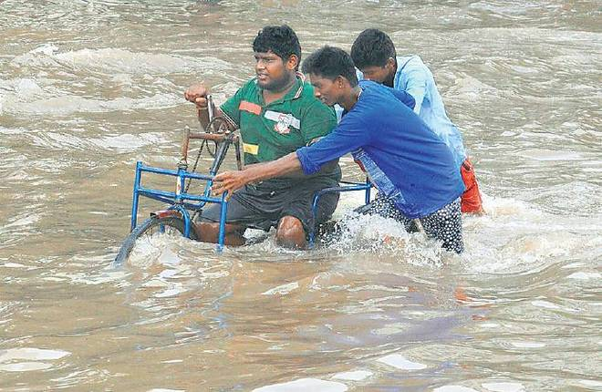Climate change is an existential issue for Commonwealth countries. This is especially true for the 24 small island/developing states (SIDS), but major impacts will also occur in Commonwealth states in Africa and the Asian subcontinent. The ‘ABC’ countries (Australia, Britain and Canada) will be affected and to some degree are already experiencing symptoms such as drought, famine, and wildfires. In the Commonwealth South there will be adverse effects on the rights and livelihoods of large parts of their populations.

We appreciate the COP27 reception held in London by King Charles III, who is Head of the

Commonwealth and an acknowledged authority on climate change and biodiversity, to begin discussions in advance of the COP about ways of tackling climate change. We also recognise the strong statement from UN Secretary General António Guterres and his call for a CLIMATE SOLIDARITY PACT.

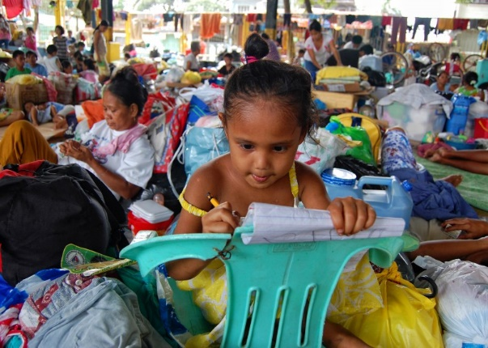It is an urgent priority to deliver on commitments already made to finance adaptation and mitigation measures in developing countries and to support a just and equitable transition to a sustainable zero carbon development path for all Commonwealth states. Freedom of speech and the human rights of climate activists must also be acknowledged and respected, as must the rights of women and girls, who are disproportionately affected by climate change. These are expressed in the [UNFCCC GENDER ACTION PLAN](https://womengenderclimate.org/wp-content/uploads/2022/05/Background-Paper-The-GAP_v3.pdf), which aims to advance gender-responsive climate action and ‘women’s full, equal and meaningful participation in the UNFCCC processes.

At COP26 the Commonwealth Secretariat hosted a pavilion to profile and facilitate climate initiatives across the full suite of its [POLICY INITIATIVES](https://thecommonwealth.org/cop27). We still believe that the Commonwealth, with its unique heritage and role in international diplomacy, is an association that deserves support and funding from its member governments to combat climate change, and we draw attention particularly to the fact that such support precludes doubling down on the use of fossil fuels in developed Commonwealth countries.

The impacts of climate change do not fall evenly across Commonwealth countries. Those who have added most to global warming, – THE RICH NORTHERN INDUSTRIALISED COUNTRIES – are most able to protect their populations from climate change impacts but should also support calls to fund adaptation and mitigation measures in the Commonwealth South.

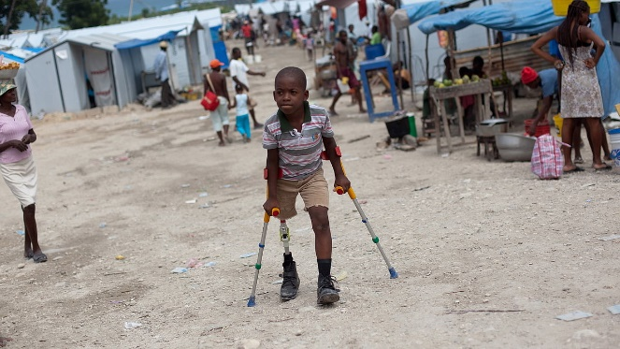The former UN High Commissioner for Human Rights, [MICHELE BACHELET](https://news.un.org/en/story/2021/10/1104352), recently stressed that “the triple threat of climate change, pollution and biodiversity loss constitutes the single greatest challenge to human rights in our era”. Climate change negatively impacts the enjoyment of human rights - including the right to health, housing, water and food - disproportionately affecting people in [SITUATIONS OF VULNERABILITY](https://www.ohchr.org/sites/default/files/Documents/Issues/ClimateChange/COP21.pdf). The [UN GENERAL ASSEMBLY](https://sdgs.un.org/2030agenda) has also affirmed in the context of the 2030 Agenda for Sustainable Development that “climate change is one of the greatest challenges of our time and its adverse impacts undermine the ability of all countries to achieve sustainable development.”

Looking ahead, Commonwealth States have an obligation to prevent, address, and remedy the negative human rights impacts caused by climate change. They also need to remove the barriers to participation at COPs and at related meetings that are faced by activists and by marginalised and vulnerable groups, including indigenous peoples, older people and PWD’s.

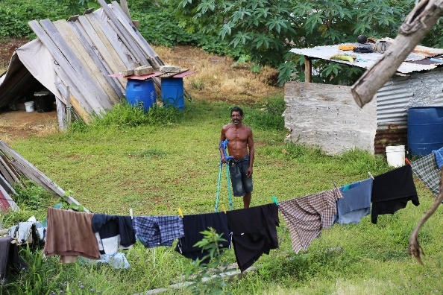Member states must ensure that strategies are put in place to give priority evacuation to persons with disabilities and other vulnerable groups in times of crisis or catastrophe. Indeed, all those at risk need the nations represented at COP27 to pool their knowledge, understanding and wealth to avert escalating climate catastrophes. The key to success in all of this is a reversal of the global warming that has already occurred.

As representatives of the Commonwealth Accredited Organisations, we wish to express our concern about the lack of real progress at COP27 and would encourage work towards a more positive outcome at COP28.

We wish to celebrate the breakthrough agreement to provide “loss and damage” funding for vulnerable countries hit hard by climate disasters and congratulate negotiators from across the Commonwealth on this achievement. However, the lack of ambition on emissions reduction leaves much to be done in preparation for COP28.

CDPF needs to treat Disability and Climate Justice much more seriously. We need to develop a strong policy and intervention for COP28. Use this material to develop policy in your organisations and send to the CDPF General Secretary [rlieser@gmail.com](mailto:rlieser@gmail.com)

**ADDITIONAL ARGUMENTS FOR A HIGHER PROFILE FOR DISABLED PEOPLE IN CLIMATE MOVEMENT NOW AND IN THE FUTURE.**

* [DISABILITY INCLUSION IN CLIMATE JUSTICE](https://www.youtube.com/watch?v=36jwHDRtmGg) Climate Justice for PWD’s (05 mins)
* [GLOBAL DISABILITY JUSTICE IN CLIMATE DISASTERS](https://www.healthaffairs.org/doi/10.1377/hlthaff.2022.00474): Mobilizing PWD’s as Change Agents
* [CLIMATE CHANGE, ENVIRONMENTAL ACTIVISM, AND DISABILITY](https://ssir.org/articles/entry/climate_change_environmental_activism_and_disability): PWD’s are on the front lines of the climate crisis. Efforts to address the crisis must include them. By [Valerie Novack](https://ssir.org/bios/valerie_novack) & [Daphne Frias](https://ssir.org/bios/daphne_frias) [Winter 2022](https://ssir.org/issue/winter_2022)
* [INDIGENOUS PEOPLE WITH DISABILITIES ARE ON THE FRONT LINES OF THE CLIMATE CRISIS](https://truthout.org/articles/indigenous-people-with-disabilities-are-on-the-front-lines-of-the-climate-crisis/) by Jen Deerinwater
* [ENVIRONMENTAL INJUSTICE AND DISABILITY: WHERE IS THE RESEARCH?](https://www.ehn.org/disability-justice-2654683649.html)  by Krystal Vasquez for Environmental Health News
* [A DISABILITY SHOULD NOT BE A DEATH SENTENCE DURING A NATURAL DISASTEr](https://www.ehn.org/natural-disasters-disabled-community-2652503611/wildfire-bobcat-fire) by Krystal Vasquez for Environmental Health News
* [IT’S TIME TO RECOGNIZE CLIMATE CHANGE AS A DISABILITY RIGHTS ISSUE](https://rootedinrights.org/its-time-to-recognize-climate-change-as-a-disability-rights-issue/) by Tiffany Yu for Rooted in Rights
* [A CALL FOR CLIMATE ACTION](https://disabilityrightsfund.org/a-call-for-climate-action/) by Ipul Powaseu for the Disability Rights Fund
* [CLIMATE DARWINISM MAKES DISABLED PEOPLE EXPENDABLE](https://www.forbes.com/sites/imanibarbarin/2019/11/02/climate-darwinism-makes-disabled-people-expendable/#1c62b0003d5a) by Imani Barbarin for Forbes
* [TO SURVIVE CLIMATE CATASTROPHE, LOOK TO QUEER AND DISABLED FOLKS](https://www.yesmagazine.org/opinion/2019/07/31/climate-change-queer-disabled-organizers/) by Patty Berne and Vanessa Raditz for YES!
* [DISABILITY AND DISASTER RESPONSE IN THE AGE OF CLIMATE CHANGE](https://psmag.com/environment/fixing-americas-disability-disaster-response) by David Perry for Pacific Standard
* [THE END OF THE WORLD AS WE KNOW IT](https://www.newmobility.com/2016/03/climate-change-and-disability/) by Alex Ghenis for New Mobility
* [TO EACH ACCORDING TO THEIR OWN ABILITIES: DISABILITY AND ENVIRONMENTALISM](http://meloukhia.net/2012/06/to_each_according_to_their_own_abilities_disability_and_environmentalism/) by S. E. Smith
* [TOWARD DISABILITY JUSTICE: DON’T FORGET THE PLASTIC THAT GIVES ME FREEDOM](https://www.yesmagazine.org/issue/solving-plastic/2021/05/10/toward-disability-justice) by Luticha Andre Doucette for YES! Magazine

**PODCASTS AND FILMS**

* [ENVIRONMENTAL JUSTICE AND DISABILITY](https://judithheumann.com/environmental-justice-and-disability-with-pauline-castres/): With Pauline Castres, the Heumann Perspective Podcast
* [ECO-ABLEISM](https://disabilityrightsflorida.org/podcast/story/episode_25): An episode of Disability Rights Florida’s *you First* podcast
* [DISABILITY INCLUSIVE CLIMATE JUSTICE](https://youtu.be/JnOIRdFFdMk): European Disability Forum
* [EPISODE OF THE DISABILITY VISIBILITY PODCAST](https://disabilityvisibilityproject.com/2020/10/05/ep-87-climate-action/): On Climate Action with Kera Sherwood-O’Regan
* [CRIPPLING THE ANTHROPOCENE](https://www.sinsinvalid.org/podcast/2020/10/16/episode-1-foundations-of-climate-justice-and-disability-justice): A podcast from Sins Invalid exploring the connections between disability justice and climate justice
* [THE RIGHT TO BE RESCUED](https://rootedinrights.org/therighttoberescued/): A documentary from Rooted in Rights

**GOVERNMENTS STILL HAVE MUCH TO DO TO ACHIEVE DISABILITY INCLUSION IN CLIMATE ACTION**

Note: the contents below are some excerpts from an article by IDA, on the subject of [SOME GOOD NEWS FOR PERSONS WITH DISABILITIES FROM COP27](https://www.internationaldisabilityalliance.org/blog/some-good-news-persons-disabilities-cop27).

The 27th Conference of Parties to the United Nations Framework Convention on Climate Change (COP27) has concluded in Sharm El-Sheikh, Egypt. Little attention was given to the rights of the one billion PWD’s who are among the most affected by the climate crisis. Despite years of advocacy by PWD’s and their allies, and notwithstanding their obligations under the Paris Agreement and the UNCRPD, governments continue to fail to comply with their duties to respect, protect, and fulfil the rights of PWD’s in their response to climate change. COP27 was ground-breaking for disability inclusion in many ways: the number of PWD’s participating multiplied compared to earlier conferences, as did the number of events addressing disability organized by different Governments, UN agencies, and other stakeholders.

In the Key Findings & Recommendations for Moving Forward, authored by IDA stated that disability rights approach to climate governance stresses the importance of recognizing and protecting the substantive and procedural rights held by PWD’s in the development, implementation, monitoring, and evaluation of climate policies and programs. Unfortunately, States are falling far short of their obligations in this regard.

A minority of State Parties to the Paris Agreement include PWD’s in their NDC’s and climate adaptation policies. In cases where disability has been included, it is largely to indicate the vulnerability of PWD’s to climate change impacts or to signal the need for their inclusion, without providing concrete measures to protect their rights or enhance their resilience and adaptive capacity. The exclusion of PWD’s from most domestic climate policies is especially troubling given the evidence that they are disproportionately affected by climate impacts and are often adversely affected by measures adopted to reduce carbon emissions.

The on-going failure of most States to take affirmative measures to prevent the harms caused by climate change and to effectively consider their rights and perspectives in the design of climate policies constitute clear breaches of their obligations under the UNCRPD and international human rights law.

The report concludes that even when Governments refer to disability, many do so in a cursory manner, without including meaningful mechanisms to consult people with disabilities or ensure their rights are respected in climate policies.

Read the Full Report: [DISABILITY RIGHTS IN NATIONAL CLIMATE POLICIES STATUS REPORT NOVEMBER 2022](https://www.internationaldisabilityalliance.org/sites/default/files/drcc_status_report_english_nov_2022_formatted.pdf).

**COMMUNIQUE OF THE COMMONWEALTH HEADS OF GOVERNMENT** MEETING “DELIVERING A COMMON FUTURE: CONNECTING, INNOVATING, TRANSFORMING”

**GOVERNANCE, HUMAN RIGHTS AND THE RULE OF LAW**

*Rule of Law and Human Rights*

19. In pursuit of SDGs 10 (reduced inequalities) and 16 (peace, justice and strong institutions), Heads committed to fully implement laws that promote and protect inclusion, to eliminate discriminatory laws, policies and practices, and to promote appropriate legislation, policies and action.

23. Heads noted that persons with disabilities are disproportionately vulnerable to the health, economic and social impacts of the COVID-19 pandemic and called on member countries to ensure that their COVID-19 response and recovery actions, including vaccine programmes, are inclusive. They also urged member countries to implement the UN Convention on the Rights of Persons with Disabilities, and promote alignment of any related policies**.**

*Delivering Good Governance*

29. Heads reflected on the link between good governance and transformational leadership that is accountable, transparent, inclusive, and non-discriminatory. They committed to the effective and equitable delivery of public goods and determined to continually evaluate their governance systems, and make improvements where necessary, including placing citizen participation (especially of young people, women and others facing inequality), at the heart of policy development. Heads called for increased technical assistance from the Secretariat, especially to Low-to-Middle-Income-Countries in policy formulation and development.

**COMMONWEALTH CONFERENCE OF EDUCATION MINISTERS (21CCEM)**

The 21st [COMMONWEALTH CONFERENCE OF EDUCATION MINISTERS](https://thecommonwealth.org/press-release/nairobi-conference-commonwealth-education-ministers-kicks-renewed-calls-rebuilding) (CCEM) was held in Nairobi, Kenya from 27- 28 April 2022 under the theme, ‘RETHINKING EDUCATION FOR INNOVATION, GROWTH AND SUSTAINABILITY POST-COVID-19’. Kicked off with renewed calls for rebuilding resilient education systems, delegates have addressed the educational priority issues towards the 2030 Agenda, at a time when the world is recovering from the negative impacts of the COVID-19 pandemic.

Attended by ministers, policymakers, civil society, and development partners the opportunity to engage with one another, share knowledge and good practice, and explore trends and innovative approaches that can be adapted by member countries to develop sustainable and resilient education systems. Commonwealth education ministers vow to increase investment in education and have issued a [JOINT STATEMENT](https://thecommonwealth.org/press-release/commonwealth-education-ministers-vow-increase-investment-education-nairobi-conference#:~:text=The%2021st%20CCEM%20will,post%2DCovid%2D19%27.) in which they recognised the urgent need to increase investment in education and skills at all ages, with particular focus on ensuring foundational skills for all.

Mr. Emile Gouws, CDPF Exceptive Officer (representative of under representatives groups) represented CDPF at the CCEM. Joining the High Political Forum online meeting, CDPF intervened during side events with the Minister of Basic Education of South Africa and shared the perspectives of how the underrepresented groups experienced during COVID19.

DR. Roger Y. Chao Jr., PhD. Head, Education, Youth and Sports ASEAN Secretariat presented Progress and challenges, key findings and recommendations and further explained the **ASEAN Work Plan On Education** (2021-2025), **Vietnam Education Chairmanship** (2022-2023) and **ASEAN Declaration on HRD** for the Changing World of Workand the **ASEAN DIGITAL MASTER- PLAN 2025 FRAMEWORK** and the intended outcomes.

Hon. Kay McConney, Minister of Education- Barbados presented **THE GOOD, THE BAD AND THE UGLY**, the impact of Covid19 - Caribbean perspective in protecting the right of access to quality education.

The HYBRID (Dual) event in which only Ministers of Education physically attended online whilst stakeholders, organisations and delegates took part online. As a delegate, I was surprised how well this event organised as I never felt excluded. The delegates could participate virtually and respond whilst the ministers and host listened to delegates online. It was professionally hosted and commendable effort by organisers.

**Emile Gouws**, CDPF Executive Officer (Representative for ID & Under-Represented Groups)

Vice Chair of the NEC of Autism South Africa, PhD student at the University of Pretoria.

**BRIEF INFORMATION ON GLOBAL DISABILITY SUMMIT CONSULTATIONS 2020-21- IDA**

**CONSULTING PEOPLE WITH DISABILITIES WORLDWIDE**

Persons with disabilities continue to face barriers in their participation as equal members of society and violations of their human rights in all parts of the world. To see the evidence base grow and ensure that the focus is where people with disabilities have the greatest needs, IDA, its members, local, and regional partners, organised and coordinated one regional and 27 national GDS consultations. These consultations took place in 26 countries in Africa, Asia, Latina America, Middle East, North Africa, and the Pacific. The consultations, which took place between October 2020 and April 2021, brought together more than 840 people.

**THEMES TO ENSURE THAT NO ONE IS LEFT BEHIND**

In 2018, the first Global Disability Summit was held in the United Kingdom. It brought out one hundred and 171 national governments, multilateral agencies, donors, foundations, private sector, and civil society organisations. They went on to make 968 individual commitments anchored on seven central themes: **(1). Eliminate stigma and discrimination, (2). Inclusive education (3). Routes to economic empowerment (4). Harnessing technology and innovation (5). Data disaggregation (6). Women and girls with disabilities (7). Conflict and humanitarian contexts**

The last three years have been a litmus test. Positive strides have been made towards the implementation of the GDS18 Commitments. The uniqueness of these consultations was that it gave IDA, its members and its partners the ability to assess the implementation of the GDS 2018 Commitments. Persons with disabilities and their representative organisations evaluated the implementation process, identifying the milestones that had been achieved in the realisation of the Commitments and the areas that needed more collaboration and investments to ensure accelerated and full implementation.

Beyond the central themes, the consultations also identified emerging trends and areas of attention that can inform the Global Disability Summit 2022, which will take place in February. These included: **(1). Living independently and being included in the community (2). Health (3). International cooperation and disability-inclusive development (4). Accountability mechanisms**.

**THE FUTURE**

Though the Consultations revealed that there is still a gap in the implementation of the commitments, the GDS Secretariat, IDA, its members, and global, regional and national partners are working to incorporate GDS Consultations around the world to be able to continue learning. In the coming months, various online and face-to-face consultations will ensure that persons with disabilities and representative organisations have a platform to express their views and shape the planning and implementation towards GDS22.

(Source: [INTERNATIONAL DISABILITY ALLIANCE](https://www.internationaldisabilityalliance.org/content/global-disability-summit-gds-regional-and-national-consultations-report) Official Website).

Read Brief Report: [BRIEF INFORMATION ON GLOBAL DISABILITY SUMMIT CONSULTATIONS 2020-21](https://www.internationaldisabilityalliance.org/sites/default/files/brief_info_gds_consultations_20-21_0.pdf).

Read Full Report: [GLOBAL DISABILITY SUMMIT REGIONAL AND NATIONAL CONSULTATIONS REPORT](https://gds-imagez.s3.amazonaws.com/l2gwelc8oy192tneffpizpaqfi8f?response-content-disposition=inline%3B%20filename%3D%22gds_report_2020_2021_final_4%20%25281%2529.pdf%22%3B%20filename%2A%3DUTF-8%27%27gds_report_2020_2021_final_4%2520%25281%2529.pdf&response-content-type=application%2Fpdf&X-Amz-Algorithm=AWS4-HMAC-SHA256&X-Amz-Credential=AKIAVGJB6RJHV2D3XRVN%2F20221129%2Fus-east-1%2Fs3%2Faws4_request&X-Amz-Date=20221129T103539Z&X-Amz-Expires=300&X-Amz-SignedHeaders=host&X-Amz-Signature=62ad610e65763813fa7ee6dd4a826ff433b8e1ec71199109b123f439be763e04)

**CDPF APPROACH: CHILD PROTECTION AND PREVENTION OF SEXUAL EXPLOITATION, ABUSE AND HARASSMENT (PSEAH)**

**COMMONWEALTH DISABLED PEOPLE’S FORUM 24 OCTOBER 2022**

**CHILD PROTECTION AND PREVENTION OF SEXUAL EXPLOITATION,**

**ABUSE AND HARASSMENT (PSEAH)**

While the CDPF does not work with children, and CDPF representatives are meeting in a management and planning capacity and not directly with individuals, we need to show our member organisations that we take the issues of Child Protection and the prevention of sexual exploitation, abuse and harassment (PSEAH) seriously. We therefore plan to take the following steps to begin implementing our plan:

1. The Finance and General Purposes committee (F&GP), a subset of the Executive Committee (EC), will meet on the 4th November 2022 and will agree complaints procedures for both Child Protection and PSEAH.
2. The Executive Committee will meet on the 24th November and will have key points raised on the importance of CP and preventing SEAH in an international context in a specially organised session as an extension to the meeting. To prove we are committed to this area, we are confirming an external trainer and will incur more captioning costs. This session will be recorded.
3. We will have the revised policies sent for approval to the Executive Committee before the end of the year. This send out will include the recording of the training above. Once approved, we will send the policies and the link to the recording, to our members via email.
4. We will have a prolonged EC, either in person or remote, in the Spring of 2023, which will include a fuller session on SG scenarios and how to deal with them, by an experienced trainer in this field. We may need to raise additional funds to cover the costs of this training.

In addition to the 2 parts of training, we will announce in the next CDPF newsletter, by way of a short illustrated article our Treasurer (who as an important figure in Human Rights in Malawi) is producing on the importance of Safeguarding in all its forms (Child Protection and PSEAH). This is a conduit to our member organisations that we are as serious as they are, or to instil importance in them, in this area.

We are confident that this will help everyone be fully versed with our policies.

With thanks



**Richard Rieser**, **General Secretary** – **CDPF**

Note: CDPF Executive are currently having training and developing a safeguarding policy and code of conduct which when complete, will be circulated to all member organizations. See Page 13 for the Statement & Page 14 for an Article by **Scader Loise**.



**01 NOVEMBER, 2022**

**CHILD PROTECTION, SAFEGUARDING AND ROLE OF COMMONWEALTH DISABLED PEOPLES FORUM (CDPF) ON THE RIGHTS AND WELFARE OF THE CHILD: LOOKING AHEAD;**

According to the World Health Organization (WHO) 2020 Global status report on preventing violence against children, one billion children – or one out of two children worldwide - suffer some form of violence each year. In addition to its immediate harms to individuals, families and communities, violence against children has pernicious, lifelong effects that undermine the potential of individuals, and when aggregated across billions of people, may impede economic development

Studies have shown that disabled children are more likely to experience violence and abuse than non-disabled children. One in every 20 children has a moderate to severe disability. Disabled children are 3.8 times more likely to be neglected or physically abused, 3.1 times more likely to be sexually abused and 3.9 times more likely to be emotionally abused. In fact, findings show that 31% of disabled children suffer abuse compared with 09% of the non-disabled child population. Further to this, disabled children are also at a higher risk of experiencing multiple abuses and of enduring multiple episodes of abuse.

.

CDPF has zero tolerance towards incidents of violence or abuse against children or adults, including sexual exploitation or abuse, committed either by employees or others affiliated with our work. Our organisation through existing policies currently under revision emphasize the unique vulnerabilities and special protection requirements for children, along with the importance of preventing sexual exploitation and abuse (SEA), in particular, among other forms of adult beneficiary abuse. Safeguarding children and vulnerable adults we serve is foundational to all CDPF activities and programmes

.

Central to everything we do is our commitment to first do no harm to children or adult beneficiaries and to respect the rights of all beneficiaries. CDPF is committed to continuous improvement of safeguarding efforts which emphasizes {Prevention of Sexual Exploitation and abuse (PSEA) and other forms of violence or harm. We abhor any misuse of power, status, or trusted position for any sexual or other exploitative purposes. We endeavour to tackle this root cause of abuse in our prevention and training efforts.

**SCADER LOUIS**, Treasure – CDPF

Chairperson, Malawi Human Rights Commission

**SITUATION REPORT 01: ADDRESSING EMERGING HUMAN RIGHTS ISSUES IN MENTAL HEALTH SERVICES DELIVERY IN MALAWI**

On the 16th September 2022, the Malawi Human Rights Commission (MHRC) disseminated a [HUMAN RIGHTS BASED MENTAL HEALTH MONITORING REPORT](http://www.mhrcmw.org/sites/default/files/MHRC%20Mental%20Health%20Report.pdf). The dissemination was held in the capital city of Lilongwe. Stakeholders from government ministries and departments, media, local CSO’s and international NGO’s, and development partners, including the UN Agencies attended the meeting.

The Chairperson of the Commission, Scader Louis, stated that the report was a product of a human rights investigation and monitoring mission that MHRC conducted in the second quarter of 2022 as a result of increased human rights violations induced by mental health-related issues.

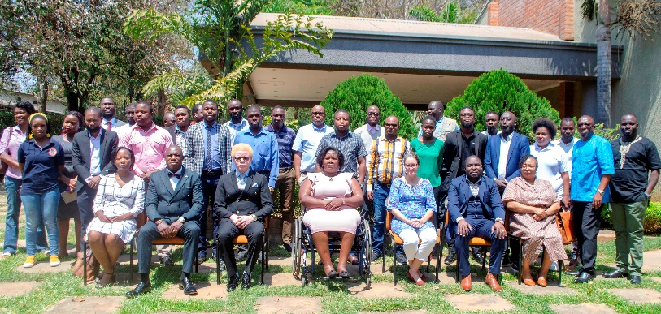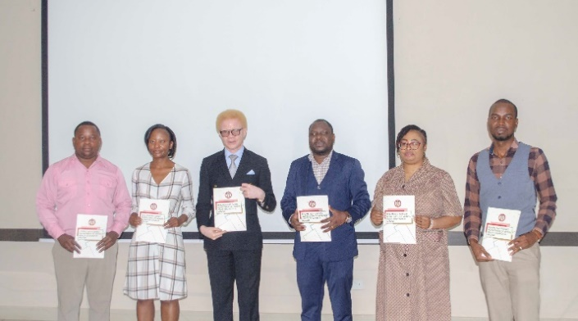

Photo Credit: Scader Louis

The Commission conducted this human rights-based mental health investigation and monitoring to ascertain the magnitude of mental health issues affecting the enjoyment of human rights in Malawi. The Commission anticipates that the findings contained in the report will facilitate a national conversation on mental health effects and actions on human rights.

In his remarks, the Director of Non-Communicable Diseases and Mental Health of the Ministry of Health, Dr. Jonathan Chiwanda commended the Human Rights Commission, Malawi for disseminating the report which he said unveils critical issues the mental health sector is facing in Malawi. Dr. Chiwanda assured stakeholders that the government will seriously study the report and collaborate with other actors to implement the recommendations.

The Commission received technical and financial support for this investigation, monitoring and dissemination from the European Union through the Chilungamo Justice and Accountability Program.

The Commission also recently published a [REPORT ON COVI19 AND PWD’s](http://www.mhrcmw.org/sites/default/files/Report%20on%20COVID-19%20and%20PWDs_0.pdf) in July 2021.

**Scader Louis**- Executive Officer-CDPF

Treasurer -Federation of Disability Organisations in Malawi (FEDOMA)

The Chairperson-Malawi Human Rights Commission (MHRC)

**SITUATION REPORT 02: SCHOOL HITS THE AIRWAVES: SIERRA LEONE TURNS TO EDUCATION RADIO AS A RESPONSE TO COVID19**

Sierra Leone's experience with education radio during the 2014 Ebola outbreak has helped strengthen its radio programming during school closures caused by the COVID-19 Pandemic. This model of rapid response in an educational emergency can be easily scaled up and replicated by other countries, even in low-resource settings.

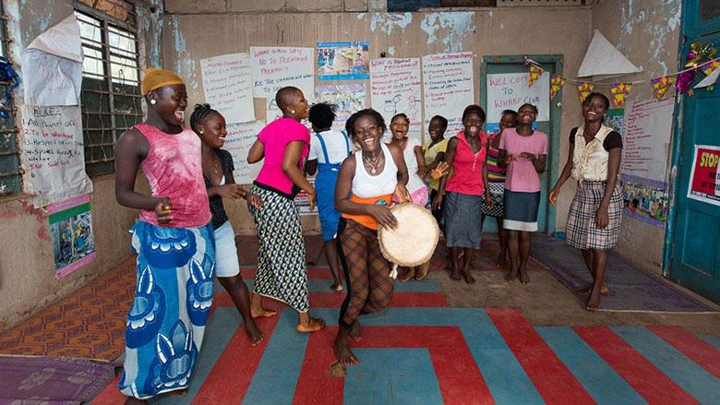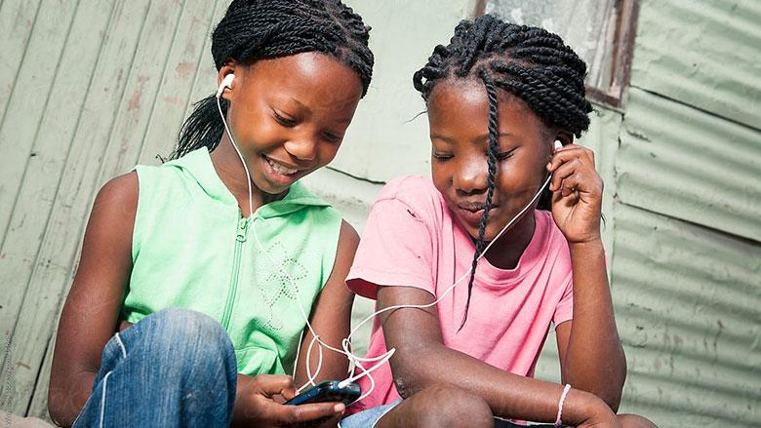Across the world, radio has been widely used as a tool for remote learning since the beginning of the COVID-19 pandemic. We've seen this in countries like Colombia, Liberia, Malaysia, and Rwanda, among others. But education radio is now being used in other engaging ways, not only to support distance learning but to enhance in-classroom teaching and the training of teachers.

Photo Credit: Alison Wright, BRAC/NPR Photo Credit: Mickey Wiswedel/Stocksy

Between 2014 and 2016, radio was used extensively to foster children's education at home during the Ebola outbreak. Sierra Leone took a similar approach to respond to the impact of COVID-19 on learning.

This initiative is part of the global program for Continuous and Accelerated Learning in response to COVID-19 supported with funding from the Global Partnership for Education (GPE), and implemented with UNESCO and UNICEF (acting as a consortium).

Note: This story was first published by the World Bank and featured in the Global Partnership for Education. More details are available and viewed by visiting the [WORLD BANK](https://www.worldbank.org/en/news/feature/2021/05/13/school-hits-the-airwaves-sierra-leone-turns-to-education-radio-as-a-response-to-covid-19) and [GLOBAL PARTNERSHIP FOR EDUCATION](https://www.globalpartnership.org/blog/school-hits-airwaves-sierra-leone-turns-to-education-radio-as-response-to-covid19).

**COMMUNIQUE OF THE COMMONWEALTH HEADS OF GOVERNMENT** MEETING “DELIVERING A COMMON FUTURE: CONNECTING, INNOVATING, TRANSFORMING”

**YOUTH -** Education

97. Heads acknowledged the transformative impact of technologies on education and committed to addressing the digital divide and the digital skills gap, with particular attention to supporting disadvantaged and vulnerable groups, through appropriate access to technology and enhanced teacher capacity. Heads also noted the value of digital skills, vocational and trade skills, non-formal education, and lifelong learning, emphasising the key role which education and skills play in the drive towards the implementation of the 2030 Agenda.

**SITUATION REPORT 03: PRELIMINARY STATEMENT ON THE OBSERVATIONS OF THE 2021 GENERAL ELECTIONS - ZAMBIA FEDERATION OF DISABILITY ORGANISATIONS**

**SUMMARY**

The Zambia Federation of Disability Organisations (ZAFOD) observed both the pre-election environment and Election Day processes in 60 districts across all 10 provinces of Zambia as part of the organization’s thematic observation of the 2021 general elections. In the pre-election period, ZAFOD deployed 20 long-term observers (two per province) and for Election Day, ZAFOD deployed 74 short-term observers as well as 20 mobile observers to polling stations across the country. The short-term observers, all of whom were duly accredited by the Electoral Commission of Zambia (ECZ), arrived at their assigned polling station and polling stream at 05:30 hours and remained there throughout the polling station setup and opening, voting, and counting until the official results for all electoral races for the entire polling station were publicly announced and posted. The goal of ZAFOD’s thematic observation of the 2021 elections was to assess the accessibility of electoral processes for persons with disabilities and to make elections more transparent by providing systematic factual information on the conduct of the process, with a particular focus on the inclusion of PWD’s.

While ZAFOD welcomes the incremental progress that has been made by the ECZ, political parties and other electoral stakeholders over the last two electoral cycles to improve the accessibility of elections, ZAFOD notes with concern that the organisation’s initial observation findings indicate that electoral processes in Zambia remain inaccessible for many persons with disabilities, undermining the right to equal participation and in contravention of the Government of Zambia’s legal obligations under domestic and international law.

**ACCESSIBILITY AND ELECTIONS IN ZAMBIA**

September 2021 will mark the ten year anniversary of the landmark Sela Brotherton vs. ECZ court case, in which the High Court ruled that persons with disabilities were being unlawfully discriminated against and prevented from freely exercising their right to vote due to the inaccessibility of polling stations, and that the ECZ must implement measures to remedy this. The ruling stipulated that, among other actions, the ECZ should install ramps, ensure that polling stations are located on the ground floor and in places that are accessible for persons with disabilities, and provide a tactile ballot guide for voters who are blind or visually impaired. The ECZ was also required to develop a detailed action plan and budget for the 2016 elections to ensure the equal participation of persons with disabilities.

In 2016, ZAFOD took part in election observation under the umbrella of the Foundation for Democratic Process (FODEP) observation activities. As noted in the 2016 final observation report of the EU Election Observation Mission (EU EOM), “ZAFOD commended ECZ for its efforts to increase accessibility,” including moving polling stations to the first floor and installing ramps in some locations. As a result, the EU EOM assessed that 72 percent of polling stations were accessible for persons with disabilities. However, the report also noted several shortcomings, including inadequate voter education for persons with disabilities, and a lack of sign language interpretation during voter registration.

Unfortunately, despite the progress made between the 2011 Brotherton ruling and the 2016 general elections, ZAFOD’s observation of the 2021 general elections found that the measures in place to ensure the equal participation of persons with disabilities have not improved since 2016 and, in some areas, have worsened. While directly comparable data between 2016 and 2021 is not available, 62 percent of ZAFOD observers reported that the observed polling stations were accessible for persons with disabilities in 2021, a decrease from the EU EOM’s assessment of 72 percent of polling stations being accessible in 2016. ZAFOD also notes that, unlike in 2016, no action plan or budget was publicly released by the ECZ for the 2021 general elections, which reduced transparency and the ability of civil society organizations to provide feedback and oversight on accommodations for persons with disabilities.

**PRE-ELECTION ENVIRONMENT**

ZAFOD’s observation of the pre-election environment found that persons with disabilities were relatively well-represented in voter education and campaign activities, with 68 percent of long-term observers reporting having witnessed or heard about voter education activities targeting persons with disabilities by the ECZ. 48 percent of ZAFOD observers also witnessed or heard of distribution of voter education materials in accessible format for persons with disabilities. In addition, 30 percent of long-term observers reported campaign messages and materials targeting persons with disabilities by PF, 22 percent reported similar messages and materials by UPND, and 14 percent reported messages and materials by other political parties.

ZAFOD welcomed the fact that at least 12 candidates on the ballot on August 12, including four at the parliamentary level, were persons with disabilities. However, these candidates reported facing stigma and 15 percent of ZAFOD long-term observers reported hearing threatening, abusive or insulting language towards candidates with disabilities. In one case a candidate also noted that he has received little to no support from his nominating party as compared to other candidates without disabilities in his party. While the COVID-19 pandemic has caused challenges for all candidates during the campaign period, the temporary ban on road shows and rallies placed an additional hardship on candidates with mobility disabilities, as moving door-to-door to campaign was difficult for them.

**ELECTION DAY PROCESSES**

ZAFOD observers reported that Election Day processes at the 74 observed polling stations largely followed established electoral procedures for setup and voting, with all polling stations observed opening no later than 06:30 am. All 74 observed polling stations were equipped with permanent/indelible ink for marking voters’ fingers, official stamps for marking ballot papers, and voters’ registers. At all 74 polling stations the presidential ballot box was shown to be empty at the start of voting. Party agents for the Patriotic Front (PF) and United Party for National Development (UPND) were reported to be present at 73 of the 74 polling stations, and party agents representing parties other than PF and UPND were present at 66 of the 74 polling stations.

**COVID-19 MEASURES**

ZAFOD observers reported a high level of adherence to COVID-19 mitigation measures among polling station officials, specifically the use of face masks and sanitizer. 97 percent of observed polling stations had hand washing or sanitizing facilities available. However, social distancing was less rigorously adhered to, in part due to the long queues of voters at many polling stations. In addition, only 10 of the 74 polling stations were reported to have a thermometer/thermo scanner to check voters’ temperatures upon entry. Nine observers reported that “a few” (one to five) or “some” (six to ten) voters were turned away for non-adherence to COVID-19 protocols.

**PARTICIPATION OF PWD’S AS PARTY AGENTS AND CITIZEN OBSERVERS**

ZAFOD observers reported six persons with disabilities serving as party agents at observed polling stations, and seven persons with disabilities serving as citizen observers for organizations other than ZAFOD. ZAFOD also notes that the ECZ has taken steps to increase the number of persons with disabilities serving as polling station staff. ZAFOD applauds the inclusion of persons with disabilities as polling officials, party agents and citizen observers, and urges political parties and civil society groups to continue to intentionally recruit and encourage the participation of persons with disabilities in these important roles.

Accessibility of Polling Station Locations

Among the 74 polling stations observed, the majority (85 percent) were located in schools, primarily in classrooms (74 percent). Observers reported that nearly two-thirds of observed polling stations (62 percent) posed some difficulty to entry for persons with disabilities. 49 percent of observed polling stations required voters to go up steps or stairs to enter the polling station. (Reference: The [CHRISTIAN CHURCHES MONITORING GROUP](https://ccmgzambia.org/ccmg-preliminary-statement-on-the-2021-general-elections/) (CCMG) reported in the group’s preliminary statement on the 2021 elections that 48 percent of the group’s 1500 observed polling sites required voters to go upstairs or steps). Only 16 percent of observed polling stations (12 sites) had ramps, three percent (two sites) had handrails installed, and seven percent (five sites) had both. Nearly three-quarters of observed polling stations (74 percent) had no ramps or handrails to assist persons with mobility disabilities to enter or move through the polling station. 42 percent of observed polling station locations reported additional barriers that hindered entry for persons with disabilities, including sand, gutters, corridors that are difficult to navigate in wheelchairs, or other/multiple barriers.

**VOTING PROCESSES FOR PWD’S**

Persons with disabilities voted at 99 percent of observed polling stations. ZAFOD observers reported that sign language instructions or procedures were provided at 34 percent of polling stations observed and that Election Day procedures for persons with disabilities were posted at 64 percent of locations observed. Braille ballot jackets for blind voters were available at 43 percent of polling stations observed. (Reference: CCMG reported in the group’s preliminary statement that 44 percent of the group’s 1500 observed polling stations had Braille jackets). ZAFOD staff serving as roving monitors in Lusaka also reported poor sensitization among polling officials regarding the use of braille jackets.

A large majority of observers (85 percent) reported that the ballot boxes in the interior of observed polling stations were accessible for persons with disabilities to independently cast their vote, although 26 percent noted that the height of the ballot boxes was not suitable for wheelchair users. 85 percent of observers also reported that persons with disabilities were assisted to vote, including by ECZ officials, security officials, and polling agents.

**INCIDENTS**

ZAFOD received a total of 26 critical incident reports on Election Day, of which seven have been confirmed so far. The critical incident reports confirmed by ZAFOD included violence, harassment or intimidation at polling stations, attempted stealing of election materials, and a polling official who was taking pictures of voters cards and NRC.

Two of ZAFOD’s observers were also unable to fully complete their reporting due to disruptions at polling stations in Lusaka and Southern provinces. In the incident in Southern province, the ZAFOD observer was barred from re-entering the polling station with her observation forms due to suspicion among voters in the queue of carrying pre-filled ballots, and was subsequently harassed and felt unsafe to remain at the polling station. In the other incident, in Lusaka province, party cadres disrupted the counting process and although the situation was eventually resolved by police, the observer did not feel safe to remain at the polling station.

**CONCLUSION**

ZAFOD calls on all stakeholders, particularly the ECZ, political parties, and other electoral actors, to redouble efforts to enhance the accessibility and inclusion of persons with disabilities in political and electoral processes. Particular attention is needed to ensure that all polling stations are adequately accessible for persons with disabilities and that accessible voting materials, such as braille jackets, are widely available and are well sensitized among polling officials. ZAFOD further calls for greater transparency and stakeholder engagement on the part of the ECZ with regards to the development of future action plans and budgets for accessibility. ZAFOD continues to welcome and encourage political parties and other stakeholders to support the inclusion of persons with disabilities at all levels of party structures and in all political and electoral processes, including as candidates, party leaders, voter educators, party agents, and citizen observers.

ZAFOD issued the [PRE-ELECTION OBSERVATION OF THE 2021 GENERAL ELECTIONS](https://www.zafod.net/pre-election-observation-of-the-2021-general-elections-for-accessibility-of-persons-with-disabilities-final-report/) for Accessibility for Persons with Disabilities Final Report on 13 August 2021 and [THEMATIC OBSERVATION OF THE 2021 GENERAL ELECTIONS FINAL REPORT](https://www.zafod.net/wp-content/uploads/ZAFOD-Thematic-Election-Observation-Final-Report.-1.pdf) on 28 September 2021.

[ZAMBIA FEDERATION OF DISABILITY ORGANISATIONS](http://www.zafod.net/) (ZAFOD) is the national civil society umbrella body of over 15 affiliate member organisations of and for persons with disabilities in Zambia. Since the early 1980s, ZAFOD has been advocating for the promotion and protection of disability rights and the inherent dignity of persons with disabilities, including advocacy for the observance of rights to political and public participation of persons with disabilities through inclusive and accessible electoral processes.

**SITUATION REPORT 04: OPENING THE DOORS OF PERCEPTION: A YOUNG DEAF WOMAN FINDS HER CALLING THROUGH TECHNOLOGY, COMMUNITY AND EDUCATION**

Note: The contents below are some excerpts from an article by **MEKIYA WALTERS** on how **SARNA SHAH**, a Bangladeshi deaf women’s life changed through an opportunity offered by the CDD to work with Technology, Community and Education. This well narrated article showcases the experience of one individual and effectiveness of change through technology, community and education. Author has done a tremendous work by compiling this article in such a way to make the reader interesting and live. Full article published in [ABILITY MAGAZINE](https://abilitymagazine.com/opening-the-doors-of-perception/).

[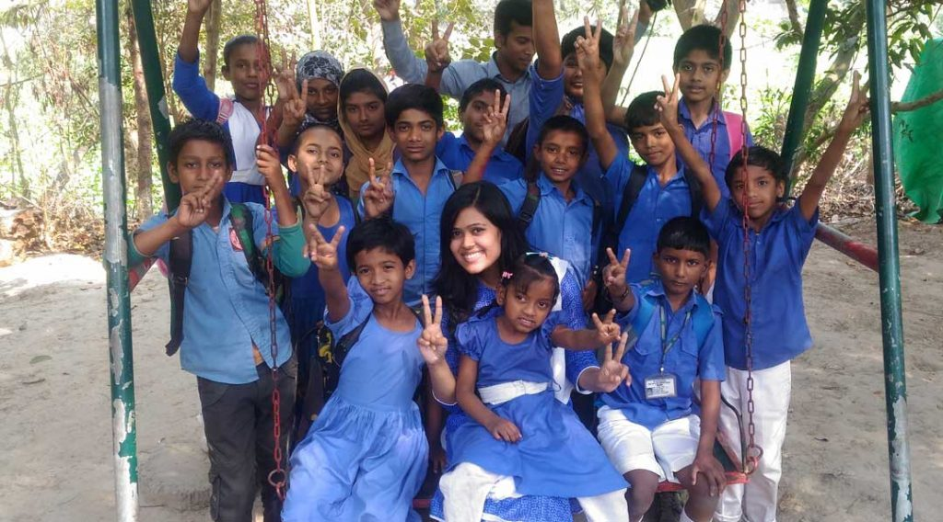](https://abilitymagazine.com/wp-content/uploads/2022/02/With-deaf-students-of-ECD-centre-Jhenaidah.jpg)[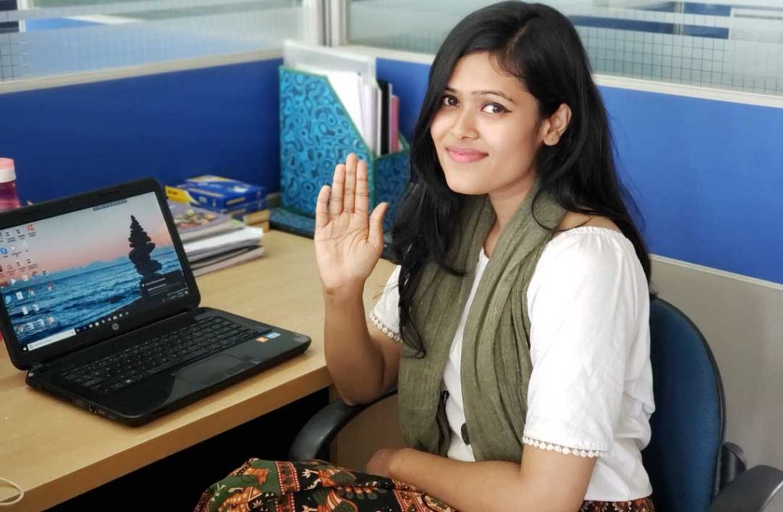](https://abilitymagazine.com/wp-content/uploads/2022/02/sarna.jpg)The [CENTRE FOR DISABILITY AND DEVELOPMENT](https://cdd.org.bd/) (CDD) is not-for-profit organization in Bangladesh founded in 1996 “to develop a more inclusive society for persons with disabilities.” They partner with over 350 organizations, both nationally and internationally, to promote inclusion of persons with disabilities and provide PWDs with community support and access to assistive technology and education. The CDD for Disability in Development (CDD) offered Sarna Shah an internship in 2018. Sarna lost her hearing at the age of seven to a bout of meningitis, an experience that she described as initially “traumatizing”. When she had no choice but to communicate, she would use a pen and paper, but engaging with strangers always triggered anxiety. Despite societal pressures, Sarna’s family showed her nothing but support and love. After a year, Sarna realized she was learning to lip-read. She also started studying Bangladeshi Sign Language, though without exposure to a signing community, she wouldn’t achieve fluency until years later, after she was working for the CDD.

Photo Credit: Mekiya Walters (Author) Deaf students of ECD centre, Jhenaidah

Sarna graduated from the University of Dhaka in 2017 with an MBA in human resource management, but degree or no degree, she was a young, Deaf woman in Bangladesh, and things were looking grim. There aren’t enough jobs. There are so many young people graduating with advanced degrees, and then they can’t find employment. That’s true even for the non-disabled. And most Bangladeshi employers aren’t very friendly to persons with disabilities.

For Sarna, as for many others, technology has played a life-saving role, even with its limitations. During the interview, Sarna, who knows both English and Bangla, used the Live Transcribe app on her phone, supplemented by text messages, because captioning on Microsoft Teams wasn’t working.

Later, it was revealed that the audio hadn’t been recorded, either! The first draft of this profile was reconstructed from memory, and Sarna fact-checked and filled in the gaps, further demonstrating not only technology’s limitations, but also the creativity, adaptability and patience required to overcome them.

In addition to assistive technologies, Sarna finds special value in a suite of devices and software that most people, whether or not they identify as disabled, now consider mundane. “Google is really important, especially Google Maps, because it lets me find information without having to ask strangers,” she said. She uses the service to let her loved ones know where she is and whether she’s safe. “My mother was never too good with technology, but she’s getting better and better every day! Now, if she needs to know where I am, I can simply drop a pin on Google Maps and let her know.” Most smartphones now come with these features built in, they’re expensive. Not everyone can afford it.

Though financially independent, Sarna still lives with her family in their hometown of Tongi, Gazipur, near Dhaka. “We have a really good relationship,” she said, beaming. “We always have. This means so much to me.” Though her parents don’t sign, she’s become an excellent lip-reader and uses Bangla and English with her family, colleagues and friends. In the evenings, she and her family sit together and watch the news, and her parents repeat the newscaster’s words in case she doesn’t catch them. They’re proud of everything that she’s accomplished, but Sarna says she’s only getting started. Sarna’s goal is to serve as a bridge between the Deaf and hearing worlds.

**KIGALI DECLARATION ON CHILD CARE AND PROTECTION REFORM**

We, as Commonwealth Heads of Government, commit to:

**POSITIONING** the Commonwealth as a leading advocate on child care and protection reform by implementing the UN Resolution on Children without Parental Care; **RECOGNISING** the resilience shown by children and young people during the COVID-19 pandemic; **PROMOTING** zero tolerance against violence, harassment, abuse online and offline, discrimination and neglect, paying particular attention to children in vulnerable circumstances; **RECOGNISING** the importance of providing a range of quality alternative care options, including, inter alia, family and community-based care and, where relevant, redirecting resources to family and community-based care services, with adequate training and support for caregivers and robust screening and oversight mechanisms, and progressively replacing institutionalization accordingly, we undertake to take appropriate measures to: **WE,** as Commonwealth **HEADS OF GOVERNMENT, COMMIT TO**:

7. Encourage development agencies by 2025 to:

a. Support staff, as well as applicants and recipients of aid, development assistance and investment, to prioritise quality care arrangements at the community level, over institutionalisation, including for children with disabilities;

b. Support projects which take a holistic and inclusive approach to child protection systems development and family strengthening;

c. Provide clear information on how funding supports families and family-based systems of care.

d. Amplify and support the voices of children and their families, including the underrepresented voices of girls, children with disabilities and other marginalised groups, and support the meaningful participation in society of children, young people, their families and their representative groups;

e. Support inclusive, accessible, quality community services, including all aspects of education, health and social services, that meet the diverse requirements of children and their families, and support the choice, dignity, autonomy and full participation of all children and their families in society, including the most marginalised;

**CPDF NOTICES:**

**CDPF WOMEN’S COMMITTEE CONVENED**

CDPF Women’s Executive Committee (CDPF-WC) established with the inclusion of all female CDPF Executive Officers (17) and co-opting another five (05) members for the CDPF-WC. The nomination of the following were adopted.

1. Sharmalee Cardoza-Kammerer, Jamaica
2. Nathalie Murphy, Dominica (Former CDPF Executive Officer)
3. Mwaunyo Yakor-Dagbah, Ghana (Former CDPF Executive Officer)
4. Rosemarie Ramitt, Guyana
5. Sushree Sarangi, India

The CDPF-WC would convene at-least two COMMONWEALTH DISABLED WOMEN’S FORUM meetings per year. In order to give exposure to young women with disabilities who are keen to become disabled women activists /leaders are encouraged to participate during the CDPF-WC meetings as OBSERVERS, to follow the proceeding and to provide any feedbacks / inputs as and when required by the CDPF-WC and also as a part of a mentoring process.

**Young women with disabilities from CDPF member organisations who are interested can communicate with Convener of the CDPF-WC, GAUDENCE MUSHIMIYIMANA,** CDPF Exceptive Officer and **Women’s Representative by email:** [unaburwanda@yahoo.com](mailto:unaburwanda@yahoo.com)**.**

**CDPF DPO YOUTH ADVOCATES FORUM / NETWORK**

With the declaration of year 2023 as the COMMONWEALTH YEAR OF THE YOUTH, CDPF has initiated a dialogue with CDPF Youth Exceptive Officers and the youth representative from CDPF membership who are actively working for the cause of disabled youth mobilisation. As an integral part of the youth mobilisation CDPF has decided to establish the CDPF YOUTH ADVOCATES FORUM / NETWORK (CDPF-YAN) and to frame a sustainable plan of action for meaningful inclusions and effective participation. Young men and women with disabilities from CDPF member organisations who are interested in joining and engaged with the CDPF-YAN can communicate with the CDPF Youth Representative or any CDPF Executive Officer listed below.

**KIHEMBO WILBERT** - CDPF Exceptive Officer (Elected Youth Representative)

& Voice of Youth Uganda. Email: [kihembowilb@gmail.com](mailto:kihembowilb@gmail.com)

**EMILE GOUWS -** CDPF Executive Officer (Rep. for Intellectual Disability and Under-Represented Groups) & Autism South Africa. Email: [mieliemeel93@gmail.com](mailto:mieliemeel93@gmail.com)

**SAISTA PARWIN** **-** CDPF Executive Officer (Representative for India) & Swabhiman Foundation, Odisha, India. Email: [parwinnluo@gmail.com](mailto:parwinnluo@gmail.com)

**DIVYA GOYAL**-CDPF Exceptive Officer (Representative-CCYDN)

Email: [divya.goyal131999@gmail.com](mailto:divya.goyal131999@gmail.com)

**DANIEL GRICE** -CDPF Exceptive Officer (Representative-CCYDN)

Email:  [danielj.grice1998@gmail.com](mailto:danielj.grice1998@gmail.com)

**UN CHARTER BODY / TREATY BODY REVIEW OF COMMONWEALTH COUNTRIES**

**CRPD COMMITTEE STATE PARTY REVIEWS OF COMMONWEALTH COUNTRIES**

|  |  |  |  |
| --- | --- | --- | --- |
| **COUNTRY** | **STATE PARTY REPORT DUE/SUBMITTED** | **REVIEW DATE** | **SESSION** |
| Canada | 11-Apr-20 / 07-Nov-20 |  |  |
| Dominica |  | 27-31 March 2023 | 17 Pre Session WG |
| India | 1-Nov-25 |  |  |
| Kenya |  | 11 – 15 Sept 2023 | 18 Pre Session WG |
| Kiribati |  | 27-31 March 2023 | 17 Pre Session WG |
| Ghana |  | 2024 or later |  |
| Malawi |  | 14 Aug- 08 Sept 2023 | 29th Session |
| Maldives |  | 2024 or later |  |
| Malta | 10-Oct-26 |  |  |
| Mauritius |  | 2024 or later |  |
| New Zealand | 24-Aug-22 |  |  |
| Rwanda | 14-Jan-23 |  |  |
| Sri Lanka |  | 2024 or later |  |
| Togo |  | 06 – 24 March 2023 | 28th Session |
| Trinidad and Tobago |  | 2024 or later |  |
| Tuvalu | 23-Nov-26 | 2024 or later |  |
| Uganda | 25-Oct-22 |  |  |
| United Kingdom | 8-Jul-23 |  |  |
| Vanuatu | 23-Nov-26 |  |  |
| Zambia |  | 2024 or later |  |

**UNIVERSAL PERIODIC REVIEWS OF COMMONWEALTH COUNTRIES**

|  |  |  |
| --- | --- | --- |
| **COUNTRY** | **UPR SESSION** | **REVIEW DATE** |
| Australia | 43rd Session | 3-May-23 |
| Bangladesh | 44th Session | 13-Nov-23 |
| Barbados | 43rd Session | 5-May-23 |
| Botswana | 43rd Session | 3-May-23 |
| Cameroon | 44th Session | 14-Nov-23 |
| Canada | 44th Session | 10-Nov-23 |
| Gabon | 42nd Session | 24-Jan-23 |
| Ghana | 42nd Session | 24-Jan-23 |
| India | 41st Session | 10-Nov-22 |
| Pakistan | 42nd Session | 30-Jan-23 |
| South Africa | 41st Session | 16-Nov-22 |
| Sri Lanka | 42nd Session | 1-Feb-23 |
| Tonga | 43rd Session | 1-May-23 |
| Tuvalu | 44th Session | 8-Nov-23 |
| United Kingdom | 41st Session | 10-Nov-22 |
| Zambia | 42nd Session | 30-Jan-23 |

**UPCOMING EVENTS**

**WEBINAR ON INCLUSIVE QUALITY POLICE SERVICES FOR PERSONS WITH DISABILITIES IN AFRICA**

The Special Envoy of the United Nations Secretary-General on Disability and Accessibility and the [COMMONWEALTH SECRETARIAT](https://thecommonwealth.org/events/webinar-inclusive-and-quality-police-services-people-disabilities-africa) Human Rights Unit are convening a webinar to discuss inclusive quality police service for persons with disabilities. Taking as a starting point the role of police to communicate, inform and, in general, facilitate and guarantee the means of access to justice for all persons without distinction, including persons with disabilities, the webinar will consider the tools police personnel require to eliminate barriers that persons with disabilities encounter in police environments.

**OBJECTIVES:** The overarching objective is to raise awareness of inclusive quality police services for persons with disabilities in the African region as a necessary measure in the fulfilment of human rights and sustainable development in the 21st century. Specific objectives are:

• To highlight the challenges encountered by persons with disabilities in Africa and their experiences in interacting with police services.

• To promote the recognition and respect of all human rights and fundamental freedoms of persons with disabilities.

• To identify effective actions for eliminating all forms of discrimination in interaction between persons with disabilities and police and police precincts.

• To publicize the United Nations campaign ‘For inclusive quality police services for persons with disabilities’ and its accompanying guidelines in 10 action areas.

• Share and present good practices to be carried out by police personnel when engaging with persons with disabilities.

MODERATOR: **\* Dr. Shavana Haythornthwaite:** Adviser and Head of the Human Rights Unit at the Commonwealth Secretariat

WELCOME: **\* Professor María Soledad Cisternas Reyes**: Special Envoy of the United Nations Secretary-General on Disability and Accessibility

**\* Anne Wafula Strike:** Commonwealth Champion for Equality in Sports

PANEL: **\***  **Hon. Wilma Susan Newhoudt-Druchen:** Member of the National Assembly and Member of the Portfolio Committee on Justice and Correctional Services, South Africa.

**\* Hon. Marie Claire Mukasine:** Chairperson, Rwanda National Commission for HR.

**\* Ms. Thandiwe Mfulo:** Deputy Secretary-General, Disabled People South Africa, and Commonwealth Disabled People’s Forum Executive Officer Representing Africa.

**\* Maureen Pino Dreckmann**: Legal Assistant to the Special Envoy of the Secretary General of the United Nations on Disability and Accessibility.

CONCLUSION: **\* Gertrude Oforiwa Fefoame:** Global Advocacy Advisor (Social Inclusion), Sightsavers; Member, United Nations Committee on the Rights of Persons with Disabilities, and President, International Council for Education of People with Visual Impairment.

**Ms. Thandiwe Mufulo** is representing CDPF at this important meeting to mark UN Day of Disabled People. Link to [REGISTER](https://us06web.zoom.us/meeting/register/tZMscu2sqjwoGtxu95p9k2M0BuHEB96decBk.).

DATE: Friday, 2 December 2022 at 14:00 -17:00 British Standard Time

(18:00 Mauritius, 17:00 Nairobi, 16:00 Johannesburg, 14:00 Accra, 11:00 Santiago)

**COMMONWEALTH YOUTH CLIMATE NETWORK LAUNCH COMPETITION TO BOOST YOUTH-LED ACTION**

The Commonwealth Secretary-General and the [COMMONWEALTH YOUTH CLIMATE CHANGE NETWORK](https://www.yourcommonwealth.org/cycn/) (CYCN) launched a global competition to inspire, empower and reward [YOUNG PEOPLE TAKING ACTION ON OCEANS](https://thecommonwealth.org/news/commonwealth-youth-climate-network-launch-competition-boost-youth-led-action) on 12 November 2022. Young people between the ages of 18-30 from Commonwealth member countries are eligible to participate and are invited to submit photos and videos on actions they have led or contributed to which promote the blue economy and awareness of SDG 14 actions at large. Under the theme of SDG14, the CYCN have come up with a [LIST OF 14 ACTIONS](http://production-new-commonwealth-files.s3.eu-west-2.amazonaws.com/s3fs-public/2022-11/Actions%20-%20Youth%20Lead%20SDG14%20Challenge.pdf?VersionId=UKcQC6CX21R7xg7G6ndNliFgHxZC7VA1) entrants are asked to complete as part of the #YouthLeadSDG14 Action Challenge. Below is the [CAMPAIGN TIMELINE](https://www.yourcommonwealth.org/join-the-youthleadsdg14-for-global-climate-action-campaign/).

1. 12 November 2022: Official Launch of Campaign with CYCN (during COP27)
2. 12 November – 8 December 2022: Competition entries promoted on Commonwealth Secretariat Youth and CYP social media platforms
3. 08 December 2022: Deadline for signing up to the Action Challenge.
4. 09-10 December 2022: Judging of Actions Taken & Submitted. Create and publish an impact report highlighting the progress achieved via the campaign.
5. 11 December 2022: Announcement of Top 3 Winners: Three winning participants will share a cash prize sponsored by the Commonwealth.

**MEETING OF COMMONWEALTH YOUTH MINISTERS**

The tenth (10) [COMMONWEALTH YOUTH MINISTERS MEETING](https://thecommonwealth.org/news/commonwealth-heads-declare-2023-year-youth#:~:text=Heads%20then%20sealed%20their%20commitment,'Year%20of%20the%20Youth) will be take place in Islamabad, Pakistan from 23rd to 26th January 2023. Previously, the 09th COMMONWEALTH YOUTH MINISTERS MEETING [(9CYMM)](https://thecommonwealth.org/our-work/youth-ministers-meetings) was held between 31 July and 4 August 2017 in Kampala, Uganda.

The Commonwealth Secretariat convenes a four-yearly Commonwealth Youth Ministers Meeting (CYMM), including a Youth Leaders Forum and Stakeholders Forum. The meeting enables government ministers and senior officials to share good practices, debate emerging issues, take stock of pioneering initiatives and forge new partnerships for resourcing youth development. The recommendations from each Commonwealth Youth Ministers Meeting are considered by leaders at the biennial Commonwealth Heads of Government Meeting (CHOGM). CDPF have put forward 03 Disabled Youth representatives to attend.

Ends.