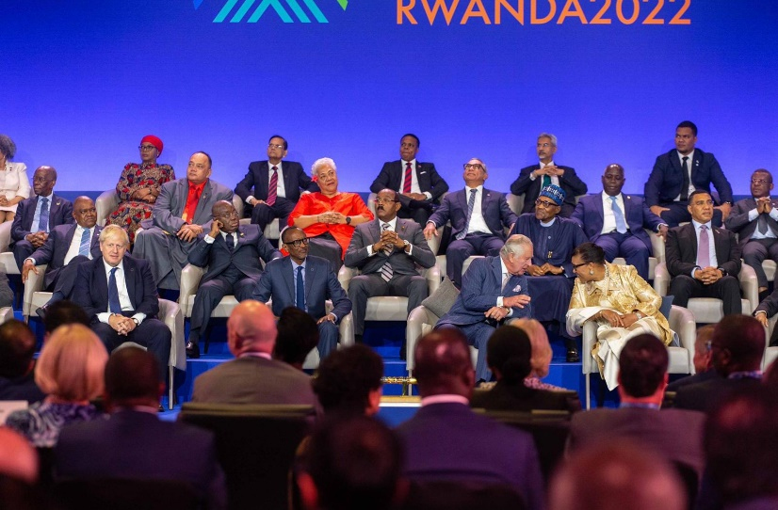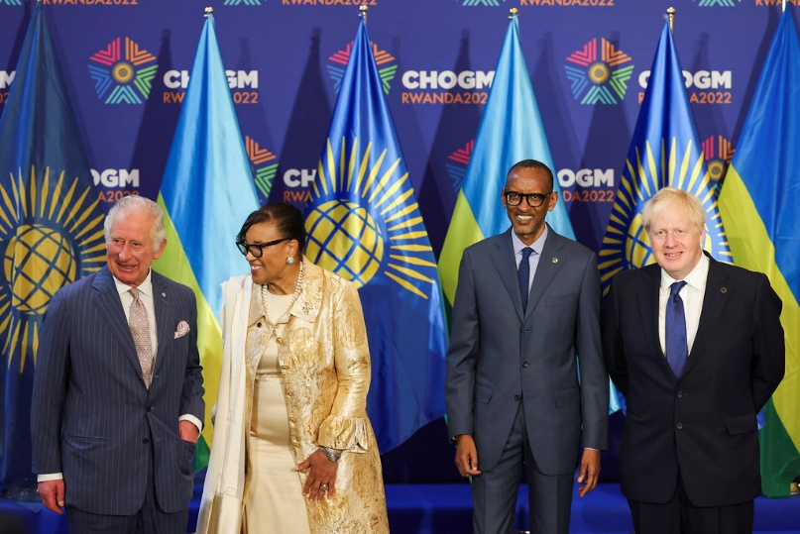

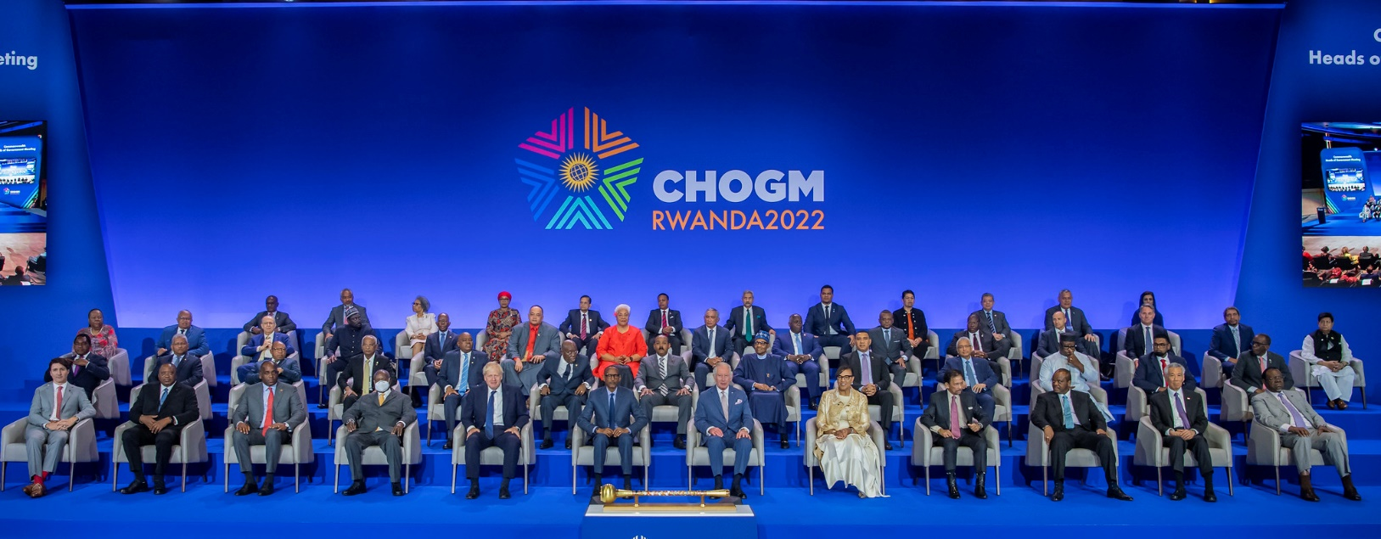

IN THIS ISSUE:

01. COMMONWEALTH HEADS OF GOVERNMENT MEETING, KIGALI, RWANDA: 19 -26 JUNE 2022

02. CONFERENCE OF STATES PARTIES TO THE UNCRPD: 13 TO 16 JUNE 2022

03. CDPF VIRTUAL GENERAL ASSEMBLY: FEBRUARY TO 08 APRIL 2022

04. ELECTED EXECUTIVE OF COMMONWEALTH DISABLED PEOPLE’S FORUM: 08 APRIL 2022

05. VIRTUAL DISABILITY SUMMIT: 16-17 FEBRUARY 2022

06. COMMONWEALTH PARLIAMENTARY ASSOCIATION: 03 DECEMBER 20211 & 26 AUGUST 2022

07. SITUATION REPORT: DOUBLE JEOPARDY FOR THE DISABLED PEOPLE IN SRI LANKA.

08. SITUATION REPORT: AWARENESS ON INCLUSIVE AND ACCESSIBLE ENVIRONMENT- INDIA.

**09. NOTICE OF COMMONWEALTH SCHOLARSHIPS FOR DISABLED CANDIDATES THROUGH CDPF.**

10. UN CHARTER BODY / TREATY BODY REVIEW OF COMMONWEALTH COUNTRIES.

11. RECOGNITIONS/ ACKNOWLEDGEMENTS/ APPRECIATIONS.

12. UPCOMING EVENTS….

13 EMERGENCY RESPONSE: PERSONS WITH DISABILITIES IN FLOOD AFFECTED AREAS IN PAKISTAN

**COMMONWEALTH HEADS OF GOVERNMENT MEETING - KIGALI, RWANDA 19 -26 JUNE 2022**

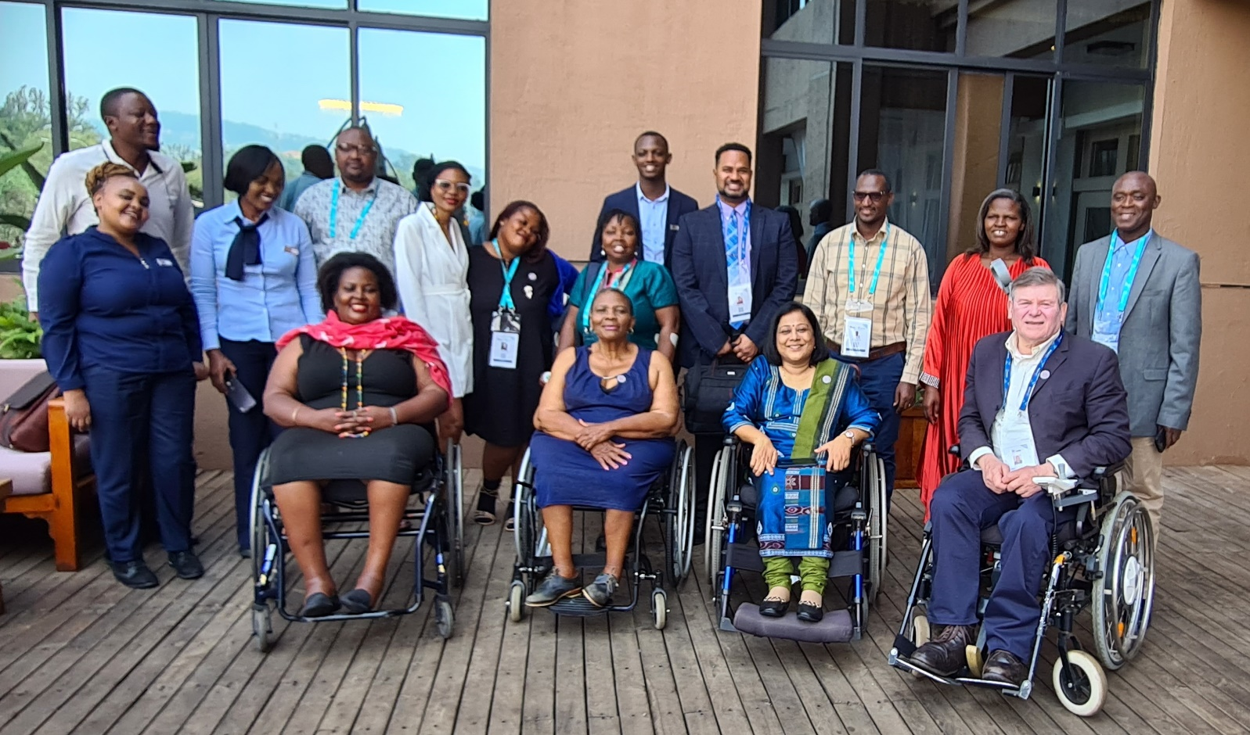

Some of the CDPF Delegates at CHOGM (Kigali, Rwanda. 19th to 26th June 2022). Represented by Key officers l-r front Scader Louis, Thandiwe Mufulo, Dr Sruti Mohapatara, Richard Rieser,second row including Gaudence Mushimiyimana and Chair Sarah Kamau and members from the National Organisations in African Continent and Mephilius James from St Lucia. Photo Credit: Richard Rieser.

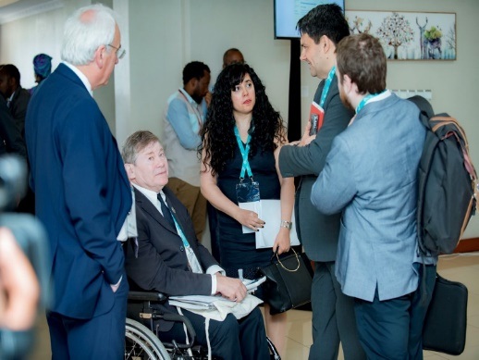 During the CHOGM, CDPF was well represented. **CPDF Chair**, Sarah Kamau (from Kenya), **Africa Representative** Thandiwe Mufulo (from South Africa), **Vice-Chair** Dr. Sruti Mohapatra (from Odisha, India), and **General Secretary** Richard Rieser (from UK) represented CDPF at the PEOPLES FORUM. All four made good interventions from the floor. **Women Representative** Gaudence Mushimiyimana (from Rwanda) represented CDPF at the WOMEN’S FORUM. **Rep for Intellectual Disability** Emile Gouws (from South Africa) and **Executive Officer** Saista Parwin (from India) represented CDPF at the Youth Forum. CDPF delegates distributed 400 copies of the CDPF Policy Broadsheet throughout CHOGM. Refer: [Full text of the CDPF message to the delegates at CHOGM, Kigali 2022](https://commonwealthdpf.org/commonwealth-disabled-peoples-forum-messageto-delegates-at-chogm-kigali-2022/).

CDPF held a successful side meeting on Thursday 23rd June after the close of the PEOPLE’S FORUM with a room funded by Commonwealth Foundation attended by 27 delegates. Refer: [Full broadcast via YouTube](https://www.youtube.com/watch?v=wqAPSG7RlrM&list=PLwI6nQoN43w2187LBv-wC1sJ5X0o4sEDa). Anne Gallagher, Secretary General of the Commonwealth Foundation complimented CDPF for the role it plays and for various interventions. There was a general view that disability would be taken much more seriously in the future by the Commonwealth and need for disabled panellists to be included in all sessions (Climate, Economy, Business, etc.)

Emphatically, disabled people’s attendance needs to be taken much more seriously by the Commonwealth and/or member states as a matter of priority. It is evident that the CHOGM has no protocol providing different formats or proper accessible infrastructure and processes. There are no questionnaire to ask for needs during registration, washrooms are not wheelchair accessible, no proper follow ups by organisers for accessibility inquires and the Sign Language Interpretations were provided by the Rwandan Deaf Organisation as an initiative by them. The CDPF should advocate for positions, to speak on platforms and argue for a Commonwealth Disabled People's Meeting during CHOGM.

The General Secretary is to meet Anne Gallagher who is open to meetings with CDPF for CW council to support drawing up a Disability Protocol similar to United Nations we will also be approaching the President of Rwanda as Commonwealth Chair in Office to Rwanda and get him to be the Champion for Disability Inclusion in the CHOGM Agenda.

Prior to the CHOGM, CDPF wrote to all Governments via national umbrella organisations requesting them to fund disabled delegates to CHOGM. CDPF is pleased to thank the **Government of St. Lucia** for sending Merphilius James and **Government of Malawi** for sending Scader Louis (CDPF Treasurer) for the meeting. During the next CHOGM this should be done earlier to get more delegates funded. We also made good links with representatives from 3 of our Rwandan membership organisations who were represented at the PEOPLE’S FORUM. [Participants at side Meeting]

Richard Rieser – General Secretary, CDPF

**CONFERENCE OF STATES PARTIES TO THE UNCRPD – 13 TO 16 JUNE 2022**

15th session of the Conference of States Parties to the CRPD was held under the OVERARCHING THEME: “*Building disability-inclusive and participatory societies in the COVID context and beyond”.* Sub-Themes were:

(1). Innovation and technology advancing disability rights

(2). Economic empowerment and entrepreneurship of persons with disabilities

(3). Participation of persons with disabilities in climate action, disaster risk reduction and resilience against natural disasters.

CDPF canvassed for 09 delegates to re be re-elected, Rosemary Keyes -Australia, Gertrude Fefoame -Ghana, Laverne Jacobs - Canada, all elected. For the first time there are 11 Women and 07 men on UNCRPD committee. 15 of 18 have disabilities. 06 Africa, 03 Asia, 04 Latin America, 05 Australia and Oceania. CPDF was represented at the COSP15 through a [pre-recorded speech](https://commonwealthdpf.org/richard-riesers-crpd-speech-to-cosp15/) by CDPF General Secretary Richard Raiser.

**VIRTUAL GENERAL ASSEMBLY - FEBRUARY – 08 APRIL 2022**

Since the last Newsletter we held our VIRTUAL GENERAL ASSEMBLY (VGA) where we elected a new [Executive Committee](https://commonwealthdpf.org/executive-committee/), [Amended our rules](https://commonwealthdpf.org/wp-content/uploads/2022/05/Adopted-Constitution-COMMONWEALTH-Disabled-Peoples-Forum-2022-adopted-by-Virtual-Assembly.doc) and agreed an [Work Plan for the next two years**.**](https://commonwealthdpf.org/wp-content/uploads/2022/05/CDPF-Declaration-and-Work-Plan-8th-April-2022.pdf) The VGA process was initiated in December 2021 calling to nominate delegates from all CDPF national members’ organisations and associates and the nominated delegates were involved during the 06 phased VGA Cycle from February – 08 April 2022. Co-options were ratified at the first Executive meeting after the General Assembly held on 21 March 2022. The Co-option for a DPO Rep from Australia or New Zealand is still vacant. Following are the new CDPF Executive Committee and their contact email address.

**ELECTED EXECUTIVES OF COMMONWEALTH DISABLED PEOPLE’S FORUM – 08APRIL 2022**

CHAIRPERSON: **Sarah Kamau,** United Disabled Persons of Kenya. [sarahmuthoni95@gmail.com](mailto:sarahmuthoni95@gmail.com)

VICE CHAIR**: Sruti Mohapatra,** Swabhiman Foundation, Odisha, India. [sruti_m@hotmail.com](mailto:sruti_m@hotmail.com)

VICE CHAIR: **Kerryann Ifill,** Barbados Council of the Disabled.

[president@bcd.org.bb](mailto:president@bcd.org.bb)

GENERAL SECRETARY: **Richard Rieser,** Reclaiming Our Futures Alliance, UK.[rlrieser@gmail.com](mailto:rlrieser@gmail.com)

TREASURER: **Scader Louis**, Federation of Disability Organisations in Malawi (FEDOMA). [scaylouis@gmail.com](mailto:scaylouis@gmail.com)

COMMUNICATION OFFICER:  **Prasanna Kuruppu,** Disability Organisations Joint Front (DOJF), Sri Lanka. [prasannakuruppu@gmail.com](mailto:prasannakuruppu@gmail.com)

INDIGENOUS PEOPLE’S REPRESENTATIVE: **Diethoro Nakhro,** National Centre for Promotion of Employment for Disabled people, Nagaland India. [dnakhro@gmail.com](mailto:dnakhro@gmail.com)

REPRESENTATIVE FOR INTELLECTUAL DISABILITY AND UNDER-REPRESENTED GROUPS: **Emile Gouws,** Autism South Africa. [mieliemeel93@gmail.com](mailto:mieliemeel93@gmail.com)

WOMEN’S REPRESENTATIVE: **Gaudence Mushimiyimana**, Rwandan Organization Women with Disabilities (UNABU), Rwanda.   [unaburwanda@yahoo.com](mailto:unaburwanda@yahoo.com)

ELECTED YOUTH REPRESENTATIVE**:**  **Kihembo Wilbert,** Voice of Youth Uganda [kihembowilb@gmail.com](mailto:kihembowilb@gmail.com)

YOUTH REPRESENTATIVE 01: **Divya Goya**, India. (Commonwealth Children and Youth Disability Network) [divya.goyal131999@gmail.com](mailto:divya.goyal131999@gmail.com)

YOUTH REPRESENTATIVE 02: **Daniel Grice,** United Kingdom. (Commonwealth Children and Youth Disability Network) [danielj.grice1998@gmail.com](mailto:danielj.grice1998@gmail.com)

AFRICA REGIONAL REPRESENTATIVES:

**Patience Ogolo-Dickson,** Advocacy for women with disabilities Initiative (AWWDI) Nigeria. [patienceodickson@gmail.com](mailto:patienceodickson@gmail.com)

**Thandiwe Mfulo,** Disabled People South Africa. [moratiwa.sinothando@gmail.com](mailto:moratiwa.sinothando@gmail.com)

**Eric Ngondi,** United Disabled Persons of Kenya (UDPK). [Engondi1@gmail.com](mailto:Engondi1@gmail.com)

**Rachel Chomba,** Zambia Federation of Disability Organizations (ZAFOD). [rachealmuuma@yahoo.co.uk](mailto:rachealmuuma@yahoo.co.uk)

PACIFIC REGION **Faatino Utumapu** National Advocacy Organisation of Persons with Disabilities, (Nuanua Ol Alofasaid) Samoa. [Manager.nola@nola.org.ws](mailto:Manager.nola@nola.org.ws)

SOUTH ASIA AND MALAYSIA REGION REPRESENTATIVES:

**Abia Akram,** STEP, Pakistan. [abia.akram@gmail.com](mailto:abia.akram@gmail.com)

**Mohua Paul,** Access Bangladesh Foundation. [paulmohua@yahoo.com](mailto:paulmohua@yahoo.com)

**Rasanjali Pathirage,** Disability Organisations Joint Front (DOJF), Sri Lanka. [rasanjali1979@yahoo.com](mailto:rasanjali1979@yahoo.com)

**Havindar Kaur,** Malaysian Confederation of the Disabled (MCD). [mcddpi.my@gmail.com](mailto:mcddpi.my@gmail.com)

CARIBBEAN REGION REPRESENTATIVE:

**Ganesh Singh,** Guyana Council of Organisations for Persons with Disabilities. Guyana. [ganeshyvg@gmail.com](mailto:ganeshyvg@gmail.com)

AUSTRALIA, CANADA, BRITAIN, NEW ZEALAND AND MALTA REPRESENTATIVE**:**

**Steve Estey,** Inclusion Canada. [steven.estey@icloud.com](mailto:steven.estey@icloud.com)

*……………………….…………. Seconded by Executive 21st March 2022 ……………………………………….*

PACIFIC REGION:

**Simon Delaiano,** People with Disabilities Solomon Islands **PWDSI** [4dolaiano@gmail.com](mailto:4dolaiano@gmail.com)

SURVIVORS MENTAL HEALTH**:**

**Rose Umutesi,**National Organisation of Users and Survivors Psychiatry in Rwanda [rosemutesi11@gmail.com](mailto:rosemutesi11@gmail.com)

INDIAN OCEAN, MAURITIUS:

**Dookoo Suvan Sharma,** Federation of Disabled People's Organisations Mauritius (FDPOM). [soovan12paix@gmail.com](mailto:soovan12paix@gmail.com)

**Saista Parwin,** Swabhiman Foundation, Odisha, India. [Parwinnluo@gmail.com](mailto:Parwinnluo@gmail.com)

**Membership: With the joining of Gabon and Togo to Commonwealth on 26th June 2022 we welcome Federation Nationale des Associations des pour Personnes Handicapees du Gabon (FNAPHG) as a our 46th Full country member and 48th out of 56 Member countries. We also have 47 Associate members**

**VIRTUAL DISABILITY SUMMIT - 16-17 FEBRUARY 2022**

A key theme of this Global Disability Summit is strengthening capacity of DPOs/OPDs in the Global South. During the Virtual Disability Summit on 16 February 2022, CDPF held [a successful side meeting on our key demand for core funding for DPOs from their Governments](https://commonwealthdpf.org/global-summit-side-meeting/) to develop their capacity as a representative voice and to be able to work with Government to implement the UNCRPD.

**COMMONWEALTH PARLIAMENTARY ASSOCIATION**

The General Secretary chaired a meeting of the Commonwealth Parliamentary Association and was asked to write an article about CDPF in [The Parliamentarian,](https://commonwealthdpf.org/wp-content/uploads/2022/02/Parl2021Iss4FINAL-CDPF-Rieser-Disabilities-1.pdf) Journal of the Parliaments of the Commonwealth which published on 03 December 2021 with cover page titled “*What role can Commonwealth Parliaments and Parliamentarians play in advancing and supporting People with Disabilities?”*, emphasising the challenges and barriers facing people with disabilities in the Commonwealth. Refer: [The Parliamentarian](https://www.cpahq.org/media/kaydyvnp/parl2021iss4finalsinglereduced.pdf) for the full text of the journal.

Commonwealth Parliamentary Association Meeting was held on 26th August 2022 in Halifax, Canada and CDPF was represented by Steve Estey, CDPF Regional Representative for Australia, Canada, Briton, New Zeeland and Malta.

**COMMONWEALTH HEADS OF GOVERNMENT MEETING 2022 - LEADERS’ STATEMENT**

1. We, the Commonwealth Heads of Government, met in Kigali on 25 June 2022…..

8. We agreed on the Commonwealth Call to Action on Living Lands, the Declaration on Sustainable Urbanization, and the Kigali Declaration on Child Care and Protection Reform.

9. We agreed to encourage public-private partnerships, in collaboration with multilateral and other entities, to create high-quality digital jobs for young people across the Commonwealth, with the full participation of the Commonwealth of Learning.

**SITUATION REPORT: DOUBLE JEOPARDY FOR THE DISABLED PEOPLE IN SRI LANKA**

Sri Lanka is going through the worst economic crisis since independence. Disabled community is severely affected after experiencing two long years of intermittent mobility restrictions due to the Covid19 Pandemic that drastically paralysed the livelihoods and wellbeing of most of the vulnerable communities. The disabled community considered to be 8.72% of the total population of Sri Lanka as per Government of Sri Lanka (GoSL) statistics, they are yet to enjoy their rights as equal to the rest of the society and long awaiting for an environment conducive for them to live independently without being a burden to the country. Due to the COVID-19 Pandemic in early 2020, the whole country was affected economically and socially. Disabled people were the most affected segment as the restriction of movements and lockdowns has severely excluded them from their essentials and routines.

From the outset, the economic crisis that has arisen since 2022, their lives have become much more vulnerable, very uncertain and challenging. Lack of sensitivity towards the challenges experienced by the disabled community, namely in access to public places and for essential services and receiving accurate and up-to-date information they encounter enormous difficulties and are excluded in most of the ad-hoc remedies and arrangements adopted by the GoSL in general to sustain the crisis. On the other hand, as the Government has imposed import restrictions due to foreign currency scarcity, assistive and mobility devices used by disabled people as well as commonly used drugs and medicine are not available for their use, even to purchase from outside the universal health system. Children with Disabilities had to go through hard times for obtain accessible learning materials, devices etc. Usually, devises used by the disabled (assistive & mobility) are considered to be part of their physical body. When the spare parts and replacements are short of supply they cannot move around.

In Sri Lanka, out of the disabled population 71% in the age group of 15 – 60 years are not engaged in any income generation or economic activity. The common & easiest remedy by the state is the provisioning of social security; by way of providing financial support for disabled persons in the low-income families. The living allowance given for them is LKR5,000 (Approx. 15US$) a month and received by over 72,000 disabled persons. However, there are over 50,000 registered in the waiting list. As the crisis heaped, the World Bank intervened for temporary relief and funded for increase this allowance by LKR2,500 a month for three months effective from May 2022 and provided LKR5,000 for the disabled persons registered in the waiting list also for three months. Now the 03 months have lapsed and the temporarily measure is withheld. World Bank offered US$300M to provide direct financial assistance for low-income families in Sri Lanka under this scheme. The people who engaged in self employment and income generation activities cannot sustain their work as the crisis is affected to the whole society. Waged employees are vulnerable as the small and medium level industries are shutting down their operations. Provisioning of energy such as Petrol/Diesel, domestic LP gas etc. are competitive and challenging due to high demand and short supply where in most of the instances disabled persons are victimised.

Sri Lanka is one of the leading counties in the region that has developed very comprehensive National Policy on Disability (2003), National Actions Plan on Disability (2014) and National Human Rights Action Plan (2017-2022) where a separate chapter with concrete actions and remedies were outlined but all these documents remains in paper and the stakeholders responsible for implementation are hardly aware of such policies and strategies. These documents speak loudly about meaningful stakeholder participation and inclusion, coordination and government civil society partnerships and resource mobilization in order to mainstream disability into development, meaningful disability inclusion.

Disability Organizations Joint Front (DOJF) is the leading umbrella organization engaged in high level policy dialogue and advocating for the rights of Persons with Disabilities with representatives of the leading national DPOs. Their efforts were futile due to non-availability of designated disability focal points and the absence of a proper national coordination mechanism and high-level political leadership. DOJF has been instrumental in advocating for implementation of the norms and principles of the UNCRPD since the GoSL became a signatory and urging the state to incorporate the UNCRPD Article 33 in the same spirit as per its intended purpose. However, Sri Lanka is yet to obtain the parliamentary approval for the Disability Rights Bill, which is subject for various revisions and omissions during the last 12 years due to the lack of insensitivity, acceptance and political will of the political leader and senior state official.

However, the DOJF and the disabled community is optimistic even during these difficult times anticipating an acceptable system change and the drastic reforms considering the outcomes of the ongoing dialogues, transparent, democratic, participatory and inclusive futuristic approaches spelled out by many political party leaders, state officials, professional bodies and civil society groups who expressed disability inclusions, effective and meaningful participation in the new Governance structure during the recent discussions. However, the Head of the State has had made many statements on participatory and inclusive decision making process but is still silent on the disability inclusion and yet to be declared his status. His Chief of Staff and the Economic Advisor had heard our voices just before the interim budget and pledges for a more proactive consultative process.

Prasanna Kuruppu- Communication Officer, CDPF

DOJF Officer Designated for International & Regional Affairs

President- Sri Lanka Foundation for the Rehabilitation of the Disabled

COMMUNIQUE OF THE COMMONWEALTH HEADS OF GOVERNMENT MEETING “DELIVERING A COMMON FUTURE: CONNECTING, INNOVATING, TRANSFORMING”

**DELIVERING GOOD GOVERNANCE**

29. Heads reflected on the link between good governance and transformational leadership that is accountable, transparent, inclusive, and non-discriminatory. They committed to the effective and equitable delivery of public goods and determined to continually evaluate their governance systems, and make improvements where necessary, including placing citizen participation (especially of young people, women and others facing inequality), at the heart of policy development. Heads called for increased technical assistance from the Secretariat, especially to Low-to-Middle-Income-Countries in policy formulation and development.

.

**SITUATION REPORT: AWARENESS ON INCLUSIVE AND ACCESSIBLE ENVIRONMENT- INDIA**

SASHAKT CAMPAIGN - MULTI-LEVEL, MULTI-STAKEHOLDER AWARENESS CAMPAIGN

The SASHAKT Campaign is a multi-level, multi-stakeholder campaign to build awareness of disability issues, new law and support for an inclusive and accessible environment for individuals with disability in India. It was flagged-off in the 1st week of May 2018 and covered all the 30 districts headquarters in four weeks, 28th June 2018. An Awareness-vehicle (SASHAKT DOOT – Doot meaning messenger) along with one mobile photo exhibition, an inclusive group of street play artists travelled along with the campaign team to all districts.

Passing of the “Rights of Persons with Disabilities (RPWD) Bill-2016” by Parliament was one of the major achievements of the present government. RPwD Bill was in limbo since 2010. It was passed by the Lok Sabha on 14 December, by the Rajya Sabha on 16 December and received the President's assent on 27 December 2016. The Act become operational on 19 April 2017. And next plan was to popularise it, create awareness on it and build knowledge around it. We are very grateful to you for your support in this phase.

This multi-level, multi-stakeholder campaign was conducted by Odisha State disAbility Network (OSdN - a conglomeration of about 100 NGOs, CBOs and Networks) from across the state), facilitated by Swabhiman, and covered 4,100 km across the 30 districts of the state, conducting public meetings in 55 blocks and 30 district headquarters, meeting with over 50,000 people. The Sashakt Doot reached Bhubaneswar on 13 June 2018.

The campaign focussed on youth as the campaigners and, folk art, folk dance and folk music as the tool to disseminate the information. The Campaign Reached:

• 30 districts of Odisha

• 50,000 people with disabilities empowered through participation in the campaign

• 1,00,000 digital and physical footprints

• 500 articles in various media

• 1,500 Government officials sensitised and more accountable to ensure the rights of PWDs

• 5,300 km of physical distance

The then Minister MSJE (Shri Thawar Chand Gehlot ji) and the then secretary of DEPwD (Smt. Shakuntala Gamlin) attended the first Global Disability Summit (GDS18), held in July 2018 in London. The IEC materials that they took with them for display from India were posters, RPwD Act in different formats (Braille, large print, easy to read etc,) created by SASHAKT campaign. Kindly refer to pages 79-83.

I hope you all will enjoy reading the report. It can be included in CDPF's newsletter on upholding obligations to UNCRPD, fulfilling the SDGs (the best chance of achieving the SDGs is if everybody is aware of them. Help build this awareness - UN Secretary-General António Guterres) and progressing towards a sustainable planet.

DR. SRUTI MOHAPATRA

Vice-Chair of Commonwealths Disabled Peoples Forum

Swabhiman- Odisha, India

**URGENT 2023 COMMONWEALTH SCHOLARSHIPS FOR THE DISABLED CANDIDATES**

2023 Commonwealth Scholarships Committee (CSC) open for the submission of applications for Masters and PhDs programs from 06 September - 18 October 2022. To be considered by Commonwealth Disabled People’s Forum (CDPF) you must apply in addition and separately, by 06 September - 14 November 2022 until 4.00pm GMT. CDPF can nominate 10 candidates for Master’s and 05 for the PhD’s.

Please circulate in your country if on list at bottom of this notice, to disabled people with a good first degree (2.1) for Masters and a Masters level for PhD scholarships. Closing date to CSC by 18th October 2022. Please make sure you meet all selection criteria with all necessary attachments when you apply. Refer: <https://cscuk.fcdo.gov.uk/about-us/scholarships/> (CSC website) for more details.

The CDPF is a nominating partner of Commonwealth Scholarships. If you are a disabled person and you want to apply you must register with CDPF by 18th October 2022 by sending an email to rlrieser@gmail.com demonstrating you are disabled and have the requisite qualifications to apply. You must also complete your application to Commonwealth Scholarships Committee by 16.00 GMT on 18th October 2022.

If you want CDPF to consider nominating you as a disabled candidate you must submit the following to CDPF to [rlrieser@gmail.com](mailto:rlrieser@gmail.com) by 14th November 2022 (16.00 GMT). Application to CDPF should consist of:

1. Your full name, country, email and telephone number, gender, date of birth.

2. A copy of your completed application to CSC and attachments submitted by 18th October 2022.

3. Demonstrating the nature of your impairment and the reasonable accommodations you require. Up to 100 words with supporting documentation.

4. Up to 250 words on your contribution to disabled people’s rights to date.

5. Up to 250 words to demonstrate how your studies will lead to improvement in the position of disabled people in your country.

**ELIGIBLE COUNTRIES FOR MASTER’S CANDIDATES:** Bangladesh, Belize, Botswana, Cameroon, Dominica, Eswatini, Fiji, Ghana, Grenada, Guyana, India, Jamaica, Kenya, Kiribati, Lesotho, Malawi, Malaysia, Maldives, Mauritius, Montserrat, Mozambique, Namibia, Nauru, Nigeria, Pakistan, Papua New Guinea, Rwanda, Samoa, Sierra Leone, Solomon Islands, South Africa, Sri Lanka, St Helena, St Lucia, St Vincent and the Grenadines, Tanzania, The Gambia, Tonga, Tuvalu, Uganda, Vanuatu, Zambia. (Masters candidates need: 2 references + university transcript showing a 2.1 degree).

**ELIGIBLE COUNTRIES FOR PHD CANDIDATES:** Bangladesh, Cameroon, Kenya, Kiribati, Lesotho, Malawi, Mozambique, Nigeria, Pakistan, Rwanda, Sierra Leone, Solomon Islands, Tanzania, The Gambia, Tuvalu, Uganda, Zambia only.

All potential applicants must apply to the CSC by 18th October 2022 (16.00GMT) with the required attachments and for PhDs candidates’ need: 2 references, a supervisor statement + university transcripts – undergrad and masters.

CDPF experience is that PhD candidates without a supervisor at a UK University, which means having applied and being accepted to study for a PhD, will not be successful. CDPF operates a policy of gender balance in choosing applicants to nominate.

**UN CHARTER BODY / TREATY BODY REVIEW OF COMMONWEALTH COUNTRIES**

UPCOMING CRPD COMMITTEE STATE PARTY REVIEWS OF COMMONWEALTH COUNTRIES

|  |  |  |
| --- | --- | --- |
| **COUNTRY** | **REPORT DUE DATE** | **REVIEW DATE** |
| Bangladesh | 26-Aug-22 |  |
| India | 1-Nov-25 |  |
| Kiribati |  | 2023 or later |
| Ghana |  | 2023 or later |
| Malawi |  | 2023 or later |
| Maldives |  | 2023 or later |
| Malta | 10-Oct-26 |  |
| Mauritius |  | 2023 or later |
| New Zealand | 24-Aug-22 |  |
| Rwanda | 14-Jan-23 |  |
| Sri Lanka |  | 2023 or later |
| Togo |  | 2023 or later |
| Trinidad and Tobago |  | 2023 or later |
| Tuvalu | 23-Nov-26 | 2023 or later |
| Uganda | 25-Oct-22 |  |
| United Kingdom | 8-Jul-23 |  |
| Vanuatu | 23-Nov-26 |  |
| Zambia |  | 2023 or later |

UPCOMING UNIVERSAL PERIODIC REVIEWS OF COMMONWEALTH COUNTRIES

|  |  |  |
| --- | --- | --- |
| **COUNTRY** | **UPR SESSION** | **REVIEW DATE** |
| Australia | 43rd Session | 3-May-23 |
| Bangladesh | 44th Session | 13-Nov-23 |
| Barbados | 43rd Session | 5-May-23 |
| Botswana | 43rd Session | 3-May-23 |
| Cameroon | 44th Session | 14-Nov-23 |
| Canada | 44th Session | 10-Nov-23 |
| Gabon | 42nd Session | 24-Jan-23 |
| Ghana | 42nd Session | 24-Jan-23 |
| India | 41st Session | 10-Nov-22 |
| Pakistan | 42nd Session | 30-Jan-23 |
| South Africa | 41st Session | 16-Nov-22 |
| Sri Lanka | 42nd Session | 1-Feb-23 |
| Tonga | 43rd Session | 1-May-23 |
| Tuvalu | 44th Session | 8-Nov-23 |
| United Kingdom | 41st Session | 10-Nov-22 |
| Zambia | 42nd Session | 30-Jan-23 |

**RECOGNITIONS/ACKNOWLEDGEMENTS**

**NATIONAL AWARD BY PRESIDENT OF INDIA: DR. SRUTI MOHAPATRA**

DISABILITY RIGHTS ACTIVIST, SWABHIMAN- ODISHA, INDIA AND CDPF VICE-CHAIR

It is the highest civilian honour for women in India, and is presented by the president of India on International Women's Day (8 March) at Rashtrapati Bhavan in New Delhi. Twenty-eight awards — 14 each for 2020 and 2021 — were given to 29 women in recognition of their exceptional work towards women empowerment, especially the vulnerable and the marginalised communities. On the eve of International Women's Day, Prime Minister Narendra Modi interacted with these awardees and said that the success of government efforts, like vocal for local, is dependent on the contribution of women. “Odisha’s Sruti Mohapatra, a disability rights activist, a former Chairperson of the Odisha State Commission for the Protection of Child Rights and a current Member of the National Committee on the Rights of Persons with Disabilities.

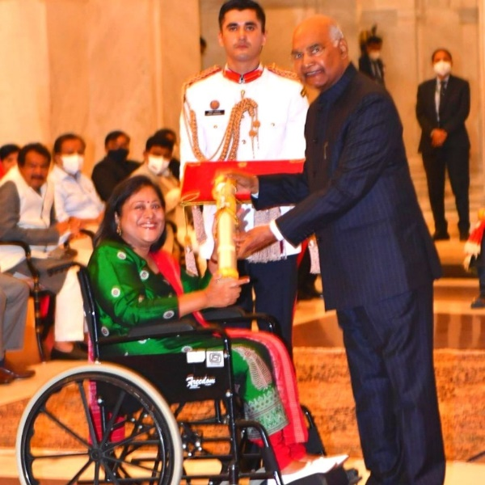President designated her as the ‘Crusader in a Wheelchair.’ In 2001, she founded ‘Swabhiman’ and ‘SHARE’, NGOs working for up-liftment of divyangjan in Odisha. She also founded Project Anjali for Divyang children to showcase their talents and other projects for education and selfemployment support for Divyangjan. Mohapatra worked for the passage of the PWD Act in 1996 and the RPWD Act in 2016. She was awarded with Vidya Bhawan Social Service Award in 2013 and National Young Scientist Award in 1992. “The Nari Shakti Puraskar is awarded to her indomitable spirit and for outstanding contribution towards upliftment and empowerment of Divyangjan,” the press release added.

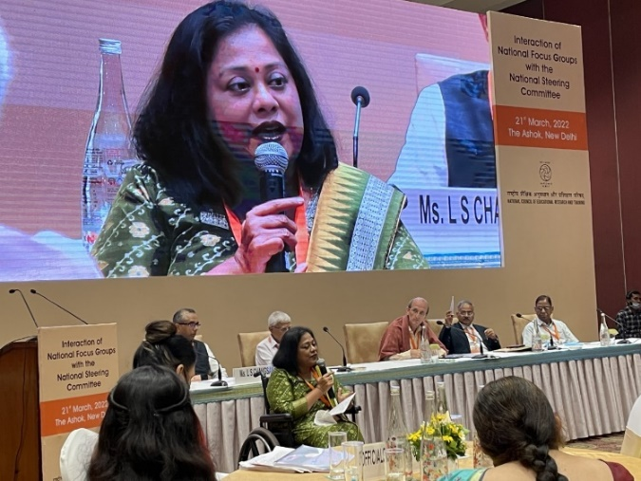MEMBER NFG - INCLUSIVE EDUCATION: Every country formulates a National Education Policy to give direction to its education system. The policy serves as base to prepare curricular frameworks and design the national syllabus as guidelines for the states to develop their own syllabus. Dr.Sruti Mohapatra, an inclusive education expert of 25 years, is a member of National Focus Group on Inclusive Education and the only person with disability to lead the formulation of NCFs to ensure inclusive education in India for next 20-25 years.

Richard Rieser, our General Secretary, gets OBE from Prince Charles at Windsor Castle in June, for his role as “Chief Executive Officer, World of Inclusion Ltd & General Secretary of the Commonwealth Disabled People's Forum and for services to Disability Inclusion in the UK and globally".

**APPRECIATIONS**

**FAIRWELL & THANKS TO FORMER EXCEUTIVE MEMBERS OF CDPF**

1. Mawunyo Yakor-Dabgah- Ghana Federation of Disabled (Former Treasurer)
2. Michael Njenga - Users and Survivors of Psychiatry, Kenya (Former Rep for Underrepresented)
3. June Reimer- First Peoples Disability Network, Australia (Former Rep for Indigenous Peoples)
4. Wabotlhe Chimidza - Botswana Federation of the Disabled (Former Africa Regional Representative)
5. Muhammad Atif - Special Talent Exchange Program (STEP), Pakistan (Former Rep for Asian Region)
6. Nathalie Murphy - Dominica Association of Persons with Disabilities (Former Regional Rep for Caribbean Islands)
7. Dickson Mveyange - Tanzanian Association of the Deaf, Chiavita (Former Rep for Deaf Community)

There are seven Executive Officers from the 2019-2021 term who do not represent the CDPF Executive Committee. We hereby appreciate their contributions during their term and wish them all the very best and good luck for their future endeavours.

COMMUNIQUE OF THE COMMONWEALTH HEADS OF GOVERNMENT MEETING “DELIVERING A COMMON FUTURE: CONNECTING, INNOVATING, TRANSFORMING”

**SUSTAINABILITY**

*The Urgent Threat of Climate Change*

57. Heads expressed their appreciation for the leading role women and young people play in galvanising support for climate action across the Commonwealth and committed to ensuring gender responsive implementation. Heads noted the Commonwealth Youth Statement on Climate Change with its call to support communities and safeguard the most vulnerable, including youth, women, the elderly, and persons with disabilities. This should be done by ensuring predictable finance to the local level to enable greater locally-led action.

**UPCOMING EVENTS**

* 27th Conference of the Parties of the UNFCCC (COP27) is schedules to be held from 07th to 18th November 2022 in Egypt.
* CDPF is planning to conduct an online Celebration to Commonwealth Disabled Peoples Day on 02 December 2022. Details will be sent in due cause.

**EMERGENCY RESPONSE: PERSONS WITH DISABILITIES IN FLOOD AFFECTED AREAS IN PAKISTAN SPECIAL TALENT EXCHANGE PROGRAM by Abia Akram Executive**

**www.step.org.pk**

Background: Pakistan continues to be affected by monsoon rainfall, leading to an increased humanitarian impact. On 23-24 August, the National Disaster Management Authority (NDMA) reported 73 fatalities (of which 31

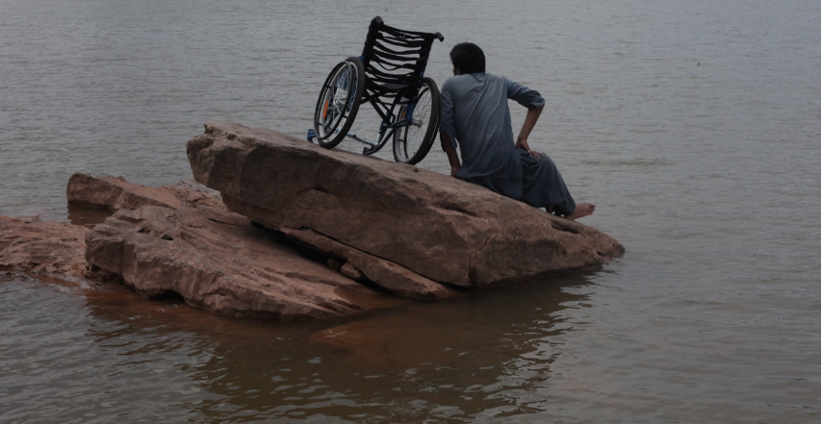in Singh Province), due to floods, landslides, flash floods, and severe weather-related incidents. Since the beginning of the monsoon season (mid-June), more than 900 people have died, and around 1,290 individuals sustained injuries. More than 3 Million persons have been affected by monsoon rains, of which 184,000 have been displaced to relief camps across Pakistan. Damage has been reported to more than 495,200 houses. In addition, 702,100 livestock has been lost and more than 3,000 km of roads and 130 bridges have been damaged. (ECHO, 25 Aug 2022). The rural communities in the south-western province Balochistan hardest hit. ([ECHO, 25 Aug 2022](https://reliefweb.int/node/3879931/)). According to WFP and NDMA 1,087,654 people are affected so far and at least 1150 people have been severely injured.  Recent data indicate that in this crisis situation people with disability may have been affected even more seriously.

Source: www.floodpk.com

The Pakistan government and civil society is struggling to rebuild as there are cuts in the foreign aid. In this situation persons with disabilities have not been counted at all, though we are trying to get some information through our networks of OPDs (Organizations of Persons with Disabilities) as much as possible.

The rehabilitation phase is starting from next week but persons with disabilities are in the most vulnerable conditions, still waiting for evacuation. After our visit today we are compiling some assessments and will share them with you to seek your advice on collaboration

**Proposed Interventions**

Different populations may face similar risks of exposure to the negative effects of environmental and man-made disasters, but their actual vulnerability is dependent on their socio-economic conditions, civic and social empowerment, and access to mitigation and relief resources. Individuals with disabilities are disproportionately affected in disaster, emergency, and conflict situations due to inaccessible evacuation, response (including shelters, camps, and food distribution), and recovery efforts.

In past a few weeks experience during the devastating floods reveals that women with disabilities are more likely to be left behind or abandoned during evacuation due to a lack of preparation and planning, as well as inaccessible facilities and services and transportation systems. Most shelters and relief camps are not accessible and people with disabilities are many times even turned away from these facilitiesdue to a perception that they need “complex medical” services. Disruption to physical, social, economic, and environmental networks and support systems affect persons with disabilities much more than the general population. There is also a potential for discrimination on the basis of disability when resources are scarce.

Having an experience of working closely with disabilities at the grassroots level and sound recognition of advocating about disability-inclusive emergency response and DiDRR at policy making as well as global platforms STEP would like to propose following interventions:

1. A comprehensive situation analysis of men and women with disabilities in all flood affected areas across the country, Recognise the diversity of persons with disabilities and collect sex, age and disability disaggregated data that acknowledges and links with

intersectionality.

2. Coordination with DPOs/OPDs (Organizations of Persons with Disabilities) and their self-help groups to bridge them with organizations engaged in emergency response and rehabilitation. Include people with disabilities and their representative organisations of persons with disabilities) to publicly lead on accessible DRR and response.

3. Need assessment of the assistive devices destroyed by flood being used by persons with disabilities in these affected areas.

4. Develop preparedness and recovery planning processes that support the health and

wellbeing of people with disability before, during and after emergencies.

5. Prioritise universal design and gender equality principles in DRR and recovery

investments.

