Commonwealth Disabled People’s Forum
Amplify the Voice of Disabled People in the Commonwealth.
CHOGM Side Meeting
10am to 11.30 am Thursday 23rd June
Meeting Room Level 3 M Hotel, Kigali.
Speakers include :
Chair Sarah Kamau, Kenya
Vice-Chair Sruti Mohapatra, India
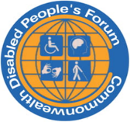
Gen. Sec. Richard Rieser, UK
Women’s Officer Gaudence Mushimiyimana,Rwanda
Mephilius James, St Lucia
Thandiwe Mufulo, South Africa
Treasurer Scader Luois, Malawi Come and Join Us www.Commonwealthdpf.org

