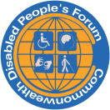
Commonwealth Disabled People’s Forum
Newsletter No 5 June 2021
Covid Vaccination for All .
CDPF Appeal to Boris Johnson
Chair of G7 on eve of the G7 Conference

Dear Boris Johnson, 2nd June 2021
I write to you as UK Prime Minister and Chair of the upcoming G7 meeting, in my capacity as the Secretary of the Commonwealth Disabled People’s Forum (CDPF). We represent the 450 million plus disabled people across the Commonwealth of 54 countries, which contain 40% of the world’s population. CDPF has 84 Disabled People’s Organisations from 47 countries.

Next week’s G7 comes at a crucial time in the evolution of the COVID Pandemic. It is now becoming clear that mutations of the virus with more transmissibility and different pernicious effects, are continuing around the globe. The Delta variant is a case in point. It had such damaging effects in India and is now working its way across the UK and other countries. Both the World Health Organisation and the World Bank have called for a much more organised and properly funded Global Response to the Pandemic. The only obvious way of controlling the spread of these viruses is by a full population vaccination programme in every country. We have the knowledge and expertise as humanity to produce and develop vaccines to contain current and future outbreaks, but only if these are available in sufficient quantities throughout the world.
As former Prime Minister Gordon Brown said, it would take a “herculean” mobilisation – spearheaded by the G7 – to reach the greatest number of people in the shortest time. The real problem was not a shortage of vaccines but the lack of money to pay for them, he added. The CDPF urges you in the strongest possible terms to set an example at the G7 and get an agreement to meet 60% of this cost in line with the proportion of global wealth the 7 countries represent i.e. £30 billion per year. We recognise that this may involve the UK Government in re-embracing your 0.7% of GDP target to Aid expenditure. However, the better than predicted economic position would make this possible. Politically it makes sense as has oft been stated ‘no one is safe until all are safe’. Your leadership at the G7 could make this a reality.
The threat is much greater to disabled people who require additional support and safeguarding to be protected. Figures for death and severe infection for disabled people (those with long term impairments) regardless of age, is at least 6 times those of non-disabled people. As well as the above, we call on UK Aid for targeted and customised measures for disabled people.
Richard Rieser General Secretary CDPF

The second and third waves of the Pandemic are continuing to wreak havoc across the world and the Commonwealth. The lack of a global planned response with different populist leaders refusing to take a cautious approach, has not only endangered their own populations but created greater opportunity for mutations and spread as the figures below suggest. There is still huge scope for infection given the very low levels of vaccination in Asia and Africa. Let us pressure and work for a unified response where world leaders will recognise they must operate effective travel bans, track and trace, quarantining, lockdowns sharing knowledge, resources and vaccines. Only unity of spirit will also address the growing global climate crisis as we go towards COP26 in November.
Top 16 Commonwealth countries by number of infections. * For comparison.
Country | Number of Infections | Deaths from Covid | Rate of death per million | Population
*World | 173,035,414 | 3,719,849 | 477.2 | 7,870,425,000
*USA | 34,174,823 | 611,612 | 1,838 | 332,791,423
India | 28,625,568 | 341,450 | 245 | 1,392,494,128
*Brazil | 16,803,472 | 469,784 | 2,196 | 213,951,414
United Kingdom | 4,499,878 | 127,812 | 1,874 | 68,214,706
South Africa | 1,680,373 | 56,765 | 946 | 59,996,485
Canada | 1,387,445 | 25,644 | 674 | 38,046,873
Pakistan | 928,588 | 21,105 | 94 | 224,829,078
Bangladesh | 807,867 | 12,758 | 77 | 166,199,732
Malaysia | 603,122 | 3,182 | 97 | 32,747,402
Sri Lanka | 198,579 | 1,680 | 75 | 21,496,028
Kenya | 171,658 | 3,223 | 59 | 54,857,497
Nigeria | 166,682 | 2117 | 10 | 210,820,823
Zambia | 97,388 | 1288 | 68 | 18,885,187
Ghana | 94,011 | 785 | 25 | 31,667,984
Cameroon | 78,929 | 1275 | 47 | 27,151,280
Cyprus | 72,626 | 362 | 298 | 1,115,456
Mozambique | 70,965 | 837 | 26 | 32,056,904
Maldives | 66,516 | 173 | 315 | 549,287
https://www.worldometers.info/coronavirus/?utm_campaign=homeAdvegas1?#countries
India : A Note on COVID from Arman Ali,National Centre for Promotion of Employment for Disabled
India has passed much progressive legislation on disability but last year saw unprecedented disruption in the status quo of disabled people due to the Covid pandemic, where they were excluded, marginalized further from the mainstream. “In March 2020,the government issued comprehensive disability-inclusive guidelines to all the States and Union Territories (UTs) for the protection and safety of persons with disabilities in the wake of the Covid-19 outbreak. Declared as a National Disaster by our Prime Minister, the guidelines outlined that the National Disaster Management Authority (NDMA) at the district, state and national levels should include persons with disabilities in disaster management activities and keep them apprised about the pandemic and share accessible information to them. People with disabilities that cuts across all groups, regardless of gender, age, religion, geography or economic background, faced severe discomfort and were the hardest hit. The government of India’s programs and many other services were ceased. Several studies were conducted by various NGOs and INGOs to measure the impact of the pandemic on people with disabilities. Among others, the study covered a wide range like access to food and essentials, Social Protection, Health, Sanitation and Hygiene, Education, Employment and Livelihood, Domestic Violence and Emotional Well-being as the areas that faced major challenges. The report highlighted several gaps in government implementation, leaving the women with disabilities highly vulnerable and dependent. The guidelines issued by the department of disability empowerment were largely inaccessible initially. Priority for food distribution was not given to people with disabilities, making it highly challenging for many to obtain food. Social security provisions were very sketchy. Although pension and additional allowances were announced, most women participants informed that they did not receive any additional amount despite being eligible. Social isolation led to loneliness and increased mental health issues. Many faced employment issues as they found it daunting to work in the changing environment and reported income and livelihood losses. A woman who is hard of hearing stated that “For those of us who depend on lip reading, it’s exhausting. We spent so much time reading the room, by the time we have grasped the conversation we are exhausted. Another study conducted in Madhya Pradesh revealed that over 60% of people with disabilities lost their jobs in the wake of the pandemic. Some governments such as Kerala, Tamil Nadu etc. took special measures to improve the lives of people with disabilities. At local levels, efforts were made by many DPOs, NGOs and individuals to work with the government to alleviate the difficult situation of people with disabilities. Overall, efforts were made by some state governments and central government to support people with disabilities, but these could have been better organized and coordinated”. Postscript Now because too many measures were relaxed by Government a 3rd Wave with a new mutations-Delta virus, is having devastating impact on the population and disabled people will be again worst affected because of the greater risk they face with lack of protection and medication.

Nigeria A Personal View Israel Balogun Disability Inclusive Development Specialist. He has physical impairment and uses a walking stick. Here he shares his concerns about the impact of the Covid-19 pandemic on disabled people in the country.
“The issue of COVID-19 has been a major point of concern for me as an individual. The humanitarian crisis already happening in Nigeria as a result of the Boko Haram crisis has a deleterious effect on the lives of persons with disabilities, who are not being included in the humanitarian response. Now COVID coming on top of it, it's double jeopardy. Most people with disabilities are the poorest of the poor, the most negated in society, so looking at the whole situation of COVID-19 and its impact on the lives of persons with disabilities got me so concerned. The enormity of the challenge is so wide. There are over 25 million persons with disability in Nigeria.”
Hunger “In developing countries at least 20% of the poorest of the poor are persons with disabilities. I'm afraid that we'll be losing most of them. Not because of COVID-19 but because of hunger. The lives of 25 million people with disabilities are at stake in Nigeria. That's just the truth. I'm so concerned. We might be committing a massacre or a genocide. Someone that could not feed himself before, they have to depend on others or probably depend on begging on the street. Or someone who is unemployed. I know a lot of qualified people with disabilities that don't have a job. So now their situation has worsened. What will they eat? Hunger will kill them even more than the COVID-19.”
Psychosocial impact “Many of us people with disabilities have low self-esteem. The discrimination and the stigmatization that happens to us also has an underlying effect on us as a people, especially for women with disabilities. We are prone to anxiety, we are prone to depression. Some of them told me that they wished they were dead. There is no support. So many of them are suffering from depression as a result of both the stigma and the economic worries associated with COVID-19. Some of them are self-employed. Some of them are depending on the family support system which is no longer there. Some of them have psycho-social impairments like schizophrenia, and COVID-19 is activating it. I have had to counsel and recommend some of them to go and see a doctor in recent times.”
Violence against women and girls “The other part that I'm even more concerned about is the rape and sexual and gender-based violence against women and girls with disabilities, who have always been victims of sexual molestation in time passed. Written reports all over the world have shown that sexual and gender-based violence has increased significantly during the pandemic. Even the UN Secretary General António Guterres had to come out and address this issue. However, in our own situation here, nobody is really coming out to address this issue. Recently rape incidents have been happening unprecedentedly in our country like never before. Nobody will report rape when it comes to girls and women with disabilities, because whenever they even try to report rape cases, people shut them down.”
Economic impact “In Nigeria we have over 82 million people in poverty. And the poverty is increasing and a lot of people are losing their jobs. A lot of people with disability I have spoken with, they are even telling me that they can't even beg because people are not outside. I met some beggar from a street in Bauchi. They do what they call transporter beginning, traveling to either Lagos state or mega cities to go and beg, and then send money home to their family. Now that that opportunity is no longer there, everywhere is locked down so you can imagine the impact on not only people with disabilities, things are becoming much more challenging for them, but for their families and their dependents. “The challenge is this, a lot of people with disabilities say: ‘Look, I have significant difficulties in my life. Why worry about COVID-19? I have other health diseases that are even much more pressing. Malaria is there, typhoid is there, all infectious diseases are there. So let me go and look for a way of begging.’”
Testing“Nobody is talking about conducting tests on persons with disability in Nigeria. However in the developed world, UK, US and other places, it has been reported that a lot disabled people who live in homes and psychiatric institutions or are in confinement are getting much exposure to COVID-19. A lot of people have died. But in my own country, nobody is even thinking about them in terms of conducting testing amongst them. It feels like the testing is selective for me. Even as a doctor, we know that the rich or the privileged that will have access to the NCDC, the Nigeria Center for Disease Control, are the ones having the access to testing. And it's getting me worried.”
The future of disability inclusion “Now that COVID-19 has come, of course it's reversing our work in the Disability Movement in Nigeria. But it's even compounding and making the situation worse. I'll give an instance. A lot of children with disabilities are back at home because the schools have shut. The government is trying to set up opportunity for them to have video messages, lectures or classrooms via radio and television. However, a lot of children with disabilities are marginalized and can’t access that, so they are further disadvantaged. Their situation is worsening. The impact is also obvious on jobs. Of course, we are advocating for people to be included in the job market. But the future of work now for them is worsening. Employers say ‘I would rather look for an able-bodied person than employing a person with disabilities who will be a further burden to me’.”
Discrimination “I studied medicine eventually, but three universities told me that I can't study medicine because of my disability. I lost eight years. When I see a person with a disability, it hurts me because I see myself. It might be someone like me again that is going to go through the systematic discrimination that is out there with living with disability in our society. It's not only in Nigeria alone. This systematic discrimination is even happening in the developed world too. I was in UK when there was a cut to the welfare benefits of a lot of persons with disabilities. I see the disparity. Those in psychiatric institutions, those that are in care homes during COVID-19, a lot of them have died. My heart is broken. And I say to myself: when the situation is like this in developed societies, then what is the fate of us here in Nigeria?”

The costs of exclusion: Economic justice for Disabled Women and Girls.
During Generation Equality Forum in Mexico on 30th March 2021, the International Disability Alliance held a Special Session with the aim to raise priorities of disabled women, reflecting on access to decent and safe work and employment, disability inclusive social protection, the impact of COVID-19 and the opportunity it presented to reimagine what inclusive access really means. The seminar included two contributors from Commonwealth countries.
Agnes Abukito, Fellow of the World Federation of the Deafblind (WFDB)-IDA, Uganda shared that the economic impact of COVID19 was felt acutely in Uganda. “Due to the lockdown, many communities could not harvest their crops, which led to increased situations of hunger and unemployment upon persons with disabilities. Persons with deafblindness in Uganda rely heavily on in person contact, and technology is very often not accessible for them. The shutting down of transportation and imposition of social distancing measures further marginalized them as, for instance, those who were in need of guide interpreters could not access the services. She also highlighted the need for Government programmes to specifically target women with disabilities from underrepresented groups. “The procedures against the Covid 19 make an accent on social distance. But these were not friendly to persons with deaf‐blindness, most especially women with deaf‐blindness because you have to move with a guide. And then when we talk about food distribution, in my country, Uganda, there was a policy that all people would get food at their door. It does not favour women with deaf‐blindness, because we are not among the group that the government targeted for food distribution…”
Meenakshi Balasubramanian, Centre for Inclusive Policy (CIP), Chennai, India presented the findings of the study “How responsive are social protection programs towards women and girls with disabilities-inferences from gender budget analysis (India)” emphasizing the lack of data disaggregated by gender and disability. Meenakshi highlighted the underrepresentation of social protection schemes for disabled women with only 30% of schemes actually considering them. Meenakshi pointed out that the design of schemes and programmes end up excluding disabled women and girls because they do not factor in the gendered barriers to access. For instance, public work programmes exclude women as work sites do not have accessible toilets or drinking water. She concluded with the need for social audits of programmes from the lens of disabled women. “The gender responsiveness and impact of multiple marginalization has to be part of the training programs of all professionals, both at the government and other levels that ensures accountability, even within the disability movement. Along with the gender training mandated by the budgeting. Then there should be greater participation of women with disabilities in all forums. Re‐look at the programs and policies to ensure gender responsive design.”
Catalina Devandas, disabled lawyer and previous UN Rapporteur on Disability “Despite efforts to bring women with disabilities to the table, we still continue to leave them out, and this is a structural issue to think about… There will not be an Equality Generation if we do not redesign the way in which we create public policies in all parts of the world, without considering all and especially those women who face the most severe structural barriers, violence, discrimination and exclusion, they do not happen in a bubble. They are filtered by all barriers… we have to open spaces so that all women can participate calmly under equal conditions.. ”
Recommendations from the seminar
• All the different barriers faced by disabled women and girls must be considered, as well as their diversity must be understood and considered in all their intersecting identities to promote their active and meaningful participation,
• We urge governments to include articles regarding ‘women with disabilities in the general law of persons with disabilities in each country’ and also to pay attention to the particular multiple and intersectional discrimination that disabled women face,
• Governments and other stakeholders should ensure the exercise of the rights of disabled women and girls on equal basis with others,
• During the COVID-19 crisis and beyond, the perspectives and the gendered barriers that disabled women and youth experience in accessing economic justice must be considered and addressed, especially from underrepresented women and young women,
• Participation in all decision-making and discussion spaces must be ensured to disabled youth, disabled women and girls, older disabled women, indigenous disabled and women from rural and remote areas,
• Disabled Women’s issues and rights must be included in educational efforts, including regarding the access to sexual and reproductive education,
• The rights of women and girls, including with autism, access to inclusive education must be ensured and promoted, as well as their right to personal autonomy, including their financial independence,
• Government and international cooperation must specifically target disabled women from underrepresented groups within their mainstream efforts,
• Social audits and removal of public programmes that excludes disabled women and girls must be factored in the gendered barriers to access, such as work sites with no accessible toilets or drinking water.
Applicants to Girls’ Education Professional Fellowships : Commonwealth Scholarships Applications for the Girls’ Education Professional Fellowships are now open. This supports a three month study visit to UK. In order to apply you must first register with us by sending a request to professional.fellowships@cscuk.org.uk. If you have any questions about the programme or how to apply all the information is on our website or don’t hesitate to get in touch with me directly. The closing date for applications is Monday 21 June 2021 at 4pm (BST).
Commonwealth Scholarships Commission Applicants to CDPF We had 105 Masters and 9 PhD applications for 10 Masters nominations and 5 PhD nominations. They needed to be disabled people, relate to UNCRPD and SDG goals and explain how will benefit their country on return. Many applications from Pakistan as only route to get a nomination was through CDPF. After three emails we reduced to a short list 13 for Masters and 7 PHDs. Fees, subsistence, travel and additional costs for reasonable accommodations are paid for UK University for successful candidates. Have to apply to info@cscuk.org.uk and for PhDs get acceptance from UK University before applying. At the Selection Meeting of Vice Chairs and Acting Chair and General Secretary we agreed and 10 Masters & 5 PhDs nominations. Will hear he result in June. Have made clear to CSC that we cannot do this again without funding from them. The next round will publicised in early November.
UN Conference of State Parties-COSP 14 June 14th to 18th
CDPF Side Meeting COSP 16th June Show-casing Success of Commonwealth Disabled People's Forum Online Disability Equality Training
- How do we build DPOs/OPD capacity and understanding of the paradigm shift from individual/medical model thinking to social/human rights model thinking?
- With at least 1.3 billion disabled people/people with disabilities in the world how can we use modern media to improve their understanding of their rights?
The Commonwealth Disabled People's Forum has grown to 82 DPOs in 47 countries. During the Covid Pandemic CDPF gathered information, held online meetings providing guidelines on the best ways to support disabled people during and after the Pandemic. There was clearly a need to develop an accessible online course to capacity build disabled activists around the 54 Countries of the Commonwealth. Funded by Commonwealth Secretariat and Disability Rights Fund, the course ran over 15 weeks, February to May 2021. The 14 Modules were delivered by experienced disabled leaders across the Commonwealth. Each week a signed/captioned presentation was put on the organisation's website. This consisted of films, powerpoint, lectures & Course Book with follow up activities. This was reinforced by 2 x 90 minute interactive online seminars. Participants in many countries really enjoyed and learned a great deal from the course. It is online for all, open access from 14th June 2021 www.commonwealthdpf.org/training
Moderator-Sarah Kamau, CDPF Acting Chair, United Disabled Persons Kenya
Layne Robinson-Head Policy Commonwealth Secretariat
Richard Rieser-General Secretary Commonwealth Disabled People's Forum
Dr Sruti Mohapatra-Vice Chair CDPF, Swabhiman, Odisha, India
A range of participants from the Course
Gemma White-Action on Disability and Development, Course Administrator
Amba Salelka-International Disability Alliance, Capacity Building Unit
Harriet Knowles-UK FCDO Disability Capacity Building programme
Diana Samarasan-CEO Disability Rights Fund

To join the meeting on Wednesday 16th June 2021 at 10am EST (3pm BST)
Email martha.aldridge@commonwealthdpf.org with your name, country and organisation. You will be emailed details of how to connect. There will be Captioning and International Sign.
Sponsors
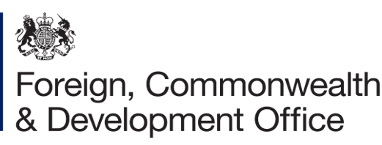
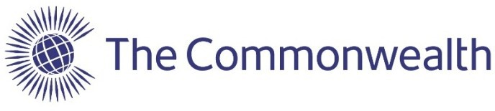

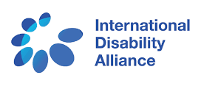
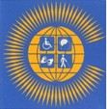
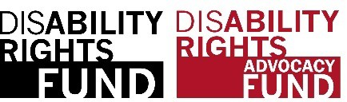
Commonwealth Disabled People’s Forum

More details of aims and content of course. Disabled activists, their organisations and leaders need to understand the oppression we face as disabled people, regardless of our impairment. We need to understand that the impact of old-fashioned thinking of us as a problem to be fixed, as people without rights, has to change to a social model/human rights approach in line with the UNCRPD and SDGs, where disabled people are in control of what happens to us as powerful subjects in civil society. We are capable of bringing about real social and economic change for the 450 million disabled people of the Commonwealth.The course targeted disabled women and young people and achieved this. Opening the course to all who met our criteria, 428 were accepted. A core group of 150 participants attended the whole course, though many others accessed resources. For accreditation there were four levels based on attendance and the amount of follow up work completed.
CDPF plan to produce the materials on a computer stick, so it can be used where internet connectivity is poor. There will be an option to translate from English to main community languages with Country DPOs organising dissemination events.
Modules
1. Models and Thinking About Disability and Implications for Action.
2. The UN Convention on the Rights of People with Disabilities, the Sustainable. Development Goals and their Impact on Disabled People’s Human Rights.
3. Health - focusing on Mental Health and Covid-19.
4. Innovation - focusing on Improving Access and Assistive Devices.
5. Trade- focusing on Improving Livelihoods and Employment.
6. Environment - focusing on the Impact of Humanitarian Situations.
7. Respect for Law-focusing on Eliminating Stigma and Discrimination.
8. Youth and Disability Rights in collaboration with CCYDN.
9. Inclusive Education.
10. Women and Girls.
11. Anti-Racism, Equality and Respect for Ethnic Minorities.
12. Data of Disability.
13. Building DPOs, Campaigning and Increasing OUR voice.
14. Influencing Government.
Accreditation for each module will require accessing and viewing module presentation, reading chapter in Course Book, completing at least 3 of module follow-up activities and attending 1 of the weekly seminars. The course was delivered by experienced Disability Equality Trainers who are members of the CDPF Training Sub-Committee led by Richard Rieser our General Secretary. The content of the course was focused on Commonwealth Heads of Government Meeting (CHOGM), Sustainable Development Goals (SDGs) and United Nations Convention on the Rights of Persons with Disabilities (UNCRPD) implementation and is aimed at activists in Disabled People’s Organisations (DPOs) throughout the Commonwealth. Each module was viewed with the Covid/Post Covid -19 Build Back Better perspective.

Other COSP Events
CDPF is sponsoring another side meeting on Tuesday 15th June 11.30 -12.45 EST on Covid and Poverty Reduction organised by Steven Estey from our Executive. Check for more information, including list of all side meetings. https://www.un.org/development/desa/disabilities/conference-of-states-parties-to-the-convention-on-the-rights-of-persons-with-disabilities-2/cosp14.html
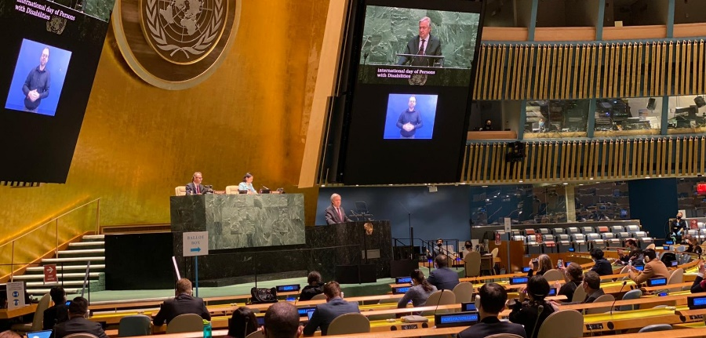
Civil Society Forum. The Civil Society Coordination Mechanism is hosting the Civil Society Forum on 14 June 2021. It will take place virtually from 9 am- 12 pm EDT. Please mark your calendars! To register for events, please click here to downaload the document in word format and here to download in PDF, or use the direct URL: https://bit.ly/2021CSF.
** Given the situation on COVID-19, after careful consideration, COSP14 will be held largely online. 15 June 2021 (in-person meetings: Opening of the conference and matters related to the implementation of the Convention, General debate). 16 and 17 June 2021 (virtual meetings: roundtable discussions, the interactive dialogue with the UN system, and the closing). **
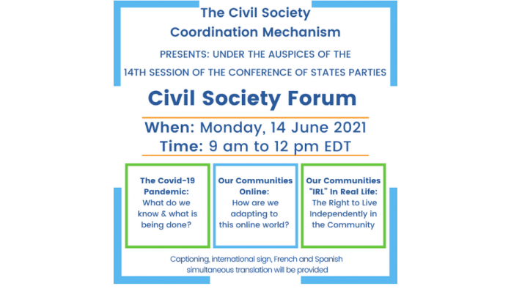
Monday, 14 June 2021 at 9am to 12pm EDT/3pm to 6pm CET. Please Register for the Civil Society Forum Here.

Becoming an Individual CDPF Human Rights Advocate. (CDPFHRA)
The Executive of the Commonwealth Disabled People’s Forum has decided to set up a network of disabled activists across the Commonwealth, to help build the Disability Movement and further the aims of the Commonwealth Disabled People’s Forum www.commonwealthdpf.org . Since relaunching in New York in June 2019 the CDPF has grown, with currently 84 member organisations in 47 Commonwealth countries. We have recently been holding an online training programme that has attracted a lot of interest. As a CDPFHRA you would not be able to influence policy except through your DPO if affiliated, but you would be able to promote our policies and other initiatives to strengthen the Disabled People’s Movement across the Commonwealth. CDPF advocates for full implementation of UN Convention on Rights Persons with Disabilities and the Sustainable Development Goals.
There are many vital Global issues where the CDPF has much to say on the impact and interface with disability policy e.g. Covid Pandemic, Environment and Humanitarian disasters, Black Lives Matter and Anti-Racism, ‘Me Too’ and the struggle against Sexism and Gender Based Violence, Equality, Inclusive Education, Income Inequality, Poverty and the need for the messages of the Disabled People’s Movement to have more political influence.
Signing up to the CDPF Human Rights Advocates will be a way to further the above issues, establish a network to help implement the aims of the CDPF and provide mutual support. We are investigating setting up a private chat room that members and advocates could discuss issues and help each other.
Those signing up will undertake to operate with respect for each other and refrain from abuse and personal attacks.
To be eligible to be a CDPF Human Rights Advocate you would need to sign an undertaking that you:
a) Will promote the aims, objects and policies of CDPF
b) Are a disabled person
c) Subscribe to social model thinking about disability
d) Will promote equality and human rights in general, practice respect for difference and for others in their functioning as an advocate
e) Are a disability activist and agree to be involved in your local and/or National DPO
f) Will promote the CDPF and our thinking locally and nationally in your country.

The application form will be found on our website at www.commonwealthdpf.org/membership/CDPFHRA

Future Events
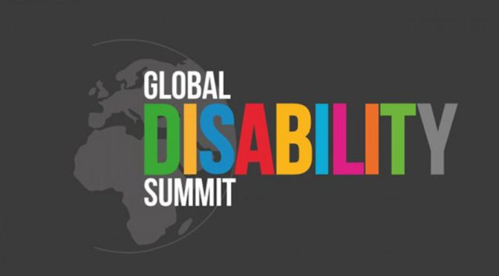
The GDS Oslo will take place in February 2022. The summit will be digital. Both IDA and the Atlas-alliance, together with the Ministry of Foreign Affairs have had several planning meetings. Norwegian DPOs are also involved. Several southern DPOs have already given input on their experience from London, and thoughts about the GDS 2022. See below for more detailed feedback. https://atlas-alliansen.no/global-disability-summit-2021/global-disability-summit-oslo-2021

Virtual General Assembly of Commonwealth Disabled Peoples Forum in 2022
Having established the CDPF over the last two years we are now accredited with Commonwealth Board and the UNCOSP. We need to take stock and renew our elected Executive Committee and examine our structures. There will be a timetable produced later in the year to allow for amendments to the constitution, nominate candidates for election or re-election to the Executive Committee and amendments to a general work plan. To date we have had a successful partnership with Action on Disability and Development . They have provided admin (the brilliant Gemma) and financial accounting support, holding and dispersing grants we have been awarded. This has enabled us to utilise two grants for $190,00 and £220,000 from the Disability Rights Fund and two smaller grants from the Commonwealth Secretariat. With this resource we have:-
- Held regular online Executive Meetings and a face to face meeting in Malta in February 2020
- Developed a number of key policy documents including an Anti-racist/Indigenous people’s, Environment/Humanitarian Risk, Inclusive Education, Girls and Women’s, Employment/Livelihood, Stigma/Discrimination Policy
- Run a workshop in the Eastern Caribbean for DPOs in Antigua in December 2019
- Run a series of international on-liner summits of Covid 19 and regional meetings
- Organised and delivered our on-line training resource
- Selected & nominated disabled scholars to the Commonwealth Scholarship Commission for Grant
- Developed and promoted Disability Policy for Commonwealth Heads of Government Meetings,
- Participated on a voluntary basis in the Independent Forum of Commonwealth Organisation
- Held side meetings at COSP 12, COSP13 and coming up COSP 14
- Had a successful partnership with ADD which we have agreed to extend a further 2 years
- Pressed forward on full implementation of UNCRPD and the SDGs at every opportunity
- Run an active recruitment campaign of DPOs/OPDs.

Way Forward. The next few months and in the run up to the General Assembly CDPF needs to consider how to grow and develop the organisation and the capacity of our membership organisations to achieve our objectives.
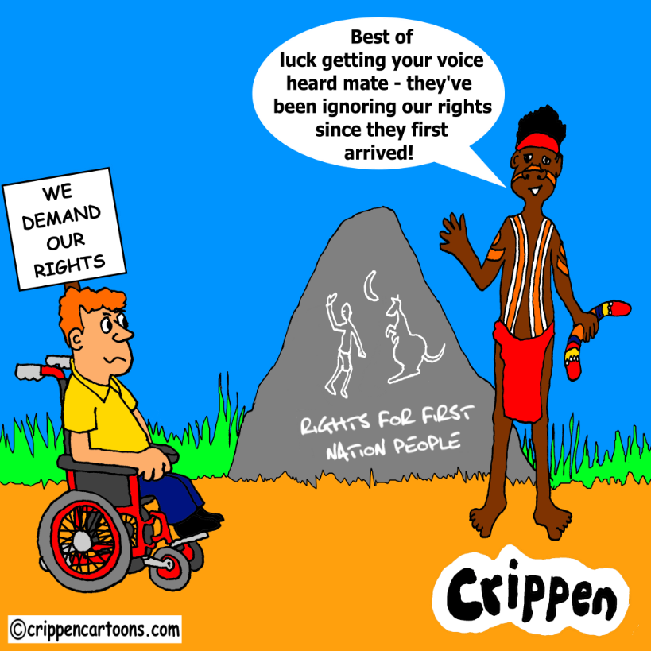
Description. A white wheelchair user with a placard saying ‘we demand our rights’ is sat facing an Australian First Nation person. This person is stood next to a large rock on which is carved First Nation art and the slogan ‘Rights for First Nation people’. He is wearing a red headband and loin cloth, carrying a boomerang also wears traditional body paint. He is saying to the disabled man: “Best of luck getting your voice heard mate – they’ve been ignoring our rights since they first arrived!”
Crippen an article in the Guardian reporting that the Australian federal government has been sharply criticised by the disability royal commission for its “serious failure” in not adequately consulting disabled people or creating a specific plan to protect them at the start of the coronavirus pandemic. Those failings “produced serious adverse consequences for many disabled people”.

Commonwealth Disabled People’s Forum
c/o World of Inclusion, 78, Mildmay Grove South, LONDON N1 4PJ
0044(0) 7715420727 email rlrieser@gmail.com Company Registration 7928235 Website www.commonwealthdpf.org General Secretary Richard Rieser

