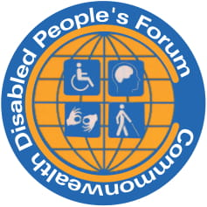

CDPF On-line Disability Equality Capacity Building Course Book

Module 1: Models and Thinking About Disability: Implications for Action.

Contents
CDPF On-line Disability Equality Capacity Building Course Book 1
Module 1: Models and Thinking About Disability: Implications for Action. 1
i) The language the CDPF uses 2
ii) Traditional ideas about disability and disabled people based on myth, superstition, culture and religion 2
iii) Albinism: a case study 6
iv) Disabled people as objects of charity, medical/deficit thinking 8
v) The Paradigm Shift from the Medical to the Social Model of Disability 10
Turning Over the Medical Model Organisationally: Rehabilitation International and Founding of DPI 10
vi) The Language We Use in English. 19
vii) The Human Rights Approach to Disability 22
viii) Future Actions and Implications from Thinking about Disability 24

i) The language the CDPF uses
Disabled people: Why we still choose to call ourselves ‘disabled people’: In the Commonwealth Disabled People’s Forum (CDPF) we call ourselves ‘disabled people’ because of the development of the ‘social model of disability’. In the C19th and C20th, a disabled person’s medical condition was thought to be the root cause of their exclusion from society, an approach now referred to as the ‘medical or individual model’ of disability. We use the ‘social model of disability’, where the barriers of environment, attitude and organisation are what disable people with impairments and lead to prejudice and discrimination. So, to call ourselves ‘persons with disabilities’ is to accept that we are objects and powerless. We also view ourselves as united by a common oppression so are proud to identify as ‘disabled people’ rather than ‘people with disabilities’. When we are talking about the UN Convention on the Rights of Persons with Disabilities we will use ‘people or persons with disabilities’.

ii) Traditional ideas about disability and disabled people based on myth, superstition, culture and religion
For thousands of years, in every culture and society, physical and mental differences have been ascribed special meaning. This was usually negative, resulting in stigma, taboos, negative attitudes and stereotypes that still persist in many cultures.
People were thought to be disabled because they or their parents had done something wrong and because all-powerful gods, deities or fate had made them disabled (karma or sin). Disabled people were often subjected to inhuman treatment. Being seen as bringing shame on their families, they were locked away. Euthanasia was widely practised on babies born with significant impairments. Such children were often abandoned and had to rely on begging to survive. Disabled people were often viewed as not fully human or possessed by evil spirits. This made it easy to make fun of or ridicule them. They became the butt of jokes and symbols for all the ills of the world, as shown by disabled people working as clowns, court jesters or in ‘freak shows’.
Other examples include the association of impairment and witchcraft. Being disabled was often taken as proof of association with Satan during the European witch hunts of 1480–1680. The last paying ’freak show’ closed in Coney Island, New York in 2001. The Bible contains more than 40 negative references to disabled people. In ancient Greek society, Aristotle and Plato argued for the ‘exposure’ of disabled babies. Richard III was given some of his impairments by Tudor historians seeking favour with their rulers, who had usurped Richard as king.
Quarmby has provided an in-depth analysis of negative attitudes to disability in the West. She has linked them in a detailed way with scapegoating, othering and hate crime towards disabled people in the UK. Unfortunately, disabled people are regularly subjected to hate and violence, drawing on this resilient cultural residue.
There are many cultural and literary manifestations of this thinking, still being reinforced in myths, legend, or literature. Even modern films, comics and television programmes draw upon and reinforce these negative stereotypes. Stereotypes are bundles of negative and untrue perceptions which often condition how people treat and respond to disabled people. (We will cover elimination of stigma and discrimination in Module 7). Similar activity is on the increase across Africa towards people albinism-See case study below.
The elements of traditional model thinking in Southern Africa listed in Figure 1 were identified by 32 participants in a 2007 workshop attended by disabled people, parents of disabled children and government officials from Botswana, Lesotho, Malawi, Mozambique, Namibia, Swaziland, Zambia, and Zimbabwe. They clearly demonstrate the power of the traditional model of disability in Africa as a barrier to the development of equality and implementation of human rights for disabled people.
Figure 1: Commonly held views about disabled people in Southern Africa
Demon possessed. | Tools to scare children.
Bewitched/a curse. | Tools for begging.
A moron/idiot/stupid. | Expressing bad feelings.
Non-achievers. | Sign of misfortune.
Disability is contagious. | Rude people.
Less of a human being. | Short-tempered people.
Disability is a result of incest. | Invalids.
Sick people. | Mad people.
Government has other priorities than  spending/wasting money on disability. | You have a child with a disability as a punishment.
Naughty. | They cannot have children
Useless to society.  They are a problem. | They are not worth it.  Shameful.
Disgusting to family members. | They are a burden.
Punishment from God for evil deeds | They are argumentative.
Albinos do not die, but they disappear. | They cannot think on their own.
Mother blamed for having a disabled child – has been unfaithful to husband. | They are unproductive.
People with disabilities are God’s people – known as beggars. | While pregnant the mother laughed  at a traditional Gulewankulu dancer.
Mothers are always blamed for bearing disabled children and are therefore abandoned. | They remain children – they are not  expected to behave like adults.
They are AIDS carriers. | They cannot be educated.
Objects of pity. | They will have disabled children.
Asexual – have no sexual feeling. | They do not have sex – HIV carriers.  It is believed that having sex with a disabled person is a cure for the HIV virus.
In 2011 World of Inclusion Ltd carried out a six-day UNCRPD capacity building workshop in Port Moresby for the UK Disabled People’s Council and the Commonwealth Foundation. Disabled leaders and disabled young leaders from Kiribati, Nauru, Papua New Guinea, Samoa, Solomon Islands, Tonga, Tuvalu and Vanuatu took part and came up with a wide range of traditional ideas about disability that are still very much part of people’s thinking on the ground.
Figure 2. Traditional views of disabled people in the South Pacific
These include:
• Mental impairment is caused by sorcerers/curses
• Slow development of children – uncaring parents during pregnancy or child’s development •Physical impairment is the person’s own fault
• If they are born with a physical impairment this is because either the parents separated or there is a scandal in the family. •Disability is the fault of a sinful mother
• Breaking the taboo, e.g. sleeping/doing something in a taboo place (taboo = restricted areas) •If pregnant mothers eat reptiles like eel-fish cats or flying foxes, their child will become disabled
• Bride price and disability: If the bride price is used to buy food, the profit becomes a cause of disability •Wrong marriages cause disability •Uncivilised (rape people with disabilities)
• Cultures sometimes teach that people with disabilities are possessors of evil or ancestral spirits
• Disabled people are bad, leave our families in isolation
• Laughing, teasing, labelling, discrimination, distance, body language, parents’ fault, a stay at home, not to have family, can’t work, look down at you, not accessible
• Mata tingo (crooked eye)/ta’ea’onga (useless)/konga e moui (abnormal)/ ne totonu peke ke petie (deserve to have the disability)/ta’etokanga matua (careless parents)/ke kehe atu koe meihe family (you’re different from your brothers and sisters)
• Papua New Guinea: Disability is caused by witchcraft because of jealousy or to pay back for some wrongs done in the past by the family members of a person with disabilities
• Aia Iango aomata aika toamau ibukiia aomata aika a mwauku a rangi n aki kukurei bwa a na iein ibon ivouia mwauku. Ma Iroura ngaira mwauku ao ti bon kona n tabe ma aron ara katei (The people in Kiribati don’t want people with a disability to get married because they think people with a disability can’t look after themselves)
• They believe that you have a disability because your parents make sins to god (or do many wrong things)
• Tonga: Worshipping idols brings a curse on a person •Disobedience to church
• If parents do not follow customs, this means that their children will have disability
• Taking newly born child out at night will lead to evil spirits cursing it
• Shark or crocodile worshipping gone wrong will lead to a disability
• A woman drinking an open cut coconut will lead to her having a facial/mouth deformity
• Cooking a chicken whilst breaking its leg will lead to a physical deformity
• Pregnant mothers should not be allowed to walk alone or should not eat certain parts of a pig •Pointing your finger at a grave
• Taking dead bodies out at night without covering the face will cause a disability from the evil spirits. •Disabled people cannot marry
• Tuvalu: If you do black magic or use magic in the wrong way it will kick back at you, and if not it will hit your kids
• Papua New Guinea: People believe that you are disabled by angry spirits
• Papua New Guinea: Belief that when someone enters or passes through a sacred site, he or she is disabled • Papua New Guinea: They look down on people with a disability
• Tagata matimii (disabled persons)• E le fai aiga (can’t marry) • E le fanau (can’t get birth) • Matua (parents) • E ele tatau ona faigaiuega (can’t work)
• Disrespect (ignorant of person with disability) •Disabled person is mad

These traditional beliefs are an embedded part of many cultures, and they are not easy to shift, but challenging discriminatory practices is easier on grounds of fairness, equality and human rights. So a discussion of the values people in the community adhere to may be a more fruitful starting point.
Educating people, involving local community leaders and families of disabled people, empowering disabled people locally in self-advocacy groups have all proved to be effective ways to challenge and change traditional thinking. If these approaches are firmly grounded in a social model human rights approach to disabilism they are much more effective. These sentiments are also backed by the Commonwealth Charter to which all Governments are signatories

Case Study: It takes a village to kill a child. Uganda's hidden Children
Due to a lack of government support and the rejection, stigma and abuse from communities towards single parents with children with disabilities, many of these children are hidden indoors with a few options of specialised care, support, screening and diagnosis services. The stigma from the community to both the child and mother affects their relationships with family members and the greater community and is the cause of this covert action. Chiefdoms and tribal leaders believe that any form of abnormality or disability will weaken the clan and therefore implement rejection and lead to physical abuse towards the child. The community leaders then recommend that the child be killed as it will serve as a form of mercy. The parent is provided with a choice and will eventually act out this action based on the fact that Disable children are ranked among the most socially outcast and vulnerable in Uganda which could lead to the rejection to receive accessible healthcare, the inability to attend any form of formal education and an increase of abuse and sexual violence.

Residents in Uganda believe that any form of intellectual and physical disability is considered a burden as some believe that students with disabilities are cursed and serve as punishment from the ancestors for the moms' wrongdoing. Not-for-profit organisation, Embrace Kulture are leading organisation that makes it their mission to find hidden children and wants to grow their numbers to help an estimated 2.5 million children living with a disability.

Follow Up Activity 1
a) List the main traditional ideas, explanations and cultural values placed on disabled people in your country or culture. b) Group by myth and superstition, cultural/folklore, religion, with some explanation. c) Then pick 3 and describe what you would say to people who hold these views and beliefs to change their thinking.

iii) Albinism: a case study
People with Albinism, most of whom live with some kind or degree of visual impairment, are reported to be ‘regularly singled out and subjected to torture, cruel, inhuman and degrading treatment or killings because of harmful practices related to accusation of witchcraft and ritual attacks (HPAWR). In 29 countries across Africa, including Ghana, people with albinism are ritually banished, attacked, and accused of witchcraft. Their graves are also desecrated for the stealing and trafficking of their body parts. These human rights violations occur due to dehumanizing myths and beliefs that people with albinism and their body parts can bring good luck, wealth and medical cures, as well as success in elections. Their existing marginalisation and exclusion made them easier targets of mutilation and killing. Parents have been forced to escort children to school or hide them at home, while others sent them away to boarding schools, camps or relatives in safer areas. The socio-cultural risks for people with albinism are ‘particularly serious in areas that associate albinism with legend and folklore, leading to stigmatisation and discrimination’.

In many places in Africa, albinism is often seen as a curse on the family. The characteristics of albinism are often believed to be caused by the mother. She is blamed and accused of having had an affair with a white person or spirits, having shaken hands with a person with albinism while pregnant, or having shared a meal with someone with albinism, among others. Other misperceptions hold that people with albinism are not human, but rather ghosts and they are often regarded as witches or as ‘omens of disaster’. They are also regarded as lazy due to their avoidance of sun to protect their vulnerable skins and the health issues they face may be seen to be a result of a curse. Other researchers highlight arguments which indicate that it is too simplistic to blame traditional superstitions for the killings of people with albinism, with strong arguments that it is poverty which drives violence towards people with albinism. In some cases, relatives or acquaintances have been involved in the attack of their children hoping to get rich by selling their body parts. Reports indicate [1] that there had been 213 killings and 402 survivors of attacks. These numbers are higher according to the UN Independent Expert. African countries known to be involved in the trafficking of body parts of persons with albinism include Tanzania, Burundi, Kenya, the Democratic Republic of the Congo (DRC), Mozambique, Malawi, South Africa and Swaziland. Further isolated reports of killings and attacks have come from Benin, Botswana, Burkina Faso, Burundi, Cameroon, Côte d’Ivoire, the DRC, Egypt, Ghana, Guinea, Kenya, Lesotho, Malawi, Mali, Mozambique, Namibia, Niger, Nigeria, Rwanda, Senegal, South Africa and Swaziland.

The Governments of Tanzania and Malawi have launched task forces to investigate killings of people with albinism, launched education campaigns, appointed people with albinism to parliament, banned all traditional healers and witchdoctors from practising their trade, made the killing of people with albinism a capital crime, and worked with police and communities to try and end abuses against people with albinism However, across sub-Saharan Africa people with albinism are still vulnerable to attack.[2] The African Union recently adopted a Plan of Action to tackle these issues. However, progress is slow and most organizations representing people with albinism have low capacity for thorough advocacy. Where government has adopted the Plan of Action through national policy with a multi-year budget, remarkable change in the protection and promotion of the rights of people with albinism have been reported.
Background article and films Albinism in Ghana https://www.nytimes.com/2018/06/09/world/africa/living-with-albinism-in-ghana.html
Films "MY COLOUR" (ALBINISM DOCUMENTARY 2020)_ HD_THISABILITY Episode 10 - YouTube
Drama 4.54 https://www.youtube.com/watch?v=gAtoZUgH8JY&feature=youtu.be

Follow Up Activity 2
Put forward to your Government, in the form of a letter, reasons why they need to act on discrimination to people with Albinism. Suggest 3 measures they could take and why you think they will work.

iv) Disabled people as objects of charity, medical/deficit thinking
Charity Model The inhuman attitudes and treatment noted in i) & ii) above often brought out a charitable or protective response which sometimes led to improvements in the material circumstances of disabled people. E.g. Missionary approaches. Motivated by religious thinking, the focus was on supporting basic human needs from a pitying point of view. Disabled people were often put into asylums to protect them from harm and abuse, only to be exposed to more abuse in such institutions. The Disabled Peoples’ Movement has rejected the charity approach in favour of a human rights approach, as under the charity approach disabled people are turned into objects who only receive and do not participate in the processes that shape their lives. The charity model also views impairment as a personal tragedy that can be fixed or made better by the support and rehabilitation the charity provides.
Many organisations that started from charitable motives are now allies and supporters of disabled people’s struggle for human rights. Many members of the International Disability and Development Consortium had their beginnings as Charities e.g. Leonard Cheshire International, Save the Children, War on Want, Light For the World, CBM, Handicap International, Sightsavers and many others. NGOs can promote negative ideas, images and stereotypes to raise support and funds rather than promoting. However, in recent years, as a result of the shift in thinking coming from the UNCRPD, more NGOs are moving towards being allies but they still wield too much power over our lives.
Charity does not really solve the problems of disabled people. Instead, it has entrenched negative attitudes and made the position of disabled people worse. Disabled people have not benefited from charity, because charity is not part of the socio-economic development process. It is often the sticking plaster on societies. Disabled people want to be treated as normal citizens with rights. They want to be treated equally and participate as equal citizens in their own communities. To achieve this, political and social action to change society is needed and Governments as State Parties must step up and take charge of implementing the UNCRPD. A popular slogan of DPOs is ‘Rights Not Charity’.

How to test if a Charity or Non-Governmental Organisation is a good Ally to Disabled People’s Organisations
a) Do they accept the leadership and thinking of Disabled People’s Organisations (DPOs)?
b) Do they do everything they can to empower and build the capacity of DPOs?
c) Do they reject the charity and medical model in favour of social/human right model of disability?
d) Do they put their organisational, financial and training resources at the disposal of disabled people and DPOs?
f) If the charity provides welfare services and treatment, do they still empower disabled people they work with?
e) Do they allow disabled people and their organisations to lead, ‘Nothing About Us Without Us’ and not ‘steal our clothes’?

Follow Up Activity 3
Write a short leaflet or make a poster challenging the thinking of a charity for disabled people to make them more respecting of the rights and participation of disabled people. (You can send us a photo of your poster)
The Medical Model: As medical science developed it was applied to disabled people with a view to ‘curing’ us or making us ‘normal’. Under medical model thinking disabled people were in the position they were in because of the impairment they had. If the impairment could be fixed, then the disadvantage would disappear. The trouble was, and often still is, that medical science did not know how to get rid of many types of impairments. However, medical knowledge has massively increased in the last 170 years.
Improvements in medical science, as long as they can be provided in a low-income environment, can reduce certain types of impairment through rehabilitation, or even eradicate them through better living conditions, nutrition, hygiene, reproductive health and vaccination. This is obviously a good thing and should be encouraged.
When we talk of medical model thinking, we are referring to the way in which disabled people are seen largely or exclusively through a medical lens. Their impairment is focused on, to the exclusion of their entitlement to live with the same rights as other members of society. The approach focused on the loss of normal function and led to us being viewed as negative or in deficit, needing to be made normal. The only trouble was that in the majority of cases this approach did not work. Even where it did work, the disabled person was seen as a collection of symptoms to be treated or subjected to therapy, with their ordinary life put on hold. What disabled people ‘could not do’ led to their being categorised by type and degree of impairment and as a result labelled, separated and related to differently from non-disabled people. This attitude often reinforced, and was grafted on to, the persistent traditional views outlined above and so became a potent means of oppression.

v) The Paradigm Shift from the Medical to the Social Model of Disability
The identification, by disabled people, of ‘medical model thinking’ as holding them back from winning their full rights, does not mean that disabled people do not welcome or need interventions from medically trained professionals. Of course they do.
A vital part of disabled people’s lives and rights are access to medically-based interventions to keep them alive, minimise their impairments and provide the best support available. In much of the South, this knowledge and support is not readily available and is strongly linked to the wealth of the country.
With the development of ‘social model thinking’ over the last 45 years, disabled people themselves began to challenge the consequences of medical model thinking on their lives.
The Union of Physically Impaired Against Segregation (UPIAS) 1975, who were the first to articulate that it was the barriers in society that denied our rights, was very clear that segregation must be opposed if disabled people were ever to be fully included in society. The focus has shifted from viewing the problem in the person and their permanent impairment to examining the barriers of attitude, organisation and environment that deny disabled people access to an ordinary life in the culture and society in which they live. This is what has now been identified as a key paradigm shift.
“It is of course a fact that we sometimes require skilled medical help to treat our physical impairments – operations, drugs and nursing care. We may also need therapists to help restore or maintain physical function, and to advise us on aids to independence and mobility. But the imposition of medical authority, and of a medical definition of our problems of living in society, have to be resisted strongly. First and foremost, we are people, not ‘patients’, ‘cases’, ‘spastics’, ‘the deaf’, ‘the blind’, ‘wheelchairs’ or ‘the sick’. Our Union rejects entirely any idea of medical or other experts having the right to tell us how we should live, or withholding information from us, or taking decisions behind our backs”. UPIAS, 1975

Turning Over the Medical Model Organisationally: Rehabilitation International and Founding of DPI
The 1960s and 1970s saw the formation of wide range of organizations of disabled persons in Canada and across the world. The Handicappförbundens centralkommitté HCK in Sweden took issue with the medical model of disability, whereby disabled people were unable to fully participate in society as a direct result of their inability to perform certain physical or mental tasks
This new wave of organizations, however, was distinguished by an increasing move towards multi-disability representation and a profound shift in how disabled people defined themselves in relation to society. This redefinition of disabled identity was integral to the founding of Disabled Peoples’ International.
In 1979, they united and formed the only national multi-disability organization in Canada, the Coalition of Provincial Organizations of the Handicapped (COPOH). A headquarters was established in Winnipeg, Manitoba.
Rehabilitation International (RI) is a worldwide organization founded in 1922 devoted to improving the quality of life of people with disabilities. With member organizations in more than 100 countries, it is comprised of service providers, government agencies, academics, researchers, and advocates both with and without disabilities.
Both the Canadian COPOH and the Swedish HCK were member organizations in 1980, when RI announced it would host its upcoming World Congress in Winnipeg. Many in the COPOH and HCK believed that RI was too tightly focused on a medical model of disability that defined the disabled as sick and needing treatment.

RI held its Delegate Assembly meeting on June 20-22, just prior to the start of the formal Congress. At the Assembly, Bengt Linqvist, a visually impaired member of the Swedish delegation, introduced an amendment calling for a change in the RI definition of “organizations of disabled people”. The amendment stated that at least 50% of the delegates representing such organizations should be people with disabilities and called for the establishment of a committee to explore the implications of having all member organizations accept a 50% disabled (the language used at the time was “handicapped”) governing policy.
The amendment was defeated sixty-one to thirty-seven. Lindqvist announced the results at a COPOH information-sharing meeting being held at the Congress. Henry Enns, a RI delegate from Canada and member of the COPOH, later said that the feelings of frustration and anger felt at the defeat of what many were calling the “equality amendment” sparked a bond of group solidarity among the 250 disabled people from 40 countries then in the room. The RI vote, he recalled “made it clear that there would be no changes made in the immediate future.

An Ad Hoc Planning Committee, with representatives from Canada, Costa Rica, India, Japan, Sweden and Zimbabwe, was elected to work out the form that this new organization would take. Henry Enns and Jim Derksen of Canada were both elected to this committee. Over two days of meetings, the committee drafted a proposal for a founding philosophy, structure, and leadership configuration. The COPOH organized another meeting of over 300 disabled delegates on June 26 where the planning committee presented their proposal. The new organization would be composed entirely of people with disabilities and be multi-disability. The proposal stated that the coalition would “be based on the philosophy of equal opportunity and full participation of handicapped people in all aspects of society as a matter of justice rather than charity”.

The proposal was unanimously accepted. The delegates then elected a formal Steering Committee for the WCPD with two representatives from seven regions of the world. Henry Enns was named Chairperson and Bengt Lindqvist of Sweden named Vice Chairperson. There was much to do. The Steering Committee met again in October 1980, in February 1981, and in August 1981.Throughout these meetings, they made a number of key decisions. They agreed to change the name of the organization to Disabled Peoples’ International (DPI), prepared a Constitution based on that of the International Labour Organization, and decided to hold a World Congress of disabled people to truly inaugurate DPI on the world stage.
The first DPI World Congress would be held in conjunction with the United Nations in November 1981 in Singapore. DPI was founded as a social movement and represented the social model of disability and a rejection of the medical model of disability. This was an important philosophical principle, which had had prompted the split with Rehabilitation International.

“In the world today, there are several international organizations which work in the field of disability”, Henry Enns explained. “Most of them specialize in one particular disability such as blindness, deafness, etc. and represent the interest of professionals and service providers. DPI is the only international cross-disability organization in which disabled people have a decisive control”. Jim Derksen, from the founding DPI planning committee, later contended that, “rehabilitation tries to change the disabled person to accommodate society. Our organizations accept that many disabilities are permanent and tries to change society so that it accommodates disabled people”.

Following on from UPIAS in 1981, Disabled Peoples’ International at its founding World Summit in Malaysia adopted the following statement:
Impairment is the loss or limitation of physical, mental or sensory function on a long term or permanent basis.
Disability is the loss or limitation of opportunities to take part in the normal life of the community on an equal level with others due to physical and social barriers”.
Disabled Peoples’ International, 1981
This proved incredibly liberating to many disabled people who had internalised society’s negative attitudes and treatment of them, often leading to very low self-esteem and isolation. If they were not responsible for the barriers, they could join together across different impairment groups and challenge the barriers and change society.
Here are 4 short films showing the impact of this change of thinking. A) Comic Relief: Break Down The Wall 1995 http://worldofinclusion.com/res/altogether/atb9.flv B) NDACA & UK: Disability History Month Social Model of Disability https://youtu.be/24KE__OCKMw C) Trainer and Consultant, Mik Scarlett: Social Model https://youtu.be/XGXqXlsxiSA D) Social Model, Scope https://youtu.be/0e24rfTZ2CQ
Illustration: In the Social Model It’s the barriers that disable! (described underneath)
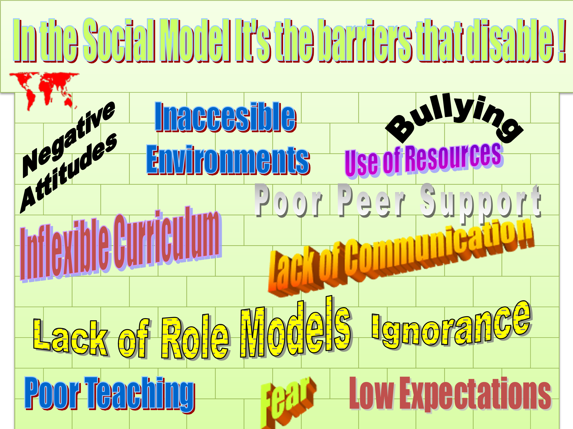
(In the Social Model it is the barriers that disable! Negative attitudes, Inaccessible Environments, Bullying, Use of resources, Poor Peer Support, Inflexible Curriculum, Lack of Communication, Lack of Role Models, Ignorance, Fear, Poor Teaching, Low Expectations.)
The emphasis changes to how to challenge and change the barriers that disable those with impairments. This perspective both empowers disabled people and provides the basis for a transformative paradigm shift in the way disability is viewed. In promoting a social model approach, the disability movement is not counterposing this to the need for access to health services, (UNCRPD, Article 25) habilitation and rehabilitation (Article 26). There should be no discrimination or prejudice in the provision of these services to disabled people.
Follow Up Activity 4: List the difference between impairments and disability in the Social Model.

Figure 3 (described underneath): The Medical Model of Disability

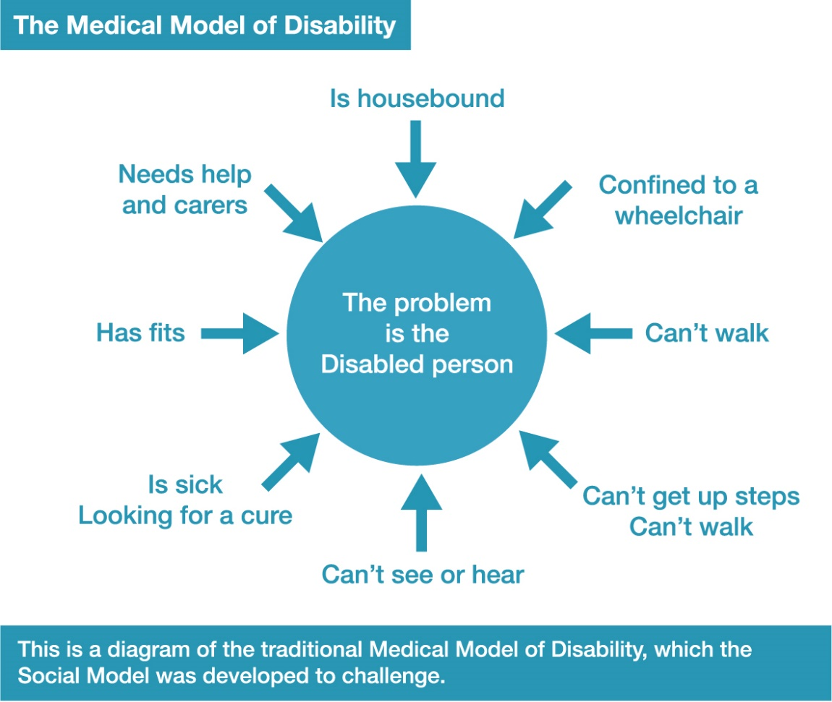
Figure 3 describes the Medical Model of Disability, with the central idea is that ‘the problem is the Disabled person’ and these factors referring to a person is pointing towards it: Is housebound, Confined to a wheelchair, Can’t walk, Can’t get up steps, Can’t see or hear, Is sick/looking for a cure, Has fits, Needs help and carers. This is a diagram of the traditional Medical Model of Disability, which the Social Model was developed to challenge.

Figure 4 (described underneath): The Social Model of Disability
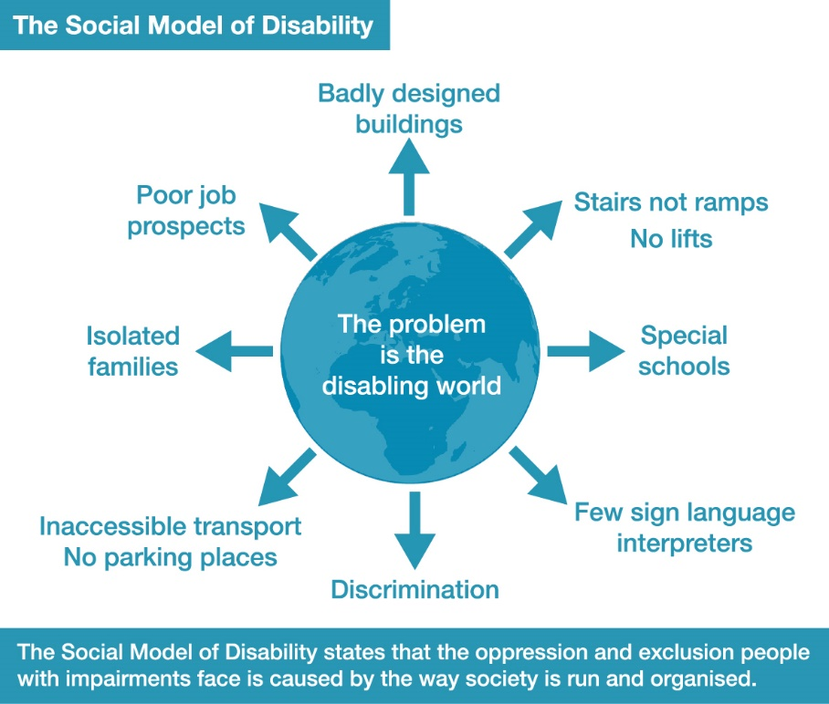
Figure 4 describes the Social Model of Disability, with the central idea that ‘the problem is the disabling world’ and these factors are pointing away from it: Badly designed buildings, Stairs not ramps/No lifts, Special schools, Few sign language interpreters, Discrimination, Inaccessible transport/No parking places, Isolated families, Poor job prospects.
Figure 5 illustrates the different approaches that flow from these two perspectives when they are applied to education. The medical model approach leaves schools and society unchanged and disabled people excluded or at a disadvantage. The social model approach allows administrators, teachers and parents to examine their thinking and practice so that they dismantle the barriers and become the allies of disabled students. In this way they can help students to maximise their social and academic achievements, and in the process society will change. The social model of disability focuses on the barriers and shows the disablement of the person with impairments, due to barriers of attitude, environment and organisation.

Figure 5: Table showing Medical model vs Social Model Thinking
Medical Model Thinking | Social Model Thinking
Child is faulty | Child is Valued
Diagnosis | Strengths and needs defined by self and others
Labelling | Identify barriers and develop solutions
Impairment becomes focus of attention | Outcome-based programme designed
Assessment, monitoring, programmes of therapy imposed | Resources are made available to ordinary services
Segregation and alternative services | Training for parents and professionals
Ordinary needs put on hold | Relationships nurtured
Re-entry if ‘normal’ enough OR permanent exclusion | Diversity welcomed, child is included
Society remains unchanged | Society Evolves

The social model approach recognises the need to:
• Change people’s thinking about disabled people;
• Alter the environment to make it accessible;
• Transform organisations and their policies, practices and procedures;
• Urgently counter low self-esteem and poor self-attitude by empowering disabled people to insist upon their rights.
The focus shifts from altering disabled people so that they can fit into a disabling world to addressing barriers, transforming society and bringing about changing attitudes and removing barriers.
This change in thinking is at the heart of the UN Convention on the Rights of Persons with Disabilities. Its preamble states: Recognising that disability is an evolving concept and that disability results from the interaction of persons with impairments and attitudinal and environmental barriers that hinders their full and effective participation in society on an equal basis with others.
Looking back, it is interesting to see how far we have come, in that nearly everybody, from the World Health Organisation, the World Bank to the UN, now appears to accept this formulation.
However, it is quite another thing to apply this analysis effectively. There are now many examples of disability development inclusion projects going wrong for lack of disabled advocates. Inclusion projects need to be led by politically aware disabled people.

Follow Up Activity 5
Analysing Barriers and putting forward solutions is one of the most powerful tools we have in the Disability Movement to bring about both local and structural change.
For your country/local area fill in barrier bricks e.g. attitudes, environments and organisation that prevent the following impairment groups from being included in society. Use 1 grid for each of these 7 impairment groups. Pick 2 from a) to g)
a) Ambulant impaired, stick, crutch or wheelchair user
b) Neuro-diverse-Autistic Continuum
c) Learning Disabled/Learning Difficulty
d) Mental Health System User/Survivor
e) Sensory Impaired-Blind People/ DeafBlind People
f) Deaf People/ Hard of Hearing People
g) Long term sick/metabolic condition/cancer survivor
For each of the 2 grids identify 2 to barriers on different bricks in the wall for A Environment B Attitude C Culture D Organisation E Legislation F Other.
Come up with barriers from beyond the person’s impairment which are preventing them being fully included. (Make 2 copies and complete for 2 impairment groups you know)
Follow Up Activity 6
Once completed examine the barriers and understand how much of an overlap there is. Pick 6 or more different barriers you have identified on your 2 sheets and explain how these barriers could be solved, be minimised or got rid of in your society?

 | Barrier 1 | Barrier 2 | Solutions
A. Barriers of Environment

B. Barriers of Attitude

C. Barriers of Culture

D. Barriers in Organisation

E. Barriers of
Legislation

F. Other barriers

Ways of undertaking Barrier Activity In the future
Once you have explained the shift from Traditional/Medical thinking and shown one or two films on it, undertake this activity. You can do this activity in many different ways.
In a large group you can give out brick shaped cards and felt pens or Post-it notes and pens to smaller sub-groups or people grouped around tables. Allocate one of the impairment groups to each sub-group. Tell them to come up with barriers from beyond the person’s impairment which are preventing them being fully included. Read them all out once stuck up to form a wall of barriers. Ask are they all different or overlapping for all barriers?
There will be a large amount of overlap, showing the common discrimination and oppression disabled people face.
Mix up the barrier cards or post Its and give them out to the sub-groups and get them to come up with solutions for a selected number of barriers.
This can be extended when training staff at a school, health centre, municipality or employer.
Ask participants to choose the main disabling barriers and to develop as a plan for what can be done to address the barriers, in the short term-next few months, middle term 6 months to 18 months and long term 3-5 years. This can then form the basis of a Disability Inclusion Action Plan.

Follow up Activity 7
Assess what will need to change to make this possible where you live.

vi) The Language We Use in English.
[Words in ‘red’ are for illustration, are offensive and should not be used] People with disabilities: For those who choose to call themselves this, disability is not separated from their impairment. They want to be seen as people first, as disability is seen as a within person problem. They do not wish to be defined/confined by their impairment. Although the oppressive and unequal treatment we are subjected to is viewed as a breach of our human rights, the clear transition to viewing disability as something rooted in society and other than our impairment has never occurred. Without an understanding of ‘social model thinking’, it is reasonable to see disability as negative and wish to distance oneself from it by, using ‘people first’. Some impairment groups, like some of those with autism, cannot separate themselves from the identity with their condition and so reject the ‘people first’ epithet, preferring Autistic People. Deaf people (with a capital D) view themselves as a cultural minority group and community, users of Sign Language and also reject people first language. However, people with learning difficulties or learning disabilities, as far back as the 1970s in Canada, rejected an imposed label such as ‘mental handicapped’ and wanted to be known as People First. Language can diminish or empower and what is acceptable to various disabled people changes over time. When in doubt, ask the disabled people how they wish to be known.
Throughout history, human physical and mental differences have been described in language and meaning which is based on the thinking of the day, reinforcing powerful stereotypes, which stretch down the years and still influence thinking about disabled people. ‘Lame’ today is used by young people to mean something that is boring or un-cool from meaning not smart or unimpressive. In Shakespeare’s time it meant both having an injured foot/leg, make walking difficult and not strong, good or effective. Other words coming from Latin lamenta –weep and wail or lamia-witch, giving us lamentation, lament and ‘lame-duck’. These words are negative. ‘Halt’ was a word in common use, meaning the same as ‘lame’, as was ‘cripple’ also meaning to move slowly, to be permanently injured or have no power. The polarity of good and evil, beautiful and unsightly is found right across all languages and is a major contributor to the devaluation of disabled people.
Eugenics and language
Following Darwin’s publication of The Origin of Species (1865), his cousin Frances Galton and many others thought they could speed up natural selection of human beings by stopping ‘inferior’ people from having children. This Eugenics movement particularly focused on those they called ‘feeble-minded’, who could pass as part of the general population, but who carried the characteristics of mental deficiency, crime, immorality and destitution, which could be passed onto to their children. Most people with more significant mental impairments or labels: ‘the mad’, ‘idiots’ and ‘imbeciles’ were already by this time kept in asylums and the Workhouse; upper and middle class people in private small asylums. The Eugenicists such as Mary Dendy, worked ceaselessly in Manchester to separate the ‘feeble minded’ from other children and adults, placing them in the home she opened in Sandleridge, Cheshire. In 1902, the Rev. Harold Nelson Burden, chaplain at Horfield Prison, and Katharine, his wife, founded the National Institutions for Persons Requiring Care and Control to care for ‘mentally retarded’ children and adults. These ideas spread throughout the British Empire and beyond and led to inhuman treatment, segregation, sterilisation and death to hundreds of thousands of disabled people.
The origin of negative words associated with disability, to be avoided and use alternatives: ‘Afflicted’ This implies that some higher being has cast a person down ('affligere' is Latin for to knock down, to weaken), or is causing them pain or suffering. Use disabled person or (talking of specific impairment) person with... ‘Cripple’ The word comes from Old English crypel or creopel, both related to the verb 'to creep'. These come from old (Middle) German 'kripple' meaning to be without power. The word is extremely offensive. Use disabled person. ‘Dumb or Dumbo’ a) Not to be able to speak. This has come to be seen as negative from the days when profoundly deaf people were thought of as stupid because non-deaf people did not understand their communication systems. Use a) disabled person or person with a speech impairment b) person with learning difficulties or disabilities. ‘Dwarf’ Through folklore and common usage, has negative connotations. Use short person or person of short stature. ‘Feeble-minded’ The word feeble comes from Old French meaning 'lacking strength' and, before that, from Latin flebilis, which meant 'to be lamented'. Its meaning was formalised in the Mental Deficiency Act 1913, indicating not an extremely pronounced mental deficiency, but one still requiring care, supervision, and control. Use person with learning difficulties. ‘Freak’ Different. From ‘Freak Show’ when in the past people paid money to look and laugh at disabled people. Use disabled person. ‘Handicapped’ Having an imposed disadvantage. The word may have several origins: a) horse races round the streets of Italian City States. The best riders had to ride one-handed, holding their hat in the other to make the race more equal b) penitent sinners (often disabled people) in Europe who were forced into begging to survive and had to go to people 'cap in hand' c) C17th game called 'cap i' hand'. Players showed they accepted or rejected a disputed object's valuation by bringing their hands either full or empty out of a cap in which forfeit money had been placed. This practice was used in C18th to show whether people agreed to a horse carrying extra weight in a race (i.e. deliberately giving it a disadvantage). Offensive. Use disabled person. ‘Idiot’ Dates from C13th and comes from the Latin word idiota, meaning 'ignorant person'. Again, it featured in the Mental Deficiency Act 1913 (see ‘Feebleminded’), where it denoted someone who was so mentally deficient that they should be detained for the whole of their lives. Highly offensive. Use person with learning difficulties. ‘Imbecile’ From C16th century and originating from the Latin, ‘imbecillus’, meaning 'feeble' (literally meant 'without support', originally used mainly in a physical sense). It was defined in the Mental Deficiency Act as someone incapable of managing their own affairs. Highly offensive. Use person with learning difficulties. ‘Invalid’ literally means not valid, from Latin 'invalidus'. In C17th it came to have a specific meaning, when referring to people as infirm or disabled. Offensive. Use disabled person. ‘Mental’, ‘nutter’, ‘mad’, or ‘crazy’ are informal (slang) words for people with mental health issues. One in four people have a major bout of mental distress or become mental health system users. The vast majority are not dangerous. Offensive. Use mental health system user or survivor. ‘Mentally handicapped’: In the UK, over 130,000 people with learning difficulties were locked away in Mental Handicap Hospitals because tests showed they had low Intelligence Quotients (IQ). These tests have since been shown to be culturally biased and only to measure one small part of how the brain works. They have chosen the name “people with learning difficulties” for themselves because they think that through education, which they have largely been denied, they can improve their situation. ‘Mong /Mongolian’: Langdon Down was a doctor who worked at the London Hospital in Whitechapel in the 1860s. He noticed that around 1 in 800 babies were born with pronounced different features and capabilities. Their features reminded him of the Mongolian people. He postulated that there was a hierarchy of races (in descending order) - European, Asian, African and Mongols. Each was genetically inferior to the group above them. This was a racist theory. Extremely offensive. Use person with learning difficulty or person with Down’s syndrome. ‘Moron(ic)’, Greek, meaning ‘foolish, dull, sluggish’. Offensive. Use person with learning difficulties. ‘Retard’: Still in common use in the USA for people with learning difficulties; from retarded or held back in development. Offensive. On October 5, 2010, U.S. President Barack Obama signed bill S. 2781 into federal law. Rosa’s Law removes the terms “mental retardation” and "mentally retarded" from Federal health, education and labour policy and replaces them with individual or person with intellectual disabilities, learning difficulties or learning disabled people. ‘Spaz’, ‘spazzie’ or ‘spastic’: People with cerebral palsy are subject to muscle spasms or spasticity. These offensive words used to describe or used just as an insult. Use people with cerebral palsy or disabled people. ‘Stupid’ Used in America at the start of C20th ‘scientifically’ to denote ‘one deficient in judgment and sense’. Do not use. ‘The blind’, ‘The deaf’, ‘The disabled’ To call any group of people 'the' anything is to dehumanise them. Use blind people, deaf people or disabled people. Often our impairments are used as a metaphor. Statements like “are you blind?”, “are you deaf?” and ”that’s lame” all have connections to negative descriptions of disability and certainly aren’t meant kindly. ‘Victim’ or ‘sufferer’: Disabled people are not victims of their impairment. This implies they are consciously singled out for punishment by God or a higher being. Similarly with the word ‘sufferer’. Use disabled person or person with chronic pain. ‘Wheelchair-bound’: Wheelchair users see their wheelchair as a means of mobility and freedom, not something that restricts them, apart from problems with lack of access. Use wheelchair user. Changing the language to words like ‘differently abled’ or ‘special’ was thought to get rid of the stigma attached to negative language. As it is the disabled person who is stigmatised, changing the label does not change the behaviour. For this reason, there is no mention of ‘special’ in the UNCRPD.
During the COVID -19 Pandemic and language
Governments and the media have almost universally come to call disabled people with underlying conditions such as weak immune systems, diabetic, learning difficulty or dementia as ‘vulnerable’ or ‘clinically vulnerable’. Disabled people are at higher risk of contracting and dying of the virus, particularly when living in a segregated institution such as a group home, old people’s home or long stay hospital. But that should mean for Governments respecting our rights, extra measures need to be in place to minimise the risk of infection. This did not happen and where we have statistics, disabled people have been subjected to a disproportionate death rate compared to the rest of the population.

Follow up Activity 8
List 10 words you find offensive used to describe disabled people. For each word explain in writing its origin and why it is offensive to disabled people.

vii) The Human Rights Approach to Disability
Theresia Degener, a disabled activist, lawyer and previous chair of Convention on the Rights of Persons with Disabilities (CRPD) committee and others have argued that the human rights model of disability, based on the CRPD is superior to and more comprehensive than the social model of disability. Degener argues that ‘while it is true that the social model of disability has been the prevalent reference paradigm during the negotiation process, my understanding of the CRPD is that it goes beyond the social model of disability and codifies the human rights model of disability’. The social model was developed by academics and activists and went in two directions. Firstly, an important contribution to staking out a new area of Disability Studies and as such it has often been critiqued as inadequate a) not dealing with pain and other impairment related issues, b) not being useful for experiential intersectionality of gender, race, sexuality and disability, c) not dealing with eradicating types of impairment, d) was good at identifying barriers but did not relate to universal rights. Secondly, the social model was developed by and used by disabled activists to give solidarity and a common struggle against oppression across different impairments, to empower isolated individuals and make them feel part of a wider struggle and set a direction for action leading to real change for disabled people. This is still as relevant today as ever.
We will see in Module 2 why human rights and the UNCRPD are vital to changing the position of disabled people in the world. They provide the road map. However, as the Covid Pandemic has clearly shown there is a huge gap between what Governments have signed up to for disabled people’s rights/ equality and the reality, where we have not been thought about, not received food, support, PPE or now vaccines and have a massively disproportionate death rate compared to the rest of the population. (More details in Module 4).
It is the view of the Commonwealth Disabled People’s Forum (CDPF) that the social model approach is the most powerful perspective to achieve our human rights. This is because i) it is empowering to disabled people to understand that barriers disable us. Although we need support and health interventions, the lack of education, employment, independent living, access, family life, parity before the law and in the political system, oppressive cultures, prejudicial attitudes and discrimination is what diminishes our lives’; ii) Recognising our solidarity across different impairment groups gives us unity of purpose, while educating us to take each other’s needs into account; iii) It enables us to build our DPOs by empowering an ever growing number of disabled people and their non-disabled allies to force Governments to fully implement the disability and other human rights they have signed up to deliver. Both the social model and human rights model start from the perspective that it is barriers in society that disable and not the older idea that the disadvantage resides in the person as a result of their impairment. Only the social model perspective helps us to build a unified Disability Movement.
Proponents of a human rights model do have some important points. 1) The social model does not seek to provide moral principles or values as a foundation of disability policy only an explanation of disablement. 2) The social model supports anti-discrimination policy civil rights reforms, the human rights model of disability is more comprehensive in that it encompasses both sets of human rights, civil and political as well as economic, social and cultural rights. 3) Whereas the social model of disability neglects the fact that disabled people might have to deal with pain, deterioration of quality of life and early death due to impairment and dependency, the human rights model of disability acknowledges these life circumstances and demands them to be considered when social justice theories are developed. 4) The social model of disability neglects identity politics as a valuable component of disability policy whereas the human rights model offers room for minority and cultural identification. 5) The social model of disability is critical of prevention policy, the human rights model offers a basis for assessment when prevention policy can be claimed as human rights protection for disabled persons. 6) Whereas the social model of disability can explain why 2/3 of the one billion disabled persons in this world live in relative poverty, the human rights model offers a roadmap for change.
Conclusion Module 1
Clearly ideas matter and how we conceptualise a problem to be addressed. As we have learned, traditional/charity and medical approaches focus on the individual and though they lead to different strategies none of them addresses the structural problems that lead to disability inequality. A hybrid approach of the social /human rights model is probably the most effective and all-encompassing to achieving real change for disabled people.

Follow Up Activity 9
Make a table with two column s entitled Social Model and Human Rights Model and list the main advantages of each approach to bringing about real change in the lives of disabled people.

viii) Future Actions and Implications from Thinking about Disability

i) Reflect on what you have learned from the above module and put forward 3 changes for your country to improve the position of disabled people. Give your reasons.
ii) What changes should the DPOs that you are involved with make, to remove barriers to the full range of disabled people in your region/country participating in their activities?
iii) Given the legacy of the traditional/individual/charity/medical thinking about disability, what are the ways that you and your organisation can empower disabled people to become agents for change in your society?

These examples are cited in Richard Rieser (2012), ‘The Struggle for disability equality ’,Ch.7 in in Mike Cole (ed.), Education Equality and Human Rights: Issues in gender, ‘race’, sexuality, disability and social class, 3rd ed., Routledge, London. http://worldofinclusion.com/v3/wp-content/uploads/2014/01/The-Struggle-for-Disability-Equality-RR-chapter-7-Copy.pdf
Katherine Quarmby (2011) Scapegoat: Why We Are Failing Disabled People Portobello ,London
Richard Rieser, Disabling Imagery, DEE/BFI, London, 2004 http://worldofinclusion.com/v3/wp-content/uploads/2014/01/wetransfer-dacfa2.zip
Participants at the DEE/SAFOD conference on ‘Training for Inclusive Education’, 29 October–2 November 2007 identified thinking that was common in the following countries – Botswana, Lesotho, Malawi Mozambique, Namibia, Swaziland, Zambia and Zimbabwe
Taken from Implementing Inclusive Education. R.Rieser Ch.3 Commonwealth Secretariat, London 2012 http://worldofinclusion.com/v3/wp-content/uploads/2014/01/Inclusive-Education-FINAL-word-text.doc
http://worldofinclusion.com/commonwealth-pacific-island-countries/
Taken from Implementing Inclusive Education. R.Rieser Ch.3 Commonwealth Secretariat, London 2012 http://worldofinclusion.com/v3/wp-content/uploads/2014/01/Inclusive-Education-FINAL-word-text.doc
https://thecommonwealth.org/about-us/charter
Donelly,R.,2020. It takes a village to kill a child: Uganda's Hidden Children. ALJAZEERA. https://interactive.aljazeera.com/aje/2020/uganda-hidden-children/index.html
See https://underthesamesun.com/sites/default/files/Attacks%20of%20PWA%20-%201%20page_0.pdf and https://underthesamesun.com/sites/default/files/Attacks%20of%20PWA%20-%20extended%20version_0.pdf
See various reports of the UN Independent Expert on the enjoyment of human rights by persons with albinism. In particular, see Thematic Report on Protection of Persons with Albinism, Report titled Preliminary Survey on the root causes of attacks and discrimination against persons with albinism and Thematic Report on Albinism Worldwide, https://www.ohchr.org/EN/Issues/Albinism/Pages/Reports.aspx
See Thematic Report: Women and Children Impacted by Albinism, https://www.ohchr.org/EN/Issues/Albinism/Pages/Reports.aspx
See note 9 Report titled Preliminary Survey on the root causes of attacks and discrimination against persons with albinism, https://www.ohchr.org/EN/Issues/Albinism/Pages/Reports.aspx
See Report titled: Mission to Malawi at para 46 and Mission to Mozambique, at para 52, https://www.ohchr.org/EN/Issues/Albinism/Pages/Reports.aspx Also see Report titled Preliminary Survey on the root causes of attacks and discrimination against persons with albinism, https://www.ohchr.org/EN/Issues/Albinism/Pages/Reports.aspx at para 57.
See note 8[1] http://doi.org/10.29053/2413-7138/2017/v5n1a6
See for instance the difference between the data for Malawi, Mozambique and Kenya as reported by UTSS vs. the UNIE on albinism at actiononalbinism.org The latter are higher.
[2] http://www.latimes.com/world/africa/la-fg-malawi-albinos-hunted-2017-story.html
See actiononalbinism.org , In particular see, https://actiononalbinism.org/en/page/sfj6gs7s8kjd5f6c6zyhw7b9
See for example, Report titled, Mission to Kenya, from para 40, https://documents-dds-ny.un.org/doc/UNDOC/GEN/G19/013/58/PDF/G1901358.pdf?OpenElement
Human-dictated audio of this page. 0dec41d0c4f9f41dd4f7e4c4e19d193e https://transnationalrepresentation.omeka.net/exhibits/show/transnational-representation--/dpi-origins
Inclusion London Fact Sheet Social Model https://www.inclusionlondon.org.uk/wp-content/uploads/2015/05/FactSheets_TheSocialModel_Sept2015.doc https://www.inclusionlondon.org.uk/wp-content/uploads/2015/05/FactSheets_TheSocialModel_Easy-Read.pdf
https://www.un.org/en/content/disabilitystrategy/
Disability and Language https://ukdhm.org/2016-broadsheet/
Office of National Statistics in UK show that though being 16% of the population 60% of the Covid-19 related deaths between March 2020 and July 2020 were among disabled people. https://www.ons.gov.uk/peoplepopulationandcommunity/healthandsocialcare/disability/datasets/coronavirusandthesocialimpactsondisabledpeopleingreatbritainmay2020
Degener,T A Human Rights Model of Disability (2014) https://www.researchgate.net/publication/283713863

