Commonwealth Disabled People’s Forum
Newsletter No 4 October 2020

Farewell to Rachel Kachaje Chair of CDPF and founder member
We are very sad and shocked to inform you of the demise of Rachel Kachaje, who until her death was Chairperson of Commonwealth Disabled People’s Forum. Rachel died on the morning of Thursday 3rd September 2020 at De Yang Luke Hospital, Lilongwe. She was buried in her home village in Kasungu District on Saturday 5th September. Rachel was a great comrade of the disability movement, being an activist for 30 years in Malawi and across Africa. In June of this year she was awarded an honorary doctorate ‘in recognition of her extraordinary contribution towards promoting interests of persons with disability’ by Stellenbosch University : https://www.mwnation.com/disability-rights-warrior/
Rachel was a leading advocate in restoring the CDPF, being Vice Chair in the original days and Chair in the reformed Forum. Her loss will be enormous and felt all over the disability movement in Malawi, Africa and the Commonwealth, especially for disabled women, where she proved a great champion of their rights. We send our love and condolences to her husband Gibson and all her family. Please share this sad news with your colleagues and friends.

New Officers Elected at Executive 1st October 2020
At the online Executive Meeting of the CDPF it was agreed to elect Sarah Kamau, Kenya as the Acting Chair and Dr Sruti Mohapatra, India as the Acting Vice Chair.[The posts are Acting as only a General Assembly can elect Executive Committee members on a permanent basis]. The full executive with contact details at https://commonwealthdpf.org/executive-committee/
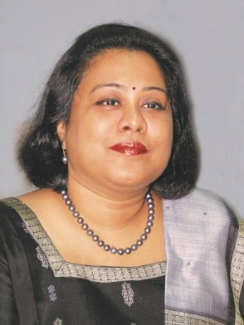
Acting Chair Sarah Muthoni Kamau, United Disabled Persons Kenya
Acting Vice-Chair Dr Sruti Mohapatra, Swabhiman, Odisha, Eastern India

Annual Report of CDPF July 2018 to July 2020 available now http://commonwealthdpf.org/wp-content/uploads/2020/10/Annual-Report-Commonwealth-Disabled-People-final.docx

Anti-Racism in the Commonwealth
In the last issue of the Newsletter No 3 https://commonwealthdpf.org/newsletter-3 the Anti-Racist Policy of the Commonwealth Disabled People’s Forum was circulated. In response the Executive Committee has decided to form a Working Party on Race/Ethnicity and Disability. We are calling for nominations from affiliated organisations for disabled people with knowledge and experience of the intersection of discrimination on race/ethnicity and disability. Nominations with up to 150 word supporting statements to be submitted by 20th November 2020 to the General Secretary CDPF. rlrieser@gmail.com . It aims to report back by May 2021.
The Foreign Ministers of the 54 Commonwealth Countries meeting virtually on 14th October have agreed a statement on Anti-Racism. https://commonwealthdpf.org/wp-content/uploads/2020/10/CFAMMVIR209REV3-Commonwealth-Statement-on-Racism-2020-1.pdf . Selected Quotes
“….Combatting all forms of racism and prohibiting racial discrimination have long exemplified Commonwealth principles and values set out in the Singapore Declaration of Commonwealth Principles, the Lusaka Declaration on Racism and Racial Prejudice, the Harare Commonwealth Declaration, the Commonwealth Charter and our Affirmation on the 70th anniversary of the Commonwealth last year. We now reiterate our unwavering commitment to these core Commonwealth principles and values.
Racism and racial discrimination intersect with issues of poverty, age, sex, disability, gender identity, race, migration and religion, and reflect stereotypes, cultural norms, legislative measures, social behaviours and application of technology. Recalling the UN Convention on the Elimination of All Forms of Racial Discrimination, the Durban Declaration and Programme of Action, the UN Declaration on the Rights of Indigenous Peoples and the programme of activities of the International Decade for People of African Descent. As such, we will continue to fight against hate speech, any targeting of groups in vulnerable situations and all forms of discrimination – whether rooted in age, sex, gender, disability, race, ethnicity, origin, religion or belief, political, economic or other grounds…..
…We will increase our efforts by sharing good practice across the Commonwealth to build mutual understanding and advance our common goal of eliminating racism and racial discrimination. Among other things, these efforts where applicable may include:
(i) introducing or strengthening legislation and administrative measures to prevent racism and racial discrimination in all its manifestations and protect vulnerable groups, including Indigenous Peoples;
(ii) ensuring that access to, and administration of, justice is free from racial prejudice and discrimination based on race, colour or ethnic origin;
(iii) combatting systemic racism in our institutions so that they meet the needs of people from all ethnic or social backgrounds;
(iv) addressing racial discrimination in social and cultural spheres, giving due consideration to how racism and sexism can intersect, and to the rights of Indigenous Peoples;
(v) ensuring education and awareness that promote equality, the value and strength of inclusion and respect for diversity, and the importance of tackling systemic racism and racial discrimination;
(vi) promoting equal economic opportunity, including for those from minority communities, in order to reduce socio-economic inequality caused by racism;
(vii) creating a safe and enabling environment for civil society and human rights defenders; (viii) countering incitement of racial discrimination and hatred, including in new forms of ICT-facilitated space, particularly during times of crisis; and
(ix) ensuring that the story of the Commonwealth reflects historical facts accurately, for example, slavery, the slave trade, and colonialism.
We will continue to work together, along with our international partners, to enhance contacts and exchanges between the peoples of the Commonwealth; to celebrate our diversity and our efforts to deliver a common future, recognising the contributions of all; and to promote equality and respect for all people.”

Please send any examples of issues as outlined above and successful campaigns to be considered by the CDPF Anti-Racism Working Party – to General Secretary rlrieser@gmail.com
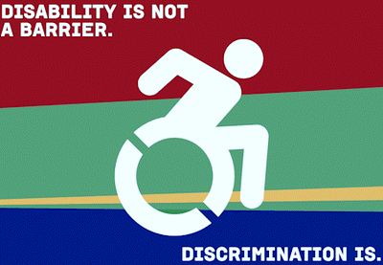
Patricia Scotland, Secretary General of Commonwealth told Telegraph (10th September 2020) "The ministers are all saying this is an issue which we are going to have to deal with, and there is a lot of support. The debate doesn't go away because you shove it under the carpet”.
"These are not comfortable conversations but this is where the Commonwealth is great, because the people and countries involved are all on that journey. It's not just talking to one side, we're all the sides."
She said something like Black History Month, held across the entire Commonwealth, could be another forum for the debate. She stressed that the Commonwealth has had to confront race and equality ever since its inception. It was born as an association of equal states after the fall of the British Empire in the 1930s and '40s, as former colonies re-established themselves as independent nations.

Any Summit on the subject would have to examine atrocities committed during the time of Empire, from the treatment of indigenous peoples in colonisation and since, slavery to Partition, the bloody division of British India into India and Pakistan ahead of Indian independence which displaced millions and saw up to two million killed. Massacres like the 1919 Amritsar massacre, in which 379 unarmed Indian civilians were shot by the British Indian Army, could also be addressed.
‘Baroness Scotland has said one option could be a truth-seeking mechanism of some kind, similar to the Truth and Reconciliation Committee established in South Africa after apartheid’. "We have never been frightened of having this conversation," said Baroness Scotland. "You can't say to young people don't talk about this, don't talk about colonialism, not about where we have been. It has never been for us black or white, rich or poor. This has been a conversation we had to have in order to create the Commonwealth."

COVID-19 Impact on Disabled People and their Rights
Covid-19 continues to impact on disabled people, their welfare and Human Rights. ‘Catastrophic global failure to protect the rights of persons with disabilities highlighted in new global report’ ‘Disability rights during the pandemic: A global report on findings of the COVID-19 Disability Rights Monitor’, which was launched on October 22, presents the findings from a rapid global survey of disabled people and other stakeholders which took place between April and August of this year. The organizations behind the study seek to catalyze urgent action in the weeks and months to come, as transmission rates continue to rise in many countries and disabled people are again subjected to restrictions which have already had severe consequences.
The report analyses over 2,100 responses to the survey from 134 countries around the world. The vast majority of responses were from disabled individuals and their family members. Very few governments or independent monitoring institutions responded.
The report highlights four major themes from the survey data:
- The failure to protect the lives of disabled people in residential institutions, which have become hotspots during the pandemic: Instead of prioritizing emergency measures to reintegrate people into the community, respondents pointed out that many institutions have been locked down, with fatal consequences.
- Widespread, rigid shutdowns that caused a dramatic breakdown in essential services in the community: disabled people could not access basic goods, including food, and supports such as personal assistance. Strict enforcement of these lockdowns by police and security forces has sometimes had tragic results, including the deaths of disabled people.
- Serious and multiple human rights violations against underrepresented populations of disabled people: Women and girls have experienced a major uptick in gender based violence, disabled children have been denied access to online education, and homeless disabled people have either been rounded up and detained or left completely to fend for themselves. “We have been forgotten about” A disabled female, New Zealand
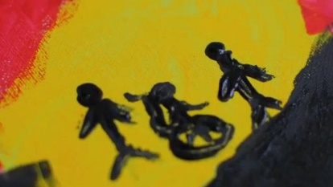
- A marked trend of denying basic and emergency healthcare, including reports about the adoption of discriminatory triage procedures: In some cases, disabled people were directly denied access to treatment for COVID-19 because of their impairment.
The survey collected over 3,000 pieces of written testimony, many of which illustrate a failure by states to adopt disability-inclusive responses. This has been the case across many countries, regardless of their level of economic development, pointing to a collective failure on the part of leaders. The report offers concrete evidence that is essential reading for law and policymakers, health and social care professionals, law enforcement, civil society and others who seek to ensure that disabled people are no longer sacrificed in efforts to contain the pandemic. The Report is very useful as it brings forward demands to be made on Governments in each of these 4 areas.

This report reinforces what we have found in two on-line summits, our own survey and a round of regional meetings across DPOS in the Commonwealth. https://commonwealthdpf.org/covid-19/

The CDPF are holding a series of on-line meetings to develop our thinking and position on Covid-19 and strategies for building back better in all areas of the UNCRPD and the SDGs.

You are invited to a Joint CDPF/ROFA(UK) Online Webinar:
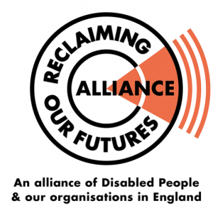
'The Impact of Covid-19 on the fight for Disability Rights Worldwide and in the UK', a Joint CDPF and ROFA meeting

1.00-3.30PM (GMT), 2nd November 2020
Co-Chairs: Sarah Kamau, Kenya, Chair CDPF
Paedar O’Dea and Anthony Ford, UK, ROFA
Agreed Speakers:
International Committee

Dr Sruti Mohapatra, India, Acting Vice Chair CDPF
Thandiwe Mfulo, South Africa, Vice Chair CDPF
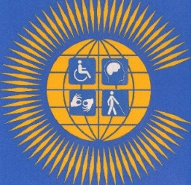
Richard Rieser, UK, General Secretary CDPF
Abia Akram, Pakistan, CDPF Women’s Officer
Emile Gouws, Autism South Africa, Executive CDPF
Michael Njenga, Users and Survivors of Psychiatry, Kenya CDPF EC
Tracey Lazard, UK, CEO Inclusion London
International Sign language and Captioning is provided.
To book a place and get the link for the meeting please register by 12 noon UK time on Friday 30th October. Send your name, email, organisation, country and if visually impaired to Gemma White gemma.white@add.org.uk
The Executive of the CDPF have agreed to hold a second series of Regional Meetings to which we welcome representatives of DPOs who have not yet joined the CDPF. The purpose of the meetings will be to update the CDPF on the current issues arising from Covid-19, best strategies for building back, how the lessons from this can be incorporated into CHOGM 21 Statement and online training we are proposing to run from February to May 2021.

5th November 12 noon GMT: West Africa; 6th November 11am GMT: East Africa
6th November 3pm GMT: Caribbean; 9th November 8am GMT: Asia;
9th November 12noon GMT: Southern Africa; 11th November 10pm GMT: Pacific, Australia, New Zealand.

To book your place and to give us your access needs contact Gemma White gemma.white@add.org.uk

Commonwealth Heads of Government issued a policy on Covid-19 October
https://commonwealthdpf.org/wp-content/uploads/2020/10/Commonwealth-Statement-on-COVID-19-FINAL-VERSION_0-2.pdf
The statement commits all 54 Governments to ..”continue to fight against hate speech, targeting of vulnerable groups and all forms of discrimination, particularly those arising from the pandemic - whether rooted in age, sex, disability, race, ethnicity, origin, religion, political, economic or other grounds. We will also take necessary measures to counter the spread of misinformation and disinformation, online and offline, including manipulated media that incites violence and divides communities, while ensuring that any action
respects human rights”…
“We are committed to working with the spirit of global cooperation, unity and solidarity to protect the health of all our citizens, and do all we can to ensure equitable access to quality essential health services and safe, effective, quality and affordable medicines and vaccines for all, particularly the most vulnerable and high-risk populations such as older persons, people with disabilities, and others who are more likely to have a pre-existing health condition” ….
“We are deeply concerned by the wide-ranging economic, social and environmental implications of COVID-19, particularly the difficulty for many countries of mounting an emergency response while maintaining adequate focus on delivering sustainable development. We will use all available policy tools to minimize the economic, social and environmental damage from the pandemic, maintain economic and financial stability, safeguard jobs and strengthen resilience”….
“The Commonwealth's 1.2 billion young people are particularly likely to suffer economically. Protecting their opportunities for income and decent productive employment is essential. We must ensure that temporary shocks do not have long-lasting or permanent implications for poverty reduction and the ability of all workers to enjoy safe and decent work. We also recognise remittance flows are important sources of support for the well-being and survival of families and communities. We will work to minimise any substantial and sustained decrease in remittance flows while maintaining financial integrity. Women and girls and other marginalised groups, including those with disabilities, are more likely to suffer economically from COVID-19. Inclusion is central to economic stimulus, health services and social protection. Marginalised groups will be particularly impacted by school closures: we will continue to encourage implementation of specific actions to provide the opportunity for at least 12 years of quality education and learning for girls and boys by 2030. We are particularly concerned that children who are spending more time at home and online are increasingly vulnerable to violence, abuse and exploitation, and are at greater risk of online harms such as sexual exploitation and abuse. Protecting the safety of children and all vulnerable groups, must be prioritised.”..

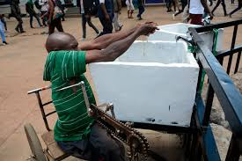
..“In making these commitments, we recognise that the strength and potential of the Commonwealth lie in collaboration between its member states, its intergovernmental organisations – the Commonwealth Secretariat, the Commonwealth Foundation and the Commonwealth of Learning; and its network of associated and accredited organisations. As we strive to maximise that potential in the face of the immediate challenge, we look forward to deepening our collaboration at the next Commonwealth Heads of Government Meeting and associated Commonwealth fora in Rwanda.”

Preparing for CHOGM
The Rwandan Government has now decided to hold the Commonwealth Heads of Government Meeting and various Civil Society Forums in Kigali in June 2021. This is likely to be a mixture of face to face and on-line meetings. The Rwandan Government have decided to have 6 focus areas Health-Covid and Mental Health, Innovation, Rule of Law, Trade, Environment/Climate and Youth.

We have met with the Commonwealth Secretariat and agreed to hold a joint meeting on-line with the Commonwealth High Commissioners in London on 2nd December 2020. We want 1 representative from each of our national member organisations on this call and the Executive. So keep the date in your diaries.

The CDPF will prepare a briefing before hand, for distribution. The meeting will have 2 purposes. To introduce the structure and breadth of the CDPF and its work and to give presentations on the interface of important disability issues under the six policy areas of CHOGM:- Health-Covid and Mental Health, Innovation-Access and Assistive Technology, Rule of Law-Discrimination and Stigma, Trade - enhancing opportunities for Disabled People’s Employment, Environment/Climate-preparing for Humanitarian Situations and Youth, on which we work with our member organisation Commonwealth Children and Youth Disability Network.

After discussions, the meeting will be followed with a briefing of wider policy points to go to all Commonwealth Governments, to aid their deliberations to enhance the disability rights and equality aspects of the draft CHOGM (2021) declaration.

Training Project 2021 Capacity Building on Disability Rights in the Commonwealth
The development and delivery of 10 internet training sessions of 4 hours to up to 50 candidates from across our Commonwealth Member Country organisations. To be followed by a second series that will be filmed and put on-line and with DVDs. We currently have members in 46 Commonwealth country DPOs. The sessions will draw on the recently published policy papers of the CDPF https://commonwealthdpf.org/policy-papers/ our policy on COVID 19 https://commonwealthdpf.org/covid-19/ and Anti Racism https://commonwealthdpf.org/newsletter-3/ .
The content of the course will be focused towards CHOGM, SDG and UNCRPD implementation and is aimed at activists in DPOs:
1. Health - focusing on Mental Health and Covid 19
2. Innovation - focusing on improving Access and Assistive Devices
3. Trade- focusing on improving Livelihoods and Employment
4. Environment focusing on the impact of Humanitarian Situations
5. Respect for Law-focusing on eliminating Stigma and Discrimination
6. Youth in collaboration with CCYDN
7. Inclusive Education
8. Women and Girls
9. Anti-Racism, Equality and Respect for Ethnic Minorities
10. Influencing Government
All will be delivered within a human rights and social model of disability perspective.
The training sessions will be accessed on the internet in two tranches. The first in February/March 2021 and the second in April / May 2021.
Applicants will need to put in a CV, reasons why they wish to attend and what they hope to do with knowledge and experience they have gained. We will use positive discrimination in favour of young people, women and under-represented impairments. The applicants will be vetted by a training committee that will comprise the deliverers of the training. 50 applicants will be selected for each tranche i.e. 100. (2 per country)
Accreditation Applicants will need to have attended 7/10 of sessions and completed the after-seminar task . There will be a chance to attend the sessions they have missed on the second round or after that the videoed versions, activities and assessments that will be online. There will be limited support to help enhance participants ability to participate on-line. Funding is yet to be confirmed.

Commonwealth Graduates Scholarships -Master’s and Research Degrees 2021.

CDPF has been accepted as a Nominating Agency for Commonwealth Scholarships by Disabled Students with a first degree. https://cscuk.fcdo.gov.uk/scholarships-filter-search/ Details for the next year are not available but will be soon. The studies come under 6 headings :-
  - Science and technology for development
  - Strengthening health systems and capacity
  - Promoting global prosperity
  - Strengthening global peace, security and governance
  - Strengthening resilience and response to crises
  - Access, inclusion and opportunity.

In addition to generous grants and fee payments, there is extra financial support for the access needs of disabled students. In return students have to undertake to return to their low income countries and work there for 3 years.

Commonwealth Parliamentarians start campaign to increase the number of disabled representatives
Two new videos https://commonwealthdpf.org/two-videos-from-commonwealth-parliamentarians-with-disabilities/
The Commonwealth Parliamentarians with Disabilities (CPwD) network has published two new toolkits as part of its Disability Inclusive Communications Guidelines. These toolkits on ‘Facilities of Inclusion’ and ‘Linguistic Principles’ provide guidance to Commonwealth Parliaments and Legislatures on how to enhance and sensitize their communications with disabled people.
Parliamentarians with disabilities are represented in national, sub-national, provincial and territorial Parliaments across the Commonwealth and across the nine Regions of the Commonwealth Parliamentary Association (CPA). The CPwD network provides a means of supporting the capacity of Parliamentarians with disabilities to be more effective in their roles and helping to improve the awareness and ability of all Parliamentarians. The network also encourages all Parliamentarians to include a perspective mindful of disabilities in all aspects of their role – legislation, oversight and representation – and helping Parliaments to become institutions that are sensitive to issues surrounding disabilities.
The CPA Headquarters Secretariat has conducted research amongst its membership of 180 Commonwealth Parliaments and Legislatures, as well as non-governmental organisations to create these two Disability Inclusive Communications Guidelines for Parliaments. The guidelines provide various examples of best practices that can be adopted by both Parliaments and Parliamentarians in order to continue to ensure that they sensitively address Parliamentarians and parliamentary staff with disabilities.
The CPA Secretary-General, Stephen Twigg welcomed the launch of the new inclusive guidelines for Parliaments and said: “The inclusion of Parliamentarians with disabilities is of vital importance to advancing parliamentary democracy across the Commonwealth and is a key priority of the Commonwealth Parliamentary Association. The two new guidelines will support CPA Branches in becoming more ‘disability confident’ in their communications with and about Parliamentarians with disabilities across the Commonwealth.”
The Speaker of the Nova Scotia House of Assembly and CPA Executive Committee Regional Representative for the CPA Canada Region, Hon. Kevin Murphy, MLA contributed the forewords for the two guidelines and said: “Giving a meaningful voice to persons with disabilities (PWDs) in Parliaments and Legislatures leads to improvements in the following three functions of a Parliament. Oversight will be more comprehensive; representation will be more equitable; and legislating will be more sensitive.” Copies of the guidelines are attached to this email. You can also click here or visit www.cpahq.org/cpahq/disabilitiesresources to download a copy of one of the Disability Inclusive Communications Guidelines.

UN Conference of State Parties in New York 30th November to 3rd December
Election of Representative to CRPD Committee at the virtual Conference of State Parties Dec.2020
30th November confirmed elections , 1st Dec. Round table 1 & 2 , 2nd Dec. Civil Society Forum, 3rd Celebration and closing COSP.
The CDPF would ask DPOs to pressure the representatives of State Parties who will be attending the virtual Conference of State Parties to consider voting for the following disabled representatives from Commonwealth Countries 182 [ All states that have ratified the UNCRPD have a vote].
Floyd MORRIS Jamaica
Samuel KABUE Kenya
Eufémia Maria Guila AMELA Mozambique
Robert George MARTIN New Zealand
Claire Lucille AZZOPARDI LANE Malta (Azzorpardi Lane is not disabled but an academic focusing on disability and a carer of a young disabled person).
In addition we support a vote for Maria Cristina KRONFLE GÓMEZ Ecuador to get Gender Equality on the Committee.
The UNCRPD Committee plays a vital role in monitoring State Parties implementation of the UNCRPD, providing advice and general comments on the Convention and adjudicating on complaints against State Parties brought to it by individuals or groups.
Registration for NGOs with ECOSOC status and NGOs Accredited to the Conference of State Parties is now open to organisations already accredited. The deadline is 25 November 2020.

The IDA Inclusive Education Global Report

When Article 24 of UNCRPD was being framed at the United Nations (2001-2006) there was much disagreement between sensory impairment organisations and other Disabled People’s Organisations DPOs, the former arguing for a right to segregation. This led to a weak and compromised wording. General Comment No 4 moved this on ten years later, but Disabled children have been largely left out in moves towards general Inclusive Education. The Cali Report UNESCO 2019 does represent progress, but at a time of globally reduced funding for education and massive disruption caused by school closures during the Covid-19 Pandemic; the real problem is one of political will to make inclusion a reality.
The Report has now been approved by the IDA Board. The four IDA members on the technical task team were : Diane Richler, Inclusion International (II); Ruth Warwick, the International Federation of Hard of Hearing People (IFHOH); Praveen Sukhraj, the World Blind Union (WBU); Joseph Murray, the World Federation of the Deaf (WFD). Additionally, representatives from DPOs in Nepal, NGOs and Paula Hunt. The process to reach a cross-disability consensus position involved three technical workshops and exchanges with numerous allies and global, regional and national level DPOs. This global report presents the views of the International Disability Alliance on how to achieve Sustainable Development Goal 4 (SDG4) – ensure inclusive and equitable quality education and promote lifelong learning opportunities for all – in compliance with the United Nations Convention on the Rights of Persons with Disabilities (UNCRPD), especially Article 24 on the rights of all learners .
An inclusive education system is the only way to achieve SDG 4 for all children – including Disabled children and youth – whoever and wherever they are. This requires an educational transformation, which is unachievable if it is considered an add-on to existing education systems. (See Webinar of different parties involved with developing the report and Global Education Monitoring Report 2020 on Inclusive Education). Points to emphasise from the consensus International Disability Alliance (IDA) reached on inclusion are:
- Enforcement of non-discrimination and Zero Rejection policies are implemented where they state, in part, that no child is refused access to their local school because of their disability;
- Significant investments (human, social and financial) are made in recruiting and training qualified teachers, including Disabled teachers, who can provide inclusive and quality learning;
- Teacher education and curriculum reforms incorporate the principles of Universal Design for Learning, including equal access and participation;
- Significant investments (human, social and financial) are made in the accessibility of needed infrastructure, materials for teachers, students and parents, curricular and extra-curricular activities, and systems for engaging parents and the community;
- Well-resourced support services are made available at all levels, to assist all schools and all teachers in providing effective learning for all students, including those with disabilities;
- Special schools and other segregated settings are progressively phased out, while key human resources and knowledge assets are converted into support services for equal access, participation and inclusion by inclusive institutions ;
- A diversity of languages (including sign languages, tactile sign languages) and modes of communication (easy-to-read, Braille, etc.) are used throughout the system.;
- Some learners may choose to attend an inclusive school or educational institution away from their community to benefit from quality support and services not yet offered locally (e.g. bilingual education, braille instruction). Because of their critical role in language acquisition for deaf and deafblind deaf schools that providing an inclusive bilingual education in a national sign language(s) (visual and tactile) and Deaf culture must be maintained and promoted as part of an inclusive education system. Deaf schools not yet providing inclusive bilingual education will be supported in their transition into inclusive bilingual sign/national language schools;
- Phasing out special education settings is going to require civil society to engage with education systems in different ways, to support new practices.
- DPOs will have new roles to play within schools (and systems): becoming advisors, providing expert advice to professionals; becoming mentors and role-models for disabled children and youth - thus, supporting regular schools to welcome and ensure the participation of disabled children and youth.
Apart from h) this list would have been agreed 20 years ago. As the UNESCO Global Education Monitoring Report shows there is remarkably little progress to system level change.
The IDA Report puts forward that including disabled children and youth requires the following minimum conditions:
- All children/learners have access to quality education in schools where their inclusion requirements are met;
- All teachers are equipped to ensure that all their students participate in quality learning;
- Well- resourced support services and resources are available to assist all schools and all teachers to provide inclusive effective learning to all learners including those with disabilities;
- All students succeed in reaching their full academic and social potential with learning outcomes measured against their own wishes, plans and benchmarks.
Whilst the IDA analysis presents a way forward, caution is needed. They argue that specific impairment DPOs should provide the advice to schools and governments on impairment specific adjustments (contained in the Annex of the Report (link1). While these reasonable adjustments and support are needed, in a world where the large majority of Disabled children, if in school attend special schools, this is a dangerous strategy that could play lip-service to full inclusion, while reinforcing segregation. The retention of special schools while they transition to inclusive schools is also a dangerous strategy, as the evidence shows they take the extra resources offered and remain an expanded version of themselves. Management and accountability measures need to be changed for this transition to be successful. It is much better if cross-impairment DPO Councils or coalitions, with parents, provide this support and advice drawing on the wealth of experience from their members to cover the full range of impairments.
IDA opposes any education setting that does not provide inclusive education in its broadest sense. IDA proposes “that any other settings be phased out, with key human resources and knowledge assets converted – whenever possible – to support equal access and reasonable accommodation towards inclusion. However, sign language access for learners who are deaf and non-visual access to learners who are blind are both essential for meeting the right to education: this access cannot always be provided in local settings”. They argue in h) a breach of the requirement for local provision in UNCRPD (24.2b), and b) ‘Persons with disabilities can access an inclusive, quality and free primary and secondary education on an equal basis with others in the communities in which they live’; This is contradictory h)sounds remarkably like keeping segregation going into the foreseeable future for a minority and no education for many. Richard Rieser
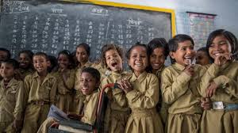
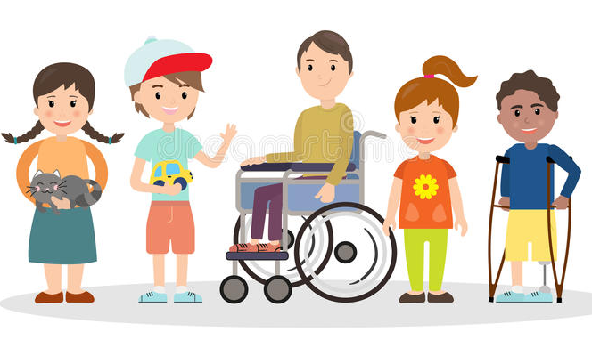
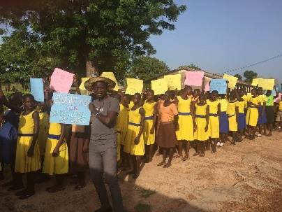
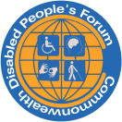
Commonwealth Disabled People’s Forum Ltd Company Registration 7928235
General Secretary Richard Rieser
Address c/o World of Inclusion, 78, Mildmay Grove South, LONDON N1 4PJ
M 0044(0) 7715420727 Landlinme +44 (0)2073592855
email rlrieser@gmail.com Website www.commonwealthdpf.org

https://www.internationaldisabilityalliance.org/ida-inclusive-education-2020
https://www.facebook.com/watch/live/?v=213085949988344&ref=watch_permalink
https://en.unesco.org/gem-report/report/2020/inclusion
An abridged version of an article in Inclusion Now 57 https://www.allfie.org.uk/news/inclusion-now/

