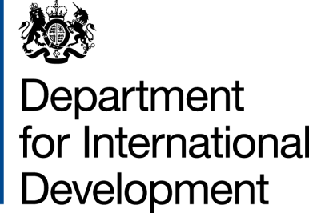 | 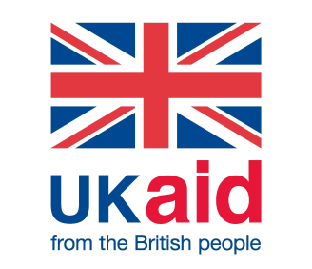
 | Our Ref: | 205547
 | 1 September 2020
Dear Richard,

Thank you for your letter detailing your concerns about the reduction in the aid budget and impact on people with disabilities. I have been asked to reply to this on behalf of the Prime Minister, as the Head of Department for the Inclusive Societies Department with responsibility for disability inclusion.

As the FCO and DFID merge to form the FCDO (Foreign, Commonwealth and Development Office) the strong emphasis is on the positive impact that the UK can have around the world, not least as we recover from the coronavirus pandemic. The firm commitment to ensure British foreign and development policy reaches the bottom billion, offers assurance that issues such as disability inclusion and gender equality will continue to be strongly in focus. Looking ahead, my Department is currently feeding into detailed planning processes for the Spending Review through to 2024. I will also add that the Government is currently developing a UK National Strategy for Disabled People, with the input of all Government departments including FCDO which will provide a framework for action going forward.
With regard to reductions to the Overseas Development Assistance (ODA) budget, as the Chancellor has set out, like many other nations across the world the UK is experiencing a severe economic downturn as a result of the COVID-19 pandemic. As the ODA budget is pinned to the economic performance of the UK at 0.7% of GNI, we have had to identify a £2.9 billion package of reductions in the Government’s planned ODA spend. The reductions were calculated based on a careful review process looking at every strand of the ODA budget, evaluating the impacts of spend and making sure we can maintain operational capacity. We hope to see a rapid recovery of the UK’s economy which will allow the total funds available for ODA to rise again.
The final package of £2.9bn in reductions was agreed by the Prime Minister on 20 July and means the Government can proceed prudently for the remainder of 2020 with its ODA spend. ODA spending departments will now work with partners and suppliers to agree the most responsible and efficient ways to implement these savings. As mentioned already, the funds we will still spend in 2020 remain prioritised on poverty reduction for the ‘bottom billion’ of poorest people in the world which includes many people with disabilities. The reduction in spend has also freed up resource to address the spread and impact of COVID-19 in developing countries.

I want to reassure you that HMG is deeply concerned about the significant impact of this crisis on people with disabilities, older people and other marginalised groups. Our development programmes have been pivoting towards COVID-19 across a variety of thematic areas. For example, the Disability Inclusive Development programme activities in Nigeria have pivoted towards providing essential support to people with disabilities, including improving food security, access to social protection and facilitating home access to education.
I would like to take this opportunity to thank you for your work across the Commonwealth and hope that you are able to continue to make positive progress during this challenging time.

Yours Sincerely,

Diana Dalton
Inclusive Societies Department

Yours sincerely,

5 spaces minimum for e-sig

Name
Department for International Development

