**Commonwealth Disabled People’s Forum**

**CDPF Policy on Humanitarian Situations and Disabled People 2020**

[**www.commonewealthdpf.org**](http://www.commonewealthdpf.org)

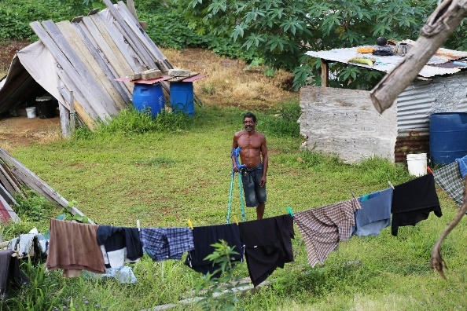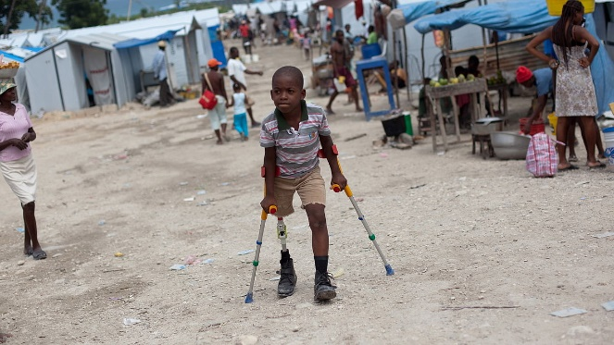

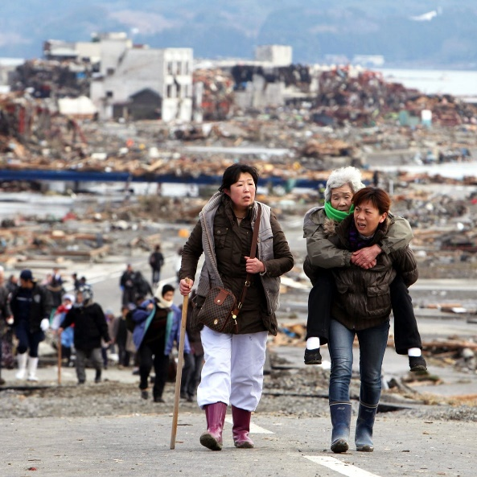

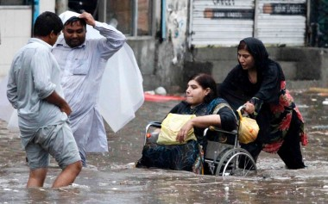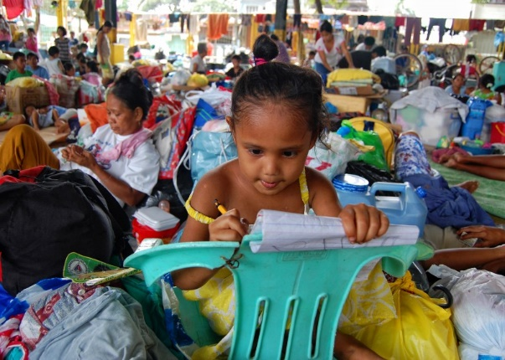

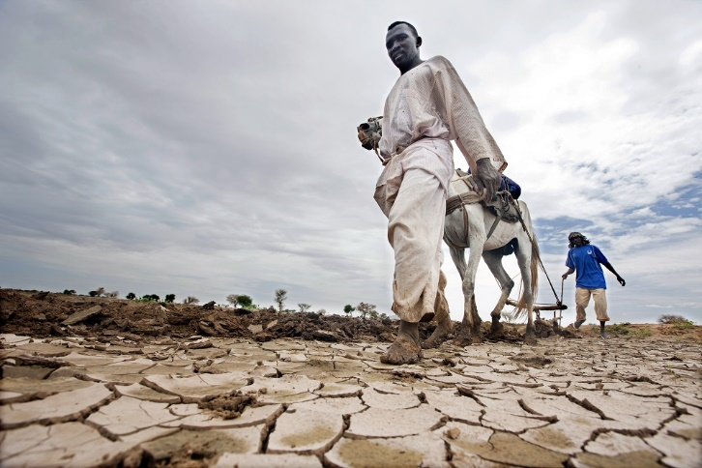

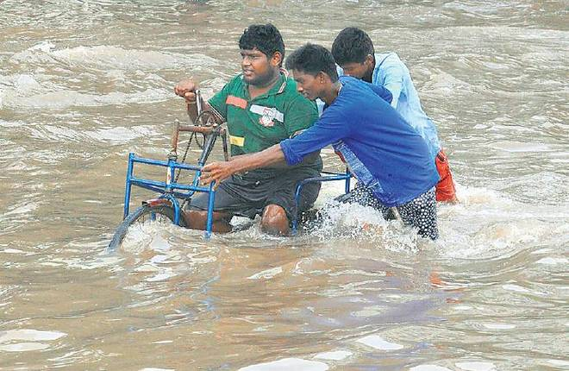

**CDPF** **Humanitarian Situations and Disabled People, Policy Document[1]**

According to the World Health Organisation, 15% of the world's population live with disabling barriers[2] as a result of their impairments, including 93 million children[3]. The recent UN report, “Disability and Development 2018[4], reveals that *despite the progress made in recent years, persons with disabilities continue to face numerous barriers to their full inclusion and participation in the life of their communities, and experience disproportionate levels of poverty; lack access to education, health services and employment; and are underrepresented in decision-making and political participation”.* These existing inequities have a snowballing effect on their vulnerability[5] in humanitarian situations, leading to social and economic exclusion.

**The toll of climate-related disasters is rising, with poorer countries most affected.** No matter the measure—whether loss of life or economic loss— disasters cause enormous suffering the world over. From 1998 to 2017, direct economic losses from disasters were estimated at almost $3 trillion, of which climate-related disasters accounted for 77 per cent of the total (a rise of 151 per cent from 1978 to 1997). Over that period, climate-related and geophysical disasters claimed an estimated 1.3 million lives. More than 90 per cent of all disasters were caused by floods, storms, droughts, heatwaves or other extreme weather events.

Poverty is a major underlying driver of disaster risk, so it comes as no surprise that the poorest countries are experiencing a disproportionate share of damage and loss of life attributed to disasters. More than 90 per cent of internationally reported deaths due to disaster occur in low- and middle-income countries. Disasters kill 130 people for every one million people in low-income countries compared to 18 per one million in high-income countries. Economic losses resulting from disasters are also much higher in poorer countries, when measured as a percentage of their gross domestic product (GDP). Among the 10 worst disasters in terms of economic damage (when expressed relative to GDP), 8 occurred in low- or middle-income countries.[6]

Several international studies have indicated that disabled people face heightened levels of risk and vulnerability both during and after a disaster: “Emergencies have particularly serious consequences for persons with disabilities. New physical barriers are created and support networks are disrupted. Access to information is difficult for everyone, especially persons with sensory disabilities. Relief services are often not adapted for disabled people, who struggle to cover basic needs and become increasingly dependent on outside support.” Research shows that the mortality rate among disabled people tends to be two to four times higher than among the general population, as demonstrated in cases such as the 2011 Japan earthquake and tsunami and hurricane Katrina (2005) in the USA. Moreover, for every person who dies during a disaster, it is estimated that three people sustain an injury, many causing long-term disabilities[7].

**The Language We Use** Why we still choose to call ourselves disabled people. In the Commonwealth Disabled People’s Forum we call ourselves ‘**disabled people’** because of the development of the **‘social model of disability’.** In the C19th and C20th, a disabled person’s medical condition was thought to be the root cause of their exclusion from society, an approach now referred to as the **‘medical or individual model’** of disability. We use the ‘**social model’** of disability. We also view ourselves as united by a common oppression so are proud to identify as ‘disabled people’ rather than ‘people with disabilities’.

**Impact of Emergency Situations on local population:**

1. Loss of income
2. Loss of shelters/home
3. Internal displacement
4. Loss of relatives/families
5. Loss of support services (i.e. personal assistant)
6. Loss of social assistance (pension, health coverage...)
7. Seeking asylum in third country

**Impact of Humanitarian Situations on Disabled People**

While all people in the affected region may be negatively impacted by the crisis, disabled people face

specific challenges that put them more at risk. Major issues can be broadly grouped as underneath:

1. **Daily Problems of Accessibility:** It has a direct physical impact with loss of mobility, damaged and/or loss of assistive devices (wheelchair etc.) and increased dependency, loss of comfort and a disruption in daily routine. In crisis situations, based on the latest statistics, 80% of adults on the autism spectrum are dependent on some form of public transport and when disaster strikes, this may lead to the disruption in daily routine and eventually the loss of "independence". The challenges mentioned will occur in some form of disorientation, the struggle with planning, organization and crisis management.

Ex. During the Hudhud cyclone in Vishakhapatnam in India, in 2014, Sai Padma, founder of Global-Aid and a wheelchair user, was stuck in her house for 20 days because a tree fell at the entrance and her wheelchair could not move until the tree was removed.

1. **Physical Vulnerability:** Lack of access to medical treatment[8], and secondary health issues like fever, infections and high rate of abuse during crises including - physical, psychological, food, water, and other forms, including sexual.

Ex. During Cyclone Vardah in Chennai in India, a 20-year old was on a ventilator and the power shutdown because of the cyclone meant that she quickly needed to arrange an alternative. It took several hours for her life to be saved.

1. **Psychological Issues**: aggravation of depression; diminished and/or loss of self-confidence. Emotional vulnerability, general frustration, self-doubt, depression. The psychological challenges mentioned can be associated with a physical cause and effect response such as self-harm or stimming.

Ex. In **Thailand**, the rapid mental health needs assessment after tsunami, 2004 was done by researchers as a part of public health emergency response. The report revealed that while symptoms of PTSD were found among 12% of displaced and 7% of non-displaced persons, anxiety symptoms were found among 37% of displaced, and depression was reported by 30% of displaced survivors.

1. **Acquiring new, secondary conditions:** psychological problems, or ulcers, pressure sores, contractures, or reduced hearing/vision. When overstimulated, sensory stimulus that is received from the different senses can lead to the fight/flight response. The key term here is ‘sensory or auditory blindness’ where visual and auditory sensory stimulus is restricted and can therefore effect the outcome and reaction.

Ex. In Bhubaneswar, a study conducted on 323 households with disabled children showed 82 children who were improving in gait training or sitting balance had developed curvatures, undergone muscle weakness and lost sitting balance due to lack of therapy in lockdown period.

1. **Livelihood Issues:** Destruction of existing livelihood resources, disruption of markets and problems with Government Disability Allowance.
2. **Lack of Access to Services**

Main barriers that impede access to services[9]:

* No information on what type of service existed
* No knowledge of where to access services
* The service was too far from temporary/home locations
* Couldn’t afford to get there
* Special services didn’t exist
* Special service was too expensive
* Special service was not physically accessible
* There were no trained staff to support
* The staff couldn’t understand needs
* The lack of empathy from service providers
* The lack of expert advice and prior knowledge of support staff

Considering the above stated vulnerabilities in humanitarian crises, CDPF has drawn a **Charter on Inclusion of Persons with Disabilities in Humanitarian Action**. The Charter sets out five principles:

* **Consideration of the fact that disabled people constitute a huge population and comprise a heterogenous group. Diverse needs must be considered before any planning.**
* **No discrimination against disabled people.**
* **Participation of disabled people and their DPOs in all stages of planning.**
* **An inclusive humanitarian response policy at global level with guidelines for local adaptations, for uniformity in action.**
* **Inter-governmental and inter-agency coordination for better response to challenging situations.**

**Specific support needed:**

Accessible information; Assistive devices; Rehabilitation services; Support services; Prosthetics and orthotics.

**Major strategies can be grouped under three sections Advance Preparation for a Disaster, Immediate Response to a Disaster and Post Disaster Recovery:**

1. **Advance Preparation for a Disaster -** Key points for disaster planning for disabled people include
   1. Equal access to shelter facilities
   2. Equal access to evacuation/ transportation
   3. Equal access to disaster clean-up
   4. Accessible shelters
      1. physical access
      2. accessible communication and communication in alternative languages and formats
      3. accessible paths
      4. accessible toilets (at least one)
      5. accessible sleeping equipment (bed)
      6. access to food and healthcare needs
      7. assistive devices storage/parking space
      8. facilities for power for people who need to recharge power devices.

Ex. After Cyclone Sidr in Bangladesh in 2007, a number of cyclone shelters were built using foreign aid. Despite information on the importance and how-to of accessible design, the shelters were not constructed to be accessible. As a study stated, “not a single one of them have ramps or any other accessibility features. Even the stairs are high and risky[10].”

* 1. To extend the preparedness beyond the civil society- government partnership to increase participation of the local community. For relatively isolated communities, private sector involvement in response planning is critical. For example, fuel, food, and transportation are often supplied by the private sector.
  2. Raising awareness of the local community and in particular the private sector on the specialized needs of disabled people and other vulnerable groups in situations of natural disasters, especially the trauma of disabled people caused by the lack of inclusion in initial planning.
  3. Emergency-preparedness drills should include real participation of disabled people and other vulnerable groups. Simulations or role play exercises where non-disabled people take the role of disabled people should be avoided.

Ex.Inclusive Vulnerability and Capacity Assessments in Odisha (India)[11]: During an accessibility audit of multipurpose cyclone shelters constructed by the Odisha State Disaster Management Authority (OSDMA), a team of HI, OSDMA, and UNDP realized that persons with disabilities had never participated in any drills in the shelters and their needs were not included in any assessments. Following this an inclusive assessment was undertaken in Bhadrak District. Persons with disabilities, and their families and caregivers were notified and given information about the assessments beforehand through household visits. When given the opportunity to participate, all persons with disabilities in the community took part in the assessment. The assessments were conducted in accessible settings and facilitated through different aids. Due to the participation of persons with disabilities and their input into the assessment, service providers gained an increased understanding of their vulnerability in a disaster situation as well as their actual capacities and needs.

* 1. To build a data base for emergency purposes, so the specific needs are included in the system.

1. **Immediate Response to a Disaster**
   1. Disabled People and other vulnerable groups need to be accommodated first not last. And then rest.
   2. Development of end-to-end early warning system[12] is fundamental to save lives when disasters occur.
   3. Developing and maintaining all feasible channels of open communication within and across vulnerable groups.
   4. Early warning system should be accessible for disabled people and other groups, especially people who are deaf and deafblind or have learning difficulties.
   5. Establishment of a 24-hour hotline for disabled people to call the local government councils.
   6. Transportation during rescue must be accessible.

Ex.The Centre for Disability and Development built a model boat to assist with evacuations in Bangladesh[13], equipped with a ramp and accessible latrines. Other options are using boats with flat floors with one side that can be brought down to provide a roll-on/roll-off ramp (e.g. see Wheelyboat).

* 1. Evacuation Processes - Evacuation Training using the Twin-Track Approach:

Ex. In Vietnam, the National Disaster Management Committees worked together with Malteser International to include disability in their Community-Based Disaster Risk Management efforts. Initiatives included a twin-track approach towards promoting accessible early warning mechanisms and priority evacuation assistance in 47 villages in the Quang Nam province. The program provides targeted training to DPOs to strengthen their capacity to implement accessible disaster management activities and empower them by improving their self-representation and self-determination. The other track focuses on making community disaster management practices and systems more inclusive through various activities such as, “Village Disaster Risk Management plans, developing inclusive early warning and evacuation mechanisms, and awareness raising”.

* 1. Healthcare facilities – Immediate medical care and first aid; regularly taken medicines, nutrients and assistive devices repair.
  2. Counselling facilities.

1. **Post Disaster Recovery**
   1. Rapid assessment of socio-economic status of all disabled people persons impacted by disaster.
   2. Livelihood assessment, destruction/harmed by disaster, support needed to re-establish business and jobs.
   3. Stable, reliable, continuous, easy to repay, micro-financing systems to be in local areas.
   4. Ensure that reconstructed infrastructure is not only more resistant to future hazards, but also more inclusive of vulnerable populations, including disabled people, the elderly, and pregnant women. Disaster recovery efforts should strive to improve accessibility for disabled people.

Ex. As has been the case in post-earthquake Haiti, which enacted a law to ensure that all buildings, both new and rebuilt, are accessible to disabled people[14].

A more comprehensive analysis can be found in Inter-Agency Standing Committee (IASC) (2019) Guidelines on Inclusion of Persons with Disabilities in Humanitarian Action.[15]

**CDPF Policy Direction**

1. As the world moves forward to achieve the 17 SDGs by 2030, CDPF proposes promoting disability-inclusive development and addressing the vulnerabilities and exclusion of disabled people, in particular disabled children and women, with special attention to situations of disaster and humanitarian crisis.
2. Raise awareness of the rights and needs of disabled people in achieving the development agenda and related efforts.
3. Incorporate disability issues and perspectives into all SDG goals, monitor progress of their relevant targets and indicators, and pay special attention to the most vulnerable groups of disabled people, including women, children and those in disasters and humanitarian crisis situations.
4. Advocate for removal of barriers to and promote the realization of accessibility as part of the general system of society. The positive externality of environmental accessibility to rural and urban infrastructures, facilities and public services, as well as information and communications technologies will strengthen rescue and relief services during and after disasters.
5. Create awareness for improved disability data collection, analysis, monitoring and evaluation for better policy development and programming of humanitarian situations. Disaggregated data will help to identify the gaps between disabled people and the rest of the population, and can contribute to better rescue, relief and post-disaster rehabilitation services.
6. Advocate for disabled people and their representative organizations, Disabled People’s Organisations (DPOs), to participate meaningfully in all pre-disaster meetings and activities, planning for rescue and post disaster rehabilitation processes. Support, including capacity development, should be provided for disabled people and their DPOs in order to facilitate such participation.

**CDPF will work to “Create Awareness (all), Orientation (government directly involved in disaster management) and Capacity Building of DPOs on Disaster Risk Reduction.”**

**The CDPF Charter sets out five principles:**

* Acceptance of the fact that disabled people comprise a huge population and constitute a diverse group.
* Non-discrimination and respect for the diverse needs of disabled people by not following “one coat for all” policy.
* Disabled people must be involved in all stages of planning and at local, regional and national level.
* Humanitarian response and services must be inclusive in nature with priority to the most vulnerable.
* A policy must be developed at the global level with flexibility for local adaptations, to follow a uniform action across the globe.
* Better coordination between inter-governmental agencies, civil society and development organizations to improve delivery of services to disabled people.

**Disaster risk reduction and the Sustainable Development Goals**

Disaster risk reduction cuts across different aspects and sectors of development. There are 25 targets related to disaster risk reduction in 10 of the 17 sustainable development goals, firmly establishing the role of disaster risk reduction as a core development strategy. **CDPF will focus on:**

**Goal 1**. Target **1.5** By 2030 to build the resilience of poor people and those in vulnerable situations and reduce their exposure and vulnerability to climate-related extreme events and other shocks and disasters.

**Goal 2.** Target **2.4** By 2030, to ensure sustainable food production systems and implement resilient agricultural practices that increase productivity and production, that help maintain ecosystems, that strengthen capacity for adaptation to climate change, extreme weather, drought, flooding and other disasters and that progressively improve land and soil quality.

**Goal 3.** Target **3.d** Strengthen the capacity of all countries for early warning, risk reduction and management of national and global health risks.

**Goal 4.** Target **4.7** By 2030, ensure that all learners acquire the knowledge and skills needed to promote sustainable development including, sustainable development and sustainable lifestyles, promotion of a culture of peace. **4.a** To build and upgrade education facilities that are child, disability and gender sensitive and provide safe, non-violent, inclusive and effective learning environments for all

**Goal 6.** Target **6.6** By 2020, protect and restore water-related ecosystems, including mountains, forests, wetlands, rivers, aquifers and lakes.

**Goal 9.** Target **9.1** Develop quality, reliable, sustainable and resilient infrastructure with a focus on affordable and equitable access for all.

Target **9.a** Facilitate sustainable and resilient infrastructure development in developing countries through enhanced financial, technological and technical support to African countries, least developed countries, landlocked developing countries and small island development states.

**Goal 11.** Targets **11.1** By 2030, ensure access for all to adequate, safe and affordable and basic services and upgrade slums.

**11.3** By 2030, enhance inclusive and sustainable urbanization and capacity for participatory, integrated and sustainable human settlement planning and management in all countries.

**11.4** Strengthen efforts to protect and safeguard the world's cultural and natural heritage.

**11.5** By 2030, significantly reduce the number of deaths and the number of people affected and substantially decrease the direct economic losses relative to global gross domestic product, caused by disasters, including water-related disasters, with a focus on protecting the poor and people in vulnerable situations.

**11.b** By 2020, substantially increase the number of cities and human settlements adopting and implementing integrated policies and plans towards inclusion, resource efficiency, mitigation and adaptation to climate change, resilience to disasters. Develop and implement, in line with the Sendai Framework for Disaster Risk Reduction 2015-2030, holistic disaster risk management at all levels.

**11.c** Support least developed countries, including through financial and technical assistance, in building sustainable and resilient buildings utilizing local materials.

**Goal 13**. Take urgent action to combat climate change and its impacts

**13.1** Strengthen resilience and adaptive capacity to climate-related hazards and natural disasters in all countries.

**13.2** Integrate climate change measures into national policies, strategies and planning.

**13.3** Improve education, awareness-raising and human and institutional capacity on climate change mitigation, adaptation, impact reduction and early warning.

**13.a** Implement the commitment undertaken by developed-country parties to the United Nations Framework Convention on Climate Change to a goal of mobilizing jointly $100 billion annually by 2020 from all sources to address the needs of developing countries in the context of meaningful mitigation actions and transparency on implementation. Fully operationalize the Green Climate Fund through its capitalization as soon as possible.

**13.b** Promote mechanisms for raising capacity for effective climate change-related planning and management in least developed countries, including focusing on women, youth and local and marginalized communities.

**Goal 14.** Conserve and sustainably use the oceans, seas and marine resources for sustainable development.

**14.2** By 2020, sustainably manage and protect marine and coastal ecosystems to avoid significant adverse impacts, including by strengthening their resilience, and take action for their restoration in order to achieve healthy and productive oceans.

**Goal 15.** Protect, restore and promote sustainable use of terrestrial ecosystems, sustainably manage forests, combat desertification, and halt and reverse land degradation and halt biodiversity loss.

**15.1** By 2020, ensure the conservation, restoration and sustainable use of terrestrial and inland freshwater ecosystems and their services, in particular forests, wetlands, mountains and drylands, in line with obligations under international agreements.

**15.2** By 2020, promote the implementation of sustainable management of all types of forests, halt deforestation, restore degraded forests and substantially increase afforestation and reforestation globally.

**15.3** By 2030, combat desertification, restore degraded land and soil, including land affected by desertification, drought and floods, and strive to achieve a land degradation-neutral world.

**15.4** By 2030, ensure the conservation of mountain ecosystems, including their biodiversity, in order to enhance their capacity to provide benefits that are essential for 17 sustainable development.

**15.9** By 2020, integrate ecosystem and biodiversity values into national and local planning, development processes, poverty reduction strategies and accounts.

**Case Studies from the Commonwealth**

**Case study 1: Supporting communities to engage in inclusive DRR and preparedness Partnering with local communities to promote disability-inclusive DRR in flood-prone areas, Bangladesh.**

**PRACTICE.** Since 2009, the Centre for Disability in Development (CDD), a Bangladesh NGO, has been working in partnership with CBM and a local NGO, Gana Unnayan Kendra (GUK), to enable disabled people and their communities to cope with the effects of flooding and climate change.

**At the household level,** the project partners provide targeted support for disabled people to access livelihood opportunities and register for government social protection as well as counselling for household preparedness. The additional income enables disabled people to buy materials to raise the level of their houses and take measures to protect their water supply by installing concrete tube wells. **At the community level** the project partners supported the establishment of self-help groups of disabled people and community-run Disaster Management Committees. These committees engage with the local government-run Disaster Management Committees to implement activities in their communities.

**OVERCOMING CHALLENGES.** Low levels of education, literacy and self-confidence of persons with disabilities in rural locations make capacity building a challenge. The project partners overcame this by adapting the training and communication materials to simplify the language and use more images. Also they recruited staff from the local community to conduct the training in the local dialect.

**KEY LESSON.** The community-based Disaster Management Committees provide a critical structure for disaster response tailored to the risks and needs of the local community. They are sustainable frameworks for the representation of people who are traditionally excluded from decision-making in government structures.[16]

**Case Study 2: Persons with intellectual disabilities lead preparedness program, New Zealand**

**PRACTICE**. In 2011, in response to the earthquake that hit Christchurch, the OPD IHC, co-developed and co-delivered a series of workshops on disaster preparedness with persons with intellectual disabilities from a local self-advocacy group. The workshops were delivered to persons with intellectual disability and their supporters across New Zealand. IHC supported the self-advocacy group to form an Earthquake Reflection Group to develop survival strategies and compile kits with essential items for future disasters. The group also established relationships with key stakeholders such as Christchurch City Council, New Zealand Red Cross, and Christchurch Earthquake Recovery Association (CERA), which ensured they had a say in the rebuilding of the city.

**OVERCOMING CHALLENGES**. Discussing preparedness soon after a disaster can trigger the re-experiencing of trauma. IHC made every effort to ensure people accessed professional and personal support to deal with ongoing emotional challenges.

**KEY LESSON.** Persons with intellectual disabilities can be active agents in disaster preparedness. This requires a genuine co-design approach, providing a safe space and ensuring accessible communication (such as easy-read or illustration) for persons with intellectual disabilities to tell their stories and take a leadership role.

**Case Study 3: Survey on the situation of persons with disabilities in cyclone prone area, Vanuatu**

**PRACTICE.** In 2015, Tropical Cyclone Pam hit Vanuatu. A category five cyclone, it was at that time the strongest storm ever to reach Pacific shores. Despite the advocacy of DPOs and the efforts of the Gender and Protection Cluster, the situation and needs of disabled people following the cyclone were generally not captured in formal mainstream assessments led by the National Disaster Management Office. To fill this gap, a multi-stakeholder group ‘Inclusion of persons with disabilities in humanitarian action’ collaborated to conduct a comprehensive survey of the situation of disabled people in Tanna, one of the most affected islands. The survey was planned and delivered over the course of 12 months by the Nossal Institute for Global Health together with CBM Australia, Oxfam in Vanuatu, the DPO Vanuatu Disability Promotion and Advocacy Association (VDPA), and the disability service provider Vanuatu Society for People with Disability (VSPD), as well as government agencies. The household survey questionnaire used for this assessment was adapted, reviewed for cultural and technical appropriateness, piloted and translated in partnership with local stakeholders, including persons with disabilities and people from Tanna. Disabled people were also included in the teams who administered the survey. The survey used the relevant Washington Group Questions (see below ) sets and a series of questions on well-being, rights, and access to services. The findings of the survey provided evidence to demonstrate the need for meaningful participation of disabled people in disaster preparedness activities, as well as the need to provide accessible evacuation centers, emergency shelter and WASH facilities, and targeted services.

**OVERCOMING CHALLENGES**. Making time for training and testing can be difficult in disaster-prone contexts. Data-collector training and survey piloting was disrupted by Tropical Cyclone Winston, which meant that interviewers began collecting data with less practical experience than planned. Data quality audits were undertaken throughout the fieldwork phase to identify particular interviewers and clusters where data was of poor quality and replacement interviews were completed. While this ensured the quality and validity of the results, it did delay fieldwork and may have increased recall bias as some respondents were interviewed some 11 months after the earlier respondents were interviewed.

**KEY LESSON.** Engagement and involvement of Vanuatu disabled people (including people from Tanna) and the DPIO in the planning, implementation and interpretation of results ensured that the research was relevant and respectful. The WGQs allow for the collection of disability data according to a standardized, internationally comparable definition. Collaboration with national statistics offices strengthens the understanding and capacity regarding the use of this international measure for disability identification, which will improve collection of reliable disability data in future national-level surveys.

**Washington Group Questions**

The Washington Group Questions (WGQs) have been developed by the Washington Group on Disability Statistics , a group under the UN Statistical Commission, with the purpose of generating reliable and comparable data on disabled people during national-level data collection exercises. There are various sets of questions for different use, including a Child Functioning module developed by the Washington Group and UNICEF. The WGQs have been successfully used in humanitarian settings to understand the prevalence of disabled people at population level, identify people who are at risk of not fully participating in programs, inform programming or service delivery, measure access rates, and gather comparable data for donors and coordination systems. Humanity & Inclusion (HI) piloted the use of the Washington Group Short Set of Questions in humanitarian settings and developed an online training package for humanitarian professionals. [17]

**Six Questions on Washington Group Short Set**

Do you have difficulty seeing, even if wearing glasses?

Do you have difficulty walking or climbing steps?

Do you have difficulty with self-care such as washing all over or dressing?

Do you have difficulty hearing, even if using a hearing aid?

Do you have difficulty remembering or concentrating?

Using your usual language, do you have difficulty communicating , for example understanding or being understood?

**Case Study 4 : DPOs and disabled people conduct rapid needs assessment, Tonga**

**PRACTICE**. In 2018, the Pacific Disability Forum (PDF) conducted an eight-day rapid needs assessment in Tonga in response to Tropical Cyclone Gita using the WGQs. The assessment was part of a response supported by CBM and was included in the response plan of the Protection Cluster. The assessment survey included demographic data and needs for referrals; the long set of the WGQs; and qualitative questions on participation in community life. The data collection was performed by two Tonga DPOs, Naunau o’e Alamaite Tonga Association (NATA) and Tonga National Visual Impairment Association (TNVIA), together with the Ministry of Internal Affairs Social Protection and Disability Department. Each actor provided two teams of enumerators, who were trained by PDF. The DPOs’ teams consisted entirely of disabled people. Findings from the assessment were used to develop specific recommendations and published to inform the humanitarian response on the challenges faced by disabled people. A group of DPO members were supported under the project to map local humanitarian actors and advocate for the recommendations to be implemented in Tonga. The New Zealand Aid Programme called New Zealand-based humanitarian agencies to consider recommendations during the response and recovery.

**CHALLENGES.** The DPOs involved expressed the need for longer training to conduct needs assessments, particularly to have greater understanding of the wording and concepts used in the extended set of the WGQs. While the DPOs had some training, it was not sufficient to empower them to define the questions thoroughly during the assessment.

**KEY LESSON**. Including disabled people and their representative organizations in the planning, implementation and interpretation of needs assessment results ensures that research is relevant and respectful, strengthens the quality of data and usefulness of the findings. Employing disabled people as enumerators for gathering disability data reduces the risk of disabled people being overlooked through assessments conducted at the household level.

**Case Study 5: Supporting local DPOs to engage with Kenya Red Cross Services, Kenya**

**PRACTICE.** Since 2012, CBM has been partnering with the Kenya Red Cross Society (KRCS) to mainstream inclusion of disabled people in their humanitarian action. A critical element of this collaboration has been initiating engagement between KRCS and local DPOs. This revealed to KRCS the basic concerns of disabled people, including a lack of information and inclusion on preparedness and evacuation plans and poor access to both humanitarian and health services following a crisis. Through this partnership, KRCS scaled up its engagement with DPOs in 2017 with training, needs assessment and response activities. The capacity of DPO was strengthened to engage with the government structures around inclusive DRR and contingency planning. When flooding hit in 2018, the DPOs and KRCS were well positioned to work together on community based health outreach activities, as well as other critical emergency-response services. Following the flood response, KRCS trained focal points from the DPOs on rights-based advocacy, early warning systems, inclusive evacuation planning, and first aid, and involved them in health referral systems and livelihoods promotion. They also registered the DPO members as volunteers on local response teams and involved them in developing flood response plans alongside local authorities.

**OVERCOMING CHALLENGES**. During response there is always the urge by humanitarian actors to act fast with the intention to “save lives.” If disability considerations are not part of the preparedness plans, the response will not be inclusive, as the response stage is not conducive to changing plans or raising awareness. Community-based health outreach following 2018 floods in Kenya, made possible by the existing collaboration between the KRCS and OPDs.

**KEY LESSON.** This practice demonstrates that disabled people can undertake a range of roles in emergency preparedness and response, such as volunteers for the Red Cross; community representatives; and advocates in planning and review meetings with government officials. This collaboration empowered DPOs to advocate for their rights to access services at the local and national levels and led to institutional learnings by KRCS on requirements to enable access for disabled people in humanitarian contexts.

**Case Study 6: Disability Inclusion Committees conduct assessments in refugee camps, Kenya**

**PRACTICE**. Since 2014, HI (Humanity & Inclusion) supports persons with disabilities to participate in assessments of barriers and enablers to access essential services in Kakuma and Dadaab refugee camps in Kenya. The assessments are conducted with Disability Inclusion Committees of disabled people and caregivers who, during focus-group discussions and observational visits, give their insights on barriers to identification, physical accessibility, information and communication, meaningful participation, as well as measures for reasonable accommodation. The findings are presented by the committee members to the agencies responsible for each sector in specific coordination meetings and are used to raise attention to barriers in community meetings. In parallel, HI conducts training and coaching for humanitarian agencies to adapt their approaches. The resulting changes include allowing alternative food collectors at distributions; prioritization of disabled people at repatriation desks; the construction of accessible toilets; and the recruitment of secondary-school teachers with experience of inclusive education. Furthermore, in Kakuma camp, four members of the Disability Inclusion Committees have been elected as representatives in the zonal governance structure established by the camp administration.

**OVERCOMING CHALLENGES.** Before the establishment of these committees, the perspectives of disabled people were not considered by the camp management actors and service providers. Disabled People were perceived as beggars and often not allowed to enter certain distribution points. It has been a challenge for HI to support the empowerment of persons with intellectual disabilities to directly participate in the activities of the Disability Inclusion Committee, as they are usually represented by parents. Together with the committee members, HI is attempting to overcome attitudinal barriers through sensitization of the wider community on the rights and capacities of all disabled people.

**KEY LESSON.** In some cases, capacity building may be an essential component for disabled people to be able to represent themselves in decision-making structures. The participation of disabled people in training, monitoring and coordination meetings increases the impact of advocacy around accessibility and inclusion.

**Case study 7: The Gaibandha Model in Bangladesh** disability-inclusive resilience Bangladesh is one of the most vulnerable countries with respect to climate change. Water stress, sea level rise, cyclones and flooding are just some of the hazards the country is faced with. In Gaibandha district in northern Bangladesh, flooding is a recurring hazard which, apart from risking loss of life, is also proving to be extremely expensive for the communities.

CBM in collaboration with a local NGO called GUK, intervened at three levels: at the household level, people with disabilities were identified and supported individually with rehabilitation measures and livelihood support. At the community level, self-help groups of people with disabilities and community-based Ward Disaster Management Committees (WDMC) were established. At municipal level, formal DPOs were established for the first time, consisting of representatives from all self-help groups. Every member of the self-help groups received individual guidance and counselling to find themselves an appropriate livelihood and get the necessary assistive devices to enable them to sustain their employment or business. At the same time, a community plan was developed for leaving no one behind in case of flooding.

A system was developed whereby when a flood is expected, persons with disabilities who are likely not to receive the early warning are alerted through individual house visits to ensure that no one is left behind. The Gaibandha Model encompasses both targeted employment support for persons with disabilities as well as inclusive governance mechanisms that ensure that persons with disabilities are not bearing the brunt of climate change[18].

**Case Study 8: Community Volunteers and first responders - crucial actors in emergency response**

The Emmanuel Hospital Association (EHA) has been working in India since 1970 with a mission to “transform communities through caring”. Many of EHA’s hospitals and programs are implemented in disaster prone areas and the need for systematic disaster preparedness and capacity building led to the establishment of the Disaster Management & Mitigation Unit in 2006. With the support of CBM, and building on a previous disaster preparedness project funded by ECHO, a pilot project entitled “Disaster Preparedness through Training & Capacity Building in the Northeast region of India” was developed to explore inclusion of disability in disaster preparedness programmes. The project was successfully implemented in eight states.

Local community volunteers, local healthcare and educational institutions, governmental and Non-Governmental Organisations working with disabled people were the target groups of the project. EHA trained more than 3000 community volunteers and professionals in First Aid, Basic Disaster response, Basic Life Support and Advanced Cardiac Life support and, the 127 local instructors are now linked to EHA’s capacity development unit. Building the capacity of individuals and professionals within communities prone to disaster risks is extremely important, as they can become key agents for change through raising awareness and spreading early warning messages as well as being the first to respond to disasters. With increased knowledge they can now also address authorities and urge them to take their responsibility for Disaster Risk Management and allocate sufficient resources at community level.

**Lessons Learned from Case Studies [19]**

**Inclusive disaster risk reduction (DRR) and preparedness. Disabled People**  and DPOs can have a critical role to play in DRR and preparedness, which could be an entry point for disabled people to engage as positive contributors to their community. At the same time, humanitarian actors need to prepare themselves to address the particular challenges faced by disabled people when the crisis strikes.

**2. Collecting and using disability** disaggregated data for assessments and programming Relevant, effective and inclusive preparedness and humanitarian programming is informed by assessments and other data-collection initiatives that include disabled people. The Washington Group Questions (WGQs) is one of the tools that can be used in humanitarian settings.

**3. Participation of disabled people and** their representative organizations in humanitarian response and recovery. Disabled People and DPOs can undertake any role in humanitarian response and recovery. For example, in contexts of mass displacement, host community DPOs can put in place humanitarian programming, both as operators and by partnering with other actors. In camp settings, disabled people can also be supported to partner and self-organize, in order to facilitate their participation in decision-making processes.

**4. Removing barriers to access humanitarian assistance and protection** Disabled People are the most effective and strongest advocates to call for the elimination of barriers to their access to services. Many humanitarian actors depend on disability mainstreaming specialists to address barriers in their programs. However, it is important that actors progressively build their own strategies, resources and expertise, in collaboration with disabled people , DPOs and actors focusing on disabilities, to mainstream disability in their organizational values and culture.

**5. Influencing coordination mechanisms and resource mobilization to be inclusive** Advocating for an inclusive humanitarian response for disabled people in a specific crisis can have positive outcomes. This can be done through disability-dedicated task forces as part of the humanitarian coordination mechanisms, and by influencing frameworks like HRPs and pooled funding. Practices show that meaningful participation of DPOs in coordination mechanisms and resource mobilization can be challenging, for which capacity building would be required.

DISASTER RISK REDUCTION – MAKE IT DISABILITY-INCLUSIVE! Humanity and Inclusion is the new name for Handicap International. 




       MAINSTREAMING DISABILITY
     INTO DISASTER RISK REDUCT...

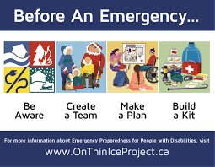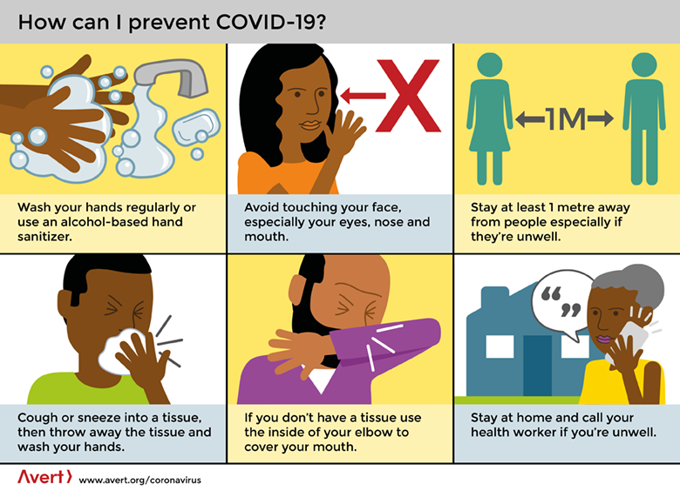

1. Compiled by: Dr Sruti Mohapatra, India with editing and additions Richard Rieser CDPF Gen. Sec.
2. CDPF uses disabled people as because whatever our impairment we are disabled by environmental and social barriers so as we are subject to a common oppression we identify as disabled people and our organisations are Disabled People’s Organisations or DPOs.
3. World Health Organisation, World Report on disability, 2011.
4. <https://www.un.org/development/desa/en/news/social/report-on-disability-and-development.html>
5. Following international convention (Handicap International 2015) this study understands vulnerability as “the characteristics of a person or group and their situation that influence their capacity to anticipate, cope with, resist and recover from the impact of a major event” (Blaikie et al 2014: 11). - <https://www.un.org/disabilities/documents/2016/Disaster-Disability-and-Difference_May2016_For-Accessible-PDF.pdf>
6. Economic losses (relative to GDP) caused by climate-related disasters, 1998–2017 (percentage)
7. <https://www.un.org/development/desa/disabilities/issues/whs.html>
8. Inclusion of Disability in Disaster Management” By Ashok Hans & Nizni Hans. <https://www.smrcorissa.org/upload_file/1156054884-1459324014_1459324014-inclusion-of-disability-in-disaster.pdf>
9. Disability in humanitarian contexts - Views from affected people and field organisations. Handicap International (2015). <https://www.hi-us.org/people_with_disabilities_left_behind_in_emergencies>
10. https://cis-india.org/accessibility/blog/emergency-services-report.pdf
11. https://cis-india.org/accessibility/blog/emergency-services-report.pdf
12. End-to-end early warning system deliver accurate warning information of potential hazards dependably and in a timely manner to both, authorities and population at risk, in order to prepare them for the danger and act accordingly to mitigate against or avoid it
13. https://cis-india.org/accessibility/blog/emergency-services-report.pdf
14. Building Back Better : Achieving Resilience through Stronger, Faster, and More Inclusive Post-Disaster Reconstruction: GFDRR.
15. <http://www.internationaldisabilityalliance.org/art11/iasc>
16. CBM (2019) **CASE STUDIES COLLECTION 2019 Inclusion of persons with disabilities in humanitarian action** 39 examples of field practices, and learnings from 20 countries, for all phases of humanitarian response <https://reliefweb.int/report/world/inclusion-persons-disabilities-humanitarian-action-39-examples-field-practices-and>
17. Humanity & Inclusion and Leonard Cheshire, Disability Data Collection: A summary review of the use of the Washington Group Questions by development and humanitarian actors (2018), at: <https://humanity-inclusion.org.uk/en/projects/disability-data-in-humanitarian-action> Humanity & Inclusion, Disability Data in Humanitarian Action (2019), at: <https://humanity-inclusion.org.uk/en/projects/disability-data-in-humanitarian-action>
18. # Persons with disabilities in a just transition to a low-carbon economy ILO 2019 <https://www.ilo.org/global/topics/disability-and-work/WCMS_727084/lang--en/index.htm>

   
19. CBM (2019) CASE STUDIES COLLECTION 2019 Inclusion of persons with disabilities in humanitarian action39 examples of field practices, and learnings from 20 countries, for all phases of humanitarian response <https://reliefweb.int/report/world/inclusion-persons-disabilities-humanitarian-action-39-examples-field-practices-and>