1

Commonwealth Disabled People’s Forum Policy on Employment and Livelihood 2020

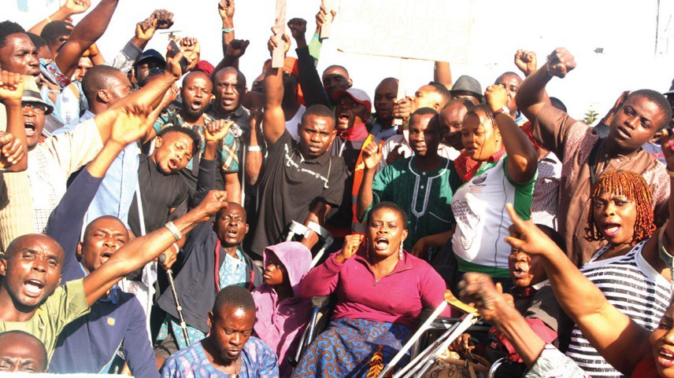
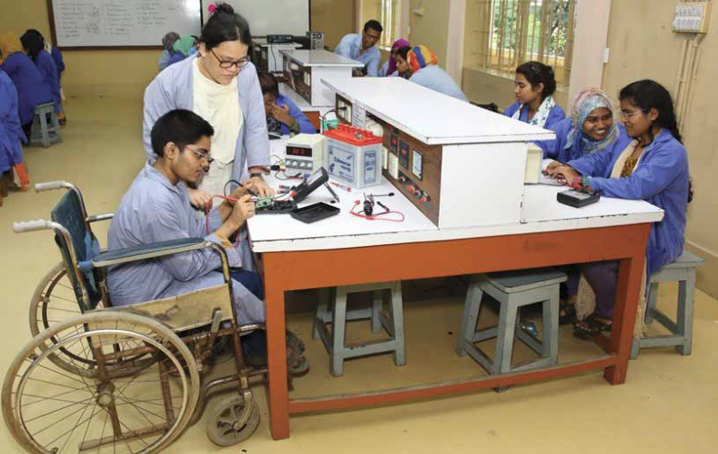
www.commonwealthdpf.org

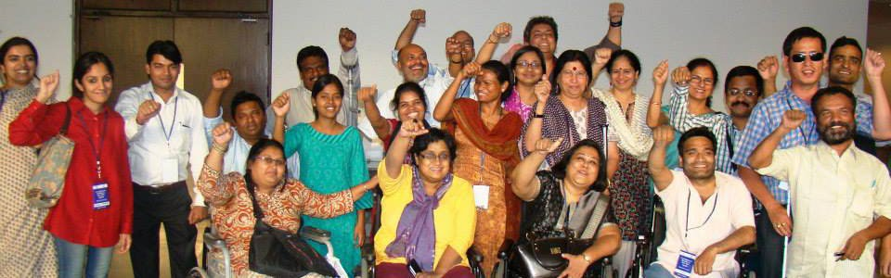

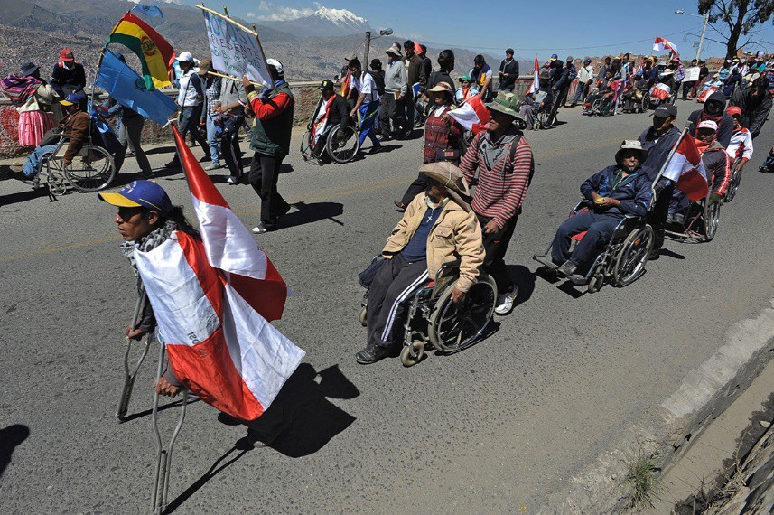

CDPF Policy Guide Employment, Livelihood and Disabled People

The Right to Work is established as a human right. “All human beings, irrespective of race, creed or sex, have the right to pursue both their material well-being and their spiritual development in conditions of freedom and dignity, of economic security and equal opportunity. The attainment of the conditions in which this shall be possible must constitute the central aim of all national and international policy”1.

Yet around the world most disabled people are not in work with women more significantly effected and impoverished as a result. A recent report identified the following barriers that must be addressed if the right to work is to become a reality for the majority of disabled people.

The Language we Use Why we still choose to call ourselves disabled people. In the Commonwealth Disabled People’s Forum we call ourselves ‘disabled people’ because of the development of the ‘social model of disability’. In the C19th and C20th, a disabled person’s medical condition was thought to be the root cause of their exclusion from society, an approach now referred to as the ‘medical or individual model’ of disability. We use the ‘social model of disability’ We also view ourselves as united by a common oppression so are proud to identify as ‘disabled people’ rather than ‘people with disabilities’. Where we are quoting international treaties, laws or direct quotes we will use people with disabilities.

Current Challenges to Labour Inclusion of Disabled People Lack of an enabling environment
- Accessibility barriers in built environments, transport, products and services
- Badly designed disability benefits, often leading to poverty of disabled people
- Insufficient support services and lack of transferability of these from one country to another
- Non-inclusive education and vocational training leading to lower levels of education and training among disabled people
- Inadequate support for disabled youth in transition from school to work
- Low level of capacity of public employment services to support disabled people into work
- General lack of compliance with employment quotas, where these exist

Employers (public and private)
- General lack of awareness and confidence on how to include disabled people in the workplace
- Inaccessible work premises and work tools, including Information and Communication Technologies (ICT)
- Inadequate provision of workplace adjustments
- Lack of support for disabled people to maintain employment and explore career development
- Lack of targeted support for SMEs regarding employment of disabled people

Trade Unions & Employers’ Associations
Insufficient level of attention to disabled people, both those in employment and those seeking to enter the labour market. The UK Trade Union Congress over the last 30 years has established disabled workers conference and affiliated unions have been encouraged to set up disabled sections and conferences2.

General Society
Disabled people are often faced with hard to dislodge stigma and stereotypes in society. Discrimination and higher exposure to situations of violence and harassment, also in the workplace3.

1 Declaration of Philadelphia, International Labour Conference, 1944
2 https://www.tuc.org.uk/union-reps/equality-and-discrimination/disability
3 Making the future of work inclusive of people with disabilities: A joint publication by Fundación ONCE and the ILO Global Business
and Disability Network, (2019)https://www.ilo.org/wcmsp5/groups/public/---ed_emp/---ifp_skills/documents/publication/wcms_729457.pdf

The UN Convention on the Rights of Persons with Disabilities (CRPD), adopted in 2006 and rapidly ratified by a majority of countries(182/194), reflects the fundamental shift that is taking place in how disability is regarded in international and national policies. Disabled people are increasingly regarded as citizens and as rights holders, rather than as objects of social welfare or charity. The CRPD provides fresh impetus to International Labour Organisation and Stat Parties activities to promote equal opportunities for persons with disabilities in training, employment and occupation.

This shift, however, is not yet fully reflected in the labour market where equal employment opportunities for women and men with disabilities largely remain an aspiration. People with disabilities have lower employment rates, higher unemployment rates and are more likely to be economically inactive than non-disabled persons. When in employment they are more likely to be in low-paid jobs with poor career prospects and working conditions. Throughout the world there is an undeniable link between disability, poverty and exclusion. The lack of equal employment opportunities for people with disabilities forms one of the root causes of the poverty and exclusion of many members of this group4.

Article 27 of UNCRPD reinforces previous international treaties on confirming the right to work for disabled people

“States Parties recognize the right of persons with disabilities to work, on an equal basis with others; this includes the right to the opportunity to gain a living by work freely chosen or accepted in a labour market and work environment that is open, inclusive and accessible to persons with disabilities”.5
States Parties to the Convention have general as well as specific obligations. General obligations laid down in Article 4 include the following:
“• to adopt all appropriate legislative, administrative and other measures for the implementation of the rights recognized in the Convention;
- to take into account the protection and promotion of the human rights of persons with disabilities in all policies and programmes;
- to ensure that public authorities and institutions act in conformity with the Convention;
- to take all appropriate measures to eliminate discrimination on the basis of disability by any person, organization or private enterprise; and
- to promote the training of professionals and staff working with persons with disabilities in the rights recognized in the Convention. Requirements in respect of rehabilitation include taking effective measures”.

The Convention’s many other Articles and rights impact on Article 27- Employment and Work, in particular Equality and Non-Discrimination(5), Women (6), Accessibility (9), Education (24), Rehabilitation (26) and Adequate Standard of living and Livelihood(28).

CRPD Article 27 Work and Employment full text
“1.States Parties recognize the right of persons with disabilities to work, on an equal basis with others; this includes the right to the opportunity to gain a living by work freely chosen or accepted in a labour market and work environment that is open, inclusive and accessible to persons with disabilities. States Parties shall safeguard and promote the realization of the right to work, including for those who acquire a disability during the course of employment, by taking appropriate steps, including through legislation, to, inter alia:

4 ILO (2015) Decent work for persons with disabilities: promoting rights in the global development agendahttps://www.ilo.org/wcmsp5/groups/public/---ed_emp/---ifp_skills/documents/publication/wcms_430935.pdf
5 Article 27 UN Convention on the Rights of Persons with Disabilities (2006) https://www.un.org/development/desa/disabilities/convention-on-the- rights-of-persons-with-disabilities/convention-on-the-rights-of-persons-with-disabilities-2.html

- prohibit discrimination on the basis of disability with regard to all matters concerning all forms of employment, including conditions of recruitment, hiring and employment, continuance of employment, career advancement and safe and healthy working conditions;
- protect the rights of persons with disabilities, on an equal basis with others, to just and favourable conditions of work, including equal opportunities and equal remuneration for work of equal value, safe and healthy working conditions, including protection from harassment, and the redress of grievances;
- ensure that persons with disabilities are able to exercise their labour and trade union rights on an equal basis with others;
- enable persons with disabilities to have effective access to general technical and vocational guidance programmes, placement services and vocational and continuing training;
- promote employment opportunities and career advancement for persons with disabilities in the labour market, as well as assistance in finding, obtaining, maintaining and returning to employment;
- promote opportunities for self-employment, entrepreneurship, the development of cooperatives and starting one’s own business;
- employ persons with disabilities in the public sector;
- promote the employment of persons with disabilities in the private sector through appropriate policies and measures, which may include affirmative action programmes, incentives and other measures;
- ensure that reasonable accommodation is provided to persons with disabilities in the workplace;
- promote the acquisition by persons with disabilities of work experience in the open labour market; (
k) promote vocational and professional rehabilitation, job retention and return to-work programmes for persons with disabilities.

- States Parties shall ensure that persons with disabilities are not held in slavery or servitude, and are protected, on an equal basis with others, from forced or compulsory labour”.

Article 27 is specifically devoted to work and employment and is quoted in full above. Discrimination on the basis of disability is prohibited in all forms of employment. States Parties are called upon to open up opportunities in mainstream workplaces, both in the public and private sectors. To facilitate this, the Convention promotes the access of disabled persons to freely-chosen work, general technical and vocational guidance programmes, placement services and vocational and continuing training, as well as vocational rehabilitation, job retention and return-to work programmes. The provisions cover people with disabilities seeking employment, advancing in employment and those who acquire a disability while in employment and who wish to retain their jobs. The Convention also recognizes that for many disabled people in developing countries, self-employment or micro business may be the first option, and in some cases, the only option.
States Parties are called on to promote such opportunities. The right to exercise labour and trade union rights is promoted. States Parties are also called on to ensure that disabled people are not held in slavery or servitude and are protected on an equal basis with others from forced or compulsory labour.

SDG 8, “Promote sustained, inclusive and sustainable economic growth, full and productive employment and decent work for all” explicitly refers to persons with disabilities in its target 8.5 which aims to, by 2030, achieve full and productive employment and decent work for all women and men, including for persons with disabilities, and equal pay for work of equal value.

The situation of disabled people and employment
According to global estimates, disabled people constitute some 15 % of the world’s population. Between 785 million and 975 million of them are of working age (15 years or older)1 and most live in developing countries where the informal economy employs a substantial proportion of the labour force. The labour force participation rate of disabled people is low in many countries. Recent figures for members of the

Organization for Economic Co-operation and Development(OECD) indicate that slightly less than half of working-age persons with disabilities were economically inactive compared to one in five non-disabled people of working age.6 While it is difficult to draw comparisons between countries on rates of unemployment due to national differences in definitions on disability and statistical methodology, it is clear that an employment gap exists across countries and regions. When they are in work they are in more insecure jobs and lower paying jobs, less likely to be involved in trades unions and are more likely to be self-employed especially in less developed countries.

Employment to population ratios for persons aged 15 years and over, by disability status, by geographical region, in 2006-2016 (based on 91 countries)7
Region | Disabled  people | Non Disabled People | GAP
Sub Saharan Africa | 34% | 53% | 19
Oceania | 47% | 66% | 19
North Africa Western Asia | 25% | 51% | 26
Eastern &SE Asia | 36% | 61% | 25
Latin America& Caribbean | 31% | 58% | 27
Europe | 44% | 67% | 23
Central and Southern Asia | 28% | 51% | 23
North America | 30% | 69% | 39
Average | 36% | 60% | 24

Employment and gender
A direct result of limited access to education among women with disabilities is their significant disadvantage upon entering the job market, in comparison with men with disabilities, and also with non-disabled women and men. According to evidence from six regions, women with disabilities are less likely to be employed than men with disabilities and persons without disabilities in all Regions. The ratios for women with disabilities are lowest in Northern Africa and Western Asia (14%) and highest in Europe (42%). In Northern Africa and Western Asia, women with disabilities are 5 times less likely to be employed as men without disabilities, in Europe they are 2 times less likely. The gap between women and men with disabilities varies between 6 percentage points in Europe to 26 percentage points in Central and Southern Asia.
Average employment-to-population ratios, for persons aged 15 years and over, by disability status and sex, in 6 regions, 2006-20168
Region | Men | Women | Disabled Men | Disabled Women
Sub Saharan Africa | 56% | 34% | 32% | 20%
Oceania | 67% | 54% | 51% | 40%
North Africa Western Asia | 68% | 29% | 32% | 14%
Eastern &SE Asia | 71% | 51% | 48% | 29%
Latin America& Caribbean | 72% | 50% | 44% | 32%
Europe | 73% | 62% | 48% | 42%
Central and Southern Asia | 77% | 39% | 44% | 18%
Average | 70% | 50% | 43% | 32%

6 WHO World Report on Disability 2011
7 Realization of the Sustainable Development Goals By, For and with Persons with Disabilities: Un Flagship Report on Disability and Development 2018 https://www.un.org/development/desa/disabilities/wp-content/uploads/sites/15/2018/12/UN-Flagship-Report- Disability.pdf p190
8 Ibid p138

In many countries, laws regulating labour still miss protections against discrimination on the ground of disability (see section on SDG 8). Due to these obstacles, many persons with disabilities who are able to work are not able to secure a job and remain an underutilized segment in the labour force. The percentage of disabled people who reported that their workplace is hindering or not accessible around 2013, was Lesotho 53%, Cameroon 50%, Sri Lanka 45%, Mozambique 18%, Malawi 17% and South Africa 11%.9

Reasonable Accommodations allow workers and their employers to take advantage of their full professional potential and thereby contribute to business success. The purpose of a reasonable accommodation at work is not to unduly burden an employer, nor is it to grant one employee an unfair benefit or advantage over another. Reasonable accommodation in the workplace means providing one or more modifications or adjustments that are appropriate and necessary to accommodate a worker or job candidate’s individual characteristics or differences so that he or she may enjoy the same rights as others. Often a reasonable accommodation may be made at little or no cost to an employer, and results in concrete benefits to both the employer and the worker.10 Failure to consider a reasonable accommodation is disability discrimination.

Reasonable accommodations used at workplaces vary from no-tech solutions which cost little or no money (like additional preparation time for an individual, or implementing a color-coded filing system), to accommodations that are technologically simple or unsophisticated (e.g. replacing a door knob with an accessible door handle or providing a magnifier) to accommodations that use advanced or sophisticated assistive technology (such as use of screen reading software with synthesized speech). Advanced assistive technology is often costly and less available e.g. in Sri Lanka in 2015 8% of employed disabled people did not need assistive products at work, while 54% use them and need more assistive products at work.
Reasonable accommodations can also apply to people with HIV/AIDs, Pregnant Women and Families, for religious observance.

Anti-Discrimination Legislation and Good Practices
Legislation is very important and an analysis from data compiled by The World Policy Centre11 on answers to the question ‘is discrimination in hiring and recruitment prohibited on the basis of disability by law?’ finds that in 25 Commonwealth countries it is specifically prohibited, in 7 it is broadly prohibited and in 22 there is no prohibition. (Countries with No prohibition are Barbados, Belize, Botswana, Brunei, Dominica, Lesotho, Malaysia, Nauru, Pakistan (law passed in 2020), Papua New Guinea, Singapore, Solomon Isles, Sri Lanka, St Kitts and Nevis, St Vincent and the Grenadines, Swaziland, The Gambia, Tonga, Tuvalu, Uganda and Vanuatu.)

Australia has both national and state legislation to address discrimination against persons with disabilities (Harris, 1919; AHRC, 2007). The Commonwealth Disability Discrimination Act, 1992 overrides state legislation and prohibits discrimination on the ground of disability in work and employment as well as other areas, including education. The Act is administered by a Disability Discrimination Commissioner within the Human Rights and Equal Opportunity Commission, which investigates complaints of discrimination. The 1992 Act allows for the development by organizations of action plans which identify barriers for persons with disabilities within the organization and set out policies and programmes, with time frames, for addressing them. The benefits of developing a Disability Action Plan are threefold: it demonstrates a commitment to anti- discrimination principles, it can be given to the Human Rights and Equal Opportunity Commission to be taken into account if a complaint is made against the organization, and it provides a tool for change.

9 Ibid p191
10 International Labour Organisation ( 2016) Promoting Diversity and inclusion Through Workplace adjustments
A practical guide, Geneva https://www.ilo.org/global/topics/equality-and-discrimination/WCMS_536630/lang--en/index.htm
11 https://www.worldpolicycenter.org/data-tables

Bangladesh In Bangladesh some 3.2 million young people with disabilities lack the skills necessary to
find employment. One reason is that Technical and Vocational Education and Training (TVET) institutions are unable to cater for the needs of those with disabilities. The Directorate of Technical Education (DTE), under Technical and Madrasa Education Division (TMED), Ministry of Education, has carried out a number of steps in collaboration with International Labour Organization (ILO) to make its 118 TVET institutes disability inclusive. This guide provides an overview of DTE’s approach to disability inclusion and provides practical advice which other departments and ministries can potentially follow and replicate. As a result of measures taken to enhance disability inclusion, enrolment of students with disabilities at DTE’s TVET institutes rose to 357 in the academic session 2015-16, significantly higher than the 56 students enrolled in 2014-2015 prior to DTE initiating these measures with ILO support. Nine TVET institutes have established partnerships with Disabled Persons Organisations (DPO). Out of 118 TVET institutes under DTE, 99 now have an Annual Disability Inclusion Action Plan featuring a budget and time-line. Dissemination of DTE’s model of disability inclusion in TVET institutes. Inclusion of 12 different types of disabled people in their monitoring system12.
Botswana Despite not having signed the UNCRPD, last year (2019) on the Commemoration of the National Day for Persons with Disabilities, most Disabled People’s Organisations were invited. The CEO of Deboswana Mining Company was invited as the Guest speaker. DPOs pleaded with her that her company should employer disabled people. After that, her company employed some of our disabled members, which is a milestone to us. Moreover, they are promising to continue to employ more of disabled people. It is the biggest company in the country dealing with diamonds.

Canada Anti-discrimination measures in Canada take different forms. Section 15(1) of the 1982 Canadian Charter of Rights and Freedoms guarantees every individual “the right to equal protection and equal benefit of the law without discrimination” and covers discrimination based on mental or physical disability. The Canadian Human Rights Act, 1985 prohibits certain discriminatory practices and disability is included among the prohibited grounds (Section 3(1)). Both the Charter (Section 15(2)) and the Act (Section 16(1)) allow for (but do not require) affirmative action to reduce disadvantages. While the Act did not originally require an employer to make “reasonable accommodation” to enable a disabled person to meet job requirements, amendments in 1998 added a duty to accommodate. The Legal and Legislative Affairs Division of Parliament explains: “Accommodation challenges employers, service providers, and other duty holders to go beyond treating all people the same and to recognize that people may in fact need to be treated differently in order to achieve true equality in a meaningful way” (Barnett, Nicol & Walker, 2012, p. 11). The Employment Equity Act, 1995, Section 10(1), also requires active measures to deal with disadvantage, including making reasonable accommodation. Disabled People are among those covered by the Act.

Ghana Barriers to Creating Work in Farming for Disabled People
In Ghana, agriculture has been described as the backbone of the economy and the main source of employment and livelihood for many. However, it appears that policymakers are yet to explore how agriculture could create sustainable employment opportunities for persons with disabilities. This study makes a major contribution to research on the eradication of poverty among persons with disabilities by exploring their participation and experiences in agriculture-related activities. One-on-one interviews and focus group discussions were conducted with 19 persons with disabilities from three communities in a district in Ghana. A recurrent theme was that agriculture was a way through which the Ghanaian government could create employment for persons with disabilities. However, the participants recounted formidable barriers that affect their participation in agriculture: lack of land, funds and farming tools, and negative attitudes. These findings

12 ILO 2017 www.ilo.org/dhaka/WCMS_543304/lang_en/index.htm

highlight the need for policymakers to engage with persons with disabilities to identify possible ways to assist their participation in agriculture.13

India In implementation of its obligations under the Convention, India enacted the Rights of Persons with Disabilities Act, 2016 (the “New Act”) and the rules there under (the “Rules”), 2017. The New Act replaced the Persons with Disabilities (Equal Opportunity Protection of Rights and Full Participation) Act, 1995 (the ‘previous Act’), which covered only 7 disabilities. The New Act covers more than 15 disabilities including dwarfism, acid attack victims, intellectual disability and specific learning disability. It defines a ‘person with disability’ as someone with long term physical, mental, intellectual or sensory impairment which, in interaction with barriers, hinders his / her full and effective participation in society equally with others. This definition under the New Act has been formulated using the text included in Article 1 of the Convention.
Under the New Act, persons with at least 40% of a disability (referred to as “persons with benchmark disability”) are entitled to certain benefits. One such benefit is that at least 4% of the total number of vacancies in Indian Government establishments in specified categories (and 1% in certain others) are required to be reserved for their employment.

Obligations on Private Establishments in India
While Indian private establishments are exempt from reserving jobs for persons with disabilities, the New Act requires them to adhere to a slew of obligations. The term ‘private establishment’ has been very widely defined to include a company, firm, factory or such other establishment. This would include the Indian presence of any foreign company, be it a liaison office, branch, subsidiary or a joint venture. The New Act makes it unlawful for an establishment to discriminate against a person on the ground of his or her disability unless it can be proved that the discriminating act in question is a proportionate means to a legitimate objective. The Rules make the “head” of the establishment responsible for ensuring that this provision of the

India New Act is not misused to the detriment of disabled persons.
The New Act requires establishments to prepare and publish an Equal Opportunity Policy (the “EOP”) for persons with disabilities. A copy of the same is required to be registered with the State Commissioner or the Central Commissioner. The EOP must inter alia contain: (a) details regarding amenities and facilities put in place for persons with disabilities; (b) lists of posts identified for such persons; and (c) details of training, promotion, allotment of accommodation and provision of assistive devices and barrier free accessibility for such persons. Further, these establishments must appoint a liaison officer to look after the recruitment of persons with disabilities including the provisions and amenities for disabled employees. Such appointment is to be notified in the EOP. Furthermore, the establishments are required to maintain records relating to persons with disabilities enumerating the following:
  - the number of disabled persons employed and the date of commencement of their employment;
  - the name, gender and address of disabled employee(s);
  - the type of disability(impairment) that such employee(s) have
  - the nature of work being performed by such employee(s); and
  - the type of facilities being provided to the disabled employee(s).
The establishments are further required to produce the aforesaid records for inspection as and when called upon to do so by the relevant authorities.

The Rules prescribe adherence to standards concerning physical environment, transport and information and communication technology applicable to disabled employees14. There are an estimated 70 million disabled

13Sustainable employment opportunities for persons with disabilities in Ghana: Exploring perceptions and participation in agricultureElvis Agyei-Okyere, William Nketsia, Maxwell Peprah, Opoku Eric, Lawer Torgbenu, Beatrice Atim Alupo,
Lois Odame 2018 https://onlinelibrary.wiley.com/doi/abs/10.1002/bsd2.43

people in India (a gross underestimate), of whom only about 0.1% are employed currently in industries. The International Labour Organization's 2011 report on Persons with Disability (PWD) states that 73.6% of disabled people in India are still outside the labour force. Currently, available evidence shows that lack of employment opportunities is a significant problem, which causes concern among working-age disabled adults. This is despite the fact that most jobs can be performed equally well by disabled people. However, myths exist that disabled people are unable to work and that accommodating a disabled person in the workplace is expensive. The National Centre for Promotion of Employment for Disabled People (NCPEDP 2009)) reported that the average percentage of employment of disabled people in India was 0.54% in the public sector, 0.28% in the private sector, and 0.05% in multinational companies. For a country like India which is a growing economy, the low rate of employment of disabled people will be a critical determinant of growth. A study was undertaken to ascertain both employee and employer perceptions on barriers existing among Information Technology (IT) and IT-enabled sectors to employ disabled people. Of the 147 interviewed physical access to and within the worksite was highlighted as a concern by 95% of respondents. The majority perceived that communication, attitude of people, discrimination, harassment at the workplace, and information were critical barriers. Only 3.8% of employers were aware that their company had a written policy on employing disabled people.
Employers stated that commitment and perseverance were important facilitators among persons with disabilities.15

Jamaica The Government of Jamaica has engaged in several initiatives to promote the employment and economic independence of the disabled. In 2008, for example, the government began reserving five per cent of all public sector jobs for qualified persons with disabilities. During 2008 and 2009, the government allocated
$20 million towards a project intended to provide small loans to persons with disabilities who wished to start their own businesses. The Ministry of Labour and Social Security held a series of seminars to provide guidance to those who had received grants from the project. The Ministry also administers the National Vocational Rehabilitation Service, which provides vocational and other productive opportunities to the disabled community. It also holds annual employment expositions, as well as meetings with private sector representatives, to encourage businesses in the private sector to employ persons with disabilities.
Furthermore, the Ministry began creating a national skills bank of qualified disabled persons in 2008 in order to more easily connect them with potential employers. In addition to these initiatives, the National Youth Service manages the Information and Communication Technology (ICT) Training for Persons with Disabilities Programme. The programme trains persons with disabilities in: occupational health and safety procedures, 12 working effectively in a technology environment, communicating in the workplace, interacting with clients, operating a personal computer, accessing the Internet, using computer peripheral devices and operating a presentation package.16

Kenya- In Kenya, various legal instruments and policies govern employment of disabled people all of which protect disabled people from marginalization in employment. Some of these include:
- The Constitution of Kenya,
- Persons with Disabilities Act of 2003,
- Convention on the Rights of Persons with Disabilities
- Kenya’s Public Service Commission Disability Policy
- Kenya National Social Protection policy

14 Rights of Persons with Disabilities in India and Other Jurisdictions 2018 Lus Laboris https://www.lexology.com/library/detail.aspx?g=c606f652-6bf9-42d7-ab1d-a764c3215e0e
15 Factors Influencing Employment and Employability for Persons with Disability: Insights from a City in South India https://www.ncbi.nlm.nih.gov/pmc/articles/PMC5763841/ Indian J Occup Environ Med. 2017 Jan-Apr; 21(1): 36–41. 16A further study on disability in the Caribbean: rights, commitment, statistical analysis, and monitoring (2009) https://repositorio.cepal.org/bitstream/handle/11362/27727/S2009003_en.pdf

- Kenya’s Vision 2030

Kenya’s Public Service Commission:
Public Officers’ Ethics Act -The Public Officers’ Ethics Act of 2003 creates an environment that nurtures respect for diversity including disability. The Act demands of public officers to treat fellow public officers, including PWDs, with respect while discharging their mandate. Public Service (Values and Principles) Act -The Public Service (Values and Principles) Act of 2015 gives effect to Article 232 of the Constitution. The Act allows public institutions for purposes of ensuring representation of PWDs and other marginalized groups, not to unduly rely on merit in making appointments, which usually disadvantages PWDs.
Employment Act -The employment Act 2007 recognizes disability and outlaws discrimination on grounds of disability in employment both in public and private sectors. Public Procurement and Disposal Act- The Public Procurement and Disposal Act 2015 and Regulations 2006 reserves thirty percent of public procurement for women, youth and PWDs as a means of empowering them. The PSC code of practice for mainstreaming disability in the Public Service- The PSC Code of Practice for mainstreaming disability in the Public Service 2010 obligates public entities to reasonably accommodate the needs of PWDs in public service by retaining, retraining and deploying public servants who acquire disabilities in the course of duty. About 46 per cent of all Kenyans live below the poverty line while 19 per cent live in extreme poverty. This policy aims at cushioning the most vulnerable citizens against the ravages of poverty. The policy also identifies orphans and vulnerable children, persons with disabilities and older persons as the priority targets for social protection.
Disability Act 2003 (Amendment Bill 2017) This is a comprehensive law covering rights, rehabilitation and equal opportunities for people with disabilities. It creates the National Council of Persons with Disabilities as a statutory organ to oversee the welfare of persons with disabilities. The Law also requires that both public and private sector employers reserve 5 per cent of jobs for disabled persons.
Kenya’s Vision 2030 This provides a long-term development framework and initiatives aimed at sustaining rapid economic growth and tackling poverty. The plan follows after the implementation of the Economic Recovery Strategy (ERS), 2003-2007. Under Vision 2030, Kenya hopes to become a globally competitive and prosperous nation with a high quality of life by 2030.
Employment of Persons with Disabilities Kenya conducted its census last year, however final data is not yet available thus unable to clearly state disaggregated data on employment of persons with disabilities in Kenya. However, public and private institutions are currently taking advantage of the incentives provided under the Disability Act on the progressive employment of 5% of persons with disabilities. A thorough report should be provided once Kenya National Bureau of Statistics releases the final report. 17

Mauritius The Training and Employment of Disabled Persons Act 1996 of contains an anti-discrimination provision which makes it an offence for an employer to discriminate against any disabled person in relation to advertisement of and recruitment for employment, and the determination or allocation of wages, salaries, pensions and other matters relating to employment. Any employer who discriminates against a disabled person shall be liable to compensatory payment or to imprisonment. Under this Act, no disabled person shall be employed on work which, with regard to the nature of the disability, is not suitable.

Nigeria and Kenya Film on Getting and Keeping a Job as a Disabled Person
As part of the Inclusive Futures initiative, we asked jobseekers we’re working with in Kenya, and employees of private sector companies partnering with us in Nigeria, to tell us about their experiences of seeking employment as a person with a disability, and some of the barriers they’ve faced in establishing their careers across a variety of sectors. This film shares a snapshot of what they told us. For more information:

17 https://www.publicservice.go.ke/images/guidlines/Draft_Disability_Policy_and_Guidelines_For_the_Public_Service.pdf https://www.ilo.org/wcmsp5/groups/public/@ed_emp/@ifp_skills/documents/publication/wcms_115097.pdf
www.sightsavers.org/inclusion-works May 2020: www.inclusivefutures.orghttps://youtu.be/SULCPkBCoo8?t=4
Nigeria, Kaduna State self-help challenging begging. In Nigeria, an estimated 20 million people have some kind of physical impairment. They have physical problems that make it difficult to find work and hold a job.
Some of the disabled end up on city streets, asking strangers for help. But in Kaduna State, a group
of disabled men has been persuading others to get off the street by offering them new skills. Our story begins outside the offices of a local charity. A group of men who are physically disabled wait there for food from the aid group. It may be the only meal they get that day. Because the men are disabled, most depend
on begging in the streets to support themselves. Aliyu Yakubu is unlike those men. He is learning job skills to earn a living wage. He is being shown how to fix tricycles and do other metal work. The 18-year-old remembers when he decided to stop begging. He says, “My former class prefect saw me begging on the street and didn’t recognize me. He gave me some money. When I stretched my hand out to collect it, then he saw my face. I felt ashamed, and since then, I decided not to beg again.”

“Isiaka Maaji is also physically disabled. He helps people like Aliyu Yakubu get work, and get off the streets. He teaches them a trade. He learned his skills from a government-operated training program. The program has been teaching vocational work since 2002. Five years ago, Mr. Maaji started helping other disabled people to stop begging. He says, “We encourage people like us to learn skills they can do to become self-reliant to support themselves and their families because being in the streets as beggars is a disgrace to all of us. To date, he has helped and trained 30 people. Some of them even have their own metal-working businesses now. They make tricycles and motor bikes designed for disabled individuals. But that is not all they make. They also make doors and windows to sell.

Ridwan Abdillahi is a member of the ‘Handicapped Association’ and a business owner. He says the group is making good quality products, but people are not buying. He says he believes many people think goods made by the disabled are not as good as those made by others. Disabled men waiting for a meal say this is one more barrier the disabled face. They say that with the help of the government and community, they will overcome it, by bringing people’s attention to their concerns”.18

The South African Constitution contains a Bill of Rights, which “enshrines the rights of all people in our country and affirms the democratic values of human dignity, equality and freedom” (Act No. 108 of 1996, Ch. 2, clause 7). Clause 9 – Equality, which forms part of the chapter on the Bill of Rights, states that equality includes the full and equal enjoyment of all rights and freedoms, and that no person may be discriminated against directly or indirectly on the ground of disability or on any of the other grounds specified. Clause 9 also states that national legislation must be enacted to prevent or prohibit unfair discrimination. Measures to facilitate work and employment The Employment Equity Act (No. 55) was passed in 1998 to promote the constitutional right of equality, eliminate unfair discrimination in employment, ensure the implementation of employment equity to redress the effects of discrimination and to give effect to South Africa’s obligations as a member of the ILO (Preamble). The Act requires all employers to eliminate unfair discrimination, direct or indirect, in any employment policy or practice, on the basis of disability or other specified grounds (Ch. 2, section 6). It is not unfair discrimination if an employer takes affirmative action measures consistent with the

18https://learningenglish.voanews.com/a/nigeria-disabled-workers/2842023.html
https://av.voanews.com/Videoroot/Pangeavideo/2015/06/b/ba/ba9b4f63-f0c8-4ff7-b418-6a65b5d5cf3c.mp4

purpose of the Act, or distinguishes, excludes or prefers any person on the basis of an inherent requirement of the job (Ch. 2, section 6(2)). The Employment Equity Act defines affirmative action measures as “measures designed to ensure that suitably qualified people from designated groups have equal employment opportunities and are equitably represented in all occupational categories and levels in the workforce of a designated employer” (Ch. 3, section 15).
Affirmative action measures must include:
- measures to identify and eliminate employment barriers which adversely affect people from designated groups;
- measures to enhance diversity in the workplace based on equal dignity and respect; and
- making reasonable accommodation for people from designated groups to ensure that they enjoy equal opportunities and are equitably represented in an employer’s workforce in all occupational categories and levels. The Act required 2% employment of persons with disabilities in public services. General Household Survey of 2016 shows that only in one province, Guateng, has this modest target been met. National Departments are at 1.14% and the other 8 provinces vary from 0.59 to 0.31%. Persons with disabilities represent 0.87% of the workforce. The unemployment rate is 36% for youth between the ages of 15 to 35, more than double the unemployment rate of the ages of 36 to 64.

South Africa Good Practice
Edu360 is a Vocational Academy that provides specialized care and educational training to neurodiverse students. The school offers two full time specialist vocational programs (Early Childhood Development and IT Technical Support) to replace Gr 10 – 12 and serve as an alternative curriculum for students with barriers to learning and SEN requirements. The school also employs these students in IT or as support facilitators.

Brownies & Downies
A NGO (coffee shop in Cape Town) that trains and employ students with intellectual disabilities in the hospitality sector. The training of these students will help to break down stigmas in society.

South Africa Comments on the State Employment Equity Report 1. It is very disappointing that after nearly two decades, the public service has not yet achieved its very low target for employment of persons with disabilities of 2%. It is worth noting that the target dates have been moved three times, yet there are no obvious consequences for the failure to meet the targets.
- The disability sector has maintained for many years that the target of 2% is arbitrary and low. The 2016 household survey shows that the prevalence of disability could be as high as 7.5%. The minimum target should have been set at 4%.
- Of the 9 provinces and national departments, only Gauteng met the target of 2%. All other provincial governments and national departments fell measurably short of the 2%.
- Of the 10,254 public servants in Senior Management posts, only 150 were persons with disabilities. The report itself acknowledges that persons with disabilities were mainly employed at salary levels 5 to 8. It is unclear how this has changed over the years, but indications are that persons with disabilities are still confined to the switchboards and receptions.
- The recommendations in the report are very high level and lack specificity. Having looked at them, I am convinced that all of them could be implemented successfully, but in ten years time the issues remain unresolved. The recommendations are not SMART. Having said all of the above, the sector should note the achievement by Gauteng of 2.22%. The province should be encouraged to pursue a representation of the TRUE disability proportion of 5% across its departments and State Owned Entities (SOEs). 19

19 http://www.labour.gov.za/About-Us/Pages/CEE.aspx

Sri Lanka The EFC, with funding from the ILO, developed the Employers’ Network on Disability with the objective of facilitating employment and training opportunities in the private sector for job seekers with disabilities, which was officially launched in the year 2000. The object of forming the Network is to have a link between the business community and the organizations dealing with disability issues to facilitate mainstreaming its work. The Employers’ Network on Disability offers a broad spectrum of facilities including: ICT training, training persons with disabilities in Job seeking skills, Soft skills, Language skills, Job placement. 20 In a recent blog the range of activities that Employers Network supported Network on Disabilities is clear.
Starting in 2000 “Today we have the support of 40 organizations and with their help, we have placed over 500 persons with disabilities in gainful employment’. Recent activities include. Supporting creative writing. The famous children’s book writer, Ms. Sybil Weththasinghe wrote the “Wonder Cristal”, “Puduma Paliguwa” which was a Guinness World record with the most number of endings written by children themselves. Children with disabilities were also included in this process. A group of persons with disabilities successfully completes a course of study in Microsoft Word at the Disability Resource Centre. A group of 8 persons with diverse disabilities (vision impaired, partially sighted and physical impaired) successfully completed a course of study in Microsoft Word. The UNDP organized the “National Youth Dialogue on Leadership Innovation and Entrepreneurship” to develop entrepreneurship skills of youth in Sri Lanka in February 2020 included three disabled trainees from the centre. The Employers’ Federation of Ceylon, Specialised Training &amp; Disability Resource Centre implements several programmes to develop Entrepreneurship Skills of people with disabilities. The Training Centre started a new course of study in Cookery for Entrepreneurs with disabilities in February 2020. The trainings are conducted by Ms. Mahila Wickramasekera .Women with diverse disabilities (multiple disability and learning disability) will be trained in Cookery to start up their own businesses.”21

United Kingdom Under the Disabled Persons’ (Employment) Act, 1944, the rights of disabled people to mainstream employment were to be achieved through a quota system. This required private employers with 20 or more employees to have at least 3 per cent of their workforce made up of registered disabled people, and through the Reserved Occupations Scheme, under which the two occupations of electric lift attendant and car park attendant were reserved for disabled people. The quota system was abolished in 1996 (for further details see 3.6) when the Disability Discrimination Act 1995 came into force. The 1995 Act contained provisions making it unlawful to discriminate against a disabled person in relation to employment, the provision of goods, facilities and services and other issues. It also contained provisions relating to education and accessibility of transport. The Special Educational Needs and Disability Act 2001 extended the 1995 Act so as to make it unlawful to discriminate against disabled pupils and students seeking access to education in schools and colleges. The Disability Discrimination Act, 1995 (Amendment) Regulations, 2003 which came into force on 1 October 2004 served to implement the disability aspects of the European Community Employment Directive 2000/78/EC (see 1.29). The Regulations also made significant changes to the 1995 Act, including ending the exemption of small businesses. Measures to facilitate work and employment employers from the scope of the Act and bringing within its ambit a number of excluded occupations such as police, firefighters and prison officers. The Disability Discrimination Act, 2005 extended and amended the 1995 Act, reinforcing and refining the anti-discrimination law, including in relation to public authorities, transport and general qualifications bodies. The Equality Act, 2010 has repealed and replaced the Disability Discrimination Act, 1995 but the same provisions have been retained. Legislation is often too narrowly defined to include Autism, however in the UK it does and the Trades Union Congress has provided a very useful guide to Autism in the Workplace22

20 For further information log on to http://efcnetworkondisability.employers.lk/
21 “Imagination and Creativity Can Change the World” May 23, 2020 Manique http://efcnetworkondisability.employers.lk/
22 TUC 2014 Autism in the workplace https://www.tuc.org.uk/sites/default/files/Autism.pdf

Zambia The People with Disabilities Act No. 6 of 2012 in Zambia provides for the continuation of the Zambia Agency for Persons with Disabilities 118 Measures to facilitate work and employment (ZAPD), the National Trust Fund for Persons with Disabilities, and the domestication of the UN Convention on the Rights of Persons with Disabilities. It lays out the functions of the Minister responsible for formulating disability – currently the Minister of Community Development, Mother and Child Health. The law contains a general prohibition of discrimination on the ground of disability and defines denial of reasonable accommodation as a form of discrimination. In relation to employment, the law provides that, in consultation with the Minister for Labour, safeguards will be prescribed to promote the right to employment of persons with disabilities, without discrimination, in all forms of employment, and that regulations be issued and measures taken to ensure the implementation of the requirements of Article 27 of the CRPD on Work and Employment (Art. 35). Enterprises employing persons with disabilities are entitled to tax rebates (Art. 37(1)), and provision is made for special incentives for persons with disabilities engaged in business (Art. 37(2)). Where discrimination is alleged, ZAPD may request the Attorney General to take appropriate legal action (Art. 64(1)).

Mentoring and coaching in “learnerships” South Africa implements a structured TVET programme called “learnership”, based on complementary theoretical and practical training at TVET schools and companies. It provides professional, technical skills and life skills, such as communication and teamwork. It is open to all young South Africans, including those with disabilities. Learnerships are based on a contract between the learner, the employer and an accredited training provider, which stipulates the training conditions and defines the rights of all involved parties for the duration of the programme. The training lasts about 12 months divided equally between in-company and classroom training. Learners receive a stipend and are awarded a nationally recognised qualification and certificate. Disabled learners receive intensive mentoring, coaching and support during their training. Proper planning is required for the success of this process. Companies need to ensure adequate support structures, such as in-company mentors and job-coaches who can assist learners with the mastery of the technical and practical skills. One of the drawbacks is that companies still employ a very low percentage of their learners. In addition, the scheme implies a large amount of paperwork if employers want to apply for financial government incentives.23

Affirmative Action One example of a public employment program with measures to effectively include persons with disabilities is provided by India. Through this programme, which guarantees 100 days of wage employment in a financial year to every household, state governments in India have to provide work that takes into account disability-related needs of persons with disabilities. For instance, efforts are made to ensure that disabled people are provided work opportunities close to their place of residence, so that they do not need to travel long distances to the workplace. Moreover, it is ensured that disabled people are paid wages equal to non-disabled people. This public employment programme also seeks to ensure a stigma-free environment at the workplace, so that disabled workers are not looked down upon or face any form of discrimination. In Tamil Nadu, 2015-16, about half of the 130,420 disabled people registered under this programme engaged in work under the scheme24 In addition to designing and implementing laws, policies, services and programmes to promote the employment of disabled people. The public sector has also played a role as an employer of disabled people. For instance, New Zealand has implemented a range of initiatives to promote the employment of disabled people in the public sector, including providing guidance on disability inclusion for leaders, managers and human resources professionals in the public sector. One of the frequent affirmative action measures used by countries to promote employment of disabled people are quota systems,

23 https://www.ilo.org/wcmsp5/groups/public/---ed_emp/---ifp_skills/documents/publication/wcms_633257.pdf
24 Mahatma Gandhi National Rural Employment Guarantee Act (MGNREGA). The Equals Centre for Promotion of Social Justice (forthcoming), A Study on Socio- Economic Impact of the Mahatma Gandhi National Rural Employment Guarantee Act, 2005 on persons with disability in the State of Tamil Nadu.

which establish an obligation for employers to fill a certain percentage of their total jobs with disabled employees.

Quotas National quota systems currently in place apply to employers in either the public or private sector or to both. In some countries, quotas are only applied to employers of a certain size, and different quota levels, typically range from 1 to 15% are often used for the public and for the private sector. Eastern and South- Eastern Asia have the lowest regional quota levels; and sub-Saharan Africa the highest. As there have been no thorough evaluations of quotas, it is difficult to assess their role in including disabled people in the labour market. Countries with quotas between 1 and 4% show a wide range of EPR gaps between disabled people and non-disabled people; countries with quotas between 5 to 9% have the lowest EPR gaps and the few countries with more than 10% quota levels have currently wide gaps. This wide variability is likely due to variation across countries in the degree of enforcement of quota levels as well as to the existence, or absence, of additional instruments to complement the shortcomings of quota systems. The most effective quota systems include the payment of a levy by the non-complying company for every designated position not held by a disabled people. Such levies typically contribute to a special fund which is used to finance measures promoting the employment of disabled people. Quota systems are of little relevance in low income countries, where the vast majority of people work in the informal economy. Also, often employers prefer to pay the sanction or include disabled people in their payroll but do not expect them to come to work.

Employment quotas can be problematic as illustrated here by information from Kenya 25
“ Implementation of the principle established in Article 54 (2) of the Constitution which provides that at least five percent of the members of elective and appointive bodies should be disabled people, should be realized fully with immediate effect and not on a progressive basis. A law to this effect should be put into place.
Similarly, Article 232(1) (i) (iii) of the Constitution on affording adequate and equal opportunities for appointment, training and advancement at all levels of the public service should be realized in respect to disabled people. In this regard, it is worth noting that data from the Public Service Commission on employment of disabled people in the Public Service highlights that of the 251 institutions evaluated in the 2017/2018 financial year, there were 2,155 disabled people represented, accounting for 1.1% of the in-post. The performance gap therefore is 3.9% of the 5% requirement. Out of the 251 evaluated institutions, 10 (4%) complied with the 5% requirement, out of which 8 were from State Corporations and Semi- Autonomous Government Agencies (SAGAs), one each from Constitutional Commissions, Independent Offices and Public Universities. None of the 44 Ministries and State Departments and all the 7 Statutory Commissions and Authorities complied. This is according to the Public Service Commission, February 2020 Evaluation Report for the Year 2017/2018 on the Public Service Compliance with the Values and Principles in Articles 10 ”.

DPOs providing training for disabled people and employers on increasing employment of disabled people. United Disabled People Kenya (UDPK) Initiative on Employment 26 Disabled people are often left out when it comes to different aspects of life and this is true when it comes to employment. Obstacles and barriers faced by disabled people make it hard for them to find and sustain gainful employment. Lack of training on skills and employers lack of awareness on disability inclusion, increases the challenges faced by disabled people at work. In the informal sector, lack of financial support and business skills by disabled people makes it harder for them to start and sustain their own business. UDPK recognise these challenges and are involved in the Inclusive Employment Project. UDPK are also involved in related work to ensure disabled people have access to job opportunities and a fair chance to start their own business. The Objectives are :-

25 Feb 2020 Memo to Building Bridges Initiative from DPOs in Kenya https://www.udpkenya.or.ke/wp- content/uploads/2020/04/Final-Copy-CDRA-UDPK-MEMO-to-National-Steering-Committee-on-Implementation-of-BBI-Task-Force- for-circulation-2.pdf
26 https://www.udpkenya.or.ke/inclusive-employment/

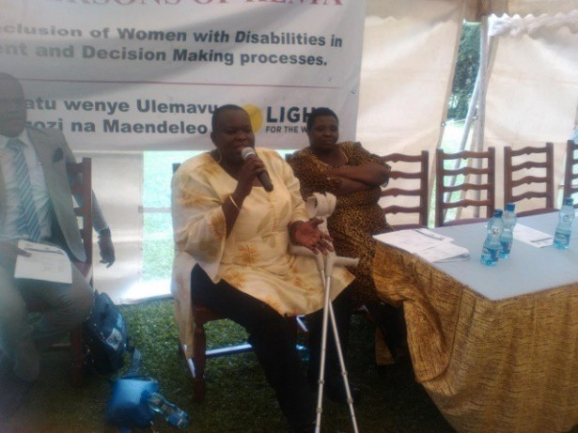
*To collaborate and work with partners in offering training on Business Skills and Knowledge to disabled people to enable them to open and run their own business
*To engage with potential employers and train them on the importance of engaging disabled people in their companies
*Creating awareness on the rights of disabled people in employment and work
*Creation of materials that employers could use as a guide on engaging disabled people in their work environment
*Be involved in making recommendation for laws and policies that concern working with disabled people.

To collaborate with partners in training on Business skills and Soft skills to persons with disabilities
Disabled People need to be equipped with business knowledge on how they can open and run their own business ventures or be imparted with more knowledge if they are running their business already. Some areas of training include
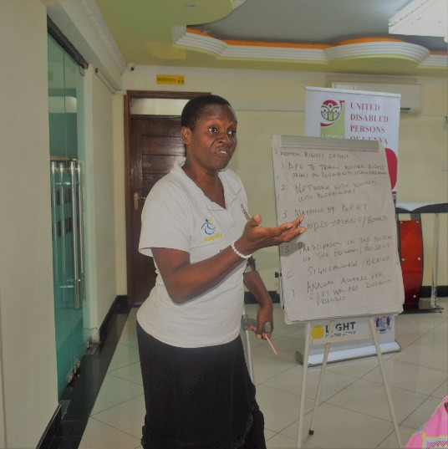
*Writing Business Plan-well thought out business plan to submit to a financial institution in order to request a loan or to potential investors for equity financing in your business.
*Developing Marketing Plan-This explains how entrepreneurs can increase sales by attracting and retaining customers and increasing business profits in the long term. Including activities like branding.
*Good Customer Service can be the difference between being able to compete and survive and failing for small businesses. This area discusses what good customer service is and guides you on how to assess and improve customer service in your small business. Excellent customer service creates loyal customers for life who are willing to refer your business to friends, family, and colleagues.
*Book-Keeping-This focuses financial and record management skills.
*Training disabled people in soft skills as communication and other related skills to help in navigating work environment.

To engage with potential employers and train them on employment and disability issues
UDPK engages with employers both in the formal and informal sector to sensitize and train them on issues concerning disabled people and employment. This will involve:
- Training employers on the employment rights of disabled people and ways on how they can engage them in employment.
- Making a disability case to them on why they should employ disabled people.
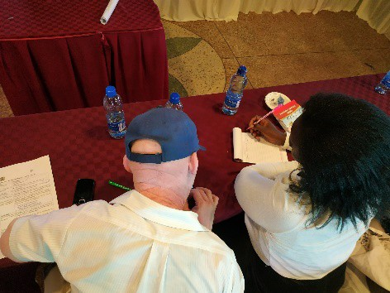
- To keep database for disabled people and provide the information to potential employers in case of arising opportunity.

Creation of Inclusive Employment materials
To guide and help employers on matters dealing with employment and disability, UDPK develops some guidelines and inclusive employment toolkit that could be used by employers to :
- Have knowledge on how to engage disabled people in their work environment
- Uphold rights of disabled people in their districts
- Have knowledge on the legal framework of disability and employment
- Enhance skills and experiences of their disabled employees

Involvement in the processes of making recommendation for laws and policies that concern employment for disabled people UDPK has been involved in the forums and processes that have been constituted to address the issues of employment and disabilities. Inclusive employment laws and policies in Government departments and agencies that deal with employment have to be aligned to address the emerging employment trends in disability and work environment. UDPK has been involved in contributing and formulation of some employment policies and laws such as
- Disability Act, Diversity policy for public service and Kenya Constitution 2010-for non-discrimination in workplace.
- Monitor the implementation of constitutional provisions concerning employment and disability.
Self Employment Supporting entrepreneurship and self-employment can work well for disabled people. In Uganda, the Association of Microfinance Institutions has taken measures to create equal opportunities for disabled people to access their financial services, with particular focus on sensitizing its staff on disability rights.

Business Support A successful initiative to address this challenge is the ILO Global Business and Disability Network (ILO GBDN)27 which provides a platform for global and local companies to exchange practices on the inclusion of disabled employees. This initiative draws on the advantages for business of employing persons with disabilities, by highlighting the talents and skills workers with disabilities bring to the company, thereby contributing to a diverse workforce that is better prepared to respond to the diverse needs of the globalised economy. A small but increasing interest of the private sector in the employment of persons with disabilities exists in developing countries, demonstrated by the establishment of national employer-led initiatives on disability inclusion, including in Bangladesh and Zambia, among others.

National practices on ensuring full inclusion in technical vocational education and training Many countries have been working to adopt or strengthen existing disability-specific anti-discrimination legislation that includes provisions relating to vocational education and training. Many have also established initiatives to promote inclusive Technical Vocational Education and Training (TVET). Some countries, including Bangladesh, Malaysia, Australia, India, Canada have introduced general or disability-specific laws, policies or strategies that promote the inclusion of persons with disabilities in mainstream TVET systems and programmes. In addition, countries including South Africa have taken steps to create more disability inclusive apprenticeship schemes, such as workplace programmes and hands-on learning, open also to persons with disabilities at a company combining on-the-job-training with complementary school-based training for a full occupation, craft or trade. In Mozambique, support has been provided for young persons with disabilities to access technical and vocational training by removing physical barriers in accommodations and training centres, for example, by developing accessible lavatories and installing lower door locks and light switchers. National initiatives that include youth with disabilities in programs offering comprehensive education, job training and job placement services to economically disadvantaged youth have been found to be especially effective in improving the work outcomes for youth with disabilities28

Employment for disabled people in the transition to low carbon economy29.
The world of work is intrinsically linked to the natural environment and climate change. Global temperature rise and extreme weather are lessening productivity and putting the health of many workers at risk. Jobs in multiple sectors such as agriculture, forestry, fisheries and tourism are being destroyed. In many instances, working conditions are being negatively impacted from extreme weather events such as heat stress. Efforts

27 ILO Global Business and Disability Network http://www.businessanddisability.org/
28 1 ILO (2017) Policy brief - Making TVET and skills systems inclusive of persons with disabilities.
29 ILO (2019) Persons with disabilities in a just transition to a low carbon economy https://www.ilo.org/global/topics/disability- and-work/WCMS_727084/lang--en/index.htm

are being ramped up to meet the long-term goal of the Paris Agreement to keep the increase in global average temperature to less than 2 degrees centigrade above pre-industrial levels. Transitioning to a more sustainable and low-carbon economy is one of the most significant actions countries can take towards this goal. While such a transition will have both negative and positive effects on the world of work, it has the potential to be a net generator of jobs and, if done right, open new opportunities to create a sustainable and inclusive world of work. This represents a tremendous opportunity to enhance decent work for persons with disabilities who currently face many socio-economic vulnerabilities in the world of work, and are disproportionately affected by adverse climate change impacts. Equally, involving disabled people - who comprise 15 per cent of the global population - is critical to achieving the goals of the Paris Agreement and the UN Sustainable Development Goals that pledges to ‘leave no one behind’.

Estimates suggest that overall, the transition to low carbon economies worldwide will be a net generator of jobs, with as many as 18 million new jobs appearing by 2030, according to the ILO World Employment Social Outlook 2018. Taking action in the energy sector to limit global warming to 2 degrees centigrade by the end of the century can create around 24 million jobs, largely offsetting the expected job losses estimated at 6 million and resulting in a net gain of 18 million jobs30.

The changing trends in the world of work offer significant opportunities to address disability-based discrimination and to promote equality for disabled people at work from the outset. Doing so will yield both immediate and long-term benefits. In the short and medium-term, changing the current labour market situation where a large number of disabled people are un- or under-employed can reverse the social and economic losses caused by exclusion, estimated by the ILO to cost between 3 and 7 per cent of low- and middle-income countries’ GDP31. Education, training and employment for disabled people will accelerate the progress to achieve the SDGs, particularly SDGs 1, 4, 8, 10 and 11.22 In fact, the goals of all the major international agreements of 2015 – be it the SDGs, the Paris Agreement or the Sendai Framework – stand to make progress when disabled people are engaged.

Furthermore, encouraging green businesses owned and controlled by disabled entrepreneurs can provide underlying infrastructure support for green industries. At the same time, negative effects of the transition to a low-carbon economy can be minimised by focusing on building capacity and securing green jobs for disabled people. Intersecting identities – such as gender, age, indigenous or ethnic identity, or migrant status – play an exacerbating role in pushing disabled people into informal, part-time, or segregated working arrangements.
Paying attention to identity specific needs, while providing opportunities for decent work, can help counter such marginalization. In the long term, including disabled people in the design and decision-making processes of new low-carbon sectors will lead to increased integration of universal access and universal design principles and contribute to designing inclusive societies for all. Furthermore, inclusive and decent work will promote positive attitudes about disabled people and help undo misconceptions about their work capacities. Negative beliefs and prejudices constitute serious barriers to education, employment, health care and social participation. Instilling positive attitudes about disabled people early on can help ensure future generations value inclusiveness and avoid perpetuating or creating barriers to inclusion.

30 ILO. 2018. World Employment and Social Outlook 2018: Greening with jobs (Geneva). Available at https://www.ilo.org/weso- greening/
31 ILO. 2009. The price of exclusion: The economic consequences of excluding people with disabilities from the world of work [Working paper] (Geneva). Available at http://www.ilo.org/employment/Whatwedo/Publications/working- papers/WCMS_119305/lang--en/index.htm

To address the current employment gaps and realize SDG 8 and Article 27 for Disabled People, the following steps could contribute to address current challenges32:

- States should ensure that national legislation protects disabled people from discrimination on the basis of disability in all matters of employment and that it includes the denial of reasonable accommodation as a form of discrimination. Reasonable accommodation in most cases does not incur costs or incurs just a minimal cost. It is important that States improve and standardize the support available for providing reasonable accommodation in the workplace.

- The public sector should lead by example by hiring disabled people and take affirmative actions to promote their initial employment and career development. This will expand the opportunities for disabled people to work, create a model for other employers and increase the legitimacy and credibility of the public sector in terms of representing the whole population it is supposed to serve.

- Public procurement policies and systems should include provisions that encourage the employment of disabled people, including by setting a clear goal on the proportion of procurement of services and products provided by disabled people.

- States should ensure that public employment services are inclusive of disabled people, including through managing disability-disaggregated data, reducing disability-based bias in recruitment practices of employers and providing financial and technical assistance in making adjustments to the workplace. Staff of PES who interact with disabled clients need to be sensitised about disability issues and disability-specific needs and should be enabled to read, interpret and develop labour market data in an efficient and effective manner and communicate it in a comprehensible way to disabled job seekers. Where disability-specific placement services exist, these should be well coordinated with the PES.

- Where employment quota legislation exists in the public and/or private sectors, the State should ensure its implementation with an effective evaluation system throughout the career development of disabled employees. Quota systems should complement anti-discrimination legislation that ensure equal working condition for disabled people after being hired. On one hand, quota systems are more effective in getting disabled people into the labour market, but do not require employers to ensure equal opportunities for the career development of disabled employees. On the other hand, anti-discrimination legislation is less effective to facilitate the entry into the labour market, but it can be very effective in guaranteeing equal working conditions for disabled workers.

- Mainstream entrepreneurship development training and microfinance systems should include disabled people by, inter alia, combatting stereotypes about disabled people entrepreneurial and financial abilities and facilitating access of current and potential disabled entrepreneurs to credit and financial services. To mainstream entrepreneurship development training, a first step could be ensuring that the trainings provide reasonable accommodation and when the courses are announced they refer to disabled entrepreneurs as welcomed participants.

- States should have policies in place that facilitate job retention and return to work for persons who acquire an impairment, including for persons with mental health conditions, with the provision of disability benefits that are compatible with full or part time work. Programs designed to support the entry or re-entry into the labour market should ensure full inclusion. The International Social Security Association (ISSA)

32 REAL IZATION OF THE SUSTAINABLE DEVELOPMENT GOALS BY, FOR AND WITH PERSONS WITH DISABILITIES UN Flagship Report on
Disability and Development 2018.p203 to 205

guidelines on job retention and return to work provide useful guidance on the different measures that need to be in place for this to happen.

- States should support disabled people in sheltered employment to benefit and enter the mainstream labour market. While sheltered workshops have played a vital role in the employment of disabled people, there is a need to move towards a more inclusive model and improve the number of disabled employees that participate in the mainstream labour market. In addition, the reference to “all forms of employment” in paragraph 1 (a) of Article 27 of CRPD ensures that disabled people working in sheltered companies or workshops should also be protected from discrimination in all the matters covered by the article.

- States should pay particular attention to encouraging employment of disabled people in the private sector, both working on the demand side, supporting initiatives that will increase disability confidence among employers, as well as the supply side, ensuring better access of disabled people to education and vocational training, and by facilitating job placement services. Private sector involvement will need to be supported by Governments through improvements in legislation, policies and services, particularly those related to skills development and adequate placement services.

- Mainstream Technical Vocational Education and Training (TVET) systems and programmes and other skills development systems should have provisions to include disabled people, for example, through building capacities of TVET staff’s in training disabled people, increasing the physical accessibility of TVET centres with a provision of reasonable accommodation, and conducting adaptations of entry criteria, teaching methods and materials as well as evaluation methods that consider disability. Disabled Women should receive particular attention. In-house and online training can also increase the participation of disabled people. Mainstream workplace-learning, particularly apprenticeships should be made inclusive of disabled people. For instance, all federal and state employment and training services should be accessible to those with impairments.

- When designing and implementing social protection systems, States should consider a flexible combination of income security and disability-related support in a complementary way to promote the economic empowerment of disabled people. Social protection systems can play a critical role in laying the foundation for many disabled people to enter and/or stay in employment. By ensuring that disabled people have income security, that their disability-related needs and extra costs are met and that they have effective access to health care services, these systems can significantly promote the participation of disabled people in the open labour market and in society at large.

- Build robust evaluation plans for the implementation of the programmes to improve the employment of disabled people. The development, implementation and evaluation of national employment policies should include a rights-based disability perspective, including measures that effectively promote the employment of disabled people as well as a meaningful involvement of disabled people’s organisations (DPOs) at all stages. Disability-disaggregated indicators need to be included in the action plans for the implementation of policies to ensure that monitoring and evaluation effectively takes disability issues into account.

- States should ensure that a database of available information and disaggregated data on disability and employment is developed and available in an accessible format. When reporting on the disability employment gap, it is important to go beyond the percentage of disabled people in employment to also include breakdowns by status in employment, hours worked, and earnings to provide a fuller picture of the differences in employment between non-disabled and disabled people. Comparisons of employment profiles non-disabled and disabled people should also include disaggregation by other significant demographic, social and economic characteristics (such as gender, age, ethnicity, economic activity, occupation and level of

education, amongst others), because of the interactive aspects of these characteristics with the impact of disability. Disaggregation should take a due regard to the need for confidentiality and statistical significance.

14 ) Race and Intersectionality In employment or ‘the job market’ prejudice towards disabled people intersects with prejudice based on gender, race and ethnicity, with frequent reports from our member organisations in ethnically mixed societies of disabled people with equal qualifications and skills being denied opportunities. This strongly needs to be borne in mind by policy makers and employers.

Useful Resources
Australian Government https://www.jobaccess.gov.au/
Disability Smart Company https://www.youtube.com/watch?v=KjwlG2HM6mg&feature=youtu.be
Disability Sensitivity Training https://www.youtube.com/watch?v=Gv1aDEFlXq8
ILO Good beginning resource for employers Info Tech https://www.ilo.org/infostories/en- GB/Stories/Employment/The-win-win-of-disability-inclusion#the-win-win-of-disability-inclusion/who-has-a- role-to-play
ILO Statistics on the Labour force characteristics of people with disabilities: A Compendium of national methodologies1 featuring 118 countries https://www.ilo.org/surveydata/files/disabilities_final.pdf Very useful data.
ILO Business as unusual: Making workplaces inclusive of people with disabilities ILO https://www.ilo.org/skills/pubs/WCMS_316815/lang--en/index.htm Based on examples from15 multinational companies, employers’ organizations and business networks, this publication presents key factors leading to the successful inclusion of people with disabilities in the workplace.
ILO Policy Brief Making apprenticeships and workplace learning inclusive of persons with disabilities http://www.skillsforemployment.org/KSP/en/index.htm
ILO Opportunities for People with Disabilities through Legislation Guidelines https://www.ilo.org/skills/pubs/WCMS_322685/lang--en/index.htm developed with a view to assisting in improving the effectiveness of national laws concerning training and employment of disabled persons.
National Centre for Promotion of Employment for Disabled People (NCPEDP) in collaboration with Oxfam India. March 2019 ‘Moving Beyond Compliance: Inclusion of People with Disabilities in Business’ https://www.ncpedp.org/sites/all/themes/marinelli/documents/Inclusion_of_persons_with_ disabilities_in_businesses.pdf
New Zealand Disability Confident Tool Kit Employing Disabled People http://www.msd.govt.nz/documents/about-msd-and-our-work/work- programmes/initiatives/disabilityconfidentnz/toolkit-employing-disabled-people.pdf
South African Human Rights Commission Disability Toolkit for Employment
www.sahrc.org.za/home/21/files/20170524%20SAHRC%20Disability%20Monitoring%20Frame
UK Equality and Human Rights Commission In employment: Workplace adjustments https://www.equalityhumanrights.com/en/multipage-guide/employment-workplace-adjustments
Win Win on disability Inclusion Vlad Cuk https://www.ilo.org/infostories/en-GB/Stories/Employment/The- win-win-of-disability-inclusion#everybody-gains-from-disability-inclusion/times-have-changed
https://www.ilo.org/infostories/en-GB/Stories/Employment/The-win-win-of-disability-inclusion#what-do-you- really-think-about-disability/how-does-your-brain-think-about-disabilityG
https://www.ilo.org/infostories/en-GB/Stories/Employment/The-win-win-of-disability-inclusion#what-do-you- really-think-about-disability/get-the-facts-right

