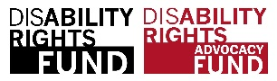
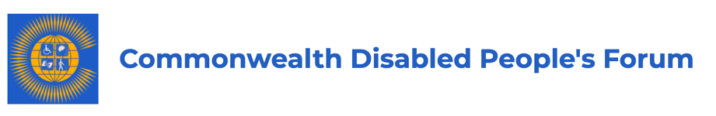

Disabled Women and Girls Policy Paper 2020

Commonwealth Disabled People Forum (CDPF)

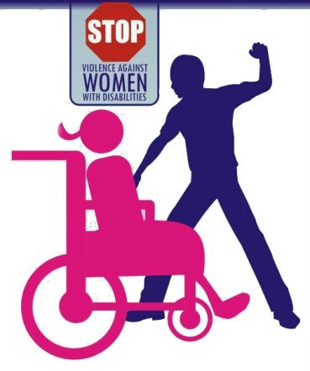
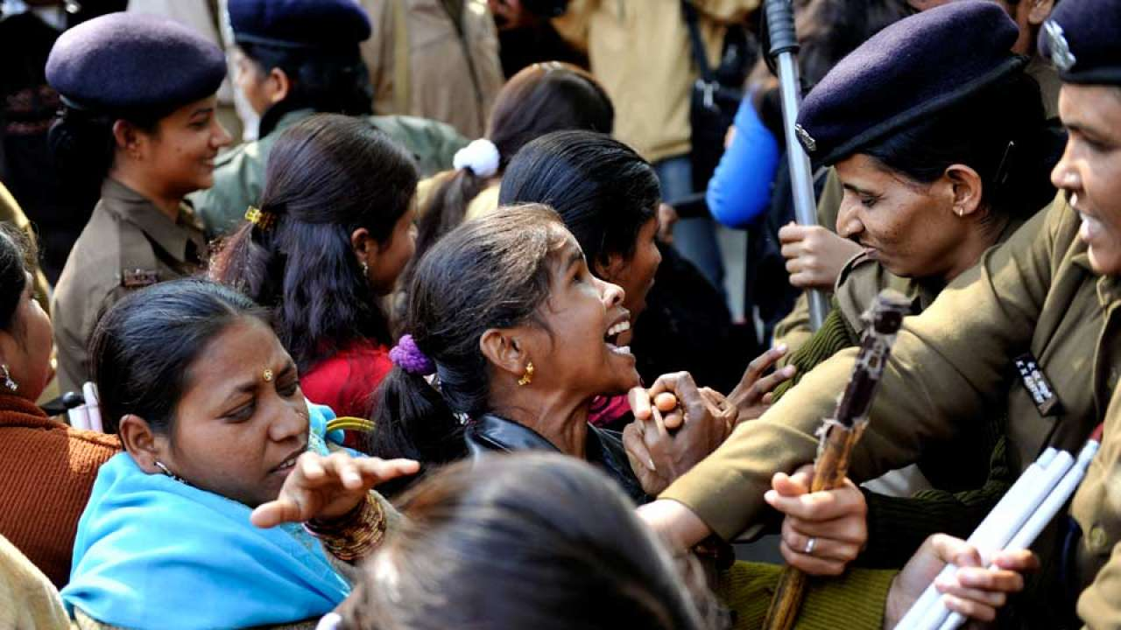

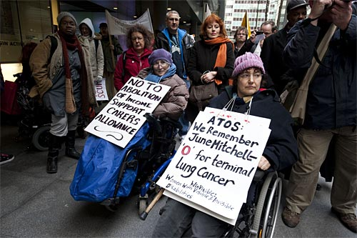
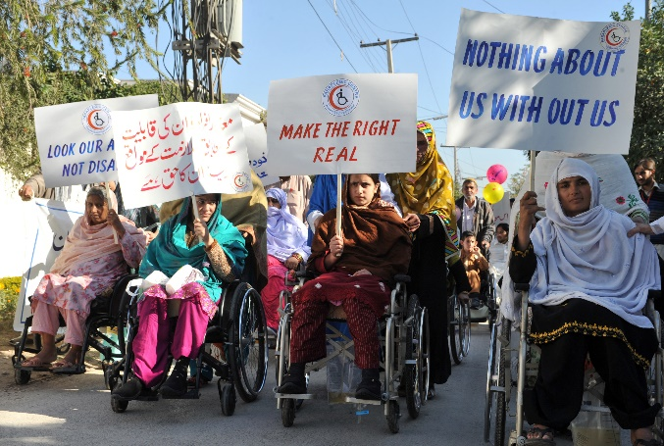

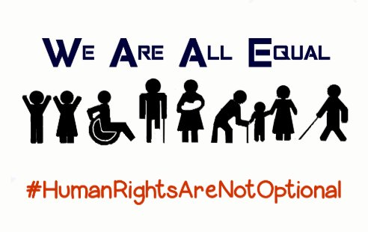
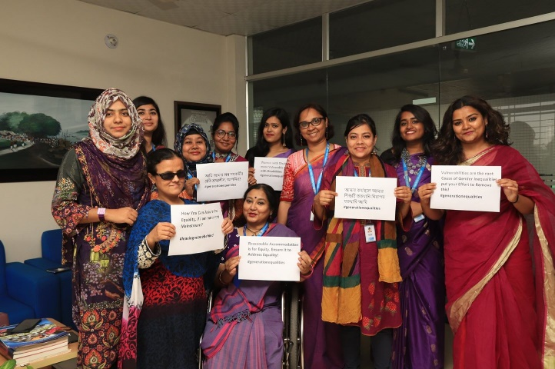

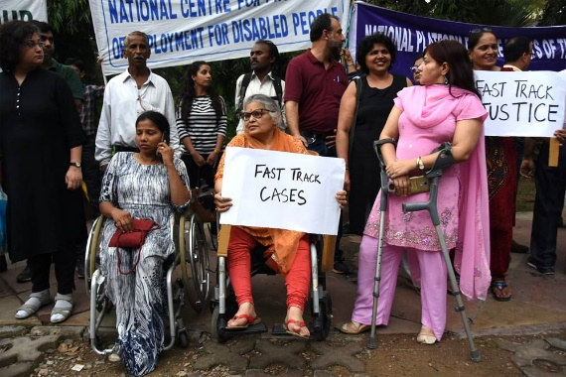
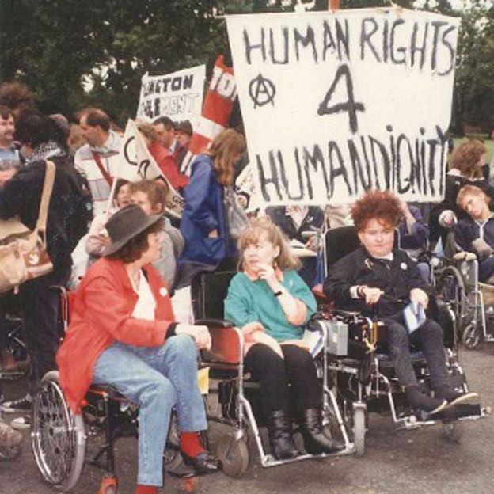
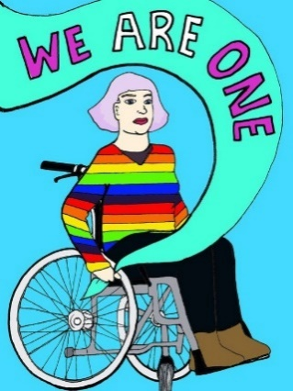

Background Information
It is estimated that more than one billion people in the world experience some form of long term impairment which in combination with societal barriers limits their activities , 50% are disabled women and 80% of them are from rural areas. In Commonwealth countries disabled women and girls include those with multiple and intersecting identities, such as being from different ethnic, religious and racial backgrounds; refugee, migrant, asylum-seeking and internally displaced women; LGBTQI+ persons; women living with and affected by HIV8 ; young and older women; and widowed women, across all contexts. The CDPF supports the social model of disability and except when quoting or referencing international or national treaties or laws, we use the term ‘disabled women and girls’ or ‘disabled people’, as we have many different impairments but are united as disabled people in our opposition to societal barriers and the oppression we face. In the case of disabled women and girls, this is also the oppression of patriarchy and sexism.

The language we use Why we still choose to call ourselves disabled people. In the Commonwealth Disabled People’s Forum we call ourselves ‘disabled people’ or ‘disabled women or girls’ because of the development of the ‘social model of disability’. In the C19th and C20th, a disabled person’s medical condition was thought to be the root cause of their exclusion from society, an approach now referred to as the ‘medical or individual model’ of disability. We also view ourselves as united by a common oppression so are proud to identify as disabled people rather than people with disabilities. Where we are quoting international treaties or laws we will use people with disabilities.

As a consequence of multiple identities, some disabled women and girls are pushed to the extreme margins and experience profound discriminations. Systemic barriers and exclusion lead to lower economic and social status; increased risk of violence and abuse including sexual violence; early and forced marriage discrimination as well as harmful gender-based discriminatory practices; barriers to access education, health care including sexual and reproductive health, information and services and justice, as well as civic and political participation.

Disabled women and girls who experience intersecting forms of discrimination also experience higher rates of unemployment and encounter other gender-based barriers, such as precarious livelihoods, unequal access to and control over assets and resources, child care responsibilities and a lack of access to maternity protection. International and national laws and policies on the rights of Persons with Disabilities have historically neglected aspects related to gender equality. Similarly, laws and policies addressing gender equality have traditionally ignored the rights of disabled women and girls.

Systemic barriers coupled with the failure to prioritize the collection of data on the situation of disabled women and girls, to disaggregate and report it accordingly continues to perpetuate their invisibility and marginalization. Barriers and gaps to the full and effective participation: Disabled women and girls in all their diversity encounter challenges to participation that arise from an array of systemic barriers, including of a legal, physical, informational, communicational and attitudinal nature. These barriers include inadequate availability, implementation and resourcing of data and evidence, legislation, policies and governance mechanisms; the lack of design of accessible products, environments and processes; and inadequate access to justice, education, rehabilitation, habilitation and personal and assistive technology services.

Disabled women are at greater risk because they are marginalized and face greater societal and institutional barriers to claim their rights. They are ‘particularly vulnerable to discrimination, exploitation and violence, including gender-based violence (GBV), but they may have difficulty accessing support and services that could reduce their risk and vulnerability. Disability inclusion appears not to have been prioritised by mainstream actors in the response to previous epidemics.

The Coronavirus (COVID-19) pandemic is a global public health emergency. There is currently very limited data and evidence on the impacts of COVID-19 on disabled women overall and those facing Gender Based Violence in this crisis. However, reports from the media, disability advocates and Disabled People’s Organisations (DPOs) point to several emerging primary and secondary impacts.

Disabled people may be at greater risk of contracting COVID-19 for several reasons. Public health information on prevention measures is often not being provided in accessible formats; water, sanitation and hygiene facilities are inaccessible to some disabled people (according to WHO and UNDESA); social distancing and self-isolation measures are unfeasible for some people who depend on carers to provide for their essential needs (according to OCHR); disabled people in residential institutions and some humanitarian contexts often live in close proximity to large numbers of people, sometimes in unsanitary conditions, and they rely on carers or officials to prevent and respond to outbreaks (according to UNOCHA).

Gaps in access to resources and capacity for disabled women and their representative organizations hinder their effective leadership and participation across the humanitarian–development continuum. Organizations of disabled women and girls find it difficult to access funding, as their work may not fit within the standard portfolios of women’s rights or disability rights. Funders or funding mechanisms are inflexible and do not accommodate them. Intentional investment, including by human rights and women’s rights donors, in these organizations and networks and their capacities is critical to bridge these gaps to ensure full and effective leadership and participation. Gaps in alliances among women’s rights organizations, organizations of disabled people and organizations of disabled women and girls often result in the rights of disabled women and girls being overlooked during the development and implementation of policies, programmes and inter-governmental processes. It is crucial to support the strengthening of alliances across movements by including disabled women and girls.

International Frameworks
Several international, national and regional norms and standards, including human rights treaties and outcomes of various global conferences, directly or implicitly call for the inclusion and empowerment of all disabled women and girls across their life course. These include the Convention on the Elimination of All Forms of Discrimination against Women (CEDAW), the Convention on the Rights of Persons with Disabilities and its Optional Protocol (CRPD), the Convention on the Rights of the Child (CRC), the Beijing Declaration and Platform for Action and the 2030 Agenda for Sustainable Development.

While CEDAW does not explicitly refer to women and girls with disabilities, the General Recommendation of the Committee on the Elimination of Discrimination of Women No. 18 (a) notes that women with disabilities are doubly marginalized and recognizes the scarcity of data, and (b) calls on States parties to provide this information in their periodic reports and ensure the participation of women and girls with disabilities in all areas of social and cultural life. The CRPD includes equality between men and women as one of its general principles.

Article 6 on women and girls with disabilities recognizes the multiple forms of discrimination faced by them, and calls for the full development, advancement and empowerment of women.

The General Comments on the Convention address issues that uniquely or disproportionately affect disabled women and girls, including General Comment No. 3 on Article 6: Women with Disabilities. The Convention on the Rights of the Child recognizes the rights of disabled children in Article 23. The Article states that children who have any kind of disability have the right to special care and support, as well as all the rights in the Convention, so that they can live full and independent lives. The Beijing Declaration and Platform for Action identifies specific actions to ensure the empowerment of disabled women and girls in various areas, bringing disability inclusion into the general efforts to address the multiple barriers to empowerment and advancement faced by women and girls.

The Sendai Framework for Disaster Risk Reduction 2015–2030 emphasizes the importance of disability-inclusive disaster risk reduction. The Framework calls for the inclusion of disabled people in the design and implementation of policies, plans and standards on disaster risk reduction, and promotes the leadership of women and youth in the process. In 2016, commitments made during the World Humanitarian Summit included the achievement of gender equality, the empowerment of women and girls, and disability inclusion in humanitarian action. The Charter on Inclusion of Persons with Disabilities in Humanitarian Action endorsed by Member States, UN agencies, including UN Women, and human rights networks and organizations made specific reference to disabled women and girls. The Charter calls for the empowerment and protection of disabled women from physical, sexual and other forms of violence, abuse, exploitation and harassment and commits to collecting data on disabled people disaggregated by age and sex.

The 2030 Agenda for Sustainable Development recognizes that systematic mainstreaming of gender-based perspectives is crucial to making progress across all the Sustainable Development Goals (SDGs) and targets and calls for the empowerment of disabled people. The 2030 Agenda has a standalone Goal on gender equality and the empowerment of all women and girls and includes disabled people in the SDGs related to poverty, hunger, education, washing, sanitation and hygiene (WASH), economic growth and employment, inequality, accessibility of human settlements, climate change, data monitoring and accountability. The effective implementation of the 2030 Agenda will further contribute to the inclusion and empowerment of disabled women and girls.

Sexual Health and Reproductive Rights of Disabled Women Disabled women and girls account for almost one-fifth of the world’s population of women and they are just as likely to be sexually active as their non-disabled peers. Despite inaccurate stereotypical views to the contrary. Accordingly, they have the same sexual and reproductive health (SRH) needs as non-disabled women and girls. Due to multiple and intersecting forms of gender and disability discrimination disabled women and girls face unique and pervasive barriers to full realization of their sexual and reproductive health and rights (SRHR).

On average, disabled women have similar rates of unmet health needs as disabled men (13 per cent and 12 per cent, respectively), but higher than both non-disabled men and women (4 per cent). This suggests that overall, barriers for disabled people are a major factor impeding access to health care for disabled women. This is consistent with other findings showing that physical, financial, and attitudinal barriers are an obstacle for disabled people in accessing health care (UN Flagship Report on Disability 2018).

The right to sexual and reproductive health means that people have the right to: complete physical, mental and social wellbeing in all matters relating to their reproductive system; a satisfying and safe sex life; the freedom to decide if, when, and how often to reproduce. A range of fundamental rights protected in a number of international and regional human rights treaties underpin the right of disabled women and girls to sexual and reproductive health information, goods, and services, including the Convention on the Rights of Persons with Disabilities (CRPD) and the Convention on the Elimination of All Forms of Discrimination against Women (CEDAW). These include the rights to:
- Life
- Health, including sexual and reproductive health
- Privacy, liberty and security of the person, and to decide the number and spacing of children
- Information and education, including information and education on sexual and reproductive health
- Equality and non-discrimination
- Accessibility
- Enjoy the benefit of scientific progress
- Freedom from torture or cruel, inhuman or degrading treatment or punishment

Disabled Women and girls must be able to make decisions for themselves about their sexuality and reproduction, with support where needed to ensure their voluntary and informed consent. Information, goods, and services must be accessible to disabled people, sensitive to their needs, provided on the basis of non-discrimination, with reasonable accommodations as needed. Comprehensive sexuality education courses and materials, as well as information on sexual and reproductive health and rights generally, must be available in alternative formats. In physical spaces where health care services are provided, medical equipment, and transportation to and from these facilities must be available and accessible to disabled women and girls. Health care workers must be trained to work with disabled women and girls to provide services that are based on dignity and respecting the autonomy of the disabled person.

Supported Decision-Making
Supported decision-making models can help empower disabled people who require assistance to make decisions independently and still retain legal authority to make decisions. Supported decision-making requires making available various support options that can facilitate an individual’s ability to make their own decisions about their lives. Supported decision-making models prioritize the individual’s will and preferences and protect her fundamental human rights, including rights related to personal autonomy, legal capacity and equal recognition before the law.

Gender-Based Violence
In addition to the increased risk due to underlying health conditions, other attitudinal, environmental and institutional barriers increase the risk for Gender Based Violence for disabled women w (Special Reporter on Disability, 2020) during COVID-19.

  - Double discrimination, as a result of their gender and disability increases disabled women and girls vulnerability and the pandemic exacerbate this.
  - The breakdown of economic structures, health care, family and community support, educational opportunities, housing, transportation and other infrastructures, increase the vulnerability of disabled women and girls. They may find it harder to flee or be left behind, making them more at risk of attack.
  - The loss of assistive devices, caregiver and protection networks following lockdown, make disabled women and girls more dependent on others and at greater risk of exploitation.
  - Disabled women and girls face increased levels of sexual and gender-based violence in and out of the home, especially those with intellectual and mental impairments. This is a result of factors such as stigma and discrimination, being seen as ‘easy’ targets, extreme poverty, social exclusion and isolation, loss of protective mechanisms and limited mobility.
  - Disabled women and girls are largely excluded from gender-based violence prevention programmes, including the variety of women’s empowerment initiatives aiming to break the cycle of vulnerability to violence.

Disabled women are often considered weak, worthless and in some cases sub-human by their societies – leading to a heightened risk of domestic and sexual violence.

Unfortunately, too many existing programmes meant to prevent gender-based violence do ignore the unique dangers and challenges faced by disabled women. Without specific attention and solutions, these women have been left behind and at risk.

Disability-based violence occurs in very similar forms to gender-based violence, i.e. on a physical, psychological or economic level, directly and indirectly. Abuse and discrimination of disabled people by medical professionals is commonplace. Often masked as “good intentions” are, in fact, acts of serious discrimination and violence, for example intrusive and irreversible treatments without informed consent, such as forced sterilisation and abortion.

The intersection between disability and gender-based violence is of particular concern because some forms of violence against disabled women have remained invisible and not been recognised as gender-based violence due to disability discrimination. Disabled women around the world experience much higher levels of physical, sexual, and psychological violence, for longer periods of time and with worse physical and mental outcome.

Global data on gender-based violence against disabled women is limited, which in itself speaks to the global inertia on this invisible crisis. The limited data available suggests higher risks for disabled women. The Working Group on Violence Against Women with Disabilities, ‘Forgotten Sisters’ (2012) cites international studies which have concluded that disabled women suffered an equal, or up to three times greater risk of rape by a stranger or acquaintance, than their non-disabled peers.

Access to Basic Facilities
Disabled women and girls experience multiple forms of discrimination by virtue of their femininity and poor standard of living. Marginalization, attitudinal and environmental barriers lead to lower economic and social status. Many are unable to access basic facilities and services, as well as education, health care and meaningful employment, hence they remain uneducated, untrained and unemployed causing a majority to live in conditions of poverty.

A significant number are at an increased risk of violence and sexual abuse, possess low self-esteem and self-worth, are prevented from making their own choices and participating in society on an equal basis with others and often denied equal enjoyment of their human rights.

Discrimination against any person on the basis of disability is a violation of their inherent dignity and human rights and Article 6 of the UN CRPD calls on State Parties to take measures to ensure the full and equal enjoyment of all human rights and fundamental freedoms by Women with Disabilities.

The CDPF Women with Disabilities Task Force supports this call and hereby proposes a few measures that should be implemented to address the situation.
- Ensure that facilities for the general population and Community services are available on an equal basis and are responsive to the needs of women with disabilities.
- Address the negative impact of poverty by ensuring that they are able to access the education system at all levels, thus enabling them to acquire the requisite qualification.
- Develop vocational and skills training programmes in order that they may acquire marketable skills.
- Promote positive perceptions towards women with disabilities as well as greater social awareness of their capabilities and contributions.
- Promote the skills, merits, abilities and contributions of women with disabilities who are contributing positively to the workplace and the labour market.
- Encourage all organs of the media to help raise awareness on the rights of women with disabilities.
- Consult women with disabilities on matters concerning their development and welfare.
- Most importantly, work in collaboration and partnership with National Disabled Peoples’ Organisations (DPOs) to implement articles 5, 10, 22, 24, 25, 27 and 28 contained in the UN Convention on the Rights of Persons with Disabilities.
What does the data show?
This subsection presents available evidence on the status of inclusion, on an equal basis with others, of disabled women and girls. It focuses on available data and information in relation to key areas of the SDGs, including poverty and hunger, access to health-care services, education and employment. The subsection also presents evidence to illustrate the situation of disabled women and girls regarding several Goal 5 targets. (5.1) whether or not legal frameworks are in place to promote, enforce and monitor equality and non-discrimination on the basis of sex. All countries conform to women having the vote other than Saudi Arabia but less than half guarantee gender equality in the constitution.This includes available data on exposure to violence (target 5.2), child marriage (target 5.3), unpaid work (target 5.4), opportunities for leadership (target 5.5) and use of the Internet (target 5.b).
The UN Flagship Report on Disability and Development summarises the global position of disabled women and girls as follows:-
“Women with disabilities are often subjected to double discrimination due to their gender and disability status and continue to be at a disadvantage in most spheres of society and development. Available data suggests that the gap is stark compared with men without disabilities: women with disabilities are three times more likely to have unmet needs for health care; three times more likely to be illiterate; two times less likely to be employed and two times less likely to use the Internet. Among those employed, women with disabilities are two times less likely to work as legislators, senior officials or managers. Women with disabilities tend also to be in a worse position than women without disabilities. Moreover, women with disabilities are at heightened risk of suffering sexual violence compared to those without disabilities.
Compared with men with disabilities, women with disabilities are more likely to have unmet health-care needs; more likely to be unemployed or inactive in the labour market; and less likely to work as legislators, senior officials or managers. In poverty, lack of access to education and the Internet as well as physical violence, the evidence does not seem to indicate a further disadvantage for women with disabilities relative to men with disabilities, suggesting that in several countries attitudinal and environmental barriers against disability, not gender, are the major factor driving the disadvantage experienced by women with disabilities. However, for lack of access to employment and sexual violence, environmental barriers and negative attitudes against both gender and disability seem to play a significant role.
The data is sparse but the report contains indicators for some Commonwealth Countries.
Poverty In Botswana(2014) disabled men and women 42% had not had food to eat in the last 2 weeks compared to 29% of non disabled women and 23% of non-disabled men.
Education In a survey of disabled people in 29 middle and low income countries the percent of 15-29 who had ever attended school averaged 86% for non-disabled men,79% non-disabled women,72% disabled men and 69% disabled women. The countries included Commonwealth countries Gambia, Mozambique, Bangladesh, Ghana, Uganda, Zambia and Maldives and showed some variation with Bangladesh and Maldives more disabled women than men attending education. In Zambia and Kenya disabled men and women have about the same attendance. Increasingly the gap between disabled men and women widens in disabled men’s favour in Uganda, Ghana and Mozambique, while in Gambia disabled men have a higher rate of attendance than non-disabled men and disabled women have a higher attendance that non-disabled women.
Literacy rates show in a survey of 36 countries in 2010 in 32 the disabled women had lower literacy rates than disabled men. In Mozambique 49% of disabled men can read compared to only 17% of disabled women.
Employment Disable Women regionally have lower employment rates. The gap between disabled men and women in Central and Southern Asia is 26%, 12% in Sub Saharan Africa, 11% in Oceania and 12% in Latin America and Caribbean.
Violence The percent of disabled people who have experienced violence because of their condition in Mozambique is 8/9% women and men and in Malawi bot 5%. However, the percent of disabled women who have ever been beaten or scolded because of their condition is 26% in Lesotho, 21% in Eswatini and 17% in Botswana.
Political Representation
“1) In 2019 only 24 per cent of the world’s parliamentarians are women. Only 6 per cent of Heads of State and 5 per cent of Heads of Government are women. In short, women’s voices are missing. More than 10 years after the adoption of the Convention on the Rights of Persons with Disabilities, significant gaps continue between commitments and action to achieve gender equality and the empowerment of women and girls with disabilities. Nonetheless, some women with disabilities are playing a prominent role in the public sphere, demonstrating their capacity and transformative role in political leadership.
2) Women with disabilities are severely underrepresented in decision-making: while both women and men with disabilities are underrepresented, evidence from 19 countries in 2017 shows that only 2.3 per cent of women with disabilities compared to 2.8 per cent of men with disabilities held a position as a legislator, senior official or manager. According to 2017 data, in 14 out of 18 countries in Asia and the Pacific region, there was no female parliamentarian with disabilities in the national legislative body; and in the other four countries, the share of women parliamentarians with disabilities ranged from 0.3 to 6.3 per cent.
3) Women with disabilities are underrepresented in national coordination mechanisms on disability matters: across 17 countries or areas from the Asia and Pacific region in 2017, organizations of persons with disabilities included nearly twice as many men as women – representing 21 per cent and 12 per cent of all mechanisms respectively. In other types of organizations, men were similarly overrepresented – making up 43 per cent of all mechanism members, versus 24 per cent for women.
4)Women with disabilities are underrepresented in gender equality institutions: in 7 of those same 17 countries, national machineries for gender equality included no women with disabilities among their membership, and in the remaining five countries, only 9 per cent of members were women with disabilities.
5) Fewer women lead organizations of persons with disabilities: social media data analysed in 2017 indicated that 42 per cent of women versus 58 per cent of men held leaderships positions in Spanish-speaking organizations working on disability issues or with persons with disabilities”.

Political Participation
Disabled women are subject to multiple discrimination and are alienated in certain areas of life like politics. The CRPD in Articles 5: 6: and 29 addresses issues of including disabled women in all spheres of development. Women are encouraged to get involved in the political arena which is dominated by men. The CRDP in Article 5: Equality and non-discrimination states that:

1. States Parties recognize that all persons are equal before and under the law and are entitled without any discrimination to the equal protection and equal benefit of the law.
2. States Parties shall prohibit all discrimination on the basis of disability and guarantee to persons with disabilities equal and effective legal protection against discrimination on all grounds.
3. In order to promote equality and eliminate discrimination, States Parties shall take all appropriate steps to ensure that reasonable accommodation is provided.
4. Specific measures which are necessary to accelerate or achieve de facto equality of persons with disabilities shall not be considered discrimination under the terms of the present Convention.

Article 6: Women with disabilities

1. States Parties recognize that women and girls with disabilities are subject to multiple discrimination, and in this regard shall take measures to ensure the full and equal enjoyment by them of all human rights and fundamental freedoms.
2. States Parties shall take all appropriate measures to ensure the full development, advancement and empowerment of women, for the purpose of guaranteeing them the exercise and enjoyment of the human rights and fundamental freedoms set out in the present Convention.

Article 29 : Participation in political and public life

States Parties shall guarantee to persons with disabilities political rights and the opportunity to enjoy them on an equal basis with others, and shall undertake:

(a) To ensure that persons with disabilities can effectively and fully participate in political and public life on an equal basis with others, directly or through freely chosen representatives, including the right and opportunity for persons with disabilities to vote and be elected,
(b) To promote actively an environment in which persons with disabilities can effectively and fully participate in the conduct of public affairs, without discrimination and on an equal basis with others, and encourage their participation in public affairs,
- Countries should formulate policies taking measures to address the multiple barriers faced by women with disabilities that prevent them from exercising their political rights, including as voters and candidates;
- Countries should adopt zero tolerance policies for violence against women with disabilities in politics,15 including psychological violence perpetuated by prejudices and stereotypes that women with disabilities are incapable of having independent opinions about public affairs and policies or the knowledge of their equal political rights;
- Countries should strengthen institutional and environmental support for women with disabilities, most of whom lack the necessary supportive and enabling conditions for developing a political career, even when they are interested and qualified;
- Countries should promote political participation of women with disabilities in all policy matters, including by demonstrating and valuing how their experiences, perspectives and expertise enrich whole societies when they are reflected in policy outcomes;
- Countries should promote the visibility of various women with disabilities who currently occupy high-level leadership positions and whose leadership positively impacts on the lives of women, girls, men and boys as a result of their merits, abilities and skills, who can serve as role models for millions of women and girls with disabilities in the world; and
- Provide equal opportunities for civic education and political leadership training to encourage women with disabilities to pursue decision-making positions;
Sustainable Development Goal 5: Achieve gender equality and empower all women and girls is a tool that can be used to include women with disabilities to participate in formulating sound policies and enforce legislation for the promotion of gender equality and the empowerment of all women and girls with disabilities at all levels.

Despite the increasing number of States ratifying the CRPD and the steps these countries have taken to implement Article 25, disabled people continue to experience unmet health needs and barriers to accessing health services in comparison to the general population. Moreover, disabled people report poorer health and poorer mental health and continue to face barriers to economic, social and political inclusion. This exclusion has negative impacts on their well-being. All these constitute a genuine obstacle to the implementation of SDG Goal 3 health and wellbeing. To improve this situation, it is essential that changes must be fully collaborative among all stakeholders, including disabled people, to promote health and well-being, with a focus on systematic actions across national health-care systems.

Health and disabled women
The Goal 3 targets focusing on health status and services can only be realized for disabled people if their implementation is in line with article 25 of the CRPD. In order to achieve the highest attainable standard of health for disabled people, the following actions should be taken into account:

1) Strengthen national legislation and policies on health care in line with the CRPD. The process of assessing existing laws and policies should involve all stakeholders, including DPOs, and should be based on information about health inequalities as well as evidence-based assessments of the gaps in health-care service delivery and of the policy and legal barriers to accessing health-care services. To legally ensure access to health-care services, and because of the wide range of accessibility issues that need to be addressed, national strategies should ensure wider, general protections to the right to the highest standard of health, either through constitutional, anti-discrimination or other national disability legislation, and then pursue the detailed accessibility issues by means of regulations and guidelines at the community level.

2) Identify and eliminate obstacles and barriers to accessibility in health-care facilities.
Develop national accessibility guidelines for health-care facilities in consultation with disabled people. Conduct accessibility assessments in medical facilities and make use of crowdsourced information and user feedback to have bottom-up information on accessibility. Ensure that disabled people have accessible transportation to health-care facilities.

3) Improve health-care coverage and affordability for disabled people as part of universal approaches to health care. Implement Universal Health Care by identifying national actions, in consultation with disabled persons, to progressively close the gap in health-care service utilization, improve the quality and range of health-care services, and reduce health-care costs for disabled persons.

4) Train health-care personnel and improve service delivery for disabled people. Integrate disability-inclusive education into the curriculum and training for health professionals. Involve persons with disabilities in the design and provision of training, to the extent possible. Develop strategies for holistic, people-centred care so as to improve the quality and continuity of care for disabled people.

5) Empower disabled people to take control over their own health-care decisions, on the basis of free and informed content. Ensure access to and accessibility of health-related information, including through alternate means of communication accessible to disabled people. Disseminate health information through training of disabled people and peer support, so that they are better prepared to make decisions about their own health and become aware of the health- care services they can benefit from.

6) Prohibit discriminatory practices in health insurance and promote health insurance schemes offering coverage for assistive products and rehabilitation services. Private and public insurance schemes should not limit the availability of coverage for pre-existing conditions. These discriminatory practices disproportionately affect disabled people. In addition, discriminatory practices on the basis of disability should be prohibited. Countries should promote health insurance schemes addressing the needs disabled people, particularly for assistive products and rehabilitation services.

7) Improve research and data to monitor, evaluate and strengthen health systems to include and deliver for disabled people by gender. Conduct further research on the need for high quality health- care services; public health promotion; disease prevention programmes; and the barriers that disabled people encounter to access these services. Establish health system monitoring and evaluation mechanisms that can track the outcomes of health system reforms that address barriers to accessing health services especially for disabled women. In addition, more studies are needed to understand the reasons for poorer self-reported health for disabled people and for their increased morbidity and mortality. Studies are also needed to assess whether these poor health outcomes are linked to underlying health conditions/ gender or environmental barriers such as lack of social support or access to health services. For health care and social service planning, it is important to investigate this causation more closely, in particular, more longitudinal research is needed.

Examples of Positive Practice

United Republic of Tanzania : As part of efforts to improve the participation and representation of women, youth and persons with disabilities as leaders in political processes, UN Women helped strengthen gender mainstreaming and inclusive electoral management and processes in coordination with UN partners ahead of the 2015 election. Consideration for disabled people led to the introduction of a tactile ballot system for the first time, and specific arrangements to ensure polling stations and information were accessible. In 2017, building on the results and partnerships with networks disabled people UN Women supported reviews of discriminatory legislative frameworks, contributing to the enactment of the Legal Aid Act which formalized legal aid services, a key indicator for access to justice to women and girls, especially disabled and the elderly, who have less access to legal support.

Fiji and Pacific 1) According to the findings carried out by Pacific Women Shaping Pacific Development, Women’s political participation currently comprises around 7.5 per cent in the Pacific. However political participation of women with disabilities in Fiji and the Pacific region is extremely low. Despite the introduction of Temporary Special Measures (TSM) in the Pacific region to ensure the active participation of women in Parliament, women with disabilities are excluded from equal political participation.
2)The information on women with disabilities engaging in the political process in the Pacific is not available anywhere. Amongst women with disabilities in political leadership roles in your country, which groups of women with disabilities (e.g. women with sensory disabilities such as visual and hearing impairments, physical disabilities, and intellectual and psycho-social disabilities) are most represented?
3)None of these groups of women with disabilities are represented in political leadership roles in Fiji and including the Pacific region.
What are the obstacles limiting women with disabilities’ participation and representation in politics in your country?
4)Women with disabilities face barriers in accessing the political process in Fiji and the Pacific region. The attitudinal barriers, intimidation, and financial barriers are some of the barriers that women with disabilities experiences.
Women with disabilities in the Pacific also face multiple barriers where stigma, discrimination is high due to cultural and traditional believes and lack of opportunities hinder their social inclusion. Most women with disabilities lack access to education or to productive employment. They are often subject to all forms of violence and abuse.
Women with disabilities also face additional barriers to achieving gender equality, and are subjected to educational, social, cultural and economic disadvantages making it more difficult for them to take part in community life and take on political leadership roles.
Voting itself is a major barrier due to the lack of accessibility of voting station, barriers to accessible information for persons with visual and hearing impairments.
5). What can be done to increase women with disabilities’ access to political leadership roles in your country? How inclusive of women with disabilities are existing programmes focused on women’s political participation? Please share concrete examples of programmes, laws, regulations, and practices.
• There is a need to targeted leadership interventions with young women with disabilities, building their capacity and providing mentoring support
• Capacity building through training for women candidates with disabilities; mentoring opportunities for women with disabilities, and research that informs programming in this area.
• More opportunities should be given for women with disabilities to get an education
Under the UNDP Pacific Office on Women’s Political Participation, young women with disabilities from Fiji DPOs are inclusive in the UNDP existing programmes focused on women’s political participation in Fiji. The Practice Parliament for Women is a program aims at encouraging women to enter parliament in Tonga. The program aims to encourage interested women, from age 21 upward to apply for a seat in the 30 seats, Practice Parliament for Women two seats set aside for youths (young women with disabilities). The objective of the exercise is to have more women representatives in parliament.

Cameroon
“The political participation of women with disabilities in Cameroon has been timid and is at grassroots levels. We have at least 3 women with disabilities who are councillors in local council areas in the Northwest region and play interesting roles of collecting data on the number of women and persons with disabilities resident in the localities with a needs assessment and furnishes that with the council for possible interventions. Apart from this, we don’t see women with disabilities anywhere in politics. Their involvement at this level is made possible by the capacity development on assertiveness and advocacy provided them by the SEEPD program. Unfortunately this information is not published anywhere as the number is so insignificant. First and foremost, the challenge is the lack of education. Few of those women living with disabilities are educated and this bars them from being able to assert themselves to be able to lobby advocate their rights. Secondly, there is poverty which is so heavily infringing on the daily living of people living with disabilities. Their triple jeopardy of being women, living with disabilities and lacking economic strength are factors that disfavour them from political participation like other community life. Access to quality education and transition to higher education is a prerequisite for women with disabilities to ply the road to politics in Cameroon. Capacity development and enhancement is equally incumbent to ensure and promote women’s participation in politics. Its always a twin tract approach. There is need to support development actors and also conscience raising of politicians to mainstream disabilities in their actions. The government on its part should put a quota representation for women with disabilities both in governance and politics. Disability inclusive data is so much lacking to even inform decision making in almost all sectors of life in Cameroon”.

International
Declaration Towards Bejing 25 signed by leading disabled women activists and their allies calls on state parties in preparing for Bejing 2025 to among other things to :

“Call upon all Member States to strengthen efforts to empower women and girls with disabilities and enhance their participation and promote leadership in society, particularly to:
(a) Ensure the full and equal participation of women and girls with disabilities in decision-making, through the formulation of national laws and policies, consistent with their exercise of legal capacity, equal protection under the law and prohibition of discrimination;
(b) Promote and protect the human rights of women and girls with disabilities with respect to power and decision-making from early childhood, recognizing that decision-making is a process that develops throughout life and is reflected in everyday life, beginning from the family, where opinions of women and girls with disabilities must be considered in individual, family and collective decisions;
(c) Take measures to address the multiple barriers faced by women with disabilities that prevent them from exercising their political rights, including as voters and candidates;
(d) Adopt zero tolerance policies for violence against women with disabilities in politics,15 including psychological violence perpetuated by prejudices and stereotypes that women with disabilities are incapable of having independent opinions about public affairs and policies or the knowledge of their equal political rights;
(e) Strengthen institutional and environmental support for women with disabilities, most of whom lack the necessary supportive and enabling conditions for developing a political career, even when they are interested and qualified;
(f) Promote political participation of women with disabilities in all policy matters, including by demonstrating and valuing how their experiences, perspectives and expertise enrich whole societies when they are reflected in policy outcomes;
(g) Promote the visibility of various women with disabilities who currently occupy high-level leadership positions and whose leadership positively impacts on the lives of women, girls, men and boys as a result of their merits, abilities and skills, who can serve as role models for millions of women and girls with disabilities in the world; and
(h) Provide equal opportunities for civic education and political leadership training to encourage women with disabilities to pursue decision-making positions.”

Malawi Suggestions for Gender Based Violence inclusive of disabled girls and women
“1) In Malawi, violence against women is widely acknowledged as a serious concern, not only from a human rights perspective but also from economic and health perspectives. To address this issue, Malawi has enacted a series of laws, including the 2006 Prevention of Domestic Violence Act, the 2011 Deceased Estates (Wills, Inheritance, and Protection) Act, and the 2013 Gender Equality Act. However, Malawi’s legal and policy framework has failed to fully take women with disabilities into account in efforts to address gender inequalities and gender-based violence. For example, although the 2015 Malawi National Gender Policy refers to persons with disabilities, it does so irrespective of their gender, and neglects to adopt an intersectional approach. Similarly, the 2014 – 2020 National Plan of Action to Combat Gender-Based Violence in Malawi refers to the “physically challenged” as part of vulnerable groups, leaving behind persons with other types of disabilities, and fails to recognize the intersectional needs of women with disabilities.
2)Gender-based violence against women with disabilities worldwide takes many unique forms, due to intersectional discrimination based on gender and disability, among other grounds. According to the former U.N. Special Rapporteur on Violence against Women, Rashida Manjoo, violence against women with disabilities can be of a “physical, psychological, sexual or financial nature and include neglect, social isolation, entrapment, degradation, detention, denial of health care, forced sterilization and psychiatric treatment.” Violence against women with disabilities also has unique causes, including violence that is perpetuated by stereotypes “that attempt to dehumanize or infantilize, exclude or isolate them, and target them for sexual and other forms of violence.” In its General Comment No. 3 on women with disabilities, the CRPD Committee has found that “[s]ome women with disabilities, in particular, deaf and deaf-blind women, and women with intellectual disabilities, may be further at risk of violence and abuse because of their isolation, dependency or oppression.” Worldwide, women with disabilities are also more likely to be in unstable romantic relationships, as due to discrimination they are often considered less eligible for marriage, and they also experience domestic violence in all of its forms—physical, sexual, emotional, psychological, and financial—at twice the rate of other women.

3) Although there is limited data on the prevalence of violence against women with disabilities in Malawi, studies and DIWA’s activities and experience indicate that this violence is widespread. For example, a small, one-year project carried out by DIWA in Lilongwe in 2015 revealed over 100 cases of sexual violence against women with disabilities. A 2018 national study documented that a significant number of women with disabilities reported being “beaten or scolded” due to their disability by family or relatives (44.1%) and others (16%).

4) Further, a 2014 baseline study by DIWA in Malawi found that, among participants, over 64% of women and 56% of girls had experienced exploitation, violence or abuse. The most frequent perpetrators were relatives, community members, health workers and people in authority, such as social service providers. Some of the most common forms of abuse were physical abuse, disability-specific abuse (such as being pushed on a wheelchair), and sexual violence. However, the vast majority of women and girls with disabilities did not report the abuse or violence, often due to stigma or because they lacked access to information about where or how to do so.

5) Women with disabilities are also particularly vulnerable to financial abuse and property grabbing by family members upon the death of their spouse.
Annie Mandundu, a 62-year old woman with a physical disability from Lilongwe, was left speechless when, following her husband’s death, his relatives came and grabbed all the property she and her husband had accumulated over the years of their marriage. The relatives fought with the kids, while Annie looked on helplessly. She did not know her rights or what to do in response to this behavior.

6)This is one of the many cases that DIWA has submitted to the Ministry but none of the cases were ever pursued except one. If it is that difficult to train, why not include this in the curriculum of the police, judicial training in schools.

Pheretu is a deaf and dumb girl who was 18 years old at the time of opening the case, coming from Lumbadzi had been raped from the age of 15 by the village chief who happened to be hIV positive until she got pregnant and bore a son who was 2 years old at the time of the case handling by DIWA. Despite everyone knowing about the case in the village including her parents, they could not report the case, until DIWA’s awareness meetings that identified the girl and discovered the case. The parents were encouraged to report the case to the police Lumbadzi station of which when they did, DIWA reported the case to the Ministry of Gender to the attention of the then Lawyer Juliet who was assigned to take care of all cases of disability. To our disappointment, the case was never followed up until DIWA took it upon itself to pursue the case and the chief was arrested and sent on remand at Maula Prison. Due to sickness, the man was released and was appearing in court as required until he died the day before judgment.

DIWA Malawi Recommendations on Gender-Based Violence and Abuse
- Involve representatives of women with disabilities, in all their diversity, in the revision process for the Plan of Action to Combat Gender-Based Violence in Malawi, to ensure that issues at the intersection of gender and disability are fully addressed.
- Create accessible “know your rights” programs targeted at women with disabilities to ensure that they have the information they need to be confident in accessing justice mechanisms when they are victims of violence.
- Train the police force, other emergency responders, and other justice system actors on how to assist victims of violence who are persons with disabilities. This training should be targeted to ensure that violence and abuse against women with disabilities is appropriately investigated and prosecuted, regardless of the disability status of the victim, and that the needs of women with disabilities are reasonably accommodated in police investigations and in legal proceedings”.

India Women with Disabilities Network the Alternative Report
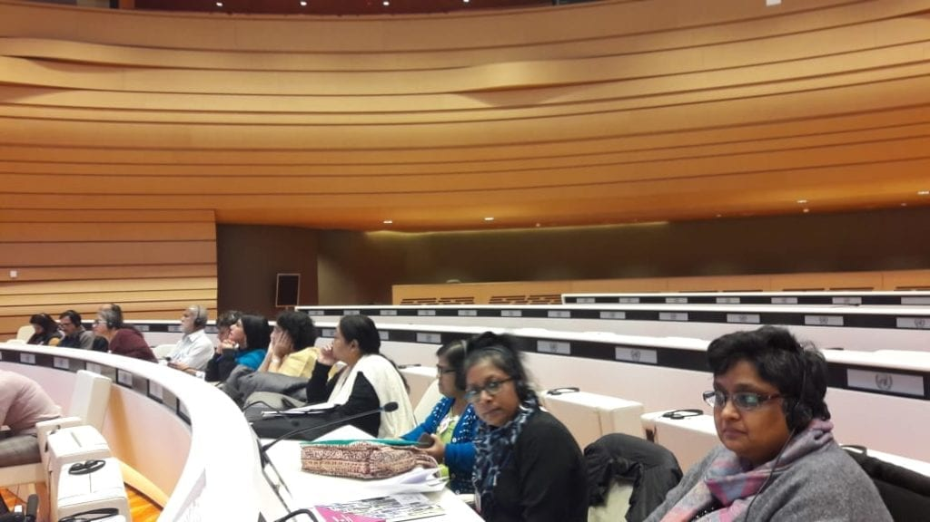
“It is the product of two years of data collection (2017 and 2018) from consultations with 441 women with disabilities in 23 states of India. Women with disabilities are one of the most vulnerable and invisible sections of society in India. They are marginalised in different ways related to education, livelihood and access to health and other services leading to different forms of gender and disability-based violence within families and communities.

The report appreciates the positive initiatives taken by the Government of India such as the passage of the Right to Persons with Disabilities Act 2016. The India Country Report has extensive listings of legal provisions, schemes and programmes for persons with disabilities in India. However, little data is provided about differential access women with disabilities have to these provisions. One of the reasons for this is that there is no coordination on issues of women with disabilities, who are relegated to the Disability Department by the Women and Child Development Department and often times overlooked. As a result, women with disabilities continue to remain far from achieving either de-facto or de-jure equality. The recognition of the legal capacity of women is partial, and this can be seen in old and even new legislation such as the Mental Health Care Act (2017).
The Women with Disabilities India Network delivered the alternative report in La Salle des Emirates in the Palace of Nations, Geneva.
Our research revealed that women with disabilities are consistently marginalised in education and employment, with low enrolment and work force participation. An insufficient number of schools in rural areas, where the vast majority of disabled people live, affects access to education; in particular, there are low enrolment numbers for girls with disabilities.
‘In practice women with disabilities have effectively no access to the justice system.’
Education of disabled girls is also affected by factors like poverty, adolescence and puberty; the distance of educational institutions from home has a specific effect on girls as they are thought to be more vulnerable during long commutes than their male counterparts. The distance between home and school along with poor commuting facilities is a crucial factor in determining dropout rates among disabled girls from educational institutions. This is compounded by lack of accessible infrastructural and residential facilities.

Our findings show that women with disabilities are particularly vulnerable to violence both in domestic and public spaces. Much of this violence is undocumented and unrecognised as policies and practices in India fail to address specific barriers faced by women with disabilities, particularly in response to gender-based violence and violations of sexual and reproductive rights. Gender-based violence against women with disabilities takes many unique forms and includes violence that is perpetuated by stereotypes attempting to dehumanise or infantilise, exclude or isolate them, and target them for sexual and physical abuse. Many women with disabilities experience gender-based discrimination in the private sphere, ranging from harassment and emotional abuse to rape and physical violence. Women with disabilities in India also face violence at the hands of intimate partners, including husbands and their families.
The Women with Disabilities India Network sat opposite the United Nations Committee on Persons with Disabilities as they delivered their alternative report.
Women with disabilities—particularly women with intellectual or psychosocial disabilities—are disproportionately subjected to practices such as forced or coerced sterilisation, contraception and abortion. Frequently, when these women are minors or are deprived of legal capacity, guardians, parents, or doctors may make the decision on their behalf. Women with psychosocial and intellectual disabilities face discrimination in the form of continued institutionalisation in state- and privately-run care homes and hospitals. Indian Laws however do not take cognisance of the special types, intensity and magnitude of violence perpetuated against women with disabilities. While some laws address violence against women with disabilities in institutional settings, in practice women with disabilities have effectively no access to the justice system.
The most obvious barriers to equality before the law in terms of disabled women’s access to the justice system are physical access, communication barriers, and financial constraints. Current policies and practices in India addressing violence against women fail to address the unique causes and consequences of gender-based violence against women with disabilities. For instance, the Rights of Persons with Disabilities Act 2016 does not address violence against women with disabilities.
While in Geneva last month, the WWDIN team presented our findings during two interactions with the CRPD – one with the entire committee and a second meeting with committee member Mr. Jun Ishikawa. In both our engagements, we were able to impress on the CRPD committee members the violations of the rights of women with disabilities in India, the roots of these problems and their varied nature. The committee members asked pertinent questions, asking for clarification on several points and duly noted that there is a need to engage more proactively on issues of violence against women with disabilities. The outcome of the pre-session has been favourable as the List of Issues mentions the violations of rights of women with disabilities and enjoins the Indian state to be more proactive in addressing the concerns of women with disabilities across the country.”
Annexure 5 Violence against Women with Disabilities

Issue | Disability | Brief Description | Date /Place | Action Takenby State
Forced Sterilization | Intellectual | 1. Not married her mother is her carer and takes decision on her behalf. Sterilized since she was not being able to handle her monthly menstruation cycle. | 1.Kept at home  (09.09.2017 Telengana) | None
 | Intellectual | 2. 23 year old illiterate woman sterilized when 17 Doctor supported to avoid unwanted pregnancy. Parents daily labourers. | 2.Secluded in the home  (19.11.2017 Raipur) | None
 | Physical | 3. Parents left her with brother and his wife and they shifted abroad. Before going sterilized as she cannot independently manage her menstruation. Studied till under graduation. Level. After an attempt at rape she was stopped from going outside the house. | 3.Secluded in the home  (19.11.2017 Raipur) | None
 | Physical | 4. Orphaned stayed with brother and wife Sterilized at age 11 as would not know how to manage menstruation | 4. At home  (28.08.2017 Koppal Karnataka)
Sexual Violence | 1.Physical | 1.Unmarried Parents Daily labourers. Her income pension INR 300per month (40 $) A drunk entered her house and tried to rape her she could not protect herself. | 1. lives with parents and brother and his family.  (25.10.2017 Odisha) | None
 | 2.Physical | 2.Illiterate. Mother and 6 siblings. She was married young battered. After 2 children underwent forceful hysterectomy was done | 09.09.2017 Telengana)
 | 3.Psycho-social | 3. Married battered sent home. | 3 With help of NGO took case to court under DV Act. Court ordered monthly allowance but not been provided.  (30.10.2017 Kolkota) | Case No
Sexual Abuse Rape | Visual Disability | Raped when young so not allowed to go to school. | (25.10.2017 Odisha)
Sexual abuse | Physical disability 50 year old | Sexually assaulted by a drunk neighbour on resisting beaten up.  Neighbours blamed her | Filed FIR two years ago  (06.06.2017 Patna) | No justice
Abandoned | Visual Impairment | Fight over family property father killed and mother committed suicide  Taken by her uncle she was beaten physically | left in an Ashram (religious place)  12.01.2017Gujarat) | No action
Abandoned | Visually Impaired – 18 years | Studied class six. Drop out Her parents unable to take care. Have not ever visited her | left her in an Ashram(12.01.2017Gujarat) | No action
Abandoned | Physical Disability | Mother died (when 1 year old) Stepmother did not accept lived with her uncle educated till class 5 then married beaten so returned home father raped her. Went to husband’s home had child and abandoned at railway station and resorted to sex work. | (30.10.2017 Kolkota) | Police sent her to a rescue home.
Abandoned | Visual 19 years | Children grown up no contact with family  Father poor, mother left them. Faced food insecurity. | Sent to a home family has never contacted  (19.02.2018 Bhopal) | No action
Abandoned | Visual 12 years | Orphan Found in garbage box. | sent to a home adopted by the person who runs the home  (16.05.2018 Deheradun) | Rescued by police
No rehabilitation | Multiple Disability (Deaf-blind) 12 years | Saved from drowning in a canal. | Sent to a home.  (12.01.2017Gujarat) | Gets shelter food but no rehabilitation
Multiple (blind-psycho-social)  Forced abortion | 40 | Married at age 20 beaten lost her sight and suffered from mental illness. In laws used ‘black magic’ to cure her. She was thrown out of the house. She was pregnant and they forced her to have a abortion | Someone guided her to a home  (26.03.2018 Lucknow) | No action
Physical disability  Motherhood | Physical disability | Her husband had an affair and brought the other women to live with them. They then threw her out. | Went court for compensation  Won case One Lakh Seventy Five thousand INR  (12.01.2017 Gujarat)
Mental illness due to marriage/violence |  | Her father passed away, brother committed suicide and to stabilize her condition she got married. Her husband used violence against her which made her mentally. | Now she is residing in Calcutta Pavlov Hospital and is undergoing treatment  (20.01.2018 Kolkota) | No action  Support to the woman by Anjali
 |  | When ill in-laws used to physically and verbally torture her. Ultimately she had to go back to her parents house were also her sister in law was abusive. Due to this psychological problem she started to wonder from place to place. | (12.01.2018 Kolkota) | Police rescued her and got her admitted Lumini Park Mental Hospital  Support to the woman by Anjali
 |  | Her husband used to physically and mentally abuse her even tie her up. He did not give her money for house hold expenses. Her 3 children were taken away from her and sent to her in -laws place and was not allowed to meet them. She was taken to Antara Home for treatment | she was admitted to Lumbini Park.  (27.10.2014 Kolkota) | Support to the woman by Anjali

Kenya 20th May 2019 Action by Disabled Women on Violence to Disabled Women
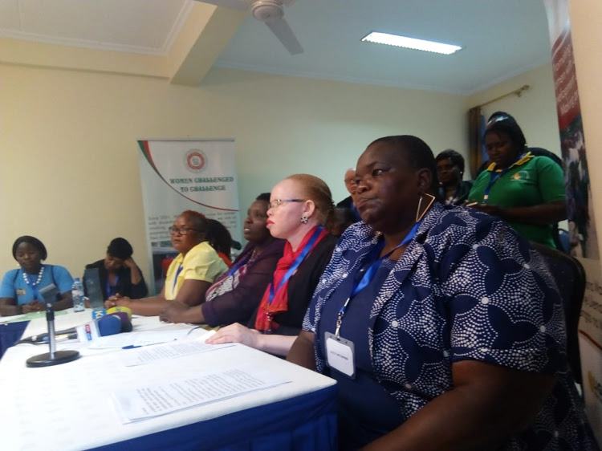
NO JUSTICE FOR DISABLED WOMEN: o Demonstrate in Machakos on Monday.
A physically disabled Machakos woman was sexually assaulted, murdered and her crutches were inserted into her private parts. That happened last Wednesday, the latest in a series of assaults on helpless women living with a physical disability. As a result, women living with disabilities will hold demonstrations in Machakos on Monday to protest against rising cases of
violence against women with disabilities
Image: MAGDALINE SAYA

They call it a crisis.
Members of the United Disabled Persons of Kenya and Women Challenged want the DCI to swiftly solve murders and other criminal assaults against women with disabilities. They cited the assault and murder of a 37-year-old woman who lived alone in Kalama location. She was found naked on her bed on Wednesday morning last week, her crutches inserted into her private parts. The body was found by relatives who live in the same compound. It was taken for a post-mortem to Machakos Level 5 Hospital.
Police are investigating. “Women with disabilities, just as all people in Kenya, have a right to be treated with dignity and respect,” Elizabeth Ombati said. “We are greatly angered and alarmed at the recent spate of sexual and physical assaults including rape and murder of women with disabilities," she told a gathering.
They said a woman living with a disability in Busia county was gang-raped and killed in July last year. A woman with a mental disability was sexually assaulted by her relatives in Nyandarua. When the case came to light, the family decided to settle out of court. “A deaf girl in Nyeri county, an orphan, was raped and the police have taken no action while the culprit, well known, has not been taken to custody,” Jane Kihungi from WCC said. In another incident, a girl with a mental disability from Nyahururu was gang-raped in 2015 and after long years of court processes with all the right supports, the case was thrown out of court for ‘lack of evidence’ early this year.
“This became one among the many cases where justice has eluded women and girls with disabilities. Indeed, the brutality of these acts of violence is only heart-breaking but also build up within our hearts. It's painful anger that cannot be expressed,” Kihungi said. The women said that in most of the cases of sexual violence against women and girls with disabilities, few people want to testify in court. “Cases come to court when they are weak and they are dismissed,” Kihungi added. The women said that because of entrenched stigma against disabled people, many family members do not want to associate themselves with public enquiries, despite the fact that the victims are their children or relatives. Kihungi said when children with disabilities witness their peers being sexually assaulted, their word is not taken as credible evidence against the perpetrators. "We must urgently address this crisis so that justice is accessible to women and girls with disabilities," Kihungi said.

“Nigerian Women Living with Disabilities Seek Equal Justice”
ABUJA, NIGERIA - Nearly half the people in Nigeria are women and about 20 percent of them live with a disability, according to research by a Nigerian advocacy group. Activists say many of those women face stigma and suffer injustices because of their condition, including gender-based violence. But one disabled woman is pushing back to ensure women like her have better access to healthcare and equal justice.
Eberendu Onyinyechi was barely a year old when she was struck with an illness that paralyzed both her legs. Undeterred by her condition, she got an education, earned a linguistic degree, and now works for the Abuja government. But like many of Nigeria's disabled women, Eberendu says she has been subjected to sexual violence.
"Many times when some of us are in a relationship, these guys tend to take advantage of us. I think sex is supposed to be something I consent to, you don't force me to do it, you don't try to use the strength of a man to try to take it. But, unfortunately, that's what many of us suffer," Eberendu said.
Women and girls with disabilities in Nigeria are three times more prone and vulnerable to gender-based violence than their able-bodied counterparts, according to a non-profit activist group. Violence by intimate partners is the most common case. They also find it harder to seek justice because of stigma and bias associated with their condition, says Irene Patrick who heads the non-profit Disabilities Rights Advocacy Center. "Most times they're not believed," she said. Patrick's Abuja-based group, known as DRAC, is helping women and girls with disabilities get better access to justice. She says the situation is serious in Nigeria. "Nobody believes that as a woman with disabilities you were raped because of the societal notion that women with disabilities are not sexually attractive, nobody can actually desire them enough to rape them. So we found that this is preventing them from getting access to justice because not only do they not want to report anymore, even when they report, nothing is done about it and in some cases they're actually ridiculed," Patrick said.
Nigeria signed its disability rights act into law about one year ago. But activists argue that ignorance, lack of access, and poverty continue to hamper progress of access to justice for Nigeria's disabled women.
Emmanuel Adedeji of the Nigerian Bar Association pledged his group's support at a recent meeting.
"I think this meeting will be an eye-opener to everyone of us to know the provisions of the laws prohibiting discrimination against persons with disabilities, which was recently passed into law after several years of ratification. The Nigerian Bar Association will be willing from today to be part of any initiative to protect the rights of persons with disabilities," Adedeji said.
Until matters improve for women with disabilities, organizations like DRAC say they will provide a safe place for them to fight for equal justice.

Managing menstruation for disabled women and girls.
“The 3rd December is international day of persons with disabilities. For this purpose, we release this blog post that summarizes how women and girls with disabilities might face challenges to manage their menstruation and menstrual hygiene, provides short recommendations for your intervention, as well shares examples from MH Day partner organisations. Different types of impairments include, among others, restrictions in mobility, reduced visual and auditory, speech and cognitive capabilities. The WHO underlines that disability is thus not just a health problem. According to a position paper by Disabled People International (DPI) disability can be understood as the outcome of the interaction between a person with an impairment and the environmental and attitudinal barriers he or she may face“. It is now recognised that disability is “just as much or more about how society puts up barriers that exclude and disadvantage people with impairments by not recognising their rights, needs and potentials (CBM).”
People with disabilities are placed at higher risk of violence include stigma, discrimination and ignorance about disability, as well as a lack of social support for those who care for them.

Disability and menstruation
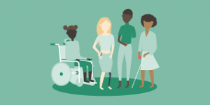
(Image by Clue)
Women and girls with disabilities may experience menarche and menstruation differently—and more negatively—compared to non-disabled women. These include frequent reports of dysmenorrhoea (painful periods), menorrhagia (heavy periods), menstrual hygiene issues and mood and behavioural changes, linked to premenstrual syndrome (PMS). Challenges in terms of managing menstrual hygiene can be:
- Women and girls with disabilities may be less likely to gather information about relevant topics themselves, and /or
- Existing education materials does not include relevant aspects for women and girls with different impairments or doesn’t cater for different learning requirements
- Women and girls with disabilities may face challenges in accessing sufficient support and especially health services
- WASH infrastructure might not cater for different impairments
- Maintaining hygiene (changing materials, personal hygiene and washing) can be challenging for some people, especially with limited physical abilities
- Menstruating women and girls with disabilities might face further discrimination and stigma
Recommendations to assure good menstrual hygiene management
All persons with disabilities have the right to be treated equally & be included.
An inclusive programming approach means that barriers to the inclusion of persons with disabilities should be removed and they are empowered to participate fully in societal life. This also includes the days of the period! In regard to Menstrual Hygiene Management, every woman and girl should be able to manage there their monthly period safely, hygienically and with dignity. Specifically for women and girls with disabilities, the following recommendations apply:
- Raise awareness about the rights of people with disabilities and specifically the MHM needs for women and girls with disabilities
- Consider disability in the design, implementation, monitoring and evaluation of interventions. Ideally consult women and girls with disabilities in all stages of the intervention
- Provide access to relevant information in adequate form: depending on the disability this could be tactical tools or more audio-visual materials with sign language, or shorter sessions. It is particularly important that women with learning disabilities be supported to play a central role in recognizing and defining the problems they experience
- Appropriate WASH Infrastructure: we recommend to consider Handicap International’s RECU principle = Reach, Enter, Circulate and Use for latrines, bathing units, changing and washing places
- Ensure access to suitable menstrual hygiene products that are changed regularly and disposed of safely
- Ensure access to adequate health services and trained care (even within family)
Yet, as abilities vary, what might be beneficial for some women and girls may not be useful for others.

Programming experiences and tools
Women and girls with disabilities are currently under-represented in menstrual health management (MHM) programming and interventions, but there are a few interventions that included girls and women with disabilities in the programme design or specifically developed educational tools for them.

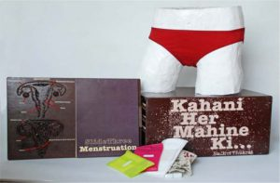
Vikalp Design, India

Already back in 2011, Vikapl and the Pearl Academy of Fashion developed the “Kahani Her Mahine Ki” – A Menstruation Kit – developed for the visually impaired young girls and women. The kit covers the subject of menstruation and how to manage during ‘periods’ and includes a life size human body model for demonstration, tactile diagrams, material and texts for the sighted and Braille for the visually impaired. Find out more: http://www.vikalpdesign.com/sadhvi_thukral.html

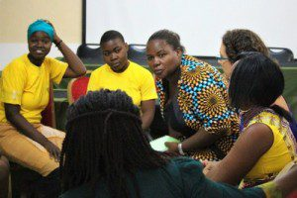
Femme International, Tanzania
In 2017, Femme International partnered with Youth with Disabilities Community Program (YDCP), an organisation in Tanga that provides services and life skills training to youth with disabilities, to bring the Feminine Health Empowerment Program to girls with disabilities, as well as providing training courses and sensitization for parents, the traditional Kungwis, parents and community leaders. Read more https://www.huffingtonpost.ca/sabrina-rubli/tanzanian-girls-with-disabilities_b_15537396.html

Huru International, Kenya

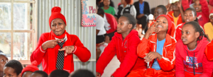
In their presentation during the MHM Virtual conference 2017, Huru International presented inclusive strategies for MHM programme design and implementation, including baseline data collection, trainings of girls and trainers. One example are educational seminars in sign language. Access the presentation here.

WaterAid and LSHTM, Nepal
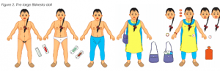
Presented as a poster for the MHM Virtual conference 2018, WaterAid and the London School of Hygiene and Tropical Medicine presented research results on the different barriers women and girls face in Nepal, and how this was translated into a training package and tool for girls with intellectual impairment. Access the poster here.

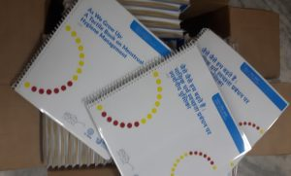
WSSCC, IndiaThe tactile book “As We Grow Up” and corresponding videos have been designed in consultation with visually impaired women and girls to break the silence on menstruation, provide spaces for dialogue and discussion, increased understanding and information. It was developed by the Water Supply and Sanitation Collaborative Council (WSSCC) in collaboration and consultation with blind and deaf women and girls together with the Centre of Excellence in Tactile Graphics (CoETG) – IIT, Delhi, Saksham Trust and Noida Deaf Society. The Ministry of Drinking Water and Sanitation in India, released the tactile (perceptible to touch) book on 22 February at a national consultation hosted by the Ministry. An electronic and an audio version will also be available for persons who cannot read braille.
Access the booklets here in English and Hindi: https://www.wsscc.org/resources-feed/grow-tactile-book-menstrual-hygiene-management-facilitators-manual/
Access videos here: https://www.youtube.com/playlist?list=PLIYPAUq6fqp-YoemTTAQ-GfvWrpDX3szo

What needs doing to close the gap.

The United Nations says to fully achieve gender equality and empower all disabled women and girls, efforts should focus on the following:
• Address the needs and perspectives of disabled women and girls in national strategies or action plans on participation in society.
• Support the empowerment of disabled women and girls by investing in their education and supporting their transition from school to work.
• Raise awareness on the needs of disabled women and girls and eliminate stigma and discrimination against them, especially Gender Based Violence.
• Enhance the collection, dissemination, and analysis of data on disabled women and girls with disabilities and disaggregate and disseminate data by sex, age and disability.

https://papers.ssrn.com/sol3/papers.cfm?abstract_id=2133332
https://social.un.org/publications/UN-Flagship-Report-Disability-Final.pdf UNDESA 2018
United Nations Department of Economic and Social Affairs (2018). “Realization of the Sustainable Development Goals by, for and with persons with disabilities.”
International Foundation for Electoral Systems (IFES),https://www.iknowpolitics.org/en/discuss/e-discussions/political-participation-women-disabilities
https://www.un.org/development/desa/disabilities/wp-content/uploads/sites/15/2019/07/Declaration-towards-Beijing25.pdf
Disabled Women in Africa (DIWA) submission to Country Review at UNCRPD Committee March 2020
This article was written collaboratively between Nandini Ghosh, Assistant Professor at the Institute of Development Studies, Kolkata, and Reena Mohanty, Programme Officer, Shanta Memorial Rehabilitation Centre, Odisha. https://commonwealthfoundation.com/author/wdin/#:~:text=The%20Alternative%20Report%20is%20the,in%2023%20states%20of%20India.&text=The%20India%20Country%20Report%20has,persons%20with%20disabilities%20in%20India.
Annexure 5 Submission of Alternative Report (Article 6) To the Committee on the Rights of Persons with Disabilities : India 2019 Submitted by the Women with Disabilities India Network On 10th February 2019 Report In Response To The Initial Report of The Government Of India
https://www.the-star.co.ke/news/2019-05-20-disabled-women-protest-increased-violence/
By Timothy Obiezu March 05, 2020 Voice of America https://www.voanews.com/africa/nigerian-women-living-disabilities-seek-equal-justice
https://menstrualhygieneday.org/managing-menstruation-for-women-and-girls-with-disabilities/

