Barbados Youth Leadership Training
The Commonwealth Disabled People’s Forum (CDPF) held a major regional workshop in Bridgetown from October 14–16, 2025, bringing together disability advocates, young leaders, and policymakers from across the English-speaking Caribbean. The initiative aimed to strengthen inclusive development and accelerate the implementation of the Commonwealth Disability Inclusion Action Plan (DIAP).
The workshop forms part of CDPF’s ongoing mission to promote full inclusion of persons with disabilities across all sectors of society, guided by the UN Convention on the Rights of Persons with Disabilities (UNCRPD) and the Sustainable Development Goals (SDGs).

Aims of the Workshop
- Empower emerging disability leaders to participate meaningfully in national and regional policymaking.
- Promote collaboration among Caribbean governments and civil society to implement inclusive laws and programmes.
- Advance the social and human rights model of disability, reaffirming the principle of “Nothing About Us Without Us.”
- Encourage the inclusion of disability rights in the forthcoming Commonwealth Strategy 2025–2030 and advocate for endorsement of the Disability Inclusion Action Plan at the Commonwealth Heads of Government Meeting (CHOGM) 2026 in Antigua and Barbuda.
“We believe that meaningful inclusion begins when governments work in partnership with persons with disabilities. This workshop is a tangible step toward ensuring that no one is left behind in our Commonwealth,” said Richard Rieser, General Secretary of the Commonwealth Disabled People’s Forum.
“Barbados offers an excellent example of how engagement with the disability community can lead to progressive laws and policies. We hope to replicate this model across the region,” Rieser added.

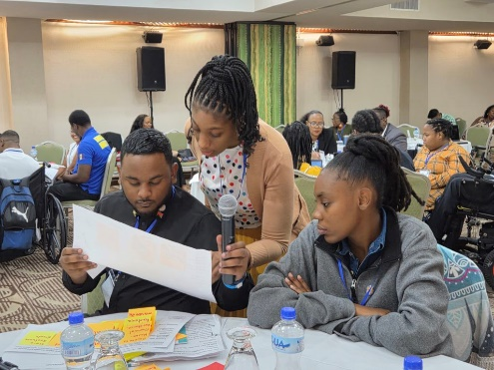
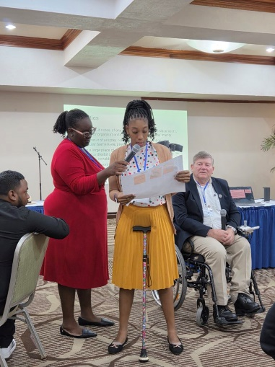
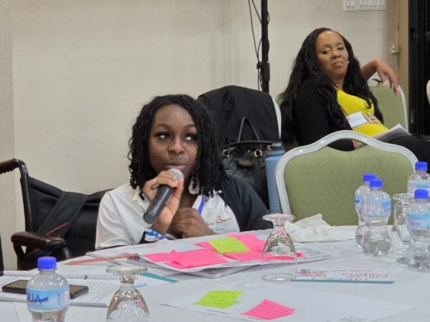
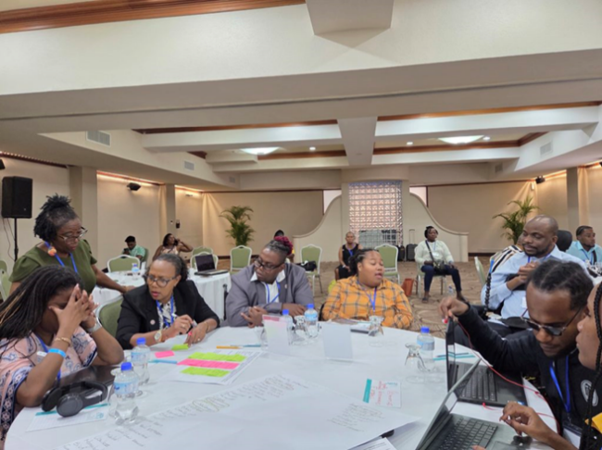

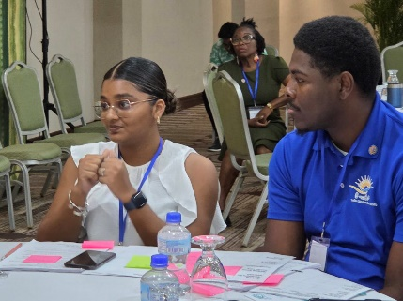
There were 20 participants from 11 Caribbean countries. 5 from Barbados.

Participants scored the training highly

Learning from Training: 4.8/5 average

Organisation of Training: 4.65 /5 average

Building my readiness for the struggle for disability rights: 4.6/5 average.

Focus on Disability in Barbados

Prior to the training The Vice Chair Kerryann Ifill and the Gen Sec were invited to participate in the Commonwealth Parliamentary Association Annual Meeting. Kerryann addressed a successful Town Hall meeting of Disability Activists and Parliamentarians with Disabilities and Richard presented at a workshop on the developing Disability Inclusion Action Plan looking forward to CHOGM 2026 in Antigua Barbuda.

After the Training 5 of the trainees and Richard, Kerryann and Ganesh took part in the Caribbean Disability Network three-day conference on developing Inclusive Education in the Region.

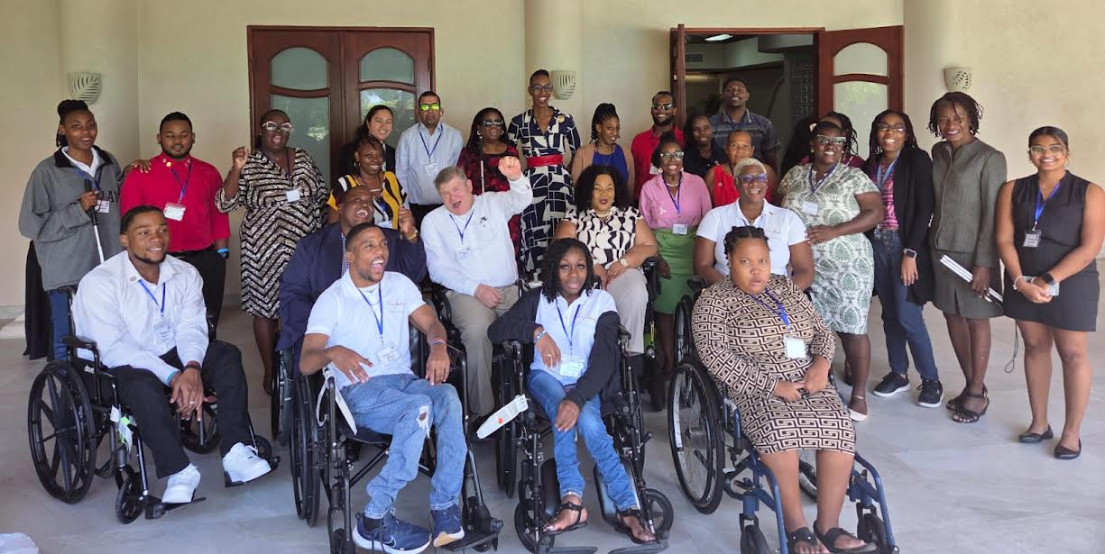

[Participants in Barbados Training at Accra Hotel]

