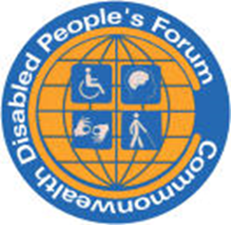
Commonwealth Disabled People’s Forum
Annual Report
April 2022 to December 2023.

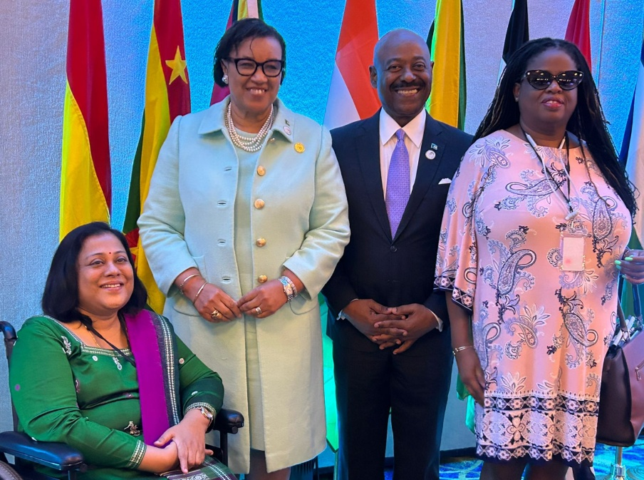
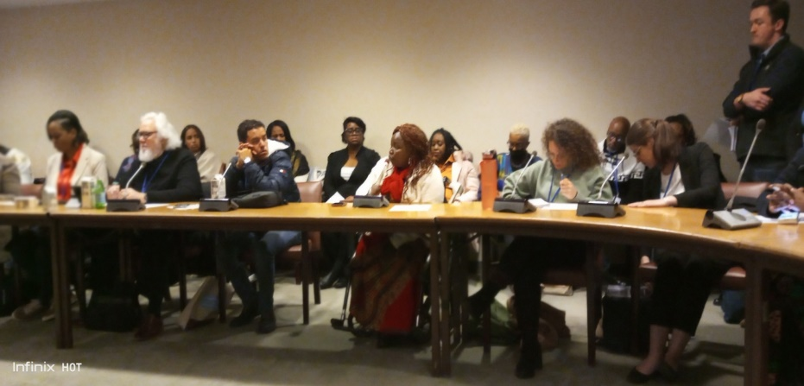

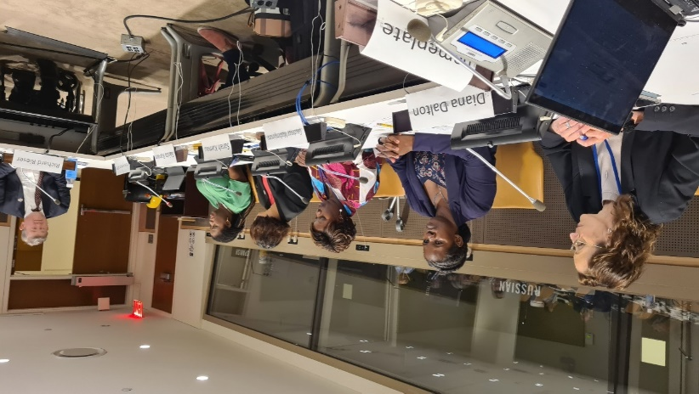
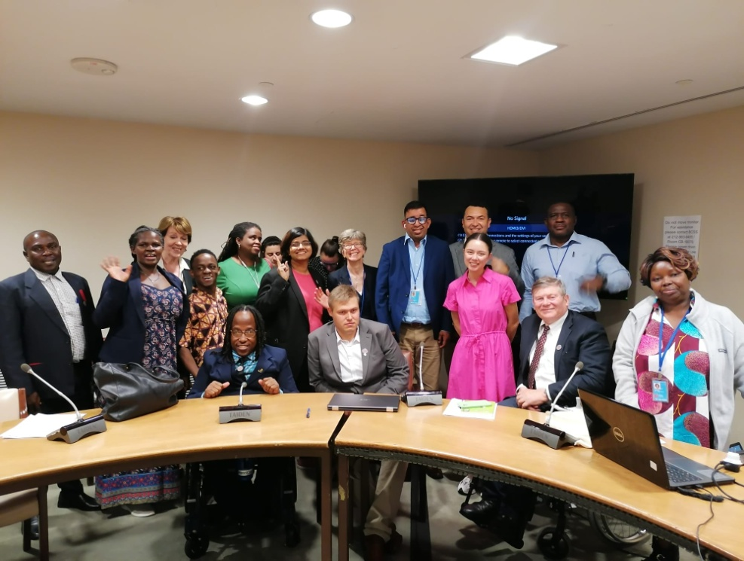

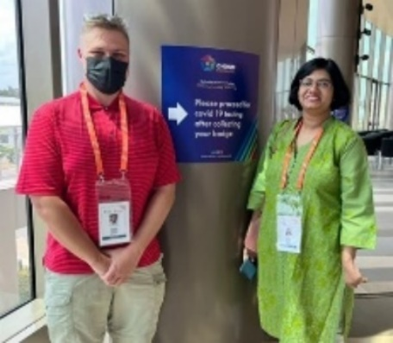
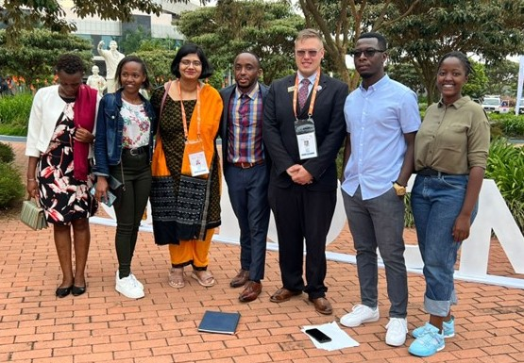
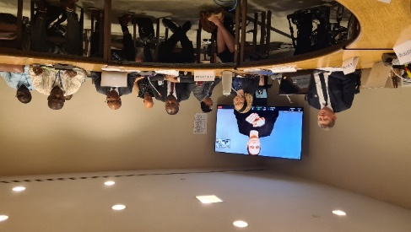

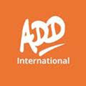
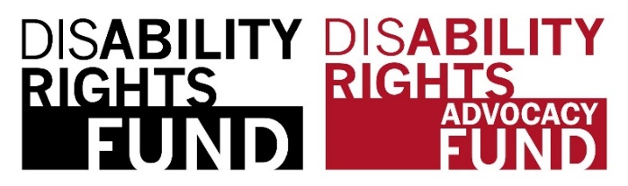

Commonwealth Disabled People’s Forum Ltd
Company Registration UK 7928235
General Secretary Richard Rieser
Address c/o World of Inclusion Ltd, 78, Mildmay Grove South,
LONDON N1 4PJ Tel.0044(0) 7715420727 +44(0)207 359 2855 email rlrieser@gmail.com Website www.commonwealthdpf.org

Chair Sarah Muthoni Nairobi, Kenya Tel +254723088888 sarahmuthoni95@gmail.com
Photos on the front page: CDPF Executive at CHOGM, COSP and Women’s meeting in Bahamas.

Mission of the CDPF: ‘To develop a unified voice for the implementation of Disability Rights and Equality for DPOs and disabled people (persons with disabilities) across the 56 countries of the Commonwealth’.
Nothing About Us Without Us.
FOREWORD
Disabled people around the world form 16% of the global population, which is approximately 1.3billion people. Out of this population, approximately 400 million disabled people live in the 56 commonwealth countries. The Commonwealth Disabled Peoples Forum (CDPF), as an accredited organization represents disabled people of cross impairments and their organizations across the Commonwealth countries.

In the year under review, CDPF has been engaged in various activities albeit the challenges it has experienced to ensure inclusion of disabled people in all spheres of life. Since disability rights are human rights, CDPF has been conducting capacity building through disability equality trainings to empower them to understand and to take charge of their rights.

Full realization of the human rights of disabled people is an integral and indivisible part of all human rights and fundamental freedoms. This is in line with the principles of the Convention on the Rights of Persons with Disabilities (CRPD) among other laws. CDPF has endeavoured to encourage countries that have not signed the United Nations CRPD and the optional protocol to do so as well as implement fully the convention in earnest.

This annual report outlines the milestones CDPF has made that include robust executive committee meetings, virtual general assembly, attendance to various international conferences, developing a disability equality youth training, development of a youth manifesto and a CDPF Women’s declaration, establishment of a climate change and disability committee, forging relationships with other development partners and formulation of a strategic plan among others. This reports therefore aims to document the achievements and lessons learnt for coming year.

Sarah Kamau CHAIR – CDPF

Contents
GENERAL OVERVIEW OF ACTIVITIES APRIL 2022 TO DECEMBER 2023 4
Virtual general assembly 4
CDPF Intervention at CHOGM, Rwanda 4
Forums and Subcommittees 4
Commonwealth Roundtable and Disability Inclusion Protocol 5
Conference of State Parties, New York: 5
Membership 6
Governance 6
EXECUTIVE COMMITTEE OF COMMONWEALTH DISABLED PEOPLE’S FORUM AS OF 31st December 2023 6
COMMONWEALTH HEADS OF GOVERNMENT MEETING KIGALI, 19th /26th JUNE 2022 13
CONFERENCE OF STATES PARTIES TO THE UNCRPD – 13 TO 16 JUNE 2022 15
Youth Forum and Year of Youth 20
CDPF DISABLED YOUTH MANIFESTO 22
CDPF DISABLED YOUTH LEADERSHIP TRAINING COURSE 22
CDPF DISABLED WOMEN’S FORUM AND REPRESENTATION 23
ENVIRONMENT CLIMATE CHANGE AND DISABLED PEOPLE. 25
COMMONWEALTH ROUNDTABLE ON ADVANCING THE RIGHTS OF PERSONS WITH DISABILITIES: 27
RELATIONS WITH OTHER BODIES 29
THE COMMONWEALTH PARLIAMENTARY ASSOCIATION (CPA) 30
Financial Status Information and Reporting 32
Audit Trail 35
FUTURE PLANS 35
APPENDIX 1 REVISED CONSTITUTION OF COMMONWEALTH DISABLED PEOPLES’ FORUM (2008,2019) WITH UPDATES INCORPORATING AMENDMENT AGREED BY THE VIRTUAL GENERAL ASSEMBLY FEBRUARY/APRIL 2022 37
APPENDIX 2: MEMBERSHIP AS OF 31ST DECEMBER 2023 44
APPENDIX 3 DRAFT CDPF DISABILITY INCLUSION PROTOCOL 46
APPENDIX 4 CDPF SAFEGUARDING POLICY 52
APPENDIX 5 COMMONWEALTH DISABLED PEOPLE’S FORUM POLICY ADDRESSING THE NEEDS IN CALAMITIES, RISKS, AND EMERGENCIES IN ACCORDANCE WITH THE UNITED NATIONS CONVENTION ON THE RIGHTS OF PERSONS WITH DISABILITIES (UNCRPD) ARTICLE 11. 52

GENERAL OVERVIEW OF ACTIVITIES APRIL 2022 TO DECEMBER 2023

Virtual general assembly
We held our VIRTUAL GENERAL ASSEMBLY (VGA) where we elected a new Executive Committee, Amended our rules and agreed a Work Plan for the next two years. The VGA process was initiated in December 2021, calling to nominate delegates from all CDPF national members’ organisations and associates. The nominated delegates were involved during the phased VGA Cycle from January – April 2022. Co-options were ratified at the first Executive meeting after the General Assembly held on 21 March 2022. 107 delegates were involved where the constitution was amended, new Executive elected and a new work programme was agreed. This set up the CDPF for a busy 20 months.
Dissemination of training resources. CDPF’s successful Disability Equality Capacity Building Training Course developed and delivered online in 2021 (consisting of 14 Modules), needed to be spread more widely. We were aware of many disabled people who did not have the bandwidth needed to access the course or could nor afford to buy internet bundles. Consequently in 2022, CDPF carried out the process of distributing, by post, 1000 computer memory sticks with the entire course and resources to our member organisations across the Commonwealth.
Communications Our website www.commonwealthdpf.org is updated and maintained and contains all our policies and reports of activities. For more frequent communication emails to our members. We produce regular Newsletters and present at various international meetings, such as the Global Summit on Disability and the United Nations Conference of State Parties (See Issues 7, 8,9 ,10 and 11 of our Newsletter covering the period of this report. This is emailed to all member organisations and on our website https://commonwealthdpf/news). Newsletters are sent to all member organisations 3 or 4 times a year, also to our individual CDPF Human Rights Activists database (disabled individual activists who support our aims in individual countries). CDPF also maintains a database of our individual contacts who have undertaken to be CDPF Human Rights Advocates. This currently comprises 212. They get Newsletters and invites to online meetings. Plans are underway to set up a Youth WhatsApp group.
https://commonwealthdpf.org/newsletter-11/
https://commonwealthdpf.org/cdpf-newsletter-10/
https://commonwealthdpf.org/cdpf-newsletter-9/
https://commonwealthdpf.org/cdpf-newsletter-8/
https://commonwealthdpf.org/cdpf-newsletter-7/

CDPF Intervention at CHOGM, Rwanda: In June 2022 we sent 8 delegates from India, Caribbean, Malawi, South Africa, Kenya and Rwanda to the CHOGM people’s, youth and women’s Forums. We made very effective interventions and put disability rights on the Commonwealth Map for the first time. The Executive became more concerned about the lack of understanding about Disability Equality and access in Com Sec and across the Commonwealth and resolved to tackle this in the run up to the next CHOGM. An extensive report on CHOGM can be found later in this report.

Forums and Subcommittees
CDPF set up both a Women’s Forum and a Youth Forum in the October and November 2022 and these two initiatives lead to a great deal of activity over 2023.
Youth Electing A Youth Officer, Setting up Youth Forum, Developing a Youth Manifesto. Launching at Launch Commonwealth Year of Youth, Organising and recruiting 150 plus Young Disabled People from 33 Commonwealth Countries for Disabled Youth Leadership Online Course. This will run September 2023 to March 2024. Sending a delegate to 13th Commonwealth Youth Ministers Meeting in London September 2023
Women: CDPF Disabled Women’s Forum. Women members of the Executive set up with 6 coopted. Held several meetings agreed to carry out a survey that in January 2023 included 34 DPOs. This was formed into a CDPF Women’s Declaration. 2 delegates were paid by Commonwealth Secretariat Women's Section go to New York CSW meeting in March 2023. Gave Presentations. A further survey carried out and 2 further different delegates presented at the CWMM in Bahamas leading to the inclusion of a number of important points in the final Ministerial Statement.

Environment /Climate Emergency. A Sub Committee was established and held three meetings and a policy was agreed and taken by the chair of the sub-committee to COP28 in Dubai.

Commonwealth Roundtable and Disability Inclusion Protocol
Held on 30th November 2023 with a discussion on the way forward on 1st December was a success with a consensus emerging. CDPF initiated the idea of to mark international Day of Disabled People and discuss a strategy for moving forward. This was successfully held in a hybrid format with the Commonwealth Secretariat as a partner with 90 attendees online and 15 in person.

CDPF Draft Disability Inclusion Protocol/Strategy and Appendix 3, was presented and participants were invited to read and discuss and send in any important additions they would like to have included. CDPF will not go ‘to the wall’ on the language. CDPF favour ‘disabled people’ as we are disabled by the barriers in society, not our impairments. There have been impairments as long as humans have existed. It is the social and culturally derived oppression that has to change by removing barriers and giving us equal rights. But we recognise many people prefer ‘persons with disabilities’ and so we suggest these words are used interchangeably in the Protocol/Strategy. The key message is that is essential is that the Commonwealth “ups its game” on disability and a Protocol/Strategy gives this possibility.

CDPF most importantly urged DPOs to have discussions with their Government to win their support for this initiative being adopted by the Commonwealth Heads of Government Meeting (CHOGM) in October 2024, in Samoa.

Conference of State Parties, New York: In June 2022 the Gen Sec recorded a speech that was played.
In 2023 CDPF had a much bigger role with three side meetings: 2 sponsored by UK’s FCDO and one by the Government of Barbados
1 Collaboration DPOs and Government on Implementing Elements of UNCRPD
Speakers Barbados Minister, KI, Kenya Ministry, SK, RP Exec Sri Lanka, Ero I Albinism Africa, RR Chair.
2. Women and Sexual Reproductive Health and other Issues: Chair: Sarah Kamau, Gaudence Mushimiyimana (Exec) FCDO’s Diane Dalton speakers, with Kerryann Ifill (Exec) , Saista Parwin (Exec) Shavana Haythornthwaite, Commonwealth Secretariat Human Rights Unit and Richard Rieser.
3. Youth Meeting: Chair Saista Parwin, Speakers Kihembo Wilbert, Emile Gouws, Penny Innes FCDO, Charlotte Young (Australia); RR on the leadership Training.
CDPF also had a Speaker (Sarah Kamau) at Commonwealth/New Zealand meeting on Employment. Emile Gouws spoke at a meeting on Autism run by Malta and Canada. Rose Umutesi also spoke in Civil Society forum but representing HI.
A series of useful one to one meetings were held at COSP 16.

Membership
CDPF membership at the end of 2023 was: Countries 49 + 2 Overseas Territories, Full Members 47, Associates 50, Observer/Ally 2. Criteria for full membership is that the organisation needs to be run by a majority of disabled people on its Management Committee or Board, agrees with a social model/human rights approach to disabled people and represent them as an umbrella the main disabled led organisations covering the country. Associate members have to also fit the above criteria but may represent one impairment group for the whole country or be a strong regional cross impairment organisation.
National umbrella DPOs from both Gabon and Togo have joined. CDPF is still seeking to get representation from Antigua Barbuda, Brunei Darussalam, Cyprus, Granada, Nevis & St Kitts Seychelles, Singapore, and are seeking to also recruit DPOs from overseas protectorates and territories and fuller involvement from DPOs in Australia and New Zealand. The Executive decided not to charge a membership fee for the 2022 to 2025 period instead relying on grants.

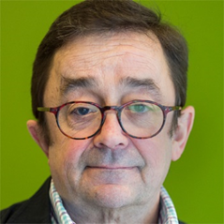
Governance
Where urgent decisions are needed, the Chair and General Secretary and the Vice Chairs take the decision which is later ratified by the Executive.
We were sorry to lose Steve Estey, a founding member of CDPF from Canada, in September due to his sudden death. Steve made a great contribution with his many years of experience of the Disability Movement and he will be much missed.

A Complaint from CCYDN and was investigated and not upheld by 2 separate independent investigations. Both finding ‘that there was no case to answer’. However, the wide circulation of the complaint by CCYDN and then subsequent repetition after a warning from the Chair ‘not to repeat this conduct’, constituted behaviour that is detrimental to the CDPF and the Executive agree to expel CCYDN forthwith from the CDPF. The Executive decided on January 24th, 2023, to expel Commonwealth Children and Youth Disability Network “The CDPF Executive note rule 8d of the CDPF constitution " a) A member may be expelled due to a cause that is detrimental to the interests and purposes of CDPF". This may be carried out between General Assemblies by the Executive Committee by a simple majority vote. " This was passed unanimously 19:0 This meant their 2 unelected members of the Executive ceased.
Administration

Day to day running of CRPD is by the General Secretary and Administrator (from ADD) aided by an assistant administrator who maintains data bases etc. The Website https://commonwealthdpf.org is maintained by a web designer. The Executive had training on Safeguarding, adopted a policy and code of practice at the suggestion of the DRF. Agenda, mailings, minutes and correspondence are maintained by the General Secretary in consultation with the Chair and 2 Vice Chairs. Financial planning and oversight are carried out by the Treasurer and General Secretary. Communications, especially the Newsletter are carried out by the Communications Office. The Women's Youth and under-represented groups are led by appropriate officers and in conjunction to General Secretary. All are collectively accountable to the Executive and General Assemblies

EXECUTIVE COMMITTEE OF COMMONWEALTH DISABLED PEOPLE’S FORUM AS OF 31st December 2023

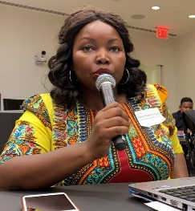
Chair Sarah Muthoni Kamau , United Disabled Persons Kenya
sarahmuthoni95@gmail.com
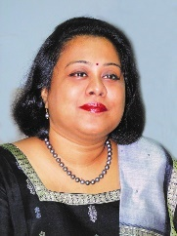

Vice-Chair Dr Sruti Mohapatra, Swabhiman, Odisha, Eastern India
sruti_m@hotmail.com
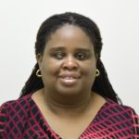

Vice-Chair Kerryann Ifill, Barbados Council of the Disabled
president@bcd.org.bb

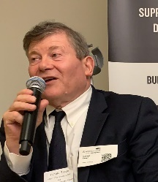
General Secretary Richard Rieser, Reclaiming Our Futures Coalition, United Kingdom
rlrieser@gmail.com

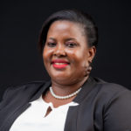

Treasurer Scader Louis, Federation of Disability Organisations in Malawi (FEDOMA)
scaylouis@gmail.com

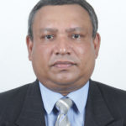
Communication Officer Prasanna Kuruppu, Disability Organisations Joint Front DOJF,
Sri Lanka prasannakuruppu@gmail.com


Representative for Intellectual Disability and under-represented groups
Emile Gouws, Autism South Africa gouwse@unisa.ac.za

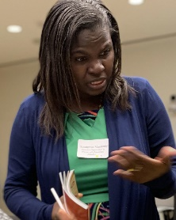
Women’s Representative Gaudence Mushimiyimana, Rwandan Organisation of Women
with Disabilities unaburwanda@yahoo.com


Elected Youth Representative Kihembo Wilbert, Voice of Youth Uganda
kihembowilb@gmail.com

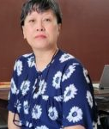
Indigenous Peoples Representative Diethoro Nakhro, National Centre for Promotion
of Employment for Disabled People, Nagaland, India dnakhro@gmail.com
Regional Representatives
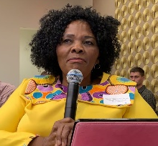
Africa Alina Thandiwe Mfulo, Disabled Persons South Africa
mfulo.thandiwe@gmail.com

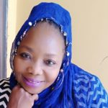
Africa Patience Ogolo-Dickson, Advocacy for Women with Disabilities Initiative
(AWWDI) Nigeria patienceodickson@gmail.com

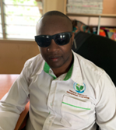
Africa Eric Ngondi, United Disabled Persons of Kenya – UDPK

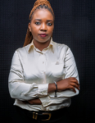Engondi1@gmail.com
Africa Rachel Chomba, Zambia Federation of Disability Organizations
(ZAFOD) rachealmuuma@yahoo.co.uk

Australia, Britain, Canada, New Zealand and Malta: It is with sadness that we will hold a bi-election for this position in due course, following the passing of Steve Estey in September 23.
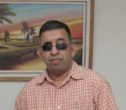
Caribbean Ganesh Singh, Guyana Council of Organisations for Persons with Disabilities ganeshyvg@gmail.com

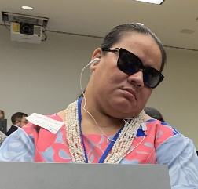
Pacific Faatino Utumapu, Nuanua O Le Alofa, Samoa tino.mutumapu@gmail.com
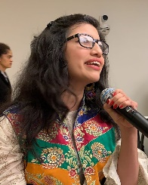
Asia Abia Akram, Special Talent Exchange Programme, Pakistan
abia.akram@gmail.com

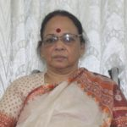
Asia Mohua Paul, Access Bangladesh Foundation paulmohua@yahoo.com

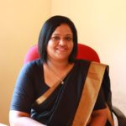
Asia Rasanjali Pathirage, Disability Organisations Joint Front DOJF Sri Lanka
rasanjali1979@yahoo.com

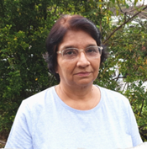
Asia Havindar Kaur, Malaysian Confederation of the Disabled attending mcddpi.my@gmail.com

Co-options:
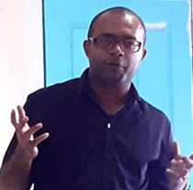
Pacific Region Simon Dolaiano, People with Disabilities Solomon Islands
PWDSI 4dolaiano@gmail.com

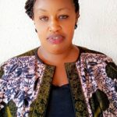
Survivors Mental Health Rose Umutesi, National Organisation of Users and
Survivors Psychiatry in Rwanda rosemutesi11@gmail.com


Indian Ocean, Mauritius Dookhoo Soovan Sharma, Federation of Disabled People’s Organisations Mauritius (FDPOM) soovan12paix@gmail.com

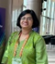
India Saista Parwin, Swabhiman Foundation, Odisha
Parwinnluo@gmail.com

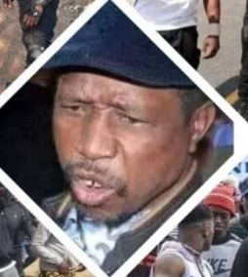
Deaf Blind Simate Simate, Zambia Deaf/Blind Association
simate1968@gmail.com

Gender Breakdown: 10 Men 17 Women of 27-person Executive

Trustees and Officers Group
The Trustees of the Registered Company in the UK Commonwealth Disabled People’s Forum Ltd Company Registration 7928235. The Company is dormant as our accounts go through ADD International
https://find-and-update.company-information.service.gov.uk/company/07928235/filing-history
Chair Sarah Muthoni Kamau, United Disabled Persons Kenya registered
Vice-Chair Dr Sruti Mohapatra, Swabhiman, Odisha, Eastern India registered
Vice-Chair Kerryann Ifill, Barbados Council of the Disabled to be registered
General Secretary Richard Rieser, Reclaiming Our Futures Coalition, United Kingdom registered
Treasurer Scader Louis, Federation of Disability Organisations in Malawi (FEDOMA) to be registered
Communication Officer Prasanna Kuruppu, Disability Organisations Joint Front DOJF, Sri Lanka to be registered
Women’s Representative Gaudence Mushimiyimana, Rwandan Organization Women with Disabilities UNABU to be registered
Africa Representative Alina Thandiwe Mfulo, Disabled Persons South Africa registered
Steve Estey until his demise in September 2023 to be removed

The above plus below constituted the Officers Group
Youth Officer, Kihembo Wilbert
Emil Gouws Representative for Intellectual Disability and under-represented groups
Co-opted in November 2023 Saista Parwin, India

Patrons CDPF has also invited a number of well-known disabled people in the Commonwealth who support and promote the aims of the CDPF to be Patrons.
Dame Jane Campbell, UK
Rosemary Keyes, Australia
Floyd Morris, Jamaica
Sir Robert Martin, New Zealand
Samuel Kabue, Kenya
Shauib Chalklen, South Africa
Ikponwosa Ero, Ghana
Structure of Governance
The General Assembly Met in June 2019 in person and Jan-April 2022 virtually and the next one is due January to March 2025 virtually. The General Assembly constitute all full member National Umbrella organisations who have 2 votes, Associate members organisations that have 1 vote and observers who do not have a vote. They agree Rule Changes, nominate and elect Officers, Agree Reports, Finances and Forward Work Plan.
Electing the Executive Committee
Elections: the whole General Assembly elect the Officers
All the delegates from within each of the 6 regions elect their regional representatives.
The Elected Officers and Regional Representatives then coopt up to 7 more representatives that Executive members can nominate to fill gaps in representation on the Executive.
In 2022 the Finance and General Purposes Group constituting firstly Trustees and some “co-optees” and then in 2023 the Officers Group that met in between Executives. The purpose of these meetings is to make organisational and financial recommendations to the full Executive. The F&GP then the Officers group can give more thought and consideration to these important issues. Over the period of this report the following meetings took place.
CDPF Executive and Other Meetings, April 22 to December 2023: All Online unless otherwise stated:
21st April 2022 New Full Executive
27th May 2022 Finance and General Purposes Committee (F&GP) (Trustee + co-options)
22nd June Meeting of delegates to CHOGM Rwanda in person
28th July 2022 Executive
22nd September 2022 Executive
4th November 2022 F&GP
24th November 2022 Executive
17th January 2023 F&GP
24th January 2023 Executive plus Training Safeguarding
19th April 2023 Executive
19th May 2023 Executive
16th June 2023 Hybrid- In Person/online Executive New York
18th July 2023 Officers Meeting (replace F&GP)
24th August 2023 Executive
20th September 2023 Officers Meeting
23rd October 2023 Executive
23rd November 2023 Officers Meeting
11th January 2024 Postponed Executive

COMMONWEALTH HEADS OF GOVERNMENT MEETING KIGALI, 19th /26th JUNE 2022
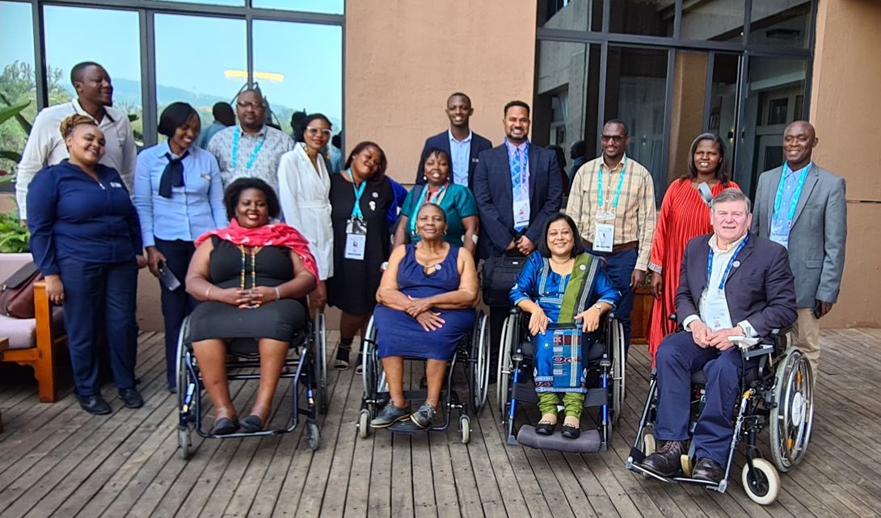
Some of the CDPF Delegates at CHOGM (Kigali, Rwanda. 19th to 26th June 2022). Represented by Key officers l-r front Scader Louis, Thandiwe Mufulo, Dr Sruti Mohapatara, Richard Rieser, second row including Gaudence Mushimiyimana and Chair Sarah Kamau and members from the National Organisations in African Continent and Mephilius James from St Lucia. Photo Credit: Richard Rieser.
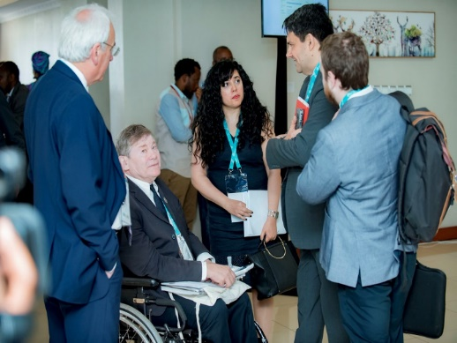
During the CHOGM, CDPF was well represented. CPDF Chair, Sarah Kamau (from Kenya), Africa Representative Thandiwe Mufulo (from South Africa), Vice-Chair Dr. Sruti Mohapatra (from Odisha, India), and General Secretary Richard Rieser (from UK) represented CDPF at the PEOPLES FORUM. All four made good interventions from the floor. Women Representative Gaudence Mushimiyimana (from Rwanda) represented CDPF at the WOMEN’S FORUM. Rep for Intellectual Disability Emile Gouws (from South Africa) and Executive Officer Saista Parwin (from India) represented CDPF at the Youth Forum. CDPF delegates distributed 400 copies of the CDPF Policy Broadsheet throughout CHOGM. Refer: Full text of the CDPF message to the delegates at CHOGM, Kigali 2022.

CDPF held a successful side meeting on Thursday 23rd June after the close of the PEOPLE’S FORUM with a room funded by Commonwealth Foundation attended by 27 delegates. Refer: Full broadcast via YouTube. Anne Gallagher, Secretary General of the Commonwealth Foundation complimented CDPF for the role it plays and for various interventions. There was a general view that disability would be taken much more seriously in the future by the Commonwealth and need for disabled panellists to be included in all sessions (Climate, Economy, Business, etc.)

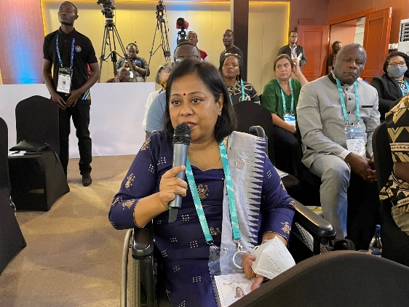
Emphatically, disabled people’s attendance needs to be taken much more seriously by the Commonwealth and/or member states as a matter of priority. It is evident that the CHOGM has no protocol providing different formats or proper accessible infrastructure and processes. There are no questionnaire to ask for needs during registration, washrooms are not wheelchair accessible, no proper follow ups by organisers for accessibility inquires and the Sign Language Interpretations were provided by the Rwandan Deaf Organisation as an initiative by them. The CDPF should advocate for positions, to speak on platforms and argue for a Commonwealth Disabled People's Meeting during CHOGM.

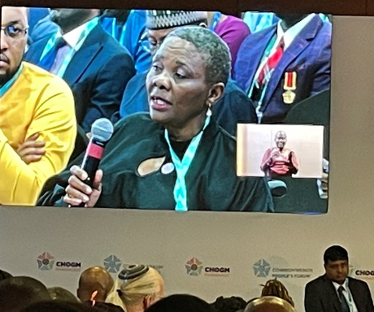
Anne Gallagher supported drawing up a Disability Protocol similar to United Nations we will also be approaching all elements of the Commonwealth to get support for a Disability Inclusion protocol that emerged from our observation at CHOGM.

Prior to the CHOGM, CDPF wrote to all Governments via national umbrella organisations requesting them to fund disabled delegates to CHOGM. CDPF is pleased to thank the Government of St. Lucia for sending Merphilius James and Government of Malawi for sending Scader Louis (CDPF Treasurer) for the meeting. During the next CHOGM this should be done earlier to get more delegates funded. We also made good links with representatives from 3 of our Rwandan membership organisations who were represented at the PEOPLE’S FORUM. [Participants at side Meeting]
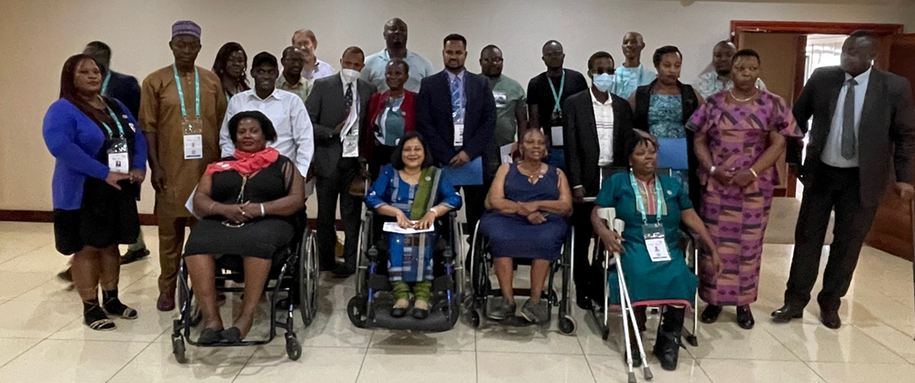
Members at CHOGM
Commonwealth youth forum Kigali 19-21 June 2022

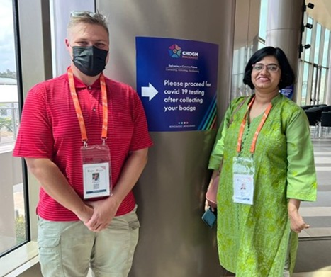
Emile and Saista (photo Emile Gouws)
Commonwealth Youth Forum (CYF) brought together young leaders from across the Commonwealth to exchange ideas, build networks, identify and debate development issues, challenges, and opportunities, agree on youth-led initiatives to mitigate challenges facing young people and create opportunities to enhance their lives. Rwanda brought over 300 delegates, including two official youth delegates from each member country, as well as key youth sector stakeholders.

CDPF delegates attended plenary meetings, lab sessions, and made connections with key role players in youth development in their respective countries. During the sessions CDPF delegates actively contributed for the deliberations specifically for the inclusion of disabled youth voices. Recommendations made during the discussions:

• Establish a FORUM FOR COMMONWEALTH DISABLED PEOPLE:
Inclusions and reasonable accommodation services for disabled people seems conveniently neglected at Youth Forum and Peoples Forum and the presence of disabled people make the CHOGM visible and inclusive.

• Forum to convene SESSION ON HYBRID MODE:
Challenges in representation of persons with disabilities from various continents could be easily mitigated by convening sessions in Hybrid mode, giving equal opportunity for intervention. Recently concluded Commonwealth Ministers of Education Summit in Kenya was a very successfully convened hybrid event, where online participants never felt excluded.

• Emphasis the importance of CELEBRATE DIVERSITY:
Uplifting the disabled people by embracing the theme “Celebrate Diversity”, in line with the social model towards disability and could be a major disability advocacy event at the Commonwealth.

• Make Labs / Plenary sessions more INCLUSIVE AND MEANINGFUL:
Some thematic discussions lacked meaningful participation, representation and clarity. Solutions for the challenges confronted by disabled people needs the insiders’ perspectives and expertise as the personal experience is highly relevant.

It was a major honour to represent CDPF as disabled youth delegates at the Commonwealth Youth Forum and raise our voices on behalf of all the disabled youth in the Commonwealth. Saista Parwin and Emile Gouws

CONFERENCE OF STATES PARTIES TO THE UNCRPD – 13 TO 16 JUNE 2022
15th session of the Conference of States Parties to the CRPD was held under the OVERARCHING THEME: “Building disability-inclusive and participatory societies in the COVID context and beyond”. Sub-Themes were:
(1). Innovation and technology advancing disability rights
(2). Economic empowerment and entrepreneurship of persons with disabilities
(3). Participation of persons with disabilities in climate action, disaster risk reduction and resilience against natural disasters.

CDPF canvassed for 09 delegates to re be re-elected, Rosemary Keyes -Australia, Gertrude Fefoame -Ghana, Laverne Jacobs - Canada, all elected. For the first time there are 11 Women and 07 men on UNCRPD committee. 15 of 18 have disabilities. 06 Africa, 03 Asia, 04 Latin America, 05 Australia and Oceania. CPDF was represented at the COSP15 through a pre-recorded speech by CDPF General Secretary Richard Rieser.

CONFERENCE OF STATES PARTIES TO UNCRPD, 13 - 15 JUNE 2023
NOTE: Photo Credit for this article: Sarah Kamau & Gaudence Mushimyimna
Introduction

The Sixteenth Session of the Conference of State Parties (16COSP) to the United Nations Convention on the Rights of Persons with Disabilities (UNCRPD) was held this year under the OVERARCHING THEME: “Harmonizing National Policies and Strategies with the CRPD: Achievements and Challenges”. Sub-Themes were:
(1). Ensuring equal access to and accessibility of sexual and reproductive health services for persons with disabilities,
(2). Digital accessibility for persons with disabilities
(3). Reaching the under-represented groups of persons with disabilities.

CPDF representation at the 16COSP was a success with three side meetings of CDPF with the collaboration of UKFCDO, Commonwealth Secretariat, Government of Barbados, African Albinism Federation and Disability Rights Fund. CDPF delegates have showcased its presence throughout the conference and made successful intervention. Detailed side event reports appear below.
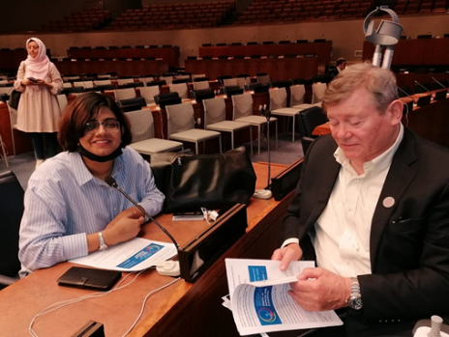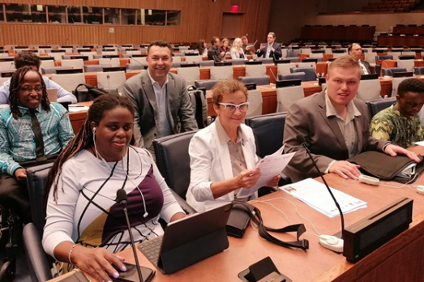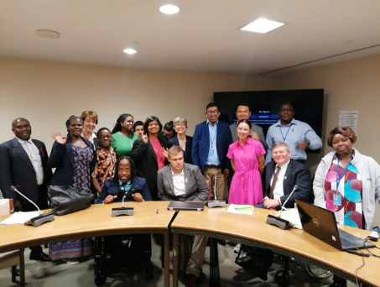

EVALUATING DPO/OPD COLLABORATION WITH STATE PARTIES ON IMPLEMENTING ELEMENTS OF THE UNCRPD ACROSS THE COMMONWEALTH
Wednesday, 14 June 2023 from 01.15pm – 02.30pm (EST) - (In Person + Zoom + Recorded)

Sponsors: Governments of Barbados, Government of Kenya, Albinism Africa, Disability Rights Fund & organised by Commonwealth Disabled People's Forum.

Chair: Richard Rieser - General Secretary - CDPF.
Speakers: Hon. Kirk Humphrey - Minister of People Empowerment and Elder Affairs, Barbados; Kerryann Ifill – Vice Chair - CDPF & President, Barbados Council of the Disabled; Moses Kamau - Social Protection Department, Ministry of Labour, Kenya; Sarah Kamau – Chairperson, CDPF & United Disabled Persons of Kenya; Ero Ikponwosa - Executive Director, Albinism Africa (on the Kenyan Model of challenging stigma); Rasanjali Pathirage - CDPF Executive (South Asia Regional Rep) & Disability Organisation Joint Front, Sri Lanka.

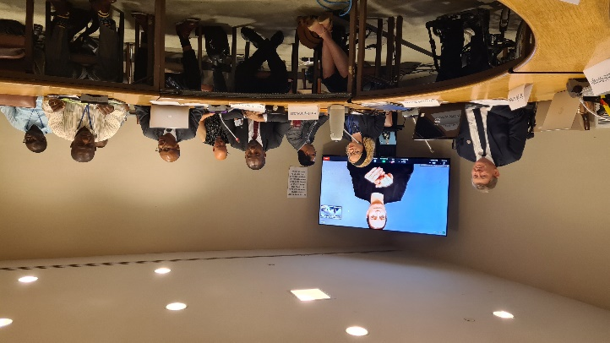
There was a very nuanced and interesting dialogue with representatives of the Barbadian and Kenyan Governments explaining how working with DPOs had been fundamental in how they were approaching implementation of UNCRPD. This was balanced by DPO reps from these two countries explaining the gains made in terms of being taken seriously as the representative voice of Disabled People. In areas such as registration, moving away from charity and medical model thinking, but both said there was still a long way to go.

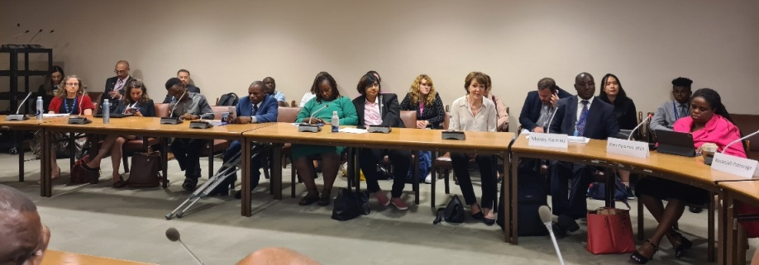
Sri Lanka reported far less collaboration with the Disability Rights Bill stuck in Parliament for many years. Albinism in Africa explained how discrimination had ceased because of a strong Government response in Kenya led by empowered self-advocates. The CDPF raised the results of a member’s survey from last year showing that more that half of their national umbrella DPOs members thought core funding from Government so they could carry out their representative role under 4.3 and 33.3 was essential. Barbados had done this Kenya was still to do it.

Another theme was the need for Umbrella organisations to be cross impairment and unite around their common oppression regardless of type of impairment. People are disabled by barriers not because of having impairment. This is why we call ourselves COMMONWEALTH DISABLED PEOPLE’S FORUM.

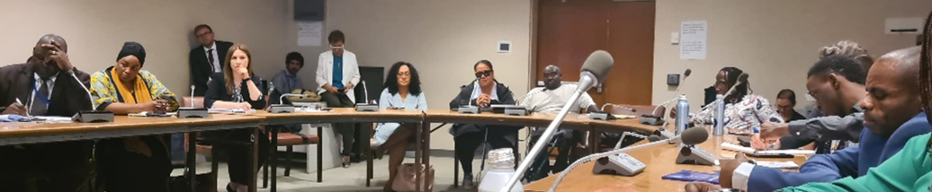
We heard from a floor speaker that this was why New Zealand had adopted the name MINISTRY OF DISABLED PEOPLE. General setting up collaborative structures of DPOs and Government was useful, but when we come up against Government blocking, we still need to use the tools of struggle. Remember Rights are not given but have to be struggled for by those who will benefit.

Partial Signed recording: https://youtu.be/lFUOmHpi_qU
Audio Recording: https://commonwealthdpf.org/wp-content/uploads/2023/06/CDPF_collaboration1.mp3Leaflet for Meeting
For more information: Contact Gen. Sec CDPF rlrieser@gmail.com

DEVELOPING WAYS OF CREATING EQUAL ACCESS FOR DISABLED GIRLS AND WOMEN TO SEXUAL AND REPRODUCTIVE HEALTH SERVICES AND GREATER EQUALITY
Thursday, June 15 2023 from 08.15am -09.30am (EST) (In Person + Zoom + Recorded)

Sponsors: Foreign, Commonwealth & Development Office of United Kingdom, Disability Rights Fund, Commonwealth Secretariat & organised by Commonwealth Disabled People's Forum.

Chair: Sarah Kamau, CDPF –Chairperson & United Disabled Persons Kenya.
Speakers: Gaudence Mushimiyimana, CDPF Executive (Women's Rep) & Rwandan Organisation of Women with Disabilities; Diana Dalton, Head of Gender and Equalities Dept, FCDO, UK; Dr. Shavana Haythornthwaite, Adviser and Head, Human Rights Unit, Commonwealth Secretariat; Saista Parwin, CDPF Executive (Youth Rep) & Swabhiman Foundation, India;
Dr. Richard Rieser, CDPF General Secretary on Men’s role as allies.

A very thorough and insightful discussion on sexual and reproductive health rights for disabled women and girls and wider issues of gender equality and the role of men as allies was held. Experiences from a number of Commonwealth countries were recounted by the disabled speakers and the Commonwealth Secretariat pleas for the enforcement of Human Rights for Disabled Women and Girls to have choice and the right to sexual and romantic relationships, to have children or terminations, access to contraception and to force the stopping of sterilization, alongside Availability, Acceptability and Support for Access to Public Health Education, Emergency Services. Nothing would change in reality until non-disabled people across countries such as India changed their attitudes.
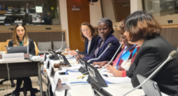 The UK Foreign Commonwealth Office spoke about their stance on challenging the global roll back on women’s rights and pointed to a number of initiatives they were involved in to empower disabled women and girls and community based initiatives, including for men to change their sexist behaviors.

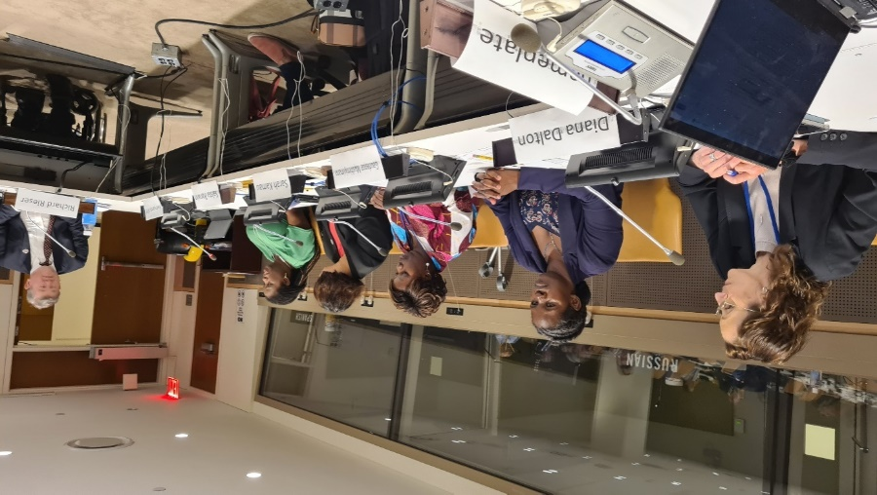Male members, especially leaders of the Disabled People’s Movement, must be held accountable for their sexism and change to allies in the struggle for Disabled Women and Girls Rights. CDPF survey had shown the General Women’s Movement had little connection with Disabled Women’s Issues. This has to change! The chair pointed participants to the CDPF Commonwealth Women’s Declaration and urge all to redouble their efforts to achieve full equality for Disabled Women and Girls
You can also find this event on our UN WebTV
And our UNDESA YouTube Channel: https://youtu.be/c-foNnLv-tg
On www.Commonwealthdpf.org/NewsFlyer for meeting

DISABLED YOUTH INVOLVEMENT, AWARENESS, EMPOWERMENT AND LEADERSHIP IN DPOS / OPDS ACROSS THE COMMONWEALTH

Wednesday, Jun 15 2023 from 03.00pm - 04.45pm (EST) (In person + Zoom & Recorded)

Sponsors: Government of Barbados, Foreign, Commonwealth & Development Office of United Kingdom & organised by Commonwealth Disabled People's Forum.

Chair: Saista Parwin – CDPF Executive (Youth Rep) & Swabhiman Foundation, India.
Speakers: Penny Innes - Head of Disability Inclusion team, FCDO UK; Kihembo Wilbert – CDPF Executive (Youth Rep) & Voice of Youth, Uganda; Emile Gouws, CDPF Executive (Underrepresented Groups Rep) & Autism, South Africa; Christopher Gilkes - Public Relations Officer, Council for the Disabled, Barbados; Charlotte Young - Council for youth with Disabilities, Australia; Ganesh Singh - CDPF Executive & Council of Organisations for Persons with Disabilities, Guyana; Richard Rieser - General Secretary, CDPF on Training Disabled Youth for Leadership project.

Ensuring Disabled Youth are aware of their rights, become empowered, engage with DPOs/OPDs and join the struggle to implement their rights is crucial. Number of Disabled Children and Youth with long term impairments in the Commonwealth is growing and their exclusion from education, training, employment, health and wellbeing is increasing, especially in low- and middle-income countries. The World Health Organisation now identify 16% of the population as disabled people, 1.3billion people. In the Commonwealth where 60% of the population are aged 30 years or under, there are likely to be 230-250 million disabled children and youth in the Commonwealth. 2023 is Commonwealth Year of Youth. The Commonwealth Disabled Peoples Forum (CDPF) which represents Disabled People's Organisations in 50 of the 58 countries in the Commonwealth wants this year to make a difference. Two thirds of the Commonwealth population are under the age of 30.
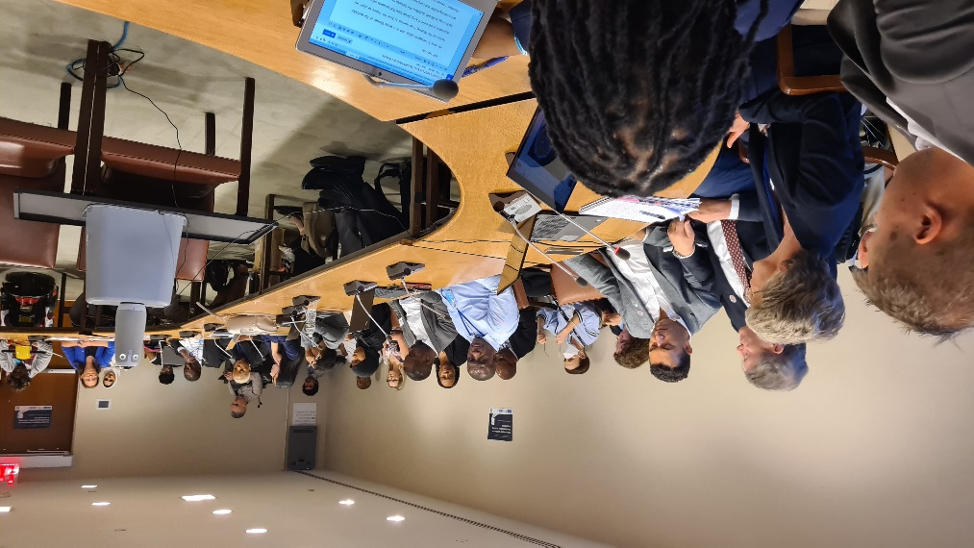The presentations and discussion were vibrant and full of hope. We need to get to the grassroots especially in hard-to-reach areas and train and recruit disabled youth. Drastic action is needed for a drastic problem especially for neurodiverse and cognitively impaired youth across the Global South.

In the high-income countries especially, intersectionality needs to be a watchword, especially when working with indigenous disabled youth. In large economies such as India we have to get employers and Governments to understand disabled youth can bring profits through their skills. We must use digital media as a tool to reach disabled youth and to empower them as in Uganda. In South Africa real change can only come from the bottom up involving those hitherto excluded. We heard how in Guyana the umbrella DPO had embarked with support from USAID on a several year project to train and empower disabled youth and bring them into DPO leadership. In Barbados, the Disability Council has been engaging for a number of years through youth conferences and training projects on empowerment. The Australian Council for Youth with Disabilities had held regular conferences and has been presenting the views gathered to the Government.

CDPF Youth Leadership Training was explained and publicised. It was emphasised this would be based on a paradigm shift and capacity building.
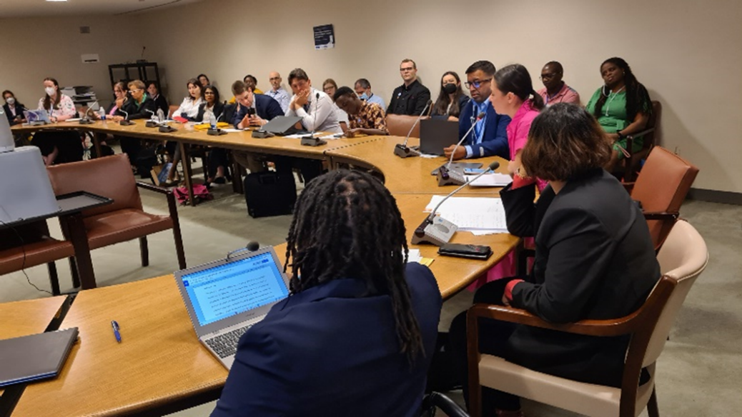
UKFCO were thanked for their support and complimented for their Disability Strategy which emphasises building and supporting the development of DPO voices which may take longer than quick fixes from NGOs, but because rooted in the community is likely to have far reaching and longer lasting impact especially if encouraging disabled youth involvement.

Video Link https://www.youtube.com/watch?v=A5zzrdt_bYw
Kihembo’s Video https://youtu.be/m39XG1GxBGg
Meeting Leaflet CDPF Disabled Youth Manifesto

One to ones meetings at COSP 16
IDA with Vladimir Cuk CEO promised a meeting with Key Board members re CDPF membership. Did not
happen - SK needs to follow up. World Bank with Charlotte McClain organised by Emile G. The Bank can only support Governments, but DPOs can participate and push their Governments to seek funding for particular disability projects they participate in. FCDO Agreed to look seriously into providing CDPF long term core funding. Will support in principle Disability Inclusion Protocol. New Zealand with Paula Tesoriero Head Ministry of Disabled People agreed to work together. Get NZ DPOs more involved in CDPF. Commonwealth Human Rights Unit gave us use Commonwealth Office in New York for our Executive meeting (Hybrid). Meeting Com Sec Human Right Unit discussed working with Women’s Forum and to work more closely on their Paper for 13th WAMM in Bahamas. Recruitment Togo Federation, Australia 2 DPOs

Youth Forum and Year of Youth

CPDF POLICY POSITION ON THE DISABLED YOUTH

The Commonwealth Disabled People’s Forum are of the view disabled youth have been largely left out, both our delegates to the recent Youth Forum at CHOGM reported feeling marginalized with no disabled platform speakers and little effort made to include them and few reasonable adjustments.

This underlines one of CDPF’s main aims during the year to get the Commonwealth to develop a Disability Inclusion Protocol which does not currently exist, unlike the United Nations that adopted such a protocol in 2014.

If we take the conservative estimate that 10% of children and youth in the Commonwealth are disabled, then there are 156 million disabled children and youth, aged 30 or less. The record is appalling of our 58 Commonwealth countries in addressing the rights of this group and implementing the United Nations Convention on the Rights of Persons with Disabilities, which nearly all Governments have ratified.

Most do not attend school, complete their studies or get access to quality vocational education or higher education or employment. Many are subject to stigma and prejudice on a systematic basis and amount to harassment and abuse. Disabled children and youth in the main, do not have access to quality healthcare, rehabilitation or to the aids and appliances which would empower them. Neither are the vast majority made aware of the liberation paradigm of the UNCRPD or Medical model which would empower them to become part of the solution and not be seen as the ‘problem’.

CRPD is calling on all our member organizations and their members to mass e-bomb the leaders of their respective countries on 02nd December - International Day of Disabled People. Calling on Leaders to meet with National DPOs/OPDs with Youth Representative soon in the New Year to agree a programme of Conferences, events and actions to tackle these inequalities. We are also calling on all our DPO members to prioritize Disabled Youth Involvement in their DPOs. CDPF will get funding to develop a training course for Disabled Organization Youth Leaders. CDPF Executives on 24th November 2022

VIEWS OF THE CDPF YOUTH ADVOCATES ABOUT COMMONWEALTH YEAR OF THE YOUTH

“As a young leader with a disability, I think that there is a vacuum in terms of developing youth capacity to become an empowered generation. I would like to see an increasing number of youth with disabilities enrolling in higher education institutions. Persons with disabilities are the hardest hit and most vulnerable due to the ongoing economic crisis and high cost-of-living where youth with disabilities face trauma as a result of economic, environmental, and discriminatory issues. We need to find possible solutions for these issues in a more proactive and innovative way. Need effective interventions to address the mental health concerns of young men and women. The obligation of the authorities are to have regulations that will integrate youth with disabilities in public planning processes, which should be implemented by community leaders through local and national programming; create more employment opportunities where accessibility and communication needs are addressed through the concept of reasonable accommodation. I also urge the governments to exclude disabled people, their organisations and disability service providers/companies from paying taxes”.

KIHEMBO WILBERT - CDPF Exceptive Officer (Elected Youth Representative)
& Voice of Youth Uganda. Email: kihembowilb@gmail.com

“As a representative of underrepresented groups in the Commonwealth Disabled People’s Forum, year of the youth is a fantastic opportunity for young people especially disabled activists to showcase their talents and leadership skills. As the COMMONWEALTH YOUTH AWARDS headlines the COMMONWEALTH YEAR OF THE YOUTH, I would like to encourage the Commonwealth Secretariat and higher authorities to acknowledge disabled activists for their contribution and dedication to drive for change and continuous struggle to create the paradigm shift. It does not matter from which country, race or even disability, the body of work of these individuals needs to be known and respected”.

EMILE GOUWS - CDPF Executive Officer, (Rep. for Intellectual Disability and Under-Represented Groups) & Autism South Africa. Email: mieliemeel93@gmail.com

“As a representative of India in the Commonwealth Disabled Peoples Forum, I expect the COMMONWEALTH YARER OF THE YOUTH to be more just equitable and inclusive for all, especially for young disabled women and marginalized sections within the disabled community. This is an opportunity for young disabled people especially disabled leaders / activists to raise their voices and speak up for the voiceless. I urge the authorities to make provisions for the meaningful inclusion and effective participation of young men and women in all matters related to their life and rights not only in words but in action as well. Their dedication and devotion should be acknowledged and rewarded with dignity”.

SAISTA PARWIN - CDPF Executive Officer (Representative for India) & Swabhiman Foundation, Odisha, India. Email: parwinnluo@gmail.com

CDPF DISABLED YOUTH MANIFESTO

CDPF launched its Disabled Youth Manifesto on 31st January 2022 at the Commonwealth Year of Youth Launch at Marlborough House, following consultation with members of our Youth Forum led by the three advocates Above. CDPF Disabled Youth Manifesto . The Secretary General, Patricia Scotland mentioned our initiative in her speech (see video 01.16.45 - 01.37.45) at this event, in particular mention of CDPF Manifesto for Youth(see video 1.34.55).

CDPF DISABLED YOUTH LEADERSHIP TRAINING COURSE

CDPF’s main effort during Commonwealth Year of was to develop recruit and deliver a 6 module course on line and with interactive regional seminars. This course built on the 14 Module CDPF On-line Disability Equality Capacity-building Course-2021 that is still online and participants were asked to access prior to taking part in the leadership training.

https://commonwealthdpf.org/training/disabled-youth-leadership-course/module-1/
Selection we wanted to have as much country and regional balance , but we got high numbers applying from Nigeria and Kenya and an extra selection process was undertaken by two panels of three.
The closed list to be agreed is from 33 countries, comprises 152 applicants as follows UCT is time behind or ahead Universal Central Time (old GMT):-
Nigeria 24 | Malaysia 4 | Australia 2 | Togo 1
Kenya 17 | Rwanda 4 |  | Canada 1
Bangladesh 10 | Tanzania 4 | Dominica 2 | Botswana 1
Uganda 14 | Sierre Leone 4 | Guyana 2 | Zambia 1
Namibia 7 | The Gambia 4 | St Lucia 2 | Trin &Tobago 1
South Africa 6 |  | Mozambique 2 | Kiribati 1
Malawi 6 | Solomon Isl. 4 | Ghana 2 | Malta 1
India 5 | Cameroon 3 | Lesotho 2 | Papua New Guinea 1
Pakistan 5 | Sri Lanka 3 | Barbados 2
Late entries will be assessed and join groups.
We will have 4 regional groups of 30 to 40. Each with 3 mentors.
Group 1 Asia/Pacific 40 Last Monday of month. Mentors Prassana, Saista and Charlotte Young (can’t do 1st 2)
Group 2 East Africa 39 Last Tuesday of month. Mentors Gaudence, Sarah and Eric
Group 3 Central/West Africa/Europe 39 Wednesday Mentors Scader, Emile, Rachael
Group 4 West Africa/ Americas 34 . Thursday. Mentors Ganish, Patience and Nathalie Murphy. Around 50% attended Regional Seminars 1 &2, attendance dropped off in Module three. The EC decided in response to collapse 1&2 into Seminar 1 and 3&4 into Seminar 2 from January 2024.
In addition all participants were informed of criteria for an attendance certificate and the requirement to complete 3 activities for each module by 7th April 2024. These can be completed even if participants had not attended regional seminars for access issues, cost of connection or other issues. All material and seminars were captioned and Sign Language provided where requested.
Modules Each Module consists of Hour-long presentation on the theme with filmed interviews , a Course book with activities to be completed by participants and attendance at a monthly seminar with mentors from CDPF , to discuss and reinforce the key point. These are all on the website. The regional seminars are only accessible by participants pass word.

1.The paradigm shift and its implications for organising-September.
2.Organising for Disability Equality and the Struggle for Equality-October.
3. Ensuring Equality- November.
4.DPO Democracy, Disabled People and Democratic Process Building Coalitions-January.
5.Bookkeeping and Project Management -February
6. Influencing Government-March
Participants as part of accreditation will be expected to complete a monitoring and evaluation form.

It is planned in early 2024 to hold regional seminars with the leaders of umbrella DPOs to discuss ways of improving youth involvement in their organisations.

CDPF with Year of Youth extended, is seeking financial SUPPORT TO RUN THE COURSE AGAIN IN 2024.

CDPF DISABLED WOMEN’S FORUM AND REPRESENTATION

We set up a Women’s Forum in the Autumn of 2022 consisting of all the 17 women on the Executive plus 5 coopted. Sharmalee Cardoza-Kammerer, Jamaica, Nathalie Murphy, Dominica
Mwaunyo Yakor-Dagbah, Ghana, Rosemarie Ramitt, Guyana, Sushree Sarangi, India.

They met in January and decided that CDPF should carry out a survey of Women in our affiliates. Based on the results from 34 respondents a Women’s Declaration was developed and distributed.

We were well represented in March 2023 by Ms. SARAH KAMAU (CDPF Chair) and Mrs. GAUDENCE MUSHIMIYIMANA (CDPF Women Rep) at the UN Committee on the State of Women where they presented the outcome of CDPF Women's Survey that 34 CDPF member organisations responded. These outcomes were then discussed at CDPF Women's Forum and led to the presentations and a CDPF Women’s Declaration.
Com Sec Women’s Section funded our 2 delegates.

This was followed up by a very successful side meeting at COSP16 at the UN in New York in June 2023(see above). This involved the Commonwealth Human Rights Unit. This led to CDPF being involved in making many suggestions the HRU briefing to the Briefing Paper for the session 13th Commonwealth Women’s Affairs Ministers Meeting in August. Com Sec funded our Vice President Dr Sruti Mohapatra to present and CDPF funded our other Vice President Kerryann Ifill from Barbados to attend and she made a presentation at a Women in Business side meeting.

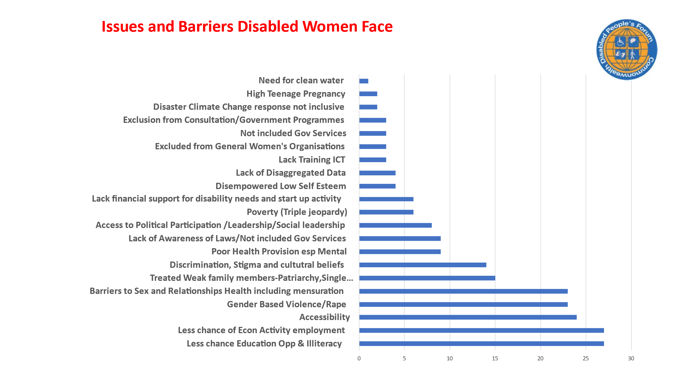

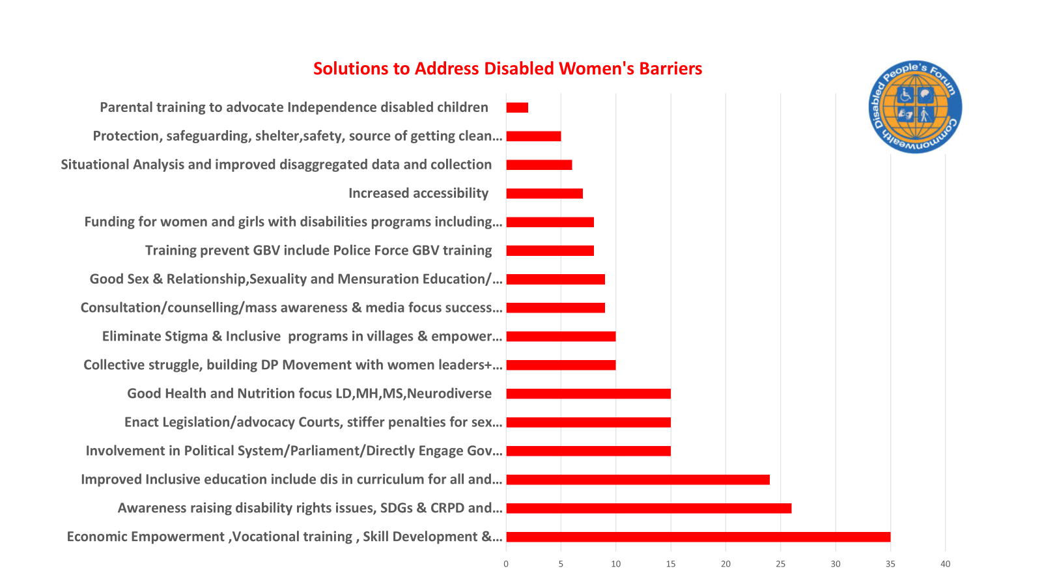

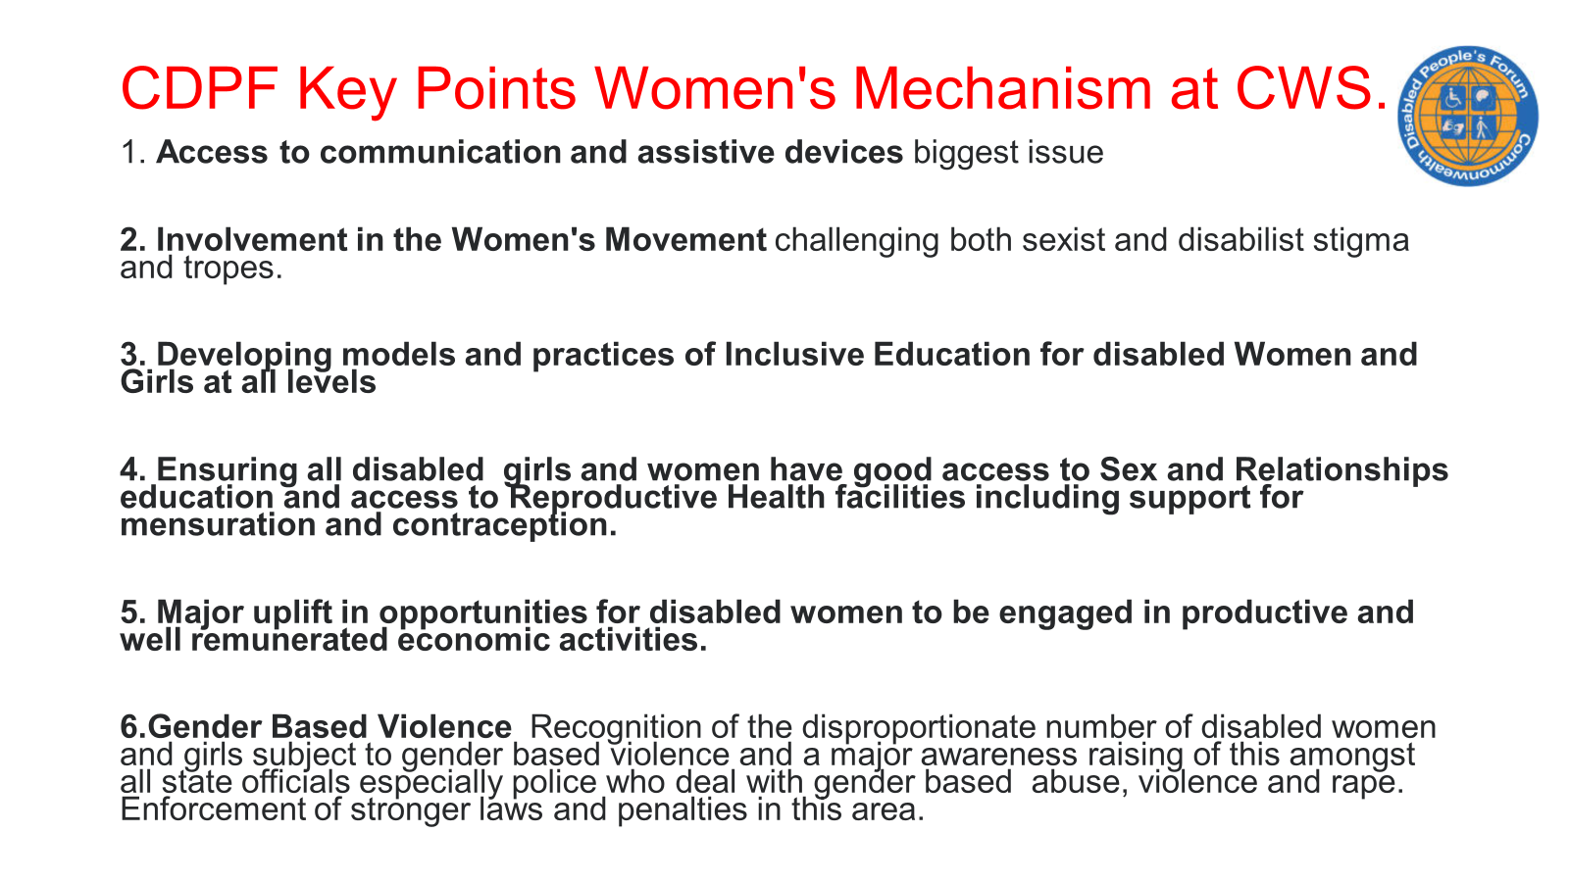
“Dear Dr Mohapatra,
13th Commonwealth Women’s Affairs Ministers Meeting
The Bahamas, 21 - 23 August 2023
I write to thank you for your valuable contribution to the Thirteenth Commonwealth
Women’s Affairs Ministers Meeting (13WAMM) which was held from 21-23 August 2023 in
Nassau, The Bahamas.

We are very pleased with the turnout at 13WAMM and the Outcome Statement which
contains the conclusions of the Ministers and Heads of Delegations. The key decisions will
be followed through by the Secretariat and an update will be provided to member countries
at the 2024 Commonwealth Consultation of National Women’s Machineries in the margins of
the United Nations Commission for the Status of Women in New York, in March 2024.
We look forward to continued engagement and collaboration with you in the work
towards gender equality in the Commonwealth.

Yours sincerely, Jennifer Namgyal, Head of Gender Section, Office of the Secretary-General”

ENVIRONMENT CLIMATE CHANGE AND DISABLED PEOPLE.

CDPF had previously produced a policy paper on this important issue and Module 6 of our 2021 Disability Equality Training.

In 2023 we set up an Environment Sub Committee
This met on 30th August19th September and 12th October. The Chair was Dookhoo Suvan Sharma from Mauritius with representation from Bangladesh, Sri Lanka, India, Malawi and Guyana.

They produced a policy statement :
Commonwealth Disabled People’s Forum Policy Addressing the Needs in Calamities, Risks, and Emergencies in Accordance with the United Nations Convention on the Rights of Persons with Disabilities (UNCRPD) Article 11.(Appendix 5)
Dookhoo Suvan Sharma was sent as CDPF representative to COP28 in Dubai. His success was limited though he made a number of important contacts because CDPF did not have access to the Blue area. We have suggested to the ComSec that in future years they should extend their recognised status to delegates from Accredited Organisations.
Disabled people, especially women, are at significantly greater risk than the rest of the population
Because of difficulties in getting accessible news of dramatic events, living in poverty more than the rest of the population and emergency and evacuation services not trained to meet their needs. CDPF aims to increase its efforts in this area.

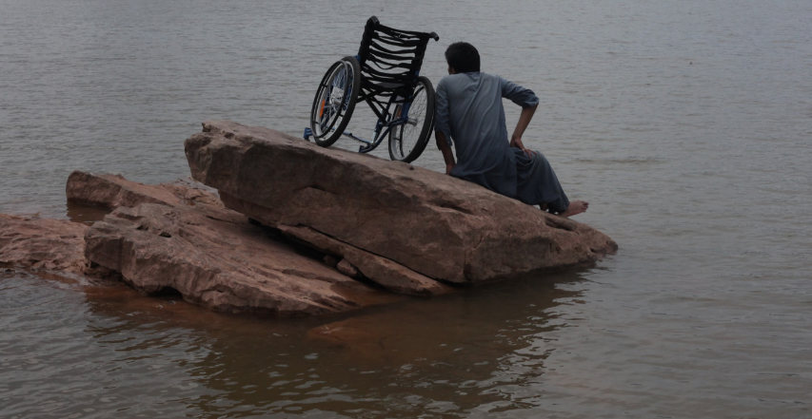
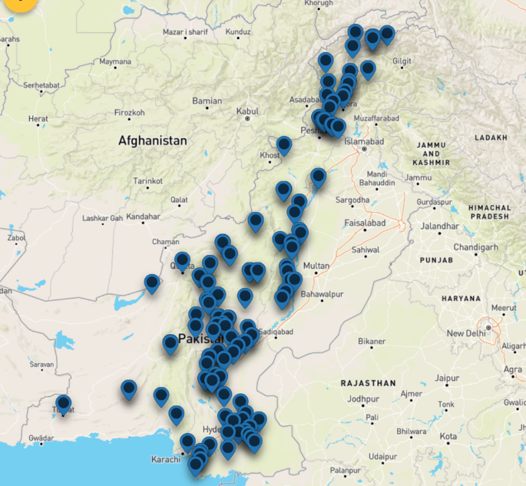

Our National Member organisation in Pakistan STEP response to severe flooding.
“Proposed Interventions:
Different populations may face similar risks of exposure to the negative effects of environmental and man-made disasters, but their actual vulnerability is dependent on their socio-economic conditions, civic and social empowerment, and access to mitigation and relief resources. Individuals with disabilities are disproportionately affected in disaster, emergency, and conflict situations due to inaccessible evacuation, response (including shelters, camps, and food distribution), and recovery efforts.

In past a few weeks experience during the devastating floods reveals that women with disabilities are more likely to be left behind or abandoned during evacuation due to a lack of preparation and planning, as well as inaccessible facilities and services and transportation systems. Most shelters and relief camps are not accessible and people with disabilities are many times even turned away from these facilities due to a perception that they need “complex medical” services. Disruption to physical, social, economic, and environmental networks and support systems affect persons with disabilities much more than the general population. There is also a potential for discrimination on the basis of disability when resources are scarce.

Having an experience of working closely with disabilities at the grassroots level and sound recognition of advocating about disability-inclusive emergency response and DiDRR at policy making as well as global platforms STEP would like to propose following interventions:

1. A comprehensive situation analysis of men and women with disabilities in all flood affected areas across the country, Recognise the diversity of persons with disabilities and collect sex, age and disability disaggregated data that acknowledges and links with
intersectionality.

2. Coordination with DPOs/OPDs (Organizations of Persons with Disabilities) and their self-help groups to bridge them with organizations engaged in emergency response and rehabilitation. Include people with disabilities and their representative organisations of persons with disabilities) to publicly lead on accessible DRR and response.

3. Need assessment of the assistive devices destroyed by flood being used by persons with disabilities in these affected areas.

4. Develop preparedness and recovery planning processes that support the health and
wellbeing of people with disability before, during and after emergencies.

5. Prioritise universal design and gender equality principles in DRR and recovery
investments”.

COMMONWEALTH ROUNDTABLE ON ADVANCING THE RIGHTS OF PERSONS WITH DISABILITIES: CELEBRATING INTERNATIONAL DAY OF PEOPLE WITH DISABILITIES 30TH NOVEMBER AND FOLLOWED BY A DAY OF DELIBERATION ON THEW WAY FORWARD ON 1ST DECEMBER 2023

Following a proposal from the CDPF in September 2023 and in commemoration of the International Day of Persons with Disabilities, annually celebrated on 3 December globally, the Commonwealth Secretariat, the Commonwealth Disabled People’s Forum, supported by the Centre for Disability Studies at the University of the West Indies, organised a special roundtable for Commonwealth stakeholders. The roundtable will focus on disability inclusion in the Commonwealth, with specific sessions considering the practicalities of strengthening accessibility and mainstreaming disability inclusion across the Secretariat’s operations; examining legislative case studies of CRPD implementation from selected Commonwealth members; and exploring means of strengthening CRPD implementation.

Objectives The overarching objective of the roundtable was to raise awareness about the rights of persons with disabilities across the Commonwealth.
Specific objectives are to:
1. Commemorate the International Day of Persons with Disabilities.
2. Explore the benefits of implementing a Commonwealth disability inclusion strategy and action plan and highlight the opportunities to develop such a strategy for the Commonwealth Secretariat.
3. Explore opportunities to strengthen respect, protection, and fulfilment of the rights of persons with disabilities in the Commonwealth.
4. Share examples of comprehensive disability legislation in member countries.
5. Exchange experience and good practices in implementing the CRPD.

Methodology: The roundtable will be a hybrid event, with the main activities hosted in person at Marlborough House in London and will include international sign interpretation and closed-captioning. Participants who are unable to visit the physical roundtable location will be able to join via Zoom. As a hybrid event, the roundtable will feature moderated panel discussions with in-person and online speakers, as well as recorded interventions.
The Day was attended by 90 disabled people from across the Commonwealth online and in person by 15 at Marlborough House where we were joined by representatives of the High Commission of South Africa, Kenya and New Zealand who gave an opening address. New Zealand High Commissioner Hon Phil Goff gave some very encouraging remarks. New Zealand has recently set up Whaikaha- Ministry of Disabled People. The leadership team of Whaikaha is led by Chief Executive Paula Tesoriero, a disabled person. The Secretary General of the Commonwealth sent a very supportive recorded message, as Patricia Scotland is leading the Commonwealth delegation to Cop 28.

Sarah Kamau our Chair, co-chaired the Roundtable from Marlborough House in London with Layne Robinson of Com Sec and in the afternoon with the Commonwealth Human Rights Unit. The morning session heard contributions from a number of CDPF Executive on how things were going for disabled people across the Commonwealth .We had thoughtful contributions from two CDPF Patrons, who are members of the UNCRPD Committee, Dr Samuel Kabue (Kenya) and Senator Dr Floyd Morris from Jamaica We heard from Scader Louis of Malawi (CDPF Treasurer) on the experience of attending the UNCRPD Committee in Geneva. Soovan Sharma from Mauritius, Chair CDPF Climate and emergencies sub-committee who is currently attending COP 28 on CDPFs behalf. Dr Emile Gouws, CDPF Executive member for underrepresented groups and a neurodiversity self-advocate addressed the issues of getting hard to reach disabled people into the movement. Kihembo Wilbert from Uganda, CDPF Youth Representative sent a strong message both on behalf of all disabled youth to be leaders now not just in the future and on behalf of the millions who are non-verbal. Sruti Mohapatra our Vic Chair from India, gave a great presentation on the state of play in India and Kerryann Ifill our other Vice Chair gave a short presentation. Kerryann is from Barbados in the Caribbean. Gaudence Mushimiyimana, CDPF Women’s Rep and convenor of the Women’s Forum explained that with the help of the Women’s Section of Com Sec we had held a number of Women’s Forums and sent reps to New York in March and the Commonwealth Ministers Meeting on Women’s Affairs in the Bahamas in August . This led to the inclusion of a number of important policy points in the declaration.

Dr Richard Rieser, OBE our General Secretary raised important points throughout the day and the next morning on the way forward arguing strongly for a stand-alone Disability Inclusion Protocol to go to CHOGM. Mainstreaming as favoured by Com Sec will not work. We need a twin track approach which both allows for the inclusion of disability equality generally and providing for the specific impairment based reasonable accommodations, support and aids and appliances we require. Richard’s message is contained in his International Disabled People’s Day message.

Our Draft Disability Inclusion Protocol/Strategy can be found at https://commonwealthdpf.org/wp-content/uploads/2023/12/THE-COMMONWEALTH-DISABILITY-INCLUSION-PROTOCOL-draft-1-2-3.docx
Appendix 3.

Participants were invited to read and discuss and send in any important additions they would like to have included. CDPF will not go to the wall on the language. CDPF favour disabled people as we are disabled by the barriers in society, not our impairments. There have been impairments as long as humans have existed. It is the social and culturally derived oppression that has to change by removing barriers and giving us equal rights. But we recognise many people prefer persons with disabilities and so we suggest these words are used inter-changeably in the Protocol/Strategy. The key message ‘It is essential is that the Commonwealth ups its game on disability and a Protocol/Strategy gives this possibility’.

CDPF most importantly urged DPOs to have discussions with their Government’s to win their support for this initiative being adopted by the Commonwealth Heads of Government Meeting (CHOGM) in October 2024, in Samoa.

The meeting on 30th was attended by a number of activists from the UK Disabled People’s Movement and allies from the UK Government FCDO who from next year will help to fund CDPF and last year produced a progressive FCDO disability inclusion and rights strategy 2022 to 2030
Also in attendance was a representative of Commonwealth Parliamentary Association who have a vibrant Network of Parliamentarians with Disabilities.
CDPF Encourages Parliamentarians who are disabled people to be active in this Network and encourage them to support our struggle for full implementation of the UNCRPD and equal rights for disabled people in their country.

RELATIONS WITH OTHER BODIES

ACTION ON DISABILITY AND DEVELOPMENT (ADD INTERNATIONAL)
Remained our Fiduciary Partner handling our money-Receiving Grants on CDPFs behalf and paying invoices from these monies, providing us with a part time Administrator - Gemma White who has proved invaluable in booking fares and accommodation, arranging sign interpretation and captioning, organising trainees and editing documentation amongst many tasks. We have a Memorandum of Understanding between our two organisations and this has recently been extended to September 2025. During the period to then we plan to set up as a Community Interest Company and set up our own bank account, but we may continue to use their services for a fee.
DISABILITY RIGHTS FUND has been a loyal and supportive funder to CDPF and we are currently in our 3rd Grant since 2019.
Grant Number: 19-072 $220,000 to restart CDPF 2019-21 General Assembly NY, Face to Face Executive, Online Training replaced in person training, Administration
Matched £35,000 Com Sec
Grant 21-22 $80,000 for dissemination training materials, CHOGM 22, Administration
Grant 23-24 $89,998 Plus $20,000 to establish wider base of funders. Youth Training, COSP attendance Administration

COMMONWEALTH SCHOLARSHIP COMMISSION
We have just completed our 4th Annual round of advertising and selecting disabled candidates from authorised countries across the Commonwealth to be recommended for a Masters or PhD grant at UK Universities . The work is largely done by General Secretary aided by a selection committee of senior officers. We can recommend 10 for Masters and 5 for PHDs. The selection is made against our agreed and publicised criteria. These are advertised on our website https://commonwealthdpf.org and in our Newsletter.
The CPDF is a partner of the Commonwealth Scholarship Commission (CSC). Applications for CSC-2024 must be submitted by 17th October 2023. Those who are disabled applying to the CSC for 2024 may also apply to CDPF by 1th November..

Each year CDPF select and recommends 10 Masters Candidates and 05 for PhD Candidates for the CSC..
Commonwealth Scholarship Nominations. Panel of 4 Officers met (SK,KI,SM,RR) on several occasions on line in December 2022 and December 2023, after RR had rejected incomplete applications.
Selection Criteria- Masters
i) meet CSC criteria, ii)Disabled and have understanding Reasonable Accommodation, iii)course study benefit to disabled people in their country, iv) what will do after course that will benefit disabled people in their country? For PHDs these 5 criteria plus number of published works, accepted by UK University for their research proposal and have a testimonial from their tutor.
Applying these criteria and gender balance we put forward in 2022 for Master (6 F 4 M) plus reserves (I F 1 M). For PHDs 2 Highly recommended (1 F 1 M), 3 recommended – not a high standard (3 M). All candidates notified. 38 Masters, 7 PHDs after first round. All candidates notified of outcomes.
In 2023 we selected 10 Masters out of 51 application received for nomination (5F/5M), PHDs 18 applicants nominate 5 (3F/ 2M) all with a good spread of impairment type and geographic location. CSC provide us with a fee of £2,800 for this selection and nomination process.
THE COMMONWEALTH PARLIAMENTARY ASSOCIATION (CPA)
In autumn 2021, we had a four page article about CDPF in The Parliamentarian, the Journal of Parliaments of the Commonwealth, and in 2022 chaired a side meeting for them at the 2nd Global Summit on Disability about electoral participation. In August 2022, Steve Estey, CDPF Executive attended a day of the CPA Annual Meeting in Halifax, Nova Scotia, Canada. We have been having discussions about how we can collaborate with them more, especially with their Commonwealth Parliamentarians with Disabilities Network.
The Commonwealth Parliamentarians with Disabilities (CPwD) network has been established in recognising of the need to increase representation of persons with disabilities in political institutions and to facilitate activities and programmes to champion and increase the representation of persons with disabilities in Commonwealth Parliaments and to work towards the mainstreaming of disability considerations in all CPA activities and programmes, with the mission “To encourage Commonwealth Parliaments to enable effective and full participation of persons with disabilities at all levels”.

Recently, CDPF General Secretary met the Chair of CPwD Network, Hon. LAURA KANUSHU, Member of the Parliament of Uganda who is an old friend of CDPF, having been a youth representative at CDPF founding meeting in 2008 and subsequently on the Executive. The discussion was about what had happened to CDPF up to 2013 and the progress since we restarted in 2019 and exploring the ways of working together and lead to setting up a triumvirate of CDPF, CPwD and Commonwealth Human Rights Institutes (HRI) to push forward implementation of the UNCRPD in line with Article 32 (International Cooperation) and Article 33 (National Implementation &Monitoring) which mentions Parliaments, Independent Focal Points (HRI) and DPOs.

The main focus of CPA around disability has been issuing grants to Parliaments to make them more accessible. For example this year CPA gave grants:-

CPA Parliament | Activity
Zambia | - Increase accessibility of Parliament Buildings by Parliamentarians and the public.  - More persons with disability observing the Sitting of the House
Monserrat | - Will enable more individuals with audio or learning difficulties to have a great opportunity to see what is happening in the Assembly and engage in its proceedings.
St Helena | - Ramps to enable access as elected Speaker and Deputy who are both Wheelchair users.
66th Commonwealth Parliamentary Conference (CPC) was held in Ghana from 30 September – 06 October 2023 Ghana Federation of Disability Organisations (GFD) our Full member in Ghana were involved.
CPwD Network does not have details of all Parliamentarians who consider themselves as disabled people. Therefore, we hereby request member organisations to send the details of disabled parliamentary representatives such as the nature of their impairment and whether male or female to CDPF General Secretary by email rlrieser@gmail.com.

FOREIGN COMMONWEALTH AND DEVELOPMENT OFFICE, UK
CDPF has a good working relationship with the UK Government FCDO, especially the Disability Team. The FCDO recommended us to DRF when we were trying to get restarted in 2019 and also provided funding for on-line side meetings at COPSP and the Disability Summit in 2021. In the Autumn of 2021 we helped develop focus group on the future FCDO Disability Strategy. This document shifts the focus to the centrality of the voice of DPOs/OPDs. FCDO Disability Inclusion and Rights Strategy 2022 to 2030

In 2023 the FCDO supported 2 successful side meeting CDPF held at the UNCOSP and discussions were initiated about FCDO providing Core funding directly to CDPF. This has comer top fruition with a grant of £250,00 pa from April 2024.

In June CDPF also met with Minister Andrew Mitchell. We had just managed to get our Youth Officer a Visa to USA to attend COSP 16 with the help of FCDO. We thanked Minister Mitchell for this. We sought and got in principle support for our initiative to get a Disability Inclusion Protocol adopted by CHOGM in October 2024. We got an indication that requests for core funding would be looked at favourably. Finally we had a discussion about the value of Disability Equality Training delivered by Disabled People and Minister Mitchell agreed to the value of this approach.

COMMONWEALTH CHILDREN AND YOUTH DISABILITY NETWORK CCYDN
The CDPF started in 2007, but from 2013 to 2018 had a hiatus of activity, but once the decision to reconstitute and commence activities it was always based o n being representative of the DPOs of the Commonwealth. The CCYDN on the other hand was a network of young disabled people in the Commonwealth., The CCYDN sought to get a MOU with CDPF demarcating all work with disabled youth as their realm. This was rejected in February 2020 by the CDPF face to face Executive meeting. Following this attempts were made to work together with CCYDN taking part in the delivering the Youth Module in the 14 Module Training Course in 2021.

CDPF reps at CHOGM Youth Forum complained that they had been treated by the founder of CCYDN as if they had no independence from CCYDN. This led to the setting up of CDPF Youth Forum and complaints from CCYDN.

Until January 2023 the Commonwealth Children and Youth Disability Network had 2 unelected members on the Executive, but their organisation was expelled from the CDPF in January 2023 following 2 enquiries into a complaint that was not upheld. The expulsion occurred because the CCYDN persisted in widely circulating the complaints and supporting documents, ignoring the procedure and confidentiality, despite being told by the Chair to desist, which brought the CDPF into detriment.
The CCYDN two representative which changed during this period were initially Jonathan Andrews, Sarah Mwikali who were replaced by Divya Goyal and Dan Grice. We thank them for their individual service.
CDPF will collaborate with CCYDN where it is appropriate such as at the Disability Roundtable on 30th November and follow up discussions 1st December 2023, but will organise and train disabled youth in relationships to DPOs.

INDEPENDENT FORUM OF COMMONWEALTH ORGANISATIONS IFCO
As a Commonwealth Accredited Organisation CDPF has regularly attended IFCO meetings and shared information with the Forum. Through IFCO CDPF also contributed to The Contribution of Commonwealth Accredited Organisations to Advancing the Commonwealth Charter An Independent Study October 2023. CDPF attended the launch in October and along with most other accredited organisations who attended resented the suggestion from the organisers that there were too many UK based organisations. As we pointed out Com Sec is based in London and we have members all over the Commonwealth many with high levels of organisation. It makes sense for CDPF to be based in London to communicate with the Com. Sec. and the High Commissioners. We are however seeking to set up regional nodes. This seemed to be to do with internal politicking within Com Sec.

Financial Status Information and Reporting
CDPF remains a Company Limited by guarantee at Companies House, but because of the arrangement outlined below remains dormant. Plans are in hand to change to a Community Interest Company with its own Bank Account and Accounts during 2024-2025.
Action on Disability and Development (ADD International) is the Fiduciary partner of the Commonwealth Disabled Peoples Forum. This relationship is covered by a Memorandum of Understanding, (twice renewed) and currently covering the period up until September 2025. ADD receives all monies and grants for CDPF and accounts for them separately in their audited accounts. ADD’s Financial Year runs January to December and we currently have accounts for 2021 and 2022 tied to their audited accounts. ADD also provides a part time administrator to CDPF (Gemma White) both of these services are paid for out of the 3 grants we have received from the Disability Rights Fund.
CDPF estimate our income likely expenditure for the period from April 2022 to December 2023 was £133,800. This is a ballpark figure based on the two excel spread sheets with rough translation dollars to £ stirling. We also have included Accounts for 2021 and 2022 extracted from ADD Audited Accounts

FINANCIAL REPORT AND ACCOUNTS
Disability Rights Fund (“DRF”) has approved a grant in the amount of $220,000.00.00 USD to Action on Disability and Development (“Grantee”) held for CDPF. The grant period will begin on 9/1/2019 and end on 8/31/2020.Due to Covid this was extended and repurposed to online training with and additional grant of £35,000 from Com Sec. This cover the relaunch in New York, Face to Face Executive and Online Training Course delivery and development It was extended until 2021
Disability Rights Fund (“DRF”) has approved a grant in the amount of $80,000.00 USD (the “Grant”) to ADD International (“Grantee”). The Grant period will begin on December 1, 2021, and end on November 30, 2022. This covered the virtual Executive, Administration, Distribution of Training Couse on Computer Stick, Attending CHOGM
Disability Rights Fund Grant April 23 to March 24. $110,000 Recommendations to set things moving.
To provide continued support for the core work of the Commonwealth Disabled Peoples’ Forum (“CDPF”) over the next year. To ADD $20,000, include Gemma for Admin; Gen Sec $ 11,250 Access costs for Executive meetings $10,000
Specifically, the forum will:
- Develop and deliver an online Training Disabled Youth into DPO Leadership training module; $19,300
- Engage DPO Leaders in enhancing involvement of disabled Youth;
Organize regional online seminars for DPO leaders x 2 for Caribbean, Southern Africa, East Africa, West Africa, South Asia &amp; Pacific;$5,700
- production of guidance and a checklist from best practice ideas raised in the dialogue
- CDPF representation (one person and PA) in the following events: Youth seminar -Commonwealth Youth ministers in September 2023, Islamabad; Climate Change Conference (COP) 28 November 2023, Dubai; COSP 16 June 2023. $13,988
Finally, CDPF will identify and hire a consultant to map donors and facilitate the development of bids for new funds and projects. $9,750
Will be paid in two tranches of $45,000.2nd tranche will be paid with additional $20,000 core. By then CDPF must identify how allocate additional $20,000.

The next page shows the income and expenditure of the CDPF through ADD for 2021 and 2022

Audit Trail

the income and expenditure include all the money we have received from DRF and other donors, therefore also include the expenditure for ADD hosting CDPF.

Please see attached ADD’s audited accounts for 2021 and 2022.

The income is included in Charitable activities - Restricted funds total and the expenditure is included in Disability Movement – Restricted funds total.
The bank is included in Currents assets – Cash at bank and in hand.

There is breakdown income by donor:

Please see the relevant page for YE 21 ADD accounts:

Total income received from DRF for 2021 - £84,830, which is total for Project PR9911 - 2nd grant (£52,469) and PR9920 -3rd grant (£31,911)
Total income received from Commonwealth Secretariat - £35,000

Please see relevant page on YE 22 ADD accounts:

Total income received from DRF for 2021 is showing as £42,221. This includes £9,750 grant income from DRF for Uganda project (Supporting Livelihood Initiatives for 5 young women with disabilities in Uganda), therefore CDPF it is £32,471.
Total income received form Commonwealth Scholarship Commission £2,800

The audited accounts do not include breakdown by expenditure by donor. I have extracted this from the complicated detailed workings, which feed from the transactions downloads from PSF accounting software, on which the audited accounts are based on.

Action on Disability and Development 2021 Full Audited Accounts

Action on Disability and Development 2022 Full Audited Accounts

FUTURE PLANS
1 Transition to a Free-Standing Organisation
a. Renew Memorandum of Understanding with ADD International as our fiduciary partner holding our money, making payments and providing Gemma as pt administrator to cover transition to a free-standing organisation until 30th September 2025. Consider how can still use support from ADD.
b. Change registration from Company Limited by Guarantee to a Community Interest Company
c. Set up bank account with 2 of 5 Officers to authorize expenditure appears Standard Chartered Bank can provide type of account we need.
d) Identify locations of regional desk hosting and requirements
e) General Assembly to be held virtually January /February 2025.

2. Funding
a. FCDO confirmed they will fund core £250k CDPF. submit detail by 1st March for core funding from April 2024 and possible subsequent years
b) Deploy money for fundraiser to get other funding streams
£5k for work in India to get funding for CDPF Office based at Swabhiman (Sruti’s Organisation) but part of CDPF £15k for Fund raiser to help develop business plan, find other funders and help to set up as CIC and work out a structure. Work on setting up regional desks.
c) Get funding for Disabled Girls Empowerment Project in Africa approach FCDO. Women’s Council and other funders
d) Seek funding- DRF and others areas of activity especially more face to face training and capacity building.

3. CDPF areas of activity
a) Adoption of Commonwealth Disability Inclusion Protocol at CHOGM week 21st October in Samoa Priority in next 12 months
i) Draft a Declaration
ii) Develop Action Plan
iii) Focus on Samoan Government and Prime Minister
iv) Contact all Governments and High Commissioners in London. Link to invite on Joint Meeting 1st December.
v) Consolidate steering group from states showing strong support -UKFCDO, New Zealand, Samoa, Malta, Barbados, Kenya others?
vi) Work with Human Rights Unit -Joint Meeting, Commonwealth Disability Dashboard and Develop and help deliver Disability Equality and UNCRPD Implementation for State Parties
b) Enhance work on Women, Youth and Environment
c) Develop work on Inclusive Education, Employment and Electoral and Political involvement.
d) Develop strategies to Involve hard to reach groups of disabled people.
e) Face to Face Executive May-July later decided to merge with a training week.
f) Intervention UN COSP June 24 (get State parties to host 2 meetings) , CHOGM Samoa 24

4. Building CDPF
i) Recruit remaining Country DPOs -Granada, Antigua Barbuda, Nevis & St Kitts, Singapore, Brunei Darussalam
ii) Recruit DPOOs Scotland, Walesa and Northern Ireland and/or UK wide DPO grouping
iii)Hold regular meetings on a regional basis with Member DPOs starting with February 2024 on Youth and Protocol.
iv) Set up Overseas Territories Category and recruit DPOs in these territories.
v) Consolidate Youth Forum with Reps of Disabled Youth Networks/Orgs across Commonwealth
vi) Consolidate Women’s Forum
vii) Activate membership and Human Rights Advocate Network on Social Media and building UNCRPD Implementation Campaigns.

5. External Relations
Meet with Membership IDA -3 to attend-meeting offered.
Develop stronger relations with Commonwealth Governments.

Approved by Executive 18th October 2023

APPENDIX 1 REVISED CONSTITUTION OF COMMONWEALTH DISABLED PEOPLES’ FORUM (2008,2019) WITH UPDATES INCORPORATING AMENDMENT AGREED BY THE VIRTUAL GENERAL ASSEMBLY FEBRUARY/APRIL 2022
Preamble
In light of the adoption UN Convention on the Rights of Persons with Disabilities (UNCRPD) by the General assembly in December 2006, the recognition by Commonwealth Heads of Government, in their statement in Kampala in November 2007 and subsequent statements of the need to adopt, ratify and implement the UNCRDP throughout the Commonwealth, to achieve the Sustainable Development Goals by 2030 and challenge the continuing inequalities and exclusion disabled people face throughout the Commonwealth, we resolve to set up a Commonwealth Disabled Peoples’ Forum.
The principles governing the CDPF
The following principles shall govern the operations Commonwealth Disabled Peoples Forum.
(a) Respect for inherent dignity and individual autonomy of members.
(b) Non-discrimination;
(c) Full and effective participation and inclusion in society;
(d) Respect for difference and acceptance of disabled people as part of human diversity and humanity;
(e) Equality of opportunity;
(g) Equality between men and women and between member countries;
(h) Respect for the evolving capacities of disabled children and respect for the right of disabled children to preserve their identities.
Article 1: Name
The name of this organization is Commonwealth Disabled People’s Forum (CDPF)
Article 2: Purpose
- The purpose of CDPF is to bring disabled people together, regardless of type of impairment, gender, age, race, indigenous, geographical background, religion, political affiliation from all countries of the Commonwealth, with a view to having one voice to advocate for promotion and equalization of opportunities for all disabled people.
- To engage and influence the structures and organs of the Commonwealth, especially the Commonwealth Heads of Government Meeting and the wider global human rights and disability rights movement.
- Implement the principles outlined in the preamble as contained in these documents.
Article 3: Objects
The objects for which the Forum is established are:
  - To establish a Forum for all Disabled Peoples Organizations in the Commonwealth, open to organizations representing people with all forms and types of impairments.
  - To promote solidarity, enhance their development and to support the acquisition of all their human rights.
  - To promote equality for disabled people, meaning the process through which the general systems of society are made accessible to all by the removal of social, economic, civil, political, cultural, environmental and attitudinal barriers, such as the physical and cultural environment, housing, transport, information technology, health, social services, education, employment, family life, independent living, sports and recreation activities.
  - To advocate and provide support for the signing, ratification and monitoring full implementation of the Convention on the Rights of Persons with Disabilities by all Commonwealth countries.
  - To develop capacity building, awareness, empowerment among the general public, government authorities, professionals and disabled people and their organizations of their potential and rights.
  - To influence governments of the Commonwealth and regional mechanisms to fully involve the CPDF and DPOs in formulation of policies, programmes, monitoring of implementation of the UNCRPD and SDGs or all other decisions and programmes which affect disabled people.
  - To serve as a home of expertise and reference for the Commonwealth Governments, DPOs and other disability stakeholders in Commonwealth countries through technical assistance, guidance and documentation on disability matters.
  - To strengthen and empower disabled women and girls’ human rights in Commonwealth countries, to end violence against women and girls and address sexual health and reproductive rights of disabled women and girls with reference to CEDAW, CRPD Article 6 and the Beijing Platform for Action (1995).
  - To recognise the impact on disabled people within the history of the Commonwealth and the impact of colonization, dispossession, current and historical colonial acts of oppression, injustice and inequality and ensure that measures are in place to address these issues so that reconciliation can take place.
  - To promote sustainable programmes and activities for disabled Women, Youth and Indigenous People to develop their empowerment and independent living.
  - To build and strengthen relations with local, national, regional and international donors, potential donors, NGOs and other institutions or individuals who subscribe to the aims and the objectives of the CDPF.
  - To mobilize resources through fundraising, subscriptions, donations, endowments and income generation projects.
  - To solicit support from governments and other agencies and the general public through negotiations, persuasions, appeals and other ways.
  - To borrow or raise money in such a manner as the CDPF may deem fit.
  - To invest the moneys of the CDPF, not immediately required for its purposes, in such manner as may be approved by the Executive Committee.
  - To undertake and execute any trusts which may lawfully be undertaken by the CDPF to further its objectives.
  - To print and publish any virtual materials, website, social media, pamphlets, articles, newspapers, periodicals, books, film, leaflets that the CDPF may think desirable for the promotion of its objectives in accessible formats.
  - To support and subscribe to any organisation, institution, society, club or cause which may be for the benefit of the CDPF or its employees or for the advancement of its objectives.
  - To do any other such lawful things as are incidental or conducive to the attainment of the above objects or any of them.
Article 4: Registered Office There will be a registered office of CDPF which will be situated in London, United Kingdom and in other Commonwealth countries as resources allow.
Article 5: Membership
a) Within CDPF there shall be full members, DPO Associate members, corporate members, associate and individual members. The Forum shall seek the widest representation of groups of disabled persons of national populations as well as regards gender, religion, race, language, geography and impairment, etc. Organizations including family members and/or relatives of persons with disabilities, which are pivotal in facilitating, promoting and securing the interests and supporting the autonomy and active participation of their relatives with intellectual disabilities, dementia and/or children with disabilities, when these groups of persons with disabilities want to be supported by their families as united networks or organizations. In such cases, these organizations should be included in consultation, decision-making and monitoring processes. The role of parents, relatives and caregivers in such organizations should be to assist and empower persons with disabilities to have a voice and take full control of their own lives. Such organizations should actively work to promote and use supported decision-making processes to ensure and respect the right of persons with disabilities to be consulted and to express their own views; in line with General Comment No 7 are counted as DPOs. paragraph 12 (a) [then quote the paragraph]. These organisations are understood to be organisations "that are led, directed and governed by persons with disabilities. A clear majority of their membership should be recruited among persons with disabilities themselves" (CRPD General Comment, paragraph 10). No more than 10% of any voting body of the CDPF will be comprised of such organisations.
- Full Members Full membership of the CDPF shall be open to national Disabled Peoples Organisations (DPOs) in any country of the Commonwealth qualified under the provisions of this article. "DPOs" means that a majority of the members as well as the governing body shall be disabled people and in the case of those with intellectual disabilities or others mentioned in 5a also their families and they shall represent a wide range of impairments and local DPOs in line with the stipulations of 5a. ‘A national DPO is one with membership in at least one half of the country and representing a wide range of impairments.’ Full members shall exercise voting powers- 2 votes, send delegates to CDPF organs, and nominate persons to CDPF offices.
c) DPO Associates. This is for country regional organisations which are not national or national organisations for a single impairment group, which are run by a majority of disabled people on governing body and have a majority of their membership who are disabled people and in the case of those with intellectual disabilities or others mentioned in 5a) also their families They will be able to attend meetings, speak, and have 1 vote send delegates to CDPF organs.
d) Corporate Members Corporate membership may be granted to international disability organizations which support CDPF objectives, and which are organizations where a majority of members as well as the governing bodies are persons with disabilities in accordance with definitions in article 1. Representatives of corporate members have speaking rights at the CDPF General Assembly. A limited number of persons representing corporate members can attend the General Assembly with speaking rights has no voting rights, nor the right to be nominated or to nominate persons to office but has speaking rights.
e) Associate members may be granted membership if they are international Non-Governmental Organisations who will fund, support and will promote the objectives of the CDPF. Their disabled representatives may attend general assemblies with speaking rights but without no voting rights, nor the right to be nominated or to nominate persons to office.
f) Individual Members Individual membership may be granted by the General Assembly on recommendation by the executive committee to prominent disabled individuals who may not necessarily be in any DPOs, but who support CDPF objectives and would wish to be associated with it.
An individual member has no voting rights, nor the right to be nominated or to nominate persons to office but has speaking rights.
g) Existing Members of the current Executive not nominated as delegates to the General Assembly can speak and have 1 vote.

Article 6: Application for membership
Membership applications and applications for re-admission as a member of CDPF shall be decided by the General Assembly on recommendation of the Executive Committee.
Article 7: Membership Fees
The General Assembly shall have powers to levy membership and other fees on recommendations of the Executive Committee. A member unable to pay prescribed membership fees can seek partial or complete exemption from the Executive Committee. The General Assembly will determine fees.
Article 8: Termination of Membership
- The General Assembly shall have powers to determine the continued compliance with membership requirements of the members.
- A member that wishes to terminate its membership shall give notice to the Chairperson. Such notice shall take effect six (6) months after it is received provided that the member has at that time fulfilled its entire financial obligation to CDPF.
- A member may be expelled if is in serious arrears in payment of financial contributions to CDPF by a resolution of the General Assembly passed by a simple majority of those present and voting.
- A member may be expelled due to a cause that is detrimental to the interests and purposes of CDPF.
- The General Assembly may, by resolution passed by simple majority of those present and voting, determine the outcome of non-compliance with membership requirements.
- The affected member shall be given due notice and an opportunity to respond.
- A member shall cease to be a member of the CFDP if the member’s country ceases to be a member of the Commonwealth.
- All members shall automatically cease to be members if the CFDP is wound up.

Article 9: Organization
CDPF shall consist of the General Assembly, Executive Committee, and Staff. In all elections of CDPF, secret ballots shall be used.

Article 10: General Assembly
- The General Assembly shall be the supreme policy making body of the organisation and it shall consist of representatives from all paid up member DPOs of the Forum from Africa, Caribbean, South Asia, Pacific, South East Asia and the ABCN countries shall attempt to ensure that all groups of disabled persons and gender are fairly represented.
- The General Assembly shall, among other things, adopt and amend the constitution; elect the Executive Committee, the Patron and Auditors; determine membership and annual fees; approve policies, programmes, work plans and budgets of the Forum; receive and adopt reports and audited accounts from the Executive and approve admission of new members.
- The General Assembly shall be convened bi-annually preferably in person or virtually depending on pandemics or finances, before the Commonwealth Heads of Government Meeting (CHOGM) for the purpose of, among other things, receiving the chairperson’s reports and audited accounts; electing the Board of Directors, and Patron and appointing Auditors.
- Notice of the bi-Annual General Assembly shall be 21 days and Extraordinary or Special General Assembly 14 days given in writing and signed by the Secretary addressed to each member entitled to receive notice and widely publicized in mass media.
- The General Assembly shall serve as final court of appeal on all matters as regards the rights and obligations of members.
- The quorum for the general assembly is 20% of membership
Article 11: Commonwealth Disabled Peoples Conference
- The Commonwealth Peoples Conference as far as possible be convened bi-annually before CHOGM, among other things, to review current developments in the disability field and prepare proposals for submission to CHOGM for consideration.
- All members of the Forum shall be entitled to send delegates to the bi-Annual Disabled Peoples Conference and shall be entitled to speak at the conference, and to share materials and good practice..
- The Executive Committee may assist DPOs in the country hosting CHOGM or any other Commonwealth country as may be decided by the Executive Committee to organize the bi- Annual Commonwealth Disabled Peoples Conference.
Article 12: Executive Committee
- Executive shall consist of a Chairperson, Vice Chairperson (2 at least I shall be a woman. When the Chair is from one Region, the 2 Vice Chairs shall be from two other different Regions of the CDPF.[ Note the CDPF has 5 Regions Africa, Caribbean, Pacific, South Asia, and Australia, Britain, Canada, New Zealand countries] Secretary, Treasurer, Women Representative (1), Youth Representatives (3) (2 from CCYDN and 1 directly elected [28 years old or less at time of election], Indigenous People’s Representative (1),Communication Officer (1) Intellectual Disability and under represented groups and others as defined in 5a (1) and representatives from each of the regions of Africa (4 to include 1 from Nigeria), the Caribbean (1), South Asia/SE Asia including Malaysia (4), Pacific (1) and the Australia, Britain, Canada, New Zealand countries (1) elected at the bi-General Assembly of the Forum and shall hold office for two years.
- At its first meeting, the Executives may co-opt not more than seven other members bearing in mind gender, disability categories and other consideration. Co-opted members shall also serve for two years.
- Finance & General Purposes (F&GP) Sub- Committee of 8 to comprise Chair,2 Vice Chairs, General Secretary, Treasurer and 3 other members of Executive to be elected by the Executive.
- Establish a standing Women’s Committee consisting of all women on the Executive with power to co-opt up to 5 Women from Member organisations.
- Meetings of the Executive Committee shall be convened by the chairperson at least once a year, and written notice dully signed by the Secretary shall be sent to all members of the Board giving fourteen days notice. At all meetings of the Executive the quorum shall be 10 of the membership of the Board. Other meetings will take place using alternative communication.
- The Executive Committee shall exercise all such powers as may be exercised or done by the CDPF except those things required to be done by the CDPF in a General Assembly. No regulations made by the Forum in a General Assembly shall invalidate any prior act of the Board which would have been valid if such regulation had not been made.
- All acts done by the authority of the Executive Committtee or any sub committee thereof and of the individual members of the Executive, in good faith and with the authority express or implied of the CDPF, shall be deemed to be the acts of the CDPF and every member of the Executive shall be indemnified by the CDPF for any costs, losses and expenses incurred for the furtherance of the objects and purposes of the CDPF.
- Upon petition signed by one half of the Executive Committee, the Chairperson shall convene a special meeting of the Executive Committee giving seven days notice and special business to be conducted.
- A member of the Executive shall cease his/her membership if he resigns, or becomes, or his country ceases to be a member of the Commonwealth, or if removed by two thirds majority of members of the Board or absents himself from meetings for one year with out cause, or commits a criminal offence, or is declared bankrupt or dies.
- The Executive may fill casual vacancies from members who are qualified to serve on the Board.
Article 13: Functions of the Executive Committee
The Executive Committee shall act on behalf of the General Assembly, in between its meetings and shall, among other things:
- Set up a secretariat and appoint staff on such terms and conditions as they may deem fit and regulate their performance and conduct.
- Consider ways and means of financing the operations and programmes of the CDPF and also protect and preserve its assets.
- Ensure the attainment of the objectives for which the CDPF is established and maintain effective reporting to the General Assembly of all matters which requires its attention.
- Receive, consider and approve applications for membership and maintain a register of members.
- Prepare and present to the General Assembly for approval annual reports, budgets, programs and plans and audited financial accounts.
- Set up committees to perform such specific tasks as may be deemed necessary for attainment of the CDPF objectives.
- Draw up rules and regulations to regulate their own conduct and that of the secretariat and its staff.
- Serve all members of the CDPF as equitably as possible and convene meetings of the CDPF as provided for in this constitution.
- Ensure maximum participation possible by all categories of disabled persons in CDPF activities.
- Advise the Commonwealth, United Nations, and other relevant bodies on matters relating to the activities of CDPF.
Article 14: Officers of the Executive
- The Chairperson shall be the head of the Forum and Executive and shall convene and preside over meetings of the General Assembly and Board of Executive.
- The Vice Chairperson shall act in the absence of the Chairperson or in case of his/her inability to perform.
- The Secretary shall be the secretary of all meetings of the General Assembly, the Executive and Committees of the CDPF and shall notify members of meetings, take minutes of all meetings and circulate them to all members entitled to receive them.
- The Treasurer shall take custody of all the funds and other assets of the Forum and shall be accountable for all funds to the Forum in the General Assembly. The financial year of the Forum shall be 1st April to 31^{s} March of each succeeding year.
- The Women’s Representative shall be responsible for ensuring that there is mobilisation, sensitisation and empowerment of disabled women and welfare programmes for disabled children are initiated by the CPDF.
- The Youth Representatives shall be responsible for ensuring that there is mobilisation, sensitisation, empowerment of the youth with disabilities and that they are afforded opportunities for participation in sports and cultural and other activities.
- The Indigenous Peoples’ representative shall be responsible for ensuring that there is mobilisation; sensitisation, empowerment of indigenous disabled people and that they are afforded opportunities for participation in sports and cultural and other activities.
- The Communications Officer will ensure regular communications with the membership and develop electronic communications.
- Intellectual Disability and other under-represented groups Officer will ensure their issues are part of CDPF proceedings.
- Executive Committee members shall attend all meetings and play a full part in running the CDPF.
- The Executive shall draw up guidelines to regulate the Executive Committee in the conduct of its business.
Article 15: Country Focal Point
1. The Executive shall nominate one national DPO from each of the Commonwealth countries to be known as Country Focal Point to represent the interests of the CDPF in that country and for purposes of this Article every member of the Executive shall be a Country Representative of his or her country.
2. The functions of a Country Focal Point shall include, among other things:
- Recruitment of qualifying DPOs as members of the Forum.
- Providing information to DPOs about the Forum and promote the interests of the Forum in that country.
- Ensuring that member DPOs discharge their responsibilities to the Forum,
- Monitoring on behalf of the Forum the implementation of the Convention on the rights of people with disabilities and submit reports appropriately.
- Submitting annual reports to the Board on the state of disabled persons in the country especially with regard to new innovative policies, legislation in the area of promoting inclusion and protection of rights, among others.
- Undertaking any other tasks as may be assigned by the Board or the Chairman from time to time.
Article 16: Patron
- The Patron shall be a distinguished personality in the Commonwealth nominated by the Executive Committee and approved by the General Assembly.
- He or she shall represent the interests of the CDPF at the highest level in Commonwealth Governments; promote its development, may help raising funds for the programs of the CDPF, and shall hold office for two years and eligible for re- election for further terms of two years.
Article 17: Relations with other International Organizations
- CDPF may cooperate, in accordance with the provisions of this constitution, with any international organization of interest to CDPF in the promotion of its objectives either by way of corporate membership or observer status.
- The CDPF may permit the participation of governmental and non- governmental organisations in CDPF meetings and activities, and may also participate in meetings, programs or activities of other organisations having similar objectives.
- It may also be affiliated to another organisation with similar objectives by a resolution of the Executive approved by the General Assembly.
Article 18: Financial and Budgetary Arrangements
- The funds of the CDPF shall consist of membership and annual subscription fees; grants and donations from governments, international organisations and well wishers; funds raised from functions of the CDPF; funds raised for specific programs; funds raised from profits, interests, deposits, commissions, dividends accruing to the CDPF and Funds raised from any other lawful source.
- The Executive may from time to time raise funds by way of borrowing from banking or other financial institutions or company on such terms as shall be approved by the Executive Committee.
- The Treasurer shall deposit all funds of the CDPF with the bank or banks approved by the Executive.
- The Executive may set up a special trust fund for money received for special purposes and shall submit regular reports certified by the auditors on the functioning of the fund.
- The Executive may at any time call upon any member of the CDPF to pay forthwith any account due and on failure to make such payment, a member shall not be allowed the privileges of the Forum until the account is settled and the Executive may take such other action as they may deem necessary to recover the debt.
- The Executive shall draw up financial regulations relating to signatories to cheques and negotiable instruments and make other rules and regulations for the proper and effective management of the funds of the CDPF.
- There shall be strict accounting practices in the CDPF and as far as possible the Treasurer shall demand and give receipts on behalf of the CDPF and the authority to expend and withdraw funds shall rest with the Executive Committee provided that the fixed assets of the CDPF shall be only disposed of by a resolution of the Executive.
Article 19: Audit
- The General Assembly on recommendation by the Executive shall appoint auditors and may be paid such fees or honourium as may be recommended by the Executive Committee and approved by the General Assembly.
- The annual accounts shall be closed on 31st March of each year and the accounts shall be audited by 30th September, printed and a copy shall be presented to the bi - Annual General Assembly.
Article 20: By Laws
- The Executive shall have powers to make, alter and rescind such bye laws or rules as they may from time to time deem necessary, expedient or convenient for the proper conduct, management and welfare of the CDPF, in particular, but not exclusively by such by laws.
- There shall be a set of bylaws with more detailed rules and regulations on the procedures to be followed in the organization.
Article 21: Amendments to the Constitution
- This constitution may be altered or amended from time to time on the recommendation of the Executive only at the General Assemblies or at special General Assemblies called for that purpose, by a majority of two thirds of members present with the right to vote.
- The Executive, prior to submission to the General Assembly, shall circulate the proposed amendment or amendments to members for their opinions at least 2 months’ notice should be given.
- The quorum necessary to invoke this article shall be two thirds of the delegates entitled to attend and vote representing paid up members of the Forum.
Article 22: Interpretation
The powers to give final interpretation of any provision of these Articles shall rest with the General Assembly whose interpretation shall be binding on the members.

Article 23: Dissolution of the Organization
- The General Assembly, on recommendation of the Executive, shall by resolution supported by two thirds of the members present and entitled to vote, dissolve the Forum.
- In the event of dissolution of the Forum the property of the Forum shall be disposed of in such a manner as shall be determined by the General Assembly provided that no property whatsoever shall be given to an individual but shall be donated to another organisation with similar objectives.
Article 24: Entry into force
This version of the constitution entered into force when approved by General Assembly held on 8th April 2022.

APPENDIX 2: MEMBERSHIP AS OF 31ST DECEMBER 2023

Anguilla Department of Social Development (Observer/ally)
Australia People with Disabilities Australia (Full)
Australia First Peoples Disability Network Australia (Associate)
Bahamas Connects, Disability Advocacy & Inclusion (Associate)
Bangladesh National Grassroots Disability Org (Associate)
Bangladesh Access Bangladesh Foundation (Associate)
Bangladesh Women with Disabilities Development Foundation WDDF (Full)
Bangladesh Disabled Child Foundation (DCF)
Barbados Barbados Council of the Disabled (Full)
Belize Assembly for Persons with Diverse Abilities (Bapda) (Full)
Botswana Federation of the Disabled (Full)
Cameroon Platform Inclusive Society for Persons with Disabilities (Full)
Canada Council of Canadians with Disabilities (CCD) (Full)
Canada Canadian Association for Community Living (CACL) (Associate)
Canada Canadian Autism Spectrum Disorder Association CASDA. (Associate)
Canada Environmental Health Association of Quebec. (Associate)
Dominica Dominica Association Persons with Disabilities DAPD (Full)
Fiji Fiji Disabled People’s Federation (Full)
Gabon Fédération Nationale des Associations des et pour Personnes Handicapées du Gabon (FNAPHG). (Full)
Gambia Gambia Federation of the Disabled (GFD). (Full)
Gambia Gambia Association of Physically Disabled (GAPD). (Associate)
Gambia The Gambia Organisation of the Visually Impaired (GOVI). (Associate)
Ghana Ghana Federation of Disability Organisations GFD (Full)
Guyana Guyana Council of Organisations for Persons with Disabilities (Full) India Swabhiman Smile Foundation (Associate)
India National Centre Employment Disabled People (Full)
Jamaica Combined Disabilities Association (Full)
Kenya Ability Society (Self Advocacy Orgs) (Associate)
Kenya Kenya Users & Survivors Psychiatry Ass. (Associate)
Kenya United Disabled Persons of Kenya UDPK (Full)
Kenya Disability Development Network Community Board Organisation DDNCBO (Associate)
Kiribati Te Teo Matoa (Full)
Lesotho Lesotho National Federation of Org. of the Disabled LNFOD (Full)
Malawi Disabled Women In Africa DIWA (Associate)
Malawi Federation of Disability Orgs. in Malawi FEDOMA (Full)
Malawi VIHEMA Malawi Visual Hearing Impairment Membership Association (Associate)
Malawi Spinal Injuries Association of Malawi SIAM. (Associate)
Malaysia Damai – Disabled Persons Association (Associate)
Malaysia Harapan OKU. (Associate)
Malaysia Malaysian Confederation of the Disabled. (Full)
Maldives Maldives Association of Persons with Disabilities (Full))
Malta Malta Federation of Organisations of Persons with Disabilities (MFOPD) (Full)
Mauritius Youth with Disabilities Empowerment Platform (Associate)
Mauritius Federation of Disabled People’s Organisations Mauritius (Full)
Monserrat Montserrat Association for Persons with Disabilities (Associate)
Mozambique Mozambiquian Association of Disabled People FAMOD (Full) (Associate)
Mozambique Mozambican Association of Women with Disabilities (Associate)
Mozambique Mozambican Mental Health Users Association AMUSAM (Associate)
Namibia Autism Association of Namibia. (Associate)
Namibia National Federation of People with Disabilities in Namibia (Full)
Nauru Nauru Persons with Disabilities Organisation (Full)
New Zealand Kapo Maori Aotearoa (Associate)
New Zealand Disabled Persons Assembly, Deaf Action (Associate)
Nigeria Advocacy for Women with Disabilities Initiative AWWDI (Associate)
Nigeria Association for Comprehensive Empowerment of Nigerians with Disabilities (ASCEND) (Associate)
Nigeria Joint National Association of Persons with Disabilities of Nigeria JONAWPWD (Full)
Nigeria National Association of Women with Disabilities NAWID (Associate)
Nigeria Family Centred Initiative for Challenged Persons FACI (Associate)
Nigeria Spinal Cord Injuries Association of Nigeria. Associate
Pakistan Policy Research and Development (PRAND) Organization. (Associate)
Pakistan Special Talent Exchange Program (Full)
Papua New Guinea Papua New Guinea Assembly of Disabled Persons (Full)
Rwanda Rwandan Union of the Blind RUB (Associate)
Rwanda National Union Disabilities Organizations in Rwanda NOUSPR (Full)
Rwanda Rwanda Ex-Combatants and Other People with Disabilities Organisation RECOPDO (Associate)
Rwanda Rwandan Organization Women with Disabilities UNABU (Associate Delegate)
Rwanda National Organisation of Users and Survivors of Psychiatry NOUSPR. (Associate)
St Lucia National Council of and for People with Disabilities St Lucia Inc. (Full) St Vincent and the Grenadines Voice of the Disabled. (Full)
Samoa Nuanua Ol Alofa (Full)
Sierra Leone Sierra Leone Union on Disability Issues SLUDI (Full)
Solomon Islands People with Disabilities Solomon Islands (Full)
South Africa Disabled Persons South Africa (Full)
South Africa Autism South Africa (Associate)
South Africa South African Disability Alliance SADA. (Associate)
South Africa South African National Council for the Blind SANCB (Associate)
Sri Lanka Disability Organisations Joint Front DOJF (Full)
Sri Lanka Sri Lanka Foundation for Rehabilitation of the Disabled SLFRD (Associate)
Swaziland (Eswatini) Federation of Disabled Persons in Swaziland (FODSWA)
Tanzania Association of the Deaf (CHAVITA) (Associate)
Tanzania Tanzanian Federation of Disabled Persons Organisations SHIVYAWATA (Full)
Togo Federation Togolaise Des Associations De Personnes Handicapees (Fetaph) (Full)
Tonga Naunau O’E Alamaite Tonga Association (Full)
Trinidad and Tobago Persons with Visual Impairments Associate (Associate)
Trinidad and Tobago Trinidad and Tobago Chapter of Disabled Peoples’ International. (Full)
Tuvalu Fusi Alofa Association (Full)
Uganda National Union of Disabled Persons of Uganda-NUDIPU (Full)
Uganda Legal Action for Persons with Disabilities (Associate)
Uganda Youth Physical Disability and Development Forum (Associate)
Uganda The Voice of the Youth with Disabilities. (Associate)
Uganda Uganda Federation of Hard Of Hearing (UFHOH). (Associate)
Uganda Uganda National Association of the Deaf (UNAD). (Associate)
UK National Federation of the Blind (Associate)
UK (Wales) Disability in Wales and Africa DWA. (Observer/ally)
UK Reclaiming Our Futures Alliance ROFA (Full)
Vanuatu Vanuatu Disability Promotion & Advocacy Association VDPA (Full)
Zambia Zambia Federation of Disability Organisations ZAFOD. (Full)
Zambia Deafblind Association of Zambia (DBAZ). (Associate)
Totals -Countries 49 + 2 Overseas Territories, Full Members 47, Associates 50, Observer/Ally 2
Membership: With the joining of Gabon and Togo to Commonwealth on 26th June 2022 we welcome Federation Nationale des Associations des pour Personnes Handicapees du Gabon (FNAPHG) as a our 46th Full country member and Togo Federation Togolaise Des Associations De Personnes Handicapees (Fetaph) (Full) as our 47th Country Member.

APPENDIX 3 DRAFT CDPF DISABILITY INCLUSION PROTOCOL

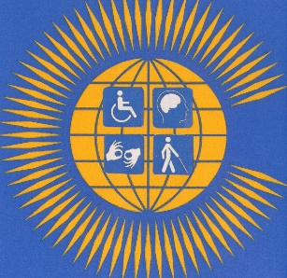
Draft: THE COMMONWEALTH DISABILITY INCLUSION PROTOCOL
Comments to R.L Rieser
General Secretary Commonwealth Disabled People’s Forum
Email rlrieser@gmail.com
Preamble
We, the Heads of State and Governments of the Commonwealth
Acknowledging the significant population of disabled people within the Commonwealth, estimated at up to 450 million citizens, with over 60% being children aged 30 years or under
Welcoming the UN Convention on the Rights of Persons with Disabilities adopted on 13 December 2006, including provisions on care which should be provided based on free and informed consent informed by dignity, autonomy and the needs of the person;
Welcoming the adoption of the 2030 Agenda on Sustainable Development, particularly the Sustainable Development Goals and the Addis Ababa Action Agenda of the Third International Conference on Financing for Development;
Considering that Commonwealth Heads of States and Government meeting in 2018 and 2022 urged Member States to implement the United Nations Convention on the Rights of Persons with Disabilities (UNCRPD)
Further Considering that 55 of 56 Commonwealth countries have ratified the UNCRPD that prohibits all forms of discrimination on the basis of disability
Recognizing that Commonwealth countries have made various efforts to make real positive and inclusive changes of disabled people and are at different levels of implementing the UNCRPD.
Noting that human rights and fundamental freedoms are universal, indivisible, interdependent and interrelated, and that the rights of every individual are recognized in international human rights instruments, including the Universal Declaration of Human Rights of 10 December 1948, the International Covenant on Economic, Social and Cultural Rights 16 December 1966 and the International Covenant on Civil and Political Rights 16 December 1966;
Acknowledging that disabled people have inherent dignity and individual autonomy including the freedom to make one’s own choices;
Recognizing the diversity of disabled people and including those with high support needs, as full and equal members of society
Concerned that disabled people continue to experience human rights violations, systemic discrimination, social exclusion and prejudice within political, social and economic spheres;
Concerned with the multiple forms of discrimination, high levels of poverty and the great risk of violence, exploitation, neglect and abuse that disabled women and girls face;
Concerned to ensure that human rights and protections are equally enjoyed by disabled children and youth, disabled indigenous people’s, regardless of cultural or economic status or position
Determined to promote and protect the rights and dignity of disabled people ensuring their full and equal enjoyment of all human rights and fundamental freedoms
Have agreed as follows
Article 1 Definitions
For the purpose of this Protocol:
“Protocol” means the Commonwealth Disability Inclusion Protocol.
"Member States” mean sovereign nations that have chosen to join the Commonwealth of Nation.
"Persons with disabilities” include those who have long-term physical, mental, intellectual or sensory impairments which in interaction with various barriers may hinder their full and effective participation in society on an equal basis with others.
"Disabled people” means embracing the social model of realizing that the systematic barriers of environment, attitude and organisation are what disable people with impairments and lead to prejudice and discrimination.
"Discrimination on the basis of disability “means any distinction, exclusion, or restriction on the basis of disability which has the purpose or effect of impairing or nullifying the recognition, enjoyment or exercise, on an equal basis with others, of all human and people’s rights in the political, economic, social, cultural, civil or any other field. Discrimination on the basis of disability include denial of reasonable accommodation.
"Inclusion” ensures that all individuals, regardless of their differences, have the opportunity to fully participate, contribute, and belong within a group, organization, or society. It involves creating an environment that values diversity and actively works to remove barriers, both structural and attitudinal, that may prevent individuals from fully participating and realizing their potential.
“Barriers” refers to any factor including communicational, cultural, economic, environmental, institutional, political, social, attitudinal, or structural factors which hampers the full and effective participation of persons with disabilities in society
"Accessibility” refers to the design and provision of products, services, environments, and information in a way that allows all people, to access, use, and interact with them comfortably and effectively.
“Communication” includes means and formats of communication, languages, display of text, Braille, tactile communication, signs, large print, accessible multimedia, written, audio, video, visual displays, sign language, plain-language, human-reader, augmentative and alternative modes and accessible information and communication technology.
“Discrimination” in relation to disability, means any distinction, exclusion, restriction on the basis of disability which is the purpose or effect of impairing or nullifying the recognition, enjoyment or exercise on an equal basis with others of all human rights and fundamental freedoms in the political, economic, social, cultural, civil or any other field and includes all forms of discrimination and denial of reasonable accommodation.
‘’Commonwealth Secretariat means’’ the coordinating and administrative arm of the Commonwealth.
“Legal capacity” means the ability to hold rights and duties and to exercise those rights and duties.
“Reasonable accommodation” means necessary and appropriate modifications and adjustments where needed in a particular case, to ensure to disabled people the enjoyment or exercise on an equal basis with others of all human and people’s rights.
“Disability Equality Training” is training delivered by disabled people based on Social Model/Human Rights paradigm who have been trained in applying this thinking to empower disabled people and identify barriers and solutions for them in environmental and social structures.
“Twin Track Approach” integrates disability-sensitive measures into all Commonwealth Secretariat and Commonwealth country policies and programmes and also provides impairment-specific accommodations and support for the inclusion and empowerment of disabled people.
Article 2 Purpose
The purpose of this Protocol is to promote inclusion, protect and ensure the full and equal enjoyment of all human rights and fundamental freedoms by disabled people living throughout the Commonwealth by the Commonwealth Secretariat and Governments.
Article 3 General Principles
This Protocol shall be interpreted and applied in accordance with the following general principles:
- Ensuring inherent dignity and respect including the freedom to make one's own choices
- Non-discrimination;
- Equality between men and women:
- Full and effective participation and inclusion in society;
- Respect for difference and acceptance of disabled people as part of human diversity and humanity;
- Accessibility;
- Reasonable accommodation
- Respect for the evolving capacities of children with disabilities and respect for the right of children with disabilities to preserve their identities.
Article 4 Equality and Non discrimination
1. Member States recognize that disabled people are equal before the law and are entitled without any discrimination to the equal protection and equal benefit of the law.
2. Member States shall prohibit all discrimination on the basis of disability and guarantee to disabled people equal and effective legal protection against discrimination on all grounds.
3.Member States shall promote equality and take all appropriate steps to ensure that individualized reasonable accommodation is provided for disabled people
4. Member States shall take all appropriate legislative, administrative, budgetary and other measures in order to implement the United Nations Convention on the Rights of Persons with Disabilities (UNCRPD) and promote equality for disabled people.
Article 5 Human Rights model of Disability
1.Commonwealth Secretariat and Member States shall take appropriate and effective measures to remove systematic attitudinal, communication and infrastructural barriers that discriminate disabled people within the Commonwealth by fully implementing the social model/human rights model of disability in line with United Nations Convention on the Rights of Persons with Disabilities (UNCRPD)
Article 6 Equal and meaningful participation
- Commonwealth Secretariat and Member Countries commit to include persons with disabilities in a meaningful way in its work, and to effectively incorporate a disability-inclusive approach in all its research, policies, programmes, projects, and operations.
- Commonwealth Secretariat shall be intentional in including disabled people as speakers and moderators during conferences, meetings and proactively ensure accessibility.
- Commonwealth Secretariat and Governments shall ensure measures to ensure that the disabled women enjoy these priorities equally with disabled men.
- Commonwealth Secretariat and Member States commit to promote physical and digital accessibility both at headquarters and in field offices through the implementation of Universal Design principles, and through the proactive identification, removal, and prevention of barriers.
- Commonwealth Secretariat commits to ensure the accessibility of all meetings, conferences and events, whether they are conducted face to face or virtually, at secretariat and in the field.
- Commonwealth Secretariat and Member States shall put in place appropriate measures to effectively remove barriers, transform society and bringing about changing attitudes towards disabled people
- Member States shall establish clear accessibility standards for all communications and online and face-to face meetings to ensure they are inclusive of disabled people.
- Commonwealth Secretariat and Governments shall ensure that all documents, presentations, and materials shared during meetings are created in accessible formats,
- The Commonwealth will adopt a twin-track approach to Implementation of Disability Rights. This means generally including a disability equality perspective across all activities (as the first track), but also recognizing that disabled people with different types and degrees of impairment require specific reasonable adjustments and support to exercise equality.
Article 7 - Promote disability-inclusive procurement of goods and services, including for employment of third-party contractors who work Commonwealth secretariat and various governments.
Article 8Inclusion of Disabled people in policy development
1. Commonwealth secretariat and Member States shall ensure that when developing, adopting and implementing policies, laws and programs relating to disabled people, there is direct engagement, consultation and involvement of disabled people as experts through their recognized representatives to ensure perspectives of disabled people are incorporated.
Article 9 Equal employment of disabled staff
1. Commonwealth Secretariat shall champion recruitment of disabled people and ensure Member States are putting in place effective measures and strategies to ensure barriers are progressively removed to enable a wide range of disabled people to be employed in the public and private sector including by reserving and enforcing minimum job-quotas for disabled employees.
Article 10 Implementation
The Secretariat and Member States shall ensure the implementation of this Protocol and shall indicate in their periodic reports submitted to the Commonwealth Secretariat, including the legislative and other measures undertaken for the full realization of the rights recognized in this Protocol and by collaborating with implementing the Protocol Action Plan.
Article 11 Emergency situations and risk reduction.
Disabled people have been shown to be most at risk in the recent global Covid-19 pandemic and in the increasing hazards created by climate change and natural disasters. Disabled people should be maximally involved in emergency measures and risk reduction programmes and procedures.
Article 12 Capacity Building
Commonwealth Secretariat and Member States shall take all appropriate legislative, administrative, budgetary and other measures in order to build capacity of, Government Ministers and Civil Servants, Advisors and Non-Governmental Organizations in understanding Disability Equality.
Article 12– Cooperation within Commonwealth Secretariat, Member Countries and Accredited Organizations
Cooperate within the Commonwealth Secretariat and, at the level of headquarters and through Country Teams and Accredited Organizations to ensure effectiveness and consistency in implementing disability inclusion throughout the system, while considering each organization’s unique needs and characteristics.
To be adopted by the Commonwealth Heads of Government in Samoa, October 2024
THE COMMONWEALTH DISABILITY INCLUSION PROTOCOL ACTION PLAN
The CHOGM leaders agree in collaboration with the Commonwealth Secretariat to progressively realize the following:
- That within 2 years of this agreement CHOGM agree to hold a meeting of Commonwealth Ministers with responsibility for Disability within 2 years of this agreement to consider and share experiences on its implementation with a view to this becoming a regular Commonwealth event;
- To gather disaggregated statistics in line with the Washington Group questions and protocols in Census, Household Surveys, and other statistical gathering activities;
- To agree to collaborate in setting up a Commonwealth Country Dashboard on progress on this Protocol and implementation of the UNCRPD;
- Commonwealth Secretariat will support country members and civil society organisations in the reporting requirements to the UN CRPD Committee in Geneva;
- For ongoing collaboration in expertise and financial assistance between member countries, especially between those more economically developed and the rest to develop implementation of the UNCRPD and disability equality;
- To ensure that reasonable accommodations over access to buildings, access to information and accommodation is increasingly built into the planning of Commonwealth events;
- Over time, developing a pool of Disability Equality Trainers and Access Auditors, within and between Commonwealth countries to facilitate Disability Equality Training and Access Audits of buildings;
- Agree to developing the capacity to run systematic Disability Equality Training for, Government Ministers and Civil Servants, Advisors and Non-Governmental Organizations;
- To run all development plans through the requirements of the UNCRPD and the need for disability equality;
- To increase the number and seniority of disabled people employed in the Governments and the Commonwealth Secretariat;
- To work with the private sector to develop cheap and effective assistive devices & technology and ensure its distribution to those who would benefit most from these;
- To develop inter-country training and exchange of technicians who are able to develop the necessary competency to utilize such devices;
- To implement the UNCRPD the Commonwealth should give priority to collaborate in developing Inclusive Education, Health Care, work opportunities for disabled people and supporting measures that will enable disabled people to take part in elections and stand for office.
- Set up a Commonwealth Disability Advisory Committee with representation from DPO s in the Regions, CDPF, Reps of State Parties and Commonwealth UNCRPD Committee Members and others relevant.
To be adopted by the Commonwealth Heads of Government in Samoa, October 2024

APPENDIX 4 CDPF SAFEGUARDING POLICY

APPENDIX 5 COMMONWEALTH DISABLED PEOPLE’S FORUM POLICY ADDRESSING THE NEEDS IN CALAMITIES, RISKS, AND EMERGENCIES IN ACCORDANCE WITH THE UNITED NATIONS CONVENTION ON THE RIGHTS OF PERSONS WITH DISABILITIES (UNCRPD) ARTICLE 11.
Executive Summary:
The United Nations Convention on the Rights of Persons with Disabilities (UNCRPD) Article 11 recognizes the unique risks and rights of persons with disabilities in situations of calamities, risks, and emergencies. COP 28 should prioritize the inclusion of disabled people in climate change adaptation and disaster risk reduction efforts. The UN Office for Disaster Risk Reduction (UNDRR) urges us to break this cycle of disaster and inequality. High-risk countries often overlap with those grappling with widespread poverty, making it crucial to take action.
“The purpose of CDPF is to bring disabled people, regardless of type of impairment, gender, age, race, indigenous & geographical background, religion, political affiliation from all countries of the Commonwealth, together with a view to having one voice to advocate for promotion and equalization of opportunities for all disabled people.
To engage and influence the structures and organs of the Commonwealth and especially the Commonwealth Heads of Government Meeting.”
Introduction:
Disabled people are disproportionately affected by climate change-induced disasters and emergencies. COP 28 must acknowledge and address this disparity by integrating the UNCRPD Article 11 into climate action policies.
Universal Declaration of Human Rights
Article 1 United Nations Declaration of Human Rights UDHR
All human beings are born free and equal in dignity and rights. They are endowed with reason and conscience and should act towards one another in a spirit of brotherhood
Article1 United Nations Convention on the Rights of Persons with Disabilities UNCRPD
The purpose of the present Convention is to promote, protect and ensure the full and equal enjoyment of all human rights and fundamental freedoms by all persons with disabilities, and to promote respect for their inherent dignity.
Persons with disabilities include those who have long-term physical, mental, intellectual or sensory impairments which in interaction with various barriers may hinder their full and effective participation in society on an equal basis with others.
I. Legal Framework and Obligations:
Ratification and Implementation: Encourage all countries to ratify and implement the UNCRPD and incorporate its principles into national laws and policies, particularly in the context of disaster risk reduction and emergency response.
Access to Information and Communication: Ensure that disabled People have equal access to information, including early warnings and evacuation instructions, by providing accessible formats and technologies.
“Include in your country overview and which laws are relevant”
II. Inclusive Disaster Preparedness and Response:
Accessible Infrastructure: Promote the development and maintenance of inclusive infrastructure that facilitates the safe evacuation, sheltering, and transportation of disabled people.
Training and Capacity Building: Invest in training and capacity-building programs for emergency responders, focusing on disability-inclusive disaster response and communication.
“How disabled people are catered for”
III. Data Collection and Monitoring:
Provide statistics to the current situation including: population proportion, regions at risk and which calamites are prevalent.”
Accountability and Reporting: Establish mechanisms for regular reporting on the inclusion of disabled people in disaster management and climate adaptation efforts, including climate-related funding allocation.
IV. Ensuring Accessibility and Non-Discrimination:
Universal Design: Promote universal design principles to ensure that all infrastructure, communication, and services are inherently accessible to disabled people.
Reasonable Accommodations: Encourage the provision of reasonable accommodations to enable disabled people to participate fully in disaster preparedness and response activities.
V. Participation and Consultation:
Inclusion in Decision-Making: Ensure that disabled people are actively involved in the development and implementation of climate adaptation and disaster risk reduction strategies at all levels.
VI. Financing and Resource Allocation:
Resource Allocation: Allocate dedicated funding for disability-inclusive disaster risk reduction and climate adaptation programs, prioritizing the needs of disabled people.
Partnerships: Foster collaboration between governments, civil society organizations, and disabled persons organizations to maximize resources and expertise in addressing the specific needs of persons with disabilities.
Reparations: “Polluter Pays”. Ensure sufficient reparations from the developed countries are paid to the most at-risk countries, especially small island nations and coastal countries.
Conclusion:
To achieve climate resilience and sustainable development, COP 28 must prioritize the integration of UNCRPD Article 11 principles into climate action policies. This will ensure that disabled people are not left behind in situations of calamities, risks, and emergencies, and that their rights, dignity, and safety are protected.
By adopting the recommendations outlined in this policy paper, COP 28 can play a pivotal role in advancing the global agenda for disability-inclusive disaster risk reduction and climate adaptation, fostering a more equitable and resilient future for all. As stated through the Commonwealth Disabled People’s Forum: “To engage and influence the structures and organs of the Commonwealth and especially the Commonwealth Heads of Government Meeting.”
Agreed: Executive 18th October 2023

The language we use Why we still choose to call ourselves disabled people. In the Commonwealth Disabled People’s Forum we call ourselves ‘disabled people’ or ‘disabled women or girls’ because of the development of the ‘social model of disability’. In the C19th and C20th, a disabled person’s medical condition was thought to be the root cause of their exclusion from society, an approach now referred to as the ‘medical or individual model’ of disability. We also view ourselves as united by a common oppression so are proud to identify as disabled people rather than people with disabilities. Where we are quoting international treaties or laws we will use people with disabilities.

