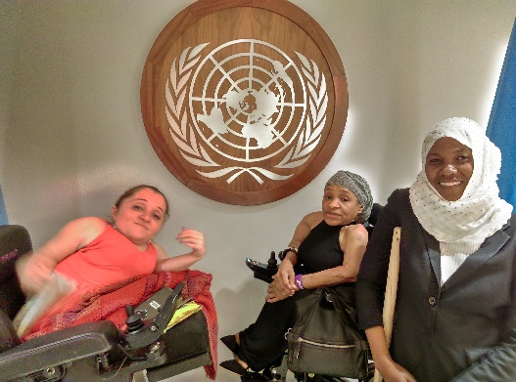
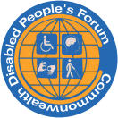
Annual Report Commonwealth Disabled People’s Forum July 2018 to July 2020.
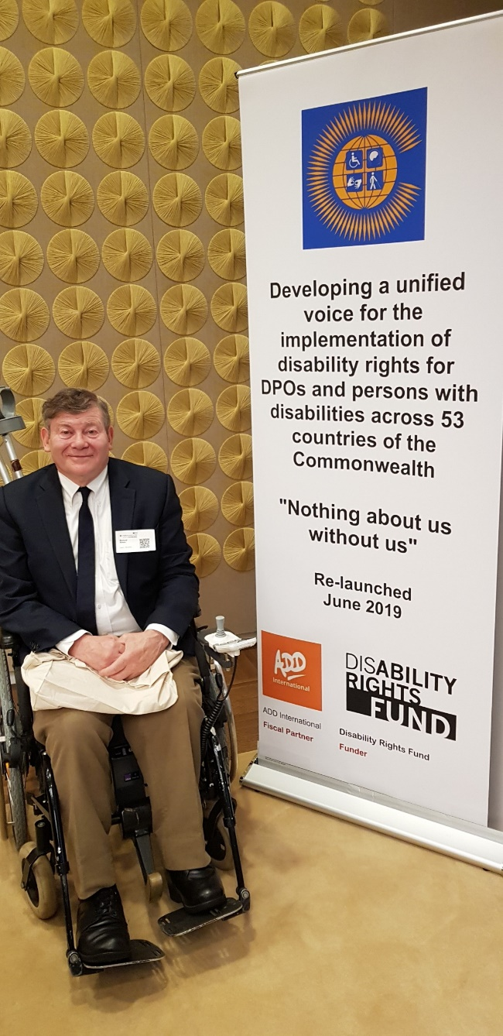

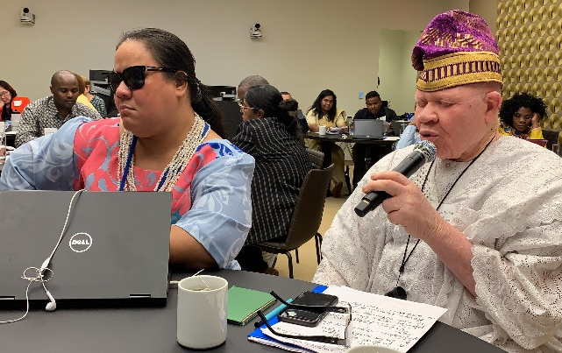

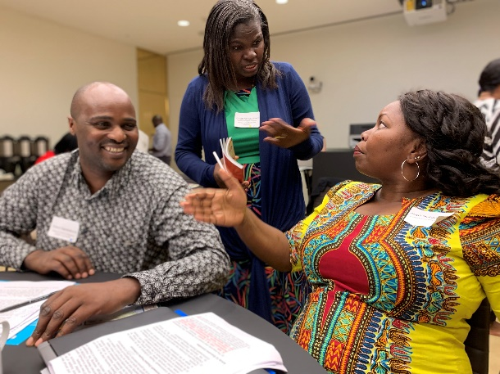

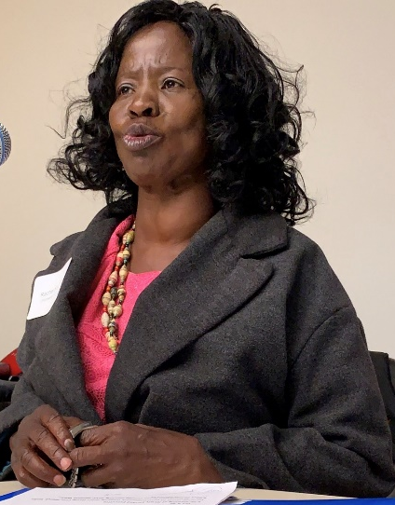
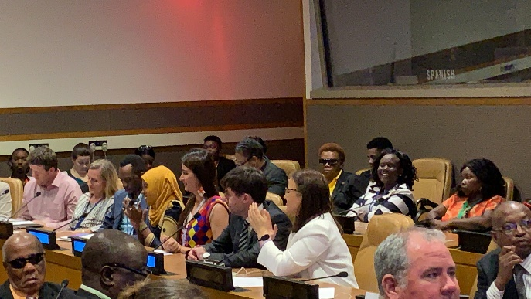
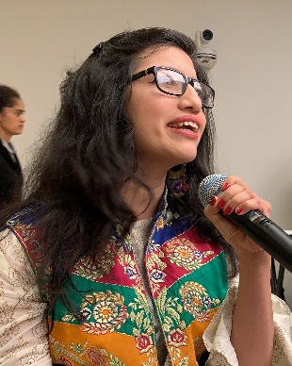

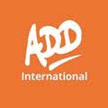
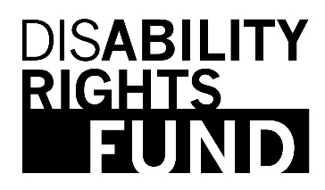
Commonwealth Disabled People’s Forum Ltd Company Registration 7928235
General Secretary Richard Rieser
Address c/o World of Inclusion, 78, Mildmay Grove South, LONDON N1 4PJ
0044(0) 7715420727 email rlrieser@gmail.com
Website www.commonwealthdpf.org

Contents

July 2018 Global Summit on Disability p.3
Organising the Re-launch 2019 p.3
Side Meeting 12th June 2019 United Nations Conference of State Parties p.4
The General Assembly of the Commonwealth Disabled People’s Forum convened on 13th June 2019 p.5
Declaration from the newly re-launched Commonwealth Disabled People’s Forum p.6
Executive Board Commonwealth Disabled People’s Forum elected General Assembly 13th June 2019 p.7
Reception after Launch, Evening 13th June 2019 p.9
Meetings of Executive and Sub-Committees p.10
Antigua and Eastern Caribbean 1st to 6th December 2019 p.11
Executive Committee 24th to 26th February 2020. Face to Face meeting Malta p.12
A Brief History of Previous Activities of CDPF Before the Re-launch p.15
COVID-19 CDPF response p.17
CDPF Policy Documents p.27
Anti Racist Statement in light of Black Lives Matter and death of George Floyd p.30
Funding and Budget p.32
Draft Accounts p.34-35
Appendix 1. Minutes of General Assembly 13th June 2019 p.36
Appendix 2 Revised Constitution CDPF 13th June 2019 p.51
Appendix 3 CDPF Membership at end July 2020 p.60

July 2018 Global Summit on Disability
At the Global Summit on Disability July 2018, a number of people from DPOs around the Commonwealth had been invited by International Disability Alliance and the UK Government. Their expenses were paid by the UK Government. On the first day a Civil Society Forum was held. Richard Rieser (original CDPF Treasurer) was there and organised an impromptu meeting for the next morning. After leafletting, 25 disabled people from around the Commonwealth attended and agreed that we should restart the Commonwealth Disabled People’s Forum and that we should try to do this in New York at the same time as the Conference of State Parties in June 2019. Richard sought funding from Department for International Development and Foreign and Commonwealth Office with no success, so it looked like this would not happen. Towards the end of January 2019, Penny Innes of DfID contacted Richard and said if we put an application into the Disability Rights Fund (DRF) they may be able to help. The DRF said we would need a fiscal partner as we had no recent financial track record. Action on Disability and Development (ADD International) were approached and agreed to be the fiscal partner with a Memorandum of Agreement signed. A grant was received to organise and run the relaunch of CDPF worth $192,000.

Organising the Re-launch 2019
There had been little contact between Commonwealth Disabled People’s Organisations in the previous six years, other than the meeting at the Global Summit on Disability (July 2018). Richard Rieser undertook the substantial work of identifying and contacting DPOs and getting them to agree to support the re-launch of the CDPF and to send delegates. This was made more difficult by the death the previous year of the Secretary Javid Abidi and loss of contact with other officers, other than Steve Estey from Canadian Council for Disabilities and Rachel Kachaje from Malawi who both supported the re-launch. DPOs in the following countries (31) agreed to the re-launch and to send delegates and observers (40) Australia, Bangladesh (No visa), Belize, Botswana Cameroon (No visa), Canada, Dominica, Fiji, Ghana, India, Jamaica, Kenya, Lesotho, Malawi, Malaysia, Mauritius, Mozambique, Nigeria (No visa), Pakistan, Papua New Guinea, Rwanda, Samoa, Sierra Leone (No delegate), Sri Lanka, South Africa, Swaziland, Tanzania, Uganda, United Kingdom, Vanuatu and the Commonwealth Children and Youth Disability Network (CCYDN) who brought 7 delegates and 2 observers to the afternoon session.
Gemma White of ADD International was supported by the grant to administer the arrangements for the launch including travel, accommodation, visas, insurance and access. Delegates were to come to New York and attend the Conference of State Parties and Pre Civil Society Forum (10th-12th June), attend a side meeting on the evening of 12th at the United Nations, then attend our General Assembly all day on 13th June, to be followed by a reception on the evening of 13th after the Executive had its first meeting. Not all the agreed delegates could get visas from the United States State Department and some had problems preventing their arrival. However, given the short notice and logistic difficulties we were very pleased by the interest and how many DPOs were represented. Apart from the country delegates, we made an effort to have delegates from under-represented groups: those with mental health issues, autism, Deaf Sign Language users and Indigenous peoples. The majority of other delegates had mobility issues, were blind or visually impaired or were deafened. We provided captioning, International and country sign language and Portuguese/English interpretation. Documents were all produced in Easy Read as well as standard and electronic formats.
Gender Balance The Disability Movement at an international level is usually over-represented by males. So initially we had asked for 2 delegates, at least one of whom should be a woman. When the funding was revised down by the funder, we said we could only fund 1 delegate and the personal assistance support they needed and that preference should be given to women. This strategy worked and the General Assembly had 25 women delegates and 15 male. This was later reflected in the Executive elected and co-opted which had 21 members (11 female/10 male).
Side Meeting 12th June 2019 United Nations Conference of State Parties
‘Developing a Unified Voice for Implementation of Disability Rights for DPOs and Persons with Disabilities Across the 53 Commonwealth Countries’. Sponsored by Commonwealth Secretariat. Supported by Disability Rights Fund, ADD International, the International Disability Alliance and DFID. The Commonwealth promotes democracy and equality across its member countries with over 2.5 billion citizens. Over 450 million are disabled people, mainly young people. The self-organisation of Commonwealth Disabled People’s Organisations, their collaboration and capacity-building with each other and advocacy play a crucial role in implementing the United Nations’ Convention on the Rights of Persons with Disabilities (UNCRPD) and the Sustainable Development Goals (SDGs). The re-launch of the Commonwealth Disabled People’s Forum, with the support of DPOs in the majority of Commonwealth countries, gives us a supportive and democratic structure to ensure disabled people across the Commonwealth are not left behind. Delegates from over DPOs in 30 countries were in attendance. The meeting was to discuss the desire for goals and the role of the CPDF, take reports from disability activists from across the Commonwealth and discuss how to influence in CHOGM, 2020 in Rwanda, 2022 in Fiji.
Chair Rachel Kachaje, Malawi.
Layne Robinson, Commonwealth Secretariat. Via Video Clip. Commonwealth Heads of Government in 2018 agreed to leave No One Behind, tackle disability stigma and promote developing strong policies for disability rights.
Robert Martin, New Zealand, UNCRPD Committee. The first person with intellectual disability on the CRPD Committee or any such body. He was committed to continue to challenge governments to tackle discrimination of people with intellectual disabilities.
Penny Innes, DFID. UK Government were pleased to support the development of the CDPF. Disability Inclusive Development was a key strategy. The Global Summit last July had led to 170 commitments and strong DPOs were important in delivering these.
Diana Samarasan, Disability Rights Fund. Funding supporting Commonwealth DPOs to hold Governments to account and also the development of CDPF to develop joint advocacy and funnel DPO capacity building.
Richard Rieser, Interim Coordinator Commonwealth Disabled People’s Forum. In 2008 originally 17 countries were involved. Tomorrow double that and the time is now right with NGO and International support to make CDPF a real force for our rights.
Jimmy Innes, ADD International (Action on Disability and Development.) The fiscal partner with CDPF for holding the grant and encouraging the development of the CDPF. ADD works with DPOs to tackle discrimination and have the best lives possible.
Points from Floor: Kenya-Need pressure to make corporate world play their part. Australia-The effects of colonisation need to be challenged as part of our work with reparations, reconciliation and healing. Malawi - Must have strong focus on getting all disabled children into school and achieving.
2nd speakers: Abia Akram, Pakistan, STEP. Despite all the conventions and agreements PWD are still discriminated against and dying. Now is the time to engage and have sustainable long term DPO led implementation plans. Nathalie Murphy, Dominica. 11 Caribbean countries made strong progress in 1980s under DPI. Now Governance and finance problems for DPOs. Must force all Governments to legislate. So far only 4 have. Angeline Chand, Pacific Region, Fiji. We are reviewing legislation, ensuring adequate statistics are gathered, developing advocacy and capacity building with partners, such as Australian and NZ Governments and IDA. Dickson Mveyange, Chavita, Tanzania. For Deaf people it is very important to consider both local and national organisation. Our DPOs are very weak on advocacy. We need funding to capacity build. Michael Njenga, Users and Survivors of Psychiatry in Kenya. People with Psycho-Social issues are highly marginalised. Need to use human rights model, not medical model. Don’t focus on our mental health. See us holistically. Commonwealth Children and Youth Disability Network (CCYDN): Devika Mallick, India. CCYDN was set up by Include Me Too to have a forum for young disabled people aged 13-30. Jack Milne, Australia. CCYDN have produced a Young Disabled Persons’ Charter that has widespread support. Pleased to be working with CDPF by having 2 Board places. Chair We need the young people to replace us but we also need you to learn from us.
Points from the Floor: Kenya- need to set up localised CRPD campaigns and committees. Mozambique- we bring together private sector, Government, civil society and together we do make a difference. South Africa- Need to get it in constitution, then can take Government of the day to court. We have many disabled members of parliament, but still there is a big challenge to make rights real. UK National Federation of Blind- All these words are in conventions. What we need is mission direct. Uganda-we should remember James Mwandha, who in 2007 at CHOGM first put forward a CDPF being formed. How many re-launches will we have! Let’s make sure it works this time. Chair-We must make sure tomorrow in our discussions that the CDPF will grow wings and fly like an eagle with strength in it. RR- When we made the Convention over 8 meetings it was the international disability caucus meeting before and after each daily session which drafted the UNCRPD. The Diplomats did not know what to do. We did it as Disabled People. Now in implementing the UNCRPD the Politicians do not know what to do, but we do. This is why we need the CDPF. Live Webcast http://webtv.un.org/watch/developing-a-unified-voice-for-implementation-of-disability-rights-for-dpos-and-persons-with-disabilities-across-the-53-commonwealth-countries-cosp12-side-event/6047626767001/

The General Assembly of the Commonwealth Disabled People’s Forum convened on 13th June 2019 from 10 am to 5pm
Held at the Ford Foundation for Social Justice, Dolores Huerta Room, 320 East 43rd Street New York. We were very grateful for the Ford Foundation in providing the venue and the support they gave us. (Attendance and minutes can be found in Appendix 1).
The General Assembly comprised 27 Commonwealth countries represented (4 countries who had joined were absent - visa problems for those from Bangladesh, Cameroon, Nigeria and Sierre Leone). Present were representatives of 24 Full Members, 11 Associate Members, 1 Individual and 8 CCYDN pm only. In addition, there were a number of observers and personal assistants. The Chair was taken by Rachel Kachaje who had previously been acting Chair CDPF and Richard Rieser (Treasurer) as organiser of the event took role of Secretary. The voting system operated with Full Member organisations having 2 votes (blue cards) Associate Member organisations 1 vote (yellow card).
The purpose of the General Assembly was for each delegate to introduce themselves and tell us about their organisation and issues, to then adopt a revised constitution, develop a declaration/ work programme and elect an Executive Committee. This was the first General Assembly since the founding meeting in March 2008. In the interim there had been Executive meetings but after 2013 until 2018 there had been no organised activity until a meeting called at the Global Summit on Disability July 2018 which agreed to get funding and organise today’s General Assembly.
After introductions, a discussion took place on whether the name should be changed from Commonwealth Disabled People’s Forum to Commonwealth Forum of People with Disabilities. It was argued this would put us in line with UNCRPD and that we were people first. As a counter, it was argued the name was chosen in 2008 after the UNCRPD had been agreed to express that disability is an oppression we face in common and that our struggles for equality are not due to our impairments, but due to our not being accepted in society, resulting in stigma and discrimination. Our impairment is not our disability. What unites us as disabled people, regardless of our different impairments, is our common cause of struggling for the full rights for disabled people. The CRPD is wrong on this issue. Definition in CRPD talks about people with impairments and barriers. Still being discriminated by society and stigma. It was further argued we must recognise intersectionality and the barriers we face. This is a political identity. The things around us we experience as disability. We are not people with disability. This term was imposed upon us by non-disabled people. Disabled People came out of the Social Model. It was also argued it is our name and how we are known. The issue was put to a vote and 49 to 10 agreed to keep Disabled People as opposed to People with Disability.
The amendments to the constitution and some new amendments were also considered. See minutes (Appendix 1) and adopted amended constitution. The revised constitution can be found at https://commonwealthdpf.org/resources/ and is found in Appendix 2 of this Report. Following this we went on to develop a declaration and hold elections for the Executive according to the newly adopted constitution.

Declaration from the newly re-launched Commonwealth Disabled People’s Forum
“We, the delegates of 27 Commonwealth Countries, being representative Disabled People’s Organisations (DPOs), attending the re-launch of the Commonwealth Disabled People’s Forum, applaud the adoption of a constitution, work programme and newly elected Executive Committee on 13th June 2019 in New York.
We recognise much has still to be achieved to create equality for more than 450 million disabled people throughout the 53 countries of Commonwealth and to achieve the standards set in the United Nations Convention on the Rights of Persons with Disabilities (UNCRPD) and the Sustainable Development Goals.
In particular, our organisations and countries need core funding, human and technical resources to advise and pressure our governments to fulfil their obligations towards their Disabled citizens.
We call on the international community, bilateral and multilateral donors and our Governments to adequately fund us in carrying out our role as Representative DPOs in line with Article 4 and 33 of the UNCRPD.
We are committed to improving the position of disabled people across the Commonwealth by adopting the following priorities.
Priorities for Work of Commonwealth Disabled People’s Forum (CDPF) 2019-2020
- The recruitment and active engagement of Disabled People’s Organisations across all Commonwealth Countries in the CDPF.
- To continue to support the full ratification and implementation of the UN Convention on the Rights of Persons with Disabilities (UNCRPD) and the Sustainable Development Goals (SDGs) and other legally binding treaties in all Commonwealth Countries.
- To challenge the continuing inequalities and exclusion that disabled people face throughout the Commonwealth in all areas of life. Specifically, by developing inclusive education, employment opportunities – economic empowerment and entrepreneurship, equality of livelihood, assistance in humanitarian situations, gender equality and the provision of assistive technology. To challenge stigma, discrimination and other intersectional oppressions which lead to negative attitudes, stereotypes and inequality.
- To develop the capacity of DPOs at local, regional and national levels in each country, to understand the principles of disability equality, the requirements of the UNCRPD and SDGs, the requirements and practices of running representative DPOs, and methods for effectively influencing Government policies for Disabled People, shadow reporting and monitoring.
- To develop National Umbrella cross impairment organisations of Disabled People which are widely geographically based and inclusive of different impairments.
- To support, develop and promote leadership amongst young disabled people.
To achieve the above we will:
- Encourage and support North-South and South-South Collaboration of DPOs
- Promote the Social Model and Human Rights Approach to Disability Equality and provide and facilitate training on these
- Share good practice and information
- Work with Governments, funders and donors to fund DPO projects to capacity build to implement the UNCRPD, Sustainable Development Goals and other initiatives
- Capacity Building by developing strong representative National DPOs of cross impairment groups, which are gender responsive and reach disabled people in all areas, across each country
- Develop the capability to gather data, research and monitor programmes and spread effective good practices
- Encourage disabled women’s and girls’ self-organisation and to make our DPOs habitable to women
- Work for the inclusion of disabled youth and other under-represented groups and people of all ages in our organisations
- Encourage representation on global, regional and national bodies and work with UN Development organisations, other international agencies and Non-Governmental Organisations.”

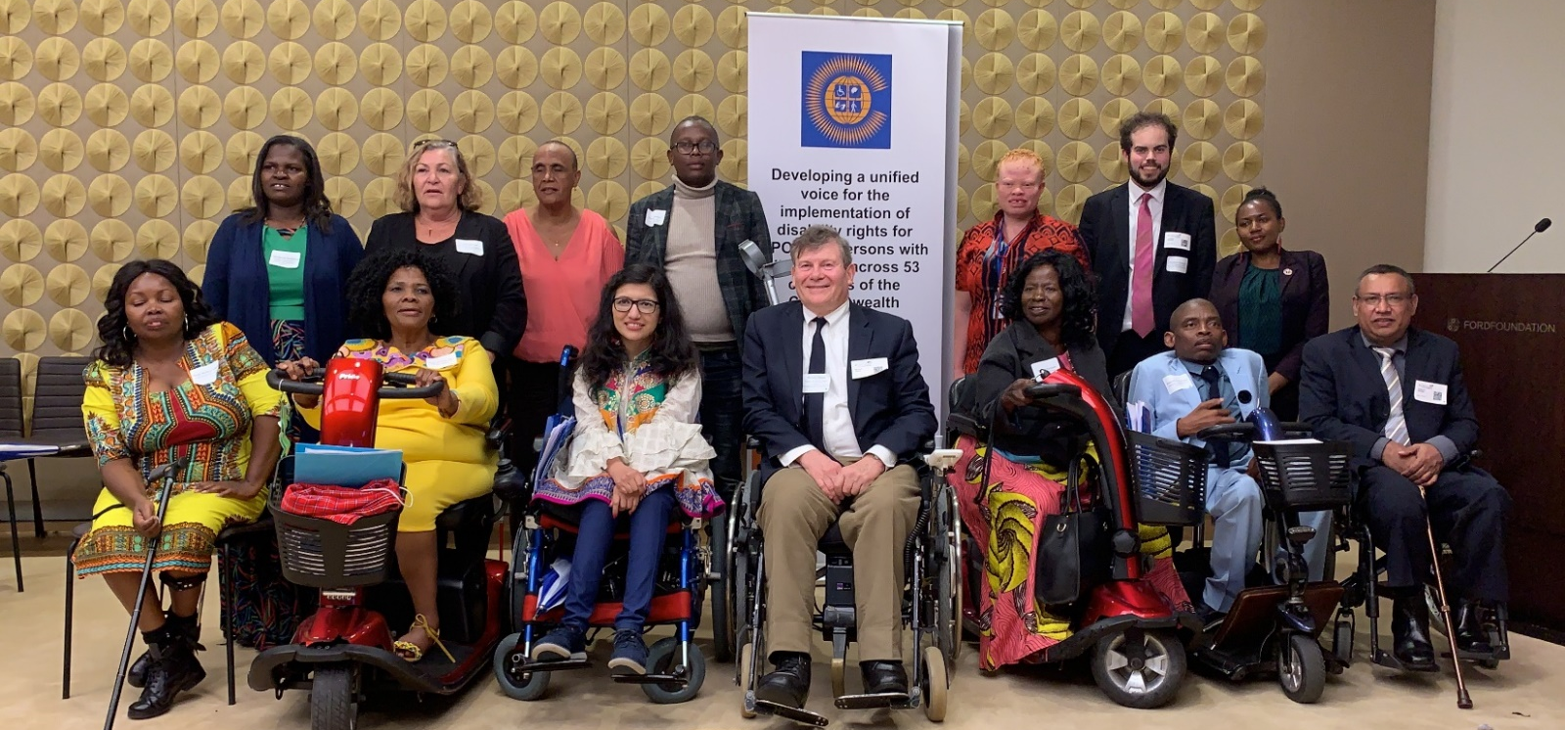
Executive Board Commonwealth Disabled People’s Forum elected at General Assembly

The New Executive Committee back row l-r Gaudence Mushimiyima (Rwanda) Africa Rep., June Reimer (Australia) Indigenous People Rep., Natalie Murphy (Dominica) Caribbean Rep., Michael Njenga, (Kenya), Under Represented Groups, Mawunyo Yakor-Dagbah (Ghana) Treasurer, Jonathan Andrews (UK) and Sarah Mwikali Musau (Kenya) Youth Reps. Front row l-r Sarah Muthoni Kamau (Kenya) Vice Chair, Alina Thandiwe Mfulo (South Africa) Vice Chair, Abia Akram (Pakistan) Women’s Officer, Richard Rieser (UK) General Secretary, Rachel Kachaje (Malawi) Chair, Wabotlhe Chimidza (Botswana) Africa Rep., Prasanna Kuruppu (Sri Lanka) South Asia Rep. Other members not in the picture Steve Estey (Canada) Australia, Britain, Canada and New Zealand Rep., Faatino Utumapu (Samoa) Pacific Rep., Muhammad Atif (Pakistan) South Asia Rep.
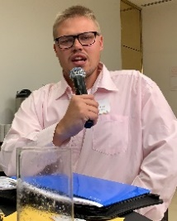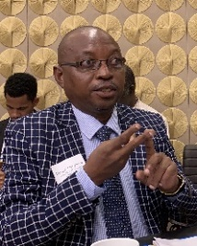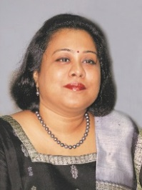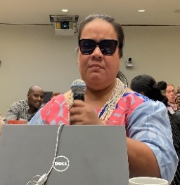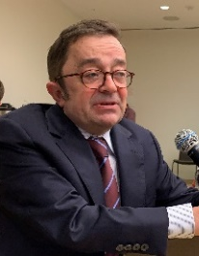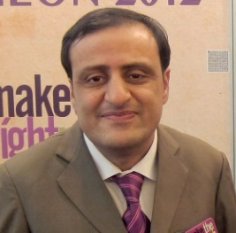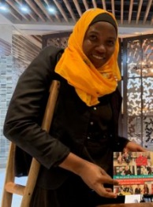
Left-Right. Emile Gouws, Dickson Mveyange, Sruti Mohaatra, Faatino Utumapu, Steve Estey, Mohammed Atif, Ummy Nderiananga
Chairperson Rachel Kachaje, Malawi email rkachaje@yahoo.com
Vice-Chair Sarah Muthoni Kamau , United Disabled Persons Kenya sarahmuthoni95@gmail.com
Vice-Chair Alina Thandiwe Mfulo, Disabled Persons South Africa mfulo.thandiwe@gmail.com
General Secretary Richard Rieser, Reclaiming Our Futures Coalition, United Kingdom rlrieser@gmail.com
Treasurer Mawunyo Yakor-Dagbah, Ghana Federation of Disability Organisations mawunyoyakordagbah@gmail.com
Under-represented Groups Michael Njenga, Users and Survivors of Psychiatry, Kenya michael.njenga@uspkenya.org
Women’ Representative Abia Akram , Special Talent Exchange Programme, Pakistan abia.akram@gmail.com
Youth Representative Jonathan Andrews Commonwealth Children and Youth Disability Network, UK jonathan.andrews4@ntlworld.com
Youth Representative Sarah Mwikali, CCYDN , Kenya mwikalisarah84@gmail.com
Indigenous Peoples Representative June Reimer, First Peoples Disability Network, Australia
juner@fpdn.org.au
Regional Representatives
Africa-Wabotlhe Chimidza, Botswana Federation of the Disabled wabotlhe@yahoo.co.uk &
Gaudence Mushimiyimana, Rwandan Organisation of Women with Disabilities unaburwanda@yahoo.com
Australia, Britain, Canada, New Zealand - Steve Estey, Council of Canadians with Disabilities steven.estey@iCloud.com
Caribbean Nathalie Murphy, Dominica Association of Persons with Disabilities nathalie.murphy1@gmail.com
Pacific -Faatino Utumapu, Nuanua O Le Alofa, Samoa tino.mutumapu@gmail.com
South Asia/SE Asia--Prasanna Kuruppu, Disability Organisations Joint Front, Sri Lanka prasanna.kuruppu@gmail.com &Muhammad Atif, STEP, Pakistan atif@step.org.pk
Co-options Selected at first Executive 5pm 13th June 2019
Deaf Community- Dickson Mveyange, Tanzanian Association of the Deaf, Chiavita dickson.mveyange@hotmail.com

Neuro Diverse – Emile Gouws, Autism:South Africa mieliemeel93@gmail.com
India- Dr Sruti Mohapatra , Swabhiman, Odisha, Eastern India sruti_m@hotmail.com
Member for Communications – Shivyawata, Ummy Hamisi Nderiananga, Tanzanian Federation of Disabled Persons Organisations ummymkenda@yahoo.com ( Co-opted Malta EC Feb 2020).

The Trustees of the Registered Company in the UK Commonwealth Disabled People’s Forum Ltd Company Registration 7928235 are:-
Chairperson Rachel Kachaje, Malawi
Vice-Chair Sarah Muthoni Kamau , United Disabled Persons Kenya
Vice-Chair Alina Thandiwe Mfulo, Disabled Persons South Africa
General Secretary Richard Rieser, Reclaiming Our Futures Coalition, United Kingdom
Treasurer Mawunyo Yakor-Dabgah, Ghana Federation of Disability Organisations
Australia, Britain, Canada, New Zealand - Steve Estey, Council of Canadians with Disabilities
Jimmy Innes CEO ADD International

Reception after Launch, Evening 13th June 2019
After the General Assembly and a short Executive Committee (EC) we held a Reception at the Ford Foundation on the evening 13th June. The Disability Rights Fund and DFID sponsored the Reception. Speakers at the reception were: Rachel Kachaje, the Chair of CDPF; Jonathan Allen, the Deputy UK Representative at the UN; Diana Samarasan and Milika Sakila of Disability Rights Fund; Mika Konliainen of Australian DFAT, Shakalela Gamlin from India’s Secretary Department for Empowering Persons with Disabilities.
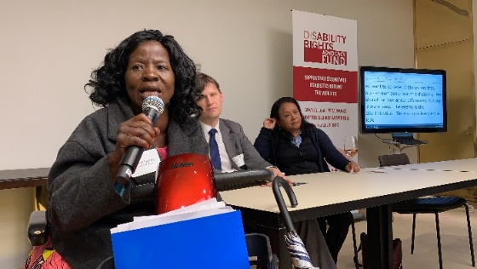
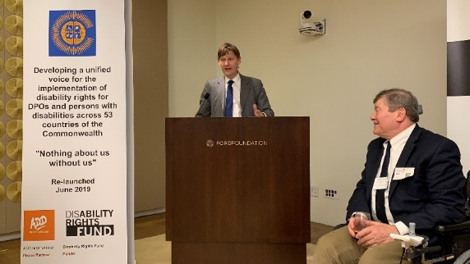

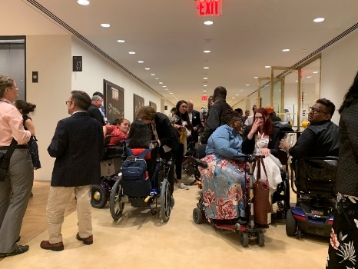

Launch Reception evening 13th June 2019
Top Left: Chair Rachel Kachaje speaking at Reception
Top Right: Jonathan Allen addressing with Richard Rieser, looking on.
Left: Delegates and guests socialising at the Reception.
Below left: Diana Samarasan and Milika Sakala ; Bottom left: Mika Konliainen ;
Bottom right: Shakalela Gamlin

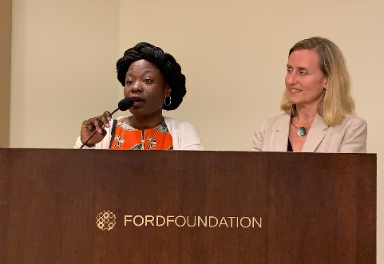

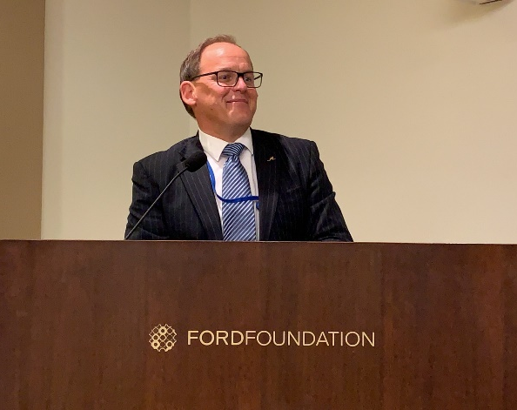

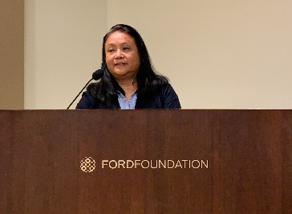

Meetings of Executive and Sub-Committees
Executive Committee Meetings (Quorum 8)
13th June 2019. Met briefly after General Assembly. 16/17 in attendance (seconded 3 members).
13th September 2019. Remote meeting. 13/20 in attendance. Set up Finance and General Purposes and 6 Policy Sub-Committees.
14th November 2019. Remote meeting. 14/20 in attendance.
15th January 2020. Remote meeting. 9/20 in attendance.
24th to 26th February 2020. Face to Face meeting Malta. 17/20 in attendance (seconded Communication Officer).
30th March 2020 Special Executive Covid. Remote Meeting. 14/21 in attendance.
21st July 2020 Executive. Remote meeting. 14/21 in attendance.

Finance and General Purposes
Rachel Kachaje (Chair), Richard Rieser (General Secretary), Mawunyo Yakor-Dabgah (Treasurer), Alina Thandiwe Mfulo and Sarah Muthoni Kamau (Vice Chairs), Steve Estey and from December Dr Sruti Mohapatra. This met between Executives when decisions needed to be discussed in detail and recommendations made to the Executive on Financial and Organisational matters.
6th October. Organisation Sub Committees. Grant Phase II. 5/6. Remote.
13th February 2020 Prepare Malta EC 5/7. Remote.
27th February 2020 Business Plan 6/7. Face to Face.
23rd March 2020. Switch Activity and Grant to Covid-19 response. 5/7. Remote.

Policy Sub-Committee

We set up 6 Policy Sub-Committees at the September 2019 Meeting to Develop Policy Papers in Different Areas. Each group had several meetings to frame the issues to be covered and provide examples.
Inclusive Education | Women and Girls | Employment & Livelihood | Stigma, Media & Discrimination | Humanitarian  Situations | Assistive Technology
  Alina Thandiwe Mfulo
  Richard Rieser
  Prasanna Kuruppu
  Emile Gouws
  Sruti Mohapatra
  Richard Rieser
  Mawunyo Yakor-Dabgah
  Abia Akram
  Sarah Mwikali
  Jonathan Andrews
  Gaudence Mushimiyimana
  Richard Rieser
  Mawunyo Yakor-Dagbah
  Michael Njenga
  Sarah Mwikali
  Wabotlhe Chimidza
  Gaudence Mushimiyimana
  Nathalie Murphy
  Dickson Mveyange
  Emile Gouws
  Sruti Mohapatra
  Sarah Muthoni Kamau
  Alina Thandiwe Mfulo
  Richard Rieser
  Mawunyo Yakor-Dabgah
  Abia Akram
  Gaudence Mushimiyimana
  Nathalie Murphy
  Faatino Utumapu
  Sruti Mohapatra
  Richard Rieser
  Abia Akram
  Prasanna Kuruppu
  Emile Gouws
  Sruti Mohapatra
  Rachel Kachaje
  Sarah Muthoni Kamau
  Richard Rieser
  Mawunyo Yakor-Dagbah
  Prasanna Kuruppu
  Sruti Mohapatra
  Alexander Bankole Williams
  Expert co-optee Ghana
Convenors of each group in bold.

Antigua and Eastern Caribbean 1st to 6th December 2019

From December 3rd to 5th the General Secretary and Lucy Mason of CDPF were invited (expenses paid) by Commonwealth Secretariat to take part in ‘I Am Able 2’ in Antigua in the Eastern Caribbean. This started with ‘I Am Able: The Future is Accessible’ church service on the morning of 3rd December, followed by a meeting of DPO representatives from Antigua, Anguilla, Barbados, Dominica, Grenada, St Kitts and Nevis, St Lucia, St Vincent and the Grenadines and Jamaica. Many of the barriers they faced with implementing the UNCRPD and SDGs were similar across the islands. There was strong interest from all national umbrella DPOs in joining the CDPF, although four were already members. Many new contacts were made.
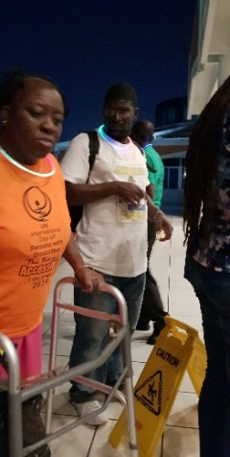
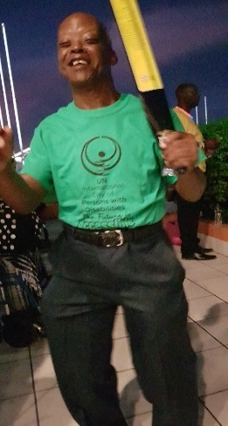
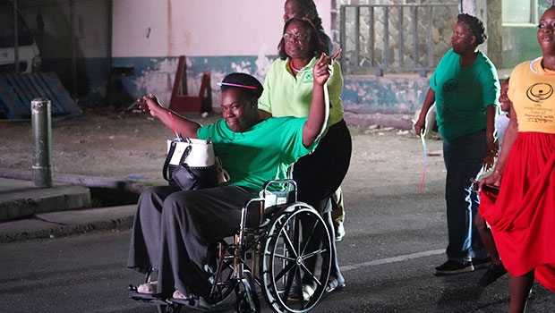
The evening saw a Glow March organised by Bernard Warner of Antigua and Barbuda Disabled Association around St Johns, the capital, to celebrate International Disabled People’s Day. There was a great atmosphere with a large sound system followed by about 200 dancing disabled people, which challenged many stereotypes, such as passivity and having no agency.

This was followed by 120 disabled people attending the 2 day ‘I am Able 2’ Conference jointly supported by the Commonwealth Secretariat, the UK High Commissioner of Antigua and Ministry of Social Transformation. This consisted of a mix of key-note speakers, panels and workshops. https://thecommonwealth.org/media/news/caribbean-disability-conference-we-are-opportunity-not-burden . Despite the aims of the event being somewhat confusing, participants gained useful insights and contacts. The Commonwealth Youth Forum played an excellent role in coordinating. The CDPF would prefer future events to have a more structured programme based on implementation of the UNCRD and SDGs, leading to concrete changes and improved understanding of the paradigm shift required to bring about disability rights.

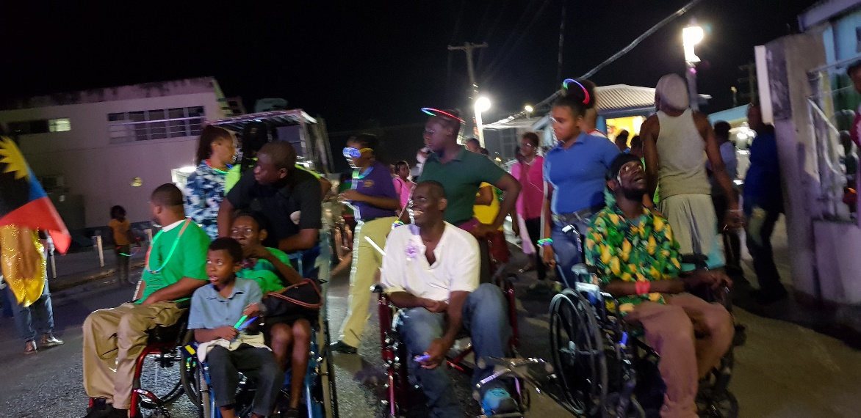

Executive Committee 24th to 26th February 2020. Face-to-Face meeting, Malta.

This was attended by 17 members of the Executive and was a very productive meeting.
Attending: Chairperson Rachel Kachaje, Malawi; Vice-Chair Sarah Muthoni Kamau, Kenya; Vice-Chair Alina Thandiwe Mfulo, South Africa; General Secretary Richard Rieser, UK; Treasurer Mawunyo Yakor-Dabgah, Ghana; Under-represented Groups Michael Njenga, Kenya; Women’s Representative Abia Akram, Pakistan; Youth Representatives Jonathan Andrews, UK and Sarah Mwikali, Kenya; Africa Wabotlhe Chimidza, Botswana and Gaudence Mushimiyimana, Rwandan; Caribbean Nathalie Murphy, Dominica; South Asia/SE Asia Prasanna Kuruppu, Sri Lanka and Muhammad Atif, Pakistan; Deaf Community Dickson Mveyange, Tanzanian; Neuro Diversity Emile Gouws, South Africa and India Dr Sruti Mohapatra.
Apologies: Indigenous Peoples Representative June Reimer, Australia; Australia, Britain, Canada, New Zealand Steve Estey, Canada; Pacific Faatino Utumapu, Samoa.

Delegation to Government of Malta, Valetta.
The Chair, Gen Sec and two Vice-Chairs attended a meeting with the Permanent Under Secretary Sivio Parnis and Gatis together with Alister De Gaetano, Office of Disability Issues (ODI) and Marthese Mugliette and Venera Micallef from Malta Federation of Organisations of Persons with Disabilities (MFODO, our Malta Membership Organisation) from 8.45 to 9.30 am in Valetta on morning 25th February . Raised concerns that Malta had not fully implemented UNCRPD in law or actions and did not seem to be going along with a Human Rights Model of Disability. There had been some difficulties but recently a change in Government so now there was a preparedness to move forward with proposed legal changes. We were concerned that although there was an ODI there was no separate Ministry, that Universal Design was not being implemented and there was not a strategy for Independent Living. We were told that the CRPD (Commission for Rights People with Disabilities) and ODI were representing disability issues in Malta. We argued that MFODO should be part of a consultative body and not just included in general public consultations. Secretary Parnis told us that there was a pension of E520 and many disabled adults were eligible and they could also work. We noted this was a progressive move as it covered the extra costs of being disabled. Alister De Gaetano told us the Government were doing many things to improve the position of disabled people in Malta. We thanked the Government for a frank exchange of views and they wished us a pleasant stay in Malta.

While we were at this meeting, Members of the Executive had met with MFODO to examine the recent report on Malta from the UNCRPD Committee. A range of barriers were identified.
When the delegation returned from the meeting with the Ministers, we were joined by The Commissioner of CRPD the head of the Office for Disability Issues, Malta. The General Secretary gave a presentation on the Paradigm Shift and the procedures for enforcing the UNCRPD through the Conference of State Parties and the UNCRPD Committee.

The Commissioner, Oliver Scicluna, told us that the CRPD was semi-independent from Government e.g. it still issues Blue Badge parking for the Government. However, he sees his role as a disabled person as defending disabled people’s rights in Malta. A National Strategy was launched in 2017. Community services need to be strengthened. Work is being done with Malta Confederation of Women. There is a lack of family-friendly support they are working on. There needs to be more provision of community aids. The CRPD can take complaints against the Government, but also it carries out research and monitoring.
Alister De Gaetano told us as head of the Office of Disability Issues he was someone with Autism who had experienced much bullying at school. Things are far from perfect in Malta but an opportunity opened up when Malta held the European Presidency. Things have improved, but there is a lot of red tape and conservative, family-based attitudes. The Constitution is being reformed. Changes in Civil Code to give more personal autonomy. The Guardianship in the Mental Health Act is being changed and there is now a good framework to challenge the Marriage Act. The restrictions on voting will stay for the time being.
This was followed by a wide- ranging discussion and the main point was that DPOs needed to be more involved Nothing About Us Without Us in Malta-Article 4.3 and Article 33.

The Executive spent time examining and discussing the draft policy papers produced by the Sub-Committees.
a) Humanitarian Situations introduced by Dr Sruti Mohapatra. Agreed to take forward incorporating points made.
b) Employment and Livelihood introduced by Wabotlhe Chimidza. Needed more from International Labour Organisation (ILO) and examples.
c) Inclusive Education introduced by Richard Rieser. Agreed to take forward more examples and link Global Monitoring Report 2020.
d) Stigma, Media & Discrimination introduced by Sarah Muthoni Kamau. Need more language, stereotypes and examples. Agreed to take forward.
e) Women and Girls. It was decided to hold a caucus at the end of the session open to all Women on EC and report back next morning. Abia Akram reported. 8 Women attended and came up with structure and deadlines. Structure, challenges found for disabled women:-Sexual Health and Reproduction, Gender Violence, Access to Justice, Basic entitlement to Education/ Work, Political Participation. 1 case study /1 good practice on each of above, divided amongst ourselves.
f) Mawunyo Yakor-Dagbah reported an outline on Assistive Devices and Access. This was at a rudimentary stage and would need a lot of work to give examples and cover the wide breadth of this essential subject.
g) It was also agreed in principle we would work on a policy paper on the Environment and disabled people.

Membership Gen. Sec. circulated list of current members. Currently members in 42 Commonwealth countries. Full members 36 countries. Associates 27 and Observer/Ally 1. Work would be done to both increase the number of National Cross Impairment Organisations and increase the density. Targets were set for different regions.

[The position at the end of July 2020 was Countries 45, Full Members 38, Associates 33, Observer/Ally 1. It was agreed all should be issued with a stamped and signed membership certificate. It was generally agreed CDPF was doing well. See Appendix 3 for list of member organisations].

Other Decisions at Executive
i. Communication Strategy and co-option to EC as Communication Officer – Ummy Nderiananga, Tanzania. Agreed.
ii. Relations with Commonwealth. Seek accreditation asap but may be delayed until 2 years of activities.
iii. Business Plan outline agreed. [ This was dramatically altered by COVID-19 Pandemic and later decision to have a strong fiscal and working relationship with Action on Disability and Development for 5 Years. A new Memorandum of Understanding must be developed].
iv. Safeguarding Policy agreed. [Funder DRF also required a Child Protection Policy to be agreed. This was circulated and agreed after the meeting].
v. Delegates to various Fora at CHOGM and to support Abia Akram with State Parties to be elected to CRPD Committee. Agreed.
vi. Long discussion of what should be focus of training in Rwanda June 2019 agreed. [ Soon after Rwanda CHOGM postponed 1 year and agreed with funder to alter budget to work on COVID-19 remotely with a possibility of on-line training later on].
vii. Commonwealth Children and Youth Disability Network. Jonathan Andrews co-chair of CCYDN & SM on the board. Gave overview CCYDN and how fit in with CDPF work. Memorandum of Understanding Document ready to be discussed. In the discussion a majority view emerged that while we welcomed the current 2 members on the Executive it was not felt we could sign the Memorandum as it would limit too much CDPF options for the future. CDPF welcomes, supports and cooperates with CCYDN. [Since this meeting we have supported their work on COVID-19]. Developing new leaders from youth for each national and international DPO is essential and CDPF will continue to make this a priority.
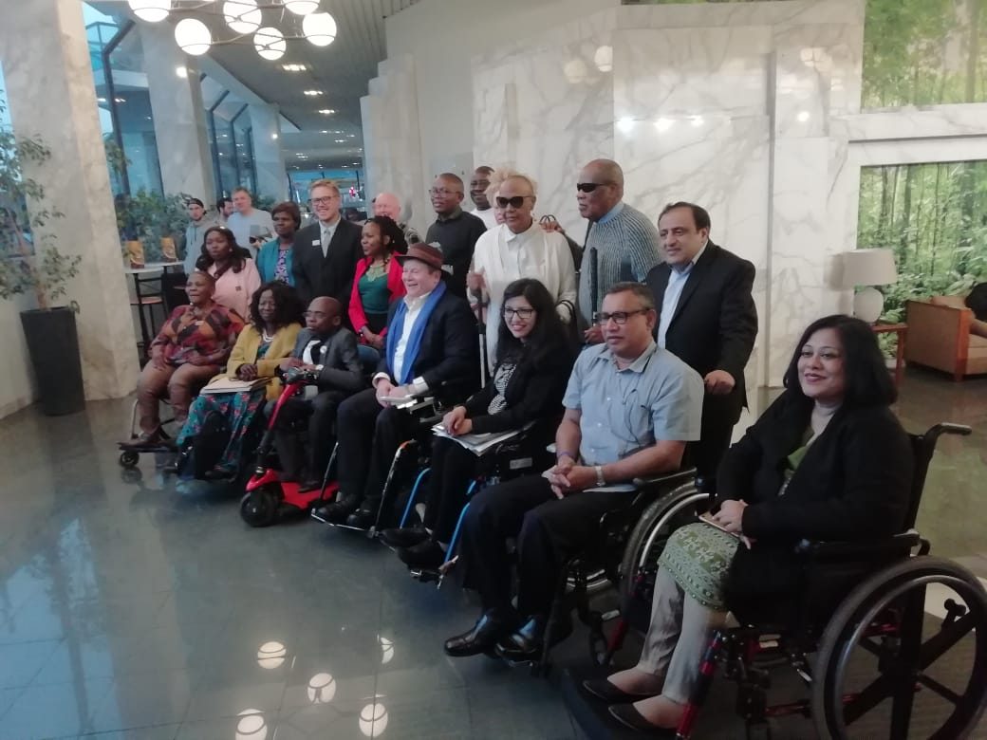
Executive Meeting Malta 23rd to 27th February 2020

Concluding Thoughts of EC Members on the Meeting in Malta
Comments from committee members– 1 thought on where we go in future
MA: we are here in Malta for EC for CDPF. Now we have got a roadmap.
EG: I think during this meeting we discussed different policy in terms of Inclusive Education (etc) – common purpose to amend constitution to include individuals with disabilities.
MYD: As a person with albinism I feel I represent all persons with albinism, not only DPOs in Ghana. Over last couple of days we achieved what we couldn’t do on skype, finely tuned policy papers. Look forward to time when can commit Governments to these by sharing policy papers with our Governments.
SK: 2 days we have been here we have put together ideas for policies that we are lobbying our Governments to have disabled people at forefront development agendas.
JA: Policies to put together for CHOGM 2020. Pleased to see CCYDN rep.
SM: Last 2 days have been really productive, setting agenda for barrier free society across CW countries.
MN: Last 2 days discussed issues of disabled people within CW. This presents us with a vision for a just and inclusive future.
NM: Have had very productive meeting. I like the interactive and participatory approach that the Gen Sec has taken and delegation of responsibilities. We have managed to somehow operationalise after the re-launch in NY. Very fine meeting. Increased knowledge considerably on many topics and will do upmost to increase membership in the Caribbean.
PK: We have discussed very important policy papers. CDPF needs to engage CHOGM and include the SDGs into the CHOGM agenda.
AA: Grateful to RR and all team to re-establish CDPF. The CW has an important part to play in international improvement. We have seen how marginalised sectors get together in single voice.
TM: CW had no disability representation, CDPF now can help to make Governments accountable for what we need in policies and more clear agreement.
WC: Past 2 days very good for us. Issues affecting disabled people. I believe and trust it will improve lives for better.
DM: Within 2 days been making the future of persons with disability within the CW. Happy that we have tried to get diversity in.
SM: Last 2 days we have had very good intensive exercises and able to come up with 6 strong policy documents. Sure that CDPF strong voice, rep over 30% of world population, for equal access and inclusion for all.
RK: Women most marginalised group. Am chairperson for CDPF so happy these 2 days have been very fruitful discussion. Have been chair of different platforms. This was the best and I liked it. Wish all the best to CDPF and I will put all energy into it.
GM: 2 days here face to face have been very important for us to strategize agenda around disabled people in CW countries
RR: Moved quantum from last June, tried to meet by skype, no substitute for face to face and this why so important. Glad funder agreed to bring people to meeting. Took delegation to Government of Malta and then met with them and office of disability issues and semi-independent commissioner answering questions. This set the tone for the rest of the policy discussions. We do have to hold Governments to account because they have signed. SDGs 9.5 years to go and so need to shift. Another generation of disabled people treated as 2nd class. 12 years since most have taken on board. Going to intervene in all forums at CHOGM, going to get to ministers and prime ministers and they will have to listen because 450 million are a lot of people who can swing votes.

A Brief History of Previous Activities of CDPF Before the Re-launch

October 2007 a founding conference in Kampala, Uganda attended by delegates from 6 Commonwealth countries. Agreed must be a Youth Section and to get funding together for a founding Conference in March 2008.

At the Commonwealth Heads of Government Meeting in October 2007, the civil society challenge to CHOGM was to mainstream disability in sustainable development, to ratify the UN Convention on the Rights of Persons with Disabilities (CRPD) and to adopt disability inclusive policies. This cannot be achieved without a strong, democratic forum of disabled youth and adults to ensure implementation. CDPF leaders were key in lobbying for the inclusion of this at CHOGM 2007.

15-17 March 2008. Disabled youth and older disabled people representing DPOs in 16 Commonwealth countries came together in London to launch a unique Commonwealth Disabled Peoples’ Forum, the purposes of which was to provide a link between disabled people’s organisations in all Commonwealth countries and all the political structures of the Commonwealth and become the single unified voice advocating for disability rights across the Commonwealth. Countries represented by 35 delegates were Antigua, Guyana, Trinidad and Tobago, Kenya, Malawi, Mozambique, South Africa, Uganda, Zambia, Bangladesh, India, Pakistan, Fiji, Vanuatu, Canada and United Kingdom. Application for recognition to Commonwealth Secretariat were turned down in September 2008- ‘did not have a track record’.

June 14-18, 2009 Kampala. 4 day Conference held on implementing the UNCRPD across Commonwealth and an Executive Meeting. Delegates from India, Kenya, Malawi, Pakistan, South Africa, Tanzania, Uganda and UK. Plan for a CDPF meeting in Australia to coincide CHOGM 2011. A Kampala Resolution Adopted.
James Mwandha represented CDPF on Global Partnership for Disability and Development in Germany in 2009 and Steve Estey represented us in Argentina meeting of GPDD in 2011.

An Office was set up and registered as a charity in India by Secretary Javed Abidi. Abidi becomes chair of DPI and but is too busy to build CDPF and has a South -South focus. James Mwandha (Uganda), Chair, dies and George Daniel (Trinidad and Tobago), Vice Chair, dies. Little activity. 2010 Youth Forum continues over internet.

2010/2011 Collaboration between UKDPC and Pacific Disability Forum to develop Capacity Building Tools and deliver training in Papua New Guinea (PNG) for 8 Commonwealth Pacific Island Countries: Kiribati, Nauru, PNG, Samoa, Solomon Islands, Tonga, Tuvalu and Vanuatu. This was a highly successful collaboration funded by Commonwealth Forum. https://commonwealthdpf.org/projects

Summer 2011. Following a meeting with Ass. Secretary Commonwealth Foundation, CDPF provided a statement for Eminent Persons Group.

Executive Committee held in New York elect new officers to replace deceased. Agree to build up membership and apply for recognition by Commonwealth. Rachel Kachaje Acting Chair.

September 2011. A side meeting at UNCOSP in New York about the DPO Capacity Building project involving youth and particularly challenging sexism. The film made was shown at UN.

October 2011. Durban at the Disabled People International Assembly held a CDPF side meeting. This generated wide interest with 35 delegates attending.

January 2012. Commonwealth Roundtable on Inclusive education and sustainable employment for people with disabilities, 4 Executive members attended and spoke and 2 members of the Youth Forum. Executive meeting 10th January agreed membership form, no fee, collaboration with DPI and to get funding and hold a members’ meeting in New York on 10th September 2012.

March 2012 CDPF addressed the Commonwealth Forum of National Human Rights Institutes in Geneva and agreement was reached to jointly run a capacity building workshop in Uganda in May 2012 for representatives from DPOs and NHRI in six East African countries. Our Acting Chair, Rachel Kachaje, attended.

3rd May 2012. We organized with the Commonwealth Secretariat and Commonwealth Foundation a successful celebration of the 4th anniversary of the accession of the United Nations Convention on the Rights of People with Disabilities, which is now ratified by 28 Commonwealth countries. The key issue now is how to implement the rights contained in the Treaty, for this to happen the CDPF needs to become a real force in the Commonwealth. Held at Marlborough House at which Rachel Kachaje (Acting Chair) presided and UKDPC, Richard Rieser and Lucy Mason presented work with DPOs in Pacific.
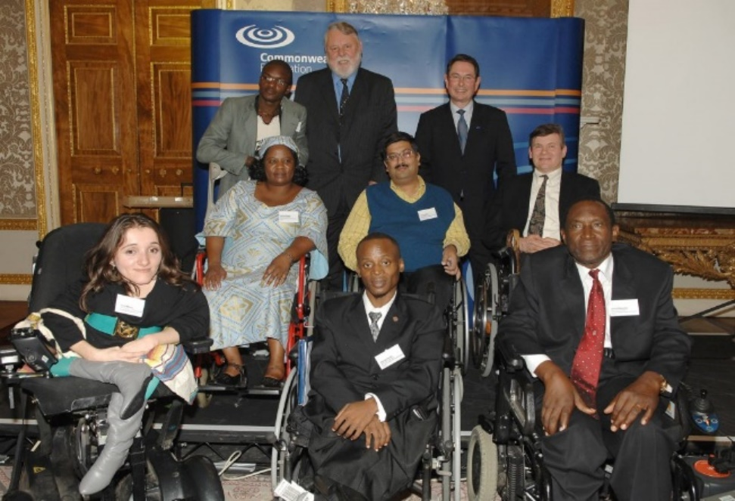
2013. Due to lack of funding, lack of support from the Commonwealth and internal differences on the Executive the CDPF effectively ceased functioning. By this time 25 Commonwealth country DPOs were in membership of CDPF.

Disability In the Commonwealth 2008: Launch of the Commonwealth Disabled People’s Forum, Marlborough House (Front rt-lf James Mwanda, Chair, George Daniel Vice Chair, Lucy Mason Youth Rep, 2nd row Richard Rieser, Treasurer, Javid Abidi, Secretary, Rachel Kachaje, Women’s Officer, George Ongolo, Africa Rep, Terry Waite and Commonwealth official.
COVID-19 CDPF RESPONSE
As with many organisations and people, Covid-19 radically altered what we planned to do and how we operate.

24th April 2020 we held an on-line Summit of our member organisation and also sent out a survey to all member organisations https://commonwealthdpf.org/commonwealth-disabled-peoples-forum-covid-19-summit-held-by-video-link-24-04-2020/

4 key points from the Summit :
- Lack of PPE for carers and disabled people, not being thought of – in particular Personal Assistants and Carers not being maintained.
- Food distribution – India did survey 30 states and nothing getting through.
- Communications – Sign Language, Easy Read, People with Visually Impairment need inclusive formats not being taken forward.
- Need to vary rules of lockdown – for psycho-social disabilities – now more countries doing this.
Majority of people affected are women as they are expected to keep home going.
Domestic violence, from mainly male perpetrators gone up considerably in UK, other countries too? Big issue here. Report from Scotland – social services have cut personal care.
At the Summit we agreed both Principles and Policy Letter which we encouraged member organisations to engage with their Governments.

Principles
“Preamble: Human Rights are not dispensable because there is a medical emergency. Indeed, the need to protect and ensure that all disabled people have their full and equal enjoyment of all human rights and fundamental freedoms, and to promote respect for their inherent dignity has never been greater. History shows us that in the past, disabled people have been inhumanely treated at times of political, social and humanitarian/medical crisis and this must not be repeated. 181 countries, including 49 of the 54 countries of the Commonwealth, have ratified the United Nations Convention on the Rights of Persons with Disabilities, with the above as its purpose. All member countries support the Commonwealth Charter which reaffirms, among other points, the core principles of Democracy, Human Rights, Tolerance, Rule of Law, Sustainable Development, Gender Equality, Access to Education, Health, Nutrition and Shelter and the Role of Civil Society (Dec.2012).
- Disabled People must receive information about infection mitigating tips, public restriction plans and the services offered in a diversity of accessible formats with use of accessible technologies.
- Additional protective measures must be taken for people with certain types of impairment and for many disabled people to function they require close personal assistance from carers or family members.
- Rapid awareness-raising and training are essential for all personnel involved in the response. This must include accommodations and support disabled people require.
- All preparedness and response plans must be inclusive of and accessible to disabled women and children.
- No disability-based institutionalization and abandonment is acceptable.
- During quarantine, support services, personal assistance, food and clean water supply, physical and communication accessibility must be ensured.
- Measures of public restrictions must consider disabled people on an equal basis with others.
- Disabled people in need of health services due to COVID19 cannot be deprioritized on the ground of their disability.
- Disabled People’s Organisations (DPOs) can and should play a key role in raising awareness of disabled people and their families.
- DPOs can and should play a key role in advocating for a disability-inclusive response to the COVID19 crisis to their Governments, Health Service and Communities.”

Statement to Commonwealth Governments from Commonwealth Disabled People’s Forum
Dear
We appreciate all that States are doing to meet the needs of their populations created by the Coronavirus COVID-19 Pandemic. However, we consider it important to direct you to the impact on disabled people, which the pandemic and remediation measures may have, and the ways these can be countered.
In the light of the current pandemic and its disproportionate impact on disabled people, the Commonwealth Disabled People’s Forum, which represents Disabled People’s Organisations in 46 countries of the Commonwealth, has developed the following recommendations for policy makers, through discussion with our members, based on our members’ current work and priorities. These recommendations aim to address the range of risks disabled people face. Disabled people face the same risk as the rest of the population, compounded by many other issues: disruption of services and support; in some cases pre-existing health conditions, which leave them more at risk of developing serious illness or dying; being excluded from health information and mainstream health provision; living in an inaccessible world where barriers to goods and services are everywhere; being disproportionately more likely to live in institutional settings or being homeless.

A. Making public health communication accessible, respectful and non-discriminatory
Every person has the right to immediate and correct information on the epidemic and the measures they and their families should take. This includes:
- Ensuring all information is in plain language and easy to read.
- Providing alternative and accessible methods of accessing general information, not only relying on websites (automatic phone lines, videos, leaflets, etc).
- Appropriate sign language interpretation and captioning.
- Information provided in community languages, plain language and in easy to read format.
- Use of fully accessible digital technology.
- Ensuring telephone numbers and other direct channels providing public health information are fully accessible, including relay services for deaf and hard of hearing people.
- Ensuring emergency numbers (both general health emergency and specific phone numbers set up for this pandemic) are fully accessible, including relay services for deaf and hard of hearing people.
- Special attention must be paid to the accessibility needs of deafblind people, as they will be very negatively impacted by social isolation measures. Authorities must provide websites with plain text and sign language interpretation in larger size (as opposed to small windows on the corner of the image).
- Many people with pre-existing health conditions, older people and people with complex needs are more at risk of serious health complications due to COVID-19. However, public messaging on the topic must be respectful and free of bias, avoiding potential of discrimination towards any part of the population based on age or disability.
- Ensure that public health messages in accessible format reach disabled people segregated in institutions (including psychiatric institutions).
- Use images that are inclusive and do not stigmatise people.
- False news about the pandemic is dangerous and states should ensure that internet providers take down such damaging messages. People should be directed to safe information on Government and Public Health websites.
- This applies to all public and private information including national and local news providers (both live and recorded) and health services. There should be specific web pages with frequently asked questions for concerns of disabled people and their families.

B. Non-discriminatory ethical medical guidelines
- In countries where healthcare professionals will not be able to provide the same level of care to everyone due to lack of equipment and underfunding of the healthcare sector, medical guidelines need to be non-discriminatory and follow international law and existing ethics guidelines for care, in the event of disaster and emergencies. These are clear: disabled people cannot be discriminated against.
- In producing these guidelines, authorities must take into account their commitment to the UN Convention on the Rights of Persons with Disabilities, especially Article 11 – situations of risk and humanitarian emergency.
They must also follow existing best practice such as:
- World Medical Association Statement on Medical Ethics in the event of disasters – “in selecting the patients who may be saved, the physician should consider only their medical status and predicted response to the treatment, and should exclude any other consideration based on non-medical criteria.”
- Bioethics Committee of the San Marino Republic produced guidance specifically for COVID-19: “The attribution of priority of treatments to be delivered, as well as the victims to be treated cannot fail to take into account the fundamental ethical principles, which materialize in a correct application of triage, trying to optimize the allocation of resources. The only parameter of choice, therefore, is the correct application of triage, respecting every human life, based on the criteria of clinical appropriateness and proportionality of the treatments. Any other selection criteria, such as age, gender, social or ethnic affiliation, disability, is ethically unacceptable, as it would implement a ranking of lives only apparently more or less worthy of being lived, constituting an unacceptable violation of human rights.”

C. Accessible, inclusive, hygienic health services and other facilities
- Facilities and services involved in providing quarantine should be fully accessible to disabled people, including full accessibility of information.
- Sign language interpreters, personal assistants and all others that support disabled people in emergency and health settings, should be given the same health and safety protections as other health care workers dealing with COVID-19.
- Health care workers should be informed about the risks facing people with pre-existing conditions. There is evidence to suggest COVID-19 may pose a greater risk to those with chronic health conditions, including pre-existing respiratory conditions, heart disease, diabetes and immunodeficiency, as well as those who are undernourished.
- Instructions to health care personnel should highlight equal dignity for disabled people, so communication should be done directly with the disabled person whenever possible. They should include safeguards against disability-based discrimination. Rapid awareness-raising of key medical personnel is essential to ensure that disabled people are not left behind or systematically deprioritized in the response to the crisis.
- All entry points to health facilities (including those which may have been deemed ‘secondary’ entrances and which are, in fact, the only accessible approach) should be treated with the same hygiene protocols as all other parts of the service. This includes cleaning handrails of ramps or staircases, accessibility knobs for doors, etc.
- Sterilisers and other hygiene materials should be equally available for disabled people. Sanitisers should be located in an accessible place. There should be accessible information to point to its location and the mechanism to dispense the product should be accessible.
- Commonwealth countries should provide countries with personal protection kits to avoid infection if they lack these. This equipment should be for frontline employees such as healthcare staff, social workers, law enforcement officers.
- Disabled people should not be segregated into separate facilities, where healthcare for COVID-19 is often of a lower standard. For those in care homes or institutions, every effort should be made to give them equal standards of hygiene and the care and support needed.

D. Invest in provision of services and support – Commonwealth and International solidarity is needed to ensure strengthening of essential services
- Health and social care systems are consistently underfunded in the developed world and partial or non-existent in many parts of the developing world. Investment in these services is essential and urgent to ensure they can meet the increased workload and costs associated with the crisis, including emergency planning, opening new facilities, medicines, respirators, protective materials and overtime of staff, in a way that is inclusive of everyone in the affected population.
- The World Community, United Nations, European Union Commonwealth Governments, Bilateral and Multilateral Aid need to provide additional emergency financial support to help States, and in particular Commonwealth States, at this extremely difficult time for many countries.

E. Involving disabled people
- Disabled people, through their representative organisations (Disabled People’s Organisations-DPOs), are the best placed to advise authorities on the specific requirements and most appropriate solutions, when providing accessible and inclusive services.
- All COVID-19’s containment and mitigation activities (not only those directly related to disability inclusion) must be planned and implemented with the active participation of disabled people and DPOs – this applies to community and population wide initiatives as well as to individual situations.

F. Ensuring marginalised and isolated people are not left without essential goods, support and human contact
- Put in place flexible and safe mechanisms to authorise disabled people to be able to leave their homes during mandatory quarantines, for short periods and in a safe way, when they experience acute difficulty with home confinement.
- Forced seclusion, forced restraint, forced medication should not be used as methods to enforce isolation.
- Introduce proactive testing and more strict preventive measures for groups of disabled people who are more susceptible to infection due to respiratory or other health complications. These measures should extend to their support network and families.
- Disabled people should not be institutionalised as a consequence of quarantine procedures beyond the minimum necessary to overcome the stage of their illness and should be treated on an equal basis with others. Authorities should take measures to drastically reduce the number of people in residential institutions, psychiatric units, prisons (low risk inmates). It is an infringement of human rights and they are also settings with higher likelihood of infection.
- If residential and psychiatric institutions are not closed, authorities should urgently ensure that strict hygiene and prevention measures are guaranteed.
- Government planners must consider that mobility and business restrictions disproportionately impact those with reduced mobility and other disabled people and allow for adaptations. Examples of such adaptations can include specific opening hours for disabled people and older people, or priority delivery services.
- When visits to care facilities are banned and social distancing is recommended, people who are already more isolated will be among those most impacted. Nobody should be left without support, food and essential services. Planners must ensure that no-one is left behind.
- Government guidelines should ensure that Commonwealth countries focus on particularly vulnerable groups, such as disabled people and their families, when addressing COVID-19. They need to make sure that during the crisis they receive all the support they may need as a result of their greater vulnerability.
- In case of food or hygienic products’ shortages, immediate measures must be taken to ensure that disabled people receive essential goods and services as a matter of priority.
- Any program to provide support to marginalised groups should be disability-inclusive.
- All plans to support women should be inclusive of and accessible to disabled women and conversely, programs to support disabled people should include a gender perspective.
- Conduct community outreach activities to identify and rescue disabled people deprived of their liberty or ill-treated at home or within communities and provide adequate support to them in a manner which respects their human rights.

G. Education
The closure of schools is necessary for the protection of children, families and communities and will help to flatten the curve so that the peak infection rate stays manageable. In many cases, children who depend on the school lunch programme will face food insecurity. All children, but particularly disabled children who are 3 to 4x more likely to experience it, become more vulnerable to violence in their homes and communities which can go undetected due to no contact. School closures also have a disproportionate burden on women who traditionally undertake a role as caregivers and in particular disabled women. In response to this challenge, we call on governments to:
- Direct educational institutions to prepare and review assignment packages for children to keep them academically engaged and provide guidance for parents on the use of the material.
- Create educational radio, TV and on-line programming appropriate for school-age children.
- Subsidize childcare for families unable to make alternate arrangements for their children.
- Expand free internet access to increase access to online educational platforms and material and enable children to participate in virtual and disability-accessible classroom sessions where available.
- Provide laptops/I-pads for children who need them in order to participate in on-line education.
- Adopt measures to ensure they continue receiving food, by making sure it can be delivered or collected and provision of food vouchers.
- Provide additional curriculum materials, advice and help on the adaptations and support required, so that disabled children can make progress in their learning, while at home.
- Provide extra financial and mental health support for families caring for disabled children.

H. Support networks and assistive devices
- Funding and practical solutions must be available to ensure that disabled people are not negatively affected by the temporary loss of people from their support networks (including personal assistants, family and specific professional services) through illness or indirect impact of COVID-19.
- Designate providers of support services (including care, support workers and personal assistants, family members) as ‘key workers’ who should continue to work and be provided with the personal protective equipment and instructions needed to minimise exposure and spread of infection, as well as be proactively tested for the virus. Workers should be allowed to travel safely to and from the workplace (both organisations or clients’ homes).
- Similarly, services involved in the provision and reparation of essential assistive devices must be prioritised.
- Deafblind interpreters and support staff often need to be physically close to deafblind people. Authorities must ensure they receive adequate physical protection equipment and that social isolation measures allow them to do their job.
- Support to agencies providing disability support in developing continuity plans, for situations in which the number of available caregivers may be reduced. This includes reducing bureaucratic recruitment barriers while still maintaining protection measures, such as background checks for caregivers.
- Authorities should provide an accessible hotline for disability services so that service users and people in the support network are able to communicate with government and raise concerns.
- Crisis and confinement measures will greatly deteriorate mental health and generate fear and anxiety. Demonstrating solidarity and community support is important for all.

I. Economic Activity / Income protection
- Authorities need to put in place financial measures (commonly within a broader-based economic stimulus package) to support disabled people. These measures may include but are not limited to a Basic or Universal Income for All, lump sum payments for qualifying individuals, tax relief measures, subsidisation of goods or leniency for the payment of specific expenses.
- Authorities need to ensure that disabled people and those with underlying health conditions can work from home. If this is not possible due to the nature of the job or any other reason, a special leave needs to be ensured which guarantees 100% of the employee’s income.
- Remote work or education services must be equally accessible for disabled employees/students. Authorities, organisations and educational institutions should ensure sign interpretation, live captioning, adapted work and any other measures in close consultation with disabled employees and students.
- In many countries there are radical changes being made in public services, including closure of education and rehabilitation services, day care facilities and crèches. It is essential that people who must leave work in order to support their family members, or others they may be assisting, continue to receive an acceptable level of income during this period.
- Provide financial support to unhoused people, refugees and women’s shelters.
- Expedite the distribution of benefits and modify sick leave, parental and care leave and personal time off policies.
- Direct businesses to invite employees to work remotely on the same financial conditions as agreed prior to pandemic.

J. Habitation, Water and Sanitation
- Implement moratoriums on evictions due to rental and mortgage arrears and deferrals of rental and mortgage payments for those affected, directly or indirectly, by the virus and for disabled people and others belonging to vulnerable groups.
- Provide increased access to sanitation and emergency shelter spaces for homeless people.
- Urgently improve standards of sanitation and habitation in slum, shanties, temporary accommodation and refugee camps.
- Distribute packages with necessities including soap, disinfectants and hand sanitizer.
Everyone does not have access to clean running water. In response to this challenge, we call on governments to:
- Ensure infrastructure is in place for clean, potable water to be piped into homes and delivered to underserved areas
- Cease all disconnections and waive all reconnection fees to provide everyone with clean, potable water
- Bring immediate remedy to issues of unclean water
- Build public handwashing stations in communities.

K. Guaranteeing the rights of disabled women and girls
- Ensure data disaggregated by sex and disability is available when compiling information: include differentiated infection rates, information on barriers faced by women when accessing available humanitarian aid and the rates of domestic and sexual violence.
- Consult directly with organisations of disabled women concerning the situation faced by disabled women and girls, their needs and the steps that must be taken to face the pandemic.
- Include the gender dimension in the responses you are offering to disabled people. Responses should differentiate the needs of disabled women and girls, but also the specific needs they may have within each specific impairment group.
- Involve disabled women in all stages of your responses and in all decision-making processes.
- Ensure disabled women working in all essential sectors (including healthcare, social services providers, shops, farming, sanitation, food production) are adequately taken care of and protected in the face of potential infection. This includes access to information, to personal protective equipment and hygiene products (including menstrual products).
- Support local organisations of disabled women or community-based groups of disabled women in developing accessible messages about prevention strategies and responses.
- Ensure access to necessary sexual and reproductive health services, including prenatal and postnatal healthcare, emergency contraception and safe abortion for women.
- Adopt measures to provide direct compensation to informal women workers, including healthcare staff, domestic staff, migrants and those in other sectors most affected by the pandemic.
- Foster policies to recognise, reduce and redistribute the unpaid work inside homes for healthcare reasons and to look after disabled people, work mostly carried out by women, including disabled women.

L. Violence against women, domestic violence/Intimate partner violence (DV/IPV)
Rates and severity of domestic violence/intimate partner violence against women, including sexual and reproductive violence, will likely surge as tension rises. Mobility restrictions (social distance, self-isolation, extreme lockdown, or quarantine) will also increase survivors’ vulnerability to abuse and need for protection services. (See Economic inequality.) Escape will be more difficult as the abusive partner will be at home all the time. Children face specific protection risks, including increased risks of abuse and/or being separated from their caregivers. Accessibility of protection services will decline if extreme lockdown is imposed as public resources are diverted. Women and girls fleeing violence and persecution will not be able to leave their countries of origin or enter asylum countries because of the closure of borders and travel restrictions. All the above impact on disabled girls and women 3 to 4x that of non-disabled girls and women. In response to this challenge, we call on governments to:
- Establish fully accessible separate units within police departments and telephone hotlines to report domestic violence.
- Increase resourcing for non-governmental organizations which respond to domestic violence and provide assistance to survivors including shelter, counselling, and legal aid.
- Ensure services in response to violence against women and girls stay available, including to disabled women, or introduce them where they do not currently exist (helplines, shelters, etc).
- Ensure that Shelters remain open and are all are accessible.
- Disseminate information about gender-based violence and publicize accessible resources and services available.
- Ensure protection services implement programmes which have emergency plans that include protocols to ensure safety for residents and clients with any necessary reasonable accommodations.
- Develop protocol for the care of women who may not be admitted to shelters, due to exposure to the virus, which includes safe quarantine and access to testing and additional support to overcome access barriers.
- Make provisions for domestic violence survivors to attend court proceedings via accessible teleconference.
- Direct police departments to encourage and respond to all domestic violence reports and connect survivors with appropriate resources.
- Ensure disabled women and girls and other people in vulnerable positions are not rejected at the border, have access to the territory and to asylum legal procedures. If needed, they will be given access to testing.

M. Ensuring disabled people are counted
Health information systems, monitoring and new systems used to monitor and contain the spread and effect of COVID-19 should be disaggregated by age, sex, disability and type of impairment.

N. Abuse of power
Disabled people in prisons, administrative migration centres, refugee camps and disabled people in institutions and psychiatric facilities are at higher risk of contagion due to the confinement conditions. They can also become more vulnerable to abuse or neglect as a result of limited external oversight and restriction of visits. It is not uncommon for authorities to become overzealous in their practices related to enforcement of the law and introduction of new laws. During this crisis, vulnerable people, especially dissidents, are at a higher risk of having negative, potentially dangerous interactions with authorities. In response to this challenge, we call on governments to:
- Adopt human rights-oriented protocols to reduce spreading of the virus in institutions, care homes, detention and confinement facilities.
- Strengthen external oversight and facilitate safe contact with relatives i.e. free telephone calls.
- Encourage law enforcement officers to focus on increasing safety rather than arrests.
- Train law enforcement officers, care workers and social workers to recognize disabled people’s needs and make necessary adjustments in their approach and engagement.
- Support DPOs, civil society organizations and country Ombudsmen/Human Rights Institutes in monitoring the developments within those institutions on a regular basis.
- Consult any changes in existing laws in an accessible manner with DPOs, civil rights societies and Ombudsmen/Human Rights Institutes.
- Commit to discontinuing emergency laws and powers once pandemic subsides and restore the check and balances mechanism.”
We held a second COVID Summit of Members on 5th June and conducted a second survey
At this online summit, the following key issues were repeatedly brought up:
- Disabled People’s Organisations are generally not being consulted by Government, with a few exceptions e.g. in Malaysia and Guyana.
- Lack of information access has been addressed in most countries. Stigma is still an issue.
- Lack of support for personal assistants, food, welfare, medicines and usual medical procedures.
- Unemployment and lack of reasonable accommodations, especially for self-employed.
- Lack of access to online schooling and erosion of support for disabled students.
- Higher fatality rates for disabled people in institutions, people with Learning Difficulties and those with chronic conditions who need shielding support from Government.
https://commonwealthdpf.org/cdpf-update-on-impact-of-covid-19-round-up-of-summit-5th-june-2020/
https://commonwealthdpf.org/commonwealth-disabled-peoples-forum-update-survey-on-impact-of-covid-19/
This was followed up by a series of letters and taking part in a whole range of
International Webinars before and after this date. We also put out weekly commonwealth country statistics https://commonwealthdpf.org/covid-19/ on the course of the Pandemic and published a number of Country Reports by our Member organisations.
https://commonwealthdpf.org/kenya-compilation-of-submissions-on-mental-health-during-the-covid-19-pandemic/
https://commonwealthdpf.org/covid-19-in-india-locked-down-left-behind/ https://commonwealthdpf.org/covid-19-and-disabled-people-in-pakistan/

Motion 1: CDPF Organisational Response to COVID 19 Pandemic.

“The CDPF will continue to publicise and gather information on the impact of the COVID -19 Pandemic on disabled people and their families across Commonwealth Countries. Campaign and advocate for equality of treatment and maintaince of human rights for all disabled people during and after the COVID-19 pandemic. The CDPF will continue to publicise and gather information on the impact of the COVID -19 Pandemic on disabled people and their families across Commonwealth Countries. Campaign and advocate for equality of treatment and maintaince of human rights for all disabled people during and after the COVID-19 pandemic. Influence and educate DPOs, Governments, funders and the population as a whole on the detrimental effects that the Pandemic is having of disabled people throughout the Commonwealth. Advocate and develop inclusive and sustainable futures that prevent the re-occurrence of the impacts of this pandemic and create a more equitable, environmentally sustainable, and fairer world, based on the principles of human rights and disability and gender equality. To achieve this the CDPF will establish a Covid-19 sub-committee, an advice desk/ worker and web presence with regular exchange of information between member organisations and CDPF and encourage the organisation and delivery of:-
a. Establish a Regional and Global level coalition to intervene with the emergency disability support services based on present lesson learned at national level responses.
b. Establish a very strong national level disability support and coordination mechanism, to take spontaneous actions during the emergency situation and post-pandemic.
c. Commence a Regional and Global level policy dialogue and accessible guideline formation, in order to better address the disability issues under any emergency situations and contingency planning based on future scenarios.
d. Request international donors/ funders to include disability as a pre-requisite in their funding application process during this period and aftermath of Covid-19 with a possible backing of international Organisations agencies including UN, World Bank and International Monetary Fund.”

Motion 2: CDPF Perspective on COVID 19 Pandemic Present and Future.
“We are facing a global health crisis unlike any in the 75-year history of the United Nations — one that is killing people, spreading human suffering, and upending people’s lives. But this is much more than a health crisis. It is a human crisis. The coronavirus disease (COVID-19) is attacking societies at their core. The crisis requires a call to action, for the immediate health response required to suppress transmission of the virus to end the pandemic; and to tackle the many social and economic dimensions of this crisis. It is, above all, a call to focus on people – women, disabled and elderly people already a risk, and youth, low-wage workers, small and medium enterprises, the informal sector that are likely to be heavily impacted..
A. Socio economic measures
- A large-scale, co-ordinated, comprehensive multilateral response amounting to at least 10 per cent of global GDP is needed now more than ever. This crisis is truly global. It is in everyone’s interest to ensure that developing countries have the best chance of managing this crisis, or COVID-19 will risk becoming a long-lasting brake on economic recovery.
- Resist the temptation to resort to protectionist measures. This is the moment to dismantle trade barriers, maintain open trade, and re-establish supply chains. Tariff and non-tariff measures as well as export bans, especially those imposed on medicinal and related products, would slow countries’ action to contain the virus
- Take explicit measures to boost the economies of developing countries Developing countries need international support, given that their ability to fund expansionary stimulus is already limited, and has been further limited in recent days by currency instability. This will require debt relief for many countries to create the domestic fiscal space. This will also require creative thinking about how to mobilize large injections of concessional finance – not only from multilateral development banks but also from private lenders such as pension funds, who will be in a hunt for low-growth investment opportunities.
- Strengthen international public finance provision International financial institutions and regional development banks can play an important role in addressing the impact of the crisis and financing the recovery. A post-crisis coordination mechanism must be created to provide the resources to all countries to have adequate fiscal space.
- Waive sanctions in this time of solidarity. Sanctions imposed on countries should be waived to ensure access to food, essential supplies and access to COVID-19 tests and medical support. This is the time for solidarity not exclusion.
B. Regional mobilization
- Adopt “Do No Harm” trade policies, preserve connectivity, and ensure regional monetary-fiscal coordination
- Engage with private financial sector to support businesses
- Address structural challenges and strengthen normative frameworks to deal with transboundary risks
C. National solidarity is crucial to leave no one behind
- Undertake fiscal stimulus and support for the most at risk
- Protect Human Rights and focus on inclusion:
Human Rights and Inclusion
- Ensure access to testing or treatment is not denied due to discrimination, whether on grounds of disability, gender, age, religion, sexual orientation, ethnicity, race or otherwise.
- Monitor incidents of discrimination and xenophobia, and swiftly respond and publicize.
- Disseminate accurate and evidence-based information and conduct awareness-raising campaigns.
- Clear and timely information need to reach everyone, in particular formats e.g. Easy Read, Sign Language and Braille, national, ethnic or religious minorities, indigenous peoples, or LGBTI people.
- Access to additional financial aid for disabled people and their families and ensure that disabled people under care, living in public and private facilities, are protected from neglect and abuse and provided PPE.
- Reduce populations in prisons, jails, and immigration detention centres through appropriate supervised or early release of low-risk category.
- Introduce moratoriums on evictions and deferrals of mortgage payments.
- Ensure that homeless people and those living in inadequate housing are not negatively impacted by virus containment measures.
- Adopt safe aggressive back to school strategies and create and employment opportunities for youth.
Whole societies must come together. Every country must step up with public, private and civic sectors collaborating from the outset. But on their own, national-level actions will not match the global scale and complexity of the crisis. This moment demands coordinated, decisive, and innovative policy action from the world’s leading economies, and maximum financial and technical support for the poorest and most atrisk people and countries, who will be the hardest hit. Given the world’s extensive economic and social interrelationships and trade— we are only as strong as the weakest health system. And when we get past this crisis, we will face a choice – go back to the world we knew before or deal decisively with those issues that make us all unnecessarily vulnerable to this and future crises. Everything we do during and after this crisis must be with a strong focus on building more equal and inclusive societies that are more resilient in the face of pandemics, climate change, and the many other challenges we face. We call on all Governments and The United Nations family to support all countries, to ensure first and foremost that lives are saved, livelihoods are restored, and that the global economy and the people we serve especially disabled people emerge stronger from this crisis. That is the logic of the Decade of Action to deliver the SDGs. More than ever before, we need solidarity, hope and the political will and cooperation to see this crisis through together^{[1]}.”
Regional Meetings on COVID 19
In July a series of regional meetings were held to involve more DPOs and encourage regional Cooperation. More will be held in the future as these were mainly very successful. Sign interpretation and palantypists facilitated access.
10th July, Caribbean https://commonwealthdpf.org/cdpf-regional-meeting-on-covid-19-caribbean-central-america-10-july/
13th July, West Africa https://commonwealthdpf.org/cdpf-regional-meeting-on-covid-19-west-africa-13-july/
14th July Southern Africa https://commonwealthdpf.org/cdpf-regional-meeting-on-covid-19-southern-africa-14-july/
16th July, Asia https://commonwealthdpf.org/cdpf-regional-meeting-on-covid-19-asia-16-july/
These were well attended including by organisations we had not worked with previously, who were not yet members of CDPF.
CDPF Policy Documents agreed 21st July 2020
The 6 Policy Documents we had worked on since October 2019 were agreed by the Executive at its meeting and have been distributed and put up on our website to aid DPOs and Governments in their deliberations to move towards the Sustainable Development Goals. https://commonwealthdpf.org/policy-papers/

Inclusive Education The approach taken in this Policy Paper has been to focus on the inclusion of disabled children and students highlighting the importance of challenging disabling attitudes and barriers from the DPO perspective. Close collaboration between Disabled People’s Organisations, Government, Schools, Teachers and Parents will ensure we empower rising generations of disabled people, making a reality of the slogan ‘Nothing About Us Without Us’. The best way to include disabled children and students is to find all the children in the neighbourhood/district, enrol them and tackle the barriers with ingenuity and enthusiasm backed by positive Government Policies and funding based on a high proportion of public spending on Education.
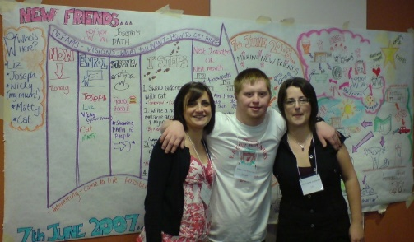
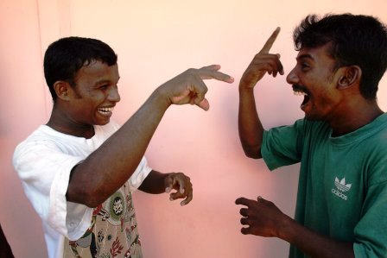

https://commonwealthdpf.org/wp-content/uploads/2020/07/CDPF-Inclusive-Education-Policy-Draft-final.docx
Policy on Employment and Livelihood
The Right to Work is established as a human right. “All human beings, irrespective of race, creed or sex, have the right to pursue both their material well-being and their spiritual development in conditions of freedom and dignity, of economic security and equal opportunity. The attainment of the conditions in which this shall be possible must constitute the central aim of all national and international policy”1.Yet around the world most disabled people are not in work with women more significantly affected and impoverished as a result. A recent report identified the following barriers that must be addressed if the right to work is to become a reality for the majority of disabled people.
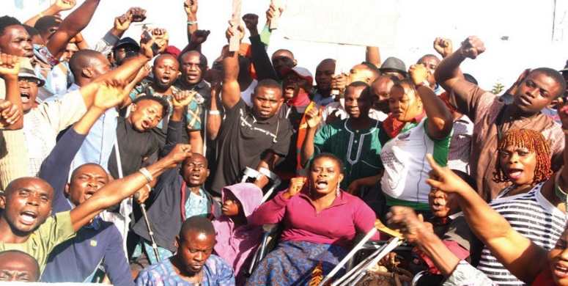
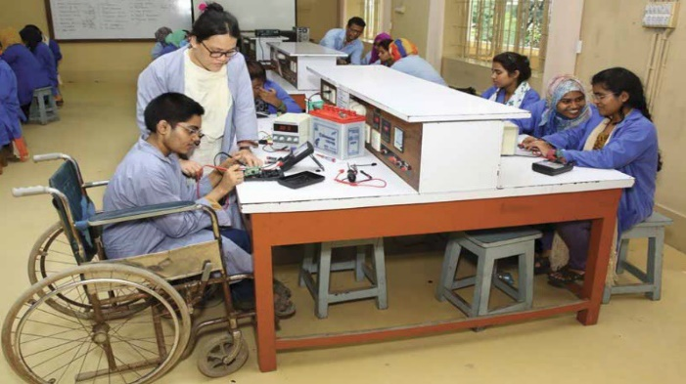

https://commonwealthdpf.org/wp-content/uploads/2020/07/CDPF-Policy-Guide-Employment-and-Disabled-People-final.docx
Humanitarian Situations and Disabled People
Several international studies have indicated that disabled people face heightened levels of risk and vulnerability both during and after a disaster: “Emergencies have particularly serious consequences for persons with disabilities. New physical barriers are created and support networks are disrupted. Access to information is difficult for everyone, especially persons with sensory disabilities. Relief services are often not adapted for disabled people, who struggle to cover basic needs and become increasingly dependent on outside support.” Research shows that the mortality rate among disabled people tends to be two to four times higher than among the general population, as demonstrated in cases such as the Japan earthquake and tsunami (2011) and hurricane Katrina (2005) in the USA. Moreover, for every person who dies during a disaster, it is estimated that three people sustain an injury, many causing long-term disabilities.
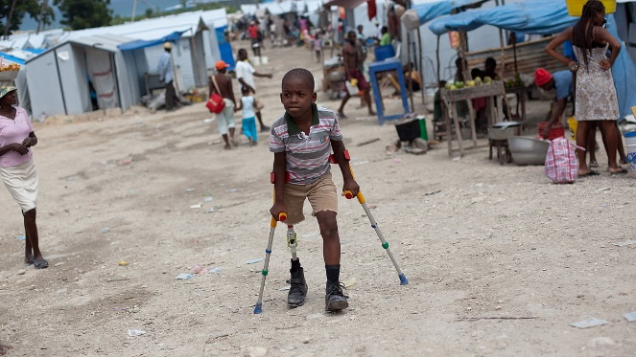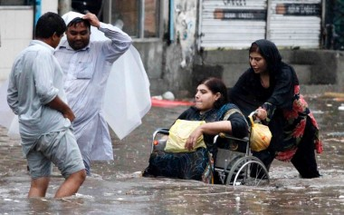
https://commonwealthdpf.org/wp-content/uploads/2020/07/CDPF-Policy-Humanitarian-Situations-and-Disabled-People-final.docx

Policy on Stigma, Media and Discrimination
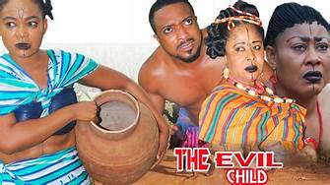
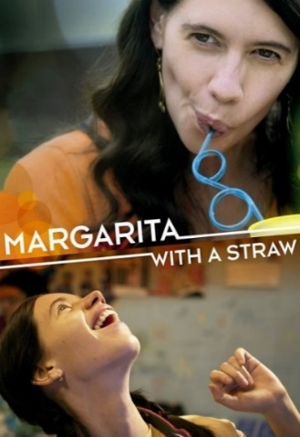
The media is a powerful tool used to communicate, create and raise awareness to reach a wide audience at a given time. Disability issues and rights can therefore be very well communicated using the media to promote accurate images and voices of disabled people. In the past, media has presented disabled people negatively as objects of pity, yet they can just be portrayed as people with different needs. The media can be used to bring to the limelight how policies, plans and programmes should have an inclusive approach to disabled people as part of development. This will ensure that the rights of disabled people are protected and implemented. Currently, there are approximately 1 billion disabled people in the world. In developing countries, evidence shows that disabled people are disproportionately represented among the world’s poor and tend to be poorer than their non-disabled counterparts. They are excluded economically and socially which is against their human rights and presents a major development challenge. The rich diversity of our societies inclusive of all its members, disabled people can help fundamental human rights and contribute to development for all.
https://commonwealthdpf.org/wp-content/uploads/2020/07/CDPF-Policy-on-Stigma-Media-and-Discrimination-final.docx

Disabled Women and Girls Policy Paper
It is estimated that more than one billion people in the world experience some form of long-term impairment which in combination with societal barriers limits their activities, 50% are disabled women and 80% of them are from rural areas. In Commonwealth countries disabled women and girls include those with multiple and intersecting identities, such as being from different ethnic, religious and racial backgrounds; refugee, migrant, asylum-seeking and internally displaced women; LGBTQI+ persons; women living with and affected by HIV8 ; young and older women; and widowed women, across all contexts. The CDPF supports the social model of disability and except when quoting or referencing international or national treaties or laws, we use the term ‘disabled women and girls’ or ‘disabled people’, as we have many different impairments but are united as disabled people in our opposition to societal barriers and the oppression we face. In the case of disabled women and girls, this is also the oppression of patriarchy and sexism.
As a consequence of multiple identities, some disabled women and girls are pushed to the extreme margins and experience profound discriminations. Systemic barriers and exclusion lead to lower economic and social status; increased risk of violence and abuse including sexual violence; early and forced marriage discrimination as well as harmful gender-based discriminatory practices; barriers to access education, health care including sexual and reproductive health, information and services and justice, as well as civic and political participation.
https://commonwealthdpf.org/wp-content/uploads/2020/07/CDPF-Disabled-Women_Paper-03-07-2020-final.docx
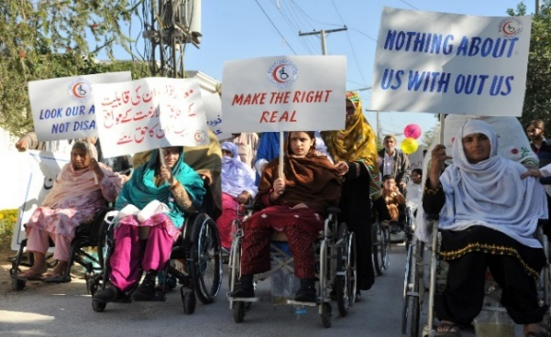
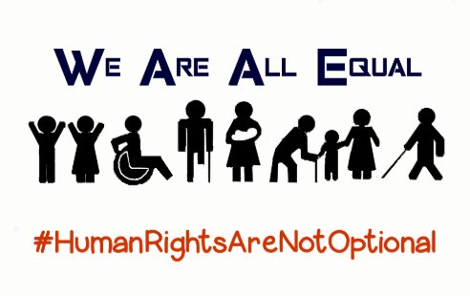

Policy on Accessibility and Assistive Technology for Disabled People
A fundamental human right is for disabled people to gain access and participation on an equal level with others regardless of our impairments. Disabled people have struggled for many years to adapt society’s lived physical and information environment for this to happen. The first International Human Rights Treaty to explicitly mention it was the UN Convention on the Rights of Persons with Disabilities (UNCRPD), 2008. There had been National Laws, building codes and standards that had partially acknowledged the need for access in the previous 120 years. All of these were fought for by disabled people and their organisations and some non-disabled led charities. People with sensory impairments were in the vanguard arguing for the teaching and use of Braille, Sign Language, gaining concessions in a minority of countries, usually higher income.

The provision of these means of communication were often provided in segregated, sometimes residential schools, colleges and ‘sheltered’ workplaces. The built environment, transport, libraries, shops, hospitals, schools, colleges, universities, housing, places of entertainment and political processes, indeed all of ‘normal’ human life, was not adapted for disabled people to take part. Where possible we had to be rehabilitated to be as ‘normal’ as possible. These moves were usually led by non-disabled medically trained rehabilitation professionals and they and some disabled people faced with the huge number of barriers in the environment, designed a wide range of assistive devices to make living in an inaccessible world easier. For those of us who could not be fitted in or rehabilitated we were either abandoned to begging or later segregated in institutions. This ‘medical model’ approach usually meant a loss of autonomy and a separate ‘voice’ for disabled people. However, alongside this approach developed struggles led by disabled people for our access, autonomy and human rights. The idea that built environments, transport and systems of communication must be adapted and as renewed, universally designed, so there are no barriers, gained support in the last 50 years as disabled people and Disabled People’s Organisations (DPOs) became better at expressing our goals through ‘social model’ thinking. This set the stage for the UNCRPD and the incorporation of the ideas and principles into the Sustainable Development Goals (SDGs).
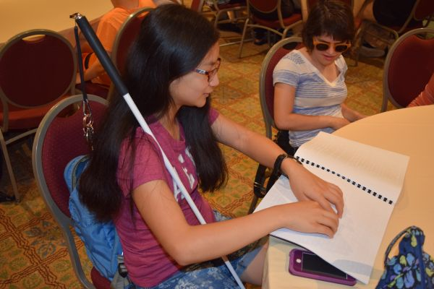
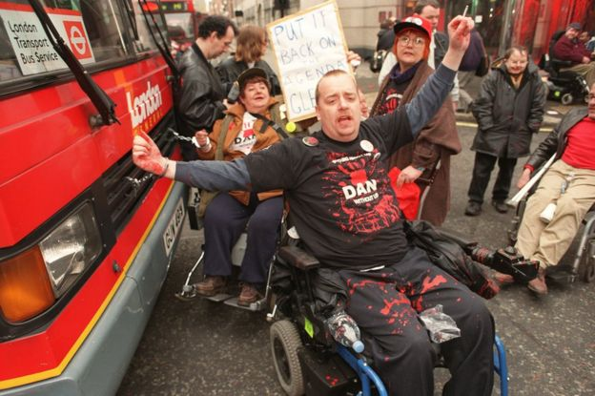

https://commonwealthdpf.org/wp-content/uploads/2020/07/Commonwealth-Disabled-People-Access-and-Assistive-Technology-final.docx

Anti-Racist Statement was approved by the EC in light of Black Lives Matter and the death of George Floyd https://commonwealthdpf.org/wp-content/uploads/2020/09/Commonwealth-Disabled-People-Anti-Racist-Statement.docx
We have agreed to set up a working group to develop a more detailed policy document and are asking members to nominate members to this working group.
Commonwealth Disabled People’s Statement on combatting Racism, Supporting Black Lives Matter and accelerating race equality and decolonization of the media, culture, school and college curricula throughout the Commonwealth.
“The Commonwealth Disabled People’s Forum, representing the more than 450 million disabled people in 54 countries of the Commonwealth, support the current global protests against racism. We further recognise the impact on disabled people of the history of racism in the Commonwealth and the need to challenge the impact of colonisation, dispossession, current and historical colonial acts of oppression and continuing injustice and inequality, especially to indigenous peoples. The CDPF works to ensure that measures are in place to address these issues so that reconciliation can take place.(Constitutional Object 3.i of CDPF).
We further recognize and reaffirm the Lusaka Declaration of the Commonwealth Heads of Government (1979) which helped created a climate to get rid of apartheid in South Africa, but was aimed at all countries. The Declaration committed the Commonwealth:
“United in our desire to rid the world of the evils of racism and racial prejudice, we proclaim our faith in the inherent dignity and worth of the human person and declare that:
1. the peoples of the Commonwealth have the right to live freely in dignity and equality, without any distinction or exclusion based on race, colour, sex, descent, or national or ethnic origin;
2. while everyone is free to retain diversity in his or her culture and lifestyle, this diversity does not justify the perpetuation of racial prejudice or racially discriminatory practices;
3. everyone has the right to equality before the law and equal justice under the law;
4. everyone has the right to effective remedies and protection against any form of discrimination based on the grounds of race, colour, sex, descent, or national or ethnic origin” and ….

“We reaffirm that it is the duty of all the peoples of the Commonwealth to work together for the total eradication of the infamous policy of apartheid which is internationally recognised as a crime against the conscience and dignity of mankind and the very existence of which is an affront to humanity.
We agree that everyone has the right to protection against acts of incitement to racial hatred and discrimination, whether committed by individuals, groups or other organisations.

We affirm that there should be no discrimination based on race, colour, sex, descent or national or ethnic origin in the acquisition or exercise of the right to vote; in the field of civil rights or access to citizenship; or in the economic, social or cultural fields, particularly education, health, employment, occupation, housing, social security and cultural life.

We attach particular importance to ensuring that children shall be protected from practices which may foster racism or racial prejudice. Children have the right to be brought up and educated in a spirit of tolerance and understanding so as to be able to contribute fully to the building of future societies based on justice and friendship.

We believe that those groups in societies who may be especially disadvantaged because of residual racist attitudes are entitled to the fullest protection of the law.

We recognise that the history of the Commonwealth and its diversity require that special attention should be paid to the problems of indigenous minorities. We recognise that the same special attention should be paid to the problems of immigrants, immigrant workers and refugees”.

The CDPF recognise that 40 years of free market economics, globalisation and COVID-19 have acted to increase racism and further marginalise many social groups, especially disabled people and that false science and outdated racist tropes and stereotypes are again circulating in the media magnified by the new largely uncontrolled social media.

The CDPF calls on all civil society organisations and the leaders of Commonwealth countries to:-

- Declare their support for ‘Black Lives Matter’ and promote racial and ethnic harmony .
- Work with community organisations and educators to decolonise school and college curricula.
- Ensure that galleries, museums and public statues recount the real history of colonialism, slavery and empire.
- Promote a spirit of peace, environmental sustainability, reconciliation and collaboration.
- Ensure reparations are made to indigenous and minority ethnic peoples wronged by colonialism.
- Ensure laws are in place and prosecutions carried out to those who peddle race hatred.
- Governments to challenge institutional racism in the police and other state agencies.
- Ongoing equality training is established for all Parliamentarians, civil servants, professionals and business managers”.

Funding and Budget
We encountered difficulties in restarting the CDPF. It was agreed to hold the launch at the same time as the Conference of State Parties (COSP) to the UN Convention on the Rights of Persons with Disabilities (CRPD). The United States State Department was not helpful, with 7 delegates from 4 countries not being granted visas. Getting and holding a grant from the Disability Rights Fund required us to have a fiscal partner with proven financial accounting systems and willing to partner the CDPF in its endeavours. We were very pleased when International Action on Disability and Development (ADD) agreed to be our partners. They signed a Memorandum of Understanding with CDPF. Jimmy Innes, CEO of ADD, is a Trustee of CDPF and can attend F&GP and Executive Committee Ex-Officio. Securing funding was difficult, but with the assistance of UK DFID we were able to secure a grant of $192,000 in Year 1 and $220,000 in Year 2, from the Commonwealth fund of the Disability Rights Fund.
The first year’s Grant ran from 1st March up until the end of August 2019 ($192,000) and covered the organising costs for the General Assembly which were for organising, getting delegates and their personal assistants to travel to and from New York, access costs, insurance, visas, legal and contingency ($175,250 allocated). Recompense went towards time for the Organiser Richard Rieser to his organisation World of Inclusion Ltd (Richard was previously Treasurer and UK Link of CDPF). The Organiser’s role was to build membership, organise content and speakers at meetings, set up electronic newsletter and website convene telephone conferences of executive, produce and distribute minutes and seek further funding (all of which were achieved) ($7,500). After the General Assembly Richard was elected General Secretary. ADD received a contribution to salary of Gemma White at ADD who acted as administrator and for accounts ($7,500). This did not compensate for time involved and was substantially increased in 2nd year’s grant.

CDPF were also pleased that Layne Robinson of Commonwealth Secretariat agreed to fund a side meeting at the United Nations on 12th June with a grant of £10,000 ($12,600) and that the Disability Rights Fund funded our Reception after the Relaunch Conference ($4000). Unfortunately, to date the Commonwealth Secretariat have not paid the £10,000 and this has left ADD to fund the shortfall.
Getting a suitable venue for a day long re-launch Conference proved difficult at the United Nations during the COSPs, but the Ford Foundation provided us with excellent accessible and hi-tech meeting facilities, for which we are very grateful.
We applied and were successful in getting a 2nd year Grant from DRF of $220,000. This was originally to run from October 2019 to 31st August 2020. It was to cover ongoing organising and administration costs; a face to face Executive Committee Meeting in February 2020, organising a training event before Commonwealth Heads of Government Conference in Kigali, Rwanda and for delegates to attend the various CHOGM Fora. The first part of the grant was carried out according to plan with a series of on-line Policy Sub-Committees, Finance and General Purpose and Executive Committees continuing membership recruitment and a successful Executive Committee in Malta.
We were to be paid this grant in three tranches. The first to the end of March 2020 was paid and spent on administration, organising and the costs of the event in Malta ($93,700).
However, by the middle of March 2020, it was becoming clear that the Covid-19 Pandemic would change both our plans and our activities. A series of online meetings, exchange of e-mails with executive members and the Disability Rights Fund telling us they would not fund face to face meetings and suggesting we shift to Covid-19 as our main activity, led to a proposal to change and extend our grant to the end of August 2021.
We requested a no-cost extension of the grant to August 2021. This is because it is not at all clear what will happen in the next year. This has been granted.

We asked DRF that the remaining grant funds be paid in two tranches, the first tranche of $54,500 to be paid as soon as possible to cover :

- The engaging of more human resources on COVID 19, increase daily rate of the Gen Sec ($250 to $275) and increase the days by 35 in addition to existing 45.
- As we are holding more online meetings we need access in terms of sign language and captioning for those attending to have equality.
- We need to purchase the capacity for IT meetings, webinars and internet videos and for this we need the services of a web-site builder and IT technician on a sessional basis.
- Engage on a part time basis a COVID Information Officer ($10,000 will provide 10 hours a week for 60 weeks.) This person will also assist on implementation of SDGs and UNCRPD information.
- ADD International will continue to provide our main admin support, accounting and organizing meetings through the great support of Gemma White. (This is the $20,000 fee and $6,500 fee). We are asking for these to be paid in full in this tranche together with the contingency. This has been agreed with the Disability Rights Fund. Due to administrative glitches not paid until September 2020 in the sum of $54,500. This has not stopped these activities going forward.

Later in 2020/2021, once the situation regarding COVID and travel is clearer, we will submit a second project change form, at which time we will request for the second and final tranche of funds to be released. ( $72,500). We anticipate likely requesting revision of those funds along the following lines:
  - to develop a programme of online capacity building for the members of the CDPF with a focus on youth and women and developing leadership skills;
  - to be used for delegates to attend face to face international meetings if and when this is possible and necessary, including the postponed CHOGM and United Nations Conference of State Parties;
  - to cover on-going secretariat expenses as well as other initiatives that may become apparent.

Therefore of the 2nd Year Grant we have received $148,200 by September 2020.

Draft Accounts

Income and Expenditure For the period March 2019 to December 2019
 | Project 1 | Project 1 |  | Project 2 |  | TOTAL
 | DRF | Commonwealth Secretariat |  | DRF
Statement of Financial Activities
Income | $197,711.00 | $12,927.50 |  | $93,000.00 |  | $303,638.50
Expenditure | -$190,981.82 | -$12,947.88 |  | -$7,437.61 |  | -$211,367.31*
Net movement in funds | $6,729.18 | -$20.38 |  | $85,562.39 |  | $92,271.19
Funder Balance at 1st March 2019 | $0.00 | $0.00 |  | $0.00 |  | $0.00
Funder Balance at 31st December 2019 | $6,729.18 | -$20.38 |  | $85,562.39 |  | $92,271.19
Balance Sheet
Bank (included in ADD USD Account) | $6,729.18 | -$12,947.88 |  | $85,562.39 |  | $79,343.69
Debtor: accrued income |  | $12,927.50 |  |  |  | $12,927.50
Total net assets | $6,729.18 | -$20.38 |  | $85,562.39 |  | $92,271.19
Represented by
Restricted Funds | $6,729.18 | -$20.38 |  | $85,562.39 |  | $92,271.19
Income and Expenditure For the period January 2020 to August 2020
 | Project 1 | Project 1 |  | Project 2 |  | TOTAL
 | DRF | Commonwealth Secretariat |  | DRF
Statement of Financial Activities
Income | $0.00 | $0.00 |  | $0.00 |  | $0.00
Expenditure | $0.00 | $0.00 |  | -$90,341.30 |  | -$90,341.30*
Net movement in funds | $0.00 | $0.00 |  | -$90,341.30 |  | -$90,341.30
Funder Balance at 1st January 2020 | $6,729.18 | -$20.38 |  | $85,562.39 |  | $92,271.19
Funder Balance at 31st August 2020 | $6,729.18 | -$20.38 |  | -$4,778.91 |  | $1,929.89
Balance Sheet
Bank (included in ADD USD Account) | $6,729.18 | -$12,947.88 |  | -$4,778.91 |  | -$10,997.61*
Debtor: accrued income |  | $12,927.50 |  |  |  | $12,927.50
Total net assets | $6,729.18 | -$20.38 |  | -$4,778.91 |  | $1,929.89
Represented by
Restricted Funds | $6,729.18 | -$20.38 |  | -$4,778.91 |  | $1,929.89
- Negative means ADD funds have been used while awaiting re-payment from Commonwealth Secretariat and Disability Rights Fund

This meeting was funded by the Commonwealth Foundation, DFID, the Foreign and Commonwealth Office and ADD
This is based on Social model thinking which distinguishes between our loss of function or impairment and the disablement that results in barriers based on oppressive ideas. Therefore whatever our impairment we are united as disabled people in fighting our common oppression.
Appendix 1. Minutes of General Assembly 13th June 2019 The agenda will include 9.30–10.00 Registration & refreshment 10.00–10.20 Welcome, DFID, DRF, Commonwealth 10.20–12.00 Introductions from each delegate (maximum 3 mins each) – Main Issues for Disabled People in their country and for their organisation. 12.00–12.15 Comfort Break 12.15–1.00 Adoption of Constitution and Rule Changes 1.00–2.00 Lunch (Hand in Nominations for Executive Committee) 2.00–2.30 Priorities for Work Plan 2.30–3.00 Organisational details for Rwanda June 3.00–3.15 Comfort Break 3.15–3.45 Election of Executive Committee of 17 Members Chairperson (1) Vice Chair (2, at least 1 woman), General Secretary (1), Treasurer(1), Women’s Rep.(1), Youth Reps (2), Indigenous People (1), Intellectual Disability (1), Africa (2), Caribbean (1) South Asia (2), Pacific (1), ABCN (1) 3.45–4.30 Next steps/AOB 4.30–5.00 Tea 5.00–6.00 Meeting of Newly Elected Executive 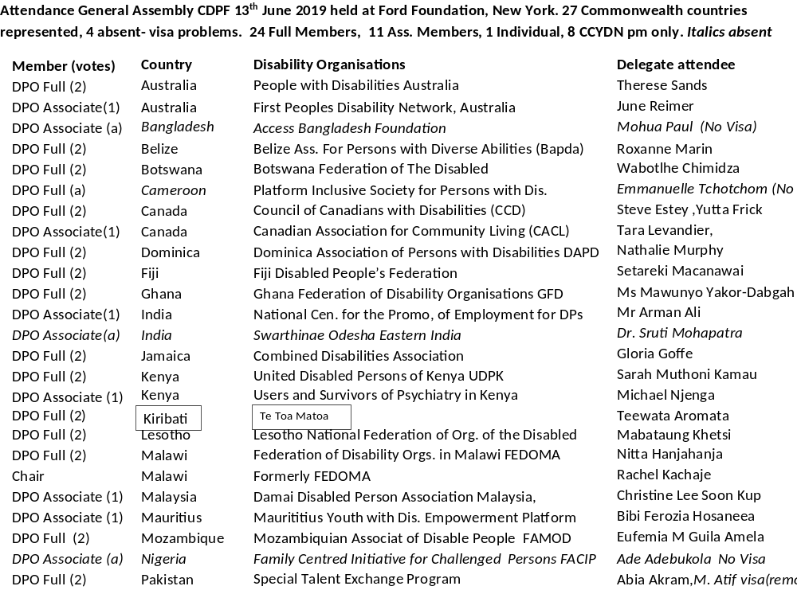 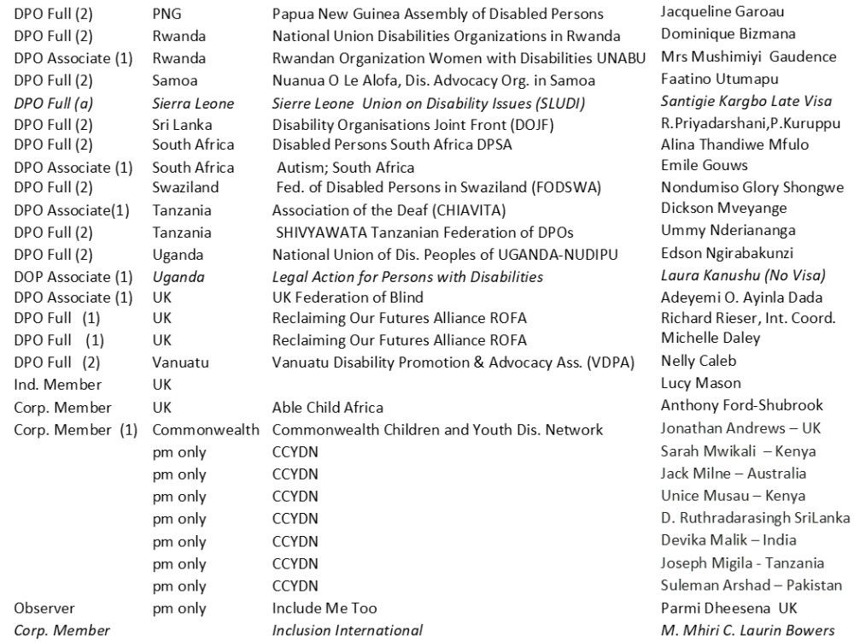 Corp Member/Fiscal PARTNER ADD International M.Hussein, J.Innes Administrator Gemma White , ADD and Susie Burrows and 4 volunteers. Minutes of the General Assembly CDPF 13th June 2019 held at Ford Foundation New York. Started at 10.20 with Rachel Kachaje (RK) in the Chair. Welcome. We are late in starting as we had to get the access right with the palantypist. Rachel welcomed the re-launch saying we must hear you and your ideas so we ensure the relaunched Commonwealth Disabled People’s Forum (CDPF) is on a firm footing. RK talked about the first attempt to set up a CDPF which started at Commonwealth Heads of Government Meeting (CHOGM) 2007 in Uganda and was formalised in London in 2008, acknowledging the driving force and vision of James Mwanda who was the first Chair and was a disabled member of Ugandan Parliament who made sure the CDPF existed. A minute’s silence was held for James and other pioneers such as George Daniels from Trinidad, the first Vice Chair. Mosharraf Hossain from Action on Disability and Development (ADD), Fiscal Partner, from Bangladesh, who had also been part of the first CDPF, welcomed friends as Director of Policy at ADD. ADD is an ally of the disability movement. In 2008 we were part of the launch meeting. The re-launching now is a better time to implement the Convention on the Rights of Persons with Disabilities (CRPD). Last year’s Conference of State Parties (COSP) meeting was not the voice of disabled people, this year’s event is. Our donors are committed to support you. We can be funding or support partners. All Commonwealth Governments should support you. This meeting is important. ADD will always be with you. Richard Rieser (RR), Interim Coordinator. It is important that we know this is a re-launch and not a beginning. Now we have more support with all of you. We have representatives from 26 Commonwealth countries and four more who supported the re-launch but failed to get visas from the American State Department-Bangladesh, Cameroon, Nigeria, Sierra Leone and 3 other delegates. So we are 30 out of 53. We need to get support from Disabled People’s Organisations (DPOs) in all remaining 23 countries and build the capacity of many of these DPOs. The CHOGM meetings in Rwanda in June 2020 and Fiji 2022 will affect what we do. Many Commonwealth Governments who have ratified the CRPD are not taking part in the COSP. This annual meeting is meant to be for all countries coming to understand what implementation means and how to make progress with the Convention. The Commonwealth Secretariat are supportive and pleased this initiative is taking place, but we are not yet officially recognised as a Commonwealth Organisation. We must work towards this for status and financial support. Many of our important funding members have died or are no longer active. We are here to build a strong, grass-roots based organisation led by your voice, not another bureaucratic level. We welcome observers here but do not have time to hear from them. We have 17 Executive positions to be filled after you have agreed a revised constitution. Hopefully we will not need an election. If we have an election, we will need a secret ballot(s). We must also agree on policy priorities. If delegates wish to amend these should be in writing, signed and handed to the chair. We must also think of the next year. This is an historic meeting and we will agree a declaration to announce our existence and policy. Can each of you introduce yourselves and one achievement and one challenge for your organisation? Introductions 10.40 Nathalie Murphy, Dominican Association of Persons with Disabilities.You will know us by the devastation caused to our island by hurricane Maria in 2017. I am the Executive Director, founding member and involved with managing the organisation since 1983. Our major achievement is we have our own Secretariat with a building funded by the Government. A challenge is getting our country to expand physical accessibility. This is my first time here with this group. Hopefully I can represent and recruit other Caribbean countries. I will pass around our 2018 annual report. Tara Levandier, Canadian Association for Community Living. We are part of Inclusion International and focus on intellectual disabilities with member organisations of people with intellectual disabilities and families in every province and territory of Canada. We have a difficult time around Article 12 of CRPD- Equal recognition before the law, in particular ensuring safeguards and support for legal capacity and that choices are respected. Lucy Mason, Individual Member from UK. I was a founder member of the original Commonwealth Disabled Youth Forum in 2008. I was the youth participation worker on the drafting of UNCRPD. I have worked on a number of implementation projects with Richard. I am interested in implementation of CRPD across the Commonwealth and want to support the involvement of young disabled people. Steve Estey, Council of Canadians with Disabilities. I am the National Coordinator. We helped with founding of CDPF in 2008. This is a great job Richard has done! There is now great potential to develop the CPDF. My focus on implementation of CRPD we are in the second round of coordinating a shadow report on Canada by liaising with DPOs across Canada. I will try to coordinate with all Canadian DPOs. I am reading the screen so I may be a bit behind the rest of you. Yutta Fricke, Council of Canadians with Disabilities. I am in same organisation as Steve and am the Chair of our International Committee. I am proud of us getting accessibility legislation under Article 9 rolled out across Canada. In Manitoba we already have this. Emile Gouws, Autism South Africa. I am a self-advocate, autistic and did not speak until I was 15. Now I have a Master’s Degree, teach autistic children and am doing a PhD on the subject. Our organisation helped produced a shadow report for CRPD. We are challenged with implementation in South Africa. We challenge Stigma along with Ministry of Social Development, but this is not mainstreamed in South Africa.. We have not made much progress in gender equality. We also need more accessibility. We have established voting rights in South Africa. Our challenge is our DPOs have the following training needs:-alternative income streams, advocacy, skills training, operational management and Human Resources. Jimmy Innes, ADD Chief Executive Officer (CEO). ADD has been active for more than 30 years to help establish DPOs in Africa and Asia working in 5 countries Sudan, Tanzania ,Uganda, Bangladesh, Cambodia and the UK. We are the fiscal and logistic partner of CDPF and are pleased to continue our support. Abia Akram , Special Talent Exchange Program (STEP), Pakistan. Very pleased to be here as a founder of Commonwealth Disabled Youth Forum in 2008. Thank you Richard for your leadership! We started in 1997 building DPO capacity and have an organisation network of 45-50 disabled people’s organisations working on implementation of the UN Convention. We have just presented a Bill in Parliament. In Asia Pacific Forum we have pushed rights of disabled women and are involved in the 2020+ Review. The challenge is linking strategies and unifying with other Commonwealth countries. Gloria Goffe, Combined Disabilities Association Jamaica. I am the Executive Director and we are well organised across the Island. We got legislation passed in 2014. Major challenge is getting employment for disabled people, especially in rural areas. June Reimer, First People’s Disability Network Australia. I am Deputy CEO. Set up in 1999.Challenge of being a minority group Aborigines, Torres Straight Islanders with disabilities, success is staying operational with no funding. Nelly Caleb, Vanuatu Disability Promotion and Advocacy Association. I am the National Coordinator. Busy implementing Disability Inclusion. Last year DRF funded 7 to attend CRPD Committee in Geneva. We held a press conference on the concluding observations and 50 journalists attended. Challenge of funding to attend international dialogue. Success- we organised a national press conference in April. Therese Sands, People with Disabilities Australia. We are a cross disabilities organisation and are well resourced. Issues we want to raise is intersectionality, to do this we have an alliance with many other organisations to form DPOs Australia. We are particularly concerned with Women , Aborigines, Refugees and Asylum Seekers with Disabilities. We focus on ending forced medical procedures on people with disabilities. We have managed to get a Royal Commission examining Incarceration, Violence, Abuse and Neglect towards Disabled People which is bringing resources. Christine Lee Soon Kup Damai Disabled Person Association Malaysia, part of Herapan Oku-Make our Rights Real, Malaysia. We are an organisation of DPOs and individuals working together. We focus on public transport. Disabled people have been excluded from mainstream development in Malaysia. The first Light Railway was not accessible because of safety and costs in 1994. We campaigned and the second one in 2007 was accessible. We led a strong protest in Malaysia. Our big challenge is enforcement of policy. We also need stronger legislation for implementation of CRPD. Anthony Ford-Shurbrook, Able Child Africa. I am someone with speech issues. It took many years to get a paid job though I am qualified. We work with disabled people in East Africa to increase education and health care. Arman Ali, National Centre for the Promotion of Employment for Disabled Persons. CEO not for profit with largest network of DPOs in India. We were largely responsible for getting 2 legislations on statute book. We campaigned and got new Law agreed (2016) that matches UNCRPD. Now the biggest problem is implementation and lack of resources to DPOs. We run the National Council for Disabled Persons which puts forward views to Government of India. Dominique Bizmana, National Union Disabilities Organizations in Rwanda. I am the Chair Person. We were established in 2010 with all types of disability represented. We have a secretariat of 22 staff and a further 78 working on local projects. 80% are disabled people. We support 2000 children with disabilities in access to education and health services. In 2017 we produced a shadow report. We campaigned and won the right of the Visually Impaired to vote. Challenges- No support from Government only International donors. There is no official data, but we have good policies Rasanjali Priyadarshani, Disability Organisations Joint Front, Sri Lanka. I am the General Secretary representing all different impairment organisations. We have 30 member DPOs. Started in 1996. Have a consultative role agreed with Government. Focus on intellectual disabilities and safeguarding rights for Disabled People. We are a member of Disabled People International. Mobilising funding is a challenge for us. Article 33 is a challenge- independent mechanism. We are donor dependent. Mawunyo Yakor-Dabgah, Ghana Federation of Disability Organisations. I am National President and we were established 2 years ago. We have 9 member organisations covering the usual and stammerers, albinism and mental health survivors. We get no support from Government at national level, but there is at district level. Help people with speech impairment. CRPD was ratified in Ghana in 2012 and a Government Committee was set up, but it has never met. We have been supported by DANDIA for 12 years but comes to an end next year. Challenge of not having government support financially. Gender equality is a challenge. We are pushing an affirmative action Bill currently, but does not include disabled women for positions. Wabotihe Chimidza, Botswana Federation of the Disabled. After 52 years we were recognised by the Government in 2018. In the process of developing a Disability Act to send to Parliament. We have no secretariat. We are housed in South Africa at SAFD. Our Government do not fund us and they have not yet ratified the UNCRPD. Alina Thandiwe Mfulo, Disabled Persons South Africa. I am the Deputy General Secretary. We are a democratic cross impairment organization, established in 1984. We have branches everywhere at province, district and municipality level in our country, so we can help everyone. Disabled people are recognised in our constitution because of us in 1994. We have councillors, MPs and Government members who are disabled. We have established Free housing for disabled people and their families and a strong Community Based Rehabilitation programme on the ground, so we know where the disabled children are. We present a very strong voice for PWD. We have little to no funding because we challenge the Government. Gaudence Mushimiyi, Rwandan Organisation of Women with Disabilities. I am the co-founder and current Director. We focus on inter-sectionality, we are growing fast and have influential partnerships. We do outreach work with 4000 girls with disabilities. We have developed a tool kit score card of disability gender equality. We inspire and advocate for change. We are lacking experts to advise our government especially on Inclusive Education. Roxanne Marin, Belize Association for Persons with Diverse Abilities. I am a person with hidden disabilities and President. We Get $100 a month from the Government so we rely on international partners. We have a population of 400,000 in 6 municipalities. We provide wheelchairs and prosthetics. We provide information to NGOs. It is very expensive to become an NGO. We have no office and a volunteer board. We must implement UNCRPD nationally and regionally. How do we get the Government to listen to us? Mabataung Khetsi, Lesotho National Federation of Organisations of the Disabled. We are an umbrella organisation for PD, HI,VI and intellectual disabilities. I am the President until 2021. We were formed in 1989 when I was a little girl. We are an umbrella organisation. We have advocated for legislation that is soon becoming law. We empower PWD to reach their full potential in all areas, by providing training, emotional support and advocating for their rights. Our vision is for a Lesotho that is accessible and all who live in Lesotho enjoy rights on an equal basis with others. Nondumiso Glory Shongwe, Federation of Disabled Persons in Swaziland. I am the Vice President. We had to push the Government and passed a Disability Act in August 2018. We have no office or secretariat and are housed at Save the Children and receive no funding from the Government. Dickson Mveyange, CHAVITA Association of the Deaf Tanzania. I am chair of this Association. I also have the Office of the African Deaf Union in our office and we work in 60 African countries. Challenge is access to communication and of political participation in the Disability Movement by Deaf People. Our chairperson is a Deaf MP. Hope to get educational and social rights and equality for Deaf People. We need to include more Deaf People in our movement. Ummy Nderiananga, SHIVYAWATA Tanzania Federation of DPOs. I am National Chairperson. We cover 26 regions and districts of mainland Tanzania. In 20118/19 we have received 2% budget in each district to support PWD. We have fought for PWD to be on decision making Boards. The Ambassador to Germany is a disabled person. We have got the Government to provide assistive devices. Challenge is employment opportunities and reach wider areas for influence and in capacity building of DPOs. Michelle Daley, Reclaiming Our Futures Alliance, UK. I am the Chair Woman of the ROFA International Committee. There has been some progress on information in different formats and accessible transport. Need progress and improvement on inclusive education -UK Government still has a reservation, independent living-too many still in long stay institutions and not getting right care package, employment, race inequality, gender inequality and intersectionality. Edson Ngirabakunzi, National Union of Disabled People Uganda. I am the Chief Executive Officer. This is the national umbrella organisation of 14 national DPOs and 112 local DPOs. We have representation of disabled people at all levels of the political system. Recently we organised a petition of 60,000 to implement our rights. Sarah Muthoni Kamau, United Disabled Persons Kenya. We have a secretariat and a Board which is representative by all our counties. We hold democratic elections for the Board. We advocate for educational inclusion and have helped develop the Government policy. We advocate for seats in parliament for PWD and for gender equality of these, 6 seats. There are not enough voices for women influencing policy and we have run courses to amplify the voice of disabled women. We are challenged by funding. Michael Njenga, Users and Survivors of Psychiatry Kenya. I am the Executive Director and Chair of the Pan African Network for people with Psycho-Social issues. We focus on Article 19 to get independent living. We also focus on Article 12, Legal Capacity and social inclusion. It is critical to have access to the justice system. We advocated for legislation that was passed by Parliament. We have many discriminatory laws and practices. Internationally we supported the adoption by the Human Rights Council of the policy Mental Health and Human Rights. Bibi Ferozia Hosaneea, Youth with Disabilities Empowerment Platform Mauritius. We are a small Island in the Indian Ocean. I am not disabled but the sister of a girl with Downs Syndrome. I founded and built this organisation working with parents and young disabled people. When we started we had 10 families now we have 500. Mauritius has 3 Reservations on the CRPD and we are working to get rid of these, especially in Inclusive Education and Independent Living. Yemi Dada, UK Federation of the Blind. I came from Nigeria to UK 50 years ago. I still have passport to show (holding up) I am albino which means I have low vision. I do not do much activity with blind people, but we must be sensitive to each others needs. The challenge we have in the UK is the spread of shared spaces in the environment. Instead of clearly designated pavements the Government has supported pedestrians, bicycles, cars and lorries all using the same road space in cities. We have campaigned and got them to pause this. If this happened in UK it can happen in your cities. Please sign our petition. Eufemia Amela, Mozambique Association of Disabled People. We are an umbrella association of 41 DPOs and I am a member of the Board. I am also Chairperson of the National Association of Women with Disabilities. Disabled Women are now able to tell about their problems and are aware of their rights. I was also recently elected chairperson of my University. Challenges include developing economic empowerment for disabled women to be independent, for which we need access to empowerment and education. Other challenges to get Inclusive education lobby to recognise the needs of disabled people and to reduce violence towards disabled people. Setareki Macanawai, Fiji Federation of Disabled People. I work as CEO of the Pacific Disabled People’s Forum. We have 10 Commonwealth countries. We have had success in getting South-South collaboration across these countries. The challenge is to reach the marginalised groups in the Disability Movement. We have a huge amount of water between our member countries and the cost of transport is very high. I would like to congratulate Richard and the team for organising this meeting and the funders. Nitta Hanjahanja, Federation of Disability Organisations in Malawi. I am the Chairperson and Rachel Kachaje was one of the founders. We had an inclusive education pilot project that has helped disabled students to go to school, especially secondary, where many buildings are now accessible and worked on ‘Leave No Child Behind’ but money ran out. Our Government ratified the UNCRPD in 2009. Our challenge is we have limited funding. Faatino Utumapu, Nuanua O Le Alofa, Disability Advocacy Organisation Samoa. Samoa ratified the CRPD in 2016. We encourage PWD to engage in society. Our difficulty is translating the provisions of CRPD into a small island country. Teewata Aromata, Te Toa Matoa, Kiribati . We have 5 Associations. I am chair of the Women with Disabilities Association. We have ratifed the UNCRPD in 2013. We worked in partnership with Government. We have a challenge with changes in political will and changes in the Government System. We are part of the Pacific Disability Forum. Jacqueline Garoau, Papua New Guinea Assembly of Disabled Persons. We were established in 2002. We are made up of more than 20 DPOs . Due to our efforts, our Government ratified the UNCRPD in 2013 and in May 2015 set up a National Policy Council. PNG have Sign Language as the fourth Official Language within the Constitution. We have over 800 languages. Domestic legislation was enacted in 2017. Challenges include capacity building, funding and establishing DPOs for minority areas within disability, such as intellectual disabilities, psycho-social and young people. Chair No matter where we come from the issues are the same. We must come together and fight. We will now take a 15 minute comfort break. 12.05. 12.27 RECONVENED. Point of Order on procedure being followed. RR We must go through and approve the Constitution before nominations and elections. It would be good for different regions to confer amongst yourselves for a nomination for your region. Since we have no registration fee any organisation with delegates can nominate. Please sign these and hand them to Hannah or Susie who will be tellers. Your nominations should be in by 1.30. We will deal with focal point positions after the elections. Our membership has widened and you as the General Assembly(GA) can make amendments to the constitution in this session. We will go through the constitution (previously circulated) paragraph by paragraph and vote on it. RK Now we will begin going through the constitution. New bits are red and underlined. Point of Order clarification on voting cards and order of business. RR answered:* New bits of constitution are in red and underlined *Blue cards equal 2 votes for Full members *Yellow cards are 1 vote for Associate members. Steve Estey, Canada: Procedural point: Go paragraph by paragraph and ask if we need votes and if not, they will be agreed upon consensus. Agreed GA to use this method by a show of hands. Preamble agreed by consensus Title agreed by consensus. Article 1 Name agreed by consensus Article 2 Purpose-objections -Clause 1 cannot mention 1 under-represented group and not others Michael Njenga, Not want to highlight only people with intellectual disabilities and add families. Kenya-objection to Preamble and sort more clarification of the principles. Agreed he would frame these and submit to General Secretary . These were later submitted as follows:- “The principles governing the CDPF The following principles shall govern the operations of the Commonwealth Disabled People’s Forum. (a) Respect for inherent dignity and individual autonomy of members; (b) Non-discrimination ; (c) Full, effective participation and inclusion in society; (d) Respect for difference, acceptance of disabled people as part of human diversity and humanity; (e) Equality of opportunity; (g) Equality between men and women and between member countries ; (h) Respect for the evolving capacities of disabled children and respect for the right of disabled children to preserve their identities”. Thandiwe Mfulo, South Africa 2. Purpose. The organisation should be about self-representation of disabled people and not families who should not be mentioned. Therese Sands, Australia 2.Purpose. Same objection as South Africa. Families offer support to a disabled person to make their decisions. This is not an organization for families. Realise pick up comment in General Comment 7. Supported decision making propose deleting and comment to General Comment 7 in membership with an amendment. Must be key point disabled people. Wabotlhe Chimidza, Botswana 1. Name. Raised an objection to Article 1 already agreed upon. Nathalie Murphy Dominica 1. Name. Why do we say Disabled People instead of People with disabilities? Dominique, Rwanda. Wants to use language of the Convention as we are able people. Richard Rieser, UK 1.Name. The wording was chosen in 2008 after the UNCRPD had been agreed to express that disability is a oppression we face in common and that our struggles for equality are not due to our impairments, but due to our not being accepted in society, resulting in stigma and discrimination. Our impairment is not our disability. What unites us as disabled people, regardless of our different impairments, is our common cause of struggling for the full rights for disabled people. The CRPD is wrong on this issue. Definition in CRPD talks about people with impairments and barriers. Still being discriminated by society and stigma. Michele Daley, UK 1. Name. We must recognise intersectionality and the barriers we face. This is a political identity. The things around us we experience disability we are not people with disability. This term was imposed upon us by non-disabled people. Disabled People came out of the Social Model. Thandiwe Mfulo, South Africa.1. Name Disabled People is how we are recognised. The tone determines, not the wording, maybe we need to vote. Gloria Goffe, Jamaica. 1. Name We adopted the term used by the CRPD because we are people first. Our disability is we are people first. Differently abled suggested. General dislike. Rachel Kachaje, Chair. Name. At the UN there were many votes and thoughts on how we should be described. We do not need to waste time on semantics but need content. Can we move to a vote or change the name. Setareki Macanawai, Fiji. Name. This is the name we are known by. Richards’ explanation and using CRPD language. I’m suggesting we vote on which term we use to clear the air. Vote Disabled People 49 People with Disabilities 10. RK The name stays the same agreed by general assembly. Richard Addressing points on Article 2. CRPD Committee said as quoted in para 5. Can delete in purpose 2a. People here and voting in 5. Keep deletion. Preamble principles in preamble should be added. Concretely Michael, Tanzania, and Edson Uganda to draft them. Agreed. Move to article 3. Intellectual deleted. a) two objects in one in a agreed split. e) Monitoring mention Commonwealth Governments-Programmes. i) Split as two objectives in one. Repository of research. m) add to social media added. Agreed. Therese. Point raised last night impact of colonisation. Strong heritage effect of colonialism and its legacy. Michael. Add ‘other regional mechanisms in the Commonwealth’ in b added. Abia need to talk on girls and women agreed a separate object. Number g Movement building. Article 4) Forum of experts- covered in f) add to f to make point. Register NGO in UK . Can be register elsewhere later. Agreed. Article 5 Membership. Therese needs to reflect DPOs made up led and governed by disabled people. Not talking about families. Need to maintain primacy DPOs. Self-advocates who we prefer. Agree suggestion. Voting should be disabled people some voting cards. Limitation no more 10% of any forum where votes are taken. Membership change ‘sex’ to ‘gender’. Edson. Page 4 members are quite elaborate 7-write up too much make it easier to read nominate CDPF officers. This was the constitution. Posts being elected are voluntary not paid. Open up smaller DPOs with no say. Principles Full member double the say. Have voted . Move on agreed. DPO Associate is this agreed. Michael N. Regional bodies not all are Commonwealth. Mental Health Survivors have a voice not a vote as a Corporate. Richard. Wider speakers and not vote. If agreed in principle. E.g. Inclusion International said they are Corporates. Article 6 and 8-11 agreed as no objections and no amendments. More money until next General Assembly no fee. From 2008 to 2012 £50 was a barrier. Agree no fee. Edson. From time to time. General Assembly agreed. Executive Committee. Chair, 2 Vice-Chair people, General Secretary, Treasurer, Womens Rep, Indigenous Disabled People. Africa and South Asia 2. ABCN Australia, Britain, Canada, New Zealand full names. Spell out CCYDN-Agreed Sri Lanka proposed South Asia has 3 representatives. Seta. Talking about countries not population. Dickson important to consider different groups otherwise leave out disability. All under represented groups 1 position quota of disability number of positions. Seat for family members. Indigenous people have different axes to make. RR proposed Vote on existing balance in 12 a. RR Positive discrimination to build different impairment groups into posts nominated. Try and stand in elections. Existing 12 Accepted. Thandi, South Asia stay as two . PNG have a glossary of acronym . Increase South Asia to 3. Over 60% of disabled people. Vote for 3 largely lost 2 accepted. Important to agree Para 12a. keeping as it is. Largely carried. 3 places to co-opt. New Executive balance itself. RR. Take vote on in principle adoption of the constitution then take nominations. Detailed later. Families will be no more than 10%. Constitution Agreed in principle. Amendments agreed will be incorporated and circulated in final version. Gender changes will be incorporated. Until 2.25. Nominations already received read out. I one vice chair, 1 South Asia. Other nominations over lunch. Federation for the Blind UK have a petition to sign. Shared space take away dropped kerbs in cities a danger to blind people and other disabled people. Return at 2.25. Have flexibility outside. LUNCH 1.45 Resumed 2.41. Hear from representative of the Commonwealth Children and Youth Disabled Network. Sarah Mwikale, Kenya CCYDN. I work setting up the network and am on the committee. CCYDN will represent children and young disabled people and work in parallel with the CPDFF providing input to disabled children and youth across the Commonwealth. We hope CDPF will recognise CCYDN as a resource to develop the inclusion and rights of disabled children in the Commonwealth. We are keen to assist in planning, monitoring and implementing the actions that are essential to foster the full inclusion of children and young people with disabilities across all sectors in order to implement the UNCRPD, UNCRC, Global children and Young People’s Charter and deliver SDGs. Jonathan Andrews, Chair CCYDN and Co-Chair of Include Me Too, who I have been working alongside for two and a half years who are an integral part of the work we do and would not be able to do without them. I will elaborate on the work plan Sarah outlined. We are focused on CHOGM in Rwanda June 2020 co-capacity building with YDP across the Commonwealth, gathering support for the Charter which we adopted in London a few months ago and launched at UNCOSP side meeting this morning. This had a good response. We are also working with Commonwealth Youth Council and the Commonwealth Young Gender Equality network. We will focus on the themes of the Global Disability Summit, with key concerns inclusive education, economic empowerment and how those two go together, ending stigma and discrimination, gender equality and making sure all forms of abuse are eliminated. We voice safeguards, advocacy mentoring and awareness of CRPD, CRC and SDGs. We are keen to work with the CDPF and enter a memorandum of understanding with the CDPF. We look to have a representative on the CDPF as will be discussed later today; invite each other to our events as observers; we recognise in the work we are doing there is room for collaboration to make sure DYP voices are heard. We need to work together for CHOGM 2020 and implement CRPD and regularly inform each other of the advocacy initiatives within the Commonwealth and at the Global level exploring collaboration and increasing impact. It is fantastic we are here and to see the CDPF relaunched and making sure young disabled people’s voices are heard. Thanks for inviting us today. RK Thanked the Young People for keeping up the energy as the future world was going to be made by Young Disabled People. Now we need to look at the work plan for the CRDP. Declaration RR Not had any amendments in writing, but sure will receive some as start discussing. We will go through paragraph by paragraph draft declaration. Para 1 Why exist to build our organisations. Agreed. Para 2 After CRPD add ‘all other legally binding documents’. Agreed. Need to particularly support those countries not yet ratified the CRPD such as Botswana and put pressure on these Governments. Para 3 Our priorities are the ones agreed by the Global Summit last July. Thandie SA can we include people in business, self-employment and entrepreneurship should be added. Dixon, Uganda proposed economic empowerment instead. Agreed. Ummy, Tanzania in all spheres of life stigma and discrimination are the root cause. We need to add ‘change attitudes and stereotypes in the media’. Agreed Michele, UK race inequality for disabled people in UK, Canada and Australia, not in majority black societies. Need to look wider issues of intersectional oppression. Agreed Lucy Mason, UK we need to support and promote leadership of young disabled people. They can get lost in all our proceedings. We need to prepare them to take on international leadership and being representatives at international level. Mawunyo Yakor-Dabgah,Ghana . Some groups are further marginalised by their impairments such as people with albinism in Africa. RR. This morning we had the discussion and agreed to co-operate on a social/human rights model and not accept we organise as separate impairment groups, but as cross impairment organisations. We can of course focus on particular issues such as albinism in Africa which is culturally focused giving solidarity to people in particular impairment groups who are persecuted. Agreed and move on. 4th paragraph approved. 5th paragraph approved. RR The CDPF will help DPOs come together in national umbrella organisations in each country and seek funding to do so. Agreed. RR Sharing good practice. We have the means to do this on our website www.commonwealthdpf.org . We rely on all of you to share good practices and send them in to the General Secretary. Ummy Nderiananga, Tanzania. We will also need to raise funding with donors for capacity building and sustainable projects and other initiatives. RR Do you mean core funding? UN Yes, core funding. Steve Estey, Canada. With regard to 4 we should also build capacity around shadow reporting to the UN CRPD Committee. Agreed Dickson Mveyeange, Chavita, Tanzania. We should include all capacity building and not be specific. Thandiwe Mfulo, South Africa. This should include Governments. Agreed RR Now we are looking at how we achieve points 1-5 under bullet points in 6. Alexandra Acesia, UNDP Observer. Work with regional offices of the UN in gathering data. This then gets fed into the UN Data protocols which are already in place. This is super important if UN to achieve SDGs. With regional capacity building work with regional offices on the ground that feed into Governments. Lucy Mason, UK. We should support CCYDN and other youth work with mentoring programmes by experienced activists with developing youth leaders. Agreed Abia Akram, Pakistan. Formation of Women with Disabilities organisation at every country level. Agreed RR. We have bent the stick on getting more female than male delegates as a form of positive action. Women often don’t find the general DPOs habitable. But the onus has to be on all men involved to reign in their sexism so as to create a space women can operate in. Both agreed. Faatino Utumapu, Samoa. On mentoring can we agree to add youth and other under represented groups of disabled people. Agreed. Yemi Dada, NFB UK. In Nigeria there is a lot of in fighting as not accept a woman’s leadership, particularly in Muslim areas. We need representation in these areas. Jonathan Andrews, CCYDN. Youth mentoring would be best if the young people themselves initiate by asking for it. Add to 6.5 ‘People of all ages particularly youth’. Agreed. Dickson, Chavita. Under 6.6 Need Research/Data and evidence base utilising research. Agreed RR Elections of Executive I have been elected unopposed as General Secretary, so I shall chair this bit, as Rachel is in an election. The following have been nominated and were unopposed. General Secretary -Richard Rieser, UK Treasurer - Mawunyo Yakor-Dabgah, Ghana Youth Representatives CCYDN- Jonathan Andrews (UK), Sarah Mwikali (Kenya) Caribbean- Nathalie Murphy, Dominica ABCN-Steve Estey, Canada Indigenous Disabled Peoples- June Reimer, Australia Pacific- Faatino Utumapu, Samoa South Asia-(2) Prasanna Kuruppu, Sri Lanka Muhammed Atif, Pakistan [Queried as not in room, but confirmed participating on line. Agreed, but should be made clear at the beginning of election if someone is taking part remotely]. Women’s Rep – was initially declared as Abia Akram. But another nomination had been made and was in order and so there would be a separate ballot. Thandi South Africa asked how many possible votes. Count was Carried out. There were 27 organisations with Blue cards x 2 votes and 12 with yellow x 1 vote. So the total possible votes that can be cast is 66. A ballot paper was produced for the contested posts and explained. There will be a hustings with each candidate for a contested post given 1 minute to speak. This will be done for all four contested elections and then voters will put 1 or 2 crosses on their ballot, against their chosen candidates. They must use their votes where 2 for the same candidate(s). Some questions on the election were resolved. Voting Commenced 3.53 pm. Chair (1 to be elected) Rachel Kachaje, Malawi (33 elected) Edson Ngirabakunzi, Uganda (27) Vice Chair (2 to be elected) Nelly Caleb, Vanuatu (23) Sarah Kamau, Kenya (28 elected) Eufemia Amela, Mozambique (7) Thandi Mfulo, South Africa (32 elected) Under Represented Group (1 to be elected) Emile Gouws, Autism South Africa (22) Micheal Njenga, Users and Survivors of Psychiatry, Kenya (37 elected) African Representative (2 to be elected) Nitta Hanjahanja-Malawi (16) Wabotlhe Chimidza, Botswana (32 elected) Gaudence Mushimiyi, Rwanda (52 elected) Session resumes 4.23. Husings for Women’s Representative Khetsi Mabataung , Lesotho (27) Abia Akram, Pakistan (32 elected) Voting Ballot collected at 4.31. RR read out Declaration was agreed (p 6 this Annual Report) Parts to constitution that were being drafted Womens’s statement- agreed Historical context of colonialisation- agreed Inclusion of family organisations in Membership agreed. Incorporated in revised constitution (Appendix 2 of this document) https://commonwealthdpf.org/wp-content/uploads/2020/07/Adopted-Constitution-COMMONWEALTH-Disabled-Peoples-Forum-2019-14-pt-2-1.doc Election results read out as indicated above. Fiji concerned about wording of declaration addressing needs add ‘human and technical resources’, approved. Lesotho wanted to know voting figures. These were read out by Susie one of tellers and are shown next to candidates’ names. Complaint about Skype participant being nominated. Explained and agreed provided told in future before election. Seta, Fiji-Elections are dominated by Africa and next time we must ensure it is more diverse. Remitted to the Executive to resolve. Michele, UK. This is about solidarity and not countries. Thandi, South Africa. No one greater than each other. I thought we would sit and caucus as a whole. Instead we separated into regional groups. We must do better next time. Dominique Bizman, Rwanda. I would like to comment on African dominance on the Board. Next time we need to be more inclusive. If there is a vote, elections should be public. Nathalie Murphy, Dominica. We have all done a great job especially the organisers. We all agreed the voting process and followed through on it. Start looking ahead, we have work to do, forget the past. We are not individuals. We are Commonwealth countries now. RK. Chair. Thanked everyone and said we had achieved what we set out to do. RR. General Secretary. Thanked everyone for their patience and participation on this historic day. Asked the Executive members to take a short break and come back to the chamber. All others please go outside or back to hotels and return to Reception here from 6.00 onwards. The Executive Board met from 5.05 to 5.42. Appendix 2 Revised Constitution CDPF 13th June 2019 Revised Constitution of Commonwealth Disabled Peoples’ Forum (2008) with Updates and amendment agreed by the General Assembly June 13th 2019 Preamble In light of the adoption UN Convention on the Rights of Persons with Disabilities (UNCRPD) by the General assembly in December 2006, the recognition by Commonwealth Heads of Government, in their statement in Kampala in November 2007 and subsequent statements of the need to adopt, ratify and implement the UNCRDP throughout the Commonwealth, to achieve the Sustainable Development Goals by 2030 and challenge the continuing inequalities and exclusion disabled people face throughout the Commonwealth, we resolve to set up a Commonwealth Disabled Peoples’ Forum. The principles governing the CDPF The following principles shall govern the operations Commonwealth Disabled Peoples Forum. (a) Respect for inherent dignity and individual autonomy of members. (b) Non-discrimination; (c) Full and effective participation and inclusion in society; (d) Respect for difference and acceptance of disabled people as part of human diversity and humanity; (e) Equality of opportunity; (g) Equality between men and women and between member countries; (h) Respect for the evolving capacities of disabled children and respect for the right of disabled children to preserve their identities. Article 1: Name The name of this organization is Commonwealth Disabled People’s Forum (CDPF) Article 2: Purpose - The purpose of CDPF is to bring disabled people together, regardless of type of impairment, gender, age, race, indigenous, geographical background, religion, political affiliation from all countries of the Commonwealth, with a view to having one voice to advocate for promotion and equalization of opportunities for all disabled people. - To engage and influence the structures and organs of the Commonwealth, especially the Commonwealth Heads of Government Meeting and the wider global human rights and disability rights movement. - Implement the principles outlined in the preamble as contained in these documents. Article 3: Objects The objects for which the Forum is established are: - To establish a Forum for all Disabled Peoples Organizations in the Commonwealth, open to organizations representing people with all forms and types of impairments. - To promote solidarity, enhance their development and to support the acquisition of all their human rights. - To promote equality for disabled people, meaning the process through which the general systems of society are made accessible to all by the removal of social, economic, civil, political, cultural, environmental and attitudinal barriers, such as the physical and cultural environment, housing, transport, information technology, health, social services, education, employment, family life, independent living, sports and recreation activities. - To advocate and provide support for the signing, ratification and monitoring full implementation of the Convention on the Rights of Persons with Disabilities by all Commonwealth countries. - To develop capacity building, awareness, empowerment among the general public, government authorities, professionals and disabled people and their organizations of their potential and rights. - To influence governments of the Commonwealth and regional mechanisms to fully involve the CPDF and DPOs in formulation of policies, programmes, monitoring of implementation of the UNCRPD and SDGs or all other decisions and programmes which affect disabled people. - To serve as a home of expertise and reference for the Commonwealth Governments, DPOs and other disability stakeholders in Commonwealth countries through technical assistance, guidance and documentation on disability matters. - To strengthen and empower disabled women and girls’ human rights in Commonwealth countries, to end violence against women and girls and address sexual health and reproductive rights of disabled women and girls with reference to CEDAW, CRPD Article 6 and the Beijing Platform for Action (1995). - To recognise the impact on disabled people within the history of the Commonwealth and the impact of colonisation, dispossession, current and historical colonial acts of oppression, injustice and inequality and ensure that measures are in place to address these issues so that reconciliation can take place. - To promote sustainable programmes and activities for disabled Women, Youth and Indigenous People to develop their empowerment and independent living. - To build and strengthen relations with local, national, regional and international donors, potential donors, NGOs and other institutions or individuals who subscribe to the aims and the objectives of the CDPF. - To mobilize resources through fundraising, subscriptions, donations, endowments and income generation projects. - To solicit support from governments and other agencies and the general public through negotiations, persuasions, appeals and other ways. - To borrow or raise money in such a manner as the CDPF may deem fit. - To invest the moneys of the CDPF, not immediately required for its purposes, in such manner as may be approved by the Executive Committee. - To undertake and execute any trusts which may lawfully be undertaken by the CDPF to further its objectives. - To print and publish any virtual materials, website, social media, pamphlets, articles, newspapers, periodicals, books, film, leaflets that the CDPF may think desirable for the promotion of its objectives in accessible formats. - To support and subscribe to any organisation, institution, society, club or cause which may be for the benefit of the CDPF or its employees or for the advancement of its objectives. - To do any other such lawful things as are incidental or conducive to the attainment of the above objects or any of them. Article 4: Registered Office There will be a registered office of CDPF which will be situated in London, United Kingdom and in other Commonwealth countries as resources allow. Article 5: Membership a) Within CDPF there shall be full members, DPO Associate members, corporate members, associate and individual members. The Forum shall seek the widest representation of groups of disabled persons of national populations as well as regards gender, religion, race, language, geography and impairment, etc. Organizations including family members and/or relatives of persons with disabilities, which are pivotal in facilitating, promoting and securing the interests and supporting the autonomy and active participation of their relatives with intellectual disabilities, dementia and/or children with disabilities, when these groups of persons with disabilities want to be supported by their families as united networks or organizations. In such cases, these organizations should be included in consultation, decision-making and monitoring processes. The role of parents, relatives and caregivers in such organizations should be to assist and empower persons with disabilities to have a voice and take full control of their own lives. Such organizations should actively work to promote and use supported decision-making processes to ensure and respect the right of persons with disabilities to be consulted and to express their own views; in line with General Comment No 7 are counted as DPOs. paragraph 12 (a) [then quote the paragraph]. These organisations are understood to be organisations "that are led, directed and governed by persons with disabilities. A clear majority of their membership should be recruited among persons with disabilities themselves" (CRPD General Comment, paragraph 10). No more than 10% of any voting body of the CDPF will be comprised of such organisations. - Full Members Full membership of the CDPF shall be open to national Disabled Peoples Organisations (DPOs) in any country of the Commonwealth qualified under the provisions of this article. "DPOs" means that a majority of the members as well as the governing body shall be disabled people and in the case of those with intellectual disabilities or others mentioned in 5a also their families and they shall represent a wide range of impairments and local DPOs in line with the stipulations of 5a. ‘A national DPO is one with membership in at least one half of the country and representing a wide range of impairments.’ Full members shall exercise voting powers- 2 votes, send delegates to CDPF organs, and nominate persons to CDPF offices. c) DPO Associates. This is for country regional organisations which are not national or national organisations for a single impairment group, which are run by a majority of disabled people on governing body and have a majority of their membership who are disabled people and in the case of those with intellectual disabilities or others mentioned in 5a) also their families They will be able to attend meetings, speak, and have 1 vote send delegates to CDPF organs. d) Corporate Members Corporate membership may be granted to international uni-disability organizations which support CDPF objectives and which are organizations where a majority of members as well as the governing bodies are persons with disabilities in accordance with definitions in article 1. Representatives of corporate members have speaking rights at the CDPF General Assembly. A limited number of persons representing corporate members can attend to the General Assembly with speaking rights has no voting rights, nor the right to be nominated or to nominate persons to office, but has speaking rights. e) Associate members may be granted membership if they are international Non Governmental Organisations who will fund, support and will promote the objectives of the CDPF. Their disabled representatives may attend general assemblies with speaking rights but without no voting rights, nor the right to be nominated or to nominate persons to office. f) Individual Members Individual membership may be granted by the General Assembly on recommendation by the executive committee to prominent disabled individuals who may not necessarily be in any DPOs, but who support CDPF objectives and would wish to be associated with it. An individual member has no voting rights, nor the right to be nominated or to nominate persons to office, but has speaking rights. Article 6: Application for membership Membership applications and applications for re-admission as a member of CDPF shall be decided by the General Assembly on recommendation of the Executive Committee. Article 7: Membership Fees The General Assembly shall have powers to levy membership and other fees on recommendations of the Executive Committee. A member unable to pay prescribed membership fees can seek partial or complete exemption from the Executive Committee. The General Assembly will determine fees. There is no fee currently. Article 8: Termination of Membership - The General Assembly shall have powers to determine the continued compliance with membership requirements of the members. - A member that wishes to terminate its membership shall give notice to the Chairperson. Such notice shall take effect six (6) months after it is received provided that the member has at that time fulfilled its entire financial obligation to CDPF. - A member may be expelled if is in serious arrears in payment of financial contributions to CDPF by a resolution of the General Assembly passed by a simple majority of those present and voting. - A member may be expelled due to a cause that is detrimental to the interests and purposes of CDPF. - The General Assembly may, by resolution passed by simple majority of those present and voting, determine the outcome of non-compliance with membership requirements. - The affected member shall be given due notice and an opportunity to respond. - A member shall cease to be a member of the CFDP if the member’s country ceases to be a member of the Commonwealth. - All members shall automatically cease to be members if the CFDP is wound up. Article 9: Organization CDPF shall consist of the General Assembly, Executive Committee, and Staff. In all elections of CDPF, secret ballots shall be used. Article 10: General Assembly - The General Assembly shall be the supreme policy making body of the organisation and it shall consist of representatives from all paid up member DPOs of the Forum from Africa, Caribbean, South Asia, Pacific, South East Asia and the ABCN countries shall attempt to ensure that all groups of disabled persons and gender are fairly represented. - The General Assembly shall, among other things, adopt and amend the constitution; elect the Executive Committee, the Patron and Auditors; determine membership and annual fees; approve policies, programmes, work plans and budgets of the Forum; receive and adopt reports and audited accounts from the Executive and approve admission of new members. - The General Assembly shall be convened bi-annually before the Commonwealth Heads of Government Meeting (CHOGM) for the purpose of, among other things, receiving the chairperson’s reports and audited accounts; electing the Board of Directors, and Patron and appointing Auditors. - Notice of the bi-Annual General Assembly shall be 21 days and Extraordinary or Special General Assembly 14 days given in writing and signed by the Secretary addressed to each member entitled to receive notice and widely publicized in mass media. - The General Assembly shall serve as final court of appeal on all matters as regards the rights and obligations of members. - The quorum for the general assembly is 20% of membership Article 11: Commonwealth Disabled Peoples Conference - The Commonwealth Peoples Conference as far as possible be convened bi-annually before CHOGM, among other things, to review current developments in the disability field and prepare proposals for submission to CHOGM for consideration. - All members of the Forum shall be entitled to send delegates to the bi-Annual Disabled Peoples Conference and shall be entitled to speak at the conference, and to share materials and good practice.. - The Executive Committee may assist DPOs in the country hosting CHOGM or any other Commonwealth country as may be decided by the Executive Committee to organize the bi- Annual Commonwealth Disabled Peoples Conference. Article 12: Executive Committee - The Executive shall consist of a Chairperson, Vice Chairperson (2 at least I shall be a woman), Secretary, Treasurer, Women Representative (1), Youth Representatives (2) (at least 1 from CCYDN, Indigenous People’s Representative (1), Intellectual Disability and under represented groups and others as defined in 5a (1) and representatives from each of the regions of Africa (2), the Caribbean (1), South Asia/SE Asia (2), Pacific (1) and the Australia, Britain, Canada, New Zealand countries (1) elected at the bi-General Assembly of the Forum and shall hold office for two years. - At its first meeting, the Executives may co-opt not more than three other members bearing in mind gender, disability categories and other consideration. Co-opted members shall also serve for two years. 1 shall be Communications officer. - Meetings of the Executive Committee shall be convened by the chairperson at least once a year, and written notice dully signed by the Secretary shall be sent to all members of the Board giving fourteen days notice. At all meetings of the Executive the quorum shall be 7 of the membership of the Board. Other meetings will take place using alternative communication. - The Executive Committee shall exercise all such powers as may be exercised or done by the CDPF except those things required to be done by the CDPF in a General Assembly. No regulations made by the Forum in a General Assembly shall invalidate any prior act of the Board which would have been valid if such regulation had not been made. - All acts done by the authority of the Executive Committtee or any sub committee thereof and of the individual members of the Executive, in good faith and with the authority express or implied of the CDPF, shall be deemed to be the acts of the CDPF and every member of the Executive shall be indemnified by the CDPF for any costs, losses and expenses incurred for the furtherance of the objects and purposes of the CDPF. - Upon petition signed by one half of the Executive Committee, the Chairperson shall convene a special meeting of the Executive Committee giving seven days notice and special business to be conducted. - A member of the Executive shall cease his/her membership if he resigns, or becomes, or his country ceases to be a member of the Commonwealth, or if removed by two thirds majority of members of the Board or absents himself from meetings for one year with out cause, or commits a criminal offence, or is declared bankrupt or dies. - The Executive may fill casual vacancies from members who are qualified to serve on the Board. Article 13: Functions of the Executive Committee The Executive Committee shall act on behalf of the General Assembly, in between its meetings and shall, among other things: - Set up a secretariat and appoint staff on such terms and conditions as they may deem fit and regulate their performance and conduct. - Consider ways and means of financing the operations and programmes of the CDPF and also protect and preserve its assets. - Ensure the attainment of the objectives for which the CDPF is established and maintain effective reporting to the General Assembly of all matters which requires its attention. - Receive, consider and approve applications for membership and maintain a register of members. - Prepare and present to the General Assembly for approval annual reports, budgets, programs and plans and audited financial accounts. - Set up committees to perform such specific tasks as may be deemed necessary for attainment of the CDPF objectives. - Draw up rules and regulations to regulate their own conduct and that of the secretariat and its staff. - Serve all members of the CDPF as equitably as possible and convene meetings of the CDPF as provided for in this constitution. - Ensure maximum participation possible by all categories of disabled persons in CDPF activities. - Advise the Commonwealth, United Nations, and other relevant bodies on matters relating to the activities of CDPF. Article 14: Officers of the Executive - The Chairperson shall be the head of the Forum and Executive and shall convene and preside over meetings of the General Assembly and Board of Executive. - The Vice Chairperson shall act in the absence of the Chairperson or in case of his/her inability to perform. - The Secretary shall be the secretary of all meetings of the General Assembly, the Executive and Committees of the CDPF and shall notify members of meetings, take minutes of all meetings and circulate them to all members entitled to receive them. - The Treasurer shall take custody of all the funds and other assets of the Forum and shall be accountable for all funds to the Forum in the General Assembly. The financial year of the Forum shall be 1st April to 31^{s} March of each succeeding year. - The Women’s Representative shall be responsible for ensuring that there is mobilisation, sensitisation and empowerment of disabled women and welfare programmes for disabled children are initiated by the CPDF. - The Youth Representatives shall be responsible for ensuring that there is mobilisation; sensitisation, empowerment of the youth with disabilities and that they are afforded opportunities for participation in sports and cultural and other activities. - The Indigenous Peoples’ representative shall be responsible for ensuring that there is mobilisation; sensitisation, empowerment of indigenous disabled people and that they are afforded opportunities for participation in sports and cultural and other activities. - The Communications Officer will ensure regular communications with the membership and develop electronic communications. - Intellectual Disability and other under-represented groups Officer will ensure their issues are part of CDPF proceedings. - Executive Committee members shall attend all meetings and play a full part in running the CDPF. - The Executive shall draw up guidelines to regulate the Executive Committee in the conduct of its business. Article 15: Country Focal Point 1. The Executive shall nominate one national DPO from each of the Commonwealth countries to be known as Country Focal Point to represent the interests of the CDPF in that country and for purposes of this Article every member of the Executive shall be a Country Representative of his or her country. 2. The functions of a Country Focal Point shall include, among other things: - Recruitment of qualifying DPOs as members of the Forum. - Providing information to DPOs about the Forum and promote the interests of the Forum in that country. - Ensuring that member DPOs discharge their responsibilities to the Forum, - Monitoring on behalf of the Forum the implementation of the Convention on the rights of people with disabilities and submit reports appropriately. - Submitting annual reports to the Board on the state of disabled persons in the country especially with regard to new innovative policies, legislation in the area of promoting inclusion and protection of rights, among others. - Undertaking any other tasks as may be assigned by the Board or the Chairman from time to time Article 16: Patron - The Patron shall be a distinguished personality in the Commonwealth nominated by the Executive Committee and approved by the General Assembly. - He or she shall represent the interests of the CDPF at the highest level in Commonwealth Governments; promote its development, may help raising funds for the programs of the CDPF, and shall hold office for two years and eligible for re- election for further terms of two years. Article 17: Relations with other International Organizations - CDPF may cooperate, in accordance with the provisions of this constitution, with any international organization of interest to CDPF in the promotion of its objectives either by way of corporate membership or observer status. - The CDPF may permit the participation of governmental and non- governmental organisations in CDPF meetings and activities, and may also participate in meetings, programs or activities of other organisations having similar objectives. - It may also be affiliated to another organisation with similar objectives by a resolution of the Executive approved by the General Assembly. Article 18: Financial and Budgetary Arrangements - The funds of the CDPF shall consist of membership and annual subscription fees; grants and donations from governments, international organisations and well wishers; funds raised from functions of the CDPF; funds raised for specific programs; funds raised from profits, interests, deposits, commissions, dividends accruing to the CDPF and Funds raised from any other lawful source. - The Executive may from time to time raise funds by way of borrowing from banking or other financial institutions or company on such terms as shall be approved by the Executive Committee. - The Treasurer shall deposit all funds of the CDPF with the bank or banks approved by the Executive. - The Executive may set up a special trust fund for money received for special purposes and shall submit regular reports certified by the auditors on the functioning of the fund. - The Executive may at any time call upon any member of the CDPF to pay forthwith any account due and on failure to make such payment, a member shall not be allowed the privileges of the Forum until the account is settled and the Executive may take such other action as they may deem necessary to recover the debt. - The Executive shall draw up financial regulations relating to signatories to cheques and negotiable instruments and make other rules and regulations for the proper and effective management of the funds of the CDPF. - There shall be strict accounting practices in the CDPF and as far as possible the Treasurer shall demand and give receipts on behalf of the CDPF and the authority to expend and withdraw funds shall rest with the Executive Committee provided that the fixed assets of the CDPF shall be only be disposed of by a resolution of the Executive. Article 19: Audit - The General Assembly on recommendation by the Executive shall appoint auditors and may be paid such fees or honourium as may be recommended by the Executive Committee and approved by the General Assembly. - The annual accounts shall be closed on 31st March of each year and the accounts shall be audited by 30th September , printed and a copy shall be presented to the bi - Annual General Assembly. Article 20: By Laws - The Executive shall have powers to make, alter and rescind such bye laws or rules as they may from time to time deem necessary, expedient or convenient for the proper conduct, management and welfare of the CDPF, in particular, but not exclusively by such by laws. - There shall be a set of by laws with more detailed rules and regulations on the procedures to be followed in the organization. Article 21: Amendments to the Constitution - This constitution may be altered or amended from time to time on the recommendation of the Executive only at the General Assemblies or at special General Assemblies called for that purpose, by a majority of two thirds of members present with the right to vote. - The Executive prior to submission to the General Assembly, shall circulate the proposed amendment or amendments to members for their opinions at least 2 months notice should be given.. - The quorum necessary to invoke this article shall be two thirds of the delegates entitled to attend and vote representing paid up members of the Forum. Article 22: Interpretation The powers to give final interpretation of any provision of these Articles shall rest with the General Assembly whose interpretation shall be binding on the members. Article 23: Dissolution of the Organization - The General Assembly on recommendation of the Executive, shall by resolution supported by two thirds of the members present and entitled to vote, dissolve the Forum. - In the event of dissolution of the Forum the property of the Forum shall be disposed of in such a manner as shall be determined by the General Assembly provided that no property whatsoever shall be given to an individual, but shall be donated to another organisation with similar objectives. Article 24: Entry into force This version of the constitution entered into force when approved by General Assembly held on 13th June 2019. Appendix 3 CDPF Membership at end July 2020 Supporting Anguilla Department of Social Development (Observer/ally) Australia People with Disabilities Australia (Full) Australia First Peoples Disability Network Australia (Associate) Bangladesh National Grassroots Disability Org (Associate) Bangladesh Access Bangladesh Foundation (Associate) Bangladesh Women with Disabilities Development Foundation WDDF (Full) Bangladesh Disabled Child Foundation (DCF) Barbados Barbados Council of the Disabled (Full) Belize Assembly for Persons with Diverse Abilities (Bapda) (Full) Botswana Federation of the Disabled (Full) Cameroon Platform Inclusive Society for Persons with Disabilities (Full) Canada Council of Canadians with Disabilities (CCD) (Full) Canada Canadian Association for Community Living (CACL) (Associate) Commonwealth Children and Youth Disability Network. Corporate Member Associate Dominica Dominica Association Persons with Disabilities DAPD (Full) Fiji Fiji Disabled People’s Federation (Full) Ghana Ghana Federation of Disability Organisations GFD (Full) Guyana Guyana Council of Organisations for Persons with Disabilities (Full) India Swabhiman (Associate) India National Centre Employment Disabled People (Full) Jamaica Combined Disabilities Association (Full) Kenya Ability Society of Kenya (Associate) Kenya Users & Survivors Psychiatry Ass. (Associate) Kenya United Disabled Persons of Kenya UDPOK (Full) Kenya Disability Development Network Community Board Organisation DDNCBO (Associate) Kiribati Te Teo Matoa (Full) Lesotho Lesotho National Federation of Org. of the Disabled LNFOD (Full) Malawi Disabled Women In Africa DIWA (Associate) Malawi Federation of Disability Orgs. in Malawi FEDOMA (Full) Malawi VIHEMA Malawi Visual Hearing Impairment Membership Association (Associate) Malaysia Damai – Disabled Persons Association (Associate) Malaysia Harapan OKU. (Associate) Maldives Maldives Association of Persons with Disabilities (Full) Malta Malta Federation of Organisations of Persons with Disabilities (MFOPD) (Full) Mauritius Youth with Disabilities Empowerment Platform (Associate) Mauritius Federation of Disabled People’s Organisations Mauritius (Full) Mozambique Mozambiquian Association of Disabled People FAMOD (Full) (Associate) Mozambique Mozambican Association of Women with Disabilities (Associate) Mozambique Associação Mocambicana de Mulheres com Deficiência Mozambique Mozambican Mental Health Users Association AMUSAM (Associate) Nauru Nauru Persons with Disabilities Organisation (Full) New Zealand Kapo Maori Aotearoa (Associate) Nigeria Advocacy for Women with Disabilities Initiative AWWDI (Associate) Nigeria Association for Comprehensive Empowerment of Nigerians with Disabilities (ASCEND) (Associate) Nigeria Joint National Association of Persons with Disabilities of Nigeria JONAWPWD (Full) Nigeria National Association of Women with Disabilities NAWID (Associate) Nigeria Family Centred Initiative for Challenged Persons FACI (Associate) Pakistan Special Talent Exchange (Full) Papua New Guinea Papua New Guinea Assembly of Disabled Persons (Full) Rwanda Rwandan Union of the Blind RUB (Associate) Rwanda National Union Disabilities Organizations in Rwanda NOUSPR (Full) Rwanda Rwandan Organization Women with Disabilities UNABU (Associate Delegate) Rwanda National Organisation of Users and Survivors of Psychiatry NOUSPR. (Associate) St Lucia National Council of and for People with Disabilities St Lucia Inc. (Full) St Vincent and the Grenadines Voice of the Disabled. (Full) Samoa Nuanua Ol Alofa (Full) Sierra Leone Sierra Leone Union on Disability Issues SLUDI (Full) Solomon Islands People with Disabilities Solomon Islands (Full) South Africa Disabled Persons South Africa (Full) South Africa Autism South Africa (Associate) South Africa South African Disability Alliance SADA. (Associate) Sri Lanka Disability Organisations Joint Front DOJF (Full) Sri Lanka Sri Lanka Foundation for Rehabilitation of the Disabled SLFRD (Associate) Swaziland (Eswatini) Federation of Disabled Persons in Swaziland (FODSWA) (Full) Tanzania Association of the Deaf (CHAVITA) (Associate) Tanzania Tanzanian Federation of Disabled Persons Organisations SHIVYAWATA (Full) Tonga Naunau O’E Alamaite Tonga Association (Full) Trinidad and Tobago Persons with Visual Impairments Associate (Associate) Tuvalu Fusi Alofa Association (Full) Uganda National Union of Disabled Persons of Uganda-NUDIPU (Full) Uganda Legal Action for Persons with Disabilities (Associate) Uganda Youth Physical Disability and Development Forum (Associate) UK National Federation of the Blind (Associate) UK Reclaiming Our Futures Alliance ROFA (Full) Vanuatu Vanuatu Disability Promotion & Advocacy Association VDPA (Full) Zambia Zambia Federation of Disability Organisations ZAFOD. (Full)

