Commonwealth Disabled People’s Forum
Newsletter No 1 October 2019

The Commonwealth Disabled People’s Forum (CDPF) was successfully relaunched at the Conference of State Parties in New York last June. With funding from the Disability Rights Fund, 37 delegates from 25 Commonwealth Countries took part in the relaunch conference. Details of this can be found on our website www.commonwealthdpf.org .
CDPF had started in UGANDA in 2007 and was formally constituted in London in 2008. It sporadically functioned until 2013 and then ceased, because of funding and organisational difficulties. At the Global Summit on Disability in London (July 2018) a side meeting was held of over 20 delegates from Commonwealth Country DPOs and it was agreed we should relaunch. The relaunch in June 2019 involved a successful side meeting at the United Nations ,sponsored by the Commonwealth Secretariat, a full day relaunch conference where after introductions, a revised constitution was adopted, a work programme and declaration were agreed and a new Executive Committee was elected.
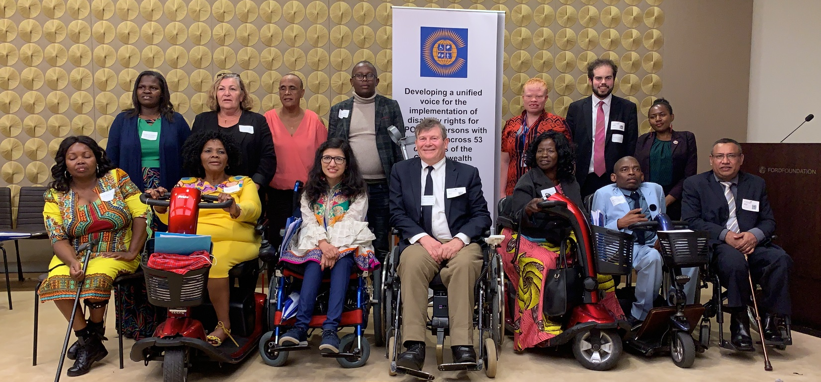
The New Executive Committee back row l-r Gaudence Mushimiyima (Rwanda) Africa Rep., June Reimer (Australia) Indigenous People Rep., Natalie Murphy (Dominica) Caribbean Rep., Michael Njenga, (Kenya), Under Represented Groups, Mawunyo Yakor-Dabgah (Ghana) Treasurer, Jonathan Andrews (UK) and Sarah Mwikale (Kenya) Youth Reps. Front row l-r Sarah Muthoni Kamau (Kenya) Vice Chair, Alina Thandiwe Mfulo (South Africa) Vice Chair, Abia Akram (Pakistan) Women’s Officer, Richard Rieser (UK) General Secretary, Rachel Kachaje (Malawi) Chair, Wabotlhe Chimidza (Botswana) Africa Rep., Prasanna Kuruppu (Sri Lanka) South Asia Rep. Other members not in the picture Steve Estey (Canada) Australia, Britain, Canada, New Zealand Rep., Faatino Utumapu (Samoa) Pacific Rep., Muhammad Atif (Pakistan) South Asia Rep. 3 co-optees:- Dr Sruti Mohapatra India, Emile Gouws (South Africa) Neuro Diversity, Dickson Mveyange (Tanzania) Deaf Community Rep.
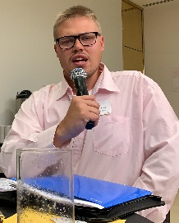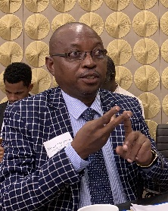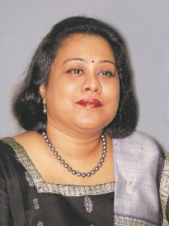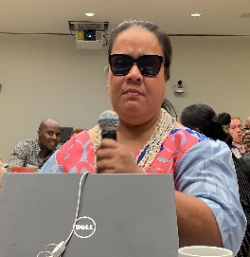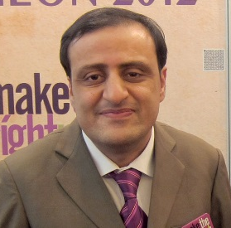
Left-Right. Emile Gouws, Dickson Mveyange, Sruti Mohaatra, Faatino Utumapu, Steve Estey, Mohammed Atif
Restarting the Commonwealth Disabled Peoples Forum We encountered difficulties in restarting the CDPF. It was agreed to hold the launch at the same time as the Conference of State Parties (COSP) to the UN Convention on the Rights of Persons with Disabilities (CRPD). The United States State Department was not helpful, with 7 delegates from 4 countries not being granted visas. Getting and holding a grant from the Disability Rights Fund required us to have a fiscal partner with proven financial accounting systems and willing to partner the CDPF in its endeavours. We were very pleased when International Action on Disability and Development (ADD) agreed to be our partners. Securing funding was difficult, but with the assistance of UK DFID we were able to secure a grant of $192,000 in Year 1 and $220,000 in Year 2, up until CHOGM 2020. This seems like a lot of money, but we need member organisations to be approaching their own Governments to get funding to get to Rwanda for CHOGM in June 2020.
We were also pleased that the Commonwealth Secretariat funded the side meeting at the United Nations on 12th June with a grant of £10,000 and that the Disability Rights Fund funded our Reception after the Relaunch Conference. Getting a suitable venue for a day long relaunch Conference proved difficult at the United Nations during the COSPs, but the Ford Foundation provided us with excellent accessible and hi-tech meeting facilities, for which we are very grateful.
Persons with Disabilities or Disabled People. We had a debate on this issue at the Relaunch. It was explained that some delegates preferred the People First Language contained in the UNCRPD. Others argued that we should use a ‘social model’ approach where people with impairments are subjected to barriers of environment, attitude and organisation which constitute an oppression or disabilism and that it is these barriers that disable us in the main. Therefore, we are not people with disabilities but people disabled by society and that the UNCRPD and national legislation seek to remove these barriers. In recognition of this we choose to call ourselves disabled people in solidarity with our common struggle for rights, equity and inclusion. This second position was adopted by a large majority, voting we keep the name Commonwealth Disabled People’s Forum name.
The role of allies and families. We wish to be inclusive of all impairment groups. We had discussions on the role of families and non-disabled supporters and decided for those with dementia, and intellectual disabilities we could accept non-disabled representatives, but our preference was always for self-advocates. The non-disabled family representatives could never be more than 10% of any decision-making body of the CDPF.
Membership of CDPF. Full members are umbrella Disabled People’s Organisations representing a range of different impairments and cross impairment organisations across their country (at least 50% of regions or districts) and having a majority of disabled people on their Board, National Council or Management Committee. Associate Members are single impairment organisations or particular focus organisations such as women or youth or indigenous disabled people or organisations representing these particular groups in more than one country across the Commonwealth. They need a majority of disabled people on their board, with the caveat above for family organisations applying. Full members have 2 votes and associates 1 vote at Conferences and General Assemblies of the CDPF.
Joining and building the CDPF.
The Commonwealth has 53 member countries with more than 450 million disabled people. Our aim is to get them all to ratify the UNCRPD and then implement it in all areas along with the Sustainable Development Goals (SDGs). We think our collaboration, information sharing and joint training and capacity building as DPOs with each other and in pushing and lobbying our state parties and the Commonwealth will enhance the position and rights of disabled people throughout Commonwealth countries and give us a voice on the world stage. Reaching all your organisations has proved difficult.
We currently have representation from 36 countries of the Commonwealth with 32 Full member organisations and 24 Associates. Each country full member needs to appoint a country focal point for their country and seek to spread the word and recruit DPOs to CDPF. We need your help to recruit to CDPF. Please can you get prospective members to complete , sign and stamp the application form. National Umbrella DPOs should also complete the monitoring form and return them to me at rlrieser@gmail.com
Forthcoming Activities
Antigua and Barbuda. We are in discussions with the High Commission for Antigua/Barbuda, the Commonwealth Secretariat, Commonwealth Youth Forum, Commonwealth Children and Youth Disability Network and Star College about a three-day Disability event in the Eastern Caribbean from 2nd to 4th December 2019. We are proposing a parallel workshop for DPO reps from the Eastern Caribbean. We will know about this by 11th October.
Face to Face Executive meeting end February/beginning March 2020. We are working on this with first choice Malta, but waiting on getting go ahead from Maltese Government. If this does not come about, we are examining Gulf or Kenya for venue.
Kigali Rwanda 17th to 20th June 2020 CDPF Capacity Building. 21st to 24th Commonwealth Heads of Government Conference Civil Society and Youth Forums. We are discussions with Commonwealth Secretariat about this. The Rwandan Government have agreed in principle to support our capacity building pre-event. The Executive will be determining criteria for financial support and who we can support. It would be great if you also approach your national Government to financially support you to attend, as our funds are limited.
Executive Meetings We met remotely on 13th September and agreed to set up working groups and Financial and General Purposes Committee. The working groups are developing policies with exemplars of good practice in the following areas:- A. Inclusive Education B. Employment and Livelihood C. Media, Stigma and Discrimination D. Women and girls E. Humanitarian Situations F. Assistive Technology. If any of you have useful policy documents or good practice examples in these areas to share, please send them in and they will be given to the groups to work on. The aim is to have draft policies to be approved by Face to Face Executive and role these out at CHOGM in June 2020. The next remote Executive Meeting will be on Thursday 14th November 2019.
SDGs and Disability by Dr Sruti Mohapatra
The 2030 Agenda for Sustainable Development enshrines 17 Sustainable Development Goals (SDGs) and 169 targets to be achieved over the next 15 years. It aims to end poverty, protect the planet and ensure prosperity while "leaving no one behind," and mentions disability 19 times on issues relative to data collection, education, work, inequalities, accessibility, justice and more. Thus, it is clearly inclusive of persons with disabilities (PwDs). It also provides a political momentum to push for the realization of the CRPD.
However, recent UN publication, ‘UN Flagship Report on Disability and Development 2018: Realization of the Sustainable Development Goals By, For and With PwDs,’ connects findings on PwDs with each of the 17 SDGs. On SDG 1 (no poverty), the report states that poverty rates are 15 percentage points higher, on average, for PwDs; in some countries, the proportion of PwDs living under the national poverty line is double that of persons without disabilities. Similarly, on SDG 2 (zero hunger), the average percentage of PwDs who are unable to afford protein every second day is nearly double that of people without disabilities. In their daily lives, they face challenges in accessibility to workplaces, businesses and public spaces, as well as access to education, health and sanitation facilities, transport and new technologies. Further, the report indicates that PwDs, particularly women and girls, are underrepresented in decision-making and political participation. It concludes that PwDs “are not yet sufficiently included in the implementation, monitoring and evaluation of the SDGs.” To fulfill ‘leaving no one behind’, SDGs have to be realized for PwDs– also in line with the CRPD, which was adopted in 2007 and which has so far been ratified by 177 States. Concrete actions are also needed to make the situation of PwDs visible in policymaking.
CDPF will focus on the following issues below. The related CRPD articles and SDGs are underneath:
CDPF Focus Areas | SDGs | CRPD
Inclusive Education | Goal 4 | Article 24
Employment and Livelihood | Goal 8 | Article 27,28
Women and Girls | Goal 5 | Article 6
Humanitarian Situations | Goal 11 | Article 11
Assistive Technology | Goals – 1, 4, 6, 8, 10, 11 | Articles – 9, 11, 13, 19, 20, 27, 29, 30
Media Attitudes, Stigma and Discrimination | Cross Cutting | Articles 5, 8 & 21
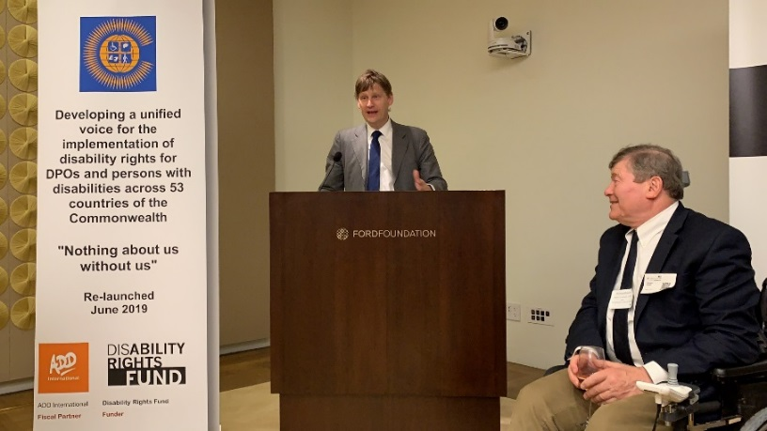

The Deputy UK Representative at UN Jonathan Allen addressing Launch Reception evening 13th June 2019

General Secretary Richard Rieser +44(0) 7715420727 email rlrieser@gmail.com Company Registration 7928235
Website www.commonwealthdpf.org

